

Meeting Date | 31st January 2024 |  | Agenda Item |  | 2.5
Report Title | Financial Report – Period 09 2023/24
Report Author | Samantha Moss, Deputy Director of Finance  Rob Thomas, Principal Finance Manager  Gemma Person, Finance Business Partner
Report Sponsor | Darren Griffiths, Executive Director of Finance and Performance, Acting Deputy Chief Executive
Presented by | Darren Griffiths, Executive Director of Finance and Performance, Acting Deputy Chief Executive
Freedom of Information | Open
Purpose of the Report | The report advises the Board of the Health Board financial position for Period 09 (December) 2023 and sets out the current forecast revenue year end outturn.
Key Issues | The report invites the Board to note the detailed analysis of the financial position for Period 09 (December) 2023.  The report includes details on the revenue position both in month and Year To Date and the forecast year-end revenue position based on current planning assumptions.  The report invites the Board to note the cash position, key balance sheet movements and the capital position. The report also includes a copy of the Strategic Cash letter that require retrospective Board ratification.
Specific Action Required  (please choose one only) | Information | Discussion | Assurance | Approval
Specific Action Required  (please choose one only) | ☒ | ☐ | ☒ | ☐
Recommendations | Members are asked to: -  - NOTE the WG Control Total and the impact on the 2023/24 Financial Plan  - NOTE that actions being undertaken to reduce the risk in terms of: -  - operational run rate  - savings delivery  - Consider and comment upon the Board’s financial performance for Period 09 2023/24 (Revenue and Capital)  - NOTE the balance sheet position at month 9.  - NOTE the Cash positon to 31st March 2024  - NOTE the Risks on the delivery of the plan to achieve the Control Total

FINANCIAL REPORT – PERIOD 9

- INTRODUCTION
The report invites the Board to note the detailed analysis of the Period 9 (December) revenue financial position along with Cash and Capital.

- BACKGROUND

  - The Health Board has two key statutory duties to achieve:

- To submit an Integrated Medium Term Plan (IMTP) to secure compliance with breakeven over 3 years.

2021/22 Annual Plan submitted
2022/23 3-year plan approved
2023/24 3-year plan submitted

The Health Board achieved this Statutory Duty in 2022/23.

- To achieve financial breakeven over a rolling three-year period, which commenced on 1st April 2020 and will end on 31st March 2023.

2021/22 £24.400m Overspend
2022/23 Forecast breakeven position
2023/24 Deficit Control Total £17.1m

The Health Board will fail to achieve this Statutory Duty.

  - Summary of Performance against Key Financial Targets

Financial KPIs : To ensure that net operating costs do not exceed the revenue resource limit set by Welsh Government | Value  £m
Reported in-month financial position – deficit/(surplus) | (0.175)
Reported cumulative financial position – deficit/(surplus) | 41.529
Capital KPIs: To ensure that costs do not exceed the capital resource limit set by Welsh Government | Value  £m
Reported year to date financial position – deficit/(surplus) | (0.495)
Forecast outturn financial position – deficit/(surplus) (prior to additional allocations) | 0.453
PSPP Target : To pay a minimum of 95% of all non NHS creditors within 30 days of receipt of goods or a valid invoice | Value  %
Cumulative year to date % of invoices paid within 30 days (by number) | 96.19

- FINANCIAL IMPLICATIONS

FINANCIAL PLAN 2023/24

The Health Board (HB) developed and submitted a revised 3 Year plan on 31st May 2023 which reported a deficit of £86.6m. Following the hard work undertaken within Welsh Government NHS Wales has received £460m of additional funding of which Swansea Bay received £60.8m for 2023/24, of which £43.3m is recurrent. For 2023/24 there is then a requirement for the HB to deliver a 10% reduction based on the original deficit plan value of £86.6m, to achieve a control total of £17m.

As outlined in the Month 7 Board Report (section 7) there are multiple actions required to achieve the Control toal set by WG, this is being overseen by what is referred in by he ‘Landing Plan’. With updates on delivery against the plan provided to Performance & Finance Committee each month.

The profile on £17m control total following the receipt of the £60.8m is provided below:

Table 1: Financial Plan

Performance against the plan and the agreed tapered values is summarised below:

Table 2: Plan & Performance 2023/24

- FINANCIAL PERFORMANCE
The key metrics linked to the revenue position are provided in the table below. Further details on the key drivers to this are provided in section 5.1 and appendix 1 of this report.

Table 3: Summary Revenue Performance

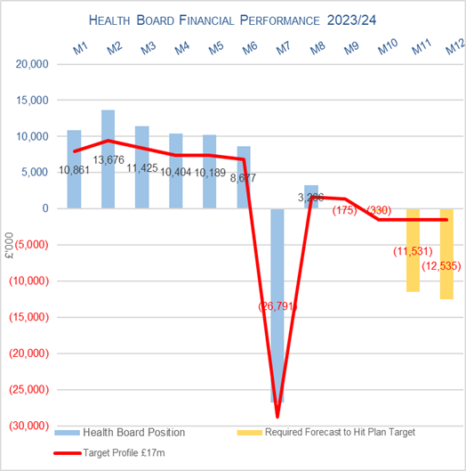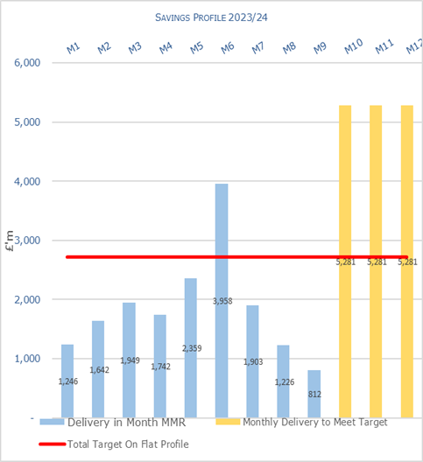

Target | In Month  £M | Year To Date (YTD)  £M
Delivery Against Revenue Resource Limit (RRL) DEFICIT / (SURPLUS) | (0.175) | 41.529
Delivery Against In Month Landing Plan SLIPPAGE / (IMPROVEMENT) | 0.800
Delivery Against Total Savings Target In Ledger DEFICIT / (SURPLUS) | 0.972 | 7.510

In summary whilst the In-Month position was £0.175m underspend, which is a significant improvement from Month 8, the Landing Plan required the Health Board to achieve £0.975m underspend In-Month. This in linked to two items (1) Capacity restrictions = Agency target (£2.1m) and (2) Targets Service Areas (£6.4m).

The Landing Plan is scrutinised in detail by the Health Board Performance and Finance Committee.

At the end of Month 9 the (£0.175m) underspend and YTD overspend of £41.529m is broken down by Service Group and Corporate Directorate as per the table 4 below:

Table 4: Summary Position by Service Group/ Directorate @ Month 9

Actions/Comments Linked Table 4:

Key points of notes by type spent:
- Income
The Welsh Health Specialised Services (WHSSC) Income as a provider continues to impact on the performance against plan, with YTD underachievement of £1.4m. Month 9 saw a further deterioration linked to reduced activity in December 2023.

As reported for the previous 8 months of 2023/24, the pressure as a result in the loss of Dental Contract Income continues, with the YTD shortfall increasing to £1.3m in Month 9.

- Pay
The Month 9 pay overspend has improved from Month 8 and stood at £1.7m (a decrease from Month 8 overspend of £1.9m), taking the YTD overspend to £14.6m. There has been a decrease of 213 WTEs between months, predominantly within Additional Clinical Services, which is largely driven by our Overseas Nurses becoming qualified, and Estates & Ancillary, which is largely driven by a reduction in Band 2 Catering and Domestic staff. There has been a reduction in Non-Medical Agency (£0.4m), Bank (£0.2m) and Irregular Sessions (£0.2m), partly due to the qualification of a cohort of Overseas Nurses and partly due to prohibiting substantive staff from taking Annual Leave over the Christmas period.

Therefore, the Health Board clearly needs to address both the underlying run rate issue and the continued spend on variable pay, which is driving the in-month pay variance.

- Prescribing
At Month 9 the in-month position reflected in the ledger on Prescribing is breakeven (Month 8 £0.6m overspent) and £4.9m YTD. The latest PAR recognises a significant price reduction in Apixaban (the most commonly prescribed DOAC), which has reduced the end of year forecast back to the £6.1m assumed within the Landing Plan.
- Non Delivery Savings
The Health Board has set a 3.5% savings target for 2023/24, after two years of achieving 4%. In additional there is a further £10.6m of unmet recurrent savings b/f from 2022/23. However there remains a gap in the delivery of savings to meet the target sets which has resulted in a £1.0m variance in Month 9, with a £7.5m YTD.

Key points of notes by Service Area:

- Morriston
The key variances:
- Income: Month 9 is £0.427m under-achieved and Year To Date (YTD) £1.337m underachieved. This is driven by WHSSC performance. Plans are being developed to recover this via the Enhanced Monitoring meetings.
  - Pay: Month 9 is £1.486m overspent, which is a £0.28m deterioration from Month 8, and is £12.183m overspent YTD. Expenditure on variable pay was £2.495m in-month, which is a decrease of £0.29m from Month 8.
  - Non-Pay (excluding Savings): Month 9 is £0.14m underspent but YTD remains overspend at £5.29m. Of the £5.29m, YTD £3.4m relates to Clinical Supplies (including Secondary Care Drugs).
  - Savings: YTD position at Month 9 is an £5.03m shortfall.

- NPTS
The key variances:
  - Income: Month 9 is an £0.074m under-achievement and YTD £0.617m under-achievement. This continues to be driven primarily by the loss of Private Patient income.
  - Pay: Month 9 is £0.650m overspent; this is an improvement of £0.144m compared to Month 8. The YTD position is £4.775m overspent. Expenditure on variable pay was £1.259m in-month, which is a decrease of £0.370m from Month 8.
  - Non-Pay (excluding Savings): Month 9 is £0.482m overspent and YTD £7.658m overspent, which relates to Clinical Supplies and Primary Care Prescribing.
  - Savings: YTD position at Month 9 shows an £2.273m shortfall.

Key Actions being undertaken
The previous reports detailed the actions being driven by the Health Board to mitigate the planned deficit and risks. Updates or additional actions above those reported in previous months are set out in the following paragraph

Landing Plan
The Health Board’s ‘Landing Plan’ to deliver the Control Total set by Welsh Government of £17.1m was presented to the Board on 30th November 2023. The Board supported the aspiration to deliver the Control Total and the opportunities and actions needed to deliver the target. The control target requirements for Service Groups have been formally communicated to Budget Holders in December via a letter from the Chief Executive. Recovery meetings with Service Groups have focused on developing plans to achieve the required reductions in run rates, with positive progress in MHLD, PCT and NPST and limited progress within MSG, largely due to the outbreaks of Norovirus, COVID, Flu and C.difficile leading to some beds being closed and other facilities opened being an unavoidable management focus. The Landing Plan will be used going forward to oversee the delivery of the Control Total and will be shared with the Performance & Finance Committee monthly to provide oversight and assurance on the delivery of the actions.

- KEY AREAS OF NOTE
Further details on specific issues impacting the revenue position are provided in Appendix 1 of this report.

The section below provides highlights on other issues influencing the delivery of the wider financial position, including balance sheet and capital:

  - Savings
As reported previously the starting point for the 2023/24 savings delivery was £32.8m.

At 5th January, the schemes identified for delivery in 2023/24 by service areas are summarised below:

Table 5.1: Summary 2023/24 Savings Target & Delivery

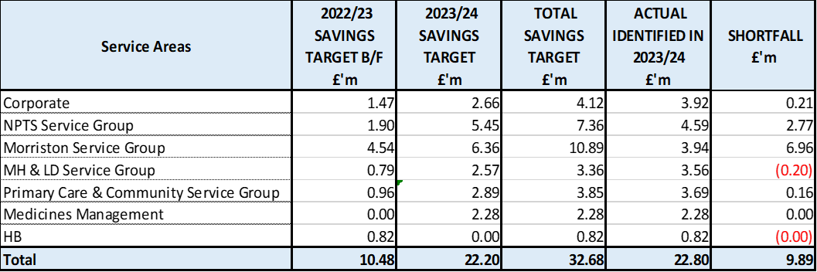

Based on the table above whilst £22.80m has been identified at the 5th January 2023 there remains a shortfall in delivery of £9.89m.

The recurrent performance against the target is provided in table 5.2 and shows that the gap to deliver recurrent savings is further adrift with an overall shortfall of £19.71m. Whilst this will not impact on performance against the position in 2023/24 this would result in the underlying position for 2024/25 deteriorating from that included within the IMTP.

Table 5.2: Summary Recurrent 2023/24 Savings Target & Delivery

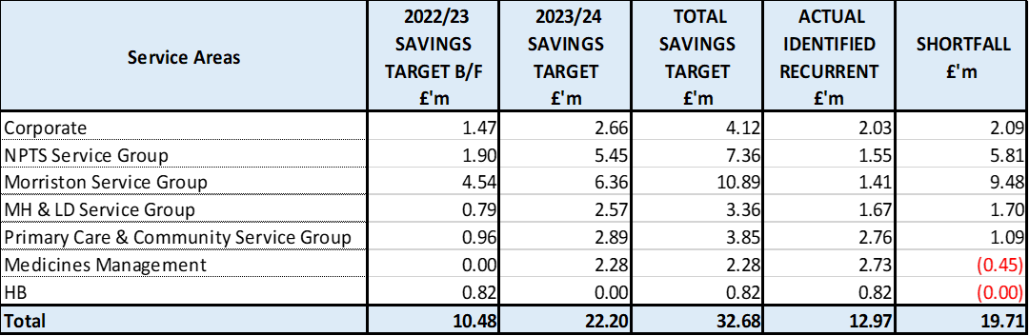

  - Capital Resource Limit (CRL)
The approved Capital Resource Limit (CRL) value issued on 14th December is £56.265m. The approved CRL value includes Discretionary Capital and schemes under the All-Wales Capital Programme

Outturn Performance

The forecast outturn shows an overrspend position of £0.453m. Allocations are anticipated on the following schemes, which will provide a balanced position.

Table 6: Allocations Anticipated Capital

Scheme | £m / Risk Level | Narrative
Business Case Fees | 0.168 / Medium | Funding anticipated from WG for design fees for Cath Lab A replacement (case approved 8 January) and Thoracic resource schedule (submitted).
Re:Fit Phase 4 – Solar Farm Extension | 0.285 / Medium | Funding increase requested from WG Energy Services (24/07/23).

The following allocation is classed as medium risk.

Scheme | £m / Risk Level | Narrative
Singleton Cladding | (0.210) / High | Potential scheme underspend as discussed at the CRM on 9 January. Discussions to be held with WG in February following updates from the scheme cost advisor on final account/gain share projections.
Regional Pathology | (0.321) / High | As discussed at WG presentation on 9 January, scheme is on hold pending agreement on proposed RIBA stage 2 / OBC redesign.
Morriston Infrastructure Modernisation Phase 2 – Sub Station 6 | (0.794) / High | Weather delays have increased programme timescales and have resulted in a re-profiling of spend into 2024/25 as discussed with the scheme cost advisor.
Re:Fit Phase 4 – Solar Farm Extension | 0.285 / Medium | Funding increase requested from WG Energy Services 24/07/23. Update from Lindsey Bromwell 19/10/23 that funding transfer from Energy Services to Health is being processed.
PET CT Scanner | 0.119 / High | Approval has been received from the national PET-CT programme board to proceed with the traditional redesign. As discussed at CRM on 9 January additional design fees of £119k will be incurred.
SARC | (0.301) / High | Delays with agreement of legal documents with New Pathways have impacted when works can commence. The Health Board works are now forecast to commence in February following the completion of the New Pathways works in their building.
Burns Unit and Critical Care Expansion | (0.621) / High | A revision to the programme has been made around M&E with slippage of £0.621m. Works have commenced this month.
Diagnostic Equipment | (0.127) / High | Savings have been made against the in-year allocation following confirmation of final costs for 2 DR rooms. This will be reported through as part of the scheme completion next year.

All other schemes are low risk and any variances are linked to planned contributions from discretionary.

Capital Disposals

No disposals expected to take place this year.

  - Balance Sheet
The key issues in respect of the statement of financial position movements are as follows:

- The inventory value has reduced slightly by £0.432m from £11.383m at the end of November 2023 to £10.951m at the end of December 2023.
- In terms of Trade receivables, there has been an increase of £18.5m from £241.2m at the end of November 2023 to £259.6m at the end of December 2023. This relates mainly to an increase of £16m in the Welsh Risk Pool (WRP) Debtors, and an increase in NHS Debtors.
- The closing December 2023 cash balance of £10.861m which is higher than the best practice cash target for the Health Board of £6m.
- The trade and other payables figure saw a decrease of £4.5m from £199.5m at the end of November 2023 to £204m at the end of December 2023. This comprised a reduction in Creditors and accrued expenditure.
- There has an increase of £24.2m in provisions from £191.9m as at the end of November 2023, to £216.2m as at the end of December 2023. The quantums received are now being reflected in the financial ledger on a monthly basis, rather than quarterly. This will create a more regular movement for both the Trade Receivables (WRP Debtors) and the Provision figures. This movement relates mainly to 7 Clinical Negligence cases, which moved from a probability 3 to a probability 1 or 2 on the quantum.

  - Cash
As at the end of December 2023, the Health Board had a cash balance of £10.861m, which is above the best practice cash target for the Health Board of £6m.

However, during December 2023 the following occurred, which meant that the cash balance was higher than originally expected:
- Received £3.3m more than expected from WRP
- Received £1.1m from WG
- Received £2m more than expected for SLA/LTA
- Received £1m additional income from the Port Talbot Resource Centre.
- Spent £3m less than expected on Revenue payment runs

Table 7: Summary Cash Forecast 2023/24
The cash deficit position of £34.245m is detailed in the table below:
The difference between the £34.245m forecast cash deficit and the Forecast I&E deficit Cash figure, reflects the £6.944m of capital cash to reimburse revenue CRL, and the movement in the working capital balances.

Following receipt of additional £60m funding from WG, and as a result of the cash deficit position, the Health Board has formally requested support from WG for the movement in working capital cash balances (£33m) and strategic cash (£17m). Due to the timing of the anticipated cashflow pressures, we have requested £25m working capital cash support for February 2024, and £8m for March 2024.

The current cash forecast is predicated on the forecast year end deficit position and the current assessment of the impact of any movement in working capital balances on the cash position. However, this position assumes all allocations (£70m) detailed in Table E, which includes COVID funding (outlined in Section 6) are received and any variance from this assumption would impact on the cash forecast. The timing of receiving this funding directly impacts when the Health Board cash position will deteriorate.

The cash flow is updated daily and a full review of the cash forecast is currently being undertaken on a weekly basis, to ensure that any changes to our cash requirements, can be communicated in a timely manner to WG.

  - Public Sector Payment Policy (PSPP)

The Health Board did not achieve the 95% PSPP target for Quarter 3 with compliance being 94.6% for the quarter.
NHS payment compliance was, however, below 95% with the quarterly performance being 80.9%. The Health Board remains focussed on improving PSPP compliance for NHS invoices and ensuring that performance remains above 95% for Non NHS invoices.
Further updates will be reported at the end of Quarter 4.

- RISKS (Revenue Income & Expenditure)
Two Board level financial risks:

- Achieving financial plan (HBR92), [now the revised Control Total issued by WG of £17m] with the key elements as follows: -

  - Risk of delivery of savings quantum
  - Risk of operational overspend being in excess of funding available agreed via the Financial Plan
  - Risk of commitment of reserves (e.g. NICE) being above reserves available.
  - Risk of achieving the actions outlined in the 2023/24 Landing Plan.

Following the Board meeting on 30th November, whilst there is a Landing Plan to achieve the control total set by WG, where is a significant amount of work to achieve the delivery of these, alongside some risk that not all with be achieved and further risks which have been included in the Month 9 letter to WG which are material to the delivery of the original landing plan and above the levels or pressures anticipated:

  - Unscheduled Care Pressures – the first week of January 2024 has seen significant pressures within the Urgent and Emergency Care environment, coupled with outbreaks of Norovirus, COVID, Flu and C.difficile leading to some beds being closed and other facilities opened. The overall impact of this is not yet known but an indicative value of £0.5m has been estimated.
  - Junior Doctors’ Industrial Action – at the time of writing, the Health Board is assessing indicative costs for coverage of the Junior Doctors’ Industrial Action based on paying the Consultant staff at the BMA rate level. An indicative value of £1.0m has been estimated based on current understanding of rota cover fill rates.
  - Delivery Run Rate Target Set – all service areas have been issued with a run rate reduction target to achieve the £17.1m Control Total in addition to the N/R opportunities identified and detailed in opening section of the letter. At this point there remains a risk that the target set may not deliver in full, particularly with regard to the Morriston Service Group target. An indicative value of £3.0m has been included at this point which will be reviewed as part of the Finance Recovery meetings. This is not a reflection of the Health Board’s inability to deliver the Control Total but the challenges in delivering an element of the plan, assuming all the other N/R Opportunities are achieved in full.
  - Unconfirmed WG Allocations Pay Award & Real Living Wage (RLW) – the plan is based on the assumption that WG will provide certain in-year allocations. The RLW was included as an anticipated allocation in the opening plan and the Pay Award elements included as the various awards have been processed during 2023/24 but neither allocations have been received at the time of writing this report. Any variance between assumed level and actual funding received from WG will impact on the delivery of the Landing Plan. The assumed values are:
    - RLW = £7.5m
    - Pay Award = £40.7m

Therefore, it is proposed that the Health Board Corporate Risk Register current report risk score of 20 score is maintained. An assessment of the risk score will be undertaken each month as the options within the Landing Plan are delivered and confirmation of material outstanding funding is received from WG.

- Availability of capital (HBR93). This risk was re-opened in 2022/23 given the reduction in discretionary capital allocation. Whilst work is underway to manage schemes to reduce commitments in 2023/24 and to produce a balanced plan, the risk varies during the year as more details on schemes emerge and potential slippage funding is made available by Welsh Government. A score of 20 is suggested at this stage as whilst the plan is now balanced, a number of schemes are on hold and the flexibility within the plan is extremely limited given the reduction in the allocation.

- RECOMMENDATIONS
Members are asked to: -
  - NOTE the WG Control Total and the impact on the 2023/24 Financial Plan
  - NOTE that actions being undertaken to reduce the risk in terms of: -
    - operational run rate
    - savings delivery
  - Consider and comment upon the Board’s financial performance for Period 09 2023/24 (Revenue and Capital)
  - NOTE the balance sheet position at month 9.
  - NOTE the Cash positon to 31st March 2024
  - NOTE the Risks on the delivery of the plan to achieve the Control Total

Governance and Assurance

Link to Enabling Objectives  (please choose) | Supporting better health and wellbeing by actively promoting and empowering people to live well in resilient communities
Link to Enabling Objectives  (please choose) | Partnerships for Improving Health and Wellbeing |  | ☐
Link to Enabling Objectives  (please choose) | Co-Production and Health Literacy |  | ☐
Link to Enabling Objectives  (please choose) | Digitally Enabled Health and Wellbeing |  | ☐
Link to Enabling Objectives  (please choose) | Deliver better care through excellent health and care services achieving the outcomes that matter most to people
Link to Enabling Objectives  (please choose) | Best Value Outcomes and High Quality Care |  | ☐
Link to Enabling Objectives  (please choose) | Partnerships for Care |  | ☐
Link to Enabling Objectives  (please choose) | Excellent Staff |  | ☐
Link to Enabling Objectives  (please choose) | Digitally Enabled Care |  | ☐
Link to Enabling Objectives  (please choose) | Outstanding Research, Innovation, Education and Learning |  | ☐
Health and Care Standards
(please choose) | Staying Healthy |  | ☐
(please choose) | Safe Care |  | ☐
(please choose) | Effective Care |  | ☐
(please choose) | Dignified Care |  | ☐
(please choose) | Timely Care |  | ☐
(please choose) | Individual Care |  | ☐
(please choose) | Staff and Resources |  | ☐
Quality, Safety and Patient Experience
Financial Governance supports quality, safety and patient experience.

Financial Implications
The Board is reporting a breakeven financial outturn.

Legal Implications (including equality and diversity assessment)
No implications for the Board to be aware of.

Staffing Implications
No implications for the Board to be aware of.

Long Term Implications (including the impact of the Well-being of Future Generations (Wales) Act 2015)
No implications for the Board to be aware of.

Report History |  | Board receives an update on the financial position at every meeting
Appendices |  | Appendix 1 – supplementary information

APPENDIX 1

- KEY DRIVERS IMPACTING REVENUE
This section provides the reader with the key aspects within the Health Board position that is influencing the financial performance against the Revenue Resource Limit above that reported in core report.

  - Pay / Variable Pay – Trends
The performance against budget both in month and YTD is provided below, with the variance spilt between Variable Pay costs and fixed staff costs.

Table: Variance on Pay 2023/24

Note – movement between Month 2 and 3 and Month 4 and 5 budget relates to the one-off funding for the Recovery pay award and changes to the budget profiling linked to year-end accruals for Leave, Overtime and Time owing. Month 7 budget includes Medical & Dental Pay Award arrears (7/12th) for 2023/24.
.

Table: Variable Pay Analysis

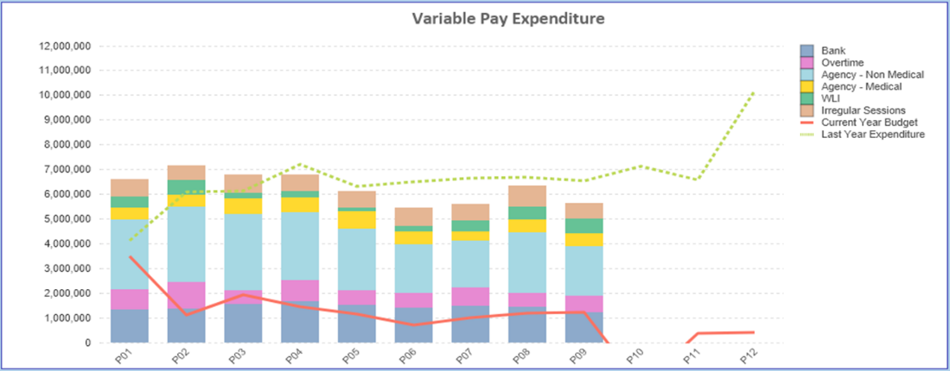

  - Non Pay
The performance against budget both in month and Year-To-Date is provided below.

Table: Variance on Non-Pay

Note – movement between Month 2 and 3 and Month 4 and Month 5 budget relates to the one-off adjustment for Losses, which is normally reflected at year end only and so had to be adjustment between months.

Below are further details on the keys areas of Non Pay (excluding savings which addressed in Section 5.1):

    - Clinical Consumables
This area continues to be a significant pressure with a YTD variance of £7.4m. With the in-month position being significantly (£1.3m) improved from Month 8 at £0.1m. The in-month improvement is predominantly driven by Heart Valves (£0.8m) due to a one-off rebate of £0.5m and reduced TAVI activity. There are 80+ subjective lines within this category including secondary care drugs but areas seeing most pressures YTD continue to be general consumables (M&SE), laboratory products and implants (which in part will be driven by activity).

    - Utilities
The most recent update on the forecast via British Gas/CCS ranges from £14.2m to £13.2m based on the email from NWSSP dated 2nd October 2023 (we will provide an update in Month 10 of the impact of the latest e-mail received on 8th January 2024 from NWSSP). It is important to note that this forecast is not based on actual or predicted volume usage but industry averages. This becomes important given the Moriston site acquires a significant amount of its power from the Solar Farm, which if using industry averages would not be built into the forecast.

Alongside this the Health Board has an assessment of its predicted usage costed at the CCS rate. The forecast in Table B for 2023/24 provides an estimate of £15.9m for 2023/24, including PFI. PFI costs are outside of the CCS forecast and to date we have not yet received any invoices for this financial year. The HB is assuming the full funding for energy of £7.8m in its overall Landing Plan.

We will continue to monitor the HB assessment of the position and review the forecast monthly as the actual costs/invoices are processed.

    - Continuing Healthcare
The variance against budget for CHC is £0.451m overspent in month, and is £1.104m overspent YTD which reflects the impact of a small number of high cost packages, predominantly in the Community and growth in MHLD. This is an improvement on the prior month, which recognised the impact of a number of retrospective packages.

An analysis of actual spend and patient numbers for 2023/24, along with the average values from 2023/24 is provided in table below.

Table: - Continuing Healthcare Breakdown

(Please note: PCT Group does not include the Singleton/NPT element - which covers Children and Young People as it is provided internally).

    - Primary Care Prescribing
At Month 9 the in-month position reflected in the ledger on Prescribing is breakeven (Month 8 £0.6m overspent) and £4.9m YTD. The latest PAR recognises a significant price reduction in Apixaban (the most commonly prescribed DOAC), which has reduced the end of year forecast back to the £6.1m assumed within the Landing Plan

    - LTA Performance
Historically LTA contracts have been based on a Cost and Volume approach, which reflects adjustments for under and over performance. From the start of the COVID pandemic in April 2020 all LTA agreements in both England and Wales transferred to a block arrangement, whereby commissioners funded providers on 2019/20 levels uplifted by nationally agreed rates with no adjustment for performance. From 1st April 2022 the previous block arrangements have ceased and a hybrid model adopted where under or over performance adjustments will become applicable above a tolerance level. This became relevant to both services we commission from other Health Boards and services commissioned from SBU HB. In 2022/23 the tolerance level was 10% but in 2023/24 the tolerance level has reduced to 5%.

Table below is the performance of Swansea Bay HB at the end of Month 6 as a provider, for services commissioned by other Health Boards. Under the previous Long Term Agreements the full year forecast for underperformance would be £1.151m, under the interim arrangements that risk has reduced and delivers a benefit of £1.304m.

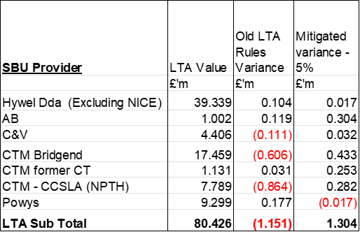

The Table below is the performance of contracts provided by other Health Boards in Wales but commissioned by Swansea Bay. Here under the previous LTA arrangements we would have seen a benefit of £4.5m but under the interim arrangement that has reduced to £3.1m.

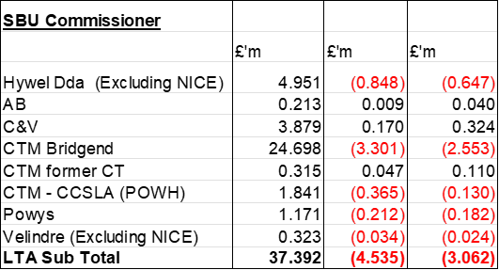

Of the net impact of £4.36m, some will already be accounted for in the YTD position, with the Landing Plan assuming there is further benefit delivered by the end of Financial Year. However, the final impact of LTA performance will not be known until the Intra NHS Exercise/Agreement of Balances is complete as part of the Year End Closedown across NHS Wales.

  - Income

Table: Variance on Income 2023/24

