
Business Justification Case

Replacement Cardiac Catheterisation Laboratory A
at Morriston Hospital, Swansea

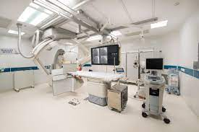

v.6.1

Document control sheet
Client | Swansea Bay University Health Board
Document Title | Replacement Cardiac Catheterisation Laboratory A at Morriston Hospital, Swansea
Version | Final
Status | Final 6.1
Author | Heather Edwards
Date | 26/10/23
Further copies from | email: heather.edwards2@wales.nhs.uk quoting reference and author

Contact details
Main point of contact | Telephone number | Email address | Postal address
Heather Edwards | 01792 286119 | Heather.edwards2@wales.nhs.uk

Contents
1 Purpose 1
1.1 Introduction 1
1.2 Background 1
2 Strategic Context 2
2.1 Introduction 2
2.2 National and Local Context 2
2.3 Local Health Board Context 2
2.4 Current Demand and Capacity 2
3 Case for Change 4
3.1 Business Needs 4
3.2 Problem with Status Quo 4
3.3 Spend Objectives 4
3.4 Potential Scope 5
3.5 Main Benefits 5
3.6 Main Risks 6
3.7 Constraints 6
3.8 Dependencies 6
3.9 Recommendation 6
4 The Economic Case 7
4.1 Introduction 7
4.2 Critical Success Factors 7
4.3 Options Appraisal Methodology 7
4.4 Preferred Option 8
4.5 Indicative Capital and Revenue Costs of each Short Listed Option 8
4.6 The Preferred Option 9
4.7 Capital Risk 9
5 The Commercial Case 10
5.1 Introduction 10
5.2 Procurement Strategy and Route 10
5.3 Essential Services 10
5.4 Key Appointments 10
5.5 Potential for Risk Management 10
5.6 Agreed Charging Mechanisms 10
5.7 Estimated Contract Length 11
5.8 Personnel Implications (Including TUPE) 11
5.9 FRS5 – Accountancy Treatment 11
5.10 Implementation Timescales 11
6 Funding and Affordability 12
6.1 Introduction 12
6.2 Capital 12
6.3 Income and Expenditure Analysis 12
7 Management Arrangements 14
7.1 Introduction 14
7.2 Project Management Arrangements 14
7.3 Use of Special Advisers 14
7.4 Arrangements for Benefits Realisation 15
7.5 Building Design and Services’ Strategies 15
7.6 AEDET (Achieving Excellence Design Evaluation Toolkit) & BREEAM 15
7.7 Arrangements for Risk Management 15
7.8 Post Evaluation Arrangements / Lessons Learned 15
7.9 NHS Wales Gateway Review (Stage 3 – Investment Decision) 15
7.10 Contingency Plans 15

Figures

Figure 1 – Morriston Hospital Cath Lab Activity (2022/23) 3
Figure 2 – Morriston Hospital Cath Lab Performance (2017/18 – 2019/20) 3
Figure 3 – Morriston Hospital Cath Lab Activity (2018/19 to 2021/22) 4
Figure 4 - Potential Service Scope Framework Options 5
Figure 5 – Critical Success Factors (CSFs) 7
Figure 6 – Long List of Options 7
Figure 7 – Indicative Capital Costs (excl VAT) £000s above baseline 8
Figure 8 – Revenue cost impact of the Shortlisted Options (£000’s) 8
Figure 9 – Key indicative milestones 11
Figure 10 – Capital Costs (£000 incl. VAT) 12
Figure 11 – Capital Funding (£000 incl. VAT) 12
Figure 12 – Revenue Impact £000’s above baseline 12
Figure 13 – Non-Cash Estimates (£000) 13
Figure 14 – Morriston Hospital’s Project Management Structure 14
Figure 15 – Special Advisors 14

Appendices
Appendix A – Risk Register 16
Appendix B – Cost Form 17
Appendix C – Indicative Programme 18
Appendix D – Benefits Realisation Register 19
Appendix E – RPA 20
Appendix F – Signed off Plan 21

1 Purpose

Introduction
The Business Justification Case (BJC) seeks approval for capital funding of £2.996m (inclusive of recoverable VAT) from the Welsh Government (WGov) for Swansea Bay University Health Board (SBUHB) to replace Cardiac Catheterisation Laboratory (Cath Lab) A’s imaging and image archive solutions at Morriston Hospital, Swansea.
This investment will replace the current obsolete imaging system and physiological monitoring system with modern equivalent and the associated supporting infrastructure.
The replacement of Cath Lab A was included as a priority in SBUHB’s 2023/24 annual plan submission during 2023/24.
Timely replacement is critical to delivering a safe and effective regional service to SBUHB, Hywel Dda University Health Board (HDUHB) and to western Cwm Taf Morgannwg University Health Board (CTMUHB) Princess of Wales Hospital. It supports SBUHB’s Covid-19 Recovery Plan and its replacement maintains continuity of modern cardiac investigation and treatment within the region.
The investment will:
- Maintain continuity of service and current capacity levels to meet forecast regional demand;
- Ensure that patients receiving catheterisation utilise the most modern and up to date technology;
- Improve safety and reliability and the Health Boards’ ability to meet waiting times, and;
- Provide patient within the region with continued access to excellent healthcare.
Health Boards within the region will manage any additional regional revenue costs associated with this investment.

Background
Morriston Hospital’s Cardiac Cath Lab A is a fundamental component of modern cardiac investigation and treatment used in the diagnosis and management of patients with both chronic stable disease and acute life-threatening conditions. It typically consists of a dedicated procedure room, which combines a single or dual plane imaging system with physiological monitoring and an image archiving system (CPACS), as well as adjunctive invasive imaging tools and resuscitation equipment.
This replacement machine will be a single plane, complementing Morriston Hospitals other two Cardiac Cath Labs. Its current caseload typically includes the following:
- Diagnostic Angiography and Right & Left heart catheterisation
- Percutaneous Coronary Intervention (PCI) – emergency (regional PPCI), acute and elective
- Insertion of permanent pacemakers
- Insertion of complex devices (Implantable Cardiac Defibrillators / Cardiac resynchronisation therapy)
- Electrophysiological studies and ablation procedures
- Structural heart interventions (TAVI and balloon aortic valvuloplasty)

Strategic Context

Introduction
This section outlines the strategic context for replacement of Cardiac Cath Lab A at Morriston Hospital, Swansea.

National and Local Context

This case supports best practice and aims to deliver improved patient flows and a more equitable cardiac service for the population of SBUHB, HDUHB and western CTMUHB.

It supports a number of national and local guidance and best practice mandatory requirements as follows:
- A Healthier Wales: Our Plan for Health and Social Care (2018)
- The Wellbeing and Future Generations (Wales) Act 2015
- SBUHB’s Clinical Services Plan 2019-2024 (2019)
- SBUHB’s Covid Recovery Plan
- SBUHB’s Annual Plan 2021/22
- SBUHB’s Site Development Control Plan and Master Plan for Morriston Hospital

Local Health Board Context

Swansea Bay University Health Board plans, secures and delivers healthcare services for the people of Neath Port Talbot and Swansea, and works to improve their health and wellbeing. We serve a population of approximately 390,000, have a budget of around £1.1billion and employ almost 13,500 staff.

We have three major hospitals providing a range of services: Morriston and Singleton hospitals in Swansea and Neath Port Talbot Hospital in Baglan, Port Talbot. We also have a community hospital at Gorseinon and primary care resource centres providing clinical services outside of the main hospitals.

We provide more than 70 specialised services to the populations of south-west Wales, south Wales, and for certain services, on a national basis. This reflects our clinical excellence and our diverse range of local and tertiary services for the people of Wales and beyond.

Primary care independent contractors play an essential role in the care of our population, and the health board commissions services from 49 GP practices, 31 optometry practices, 72 dental practices and 92 community pharmacies across our region.

Our vision is to be an excellent healthcare, teaching and research organisation for the Health Board area, and the wider region.

Current Demand and Capacity

Morriston Hospital has operated three Cath Labs since 2017. The table below provides an analysis of activity, procedure time and the cath lab sessional requirements linked to this. The analysis illustrates that there is the need for 29.33 sessions of Cath Lab activity based on the 2022/23 activity.

Figure 1 – Morriston Hospital Cath Lab Activity (2022/23)

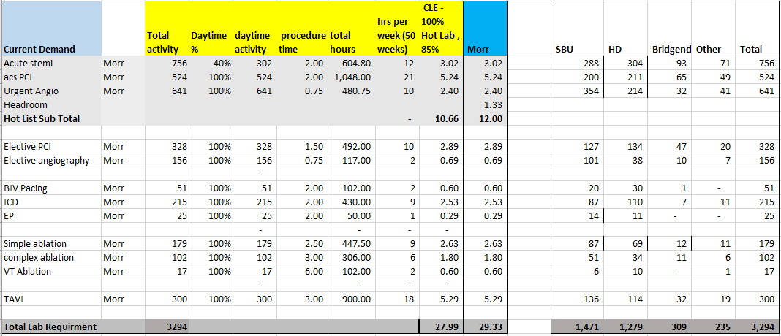

The service has continually demonstrated a high level of efficiency, which has been supported via national benchmarking undertaken as part of the National Cardiac Benchmarking Collaborative. Through this collaborative benchmarking approach, the Cath Labs in Morriston Hospital have been identified as the most efficient when compared to other NCBC centres across the UK:
Figure 2 – Morriston Hospital Cath Lab Performance (2017/18 – 2019/20)

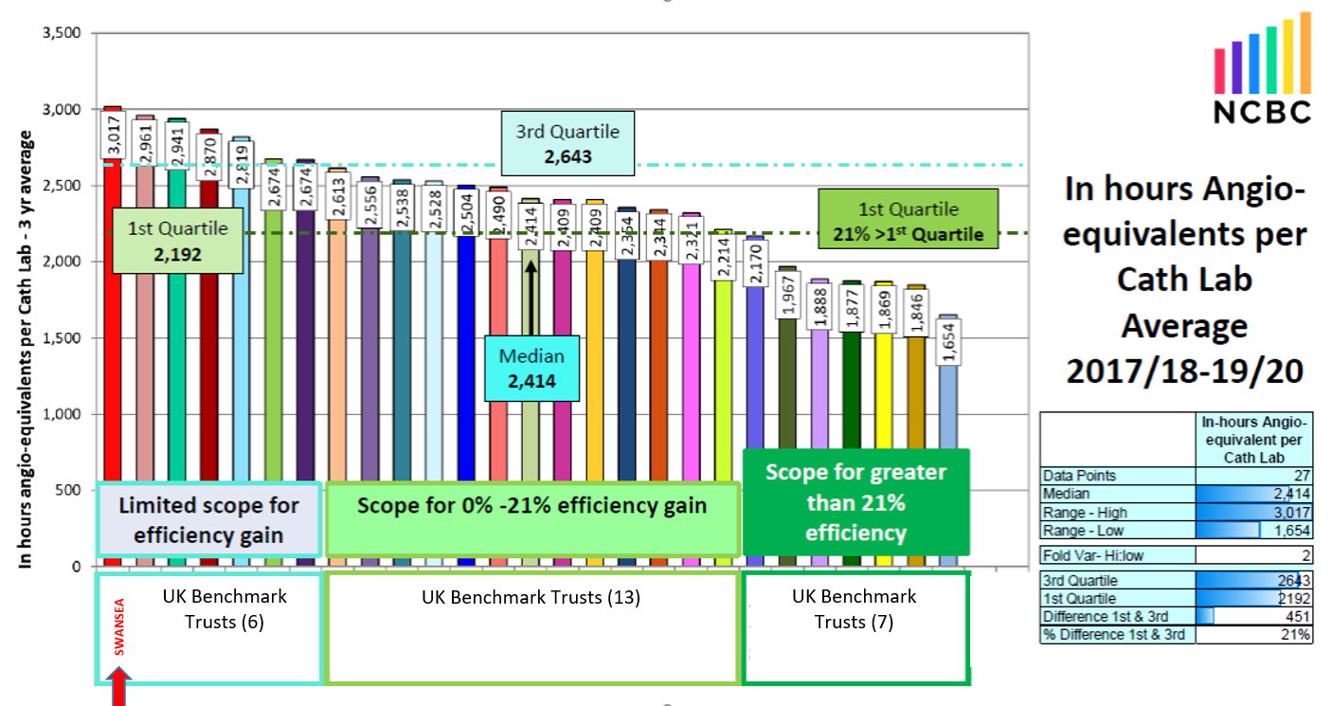

Case for Change

In outlining the case for investment this section will highlight the importance of maintaining the required levels of cardiac investigation and treatment capacity.

Business Needs

Morriston Hospital’s Cath Lab’s carry out elective admissions for Pacemaker, implants (including complex pacing), Defibrillator implants, Electrophysiological studies, Ablations (including complex AF and VT ablations), elective angiography and elective PCI procedures.

The following figure details cardiac investigation and treatment activity within SBUHB / specific to machine A during period is as follows:
Figure 3 – Morriston Hospital Cath Lab Activity (2018/19 to 2021/22)
 | 2018/19 | 2019/20 | 2020/21 | 2021/22
Angioplasty (EM/EL) | 1,470 | 1,493 | 1,530 | 1,587
Catheter (EM/EL) | 991 | 972 | 771 | 820
Ablation (AF/VT) | 186 | 229 | 177 | 245
BIVENT | 49 | 49 | 65 | 75
EP | 22 | 28 | 19 | 29
ICD | 191 | 229 | 141 | 180
TAVI | 113 | 114 | 153 | 157
TOTAL | 3,022 | 3,114 | 2,856 | 3,093

Its replacement with a modern equivalent and the associated supporting infrastructure will require appropriate supporting infrastructure. Continued investment will maintain continuity of clinical treatment capacity, ensuring access to modern equipment and technologies.

Problem with Status Quo

Cardiac Cath Labs are a fundamental component of modern cardiac investigation and treatment. Increasingly, previously some sub-specialties work was performed in theatres and this is now undertaken Cath Labs.

Morriston Hospital’s Cath Lab A’s machine, a Phillips machine, was installed in 2012. This equipment has a 10-year working life that expired in December 2022. Although the supplier is providing a maintenance contract until September 2024, the system is now classed as having ‘end of life support’ only. This cover excludes tubes and detectors, which if they were to fail will most likely mean the machine will need to be taken out of service permanently as there is no availability of these parts.

Our other two Cath Labs are both working at capacity and cannot absorb any additional workload when breakdowns occur. There have been two occasions in the last 18 months where Lab A has broken down and was out of use for a total of 3 weeks across these two periods due to supply end difficulties. This resulted in reduced activity and delays to the treatment of patients. There is a high risk this could happen again due to the age of the existing systems. This is clinically unacceptable and presents an urgent case for investment.

Spend Objectives

In accordance with NHS Wales’s guidance and this infrastructure investment, the key spend objectives have been limited in scope as follows:
Spend Objective 1: To maintain capacity and meet regional demand for Cardiac Catheterisation services - replacement of Morriston Hospital’s obsolete Cath Lab A will ensure the region maintains its cardiac investigation and treatment capacity in order to meet current and future planned demand.
Spend Objective 2: To improve the reliability and resilience of current Cardiac Catheterisation services for the regional population - this will be evidenced by the following:
- Eliminating breakdowns and providing reliable access to high-quality catheterisation services.
- Enhancing resilience within the region and across NHS Wales.
- Meeting forecast demand and delivering care for a regional population suitable for their needs.
- Demonstrating solutions fully complying with best practice.
Spend Objective 3: To provide efficient Cardiac Catheterisation services for the regional population - this will be evidenced the following:
- Eliminating disruption and extended waiting times for treatment for patients by accessing modern Cath Lab facility and infrastructure.
- By reducing risk and improving certainty in treating cardiac patients.
Spend Objective 4: To provide effective Cardiac Catheterisation services for the regional population - this will be evidenced the following:
- Maintaining access to modern cardiac treatments.
- Enabling patients with the highest health needs to have access to modern high quality cardiac treatments as recommended by NICE guidelines.
Spend Objective 5: To provide cost-effective Cardiac Catheterisation services for the regional population - this will be evidenced by evidencing the following:
- Optimising public value by making the most economic use of scare resources, e.g. by eliminating breakdowns.
All the above to be achieved by end of the 2024, subject to funding and planning approvals. There are no potential dis-benefits.

Potential Scope

This section describes the potential scope for the project in relation to the above business needs in terms of modalities and service drivers. Potential Service Scope solutions for this investment are limited to the following options:
Figure 4 - Potential Service Scope Framework Options
Business as Usual | Do Minimum
Maintain existing Cath Lab A machine | Replace Cath Lab A

Main Benefits

The main outcomes and benefits of this investment include the following:

Securing a continued and reliable provision of existing diagnostic and treatment services for patients within the region.

Improved access for patients to treatment, which in turn will improve patient outcomes.

Less disruption to clinical services and patient care resulting from fewer equipment breakdowns and associated service ‘downtime’.

Improved resilience and continued capacity in Morriston Hospital in support of the Health Board’s strategic plan to reduce cardiac pathway access times.

Please see Appendix D – Benefits Realisation Register.

Main Risks

The main business and service risks associated with the potential scope across all the options for this project together with their counter measures, are detailed in Appendix A. The key risks and mitigations are outlined below:
Risk | Risk Rating  Probability x Impact | Management Action
Working within live hospital environment | 3 x 4 (12) | Clear segregation/Project managed user group meetings
Working within existing department | 3 x 4 (12) | Strategy to be discussed with project team & stakeholders
Noise/Dust/Vibration Risk | 3 x 4 (12) | Monitoring during construction works
Risk of accidental removal/Isolation of current systems; Hospital service interruption | 3 x 5 (15) | Maintenance team/estates to be consulted prior to removals and isolations; specific attention to IT installations and their routes

Constraints

The replacement solution must be fit for purpose, make best use of the available development space and be delivered on a timely basis.

Seamlessly maintain services to cardiac patients during works and commissioning stages.

Revenue resources are limited, and the solution should provide value for money, support clinical needs, and be affordable.

The project must be delivered within project budget.

Dependencies

The main dependencies are continued support for the agreed model of care and availability of capital funding from WGov.

Recommendation
This BJC presents a compelling case for change and it is recommended that the WGov support the investment proposals set out in this case.
This scheme can be undertaken as a separate contract and works could start in Qtr 4 23/24, subject to funding approval.

……………………………………………………...  Signed & Dated: | Mrs Sue Moore (Service Group Director – Morriston Hospital Delivery Unit, SBUHB)

The Economic Case

Introduction

In accordance with the Capital Investment Manual and requirements of HM Treasury’s Green Book (A Guide to Investment Appraisal in the Public Sector), this section of the business case demonstrates that the most economic advantageous option has been selected. This option best meets the service needs, realises the most benefits, and optimises Value for Money.

Critical Success Factors

The following Critical Success Factors (CSFs) have been identified:
Figure 5 – Critical Success Factors (CSFs)
CSF | Description
CSF1 Strategic Fit & Business Needs | The solution must fit with national, regional, local strategies.
CSF2 Compliance | The solution must comply with best practice.
CSF3 Benefits Optimisation | The solution should optimise benefits, make effective use of scare resources and provide value for money.
CSF4 Potential Achievability | The solution must be deliverable on a timely basis to avoid disruption of clinical services.
CSF5 Acceptability | The solution must be acceptable to users and clinicians.
CSF6 Potential Affordability | The organisation’s ability to fund the required level of expenditure; viz, the capital and revenue consequences associated with the proposed investment.

Options Appraisal Methodology

Given the limited range of options for this replacement case the section below, summarise the assessment of each long list option.
Figure 6 – Long List of Options
Option | Reason for Acceptance or Rejection for further consideration | Finding
Option 1: 'Do Nothing' (Business as Usual) - Involves planned/ statutory maintenance or minor enhancement of the existing Cath Lab A | - Cath Lab A is over 10 years old. It is not clinically acceptable or feasible to further extend its life.  - We advise the cost of extending the life of the current machine was difficult to quantify going forward as parts are increasingly difficult to obtain and enhancement options are impracticable and offer limited clinical benefits.  - This option is not viable or reliable. | Discounted – retained as baseline comparator.
Option 2: Outsource to an adjacent Health Board/ private sector (mobile unit) provider | - This option is not practicable, sustainable or acceptable clinically.  - This option would also involve significant travel distances for vulnerable cardiac patients who would need to travel longer distances for treatment.  - Utilising a mobile facility will require a significant capital/revenue investment. | Rejected
Option 3: Replace existing Cath Lab A | - This option is clinically acceptable, sustainable and meets the strategic needs of the Health Board. It provides a safe and reliable solution. It offers the best VfM. It is the most clinically acceptable solution for patients. | Shortlisted – preferred option

Option 2 (i.e. Outsource to an adjacent Health Board/ private sector (mobile unit) provider) was excluded at this stage.

Preferred Option

Option 3 (i.e. replace existing Cath Lab A) was confirmed as the preferred option. Due to the length of works this solution will require provision of a temporary mobile unit.

Indicative Capital and Revenue Costs of each Short Listed Option
Capital Costs

The project’s cost advisor, AECOM, has prepared fully tendered capital costs. The indicative capital costs (excluding VAT) for Option 3 (see Appendix B) are as follows:
Figure 7 – Indicative Capital Costs (excl VAT) £000s above baseline
 | Option 3
Works Cost | 916
Fees | 184
Non-Works Costs | 508
Equipment Costs | 799
Planning Contingency | 120
Total | 2,527

The key assumptions underlying the development of the capital costs are:
- Capital Cost includes works, non-works, abnormals allowances, equipment costs and risk contingency, which is assessed at 4.99%.
- VAT is excluded.
- The BISPUB SEC indices at this stage is 3Q2023 (294).
- This BJC excludes economic analysis as advised by WGov and Optimism Bias.
Revenue Costs

There is no expected change in the activity baseline currently being run through the existing 3 Cath Labs. There will be a £22k increase in annual maintenance costs, which is being funded through the Morriston Service Delivery Unit financial plan. The cardiac service has agreed to create efficiency savings to cover this additional maintenance cost, to ensure there is no net increase in revenue costs within Morriston Service Delivery Unit.
Figure 8 – Revenue cost impact of the Shortlisted Options (£000’s)
 | Option 3
Pay
General Non-Pay | 22
Hotel Services
Estates
LTAs/ Other Commissioned Services
Total | 22

The revenue costings have been costed at 2023/24 prices.

The Preferred Option

The preferred option is Option 3 – Replace existing Cath Lab A. See Appendix F for the signed off Plan.

Capital Risk

The key risks associated with the scheme were assessed by an independent Cost Advisor using WGov guidance methodology for business cases. Please see Appendix A - Risk Register for a detailed analysis of the operational and construction risks.

The Commercial Case

Introduction

This section of the BJC outlines the proposed ‘deal’ as outlined in the Economic Case. The BJC is seeking to secure public funding from the WGov’s ‘All Wales Capital Programme’.

Procurement Strategy and Route

The local Engineering and Enabling works elements will be managed via SBUHB’s Local Contractor and Consultant Framework.

Essential Services

The essential requirements to be provided as part of this contract are:
- The development of a replacement Cath Lab A and supporting infrastructure;
- A transition process to ensure cardiac services are not disrupted during main works and commissioning stages, and;
- The operational commissioning of the new equipment to realise the organisational benefits of the scheme.
- The Design Team will be required to ensure compliance with clinical and IM&T requirements to ensure compatibility with other integrated systems.

Key Appointments

The following key appointments have been made:
- The Health Board will appoint a contractor (to be confirmed).
- Project Manager Services (to be confirmed).
- Architectural & Principal Design services are provided by Stride Treglown.
- Health Board Cost Advisor services and business case support services are provided by AECOM
- Structural Engineering design services are (to be confirmed).
- Mechanical & Electrical design services are provided by (to be confirmed).
- Construction and other technical commissioning services are provided by SBUHB.

Potential for Risk Management
Risk Management
A risk register has been compiled and costed relative to risks that apply over the whole of the project lifecycle at this stage (see Appendix A. The planning contingency has been assessed by an independent cost advisor. The planning contingency includes non-recoverable VAT. This assessment of risk and complies with NHS Wales Shared Services Partnership – Specialist Estates Services (NWSSP - SES) guidance at this planning stage.

Agreed Charging Mechanisms

A collaborative working model is to be adopted. All charging mechanisms are covered within the contract agreement.

AECOM, the Health Board’s appointed Cost Advisor, confirms this scheme was subject to a full tender process.

The contractor will invoice SBUHB in accordance with the Payment Mechanism. The agreed Payment Mechanism is 4 weekly assessments by the Health Board Cost Advisor with payment due within 14 days of the Assessment Date.

The contract will be let under the NEC 4 Option A.

Estimated Contract Length

The estimated contract will be approx. 24 weeks and will cover enabling and main works and, following operational commissioning, is expected to be operational by (date).

Personnel Implications (Including TUPE)

TUPE (Transfer of Undertaking and Protection of Employee) will not apply to this investment.

FRS5 – Accountancy Treatment

It is assumed that public funding will be allocated for this project and therefore capital will be included on the balance sheet.

Implementation Timescales

The implementation milestones are set out below:
Figure 9 – Key indicative milestones
Milestone Activity | Date
Health Board endorse BJC | November 2023
WGov approve BJC | February 2024
Mobilise and commence works | March 2024
Completed (subject to contractor’s programme) | August 2024
Commissioning | September 2024
New build operational | September 2024
Technical Project Evaluation (approx. 3 months post new build handover) | December 2024
Benefits Realisation (12 months post operational) | December 2025

Please refer to Appendix C – Indicative Programme.

Funding and Affordability

Introduction

The purpose of this section is to set out the financial implications of the contracted solution.

Capital

The fully tendered capital cost assessment were undertaken by AECOM, Cost Advisors. Capital funding of £2.996m (including non-recoverable VAT) would be required from WG. These are as follows (see Appendix B):
Figure 10 – Capital Costs (£000 incl. VAT)
 | Option 3
Works Costs | 1,100
Fees | 220
Non-Works Costs | 610
Equipment Costs | 959
Planning Contingency | 144
Total | 3,033
Less recoverable VAT | -37
Base Project Cost | 2,996

The key assumptions underlying the development of the capital costs are:
- Capital Cost includes works, non-works, abnormals allowances, equipment costs and risk contingency, which is assessed at 4.99%.
- VAT is at 20% except for the professional fee and other vat recoverable elements.
- The BISPUB SEC indices at this stage is 3Q2023 (294).
- This BJC excludes economic analysis as advised by WGov and Optimism Bias.

The contracted solution will involve funding all infrastructure requirements to enable the cath lab to be installed securely which will include upgrading the ventialtion system for the lab.

Figure 11 – Capital Funding (£000 incl. VAT)
 | £(000’s) | Prior Years | 23/24 | 24/25 | 25/26 | Total
 | Capital Costs | 57 | 367 | 2,572 | 0 | 2,996
 | Capital Funding Required | 0 | 424 | 2,572 | 0 | 2,996

Income and Expenditure Analysis

There is no expected change in the activity baseline currently being run through the existing 3 Cath Labs. There will be a £22k increase in annual maintenance costs, which is being funded through the Morriston Service Delivery Unit financial plan.

Figure 12 – Revenue Impact £000’s above baseline
 | Option 3
Costs | 22
Funded | (22)
Total | 0

This scheme would result in an estimated AME Impairment of £0.509m on the initial valuation of the works. This will need to be taken through the Health Board’s OCS, which the Health Board would require to be funded by the Welsh Government. The estimated annual depreciation charge is £0.243m. This updated estimate will be included in the non-cash funding submissions to the Welsh Government.

The District Valuer will value the part new engineering elements on completion and the final value attributed to the buildings will be on the Balance Sheet of the Health Board.
Figure 13 – Non-Cash Estimates (£000)
 | £(000’s) | 23/24 | 24/25 | 25/26 | 26/27
 | Depreciation | 0 | 121 | 243 | 243
 | Impairment (AME) Initial Valuation |  | 509

A process of external audit for the project has already begun and will continue throughout the redevelopment and construction process.

Management Arrangements

Introduction

The section details the plans for the successful delivery of the scheme to cost, time and quality. The details are set out below.

Project Management Arrangements

To ensure successful project delivery a robust project management reporting structure has been established. The structure is based on the Prince2 principles, with key members of the project team trained in Prince2 methodology.

The Senior Responsible Owner (SRO) is Mrs Sue Moore (Service Group Director – Morriston).

The Project Director, is Mr Dean Packman (Directorate Manager Cardiac Services, Surgical Specialties) who has the authority and responsibility to manage delivery of the project on behalf of the key stakeholders. The Project Director reports via the Project Board to the Project SRO.

The Project Manager, is to be advised.

Project Management Structure

A summary project management structure diagram is shown below for the Morriston Hospital site:
Figure 14 – Morriston Hospital’s Project Management Structure

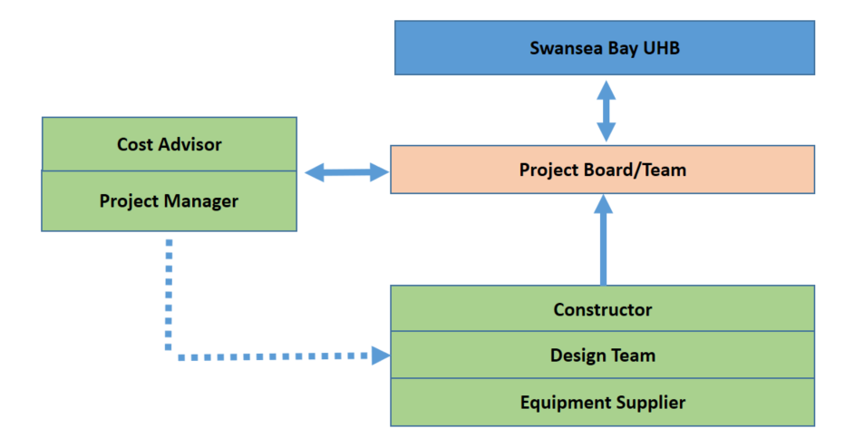

Use of Special Advisers
Special Advisors will be appointed in accordance with the Treasury Guidance: Use of Special Advisers.
Figure 15 – Special Advisors
Role | Advisor
VAT Advisor | Ernst & Young

Arrangements for Benefits Realisation

A project level Benefits Realisation Register is included in Appendix D. Benefits realisation will be monitored at Project Board.

Building Design and Services’ Strategies
Opportunities for decarbonisation solutions are limited given this is a replacement machine.

AEDET (Achieving Excellence Design Evaluation Toolkit) & BREEAM
It has been confirmed with NWSSP that an AEDET and BREEAM will not be required for this scheme as it does not involve any direct patient or clinical staffing contact.

Arrangements for Risk Management

A risk framework has been established which outlines the process for managing risk associated with developing this project, including a structure for identifying and mitigating operational and construction related risks. The risk register would use qualitative and quantitative measures to calculate the overall level of risk according to likelihood of any risk occurrence multiplied by the potential impact. The Project Board will formally review the risk register at key stages of the project. A project risk register is attached at Appendix A.

Post Evaluation Arrangements / Lessons Learned

Post Evaluation and lessons learned will be undertaken as appropriate to this investment and in accordance with best practice and NHS guidance.

NHS Wales Gateway Review (Stage 3 – Investment Decision)

A Risk Potential Assessments (RPA) has been carried out for this project. A copy is included in Appendix E. A Gateway review could be arranged WGov would carry out post submission of this BJC in accordance with WGov Investment Guidance. Further Gateways would be completed according to Office of Government Commerce (OGC) guidelines following further evaluation.

Contingency Plans

The Health Board can identify two major category of project failure: failure to achieve business case approval to deliver the project; failure of the main contractor to deliver the project to time.

The contingency plan for the project in the event of failure to achieve business case approval is for the Health Board to continue to revise its plans, working with WGov to develop an alternative solution that is acceptable.

In the event of main contractor failure, SBUHB would seek recompense in line with the agreed contractual arrangements and other contractor to complete the project.

Appendix A – Risk Register

Appendix B – Cost Form

Appendix C – Indicative Programme
Appendix D – Benefits Realisation Register
Appendix E – RPA
Appendix F – Signed off Plan

