Meeting Date | 25 September 2025 |  | Agenda Item |  | 6.4
Name of Meeting | Health Board
Report Title | Perinatal Committee and Independent Review Update Report
Report Author | Sharron Price, Group Nurse Director  Kathy Greaves, Clinical Director of Midwifery
Report Sponsor | Elizabeth Rix, Executive Director of Nursing and Patient Experience
Presented by | Elizabeth Rix, Executive Director of Nursing and Patient Experience
Freedom of Information | Open
Purpose of the Report | The purpose of the paper is to provide the Board with an update:  - from the Perinatal Committee, assurance and information relating to the risks to quality, safety and patient experience in maternity and neonatal services, with escalation of any key areas of concern; and  - on the progress against the Recommendations of the independent review since the report was published in July 2025.
Key Issues | - Publication of the Maternity and Neonatal Independent Review Report in July 2025  - Subsequent escalation of Maternity and Neonatal Services by Welsh Government from Level 3 to Level 4 in July 2025  - Gold Command has been stood down and, in its place, the Inaugural Perinatal Committee meeting has taken place
Specific Action Required | Information | Discussion | Assurance | Approval
Specific Action Required | ☐ | ☐ | ☒ | ☐
Recommendations | Members are asked to:  Be Advised on:  - Plans for project management support to develop and monitor improvement plans in response to the Independent Review are in progress.  - The 2 immediate actions from the report (relating to Intensive care Standard Operating Procedure and remote radiology reporting) are in progress  Be Assured:  - By the contents of this report  - Maternity Workforce is Birthrate Plus Compliant  - Personal Annual Development Review and Mandatory training compliance is on track  - The Perinatal Service does not currently have any elements or care that would flag as a Negative Outlier  - Maternity Services are fully established within the Obstetric Unit  Be Alerted to:  - The Single Point of Access Maternity Triage is due to launch in March 2026; this is dependent on the recruitment of newly qualified Midwifes  - There is a vacancy of 0.8 Whole Time Equivalent Neonatal Consultant Vacancy from September 2025, this will need to be recruited into to maintain British Association of Perinatal Medicine standards

CHAIRS REPORT – PERINATAL COMMITTEE
- INTRODUCTION
The purpose of the paper is to provide the Board with updates from the Perinatal Committee and assurance around quality, safety and patient experience outcomes and escalation of any key areas of concern.
The purpose of the Perinatal Committee is to:
- Provide assurance to the Board of an evidence based, quality assured, safe and sustainable service for women, people and babies receiving maternity and neonatal care at Swansea Bay University Health Board (SBUHB).
- Ensuring timely delivery of recommendations and improvement plans from a variety of sources including Health Inspectorate Wales, Health Education and Improvement Wales, Royal College of Obstetrics and Gynaecology, Royal College of Midwives and the Independent Review into Maternity and Neonatal Services.
- Make key decisions relating to strategic direction, function and delivery of services, reporting to the Quality & Safety Committee on matters pertaining to the safe, effective and efficient delivery of clinical services.
- Provide support and scrutiny on all key performance and quality standards as well as driving forward key strategies to improve Maternity and Neonatal Services

The Perinatal Committee reports directly into Quality and Safety Committee and noted via Service Group Quality, Safety & Risk Group and Senior Leadership Team.

- KEY UPDATES FROM THE MEETING

  - Terms of Reference
The terms of reference were approved in the meeting; the agreed aims of the Perinatal Committee are:
- To seek and provide assurance that the maternity and neonatal services are safe, effective, caring, responsive and well-led
- To seek and provide assurance that the Health Board is meeting relevant maternal and neonatal outcome measures
- To monitor the services against national standards and reports, and seek assurance that associated action plans have been implemented effectively
- To seek and provide assurance that the Health Board has been appropriately responsive to user engagement feedback and experience
- To provide an overview and briefing to the Health Board
- To seek and provide assurance that the Health Board is complaint with relevant requirements of the Duty of Quality and Duty of Candor.
- To seek and provide assurance that the Health Board is compliant with the relevant requirements from the Welsh Risk Pool and Learning from Events

The inaugural meeting was held on the 9th of June 2025, with a subsequent meeting held on the 29th of July 2025, chaired by the Executive Director of Nursing and Patient Experience.

  - Independent Review
The Independent Review of Maternity and Neonatal Services was received on the 15th of July 2025, in response to this the Service has been escalated to Level 4 by Welsh Government. It is also noted that on the 14th of July 2025 a Family Led Review of Maternity Services was also published.

There are clear common themes across both reports, with 10 key recommendations identified within the Independent Review, these are:

- R1 Establish a single point of access for maternity triage for all women.
Women reported inconsistent access and poor experiences. The Steering Group will oversee the design and rollout of a unified triage system, ensure staffing models are data-driven, and monitor feedback mechanisms. Implementation includes protocol development, staff training, and predictive modelling. Timeline: May 2026. Stakeholders: Midwifery leads, IT, patient experience team

- R2 Delivery of consistent care with senior clinical staff oversight
Lack of senior oversight in complex cases led to variable outcomes. The Steering Group will ensure policy mandates senior presence in high-risk deliveries and neonatal care. Implementation includes updating protocols, auditing compliance, and recruiting senior staff. Timeline: June 2026. Stakeholders: Clinical directors, HR.

- R3 Implementation of the Maternity Early Warning Scores (MEWS)
Inconsistent use of MEWS tools across sites. The Steering Group will standardize MEWS usage and ensure staff training. Implementation includes tool rollout and monitoring. Timeline: April 2026 months. Stakeholders: Clinical educators, ward managers.

- R4 Improve Quality of Investigations
Families felt excluded and timelines were poor. The Steering Group will mandate family involvement, external reviews, and timely communication. Implementation includes revising SOPs and establishing reciprocal review agreements. Timeline: May 2026 months. Stakeholders: Governance team, external partners

- R5 Delivery of compassionate and trauma-informed care
Reports of insensitive care and lack of psychological support. The Steering Group will promote trauma-informed training and review postnatal staffing. Implementation includes staff development programs and ward staffing review. Timeline: September 2026 months. Stakeholders: OD team, psychology services

- R6 Improvements in governance processes
Governance lacked clarity and oversight. The Steering Group will redesign governance structures and reporting lines. Implementation includes mapping processes and defining committee roles. Timeline: 3 months. Stakeholders: Board secretary, governance leads.

- R7 Attendance for all maternity staff for fetal monitoring training
Inconsistent training in fetal monitoring. The Steering Group will ensure mandatory training compliance. Implementation includes scheduling sessions and tracking attendance. Timeline: February 2026. Stakeholders: Education team, clinical supervisors.

- R8 Develop and implement a robust process for booking and prioritising women undergoing induction of labour.
Delays and lack of prioritization in IOL cases. The Steering Group will oversee the development of prioritisation protocols. Implementation includes creating triage criteria and monitoring scheduling. Timeline: January 2026. Stakeholders: Labour ward leads, scheduling team

- R9 Review and revise all policies and procedures within the maternity and neonatal service
Outdated or inconsistent guidelines. The Steering Group will ensure timely review and multidisciplinary input. Implementation includes establishing a guideline review calendar. Timeline: June 2026. Stakeholders: Policy team, clinical governance.

- R10 Develop and implement a wider engagement plan
Limited engagement with service users. The Steering Group will lead development of an inclusive engagement strategy. Implementation includes interviews, forums, and feedback analysis. Timeline: Monthly cycles. Stakeholders: Communications, patient experience team

There is a recognised need for dedicated project support to ensure the delivery of this plan, identification of this resource is in progress. Terms of Reference have been drafted for the Perinatal Steering Group (PSG) which will operate as the central coordinating body to ensure the ten priority recommendations outlined in the review are implemented in a timely, accountable and sustainable manner.

The PSG will bring together executive leadership, clinical experts, governance professionals and service user representatives to drive forward improvements. Its work will be guided by compassion, safety, and continuous learning. The expected impact includes enhanced patient experience, improved clinical outcomes, strengthened governance and restored public confidence in the maternity and neonatal services at SBUHB.
The PSG will be supported by three workstreams:

- Clinical Outcomes Workstream;
- Experience of care & Engagement Workstream; and
- Leadership and Governance Workstream.

The PSG will provide strategic leadership, operational oversight, and governance for the implementation of the Independent Review’s recommendations. It will act as the central coordinating body to ensure that each recommendation is translated into actionable improvements across maternity and neonatal services.

The Oversight Panel will oversee the progress and implementation of the recommendations and Welsh Government have announced the appointment of Ann Gow who will sit on the Oversight Panel as an observer on behalf of Welsh Government.
2.3 Engagement

Engagement with our service users is key to supporting the change and support the improvements. One of the 10 recommendations is to develop and implement a wider engagement plan.

The Health Board’s Engagement team has held meetings with the Independent Review Engagement leads in order to scope the best way forward and the resource necessary to deliver. This comes on the back of the Review itself undertaking a comprehensive programme of engagement in the run up to its publication in July – this engagement included reaching out to seldom heard groups as well as undertaking highly visible engagement activities such as pop-up stands / events in shopping centres.

The engagement programme going forwards will build on this, focusing on the developing MatNeo Improvement Plan and seeking feedback on it. The approach also consists of:

- Developing a richer knowledge base of women and children’s groups that could feedback on MatNeo experiences through the commissioning of the CVS’ for Neath Port Talbot and Swansea to undertake an audit of mother and baby groups and other community groups with an interest in maternity and neonatal services across the area – this knowledge base can then be used to raise awareness of opportunities to engage and feedback on positive and negative experiences of our services.
- The above knowledge base will also be used to contact specific groups directly to update them on progress, check-in with them and engage on issues relevant to them, providing greater focus to interactions whenever possible. For example, we will be able to target mothers and families from diverse communities, including ethnic minority communities and those from economically deprived areas, groups who are traditionally less likely to feedback to the Health Board
- Reviewing the Maternity and Neonatal Voices Partnership and the way it can act as a critical friend to the service
- The development of a learning event that will bring together UK-leading experts in their field as well as clinicians from a range of Health Boards and other health related organisations, plus women and families with lived experiences. The event will be an opportunity to reflect on experiences in Swansea Bay and discuss how improvements can be made
- Building on the existing ‘always on’ engagement capacity within the Health Board where every contact out in the community is an opportunity for the Health Board to seek and be given feedback on our services.
- Ensuring that the Health Board’s outreach workers, hosted by the Council Voluntary Services for Neath Port Talbot and Swansea, prioritise engagement relating to the developing MatNeo Improvement Plan as well as ongoing feedback on maternity and neonatal experiences
- Continuous engagement with staff as part of the process of delivering against the recommendations of the Independent Review and developing the Improvement Plan

In general as a Health Board, our engagement approach focuses on two distinct types of engagement:

- engaging when there are proposed services changes; and
- ongoing engagement to hear the voice of our service users in terms of their experience of care and the services we provide.

In relation to both of the above, the Health Board mobilises its network of stakeholders, contacts and interested persons and organisations. Those relevant to Maternity and Neonatal related engagement include:

- local Councillors
- Community venues including the Phoenix Centre
- Swansea Disability Forum
- Black, Asian, Minority Ethnic groups in NPT and Swansea
- Human Rights Groups
- Poverty Network
- Swansea LGBTQ+ Forums
- Mental health groups
- Stakeholder Reference Group
- Accessibility Reference Group
- Accessibility Focus Group
- Regional Third Sector Health, Social Care and Wellbeing Network
- Chai and Chat and other Groups through Diverse Outreach Team
- West Glamorgan RPB’s People’s Forum
- Primary care clusters
- Violence Against Women, Domestic Abuse & Sexual Violence groups
- Homelessness groups
- Substance misuse user forum
- Community connectors
- Local Area Coordinators
- Social Prescribers
- Specialist condition support groups
- Staff networks

The development of the knowledge base referred to above will supplement and strengthen this and allow the Health Board to deploy its wide and diverse range of engagement techniques in order to unlock valuable and actionable insight on maternity and neonatal services.

These engagement techniques include:
- Attending existing groups and meetings
- Focus groups (face to face and virtual)
- Workshops
- ‘In your shoes’ opportunities (where groups of patients meet staff on a 1:1 basis so that their experiences can be shared and a deeper understanding developed of them)
- Drop in sessions in local communities
- Sharing of documentation and inviting individuals to respond
- Creation of surveys
- One to one meetings with service users who want to share their feedback
- Social media activity to raise awareness of feedback opportunities

In addition to all of the above, engagement with Llais is part of the course of the engagement plan.

Proposed Service Change:

2.4 Oversight Panel

The Oversight Panel will maintain a focus on the Health Board and how it implements the recommendations of the independent review in a timely way.

The Chair of the Oversight Panel is Denise Chaffer and supporting her the panel members are:

- Tony Kelly, Consultant Obstetrician;
- Sarah Land, Patient Experience representative;
- Deile Murdoch’ Consultant Neonatologist’
- Ken Sutton, Engagement Lead.

Members of the Board will be aware that the Health Board’s maternity and neonatal services was escalated to level 4 of the escalation framework from level 3 following the publication of the independent review report. As part of the escalation actions the Cabinet Secretary has appointed an independent observer to sit on the oversight panel to provide assurance to Welsh Government on the implementation of the health board recommendations. Ann Gow has been appointed as the independent observer.

Ann Gow is currently Deputy Chief Executive with Health Improvement Scotland and a former Executive Nurse Leader with extensive strategic, professional and operational experience across all health and care settings.

Going forward the Oversight Panel will meet, as a minimum on a quarterly basis to undertake regular review of the implementation of the recommendations. The next meeting of the Oversight Panel will be held at the end of October to review the improvement plan before it is submitted to the November Board meeting.

- GOVERNANCE AND ASSURANCE

  - Healthcare Inspectorate Wales
Health Inspectorate Wales conducted an unannounced visit in May 2025; there were no immediate assurance issues identified. This was a positive inspection with evidence of compassionate, kind and respectful care with service users reporting a positive experience.

There were 14 recommendations within the general improvement plan. Of these 10 actions have been completed, there are 2 actions in progress relating to hospital signage (this is overdue) and achievement of the midwifery standards. One action relating to audit and update of guidelines is partially completed.

  - Key Metrics – Workforce and Establishment
Whilst Neonatal Nursing is carrying a vacancy of Band 6 10.91 WTE (with 5wte pending recruitment), there is an over-establishment at Band 5 vacancy by 13.72 WTE with a workforce plan to support a Qualified in Specialty (QIS) program to allow us to “grow your own”. Full establishment has been achieved for Neonatal medical staffing, and Midwifery Staffing in the Obstetric Unit.

PADR compliance is 83% with good governance and oversight to ensure each staff member has a meaningful PADR. In addition to the statutory and mandatory training requirements set out by the Health Board, there are Obstetric, Midwifery and Neonatal specific training that is essential to the provision of safe services.

The Obstetric and Midwifery workforce undertake fetal monitoring training in line with the All-Wales Intrapartum Fetal Surveillance (IFS) training package. This includes attending the IFS study day and attending six cardiotocograph (CTG) reflections. Current compliance for the IFS study day is 97% and the IFS passports to demonstrate the attendance of reflections are due to be submitted September 2025.

- PROMPT training compliance for Obstetric workforce 95%
- PROMPT training compliance for Midwifery workforce 95%
- PROMPT training compliance for Anaesthetic workforce 98%
- GAP Grow training compliance for Obstetric workforce is 95% and Midwifery workforce is 96%
- Neonatal Life Support (NLS) compliance for Neonatal Consultant workforce 100%
- NLS compliance for Neonatal Nursing 95%
- NLS compliance for Neonatal Juniors Tier 1 – 90.9% and Tier 2 – 100%
- NLS compliance for Midwifery workforce (undertaken during mandatory training) 97%

  - Quality and Safety Measures

    - Maternity Data
There is a protracted process of data collection that requires time and resources to support validation. Maternity Services will be rolling out Maternity Badger Notes on 31st March 2026. This new digital maternity record will give women their records on their smart phones and the Health Board will move to a complete digital record which will capture all elements of maternity care throughout a woman’s pregnancy, birth and postnatal period. Funding has been secured via the Welsh Government procurement process to roll out this single instance digital record across Wales which will improve Maternity Safety across Wales and Health Board boarders. This is a five-year programme with year-on-year incremental improvements, the first phase is the implementation of the new digital record. All Health Boards in Wales will be live with the new record by April 2026. This new digital record will ensure we are collecting the same data which will support accurate and reliable benchmarking opportunities across Wales.
3.2.2 Infection Prevention and Control
There are several quality improvement projects underway within the service relating to Infection Prevention and Control.
Surgical Site Infections
During the COVID-19 pandemic, data collection for Surgical Site Infections (SSI) was paused, leading to concerns about the reliability of reported SSI rates. In April 2023, with the resumption of accurate data collection, the SSI rate was identified as 14%, significantly higher than the recommended Public Health threshold of below 4%. It was also noted that Public Health Wales had not provided a clear definition of an SSI, such as the timeframe post, caesarean section making it difficult to ensure consistent data collection.

This issue has been escalated to the NHS Executive and is currently under review to standardise SSI reporting across Wales. Since April 2023, the service has implemented a quality improvement initiative aimed at reducing SSI rates following caesarean births. This includes providing women with wound care information, enhancing theatre and surgical infection prevention practices, training staff to accurately identify SSIs and collect wound swabs, and working collaboratively with microbiology teams to review swab results.

In June 2025, the SSI rate rose to 13.11%, following rates below 4% in April and May. A comprehensive review was conducted to investigate the cause of this increase. The analysis found no consistent patterns related to the type of procedure, the number of days post-surgery, or the type of dressing used. Additionally, the microbiology team reported a range of bacterial growths, but none were identified as indicative of infection. The SSI rate for July 2025 is reported as 5.45%
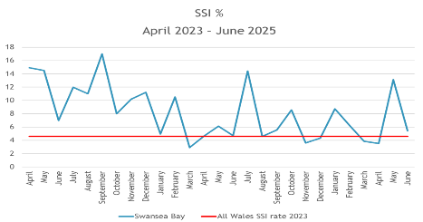
Late Onset Sepsis
Late-onset neonatal sepsis (LONS) is defined as a systemic infection occurring in newborn infants after 72 hours of life, typically up to 28 days of corrected gestational age. LONS poses significant risks, especially in preterm or low birth weight infants, and requires prompt recognition and treatment to prevent serious complications or death.
Maternity Services have launched a “Back to Basics” campaign, working collaboratively with the Infection, Prevention and Control Team. There has been an increase in training provided to staff and recruitment into substantive Band 2 HCSW to reduce the need for Bank and to improve standards.
In 2023 SBUHB were negative outliers for LOS, this was related to multiple episodes of Staphylococcus Aureus infections, this was in conjunction with a background of increased community and health board rise during the same period. The service had recognised this as an area of improvement prior to the publication of national data and approached this with a quality improvement methodology approach. In 2024 SBUHB has seen improvements in their LOS numbers and are no longer negative outliers in NNAP.
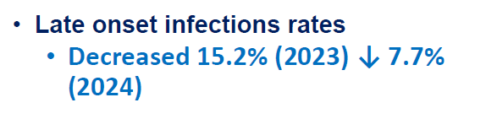
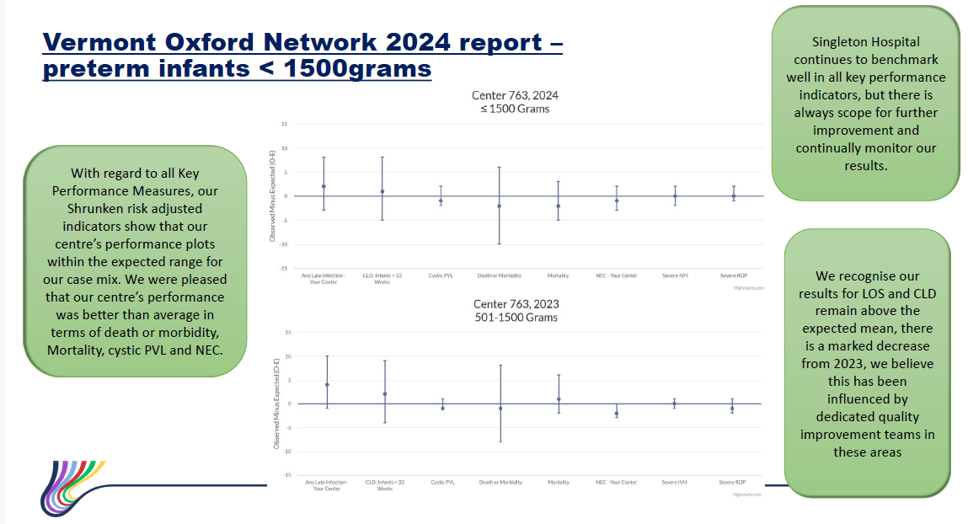

Less than 53.2.3 Neonatal National Audit Programme (NNAP)
The service received notification in August 2025, that SBUHB has positive outlier status for a number of NNAP 2024 measures, including 2 year follow-up data entry for high risk infants normothermia on admission to NICU and breastmilk by day 2 of life.
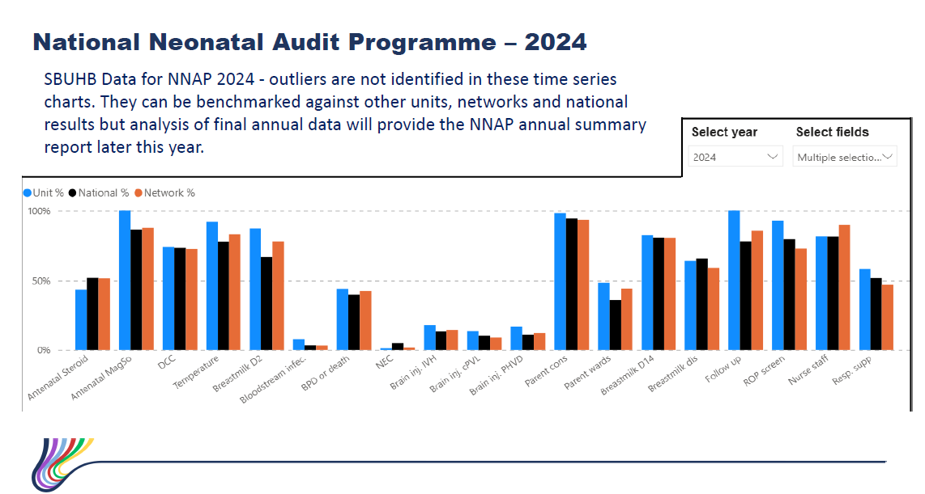
3.2.4 Hypoxic Ischaemic Enephalopathy (HIE)
In 2025, the service reported less than 5. On review of the trends of HIE cases, the service identified a significant increase in moderate to severe HIE in late 2023 to early 2024 with a mean of 2.7/1000 live births. This has now reduced to baseline levels in late 2024 and has been sustained since. The current mean HIE rate of 1.6/1000 live births is within the 95% confidence interval of HIE rates reported in England (pale yellow band) 1.49-1.7/1000 live births.
3.2.5 Small For Gestational Age Babies
Small for gestational age babies which are not identified prior to birth through ultrasound scanning or symphysis fundal height measurement are incident reported for review. Since 2020, the service has undertaken a number of service changes, governance process and guideline changes to ensure care is provided in accordance with the Perinatal Institute and Gap Grow.

Benchmarking against the Perinatal Institute
 | All Babies born with birthweight centile under 10
Quarter | Local Detection Rate | National Average Detection Rate
Quarter 1 | 43.40% | 43.00%
Quarter 2 | 43.24% | 32.30%
Quarter 3 | 49.10% | 40.50%
Quarter 4 | 51.90% | 44.10%

 | All Babies born with birthweight centile under 3
Quarter | Local Detection Rate | National Average Detection Rate
Quarter 1 | 68.90% | 41.60%
Quarter 2 | 54.80% | 41.40%
Quarter 3 | 73.70% | 59.00%
Quarter 4 | 35.90% | 38.00%

3.2.6 Admissions to Intensive Care (ICU)
There have A small number of women were admitted to the ICU. These cases have reviewed by the Multi-Disciplinary Team to identify learning.
In view of the ICU being on a separate site to Perinatal services, a standing order of practice has been developed to ensure appropriate communication and care provision between sites.
The service is exploring critical care support as part of the Action plan following the independent review.
3.2.7 Mothers and Babies: Reducing Risk through Audits and Confidential Enquiries across the UK (MBRRACE – UK)
There are missing data fields for birth weight centile, this may be due to errors in user manual entry. To mitigate this case reviews are undertaken to understand if the birth weight centile has been calculated using the Perinatal Institute calculator so that this data set can be completed as this gives critical evidence of any growth restricted babies in pregnancy.
There have been seven Stillbirths in Maternity services between January and July 2025.
There have been 6 Neonatal deaths in Neonatal services between January and July 2025. There were 6 Neonatal deaths in Neonatal services between January and July 2025, and cases which qualify for MBBRACE-UK reporting have been duly reported.

The Service is reviewing the live data on the MBRRACE database which shows the subcategories to support any trend analysis or themes for the service to be alerted to avoidable harm.

3.2.8 Perinatal Dashboard
CAESAREAN BIRTH: There is a rising trend for planned caesarean birth; to review this a task and finish group has been established to undertake a deep dive, analyze data and engage with women and birthing people to understand some of the reasons for this. This information will then inform you of a quality improvement programme.

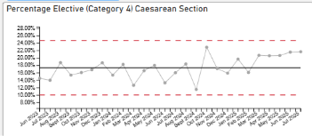
OBSTETRIC HAEMORRHAGE: The rate of obstetric hemorrhage benchmarks the service in line with the national average. Our local rate equates to 3.8 per 1000 maternities.
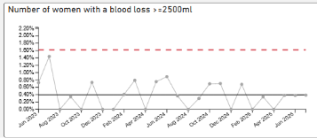

NEONATAL DATA
The Neonatal data is taking longer to produce than first anticipated due to coding in Badgernet at front-end and back-end data selection – many parts have now been solutioned and it is anticipated data availability will be within the next month; other components are still taking a while to display the correct dataset.
Data oversight continues as mitigation using national benchmarking data from Perinatal Excellence to Reduce Injury in Premature Birth Cymru (PERIPrem Cymru), National Neonatal Audit Programme (NNAP) and Vermont Oxford Network benchmarking centre for neonatal data (VON).
The Perinatal dashboard features in all governance meetings and is reviewed as part of the Perinatal Committee enacting its due diligence of oversight and assurance.
3.2.9 Incident and Incident Management
There have been 122 Maternity incidents reported in June 2025, and 28 Neonatal incidents. Of those 71 and 14 have been closed respectively.
The highest reported incident within maternity is recorded as “maternity adverse occurrence” which can cover unexpected admissions to the Neonatal Intensive Care Unit, babies born under 10th centile, post-partum hemorrhage etc., whilst the neonatal services highest reported incident type is around medication errors, either in prescribing or administration.
Maternity services had 1 outstanding incident for 2023 that has since been signed off and 7 outstanding incidents for 2024. These incidents can take some time to complete due to the nature of the investigation and robust review including where the service has sought an external review. The service undertakes weekly meetings with the senior team to update on the progress of the longest outstanding incidents.

The Neonatal service has one outstanding incident from 2023 and one outstanding incident from 2024. These remain outstanding due to the nature of their review and are dependent on external regulators to complete these.

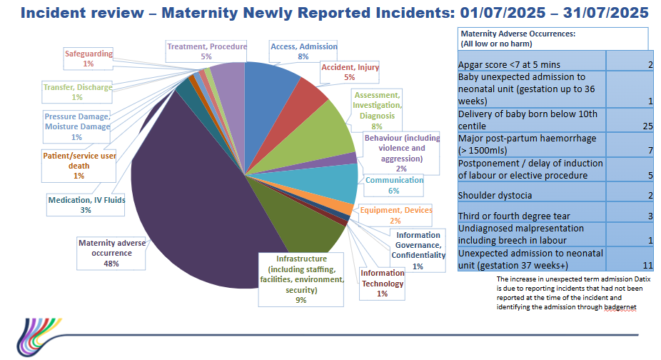
  - Patient Experience
The service has recruited into the Patient Experience Midwife to support the agenda and improve how service users are listened to. This post will work closely with the Maternity and Neonatal Voices Partnership to ensure user feedback is central to services.
The service is currently transitioning from the Maternity Voices Partnership (MNP) into the Maternity and Neonatal Voices Partnership to ensure that families are supported throughout their whole journey throughout the services.
A thematic review of concerns has been undertaken, along with women’s feedback from the Civica system. A task and finish group has been established, co-produced with the Maternity and Neonatal Voices Partnership, to improve induction of labour pathway. Speciafically the task and finish gorup will scope and review:
- Clinical indication and timing of induction of labour
- Delays due to labour ward capacity and planned care
- Womens experiences and understanding of the process of induction of labour
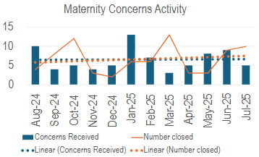
Maternity services have updated and amended the escalation policy to ensure the process of placing induction of labour on hold is considered following senior review in times of capacity and high acuity. This has avoided times where induction of labour is placed hold on unnecessarily.
The Perinatal Service is the pilot site for the NHS core questionnaire, with 46% of service users having provided feedback on their birth expereince.
There are 14 concerns for maternity serivces, of these 7 are out of time of Putting Things Right due to the complex nature of the cases and completion of external processes, Neonatal services have 2 open concerns. A weekly concerns meeting is held in the service to review and address this.
- FINANCIAL IMPLICATIONS

There will be some financial implications because of the recommendations from the Independent review, these are currently being reviewed by the Service Group as part of developing the improvement plan.

- RECOMMENDATIONS

Be Advised:
- Plans for project management support to develop and monitor improvement plans in response to the Independent Review are in progress.
- The 2 immediate actions from the report (relating to Intensive care Standard Operating Procedure and remote radiology reporting) are in progress
Be Assured:
- By the contents of this report
- Maternity Workforce is Birthrate Plus Compliant
- PADR and Mandatory training compliance is on track
- The Perinatal Service does not currently have any elements or care that would flag as a Negative Outlier
- Maternity Services are fully established within the Obstetric Unit
Be Alerted to:
- The Single Point of Access Maternity Triage is due to launch in March 2026; this is dependent on the recruitment of newly qualified Midwifes
- There is a vacancy of 0.8 WTE Neonatal Consultant Vacancy from September 2025, this will need to be recruited into to maintain BAPM standards

Governance and Assurance

Link to Enabling Objectives  (please choose) | Supporting better health and wellbeing by actively promoting and empowering people to live well in resilient communities
Link to Enabling Objectives  (please choose) | Partnerships for Improving Health and Wellbeing | ☒
Link to Enabling Objectives  (please choose) | Co-Production and Health Literacy | ☒
Link to Enabling Objectives  (please choose) | Digitally Enabled Health and Wellbeing | ☒
Link to Enabling Objectives  (please choose) | Deliver better care through excellent health and care services achieving the outcomes that matter most to people
Link to Enabling Objectives  (please choose) | Best Value Outcomes and High Quality Care | ☒
Link to Enabling Objectives  (please choose) | Partnerships for Care | ☒
Link to Enabling Objectives  (please choose) | Excellent Staff | ☒
Link to Enabling Objectives  (please choose) | Digitally Enabled Care | ☒
Link to Enabling Objectives  (please choose) | Outstanding Research, Innovation, Education and Learning | ☐
Health and Care Standards
(please choose) | Staying Healthy | ☒
(please choose) | Safe Care | ☒
(please choose) | Effective Care | ☒
(please choose) | Dignified Care | ☒
(please choose) | Timely Care | ☒
(please choose) | Individual Care | ☒
(please choose) | Staff and Resources | ☒
Quality, Safety and Patient Experience

Practical Obstetric Multi-Professional Training (PROMPT) is a program designed to improve safety and quality of care during obstetric emergencies. This is endorsed by organisations such as the Royal College of Obstetricians and Gynecologists and the Royal College of Midwives.
The Growth Assessment Protocol and Gestation Related Optimal Weight (GAP Grow) training is designed to improve fetal growth assessment in maternity care.
NNAP Dashboard - The National Neonatal Audit Programme (NNAP) is a UK-wide clinical audit initiate established in 2006, commissioned by the Healthcare quality improvement partnership (HQIP). The purpose of NNAP is to assess whether babies admitted to neonatal units in England, Scotland and Wales receive consistent, high-quality care, identify variations in care and highlight areas for quality improvements.
MBRRACE-UK (Mothers and Babies: Reducing Risk through Audits and Confidential Enquiries across the UK) is a national collaborative programme that investigates maternal and perinatal deaths to improve outcomes and reduce risks in maternity and neonatal care. It is funded by the Healthcare Quality Improvement Partnership (HQIP) and delivered by the National Perinatal Epidemiology Unit (NPEU) at the University of Oxford and the TIMMS collaborative at the University of Leicester

