Meeting Date | 25 September 2025 |  | Agenda Item | 5.2
Name of Meeting | Health Board
Report Title | Staff Health & Wellbeing Update - Supporting Managing Attendance at Work
Report Author | Paul Dunning, Professional Head of Staff Health and Wellbeing, Jessica Rogers, Head of HR Operations and Business Partnering
Report Sponsor | Tina Ricketts, Executive Director of Workforce & OD
Presented by | Tina Ricketts, Executive Director of Workforce & OD
Freedom of Information | Open
Purpose of the Report | This report sets out the roles and responsibilities for the pro-active management of staff sickness absence recognising the important role that line managers play in the health and wellbeing of their direct reports.  The report provides assurance on how the Workforce & OD Directorate is delivering on its responsibilities within available resources and identifies the need for the improved co-ordination of sickness absence management by line managers if we are to see sustained improvement going forward.
Key Issues | Evidence supports that the main responsibility for supporting and ensuring our staff are fit and well in work sits critically with the relationship between line manager and staff member.  The Workforce & OD function have a responsibility to ensure the infrastructure is in place to support effective staff management around absence. There are also wider responsibilities for the Executive Team around creating a culture to support our staff to be engaged, motivated and healthy in work.  Each of these aspects are important in ensuring a positive trend in sickness absence reduction.
Specific Action Required  (please choose one only) | Information | Discussion | Assurance |  | Approval
Specific Action Required  (please choose one only) | ☐ | ☐ | ☒ |  | ☐
Recommendations | The Board is asked to:  - CONSIDER the roles and responsibilities set out in the report noting the importance of the relationship between the line manager and member of staff on their wellbeing  - CONSIDER the benefits of a focused approach to sickness absence management which will be taken forward with the support of the HR Business Partners

STAFF HEALTH & WELLBEING UPDATE - SUPPORTING MANAGING ATTENDANCE AT WORK

- INTRODUCTION
The Board have asked for further assurance around the management of staff health and wellbeing and how we are proactively supporting sickness absence as a Workforce function.

- BACKGROUND
The health and wellbeing of our staff is central to NHS Wales performance and both Public Health Wales and Health Education Improvement Wales CEO’s have recently outlined the need for both organisations to work closely with Health Board’s to develop a collective approach to improving staff health and wellbeing. They outline four priorities:
- Resilience to infectious disease
- Physical resilience
- Psychological resilience
- The work environment
Highlighting the need for organisations to share best practice using evidence-based approaches in order to develop a shared framework across NHS Wales. They also emphasise the need to focus on prevention and ensuring a co-designed approach that can have the greatest workforce and population impact and benefit. It is anticipated that this model will inform the strategic focus of the staff health and wellbeing services over the short to medium term and this paper highlights related evidence-based intervention and prevention approaches currently supporting the health of our staff.
The Health Board’s People Strategy. Our People Aim 1 focuses on ensuring our staff are “Engaged, Motivated and Healthy” and sickness absence is one measure for us to assess this.
Currently our sickness absence is as follows:
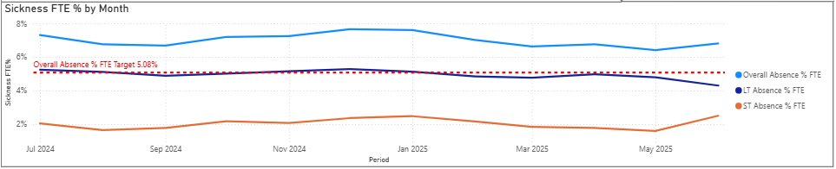
This graph shows that despite the significant programme of work in place to support our prevention and management agenda, our sickness absence is still the second highest across NHS Wales. This has historically been the case. We are seeing increasing trends of sickness in certain services e.g. Estates and Facilities and intelligence also suggests that we are seeing increased trends in areas under pressure, reflected in a 50% increase in mental health referrals to the staff wellbeing service over the past 12 months.
In the context of staff availability, it is also important to recognise the following in terms of our nurse and additional clinical services staff group (data taken from the weekly bank and agency report):
- Our Nurse and AHP bank regularly uses on average approximately 650 whole time equivalents (“WTE”) weekly.
- On average over recent months, sickness (long term and short term) equates to approximately 22% of this utilisation.
- In contrast, additionality (such as surge, 121, acuity) relates to approximately 44%.
In terms of our medical and dental staff groups:
- Approximately 20% of locum spend is attributed to covering sickness absence.
- 20% of locum spend is due to additional activity/surge.
Not all our areas have headroom attached to support effective financial management of staff availability. This is only covered in some in-patient areas. For example, it does not cover our Therapies, Sciences, Facilities & Estates workforce. In terms of management of sickness absence within effective rostering, it would be expected that services accommodate long term sickness within regular and effective rostering, but it is accepted that this may not be possible for short term absence. Our current trend is suggesting our long-term sickness is overall on a reduction trajectory, but short-term sickness is rising. However, we have recently identified a data quality issue with the recording of sickness absence so this is subject to validation.
- EFFECTIVE SICKNESS ABSENCE MANAGEMENT
To ensure our management of sickness absence is effective across the organisation the following needs to be in place:
- A fit for purpose policy
- Rights skills to implement
- Fir for purpose Occupational Health and Wellbeing Support
- Proactive Prevention agenda
- Effective management of sickness absence by managers
- The right Performance Management to gain assurance of impact; and
- An overarching cultural approach for Health and Wellbeing.
The paper covers them in more detail below for assurance in the context of roles and responsibilities.
  - THE ROLE OF THE EXECUTIVE TEAM IN SETTING THE TONE OF THE CULTURE OF THE ORGANISATION
Ensuring we have proactive sickness absence management it is much more than compliance with a policy. This is important, but more important is the tone of the culture set across the organisation. It is the role of the Executive team to ensure the following key elements to enable effective sickness absence management across the organisation:
- The right Performance Management to gain assurance of impact; and
- An overarching cultural approach for Health and Wellbeing
It is recognised that the organisation is currently reviewing its organisational performance management approach. But recognition of how we currently report and manage performance is set out below:
Our sickness reporting
We already manage and track sickness absence as part of our regular performance management framework and Board governance as follows:
- This data is provided for all to access in our new Workforce & OD (“WOD”) Dashboard. This enables managers to keep a track of their teams sickness absence data. It also enables more senior managers to understand hot spot areas for focus. The sickness absence is uploaded monthly from ESR (and then the Dashboard) so it is possible and expected that managers track their absence at least on a monthly basis. A snapshot of our Dashboard is shown below:
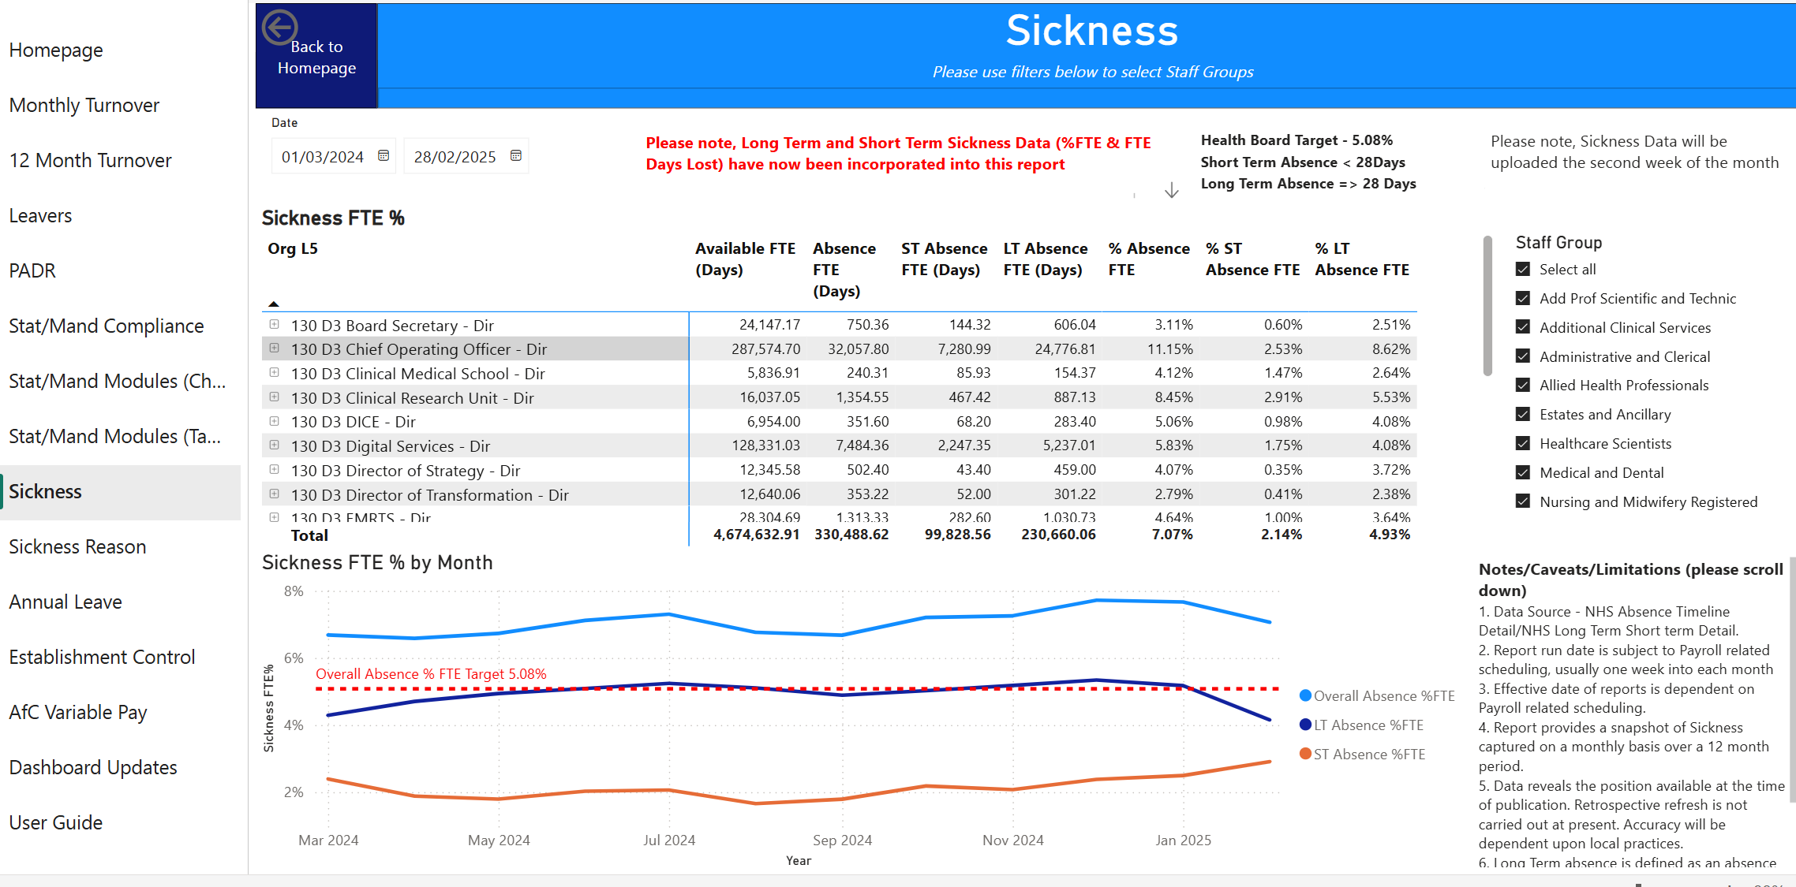
- Executive led performance management meetings that take place with each Service Group focuses on performance of key mandatory metrics including sickness absence. To ensure this is not looked at in isolation, PADR and Mandatory Training are also considered
- A Performance Report is issued to Management Board including sickness absence
- A detailed Workforce & OD Metrics Report is issued to the Partnership Forum for consideration every meeting (bi monthly)
- The same detailed Metrics Report is also presented to the Workforce & OD Committee every meeting (bi monthly); and
- The Workforce & OD Committee now has a Deep Dive focus on hot spot areas. Service Groups Management will come and share their challenges and approach.
Sickness absence is a key reported metric with high visibility across the organisation and the introduction of the new dashboard means that managers have access to their staff sickness absence data daily.
We have developed a HR Heatmap to use within the new performance framework. This data is RAG rated to allow clear visibility of hot spots to ensure Service Groups and Directorates take personal ownership to manage this.
Overall Cultural Approach to Health and Wellbeing
Organisationally we have had recognised that health and wellbeing is a core part of our People Strategy. But strategies only take us so far. This has to be seen, heard and felt across the organisation. Context of the challenges being faced by the organisation is therefore important. We are in recovery and sustainability, with significant financial pressures. Equally our Urgent and Emergency Care system is under pressure and there is a significant evidence-base to support that ‘good work is good for health’. It is critical therefore that the steps we take in managing sickness absence are appropriate and proportionate and focus on supporting health at work. It is equally important for every manager and leader to ensure appropriate check ins with staff. Nothing stops us from doing this daily in our interactions and it should be part of our approach to be compassionate leaders. This is everyone’s responsibility.
  - THE ROLE OF WOD IN SUPPORTING AND ENABLING EFFECTIVE SICKNESS ABSENCE MANAGEMENT
It is the role of the Workforce function to ensure the following are in place:
- A fit for purpose policy – There is in place a nationally agreed Management Attendance at Work Policy (“MAAW”). This is collectively agreed through our national partnership forum with our Trade Unions. Such policy is regularly reviewed through the national governance structures and programmes of work. It is not possible to vary locally. Equally it is necessary to ensure consistent approach to the policy in implementation across NHS Wales. How we bring this to life across Swansea Bay University Health Board (“SBU”) is very relevant to this.

- Right skills to implement – This is currently multi-faceted:
- There is a national training module the “All Wales Managing Attendance at Work”, which is scheduled monthly by the HR Operations team. Staff can book on through ESR which allows us to track those who have completed the module.
- The Operational HR Team have recently developed bite sized learning which is now available on our Brilliant Basics 24/7 digital learning platform; and
- The operational HR and Business Partnering teams provide bespoke and requested training as required.

- Effective Occupational Health and Wellbeing Support – the Health Board offers an extensive, high-quality service with related training and support cascaded for awareness through the monthly Executive led Team Brief sessions along with intranet bulletins and an extensive SharePoint site. We are currently working with the digital team to develop a Wellbeing app to help improve communicating the offer to staff.

Timely, multi-disciplinary Occupational Health and Wellbeing support for mental health and musculoskeletal (MSk) problems is available to staff given these are the two top reasons for long term sickness absence. Mental health support for staff includes access to timely CBT, trauma and suicide support and physiotherapy support for muscle and joint problems; the wellbeing service has seen a 46% increase in referrals over the past 12 months.

The Occupational Health Service consistently meets the All Wales NHS Occupational Health Scope of Practice and Minimum Service Standards (including related KPI’s), demonstrated by the June 2025 return to Welsh Government.

The recent appointment of a permanent Occupational Health Speciality Doctor has resulted in an increase of case reviews for complex long-term sickness absence cases, along with the development of a programme of audit and training to improve the quality of management referral reports. A Consultant Nurse led multidisciplinary team, plus digital infrastructure to support service systems and processes has resulted in a fully staffed, high quality, sustainable model of Occupational Health with increased satisfaction reported from both staff and managers. In the absence of an effective Occupational Health Service, sickness absence would be higher, the Health Board would be exposed to clinical, legal, operational and reputational risks, including increased sickness absence and related variable pay costs, non-compliance with legal and regulatory obligations, inadequate immunisation and health surveillance and related reduced staff/patient safety and quality of care.

There is an increased service focus on prevention/early intervention and population health, including staff health checks, women’s health, men’s mental health and trauma risk assessment training for all staff (TRiM) with the TRiM team increasingly supporting services after adverse and critical events; a 46% increase in referrals in the past 12 months is demonstrated in appendix 1.

An evaluation of the first year of health checks data demonstrates 1,139 staff underwent cholesterol testing and then attended a health check consultation, with 93% of staff feedback stating the appointment provided them with sufficient information to make the lifestyle changes required to improve health; this service also ensures staff are directed quickly to the wellbeing team if mental health or musculoskeletal problems are identified. Feedback is currently being gained from participants via a questionnaire to further identify the health benefits of this intervention.

In addition to the support from the Occupational Health and Wellbeing team, we also provide the following mechanisms of support and advice for staff and managers: Trade Unions, Guardian Service, HR Business Partners, HR Operations team advice and support, OD team advice and support.

- Proactive Prevention agenda – this has been a key focus over the last few years. We are supporting the established evidence base that, ‘good work is good for health’ with the recent rollout of the staff health passport to further support health at work. Current data shows over 53% of staff access the wellbeing service whilst in work, therefore helping to prevent higher sickness absence rates; this equates to approximately 42 staff each month in work who may have been prevented from taking sick leave. Clinical outcome data using the EQ5D-L demonstrates clinical improvements post-intervention, highlighting the effectiveness of the service (see appendix one). The Healthy People Forum aims to provide a strategic focus on attendance at work, including understanding local social determinants of health. This includes the Health Board roll-out of Carers Wales resources for staff with caring responsibilities; our deep dives on absence have confirmed this is a challenge being faced by our staff. 264 staff undertook the carers survey in June 2025; 42% of respondents stated they provide 21 or more hours of care weekly, with nearly 30% providing 35 hours or more. Support for carers is being rolled out with training for managers and an app for staff to access information and advice on available support.

  - THE ROLE OF MANAGERS AND OPERATIONS IN ENSURING EFFECTIVE SICKNESS ABSENCE MANAGEMENT
It is both the responsibility of all managers and senior managers to ensure effective sickness absence management. There is evidence to confirm that the relationship between manager and employee is central to positive engagement, motivation and performance impact. Effectively managing absence in line with the policy is a minimum. We would expect all of our managers to support our staff who are unwell compassionately. We would also expect them to take ownership of updating their skills in accessing training on a regular basis. It is their responsibility to ensure they understand the policy, complete the requisite training and management appropriately. This is the key factor that impacts sickness absence management.

- GOVERNANCE AND RISK ISSUES
Initial evidence from discovery work has indicated a proportion of our stress and anxiety related absences are connected with caring responsibilities and bereavement, hence additional support for these issues. It is acknowledged that Swansea is one of the oldest cities in the UK and understanding how our population health may be impacting our staff sickness is something we have started to explore. We are learning that our demographic population, with approximately 85% of staff living in the Health Board's catchment, is having an impact on our patient profile.
There is a risk that more proactive management of sickness absence, which may be a shift change, is open to challenge from trade unions in terms of current custom and practice of the policy We have seen an increase in the number of staff attending formal sickness absence review meetings due to a recent audit on those who had met the triggers. We are working proactively with staffside colleagues to ensure the policy is consistently applied across the Health Board...
It is envisaged that all governance and risk related issues will continue to be reported regularly to the Workforce and OD committee.
- FINANCIAL IMPLICATIONS
The purpose of this paper is not to set out details in terms of the cost of absence, but it is recognised this was highlighted in the last Deep Dive paper to WOD Committee in February 2025.

- RECOMMENDATION

The Board is asked to:
- CONSIDER the roles and responsibilities set out in the report noting the importance of the relationship between the line manager and member of staff on their wellbeing
- CONSIDER the benefits of a focused approach to sickness absence management, which will be taken forward with the support of the HR Business Partners

Governance and Assurance
Link to Enabling Objectives  (please choose) | Supporting better health and wellbeing by actively promoting and empowering people to live well in resilient communities
Link to Enabling Objectives  (please choose) | Partnerships for Improving Health and Wellbeing |  | ☒
Link to Enabling Objectives  (please choose) | Co-Production and Health Literacy |  | ☐
Link to Enabling Objectives  (please choose) | Digitally Enabled Health and Wellbeing |  | ☐
Link to Enabling Objectives  (please choose) | Deliver better care through excellent health and care services achieving the outcomes that matter most to people
Link to Enabling Objectives  (please choose) | Best Value Outcomes and High Quality Care |  | ☒
Link to Enabling Objectives  (please choose) | Partnerships for Care |  | ☐
Link to Enabling Objectives  (please choose) | Excellent Staff |  | ☒
Link to Enabling Objectives  (please choose) | Digitally Enabled Care |  | ☐
Link to Enabling Objectives  (please choose) | Outstanding Research, Innovation, Education and Learning |  | ☐
Health and Care Standards
(please choose) | Staying Healthy |  | ☒
(please choose) | Safe Care |  | ☒
(please choose) | Effective Care |  | ☒
(please choose) | Dignified Care |  | ☐
(please choose) | Timely Care |  | ☒
(please choose) | Individual Care |  | ☐
(please choose) | Staff and Resources |  | ☒
Quality, Safety and Patient Experience
Evidence demonstrates a direct correlation between staff health and wellbeing/experience and high-quality patient care and outcomes. Supporting and enhancing staff wellbeing and increasing attendance at work will help fulfil the aims of the people strategy and 10-year vision and contribute to improved patient safety and experience. This approach supports the People Strategy, Managing Attendance at Work (MAWW) policy principles and incorporates the “Healthier Wales Quadruple Aim” of supporting staff health & wellbeing.

Financial Implications
Many of the interventions and actions identified can be implemented within current resources and it is anticipated that the reduction of sickness absence will contribute to the Health Boards’ financial plans.
Legal Implications (including equality and diversity assessment)
Ensures compliance with Equality Act 2010.

Staffing Implications
Improved sickness absence rates will reduce the reliance on the temporary workforce.
Long Term Implications (including the impact of the Well-being of Future Generations (Wales) Act 2015)
Actions outlined in report promote “A Healthier Wales Quadruple Aim” these being:
- Improved population health & wellbeing
- Better quality & more accessible health & social care services
- Motivated & sustainable health & social care workforce

Report History |  | Workforce & OD Committee – 14 August 2025  Management Board – 20 August 2025
Appendices |  | None

