Meeting Date | 27 November 2025 |  | Agenda Item |  |  | 4.8
Name of Meeting | SBUHB Board
Report Title | Capital and Estates Strategy Implementation Update
Report Author | Simon Davies, Interim Director of Capital & Estates  Ian MacDonald, Assistant Director of Finance
Report Sponsor | Darren Griffiths, Executive Director of Finance
Presented by | Darren Griffiths, Executive Director of Finance
Freedom of Information | Open
Purpose of the Report | To present progress on delivery of the Health Board (SBUHB) approved Estates Strategy (The Strategy), which identifies the infrastructure requirements to support the future healthcare service needs and striving to obtain business continuity. The Strategy sets out the scale of work needed to address the urgent and significant backlog maintenance works following completion of the 6-facet condition survey 2022.
Key Issues | The Strategy highlights the opportunities associated with developing the existing estate in line with the clinical service plan and development control plans, whilst managing high and significant backlog maintenance risks. These include: electrical systems, ventilation systems, heating systems, fire and medical gas installations, and foul drainage replacement with removal of water services dead legs pipe runs. Due to the age of much of our estate, many of our clinical environments were not designed for the service function they are now providing.  The 6-facet survey will require updating with an asset register that informs the capital requirements alongside the services developments within the Clinical Services Plan (CSP). It will show that, with an aging estate, significant investment is required to reduce backlog maintenance to prevent potential estates failures from impacting on service delivery.  National capital funding is constrained following the outcome of the national capital prioritisation in January 2025. An update on progress with implementing the 10-year capital investment programme is presented, along with an overview of potential disposal opportunities.
Specific Action Required  (please choose one only) | Information | Discussion |  | Assurance | Approval
Specific Action Required  (please choose one only) | ☐ | ☐ |  | ☒ | ☐
Recommendations | Members are asked to:  - DISCUSS the detailed content of this report  - ACKNOWLEGDE the extensive information available to inform prioritisation to inform decision making  - ACKNOWLEDGE the importance of clear interface between estates assessments and the Clinical Services Plan  - DISCUSS and AGREE timeframes for updates and the process to give assurance on actions  - ACKNOWLEDGE the risks and mitigations currently being managed across the estate  - ACKNOWLEDGE the need for decant space to create room for maintenance work and developments  - CONFIRM the modernisation of the estates workforce to increase recruitment and retention to meet SBUHHB needs.  - ENDORSE the work in progress to develop options for future funding models to potentially accelerate capital development work

CAPITAL AND ESTATES STRATEGY IMPLEMENTATION UPDATE

- INTRODUCTION
The Board approved the SBUHB Estates Strategy (The Strategy) in May 2023. The development of The Strategy is a key enabler for delivery of SBUHB Clinical Services Plan (CSP). However, the NHS in Wales faces unprecedented challenges balancing the management of the current estates condition against other competing priorities within existing capital funding constraints.

In general terms, the Board has been advised that 75% of the existing Estate is more than 30 years old, including the Morriston Nucleus template with a number of other areas built in the 1960’s, making it challenging when developing/maintaining the Estate to support our existing and future clinical needs. 66% of the Estate is described within our 6-facet survey condition of being poor, in a bad condition and The Strategy acknowledged that we must address these areas (mainly wards and theatres) or the facilities could become unavailable for clinical care.

This is a risk that we will have to manage, especially within our older wards and theatres, which means that we will have to carry out a reactive approach to immediate repairs to maintain business continuity of services, whilst also planning to address these challenges through our pre-planned maintenance and painting programme.

The Strategy provides a strategic framework for estate development and management which demonstrates that it has responded to and identifies the facilitation requirements that meet the Swansea Bay CSP, to align the clinical accommodation to the prevailing service and strategic objectives alongside the overall development control plan.

Figure 1 - Estates Strategy

The initial stage of the Strategy is clear in that the main objective is to maintain business continuity in the current climate of limited capital funding being available. The 2023 Capital Audit report produced for the Audit Committee on our Strategy highlighted the risk around capital funding constraints.

In the short to medium term, SBUHB has utilised a combination of All-Wales capital funding, targeted Estates Facilities Advisory Board (EFAB) Funding, planned reactive maintenance and discretionary funding to address identified high priority areas. The execution of the Strategy will result in the development and expansion of specialist hospital services, including the partial decommissioning of the older estate and realising expansion space for other key services to grow.

- BACKGROUND
A priority for the Strategy is to increase estate utilisation and efficiency by decreasing some of the estate and its backlog maintenance costs, whilst still managing to improve the environment. It is also important for SBUHB to provide assurance that its health estate is well managed operationally and is safe and secure for patients and staff, and appropriate and sustainable to support current and future needs as identified in the clinical services plan.

The delivery of these plans will require financial investment along with changes in working practices and will present a challenge to the organisation as we strive to implement change and ensure our infrastructure is fit for our future.

The range of benefits to SBU and wider health economy in having a formal 10-year Estate Strategy include: -

- Assurance that the quality of clinical services provided will be supported by a safe, secure, and appropriate environment.
- A means of ensuring that capital investments reflect clinical and operational service strategies.
- A plan for change in which progress can be measured.
- A strategic context in which detailed business cases for all capital investment can be developed and evaluated.
- A means by which the Health Board can identify capital investment projects which will require formal approval from Welsh Government and relate to the overarching Local Authority – Local Development Plans (LDPs)

The SBUHB estate has grown over many years, responding to service and population requirements, and specialist requirements. The buildings owned are of various size and age, some developed before 1900s, and others after 2015. The buildings and facilities are set within a complex infrastructure of engineering systems for the provision of critical services to wards, theatres, departments, and laboratories, enabling service delivery which is appropriate and timely for patients.

The aged estate is generally more complicated to reconfigure and often changes do not enable the best and efficient delivery of modern-day services. This includes developing layouts in ward environments, which do not allow adequate segregation of patients for infection prevention and control purposes, including isolation and large open wards that cannot be converted easily to meet the required standards for privacy and dignity. The configuration of many older facilities is also not suitable for the increasing number of people with dementia or cognitive impairments.

It is generally agreed that a natural correlation exists between the underinvestment in the estate infrastructure over time and the significantly high level of backlog maintenance within the system; this has forced a higher proportion of the estate resource to shift from proactive, controlled maintenance approaches to reactionary actions as and when issues arise. This is highly inefficient and costly and carries a much greater risk of more serious system failure as attempts are made to continually maintain an operational and compliant service.

The current SBUHB estate includes: -

- Three acute multi service hospital sites (Morriston Hospital 112,071m2 750 beds, Singleton 63,283m2 439 beds and Neath Port Talbot 29,449m2 210beds)
- One Community Hospital (Gorseinon Hospital 3,835m2 44 beds)
- Health centres and clinics/ Primary Care Centres (as a system there are 49 GP’s and 72 Dental practices across the eight Clusters)
- Two Mental Health Hospitals – Cefn Coed and Tonna
- Five Resource Centres
- A large number of properties facilitating Learning Disability, Community Mental Health, Corporate functions and Primary Care services.

Buildings cover a total gross floor area of over 250,000 square metres. With such a vast, diverse and complex estate, a large proportion of which is operational 24/7, the condition of the estate is deteriorating at a rate beyond our ability to keep up and the current level of discretionary funding is insufficient to keep pace with demand; therefore, the most urgent, high-risk issues are being addressed as a priority. This is not just an issue for SBUHB, but is an NHS-wide high risk, that we and all NHS organisations have a duty to urgently address.

In response to the original CSP, SBUHB is refreshing its clinical service models within the new year 2026, which, in turn is enabling the identification and mapping of the estate changes required to facilitate them.
The completion of the 6-facet survey in 2022, identified the backlog maintenance cost needed to bring estate assets up to an acceptable good condition (Condition B), regarding their physical condition and/or compliance with mandatory fire safety requirements and statutory safety legislation. Backlog maintenance is a national challenge which is discussed at national government level. The risk-based methodology recommends the allocation of investment as follows across the risk categories and covered under the main headings below: -

- Low risk elements can be addressed through agreed maintenance programmes or included in the later years of your estate strategy.
- Moderate risk elements should be addressed by close control and monitoring. They can be effectively managed in the medium term, so as not to cause undue concern to statutory enforcement bodies or risk to healthcare delivery or safety. These items require expenditure planning for the medium term.
- Significant risk elements require expenditure in the short term but should be effectively managed as a priority so as not to cause undue concern to statutory enforcement bodies or risk to healthcare delivery or safety.
- High risk elements must be addressed as an urgent priority to prevent catastrophic failure, major disruption to clinical services or deficiencies in safety liable to cause serious injury and/or prosecution.
- SBUHB has adopted an appropriate risk management strategy regarding estates and facilities in the context of the physical condition and quality of the estate portfolio. Details of the 6-facet survey (2022) show the reported back-log maintenance figures per category over the six main Health Board sites for the financial year of 2022. The overall condition grade shows that 66% of the estate is in category C (poor) and category D (bad) condition.

Figure 2: Overall Estate Condition
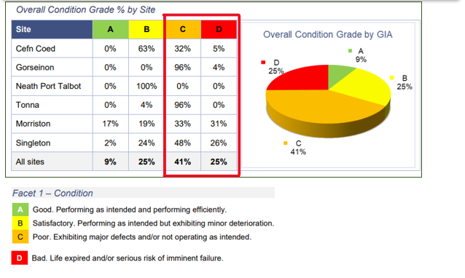
The total backlog maintenance liability for the Estate totals from the 2022 6-facet survey identified an estimated cost of £100m. Through the recent estates deep dive investigative processes, including the recent black start tests (electrical switch off to test generator back-up) at Morriston and Singleton and general whole hospital (inc electrical capacity and foul drainage), the position of these key areas of system wide infrastructure has deteriorated beyond that known in 2022. The highest proportion of backlog liability is with Morriston Hospital and Singleton Hospital with 82% of the overall backlog total.

Figure 3: Backlog Maintenance £ (exc on-costs)
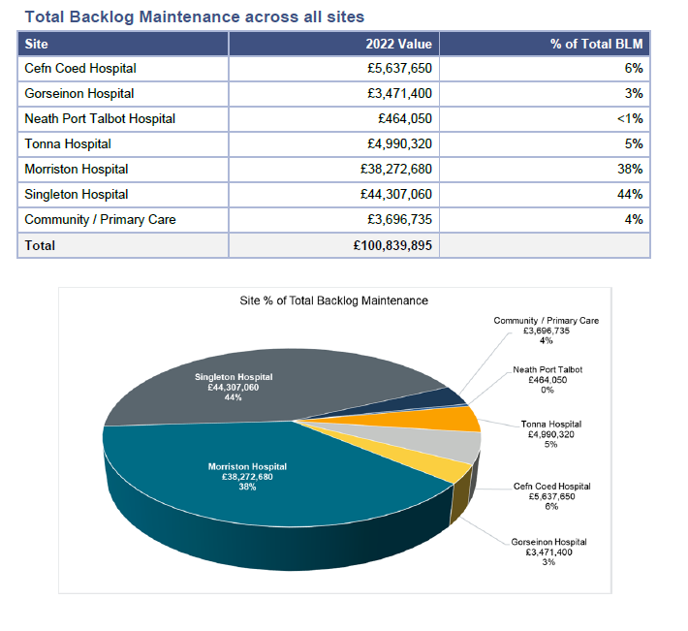

The ageing profile of the estate is a major contributing factor to the levels of backlog maintenance, with over 75% now over 30 years old and in a poor state.
Figure 4 Estate Age Profile
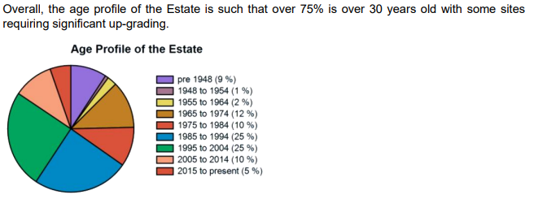
The 2022 heat maps produced below for Morriston and Singleton Hospital, highlights those areas of the estate in bad (red) and poor (orange) condition.

Figure 5: Morriston Hospital Heat Map - Backlog Maintenance
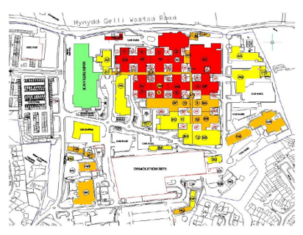

Figure 6: Singleton Hospital Heat Map - Backlog Maintenance
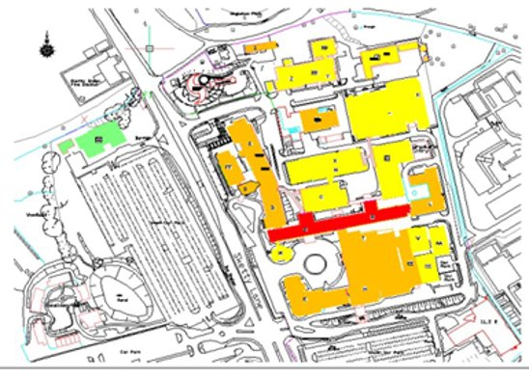

The key findings for Morriston and Singleton hospitals were: -

- Roof Coverings - require replacement, impacting on future business continuity of wards and theatres with 50% of roof fabrics and finishes replaced but on hold due to lack of decant ward (Morriston)
- Wards - most of our ward configuration does not provide adequate single room accommodation or bed spacing to support optimal Infection Prevention Control (both sites)
- Theatres - the fabric is typically worn and deteriorated. Mechanical and electrical infrastructure is dated and beyond design life in nearly all aspects, including ventilation, medical systems, fire safety and nurse call (both sites)
- Asbestos removal from the service voids in central ward block and to remove identified dead legs on the water supply pipelines (Singleton).

Existing Estate - Patient Safety and Experience
Patient outcomes adversely impacted. In the majority of infection out-breaks, there is a potential environmental risk associated. The majority of our ward configuration does not provide adequate single room accommodation to support optimal IPC management ward bed centre spacings. Issues often highlighted in HIW inspections and patient safety Walk rounds.
Patient experience adversely impacted whilst patient feedback remains positive, we know that patient dignity and privacy is sometimes compromised because of the crammed accommodation. Issues often highlighted in CHC visits.
Estates maintenance is disproportionately focused on reacting to failures more costly and is associated with greater impact on operational service delivery that a proactive maintenance programme (an issue picked up by the Wales Audit Office).
Estates failures increase impact on operational service delivery on a regular basis (theatre downtime, un-planned ward moves, temporary closure of areas, impact on access to services – such as lift failures). The HB is at risk of prosecution if anyone comes to harm because of health and safety risks associated with the condition of the estate.
Outdated technology and equipment impacting on efficient and effective care impacting on service delivery, new technology up to date equipment (Space & infrastructure requirements)

Alignment of Estate with Long-Term Clinical Strategy
SBUHB has been developing new models of service delivery for Acute Clinical Services, Primary Care and Mental Health; the models of integrated care delivery include new ways of working with primary care, to be able to identify and in some cases, begin implementation, of some of the strategic changes to the estate that will facilitate the new models of care pathways, including delivery of regional centres for some specialist services for the wider Wales populations. In determining the future requirement for space, assessments and comparisons have been made around the condition, functional suitability and locations of the existing estate which enable benchmarking of performance to shape the future estate provision. This includes looking for efficiencies and ways to improve the patient and visitor experience, by considering their access to services, and the journeys they need to make for the provision of care, both routine and specialist.

Whilst planning and enabling the estate transformation, ‘business as usual’ must be maintained as far as possible, providing a safe, compliant and operationally functional environment with minimal disruption to patients, visitors and staff where transformation or reconfiguration is undertaken.

As part of the Strategic Estates Plan the following estate objectives were identified: -

- To support the delivery of SBUHB clinical strategy by developing a property portfolio that meets the needs of the service development plans and represents efficient use of resources. This means that the estate will be continually reviewed to ensure it meets the needs of the service.
- To play a strong supporting role in development of Tertiary, Acute and Primary Care facilities to deliver healthcare with healthier outcomes.
- To maintain or improve compliance levels to ensure the Health Boards physical environment is delivered to the highest affordable standards.
- To support operational services and business development to capitalise on the Health Boards estate to bring a greater range of healthcare services, working with commissioners and stakeholders in the development of regional services.
- To deliver a low carbon, sustainable estate that minimises its carbon footprint.

Future Development Control Plans (DCP) to deliver SBUHB Vision

SBUHB will align to the national, regional and local drivers that impact on service delivery and how the estate is developed. There will also be other localised service developments because of national drivers, such as system working alongside all health, social care and third sector organisations, to tackle social detriments to health and continue to find innovative way to provide safe, high-quality care that is sustainable for future generations to come.

The CSP priorities will be refreshed to advise and support the changes as we drive forwards our joined-up approaches to service delivery and a focus on out of hospital care. By Integrating primary and community-based services, physical and mental health services, with our partners, and transitioning new pathways of care out of hospital into the community where possible will strengthen the ‘system’ as a whole and improve the health of the population.

We have compiled our development control plans for each site supporting our clinical service plan which shows quite a challenging capital programme with various capital projects at different business case stages.

It’s worth noting that one of the key planning conditions within Swansea Local Authority Local Development Plan, states that any future expansion of services on the Morriston site will require a new access route coming off the M4 junction 46 (Llangyfelach) mitigating traffic congestion on the existing road Infrastructure. Following the Business Case Scoping meeting held with Welsh Government officials on 2 April 2025, the long-term strategy includes the construction of a new Emergency Department on the 55-acre site north of the current Morriston Hospital.

A hybrid planning application for a new access route and future developments was submitted to Swansea Council on 11 July 2025 and funding is being sought for a Strategic Outline Case to advance design and cost estimates. The Hybrid Planning Application contains full planning for the new access route and outline planning for future expansion for the Morriston site. A date is pending for a Planning Committee decision.
Morriston Hospital
To deliver essential maintenance works, a key enabler will be to provide sufficient decant areas. This would support SBUHB in starting a phased a ward refurbishment plan. It is worth noting that the signed off ward design contains 50% single rooms, in compliance with the Welsh Government Guidance. This means that at some point additional wards will need to be provided using future vacated space or there needs to be a sustained and significant reduction in clinically optimised patient numbers on our acute sites.

The work identified a high risk of business continuity failure through the risk of water ingress through the fabric of the roofing systems in the oldest parts of Morriston Hospital. Whilst underlying roof structures have been assessed as safe, the external fabric of the roof is at risk of failure of a scale which could result in an unsustainable loss of bed capacity.

The DCP identifies a key project being the provision of a new Emergency Department and Critical Care Unit, to provide a new fully compliant new build to incorporate a theatre suite with full diagnostics. The precise composition of this would be subject to a rigorous business case process.

SBUHB would also be looking at completing the upgrading of High Voltage (HV) circuits and transformers and improve the control gears also within the HV sub stations and currently working on a replacement Substation 6. As part of the ward refurbishments, we would also be able to start to address the upgrading of fire alarm panels, along with looking at how we enhance the existing medical gas infrastructure to increase flow rates within the site providing medical gases per bed not shared as existing.
A business case for the provision of a new £10.436m Vascular Hybrid theatre in Morriston received approved by Welsh Government earlier this month. Work is due to commence in December 2025 with the unit due to receive the first patients in October 2026.

Figure 7: 3D View Future Morriston Hospital Development
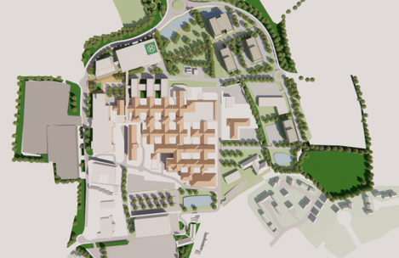

Singleton Hospital
On the Singleton Hospital site, the major issue to be addressed first is asbestos removal from the voids. Until this is completed, it is extremely challenging to start work to address the replacement of the engineering services highlighted as a significant risk within the 6-facet survey work.

Whilst it would be possible to complete some of the refurbishment work on a ward or floor basis, as explained within the strategy document, the electrical services are provided over three wards, therefore, to replace the electrical distribution panels we would be affecting services for three wards for a number of weeks which will clearly have significant clinical implications and require three decant wards.

Engagement with clinical colleagues will be needed, to understand the utilisation of the decant facility across the two sites, however, unless SBUHB addresses these issues in a planned way there is the potential of an unplanned failure of engineering services on both these sites. This could have a profound effect on our ability to provide clinical care and impact on business continuity.

The SBUHB Six Facet Survey of the condition of the Estate provided a clear indication of the costs at the time of the assessment, to address these issues but should be complemented by Development Control Plans (DCP) for the delivery of a capital infrastructure programme to address these issues, which will substantially reduce the backlog maintenance costs. The DCPs also identify the major service change projects to support the Clinical Services Plan.

The illustration below provides the high-level Singleton Hospital DCP as considered at the time the strategy was prepared. This requires refresh through the CSP now as some of the planning assumption will have changed.

Figure 8: Singleton Hospital DCP
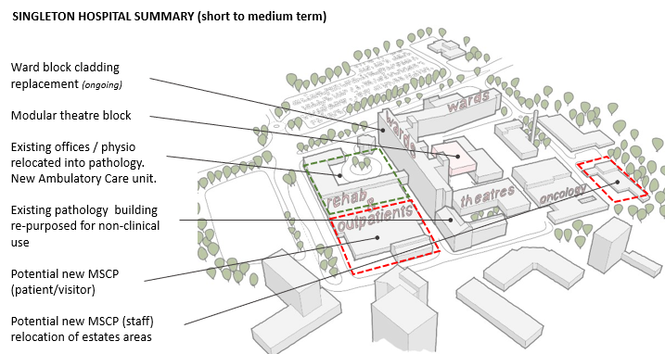

Primary Care & Community Services
SBUHB is developing an agreed ’10-year’ primary and community care estates strategy as part of the overarching Primary and Community Services strategy. That strategy included a review of the primary care estate over a two-year period, looking at functional suitability, utilisation, building maintenance and condition, compliance with health and safety regulations, healthcare guidance and building regulations including disabled access.

Local Development Plans have also been examined to establish future population growth and linkages with Local Authorities to maximise opportunities across organisations as part of the ‘One Public Estate’ agenda. The Primary and Community Estates Plan will ensure, upon completion that all Swansea Bay primary care estate premises are fit for purpose and the quality of the environment is suitable for all building users.

Work is underway to complete the design and submit a Business Justification Case to Welsh Government in Q1 2026-27 for the provision of the new Croeserw Health and Wellbeing Centre. The project is being taken through the West Glamorgan Regional Partnership Board via the national IRCF (Integrated & Rebalancing Capital Fund).

The former Swansea Wellness Centre project has this month transitioned into a new Swansea Health & Wellbeing Hub project. The newly established Project Board has commissioned several work packages, including a Schedule of Accommodation and Test to Fit exercise. The objective of the project will be to vacate the ageing Central Clinic in Swansea City Centre and move into modern fit for purpose accommodation within the Swansea City Centre within the next 2 years. Partnerships have already been formed with Swansea Council, West Glamorgan Regional Partnership Board and the Welsh Government to look at various financing streams including the IRCF objective 1 funding for Integrated Health & Social Care Hubs.

Mental Health & Learning Disabilities (MH&L:D)
Discussions have commenced on the requirements for modernised Mental Health estate for Swansea City Centre. Further work will be required to assess the priorities for the current estates and how future developments can link into the proposed Swansea Health & Wellbeing Hub (referred to above) Centre and also other developments being undertaken by the local authority. There is a requirement for a MH & LD service model to shape the buildings in this area. At this stage the discussions are focus on Child and Adolescent Mental Health Services (CAMHS), Community Drug and Alcohol Services (CDAT) and services currently located in the Westfa Unit within the Phillips Parade site.

In addition, work is underway to improve the level of capital and estates support provided to Learning Disability buildings whilst the Learning Disability strategy is being finalised.

Also under consideration is the model for capital and estates support to the Caswell and Taith Newydd Buildings at the Glanrhyd site which are currently owned by Cwm Taf Morgannwg University Health Board, but which house services provided by Swansea Bay staff. A task and finish group will be set up to take forward future proposals.

Business Cases have been submitted to Welsh Government for: -

- Reinstatement of the Cedar Ward in the Taith Newydd Low Secure Unit following the November 2024 fire £5.935m.
- Building a new Dan y Deri Challenging Behaviour Unit £9.930m

Work is underway to complete the design and submit a Business Justification Case to Welsh Government in March 2026 for the provision of two new Seclusion Suites in the Caswell Medium Secure Unit.

The Board will be separately appraised at its 27 November 2025 meeting of the interim and longer-term plans for its inpatient Mental Health model

Decant Accommodation
Part of delivering The Strategy will require an on-going programme to make decant wards available. There are several important projects that will require the provision of ward decant accommodation during the the next few years. The table below outlines the high-level requirement and possible solutions.

Discussions have commenced on the solutions for Ward A & B, Morriston and the Neath Port Talbot (NPT) Private Finance Initiative (PFI) contractual works. The PFI works will be part of the planned Life Cycle Replacement under the Project Agreement to bring the hospital back into Health Board ownership in May 2023 in Estates condition B.

The requirement for these projects is being undertaken on a planned preventative basis to mitigate the risk of any infrastructure failures causing business continuity issues. Recent infrastructure failures include, ED back-up generator and air circuit breakers supplying critical care and theatres.
Figure 9: Indicative Ward Decant Programme
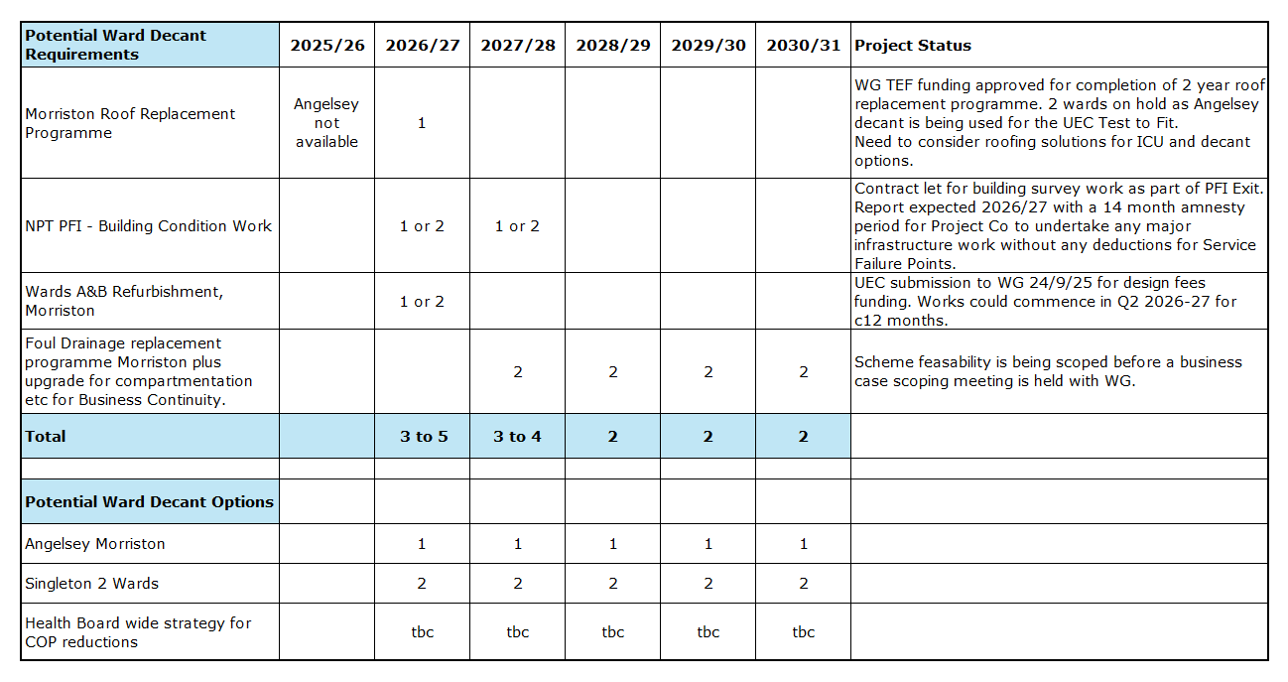
This decant illustration will be considered further in light of the revised CSP and needs to be supported by a stepped change in the numbers of clinical optimised patients across the acute sites.

- GOVERNANCE AND RISK ISSUES
The Strategy was prioritised based on a balance of business continuity risk and the requirement to modernise services though our CSP. Since presenting the results of the 6-facet survey and other findings to Board development in January 2023, six task and finish groups have been held which included officers and Independent Members (Chaired by the Vice Chair) to undertake deep dives on The Strategy and to test and challenge the emerging assumptions within it. Oversight of the strategy is through the Performance and Finance Committee with regular updates to the Board as required.

Priority Risk Issues

Embedding Risk Management at the Heart of Estates Strategy. Effective risk management is fundamental to the successful operation of the Estates function. Compliance safety groups have been reconvened, and non-pay budgets have been reviewed to establish a new baseline for 2026/27, around the current condition and configuration of our estate, including the health & safety technical compliance with Welsh Health Technical Memoranda (WHTM), Welsh Health Building Notes (WHBN), water safety and legionella risk, High Volage & Low Voltage power, medical gas and new ring-main for Morriston hospital, fire safety. Also actively managing the asbestos risk/registers across our estate but mostly at Singleton Hospital.

The recommendations raised by the NHS Wales (SES) Specialist Estates Services Authorised Engineers conducting the audits appear to be common across all sites, a synopsis of these are captured below;
High Voltage | Policy, Authorised person (AP) duties and training, ageing and end of life equipment, general housekeeping
Low Voltage | Policy, APs, and Competent Persons (CP) including contractors, maintenance and record keeping, operational manuals, schematics, labelling, signage and general housekeeping, Load bank testing / black building test, ageing and end of life plant, Generators N+1
Medical Gas | APs, CPs and Designated Nursing/Porters, Policy and operational documentation, PPMs, schematic and asset review, maintenance and record keeping, training
Ventilation | Policy, adequate resources for maintenance as well as APs and CPs, Maintenance and record keeping, review of PPMs, in line with revised HTM, accurate assets list and schematics and ageing and end of life plant equipment.
Water | Policy and Water Safety Plan, Water Safety Group (WSG) membership and attendance, maintenance and record keeping, Water Risk Assessments, Thermostatic Mixing Valve maintenance and servicing (Legionella risk issue) and actions to remove ‘dog legs’, i.e. sections of old pipework where flushing may be ineffective. Training and flushing records require focused attention.

The top risks highlighted on the SBUHB Risk Register, with challenges and potential consequences and mitigations:

- N+1, both acute sites. Good practice would have generator back up for generators that support services on essential power. This is a particular risk for hospitals that provide 24/7 emergency, urgent, and critical care services. Power outage is also one of the top risks identified by the EPRR team. Morriston and Singleton do not have N+1. N+1 signifies a back up beyond the primary source of power.
Current mitigation: allocation of available funding to prepare a design solution for installing ‘hook up points’ on Sub Stations with an initial focus on Morriston.
Future mitigation: installation of hook up points and acquisition of additional standalone generator.

- Services on essential supply. The current situation is that there is limited information on whether or not key services at Morriston are on essential supply, which is mainly due to the way in which developments have been implemented in the past. For example, Pathology, Radiology, half of the Pharmacy dispensing robot, and some of the IT Hubs, such as the Pathology Hub, are not on essential supply. A power outage could disrupt key clinical/clinical support services with very little time to restore it, e.g. the hours before refrigeration of blood stocks reaches unsafe temperatures. Singleton is not in a similar situation, which was reaffirmed during a ‘black start’ exercise in 2024. There is also a need to produce accurate survey information of all services on the Morriston site (these appear to be up to date and accurate for the Singleton site). A recent issue at Morriston revealed that the most recent survey of services undertaken as part of the Sub 6 HV upgrade project were incorrect.
Current mitigation: Estate technical staff are systematically surveying the supply to key services. A phased black was started in October 2025. A survey of services will be commissioned although timing will depend on funding and available capacity.

- Uninterrupted power supply (UPS). This is basically battery back-up that kicks in as soon as there is a power ‘spike’ or failure that could adversely affect the operation of key kit, such as Theatre equipment, or the life support pendants in Critical Care. Current practice is to replace them when they fail, i.e. there is no planned replacement programme. Current mitigation: review of UPS units underway.
Future mitigation: additional capital to establish a rolling replacement programme.

- Obsolete electrical infrastructure, Central Ward Block (CWB), Singleton. This is the original infrastructure and is over 60 years old. Failure of any element, such as the Bakelite distribution boards, would close the CWB.
Current mitigation: Survey and mitigation recommendations completed. Routine estates inspections and responsive estates team.
Future mitigation: replacement with a high-level cost estimate c£2.5m.

- Replacement of core plant and equipment, e.g. air handling units (AHUs) for Theatres and Critical Care, which are crucial for air changes and therefore infection prevention and control (IPC). Current mitigation: Core plant and equipment has been targeted through EFAB and now TEF. However, whilst there is information on some of these assets, it is very limited and does not provide any of the detail necessary to assess viability and prioritise replacement, which is not necessarily the manufacturer’s recommended end of life. An up-to-date asset register is also essential for supporting SFG20, which is the industry standard for maintenance management, and which the Health Board has acquired.
Future mitigation: A reliable rolling investment programme is wholly dependent upon accurate information.

- Foul drainage, both sites. Leaks are increasingly common, and one of the main causes is the age and state of the network. At Singleton, the height of the risers means that leaks can affect a number of clinical areas, a situation complicated by the presence of asbestos. At Morriston the cast iron drainage system in the original nucleus building is rotting away, which can impact clinical areas without warning, as happened recently when a six-bed unit had to be closed on Ward G. More recently, a leak from the main kitchens has affected Pharmacy and could potentially affect the automated dispensing system. Concrete drains at ground level are also collapsing, which is age related, most recently at Morriston in July by the original main entrance. Repair was possible externally because of the location of the collapse but would have otherwise caused considerable and extensive disruption if the ground floor corridor had to be excavated (plus the access manhole in ALAC has been built over). Doing nothing is not an option as a catastrophic failure, especially at Morriston, could compromise a number of areas and potentially close the hospital.
Current Mitigation: Reactive ad-hoc repats as required. Surveys are being commissioned of the drainage system to determine weaknesses to inform a future programme of replacement.
Future Mitigation: Likely to require a mixture of short-term and longer-term funding for a rolling replacement programme dependent on the technical solutions and availability of decant facilities.

- Electrical load, Sub Stations, Morriston. The demand on 5 of the 6 Sub Stations is excess of available capacity and not complaint with current HTM standards (Health Technical Memorandums). These have not been reviewed for at least a decade, and possibly 25 years when the first HV infrastructure upgrade was completed (both sites) and service developments and additional activity have increased demand on each Sub Station could result in power supply failure.
Current Mitigation: Investigations are on-going to understand opportunity to increase resilience of Substation 3. Reviewing current service contracts to include provision of a back-up generators. Funding application made to Welsh Government for £400k to provide temporary hook up points on all sub-stations.
Future Mitigation: Replacement programme for sub stations.

- Main steam supply from Boiler house, Morriston. The main conduit from the Boiler house to Plant Room 5 is leaking and at risk of future collapse. This provides all of the steam to the entire hospital. If the pipe fails, there would be significant disruption to hospital services.
Current Mitigation: Funding available this year to replace one corroding line.
Additional funding needed? Yes, additional funding required to provide a second line for resilience.

- Resilience. There are two 11Kv incoming HV supplies to both Morriston and Singleton Hospitals. Singleton only has one dedicated incomer (the other also supports residential accommodation in the area). Both incomers are dedicated to the hospital at Morriston. However, both originate from the same source. It is conceivable that a major power failure in the locality could result in reliance on generator supply only. It is also understood that the capacity of the National Grid to meet increasing demand, especially for decarbonisation, is under pressure. Supply capacity is capped at the amount needed but increasing this may require an alternative supply, which could be provided from the Felindre Energy Centre.
Future Mitigation: the proposed new access road to Morriston could provide access to the Felindre Energy Centre.

Asset Register: Strengthening Strategic Planning Through Asset Intelligence
Moving from an NHS 6-Facet Survey undertaken in 2022 to a compliant Estates Asset Register involves turning condition survey data into a structured, maintainable asset management system that meets NHS Estates and HTM standards. The 6-Facet Survey provided a snapshot of estate condition across six key areas (physical condition, statutory compliance, space utilization, functional suitability, quality, environmental management), but SBUHB now needs to create an Estates Asset Register: A detailed, structured database of all estate assets (infrastructure, systems, components) with attributes like location, condition, lifecycle, and compliance status.

The proposed approach also unlocks a critical opportunity to update and refine the Asset Register (a foundational tool for informed investment planning, lifecycle management, and risk mitigation). A robust, accurate Asset Register is essential for aligning capital investment with operational priorities and ensuring that resources are deployed where they will deliver the greatest impact.

This initiative will also ensure that investment in SFG20, the industry standard for Planned Preventative Maintenance (PPM), is fully optimised. Without a reliable Asset Register, the benefits of SFG20—such as improved compliance, reduced reactive maintenance, and enhanced service resilience—cannot be fully realised.

The biggest challenge is moving from “condition-only” data to a living register that supports lifecycle planning and compliance. This often requires gap-filling surveys for missing asset details. These are being undertaken on a step-by-step basis given significant revenue costs to complete the work.

Neath Port Talbot Hospital – PFI Contract
The Neath Port Talbot (NPT) hospital opened in 2002 was built using a PFI funding model. The 30-year contract (awarded to start construction in 2000) will expiry in less than 5 years in May 2030. The contract with Baglan Moor Healthcare includes the repayment of the finance costs of the hospital build and provision of hard (Facilities Management) FM.

SBUHB has started on the UK Government best practice programme overseen by NISTA (National Infrastructure and Service Transformation Authority). NISTA plays a central role in helping public bodies manage the end of PFI contracts and advises authorities to start planning 4-7 years before contract end. In October 2023 SBUHB undertook the initial 7-year Expiry Health Check (EHC) and has implemented one of the key recommendations in establishing an internal PFI Expiry and Contract Management Team. This team brings together key internal disciplines and external advisors as required and is overseen by a PFI Exit Project Board which reports to the Performance and Finance Committee. The PFI Expiry process aims to manage the contract's end in 2030, ensuring a seamless transition, risk reduction, and deciding the future model for the hospital. The future vision targets a safe, compliant estate condition B standard, delivering value for money aligned with NHS Wales priorities and Swansea Bay strategies.

Project Structure and Timeline: The project includes five workstreams: Asset Condition, Legal & Compliance, Finance, Risk and Commercial, Future Services & Transition, and Cross Cutting. A detailed roadmap outlines six phases from 2023 to 2030, covering planning, development, delivery, transition, hand back, and operation. Timelines highlight key milestones such as asset surveys, workshops, and decision points.

Figure 10: PFI hand back map
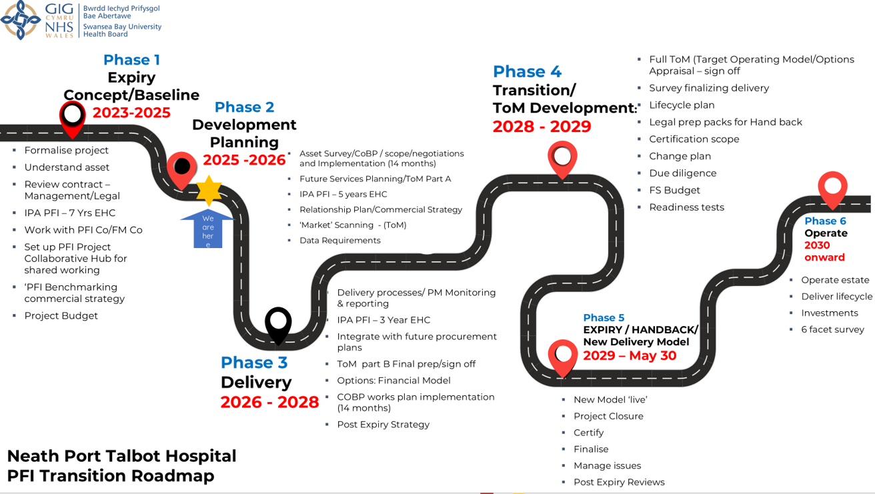

Future Service Options and Team Roles: Four future service options under review include new FM provider procurement, extension with current provider, an in-house 'big bang' model, and a hybrid phased approach aligned with Estates Strategy. The Estates and Capital Team leads design, feasibility, and alignment with Health Board strategies. The PFI Expiry Team coordinates collaborative efforts and provides contact information for inquiries.

Key Steps for a Successful Exit: -

- Governance & Resourcing: Treat expiry as a major project, not business as usual. Assign a Senior Responsible Officer and ensure adequate financial and human resource.
- Asset Condition & Surveys: Understand lifecycle obligations and conduct condition surveys well before expiry to avoid disputes.
- Legal & Commercial Strategy: Review contract terms for hand back requirements, TUPE for FM staff, and settlement agreements. Early engagement with legal advisors is critical.
- Financial Implications: Loss of ring-fenced funding post-expiry means liabilities for maintenance and operation revert to the authority. Budget planning and options appraisal are essential.

Risks & Challenges:
- Assets may return in poor condition, leading to costly remediation.
- Service continuity risks if transition plans are weak.
- Potential disputes over lifecycle investment and asset standards.

A dedicated PFI Hand back team is in place and the Health Board is progressing in line with advice. The Board may benefit from more comprehensive updates at future development sessions given the complexity of the work required.

Estates Staffing and Modernisation
Performance and Finance Committee has recently been appraised of the challenges of developing a sustainable workforce model in estates to meet the need. This work is being progressed but with recruitment and retention challenging, actions are progressing on risk prioritisation basis.
Current Mitigation: focus on risk management and prioritisation alongside more integrated working with capital planning to address core issues as highlighted in the mitigations set out above.
Future mitigation: Organisational Change Policy to reconfigure and resource department to meet SBUHB needs.

- FINANCIAL IMPLICATIONS

Running Costs of Estate
The 2025/26 budgeted running costs for the main sites are summarised in the table below. The contracts costs for the NPT PFI site include payment of the unitary charge.
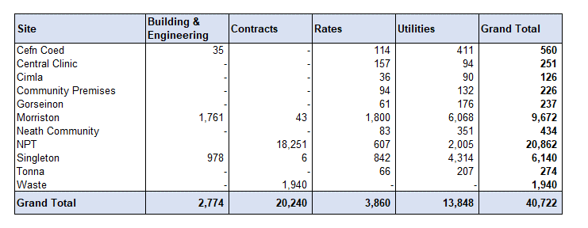

Backlog Maintenance Investment
Following approval of The Strategy in May 2023, SBUHB has been successful in accessing £10.5m additional capital funding in 2023/24 and 2024/25 through national funding streams for backlog maintenance, including the former Estates Funding Advisory Board (EFAB). For 2025/26 and 2026/27 an additional £16.524m (includes a 30% discretionary funding contribution) has been approved through the national Targeted Estates Fund (TEF). The table below shows an estimated £38.333m investment into backlog maintenance during this 4-year cycle, which also include general discretionary investment and lifecycle replacement under the PFI contract for NPT hospital.

The investments over the last 2 years from EFAB include: -

- Fire alarm replacement, Morriston £1.921m
- Ward roofing and flooring, Morriston £1.604m
- Air Handling Unit (AHU) replacements, Morriston £0.787m
- Fire doors & compartmentation, Morriston & Singleton £0.792m
- Calorifier replacement, Singleton £0.482m
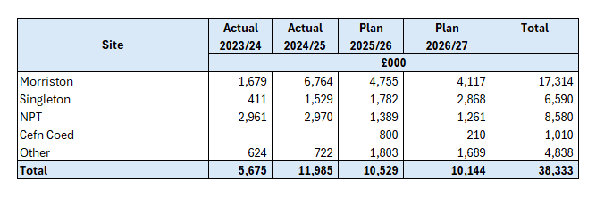

The approved £16.524m TEF funding is split across categories and includes investments for: -

- Roofing and flooring, Morriston £1.5m
- Chiller & heating plant, West Ward block, Singleton £2m
- Infection Prevention Control (IPC) improvements, Morriston & Singleton £1.150m
- Fendrod & Clyne ward improvements, Cefn Coed £1m
- Bathroom and kitchen upgrades, Learning Disability Bungalows £0.220m
- Roof repairs, Mother & Baby unit, Tonna £0.300m
- Window replacements, Morriston & Singleton £0.850m
- Fire doors & compartmentation, Morriston & Singleton £0.800m
- Oxygen ring main, Morriston £0.950m
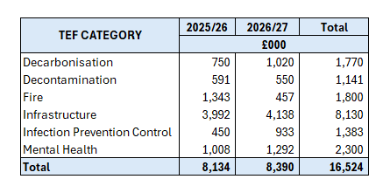
The highest priority area identified from the 2022 6-facet survey was the roof repairs required over the original nucleus template at Morriston. All wards, ICU and some theatres require full decants due to the design of the roof space above meaning it would be unsafe to carry out work whilst these areas were in use. Some theatres and the canteen roof can have work undertaken without major decants as the roof was constructed with a slab underneath. The replacement of the tiles commenced in 2023/24 utilising the decant ward made available on Angelsey. As Angelsey is no longer available as a decant whilst the UEC test of change remains in place, roofing work has shifted over to the canteen. Work has already been completed on 9 wards (G, H, J, M, R, S, T, V & PAU) and work on the canteen is expected to be complete by the end of this financial year. This will leave 3 wards areas (Pembroke, Oakwood and ICU to be completed along with other areas such as theatres. Around 45% of the template is scheduled to have been completed by the end of this financial year. Although TEF funding of £750k is available in 2026/27, most of the remaining areas will require decant facilities to be identified.

There is also a rolling programme to upgrade/replace Air Handling Units (AHU), with replacement already completed in Singleton, covering Theatres 1 – 6, including recovery. Replacement of AHU’s in Morriston will commence in Q4 2025/26 covering theatres 11 & 12. There are ongoing operational discussion for further replacement in the coming years to minimise the impact on theatre activity. In conjunction with AHU works the HB are coordinating replacement of the roof in these areas where safe to do so as this will minimise potential disruption to services if the roof cannot be replaced without closing the theatres.

10 Year Capital Programme – Major Capital Projects
The Strategy approved by the Board in 2023, identified the need for significant capital investment to support the CSP and a programme of backlog maintenance works identified by Condition Surveys. Following feedback on the All-Wales NHS Capital Prioritisation in January 2025, a new Estates Task Force was established under the leadership of the vice-chair, to provide the Board with strategic oversight of the implementation. Whilst the main elements of the prioritised 10-year plan remain intact, the Task Force recommended an urgent focus on four schemes which will require urgent short-term capital funding support from WG (in addition to long term strategic support) to ensure Operational Resilience and Safety & Clinical Suitability: -

- Adult Acute Mental Health Unit Cefn Coed
- ED Morriston
- Regional Cellular Pathology
- Taith Older Persons Ward, Glanrhyd (Fire)

There have been new capital allocations provided by Welsh Government and several business cases have been completed and submitted to Welsh Government for approval, where business case fee funding was already in place. Active business cases are summarised below and a detailed 10-year capital programme shown in Appendix D.

Figure 11 – Project Updates (2 tables)
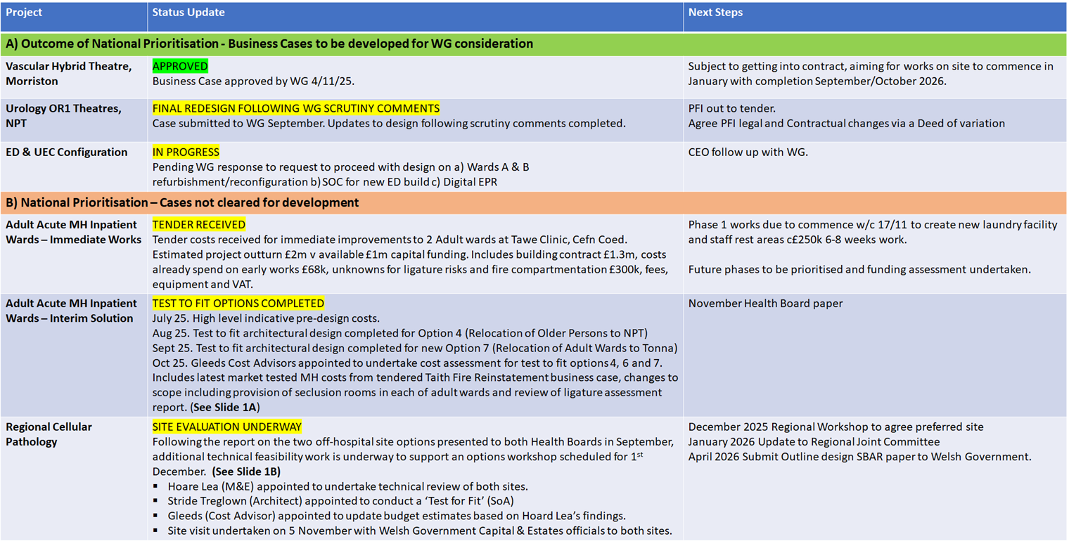

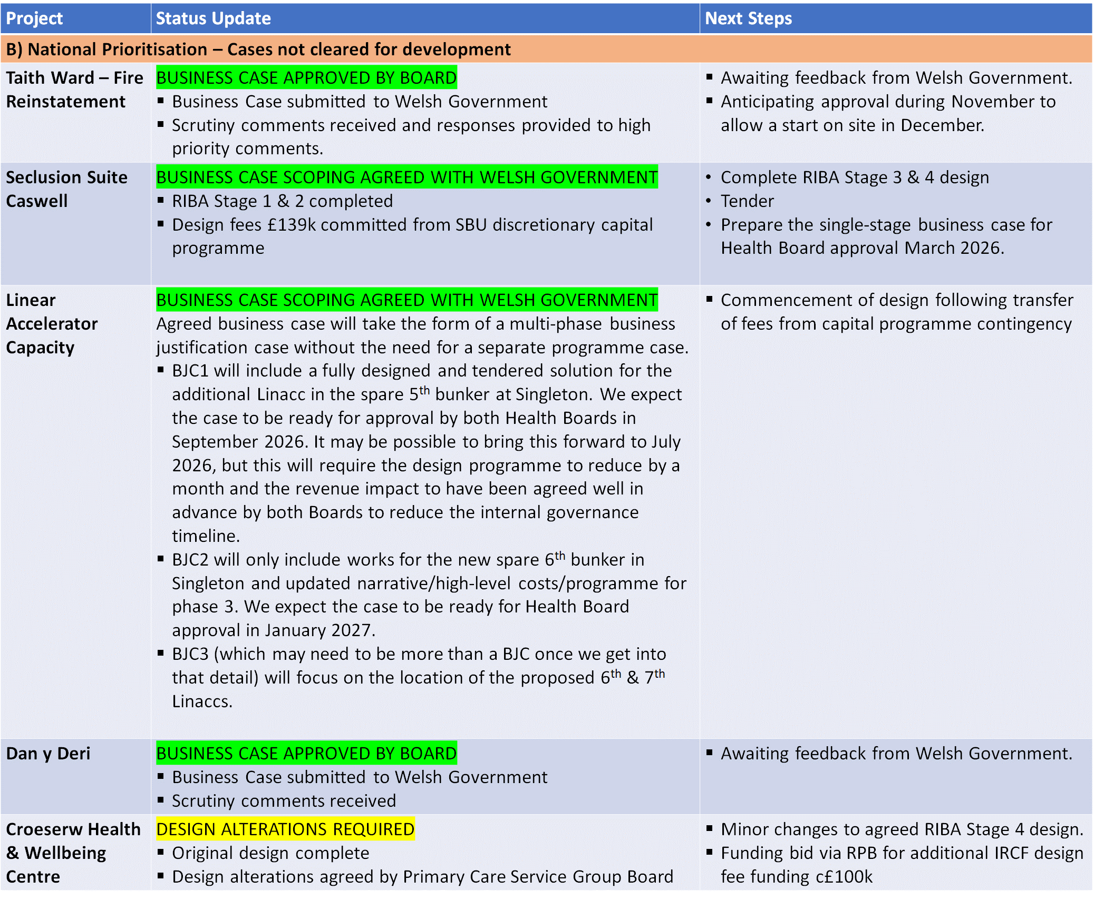

Land & Property Disposals
A number of disposals have been completed since 2023: -

- Morriston Hospital Land. Disposal of Plot D2 and purchase of Plot E August 2025 £510k receipts.
- Phillips Parade, Swansea, March 2025 £275k receipts.
- Cymmer Health Centre, March 2024 £175k receipts.

Engagement with Welsh Government on the potential of residential development opportunities took place with the Cabinet Secretary for Housing in June, with a follow up meeting scheduled in December with Welsh Government officials.

There are a number of disposal options summarised below, with further details included in Appendix D.

Figure 12: Disposal RAG Status
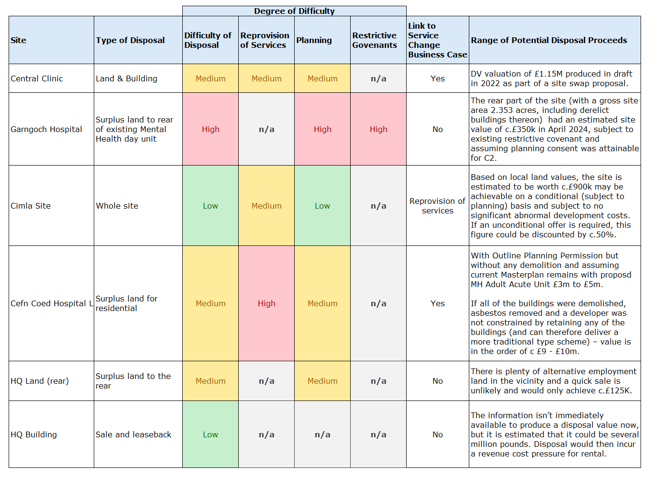

It is important to note that all the potential disposals above are based on estates assessments and are neither firm plans nor definitive in nature at this stage.

Alternative Financing Models
There are limited active alternative funding routes available for any of the substantial capital investments included in the prioritised 10-year plan. Whilst very early discussions have taken place with WG on accessing MIM (Mutual Investment Model), given the current financial climate the market for these alternative financing models is now less attractive to commercial investors, with significant issues around affordability linked to high interest rates.
The focus should now be on continuing to access alternative funding streams that are open to the Health Board. These include: -

- Targeted Estates Funding (TEF) beyond current 2-year funding 2024-25 & 2025-26 This is an area on which SBUHB should focus for its major backlog maintenance programme and to take forward the model ward proposals in Morriston. The provision of decant facilities will be crucial to undertaking works within wards and theatres. Work has commenced on identifying the next tranche of priorities for the expected next funding round for 2026-27 and 2027-28.
- Regional HCF (Housing with Care Fund) and IRCF (Integrated Rebalancing Capital Fund). SBUHB is in active discussions with the West Glamorgan Regional Partnership Board on accessing these funds for several Primary Care and Learning Disabilities projects. Design fee funding has been provided for two projects at design stage: provision of a new Learning Disabilities facility at Dan-Deri (HCF), Swansea and the replacement for Cymmer Health Centre at Croeserw (IRCF).
- Leasing. Although the revenue position continues to be under pressure, it is possible to consider leasing solutions for properties and equipment where robust business cases are provided, and sustainable financial models are evidenced.
- Commercial Partnerships. These could include further work with Swansea University through the City Deal, Local Authorities and other commercial partners such as through the Carbon Reduction Refit Cymru. The secondary funding agreement signed in 2023 between the Health Board and Swansea University as part of the City Deal Campuses Business Case provided capital funding of £960k which allowed completion of the Morriston Access Route design and submission of the Hybrid Planning Application to Swansea Local Authority in July 2025.

There is also a need to develop a clear supportive Long Term Financial Model for the revenue support needed for the Clinical Service plan and the Estates Strategy. This would be a plan set out across the 10 years of the Strategy.

- RECOMMENDATIONS
- Members are asked to:
- DISCUSS the detailed content of this report
- ACKNOWLEGDE the extensive information available to inform prioritisation to inform decision making
- ACKNOWLEDGE the importance of clear interface between estates assessments and the Clinical Services Plan
- DISCUSS and AGREE timeframes for updates and the process to give assurance on actions
- ACKNOWLEDGE the risks and mitigations currently being managed across the estate
- ACKNOWLEDGE the need for decant space to create room for maintenance work and developments
- CONFIRM the modernisation of the estates workforce to increase recruitment and retention to meet the needs of the Health Board
- ENDORSE the work in progress to develop options for future funding models to potentially accelerate capital development work
Governance and Assurance
Link to Enabling Objectives  (please choose) | Supporting better health and wellbeing by actively promoting and empowering people to live well in resilient communities
Link to Enabling Objectives  (please choose) | Partnerships for Improving Health and Wellbeing |  | ☐
Link to Enabling Objectives  (please choose) | Co-Production and Health Literacy |  | ☐
Link to Enabling Objectives  (please choose) | Digitally Enabled Health and Wellbeing |  | ☐
Link to Enabling Objectives  (please choose) | Deliver better care through excellent health and care services achieving the outcomes that matter most to people
Link to Enabling Objectives  (please choose) | Best Value Outcomes and High Quality Care |  | ☒
Link to Enabling Objectives  (please choose) | Partnerships for Care |  | ☐
Link to Enabling Objectives  (please choose) | Excellent Staff |  | ☐
Link to Enabling Objectives  (please choose) | Digitally Enabled Care |  | ☐
Link to Enabling Objectives  (please choose) | Outstanding Research, Innovation, Education and Learning |  | ☐
Health and Care Standards
(please choose) | Staying Healthy |  | ☐
(please choose) | Safe Care |  | ☐
(please choose) | Effective Care |  | ☐
(please choose) | Dignified Care |  | ☐
(please choose) | Timely Care |  | ☐
(please choose) | Individual Care |  | ☐
(please choose) | Staff and Resources |  | ☒
Quality, Safety and Patient Experience
Engineering systems within the two main acute sites have a direct impact on the experience patients, visitors and staff alike. As engineering services are past their normal lifecycle their reliability is adversely affected which has a direct impact on the delivery of services.

Financial Implications
A high level 10-year capital investment plan has been produced. The plans include projects that will reduce the level of the backlog maintenance identified in the recent 6 facet survey. Projects will require business cases to show the impact on both capital and revenue investment.

Legal Implications (including equality and diversity assessment)
None
Staffing Implications
None

Long Term Implications (including the impact of the Well-being of Future Generations (Wales) Act 2015)
If the Health Board do not address the condition of the engineering services within the Estate, there is increased likelihood that we could have system failures that adversely affect the provision of clinical services.

Report History |  | Board Estates Strategy Task & Finish Group (February to May 2023).
Appendices |  | Appendix A: Estate Portfolio  Appendix B: TEF 2025/26 to 2026/27  Appendix C: 10 Year Capital Programme (Major Projects)  Appendix D: Land & Property Disposals

Appendix A - Understanding the baseline estate
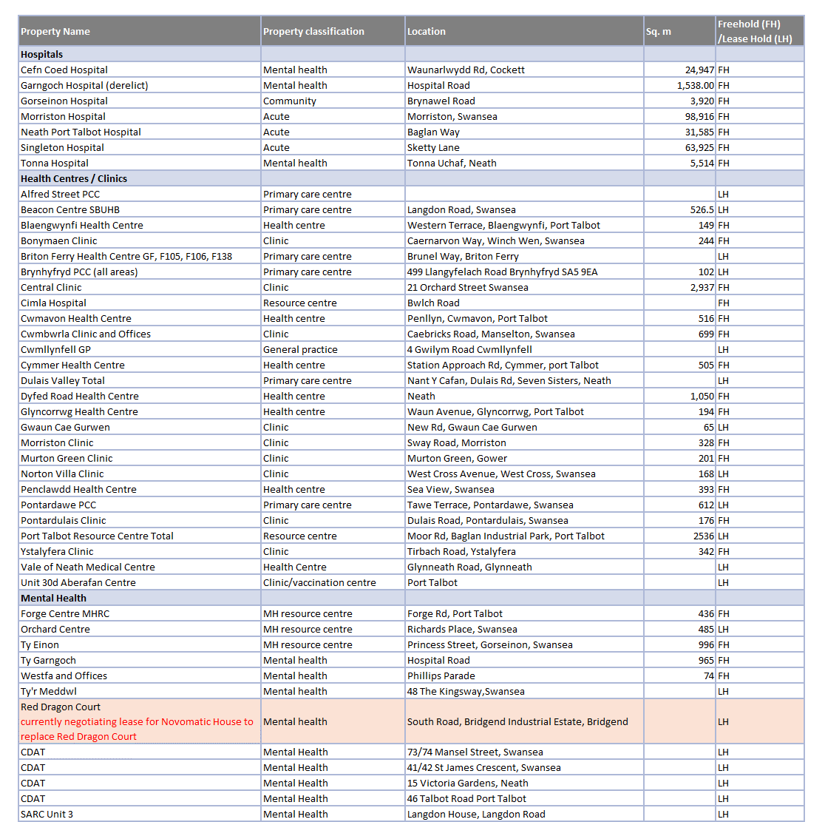

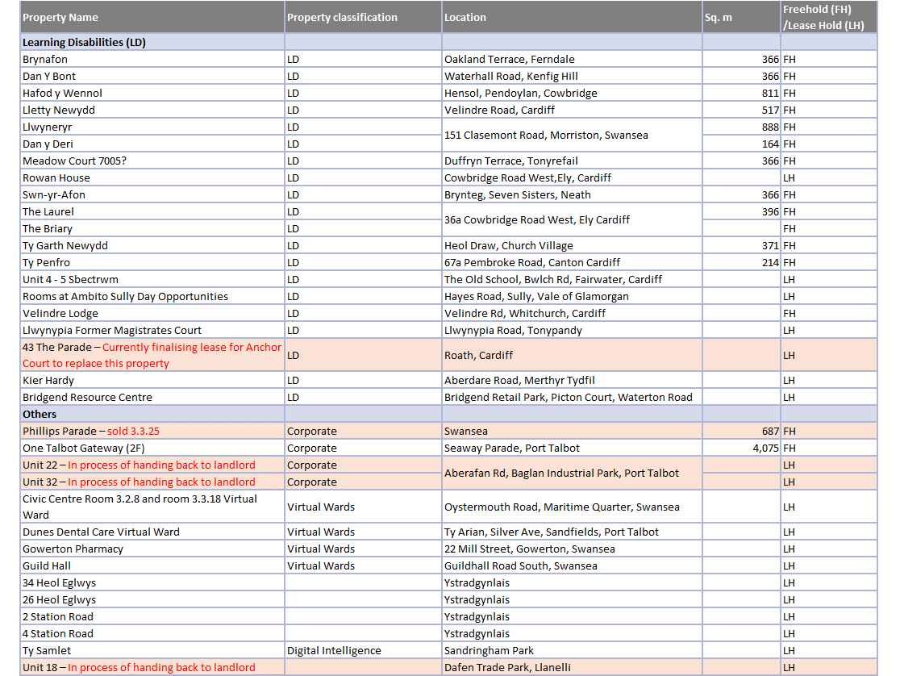

Appendix B – TEF 2025/26 to 2026/27
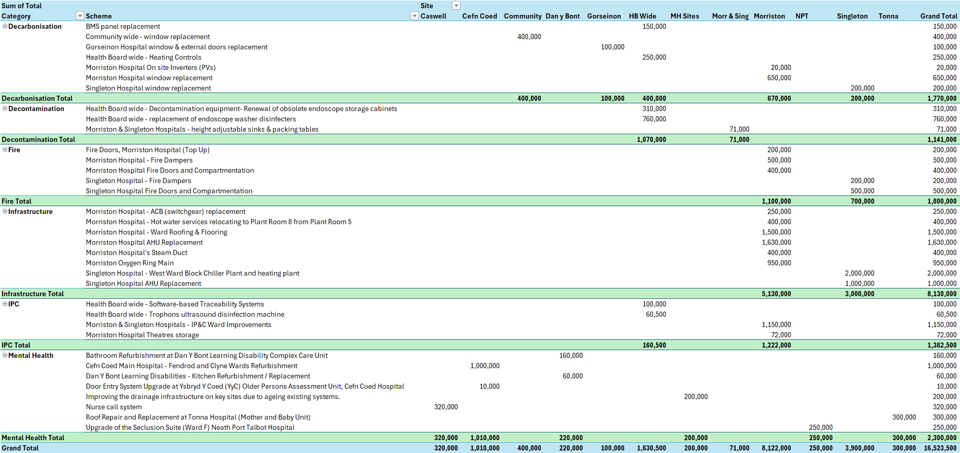
Appendix C - 10 Year Capital Programme (Major Projects)
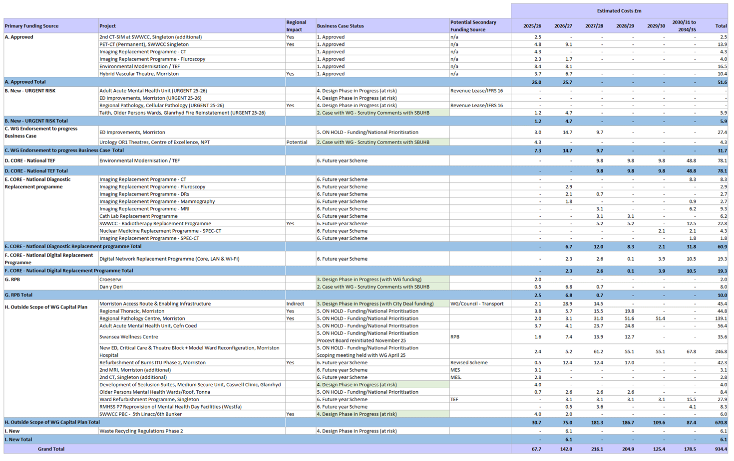

Appendix D – Land & Property Disposals
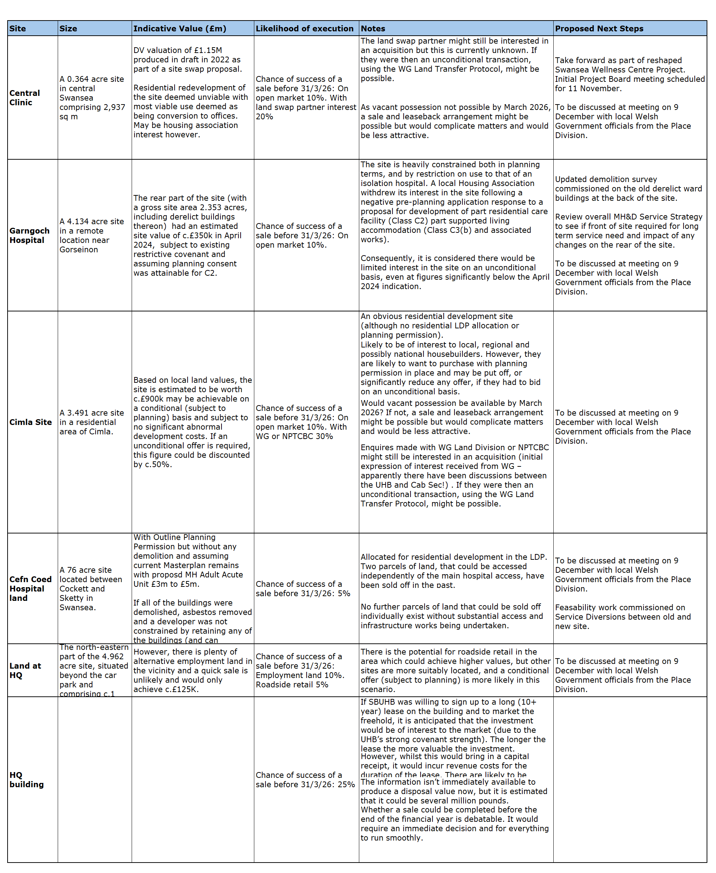

Emergency Preparedness Resilience and Response
Power is switched off to test all generators and to confirm what is on essential, as well as any failures that need to be addressed.
HV High Voltage
High Voltage

