Meeting Date | 31 July 2025 |  | Agenda Item |  |  | 4.4
Name of Meeting | Health Board Finance Report
Report Title | Financial Report – Month 3 2025/26
Report Author | Samantha Moss, Deputy Director of Finance  Gemma Pearson, Finance Business Partner  Crystal Davies, Principal Finance Manager
Report Sponsor | Darren Griffiths, Executive Director of Finance and Performance
Presented by | Darren Griffiths, Executive Director of Finance and Performance
Freedom of Information | Open
Purpose of the Report | The report advises the Board of the Health Board on the financial position for Month 3 2025/26 (June 2025) and risks regarding the current forecast revenue year end outturn.
Key Issues | The report invites the Board to note the detailed analysis of the financial position for Month 3 2025/26 (June 2025).  The report includes a summary of the key drivers of the revenue position either at Service level or by expenditure type (i.e. Non-Pay/Pay).  Risk will have been considered on the basis of the information provided within the report and the score updated where necessary.  The report invites the Board to note the Cash position, key Balance Sheet movements and the Capital position.  Whilst the key messages are provided within the main body of the report, further information is provided in the Appendices.
Specific Action Required  (please choose one only) | Information | Discussion |  | Assurance | Approval
Specific Action Required  (please choose one only) | ☐ | ☐ |  | ☒ | ☐
Recommendations | Members are asked to:  - ACKNOWLEDGE the 2025/26 Financial Plan, and the Health Board’s and Welsh Government’s inability to approve it given the planned deficit of £58.7m.  - CONSIDER the key messages and required actions regard to Welsh Government and the expectation that the Health Board will deliver a £42.5m deficit in 2025/26 in line with the 2024/25 Outturn.  - Consider and comment upon the Health Board’s financial performance for Month 3 2025/26.  - DISCUSS the risks to the position at Month 3.  - SUPPORT all actions and updates to support the management of the 2025/26 financial position.

FINANCIAL REPORT – MONTH 3 2025/26

- INTRODUCTION
The report invites the Board to note the detailed analysis of the Month 3 (June 2025) revenue financial position, along with Cash and Capital.

- BACKGROUND

The Health Board has two key statutory duties to achieve:

- To submit an Integrated Medium-Term Plan (IMTP) to secure compliance with breakeven over 3 years.
2023/24 3-year plan submitted
2024/25 3-year plan submitted
2025/26 3-year plan submitted
The Health Board will fail to meet this in 2025/26 as its plan will not breakeven over 3 years.

- To achieve financial breakeven over a rolling three-year period, which commenced on 1st April 2023 and will end on 31st March 2026.
2023/24 Deficit Control Total £17.1m achieved
2024/25 Deficit Control Total £43.7m achieved
2025/26 Deficit Plan £58.7m
The Health Board will fail to achieve this Statutory Duty.

Summary of Performance against Key Financial Targets

Financial KPIs: To ensure that net operating costs do not exceed the revenue resource limit set by Welsh Government | Value  £’000
Reported in-month financial position – deficit/(surplus) | 7.123
Reported cumulative financial position – deficit/(surplus) | 24.167
Capital KPIs: To ensure that costs do not exceed the capital resource limit set by Welsh Government | Value  £’000
Reported year to date financial position – deficit/(surplus) | 0.448
Forecast outturn financial position – deficit/(surplus) (prior to additional allocations) | 1.083
PSPP Target: To pay a minimum of 95% of all non NHS creditors within 30 days of receipt of goods or a valid invoice | Value  %
Cumulative year to date % of invoices paid within 30 days (by number) – Month 3 | 95.68%

- FINANCIAL PLAN
The Annual Plan submitted to Welsh Government on 31st March 2025 included a financial assessment, as summarised in the table below:

Welsh Government issued a letter to the Health Board on 6 June 2025 indicating that the planning process has been closed in order to focus on delivery and improvement. The letter sets out an expectation that the Health Board will deliver a £42.5m deficit in 2025/26 in line with the 2024/25 Outturn. Detailed action plans for the delivery of the planned level were submitted to Welsh Government on 30 June 2025. At Month 3 the forecast remained as per the planned submission of £58.7m.

Following the 30th June submission Welsh Government has subsequently requested two further submissions:

  - Set out by this Friday, 18th July, the detailed actions being taken to give full confidence in the delivery of the current forecast position.
  - Set out by Friday 31st July, the detailed operational, service, workforce, actions that could be taken to achieve last year’s outturn position and associated impacts.
Detailed updates will be provided to the Performance & Finance Committee and a summary of the actions included within future Board reports.

- FINANCIAL PERFORMANCE

TARGET | ACTUAL PERFORMANCE
Cash Balance Bank < £6.0m | £3.416
In Month Revenue Resource Limit < £58.7m Full Year = £4.89m Per Month | £7.123
YTD Revenue Resource Limit < £58.7m Full Year = £4.89m YTD | £24.167
In Month Capital Resource Limit < £0m | £0.448
YTD Public Sector Payment Policy > 95% | 95.68%

FINANCIAL REPORT REVENUE – MONTH 3.

The Health Board’s actual performance against the three components of the Plan (Operational Pressure, Savings Target, and Planned Deficit) for 2025/26 is provided in the table below. This table shows that in Month 3 the reported deficit was £7.123m, which is £2.23m above the £58.7m planned deficit. The YTD position reports a £24.167m deficit, which is £9.48m above £58.7m plan. The key driver of the YTD £9.48m deficit over the current plan is the non-delivery of savings. This shortfall was partly mitigated in Month 3 by non-recurrent in-month benefits for the Primary Care Service Group, a further underspend in the Corporate Directorates and the application of 10/12th of £2.7m non-recurrent opportunities.

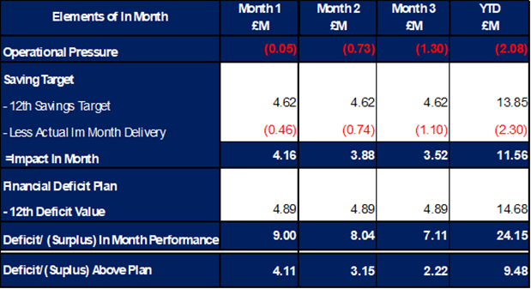

Graph 1 below reflects the actual delivery in each month, with the orange bars reflecting the performance requirements to achieve the original plan of £58.7m. Graph 2 outlines the savings delivered to date as the blue bars against monthly target set (red line), and the orange bars reflect the level of savings required in future months to achieve the £55.4m target aligned to the £58.7m plan.

Graph 1: Performance Graph 2: Savings
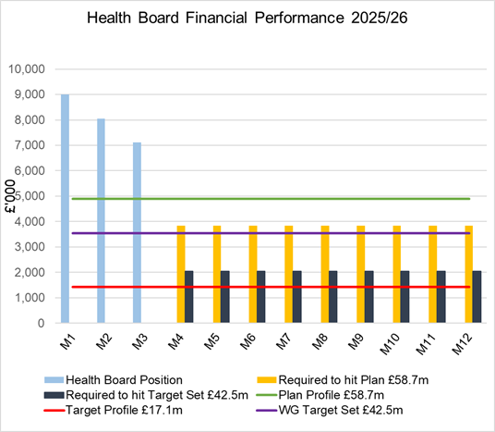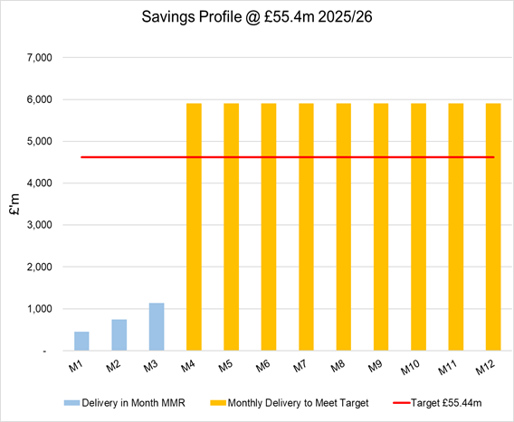

As per the above Graphs, if the Health Board is to achieve the £58.7m plan it will need to recover the £9.5m during 2025/26 by delivering more savings in future months resulting in a lower variance for Month 4-12.

Throughout Quarter 1, the key risks for delivery of 2025/26 plan has remained savings. As seen in the YTD performance, savings have not been identified or delivered at the required pace. The savings position at Month 3 identified plans totalling £19.5m of savings (including £10.3m of Red schemes) and whilst Recovery & Sustainability Board continues to scrutinise delivery of these, there is a significant increase required to deliver the plan. In addition, as per the Welsh Government letter from 6th June the requirement increased further by £16.2m if the Health Board was to reach the £42.5m deficit, taking the total savings to £71.6m.

The work of the external support will commence on the 14 July 2025 and will focus on the improved delivery of savings, alongside the other Recovery Actions included with the Financial Assessment to Welsh Government on 30th June. Updates on progress will be presented to the Health Board through July and August.

The key drivers of the Month 3 position are summarised in the tables below. Further detail at a Health Board level of expenditure on Income, Pay and Non-Pay, is also provided in Appendix 1.

  - Key Drivers by Service Area In-Month

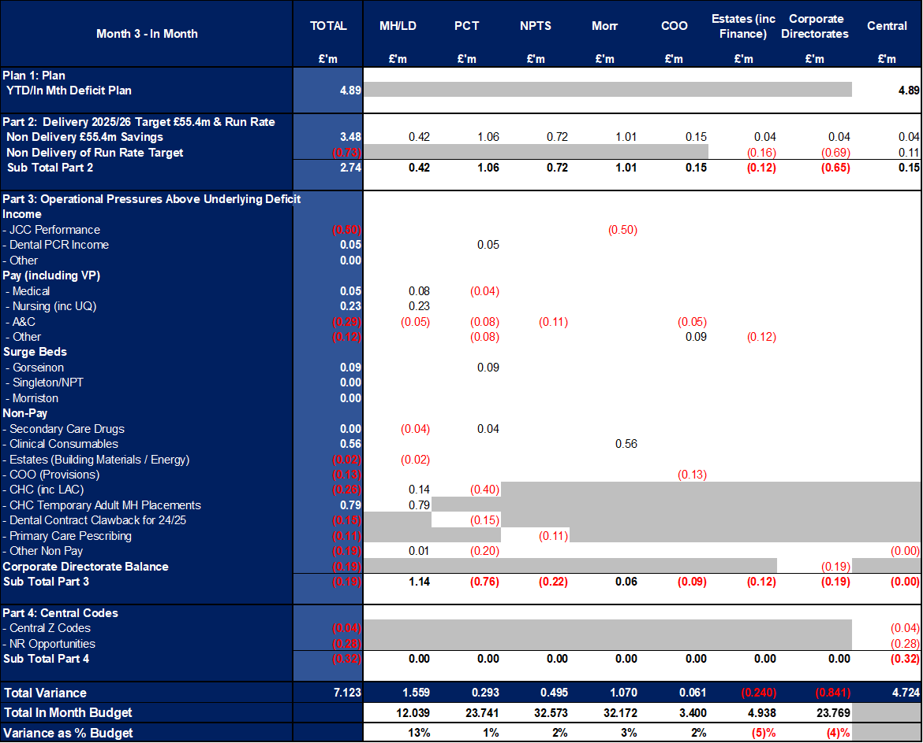

  - Key Drivers by Service Area YTD

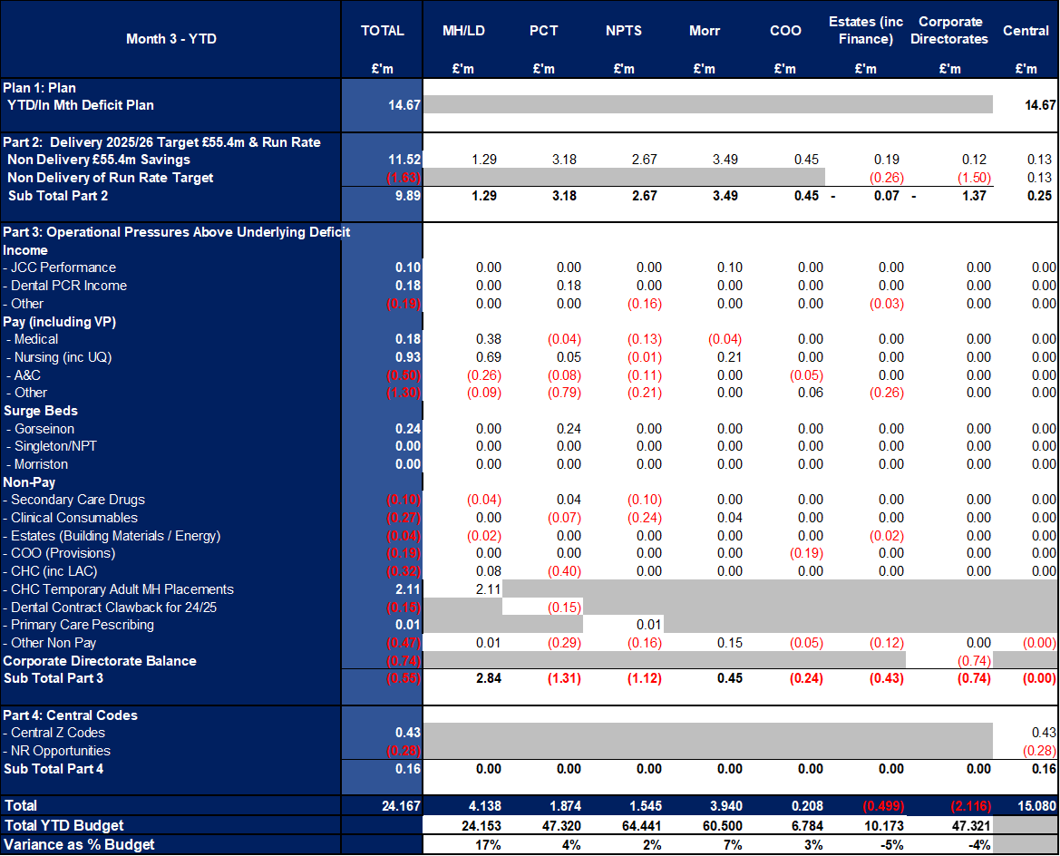

  - Summary By Expenditure Type

- Income
The Joint Commissioning Committee (JCC) Income as a provider over-performed by £0.5m in month (£0.1m YTD) and this is driven by increased activity in high tariff areas, particularly TAVI & Cardiology).

Dental Contract Income underperformed in-month by £0.051m (YTD £0.2m).

- Pay
Month 3 Pay was slightly lower in-month, with vacancies primarily in Admin & Clerical driven by the Vacancy Freeze, predominately within the Corporate Directorates.
- Clinical Consumables
(see Appendix 1)

- Prescribing
(see Appendix 1)

- KEY AREAS OF NOTE

  - Savings
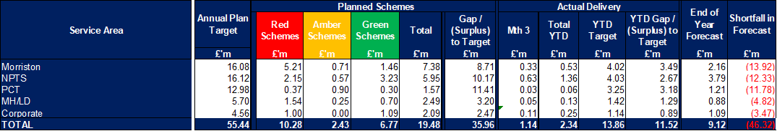

The above table reflects performance In Month and YTD, which clearly shows the shortfall delivery YTD. The forecast column of £9.12m reflects the Green and Amber savings as per the Savings Trackers at 4th July. There is a further £10.3m of planned Red/Pipeline Opportunities the Health Board is working to achieve.

Further details on savings, including the red schemes are provided in Appendix 2.

  - Capital
The approved Capital Resource Limit (CRL) value issued on 26th June is £39.146m. The approved CRL value includes Discretionary Capital, schemes under the All-Wales Capital Programme and new/renewal IFRS 16 Leases.

Outturn Performance

The forecast outturn shows an overspend position of £1.083m. Allocations are anticipated on the following schemes, which will provide a balanced position.

Scheme | £m | Narrative
City Deal – Morriston Access Road Design | 0.151 | Funding approved.
Business Case Fees -  Hybrid Theatre, Morriston | 0.449 | Business case fees incurred for schemes included in the Health Board 10 year capital programme/national prioritisation.
Business Case Fees – Urology NPT | 0.276 | Business case fees incurred for schemes included in the Health Board 10 year capital programme/national prioritisation.
Business Case Fees – Taith Newydd Fire | 0.206 | Business case fees incurred for schemes included in the Health Board 10 year capital programme/national prioritisation.

The following allocations are classed as risks.

Scheme | £m / Risk Level | Narrative
Positron Emission Tomography (PET) Service, Singleton Hospital | 4.000 / Medium | In line with our month 2 MMR disclosure, on 25th June 2025, following our initial risk assessment, the HB confirmed a return of £5.6m funding to WG which is to be re-provided in our 2026/27 CRL.  The HB also informed WG of a second risk assessment being undertaken, which we aim to confirm in August following scrutiny of cost and activity schedules by our cost advisor. The current estimate being a further return of £2m to £4m for 2026/27 reprovision.  Works are due to start in September 2025 on a 13 month programme to October 2026.

All other schemes are low risk and any variances are linked to planned contributions from discretionary and in some instances payback of prior year fees.
Capital Disposals

There are two planned property disposals of Garngoch and Morriston Land with combined expected sale proceeds of £0.800m.

  - Balance Sheet
The key issues in respect of the statement of financial position movements are as follows:
- The inventory value has decreased from £12.886m at the end of March 2025 to £11.475m at the end of June 2025, a decrease of £1.411m. The increase mainly relates to drugs stocks across all hospital sites.

- There has been a decrease in trade receivables from £251.118m at the end of March 2025 to £233.533m at the end of June 2025, a decrease of £17.585m. The reduction relates to WRP (Welsh Risk Pool) debtors of £19.028m, with other movements relating to an increase in WGA (Whole of Government Accounts) Debtors of £1.055m.

- The closing June 2025 cash balance of £3.604m is close to the Health Board target of a cash balance of £2.5m at month end and the best practice cash target for the Health Board of £6m.

- The trade and other payables figure saw a reduction from £281.199m at the end of March 2025 to £262.673m at the end of June 2025, a reduction of £18.526m. This comprises a reduction in Accruals and RBNI (receipted but not invoiced), and NHS creditors. There were increases in Capital creditors and NHS accruals.

- Provisions decreased by £12.286m from £197.627m at the end of March 2025 to £185.341m at the end of June 2025. The majority of the decrease in provision related to Clinical Negligence, due to just over £5.5m being paid out in claims, and £6.2m transferred from provisions to creditors, in readiness for payment. The quantum’s received are now being reflected in the financial ledger on a monthly basis, rather than quarterly. This will create a more regular movement for both the Trade Receivables (WRP Debtors) and the Provision figures.

  - Cash
As at the end of June 2025, the Health Board had a cash balance of £3.416m, which is between the Health Board target of a cash balance of £2.5m at month end and less than the best practice cash target for the Health Board of £6m.
The cash movements during June 2025 were:
The difference between the £94.566m forecast cash deficit and the Forecast I&E deficit Cash figure, reflects the £6.532m of capital cash to reimburse revenue CRL, and the movement in the working capital balances.

With regards to the £6.532m of revenue cash to be reimbursed to capital. Due to Revenue and Capital cash not being split (in cash terms), where there is a situation that Capital draws down more cash than it pays out within the financial year, it triggers a notional reimbursement between Revenue and Capital. The £6.532m is a cumulative figure from prior years.
We have included the working balances cash requirements in the table above, and the closing cashflow balance as of 31 March 2025 includes that value as potential cash support required in 2025/26. At this point in the financial year, this is based upon the information we available at this point and is liable to change.
The cash flow is updated daily, and a full review of the cash forecast is currently being undertaken monthly, to ensure that any changes to our cash requirements, can be communicated in a timely manner to WG.
  - Public Sector Payment Policy (PSPP)
The Health Board achieved the 95% PSPP target the % of Non-NHS Invoices Paid within 30 Days in Quarter 1 with compliance being 95.7% for the quarter.
NHS payment compliance for invoices paid within 30 days was, however, slightly below 95% with the quarterly performance being 92.3%. The Health Board remains focussed on improving PSPP compliance for NHS invoices and ensuring that performance remains above 95% for non-NHS invoices.

- GOVERNANCE AND RISK ISSUES
Two Board level financial risks:

- Achieving financial plan (HBR92) with the key elements as follows: -
  - Risk of delivery of savings quantum
  - Risk of operational overspend being in excess of funding available agreed via the Financial Plan
  - Risk of commitment of reserves (e.g. NICE) being above reserves available.
  - Risk of achieving the actions and options outlined in the 2025/26 Financial Recovery & Sustainability Assessment.

Based on the financial performance at Month 3 and the shortfall in the identification of the savings required to deliver the deficit plan, it is recommended that the Health Board Corporate Risk Register reflects a risk score of 25.

Schedule of the Risks incorporated within the Financial Assessment submitted to Welsh Government on 30th June, updated for known changes is provided in the table below:

- Availability of capital (HBR93). This risk was re-opened in 2022/23 given the reduction in discretionary capital allocation. Due to the additional capital funding provided during 2024/25 the risk score was reduced to 12.

At the start of 2025/26, whilst there has been a 24% increase in discretionary capital, the outcome of the national prioritisation and interim solutions required for high risks projects included the Emergency Department and Adult Acute Mental Health, the assessment is that at this point in the year the risk score needs to increase to 20.

- RECOMMENDATIONS
Members are asked to:
- ACKNOWLEDGE the 2025/26 Financial Plan, and the Health Board’s and Welsh Government’s inability to approve it given the planned deficit of £58.7m.
- CONSIDER the key messages and required actions regard to Welsh Government and the expectation that the Health Board will deliver a £42.5m deficit in 2025/26 in line with the 2024/25 Outturn.
- Consider and comment upon the Health Board’s financial performance for Month 3 2025/26.
- DISCUSS the risks to the position at Month 3.
- SUPPORT all actions and updates to support the management of the 2025/26 financial position.

Governance and Assurance

Link to Enabling Objectives  (please choose) | Supporting better health and wellbeing by actively promoting and empowering people to live well in resilient communities
Link to Enabling Objectives  (please choose) | Partnerships for Improving Health and Wellbeing |  | ☐
Link to Enabling Objectives  (please choose) | Co-Production and Health Literacy |  | ☐
Link to Enabling Objectives  (please choose) | Digitally Enabled Health and Wellbeing |  | ☐
Link to Enabling Objectives  (please choose) | Deliver better care through excellent health and care services achieving the outcomes that matter most to people
Link to Enabling Objectives  (please choose) | Best Value Outcomes and High Quality Care |  | ☐
Link to Enabling Objectives  (please choose) | Partnerships for Care |  | ☐
Link to Enabling Objectives  (please choose) | Excellent Staff |  | ☐
Link to Enabling Objectives  (please choose) | Digitally Enabled Care |  | ☐
Link to Enabling Objectives  (please choose) | Outstanding Research, Innovation, Education and Learning |  | ☐
Health and Care Standards
(please choose) | Staying Healthy |  | ☐
(please choose) | Safe Care |  | ☐
(please choose) | Effective Care |  | ☐
(please choose) | Dignified Care |  | ☐
(please choose) | Timely Care |  | ☐
(please choose) | Individual Care |  | ☐
(please choose) | Staff and Resources |  | ☐
Quality, Safety and Patient Experience
Financial Governance supports quality, safety, and patient experience

Financial Implications
The Board is reporting a forecast year-end deficit financial outturn.

Legal Implications (including equality and diversity assessment)
No implications

Staffing Implications
No implications

Long Term Implications (including the impact of the Well-being of Future Generations (Wales) Act 2015)
No implications

Report History |  | Updates on the financial position are provided at every meeting.
Appendices |  | Appendix 1 – Variances by Area and Type of Spend  Appendix 2 – Savings

APPENDIX 1 – FURTHER DETAIL ON VARIANCES BY AREA & TYPE OF SPEND

- Overview Financial Position

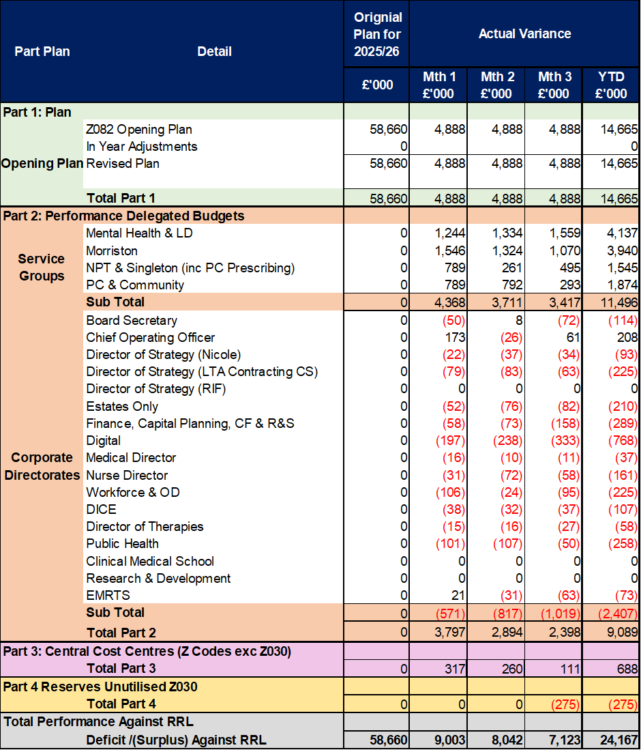

- Overview of Income

The table below compared the income performance in Month 3 to the average levels of 2023/24 and 2024/25.

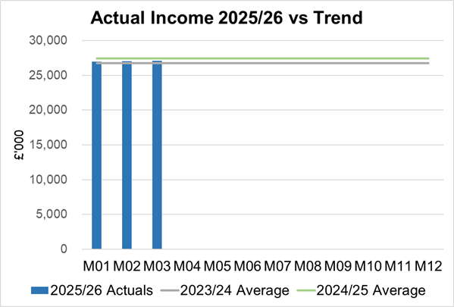

  - Anticipated Income
The below table highlights anticipated income the Health Board expects to receive during 2025/26. The current deficit plan of £58.7m is predicated on receipt of these Welsh Government funds at the levels anticipated. At the point of closing Month 3 the Health Board had not received confirmation of the NI funding. However, it has subsequently been notified of the allocation which is £3.1m less that the assessed cost of the NI changes. This is currently reflected within the Risk table in section 6 of the core report, but will be phased into the financial position from Month 4 onwards.

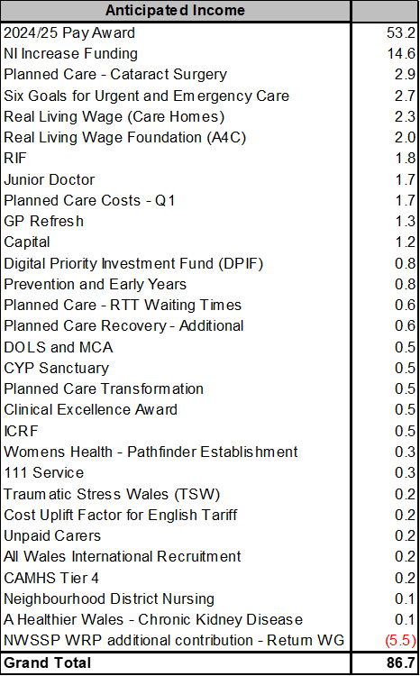

- Pay, Agency & Other Variable Pay Expenditure

Total Pay

The Month 3 total is higher than the prior two years average (as shown in the graph below). However, the Month 3 total is lower than Month 2 (£0.593m reduction), with vacancies primarily in Admin & Clerical driven by the Vacancy Freeze, predominately within the Corporate Directorates.

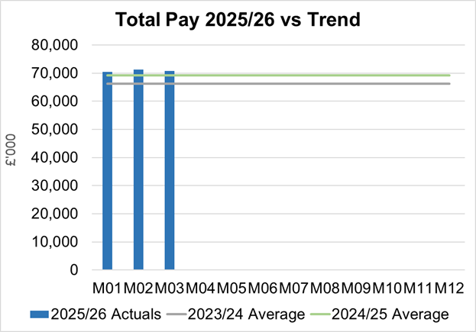
Note - 2023/24 average value has been notional increased by 5% to allow for comparison to 2024/25 and current value of 2025/26 pay value.

Variable Pay
Variable pay is £0.26m lower in Month 3 2025/26 (£5.088m vs £5.347m) when compared to the same period last year (graph below shows this year’s actual versus prior year’s average), it is £0.2m lower than Month 2.
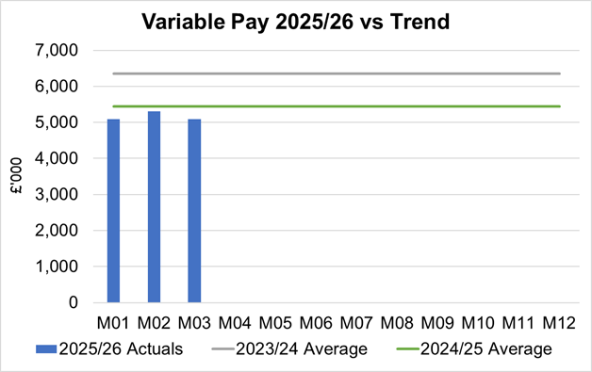

Variable Pay is classified by the Health Board into the following categories: Agency, Bank, Overtime, Waiting List Initiatives (WLI) and Irregular Sessions, a breakdown of the spend into these categorise is provided below.
Variable Pay Spend

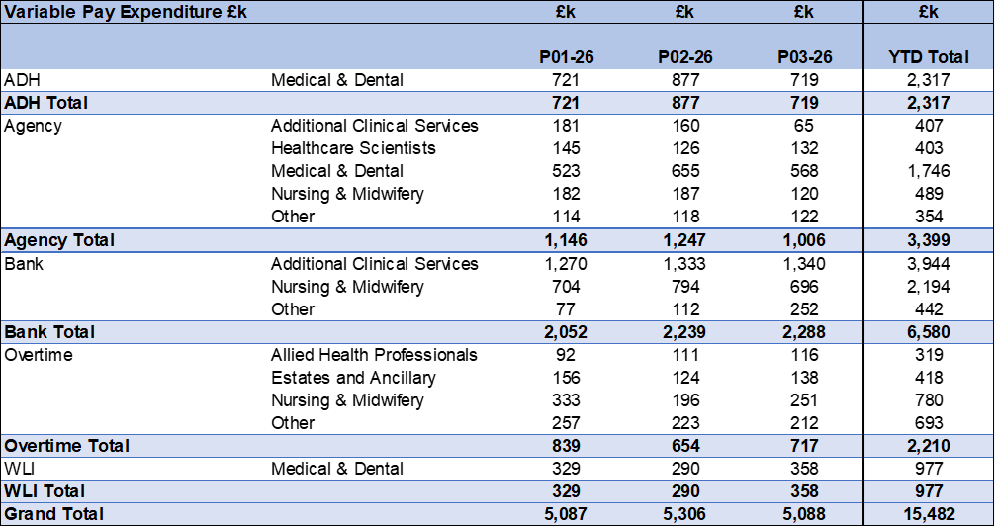

Performance against the Variable Pay Cap agreed as part of 30th June Financial Assessment is summarised in the table below. As the Health Board did not meet this cap in Month 3 the level of the cap will need to reduce further for the remaining months of the Financial Year, if the level of spend reduction is to be achieved.

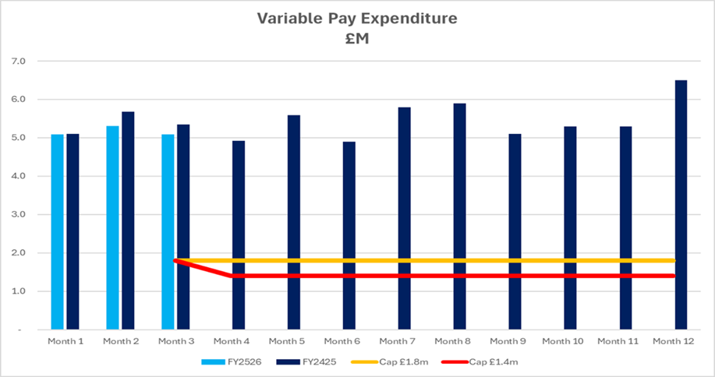

- Overview Non-Pay
Actual Non-Pay spend for Month 3 is higher than the prior two year’s average spend (as shown in the graph below):

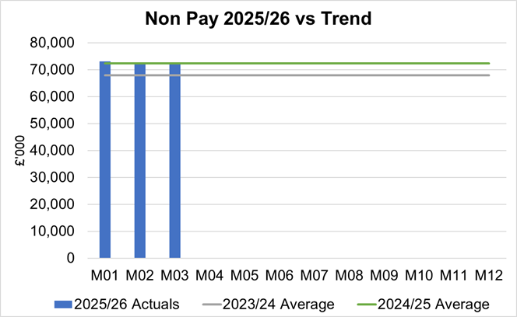

Below are further details on the key areas of non-pay:

  - Clinical Consumables
This area overall has an in-month position of an overspend of £0.4m, partly driven by the increased JCC activity in-month. There are 80+ subjective lines within this category, including secondary care drugs.

  - Primary Care Prescribing
Prescribing is providing a further small underspend in-month resulting in a breakeven position YTD following receipt of the latest datasets (April 2025). It has now been possible to validate the previously Amber scheme in relation to prescribing and YTD delivery has all been recognised in Month 3 (£0.24m in-month).

  - CHC
In Month 3 CHC was overspent by £0.5m (YTD £1.6m) and as per last month is driven by the temporary Adult Mental Health placements with external providers (25 beds in June) due to demand being more than the Health Board’s internal bed capacity. This pressure was partly offset by the Looked After Children position within the PCT Service Group. An analysis of actual expenditure and patient numbers for 2025/26, along with the average values from 2024/25 is provided in table below.

CHC Analysis by Month

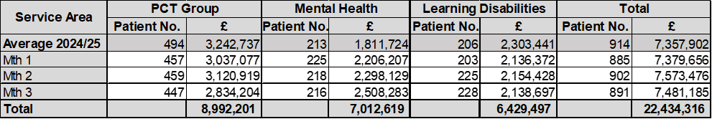
Please note:
- The above numbers include Domiciliary care cases.
- PCT Group does not include the Singleton/NPT element. The NPTS element which covers Children and Young People CHC patients is provided internally by the Health Board and as such is part of the wider NPTS position and is not recorded in the ledger as PCT/MH/LD CHC is recorded.

  - Maternity Review
The total costs for this are allocated to a dedicated Cost Centre (6F34). Total expenditure in Month 3 of 2025/26 is £0.24m.

  - Z Codes (Section 1,3-4 Table Point 1 Appendix 1)
The narrative below groups together the key elements of the Z codes detailed in Point 1 of this appendix.

- Contracting: SLA /LTA performance: JCC (previously WHSSC), LTA and SLA contract income and expenditure are transacted within this area and financial performance reported. NICE approved high-cost drugs and associated LTAs are also transacted and monitored against targets set. In addition to this, non-contracted activity income in relation to English foundation trusts invoiced on a quarterly basis are reported.

- Capital: The Finance Capital Team manage a number of cost centres covering the PFI, IFRS16 and Depreciation charges for assets both owned and donated are transacted here.

- RRL and Central Reserves: The WG funding received at the start of the year is tracked within this area. Any anticipated allocations in year are also transacted through these codes. Other HB wide funding received from HEIW and SIFT is also captured in here. All central reserves remain within the Z cost centres and details of these are provided in Appendix 2.

- Corporate income and expenditure. Any income and expenditure that is not service group specific is transacted and reported through a number of corporate Z cost centres, examples include, payroll and pension costs, VAT recovery, losses and receipts in relation to funding from Welsh Risk Pool, overseas visitors’ income and Road Traffic Accident income.

  - LTA Values & Forecast performance
This will be reported for Month 5, as the quarter 1 data was not available at the time of completing this report.

APPENDIX 2 – SAVINGS

- Summary of Savings Position as at June 2025 (Month 3)

The below table provides a summary of the achievement against the 5% savings target (Green and Amber schemes only).

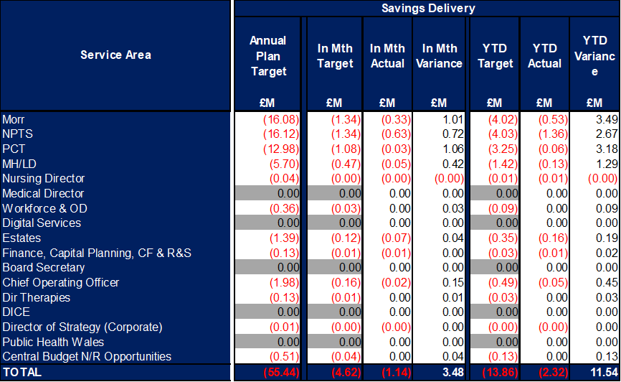

Green and Amber saving schemes acheived in Month 3 were £1.14m, as a result the shortfall of £3.48m against plan was significant and will need to be absorbed in future months if the Health Board is going to achieve its savings target of £55.44m and deficit plan of £58.7m.

- Savings schedule as at June 2025
The below table provides a summary of the planned, actual, and forecast achievement against the 5% savings target (including Red schemes).

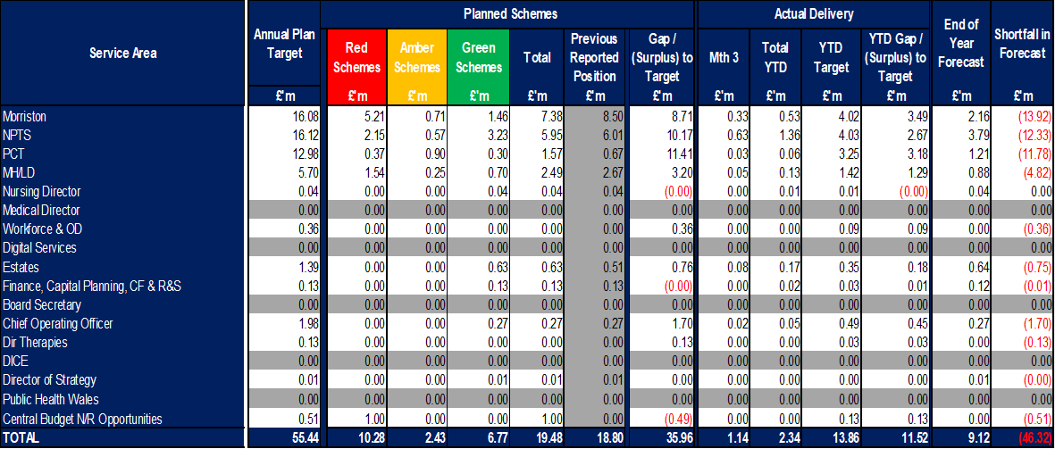

The end of year forecast delivery for Green and Amber schemes as per the tracker is currently £9.1m, which is a shortfall of £46.3m against the target of £55.4m. This represents a significant risk to the Health Board’s delivery of the plan.

The Health Board trackers detail a further £10.3m of Red/Pipeline schemes that are being developed to support the achievement of the £55.4m target. Further opportunities need to be identified and delivered at pace to close the gap.

