Meeting Date | 29 January 2026 |  | Agenda Item |  |  | 5.2
Name of Meeting | SBUHB Board
Report Title | Organised for Success Programme Update
Report Author | Tina Ricketts, Director of Workforce & OD & Matt Lewis, Programme Lead
Report Sponsor | Tina Ricketts, Director of Workforce & OD
Presented by | Tina Ricketts, Director of Workforce & OD
Freedom of Information | Open
Purpose of the Report | This report updates the Board on the progress of the Organised for Success programme. The current status of the programme is as follows:
  Phase | Description | Status
  A | Executive Portfolios | Stage 1 completed
  B | Deputy/ Tier 2 Management Structure | In progress
  C | The Establishment of a Delivery Unit | In progress
  D | Joint Posts across the Regional Partnership | Not started
  E | The establishment of a new care group structure | In progress
  F | A review of the care group leadership structure – confirming the Triumvirate Leadership model (e.g. operationally led or clinically led) | In progress for Service Group Tri level
  G | A review of the number of divisions or directorates within each new care group to ensure spans of control are reasonable and equitable. This will include a review of the specialities and services managed under each of the care groups to ensure they are organised in the best way for our patients | In planning
  H | A review of the number of management layers within the new care groups with the aim to have a maximum of 6 layers, where appropriate, from Board to front line staff with a focus for this programme on the top 4 layers (Tri, Division, Directorate, speciality/ service) | In planning
  I | A review of the wraparound support for each new care group (e.g. HRBP, Finance BP) to ensure this is reasonable and equitable | Not started
  J | A review of corporate functions sitting in/ out of care groups to ascertain the most appropriate design of the function (e.g. hub and spoke, centralised) | Not Started
Key Issues | The executive team portfolios have been reviewed and updated. These can be found in appendix two.  Work has commenced on the executive team deputy structure. This will be completed by 31st March 2026.  A central delivery unit will be established and headed up by a new role of Director of Delivery, subject to approval. The job description is being developed and the role submitted to vacancy control panel for scrutiny before being evaluated and advertised. The following functions are being considered for the delivery unit, subject to further engagement and consultation:  - PMO programme/ project management  - Transformation  - Improvement  - Business Intelligence  - Performance  The unit will be staffed within existing resource, who subject to consultation, will be redeployed into the unit. The unit will focus our existing capability and capacity on Health Board priorities and is critical to the delivery of the Organised for Success Programme.  Service Group Tri’s have been consulted on the new Care Group Structure and whether the top tier of management should be clinically or operationally led (phases E&F). The consultation closed on 4th January 2026 with the following outcomes:  - Support has been received for the establishment of 6 Care Groups with a proposed change in name for the Neighbourhood Care Group to Integrated Community Services Care Group, which has been accepted and is recommended to the Board for approval. The next step is to undertake wider engagement and consultation on what services should sit within each Care Group and how these should be grouped into Directorates.  - There was mixed feedback on whether we should move to a clinically led model and what that model should look like with concerns raised about the tight timeline for this to be implemented by 1st April 2026. This feedback has been accepted, and it is recommended that wider consultation and engagement across the organisation is undertaken to determine the preferred leadership model.  - Planning will continue at pace to establish the new care group structures and to support the identification of priority services for transformation as we move from a geographically based operational model to a thematic service model.  - Given the above it is recommended that the go live date for the new Care Group structure is pushed back to 1 September 2026.
Specific Action Required  (please choose one only) | Information | Discussion |  | Assurance | Approval
Specific Action Required  (please choose one only) | ☐ | ☐ |  | ☐ | ☒
Recommendations | The Board is asked to:  - RECEIVE the updated executive team portfolios  - PROVIDE FEEDBACK on the proposed functions of the delivery unit  - CONSIDER the outcome of the consultation related to phases E&F noting that further engagement and consultation is recommended on the proposed leadership model  - APPROVE the planning and development of a new operating model (moving from 4 x Service Groups to 6 x Care Groups) with a go live date of 1 September 2026  - APPROVE the new name of Integrated Community Services Care Group in place of Neighbourhood Care Group

Organised for Success Programme

- Introduction/ Background
The Organised for Success programme has been set up to support us to be organised in the most effective way to delivery in year and medium terms improvements. The programme is a key enabler in the delivery of the savings benefit associated with headcount reduction (as identified by the Recovery and Sustainability Board), which will include a management restructure of our clinical services and corporate functions.
This programme of work will review executive portfolios, service group structures and management spans of control and will make recommendations on how we organise ourselves for success. The programme will also bring together our PMO, transformation, business intelligence, performance and improvement capability through the establishment of a Delivery Unit.
- Terms of Reference
As a reminder the terms of reference of the programme are set out in appendix 1.
The governance structure for the programme is set out in the diagram below. The Formal Executive Team Meeting will be the Steering Group for the programme with key decisions being made by the Board. The Management Board will receive regular progress updates and will be consulted and engaged on key decisions.
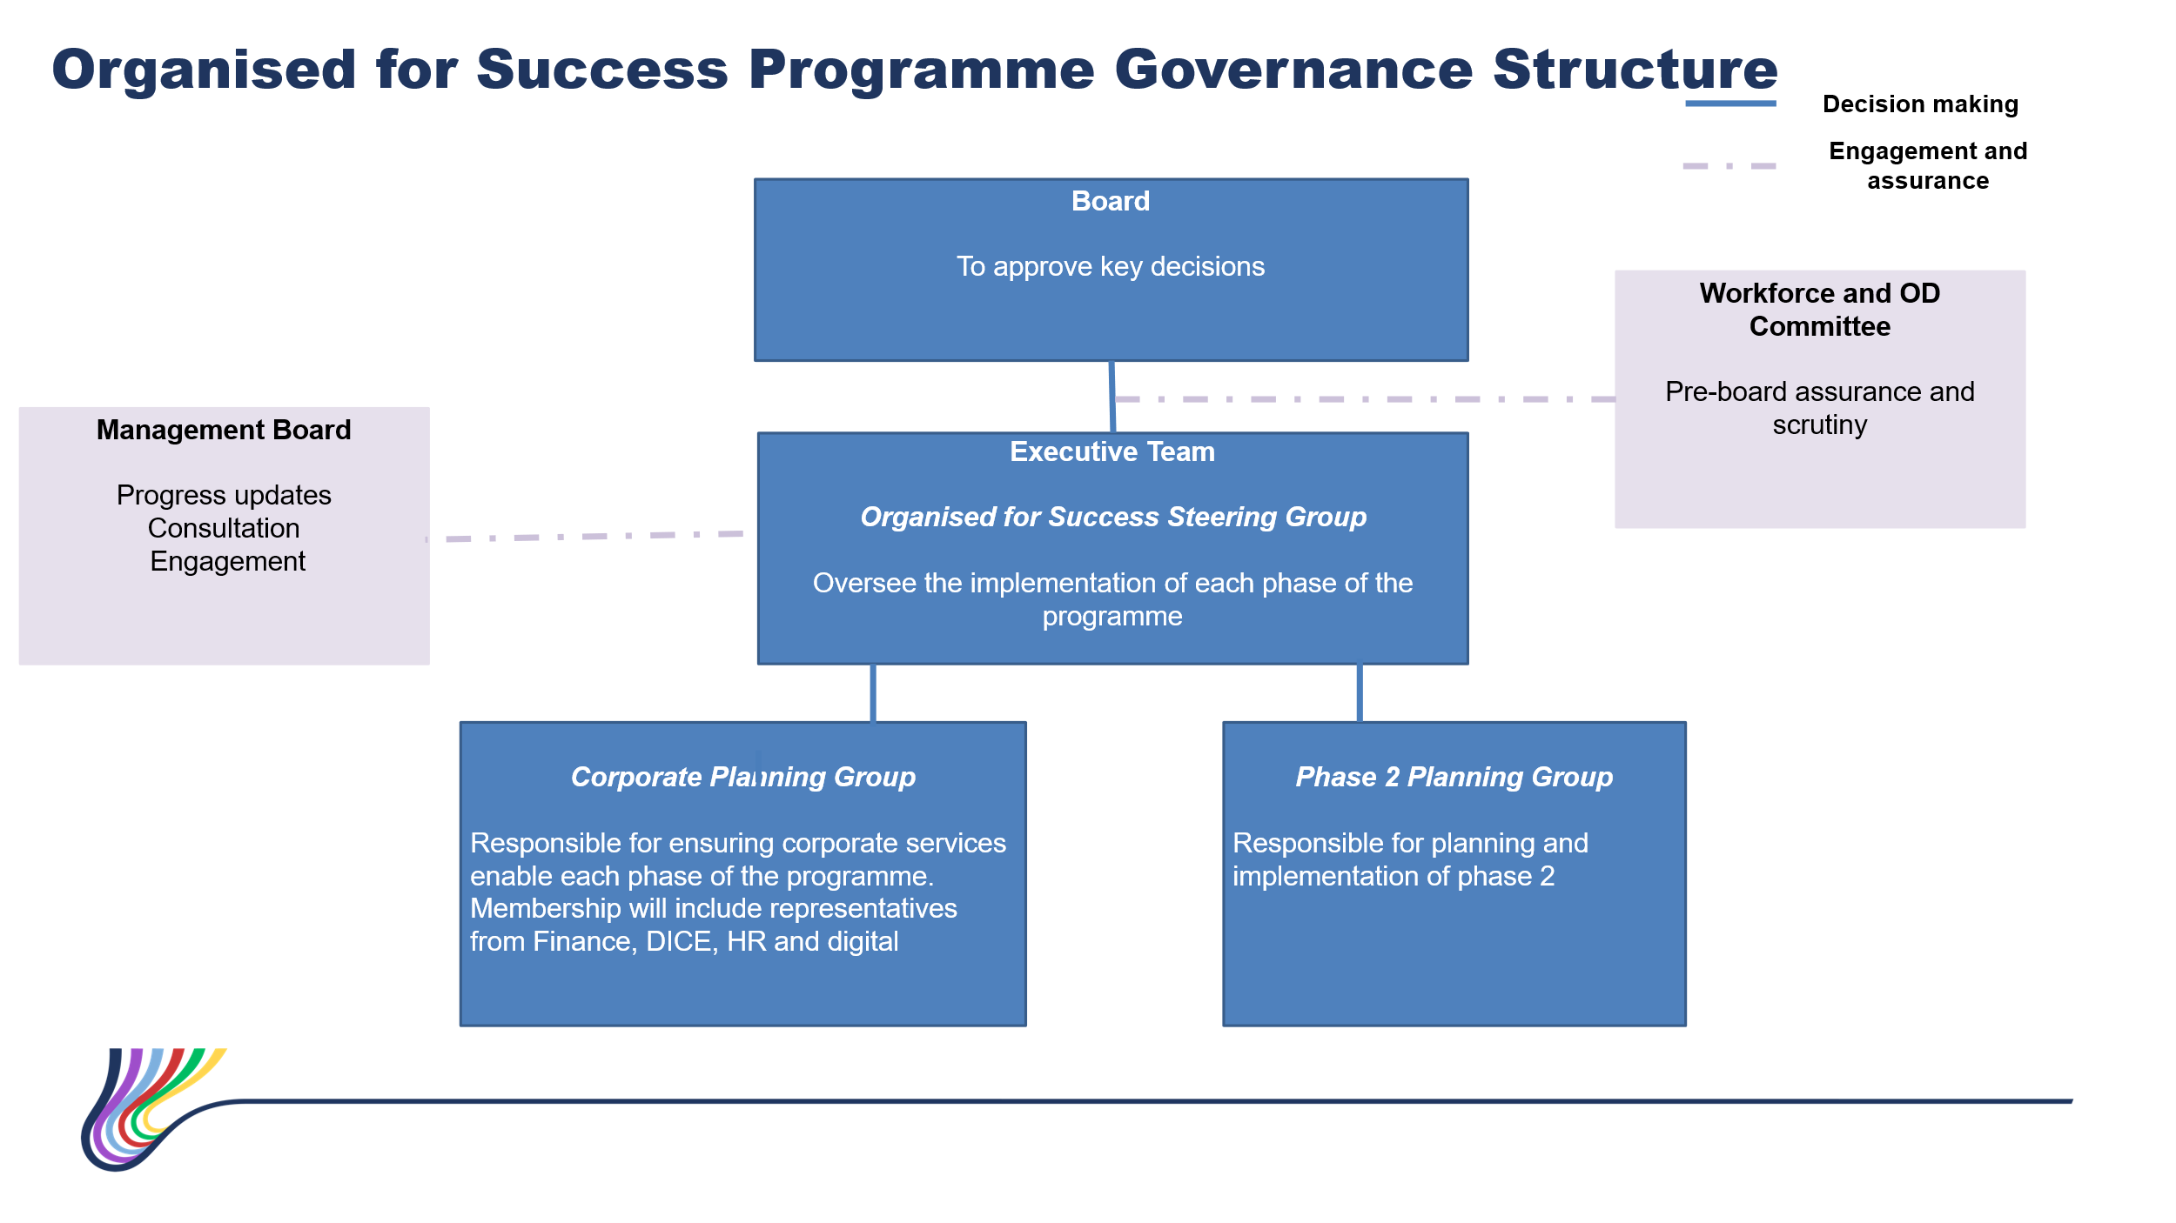
- Executive Portfolios
The review of the executive team portfolios has been completed. The updated portfolios are set out in appendix 2 for information.
The portfolios may be subject to further review following the resignation of the Director of Finance. This will be completed by 31st March 2026.
- Executive Team Deputy Structure
Meetings are taking place with each executive team director to review their deputy structure in response to the changes to executive team portfolios.
This work will be completed by 31st March 2026.
- Central Delivery Unit
A central delivery unit will be established and headed up by a new role of Director of Delivery. The job description is being developed and will be subject to vacancy control scrutiny and job evaluation. The following functions are being considered for the delivery unit, subject to consultation:
- PMO programme/ project management
- Transformation
- Improvement
- Business Intelligence
- Performance
Stage 1 will be to “lift and shift” the agreed functions into the delivery unit. Stage 2, a review of how the delivery unit should be structured, will be led by the Director of Delivery when they are in post (subject to the post being approved).
- Proposed Care Group Structure
The proposed Care Group Structure is as follows. The consultation with the Service Group Tri’s closed on 4th January 2026. There was support for the 6 Care Group structure. However, there was strong views that the Neighbourhood Services Care Group should be renamed, which has been accepted. The Board is asked to approve the new name of “Integrated Community Services Care Group”.
Further consultation and enagement will take place on the structure and content of each Care Group i.e. where each service/ speciality will sit and how they will be grouped.
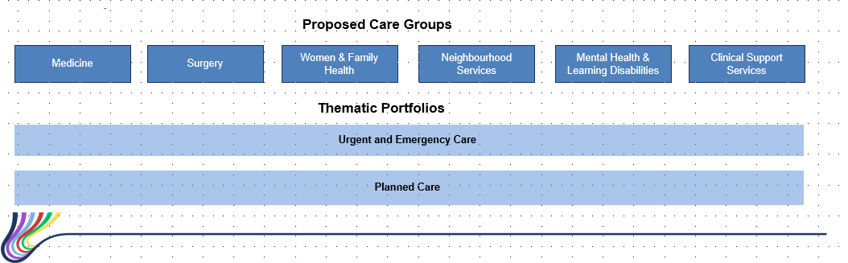
There was mixed feedback on whether we should move to a clinically led model with concerns raised about the tight timeline for this to be implemented by 1st April 2026. This feedback has been accepted, and it is recommended that wider consultation and engagement across the organisation is undertaken to determine the preferred leadership model.
Planning will continue at pace to establish the new care group structures and to support the identification of priority services for transformation as we move from a geographically based operational model to a thematic based service model.
Given the above it is recommended that the go live date for the new Care Group structure is pushed back to 1st September 2026.

- Key Risks
The Board should be aware of the following risks:
Key Risks | Current risk rating | Mitigating Actions | Risk Owner
There is a risk that the implementation of the programme will be delayed due to lack of programme management capacity | 8 | Programme Lead appointed and commenced full-time on 2nd January 2026 | Director of Workforce & OD
There is a risk that the challenging timelines of the programme will not be met due to senior colleagues not seeing this programme as a priority/ not releasing the required resource | 12 | The resourcing of the programme will be overseen by the Steering Group.  The establishment of a central delivery unit has been incorporated in phase 1 of the programme. This will be responsible for ensuring that all key HB programmes are adequately resourced. | Director of Workforce & OD
There is a risk that the operational performance of the Health Board is negatively impacted as colleagues become distracted with the programme/ associated organisational change processes | 9 | Operational performance will be overseen by the central delivery unit. The establishment of a delivery unit has been incorporated in phase 1 of the programme.  Gateways are being developed for each phase of the programme so that a decision can be made on whether we are in a position to “go” safely. The criteria for each gateway will be shared with the Board for approval. | Chief Operating Officer  Programme Lead
The programme will require a restructure of our budgets and corporate systems (e.g. the Electronic Staff Record System). There is a risk that this may limit the capacity of the corporate teams to work on other priorities. | 12 | Two planning groups have been set up with one focused on the restructure of our budgets and corporate systems. Regular updates on progress will be provided to the Steering Group. The impact on other priorities will be managed through the delivery unit. | Programme Lead

- Next Steps
The programme lead’s priorities are as follows:
- Working with the Director of Workforce & OD to update executive team job descriptions to reflect the portfolio changes
- Supporting the Director of Planning and Partnerships and the Executive Team to articulate the proposed function and remit of the Delivery Unit, with a subsequent step of drafting a consultation document, including those in scope
- Supporting the Chief Operating Officer with the outcome report for phase E&F following the closure of the consultation on 4th January 2026.
- Setting up and leading the two planning groups
- Drafting the gateway criteria for each phase of the programme

- Recommendations
The Board is asked to:
- RECEIVE the updated executive team portfolios
- PROVIDE FEEDBACK on the proposed functions of the delivery unit
- CONSIDER the outcome of the consultation related to phases E&F noting that further engagement and consultation is recommended on the proposed leadership model
- APPROVE the planning and development of a new operating model (moving from 4 x Service Groups to 6 x Care Groups) with a go live date of 1 September 2026
- APPROVE the new name of Integrated Community Services Care Group in place of Neighbourhood Care Group

Governance and Assurance
Link to Enabling Objectives  (please choose) | Supporting better health and wellbeing by actively promoting and empowering people to live well in resilient communities
Link to Enabling Objectives  (please choose) | Partnerships for Improving Health and Wellbeing |  | ☐
Link to Enabling Objectives  (please choose) | Co-Production and Health Literacy |  | ☐
Link to Enabling Objectives  (please choose) | Digitally Enabled Health and Wellbeing |  | ☐
Link to Enabling Objectives  (please choose) | Deliver better care through excellent health and care services achieving the outcomes that matter most to people
Link to Enabling Objectives  (please choose) | Best Value Outcomes and High-Quality Care |  | ☒
Link to Enabling Objectives  (please choose) | Partnerships for Care |  | ☐
Link to Enabling Objectives  (please choose) | Excellent Staff |  | ☒
Link to Enabling Objectives  (please choose) | Digitally Enabled Care |  | ☐
Link to Enabling Objectives  (please choose) | Outstanding Research, Innovation, Education and Learning |  | ☐
Health and Care Standards
(please choose) | Staying Healthy |  | ☐
(please choose) | Safe Care |  | ☐
(please choose) | Effective Care |  | ☐
(please choose) | Dignified Care |  | ☐
(please choose) | Timely Care |  | ☐
(please choose) | Individual Care |  | ☐
(please choose) | Staff and Resources |  | ☒
Quality, Safety and Patient Experience
The aim of phase 2 of the programme is to structure our services to improve patient experience. Currently services are structured on a geographical basis.
Financial Implications
The financial savings from the programme have not yet been quantified as we are still working through potential scenarios including the impact of the pay protection policy.
Legal Implications (including equality and diversity assessment)
An equality and diversity impact assessment will be undertaken for each phase of the programme.
Staffing Implications
The aim of the programme is to see a reduction in management tiers and equity in spans of control where possible. Staffing implications are still being scoped.
Long Term Implications (including the impact of the Well-being of Future Generations (Wales) Act 2015)
As set out in the report.
Report History |  | Not applicable
Appendices |  | - Organised for Success Terms of Reference v7  - Executive Team Portfolios

