Meeting Date | 27 January 2026 |  | Agenda Item
Report Title | Theatre Utilisation
Report Author | Rhodri Davies, Associate Service Group Director, Surgery  Sam Jenkins, Directorate Manager, Surgical Specialties
Report Sponsor | Deb Lewis, Chief Operating Officer
Presented by | Rhodri Davies, Associate Service Group Director, Surgery
Freedom of Information | Open
Purpose of the Report | The purpose of this report is to provide deep dive information on Theatre Utilisation across the Health Board, highlighting Neath Port Talbot Hospital (NPTH) and Singleton performance, with a particular focus on Ophthalmology.
Key Issues | - The ministerial target of 85% for theatre utilisation is a key performance area for the Health Board  - Whilst improvements have been made in some surgical specialties, others are underutilising their theatre capacity  - Morriston is achieving the 85% target on average; however, services at Singleton and NPTH theatre suites are not.  - To address the utilisation performance at Singleton and NPT Hospitals, there is improvement work ongoing. This paper sets out some examples of the work underway to improve performance.
Specific Action Required  (please choose one only) | Information | Discussion |  | Assurance | Approval
Specific Action Required  (please choose one only) | ☒ | ☐ |  | ☒ | ☐
Recommendations | Members are asked to:  - ACKNOWLEDGE- Theatres utilisation update and the actions taken to improve the overall performance in a sustainable and consistent manner.

Theatre Utilisation

- INTRODUCTION

This report provides deep dive information on Theatre Utilisation across the Health Board (HB) with a particular focus on Neath Port Talbot Hospital (NPTH) and Ophthalmology, given the performance in those areas, setting out the improvement work either underway or planned to commence.

- BACKGROUND

Operating theatres represent one of the most resource-intensive areas of the NHS, where even marginal gains in utilisation can significantly improve patient outcomes, reduce waiting lists and enhance financial stability. SBUHB operates a large and complex theatre estate across Morriston, Singleton, and Neath Port Talbot Hospitals, comprising 37 theatres in total. Ongoing demands for elective care recovery is such that the HB has prioritised theatre performance within its operational and strategic plans as it strives for improved efficiency and productivity within core capacity.
The Performance and Finance Committee (PFC) will be aware of the Ministerial target for Health Boards to achieve 85% theatre utilisation, based on the GIRFT (Getting It Right First Time) recommendations for efficient theatre productivity. A nationally recognised improvement process for theatre utilisation is “6-4-2”. This process is illustrated below:
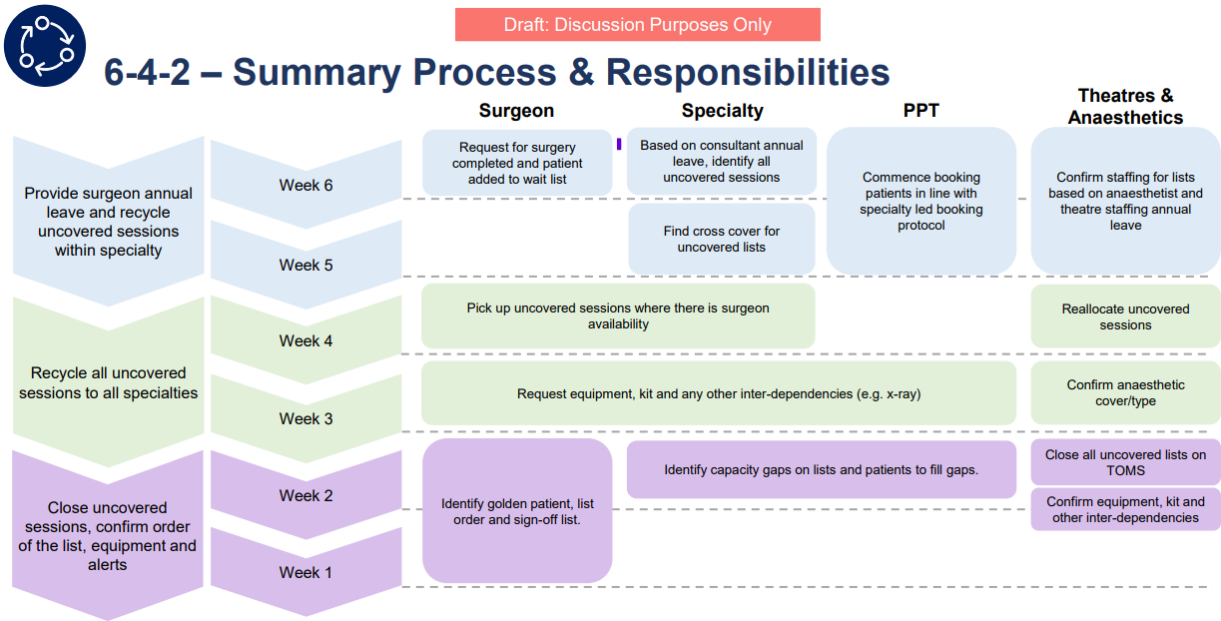
An Internal Audit review of Theatre Utilisation was undertaken in July 2025 and concluded in November 2025. The audit provided reasonable assurance to the Board and highlighted the following strengths:
- Robust governance arrangements are in place to support the efficient use of theatre resources.
- Key performance indicators are established to monitor theatre efficiency and productivity, particularly utilisation, with actions identified to drive improvement where needed.
- A clear and appropriate reporting framework exists for theatre utilisation.
- Processes are in place to ensure the quality and accuracy of data used for monitoring performance.
However, the report provided limited assurance regarding the availability of approved policies and procedures to support the effective use of theatre resources. In particular, it noted gaps in clearly defined roles and responsibilities accessible to staff.
- Theatre Utilisation Performance

Graph 1 below highlights the utilisation by hospital theatre suite. It highlights that Morriston utilisation is consistently near the Ministerial target of 85%. However, NPT and Singleton Hospital suites are underperforming consistently against the target. Given that the NPTH site is largely protected from acute and emergency site pressures, unlike Morriston, this is a concerning picture.

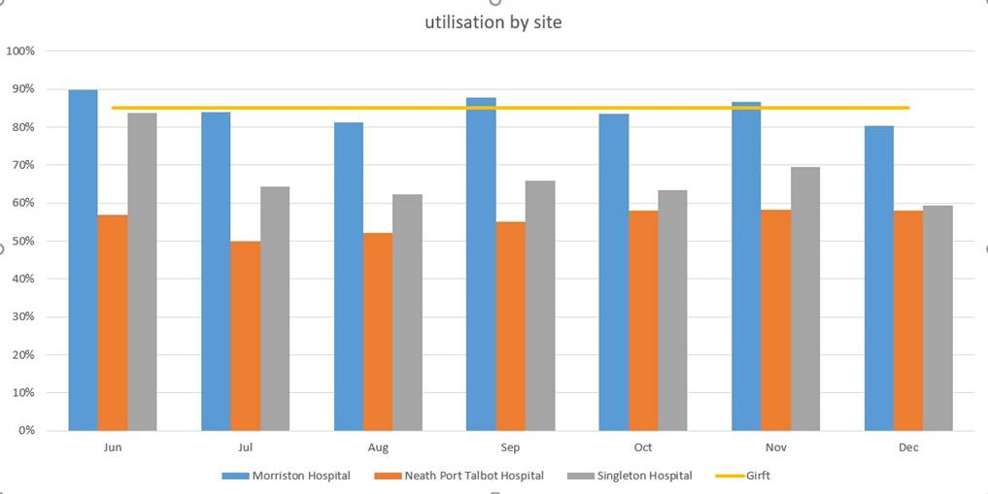 Graph 1- Utilisation by site

Graph 2 below shows theatre utilisation broken down by the surgical specialties that use theatres the most across all sites. The surgical specialties with the lowest utilisation are Vascular (63.0%), Ophthalmology (64.0%) and Plastic Surgery (71.0%)

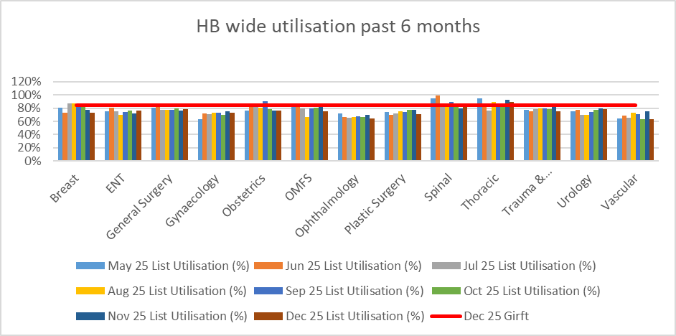

Graph 2- HB wide utilisation over last 6 months

  - Focus on NPTH

Given the poor performance against theatre utilisation in NPTH, Graph 3 below shows the following specialties that are utilising the lists in NPTH on a regular basis. Trauma, Orthopaedics and Spinal generally are achieving close to the 85% target at NPTH but other specialties are struggling such as Gynaecology, Plastics and Vascular.

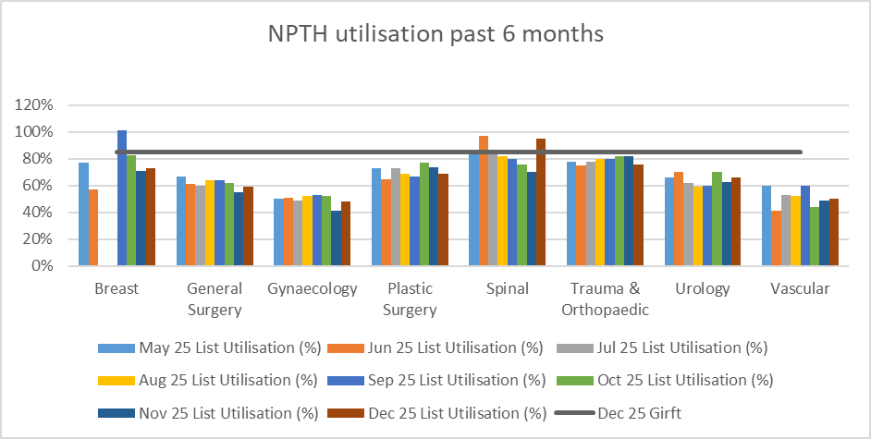

Graph 3- Specialties that are utilising the lists in NPTH
Table 1 below highlights the performance in percentages per surgical specialty.

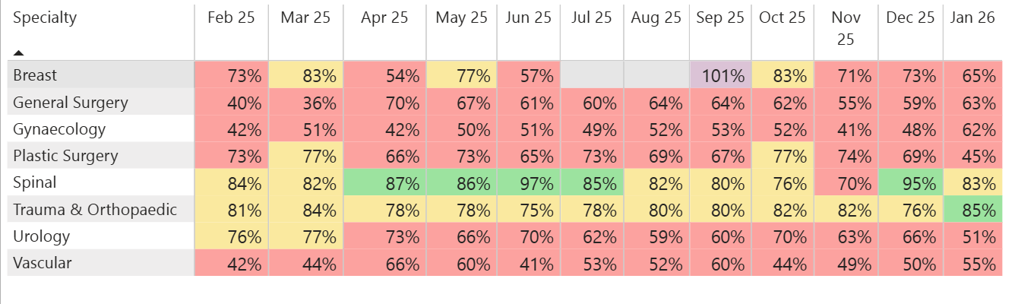
Table 1 – utilisation rates by speciality from Feb 25- Jan 26 (noting Jan 26 2wks data only) for NPT

The table illustrates an improving picture in T&O and Spinal, which is a result of significant work carried out in the areas with the implementation of a weekly scheduling approach. The meeting adopts an MDT approach to list scrutiny; where surgeons, theatre staff, anaesthetics and management team go through the previous week’s activity in detail as well as the forward look into the next 2 weeks of activity. This approach has seen list utilisation improve across those surgical areas and is now being taken forward in other specialties.

  - Focus on Singleton

Singleton performance has improved over the last year; however, some specialties are under-performing in a way that then impacts on the overall performance. Table 2 below highlights the key specialties utilising theatres on site and their individual performance.

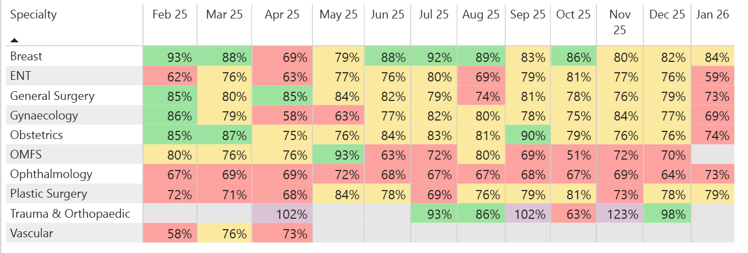 Table 2 - utilisation rates by speciality from Feb 25- Jan 26 (noting Jan 26 2wks data only) for Singleton

The Theatres Operational Group has a scrutiny process in place, which aims to identify lower performing specialties to support them to improve performance. Given the list utilisation figures for Ophthalmology, there has been some additional scrutiny as well as action taken by the service recently.

  - Focus on Ophthalmology

Ophthalmology Services in Swansea Bay University Health Board are based in Singleton Hospital and operate from Theatre 6 in Main Theatres and in Theatre A, B & C in Singleton Day Surgery Unit.

A Need for Improvement

The service faced challenges with underutilisation of theatre time, particularly due to late starts/early finishes and variability in list completion. Looking at the data on the Theatre Dashboard, Theatre Utilisation data revealed that Ophthalmology sessions often finished earlier than scheduled, resulting in lost capacity. This was compounded by inconsistent case allocation and operational delays. The Senior Team in Ophthalmology recognised that without optimising current resources, requests for additional theatre time would lack justification.

Therefore, the improvement initiative aimed to:
- Increase the number of cases per list.
- Minimise downtime between cases.
- Standardise processes across surgeons.

Therefore, it was agreed that a ‘back to basics’ audit was required to better understand how theatres were operating. In order to achieve this the service devised two key strategies:
- Data Driven Audit
- Observational Insights

Data Driven Audit

The Theatre Staff in Day Surgery Unit (DSU) agreed to undertake an audit (appendix 1) in real time during ever theatre session across DSU in December. The team completed the below proforma for each list to note the following key metrics:

- Planned Start Time vs Actual Start Time
- Planned Finish Time vs Actual Finish Time
- Planned Number of Cases vs Actual Number of Cases

This information has been key in enabling the service to better understand patterns, trends and themes across the operating lists in DSU.

Observational Insights
Operational leaders attended theatre sessions to observe real-time workflows, uncovering practical barriers such as delays in patient transfer and equipment readiness.

A standout observation has been the clinical engagement from consultant surgeons and theatre teams to improve. Surgeons were actively involved in reviewing utilisation data and improvement plans, ensuring buy-in and transparency. Furthermore, Theatre Matrons actively encouraged the operational leaders to attend and were forthcoming with advice to further improve efficiencies and utilisation.

Outcomes and Next Steps

The Ophthalmology Senior Team have met to discuss the early findings of the audit and have devised a robust action plan to implement and secure improvement.

A common theme identified with the audit has been late starts across both DSU & Main Theatres. A late start is defined as a list delayed by more than 15 minutes. This is supported by the data on the Theatre Dashboard, which you can see below:

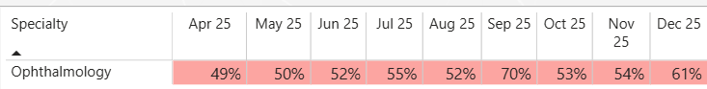

Consequently, this will be the focus for the coming weeks to ensure all lists start promptly. There is the possibility that this may impact theatre early finishes initially but it is a priority for the service to ensure lists start on time. The next step will then be to ensure once all lists are starting on time, the booking Team will ensure all lists are booked to full capacity.

Over time, the audit and resulting actions are expected to lead to:
- More cases per theatre list, bringing activity in line with national benchmarks.
- Fewer early finishes, helping to maximise theatre time and overall productivity.
- A stronger partnership between clinical and operational teams, supporting a culture of continuous improvement.
To note, during the month of January there is on-going theatre observations by the Directorate Manager.

Job Planning Event

The information gathered from the observations and audit will inform conversations and objective settings in the next round of consultant job planning. Ophthalmology Services, with the support of Medical HR, are planning to job plan the entire department in one day on 28th January. This will ensure that the cycle of job plans is aligned with the demand and capacity of the department. This is a pivotal component of improving our use of core capacity moving into the new financial year. Theatre productivity will be at the forefront of these conversations and clear theatre objectives will be set with each consultant.

  - Elective Surgery Toolkit

The Theatres and Anaesthetics team have been working with Deloitte colleagues, as part of their focus on financial recovery through improved theatre productivity. As a result, an elective surgery toolkit has been developed in conjunction with Deloitte colleagues. This has been designed to address where the HB was unable to give reasonable assurance on clear policies and procedures for theatre utilisation in the internal audit assessment (as referenced previously).

The toolkit was launched in Theatres Operational Group on 6th January 2026, with implementation from 12th January.

The aim of the toolkit is to provide clinicians and service managers with a reference guide to allow effective use of theatre capacity for their services. It is essentially pulling all the various processes and resources together that have been developed over the last year into one place and ensuring roles and responsibilities are clearly defined. It also details changes being made to meeting structures and the expectations on everyone for smarter more efficient theatre scheduling.

- GOVERNANCE AND RISK ISSUES
A number of initiatives have been introduced over the past year to strengthen the scrutiny and management of theatre utilisation. The recent Internal Audit report on Theatre Utilisation recognises this progress. However, further improvement is still required in some surgical specialties. The introduction of the Elective Surgery Toolkit in January, along with focused specialty-level work—such as the Ophthalmology example highlighted in this paper—is expected to support continued improvement in theatre utilisation.
A significant risk to the Ophthalmology cataract pathway is the need to secure additional Pre-Assessment capacity to match the increased theatre capacity being developed. At present, the service is dependent on additional Planned Care Funding to provide the extra Pre-Assessment clinics required.
The service is also exploring opportunities to expand pre-operative assessment capacity within the main clinic footprint recently established at Singleton Hospital.

- FINANCIAL IMPLICATIONS

There are no additional financial implications identified as part of this report. However, it is important to note that significant Welsh Government funding is being spent across the surgical specialties and theatres services to achieve ministerial Referral to Treatment (RTT) targets. Given the financial outlook for NHS Wales next year, the risk of reduced funding will mean services will need to deliver performance but with reduced or no additional funding. As a result, theatre utilisation, aligned to comprehensive job planning, will be of paramount importance to ensure capacity is delivered within core funding.

- RECOMMENDATION

The Performance and Finance Committee is asked to:

- ACKNOWLEDGE the Theatres utilisation update and the actions taken to improve the overall performance in a sustainable and consistent manner.

Governance and Assurance

Link to Enabling Objectives  (please choose) | Supporting better health and wellbeing by actively promoting and empowering people to live well in resilient communities
Link to Enabling Objectives  (please choose) | Partnerships for Improving Health and Wellbeing |  | ☐
Link to Enabling Objectives  (please choose) | Co-Production and Health Literacy |  | ☐
Link to Enabling Objectives  (please choose) | Digitally Enabled Health and Wellbeing |  | ☐
Link to Enabling Objectives  (please choose) | Deliver better care through excellent health and care services achieving the outcomes that matter most to people
Link to Enabling Objectives  (please choose) | Best Value Outcomes and High Quality Care |  | ☒
Link to Enabling Objectives  (please choose) | Partnerships for Care |  | ☐
Link to Enabling Objectives  (please choose) | Excellent Staff |  | ☒
Link to Enabling Objectives  (please choose) | Digitally Enabled Care |  | ☐
Link to Enabling Objectives  (please choose) | Outstanding Research, Innovation, Education and Learning |  | ☐
Health and Care Standards
(please choose) | Staying Healthy |  | ☐
(please choose) | Safe Care |  | ☒
(please choose) | Effective Care |  | ☒
(please choose) | Dignified Care |  | ☐
(please choose) | Timely Care |  | ☒
(please choose) | Individual Care |  | ☐
(please choose) | Staff and Resources |  | ☐
Quality, Safety and Patient Experience
Improving theatre utilisation will enhance patient experience by increasing the number of operations performed, which will result in reduced waiting lists for surgery

Financial Implications
There are no additional financial implications identified as part of this report. it is important to note that significant Welsh Government funding is being spent across the surgical specialties and theatres services to achieve ministerial RTT targets. Given the financial outlook for NHS Wales next year, the risk of reduced funding will mean services will need to deliver performance but with reduced or no additional funding. As a result, theatre utilisation will be of paramount importance to ensure capacity is delivered within core funding.
Legal Implications (including equality and diversity assessment)
There are no legal implications to consider.

Staffing Implications
To run an effective theatre service requires access to skilled theatre staff, surgeons and anaesthetists along with other key resources along the surgical pathway including referral from primary care, through to the outpatient clinic, Pre-Assessment and admission for surgery.
Long Term Implications (including the impact of the Well-being of Future Generations (Wales) Act 2015)
Optimizing theatre capacity across the Health Board will support an improved delivery against waiting time standards, whilst ensuring the effective deployment of resources reducing variation in cost and resources.
Report History
Appendices |  | Appendix 1 – theatre audit template

