Meeting Date | 29 January 2026 |  | Agenda Item |  |  | 4.1i
Name of Meeting | SBUHB Board
Report Title | Perinatal Committee Report
Report Author | Kathyrn Greaves – Director of Midwifery  Sujoy Banerjee – Associate Service Group Medical Director - CYPWH
Report Sponsor | Elizabeth Rix, Executive Director of Nursing and Patient Experience
Presented by | Elizabeth Rix, Executive Director of Nursing and Patient Experience
Freedom of Information | Open
Purpose of the Report | The purpose of the paper is to provide the Board with an update:  - from the Perinatal Committee, assurance and information relating to the risks to quality, safety and patient experience in maternity and neonatal services, with escalation of any key areas of concern.
Key Issues | A Perinatal Improvement Programme has commenced in 4 workstreams headed by an executive member following the recommendations of the oversight panel with a view to implement the recommendations of the external review.  The Perinatal Committee continues to monitor quality, safety and patient engagement and experience outcomes (business as usual) and provides a system of Alert, Advice, Assure to Quality and Safety Committee and Management Board
Specific Action Required  (please choose one only) | Information | Discussion |  | Assurance | Approval
Specific Action Required  (please choose one only) | ☐ | ☐ |  | ☒ | ☐
Recommendations | Members are to:  BE ADVISED THAT:  - The Perinatal Improvement Plan Executive Programme Board will develop and monitor improvement plans in response to the Independent Review, All Wales Self-Assessment and other improvement actions, will be triangulated and any gaps will be added to the overall improvement plan.  - Perinatal Improvement Programme Executive Board was held in December 2025, with workstreams agreed, Executive and service Leads assigned. Workstream meetings arranged and outputs will be reported via the Perinatal Improvement Programme Board.  - Perinatal Committee meets monthly and reviews all key metrics for perinatal services.  BE ASSURED THAT:  - The Perinatal Service does not currently have any elements of care that would flag as a Negative Outlier.  - Any stillbirths or neonatal deaths have been reported through the MBRRACE (Mothers and Babies: Reducing Risk through Audits and Confidential Enquiries) process.  BE ALERTED TO:  - There has been a strong steer nationally that there will be an All Wales maternity triage service developed as a recommendation from the All-Wales Perinatal Assessment. The Perinatal Improvement Plan Executive Programme Board has agreed to pause development of a standalone SBUHB model pending publication of the Assessment (due end of Jan 2026).  - Mitigating action to provide a single point of contact triage phoneline will be complete by February 2026. Calls will be to a single telephone entry point where women will be directed to the appropriate department based on their needs. This process will ensure that all calls for maternity triage are directed to one place.

Perinatal Committee Report

- INTRODUCTION
This report is intended to provide assurance and information relating to the risks to quality, safety and patient experience in maternity and neonatal services, with escalation of any key areas of concern.

- BACKGROUND
The Perinatal Committee was established in June 2025, to provide assurance to the Board that an evidence based, quality assured, safe and sustainable service for women, people and babies receiving maternity and neonatal care at Swansea Bay University Health Board.

The Perinatal Committee reports directly into Quality and Safety Committee and noted via Service Group Quality, Safety & Risk Group and Senior Leadership Team.

The Perinatal Committee focuses on the business-as-usual activities provided across our perinatal services. Matters relating to the Perinatal Improvement Plan are reported separately via the Perinatal Improvement Programme Board and into Management Board.

- GOVERNANCE AND RISK ISSUES

Information and graphs/tables to be included by Service leads:

Key updates from Perinatal Committee
As previously agreed, the following measures are some of the high-level information we review within our perinatal committee.

3.1 Number of births, caesarean section births and Surgical Site Infection rates
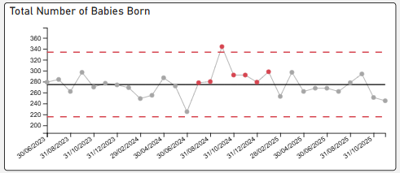
In November 2025, 238 women gave birth and 249 babies were born. Normal variation
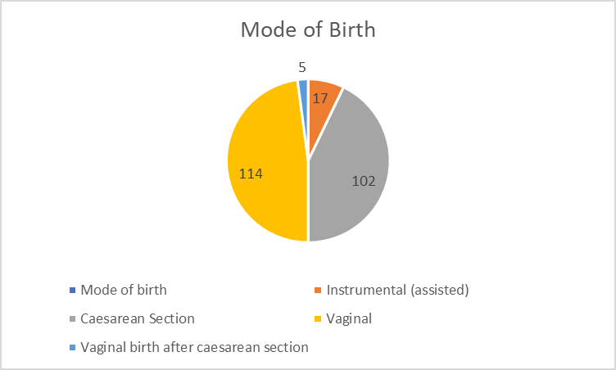
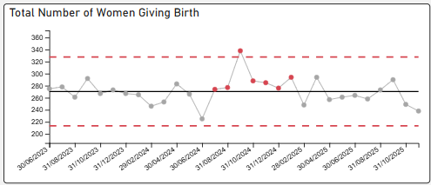
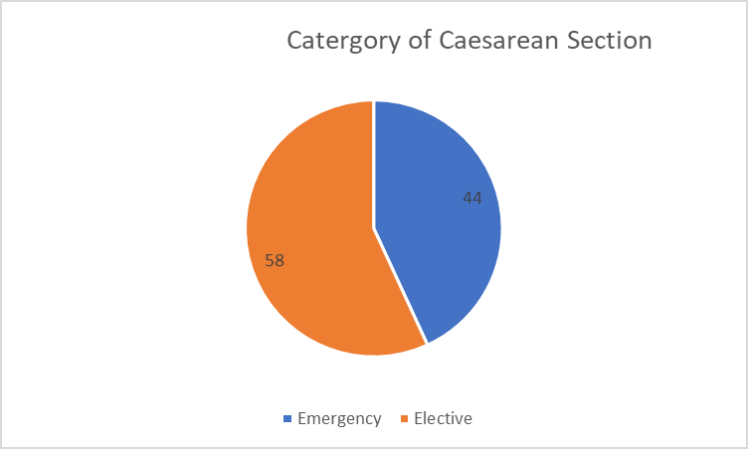
Classification of Caesarean Sections
Elective – Includes Category 3 and 4
Emergency – Includes Category 1 and 2

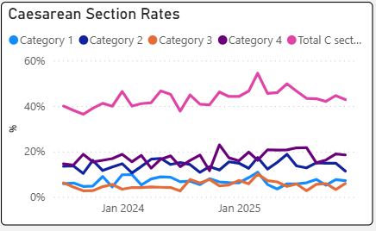

NHS maternity statistics data sets suggest caesarean sections should account for 42% of births (2023/2024), there is a national upward trend in C-Sections with Swansea Bay University Health Board (SBUHB) rates recorded as 43% (as seen above). National Maternity and Perinatal Audit (NMPA) data published in 2025 (reports 2023 data i.e. lags by 2 years) reports UK planned caesarean section rate as 16.4% (15.1-17.9%). SBUHB planned caesarean section rates were 19.87% in 2023 (outlier in NMPA report), 22.85% in 2024 and 25.2% in 2025. This is consistent with an increasing trend of planned C-sections which has been reported nationally. In some parts of the UK this mode of birth has been reported as being higher than vaginal births for the first time in recorded data collection.

In contrast our Emergency C-section rate is not an outlier on NMPA report. This suggests a greater influence of maternal choice in relation to elective C-section as a mode of delivery.

A C-section working group has been established to provide women with comprehensive and balanced information, enabling them to make fully informed decisions regarding their care.

Surgical Site Infection:
Surgical Site Infection (SSI) data for all C-section shows a decrease in quarter of the number of infections reported with improvements in compliance of reporting to provide accurate data capture and tracking (Source: Public Health Wales)
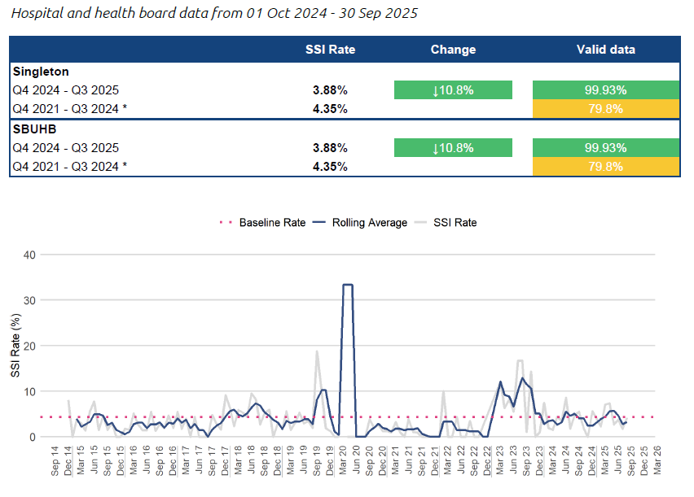
Local SSI rates

There is an increase in the SSI rate for October 2025 of 13.64%.​ On review of all swabs taken for potential of SSI, a majority of the swabs taken were taken under Primary care. As part of local quality improvement, Midwives have undergone training in the identification and reporting of SSI. Therefore, it is unclear from documentation of swabs taken by the Primary care team if there were true symptoms of an SSI or if correct cleaning of wound was undertaken prior to the swabs. The service has reinforced the need for Community Midwives to be the point of contact to review wounds within 28 days from birth.

Public Health Wales Healthcare Associated Infection, Antimicrobial Resistance & Prescribing Programme (HARP) team have confirmed that the definition of SSI and parameters for reporting have been standardised to <14 days. Therefore, the service to report SSI <14 days from January 2026. To continue data collection for <28 days until January 2026 due to ongoing Quality Improvement (QI) project.​

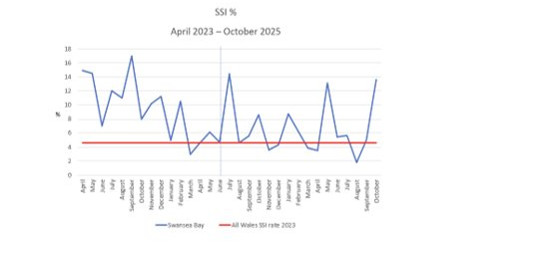

3.2 Neonatal Mortality and Morbidity
All stillbirths, Neonatal Deaths and brain injury cases are reported via Mothers and Babies: Reducing Risk through Audits and Confidential Enquiries (MBRRACE). MBRRACE’s purpose is to identify patterns, causes, and preventable factors in maternal and perinatal mortality and morbidity.

All cases receive internal and where indicated external investigation using the Perinatal Mortality Review Tool to support understanding and identify any modifiable causes to support families understand the causes of the death or brain injury and to support both local and national learning for improvement. Families are encouraged to be engaged with this process and have an assigned point of contact, who welcomes questions to be included within the review. The crude rate for Perinatal deaths in 2023 from MBRRACE was 7.49/1000 births with a stabilised and adjusted rate of 5.87 (95% CI at 4.84-7.76). In 2024 the crude rate was 5.72/1000 births (awaiting stabilised and adjusted rates). The 2025 data updated till the end of November calculates the crude perinatal mortality as 5.06/1000 births, but we will need to wait for full years data to get an accurate crude mortality rate. MBRRACE has not published the 2024 data yet and we are unable to report the adjusted and stabilised mortality rates until the publication of the MBRRACE report. MBRRACE report data in quarter 3 2026/27 each year.

3.2.1 Stillbirths from January – November 2025

There have been 11 stillbirths during this period, all are included in the MBRRACE reporting data. One case did not receive any antenatal care within Swansea Bay; one was an unknown pregnancy that delivered pre-hospital with maternity services involved postnatally to provide care and support. Based on current rates of stillbirth in the UK the national rate for number of births for a unit our size is 12 to 13.

3.2.2 Neonatal Deaths from January – November 2025
There have been seven neonatal deaths between January 2025 and November 2025 and of these cases five are reportable to MBRRACE as two were over 28 days of life. Of these five, only two will be represented in the MBRRACE report as deaths <24 weeks gestation are not included in the final report for analysis. The three deaths not included in MBRRACE analysis were extremely pre-term (less than 24 weeks) at the limit of viability.

There have been no deaths reported since August 2025. This is lower than what has been seen in recent years for SBUHB. We need to include December data before drawing firm conclusions.

3.2.3 Hypoxic-Ischemic Encephalopathy (HIE) from January – November 2025
There have been five cases of HIE reported in this period. All babies survived to discharge with good outcomes. There is limited data published to allow National benchmarking. Latest published data from National Neonatal Research Database (NNRD) is 4 years out of date (Department of Health, 2021 data). This reports a UK average incidence for Moderate and Severe HIE cases of 1.59/1000 births (1.49-1.70).

Due to the low number of HIE and births in SBUHB a rolling 12-month HIE incidence reporting is more appropriate. This shows that in November our moderate to severe rolling 12-month HIE rate was 1.84/1000 births. This represents a 45% decrease since its peak in April 2024 of 3.32/1000 births.

The 2025 HIE rate up until November was 1.68/1000 births.
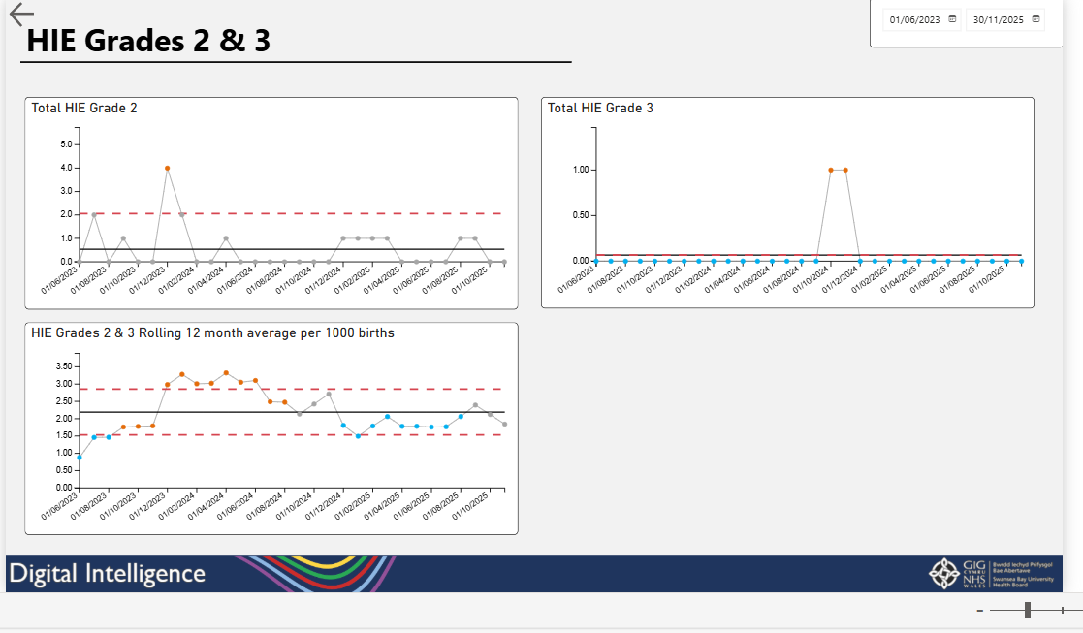

3.3 Triage Metrics
Birmingham Symptom Specific Obstetric Triage System (BSOTS) is the Maternity services emergency department to support women experiencing concerns or urgent complications with their pregnancy or postnatal period. The following metrics help the system understand how effective, efficient, timely and safe our triage system is in responding to these.

In October 466 women were reviewed in triage and assessed for ongoing care requirements.

Initial trigae within 15 minutes, standard is 90% - rate in October 90.80%.

Category | Category description | Number and percentage of total cases in month
Red | Number of women requiring ongoing immediate care | 3 (0.6%)
Orange | Number of women requiring ongoing care within 15 minutes | 68 (14.5%)
Yellow | Number of women requiring ongoing care within 1 hour | 320 (68.8%)
Green | Number of women requiring ongoing care within 4 hours | 46 (9.8%)
Uncoded cases |  | 29 (6.2%)

Communication has been sent to remind staff of the requirement for all cases to be coded. There were no incidents relating to harm reported in month. There were 4 incidents reported due to delay in obtaining medical review following initial assessment and risk stratification for yellow, amber and red pathways, which amounts to a breach of time for review of 6.9%. There were no incidents relating to harm reported as a result. Where breach in time to review is identified, an additional measure which looks at what time review was achieved will be introduced.

Singleton Maternity Triage Team celebrated 1 year since roll out of BSOTS in November 2024. During this period 5955 women attended for review - 4426 women self-referred, 526 were referred by Antenatal Clinic, 588 were referred by other allied health professionals. Congratulations to the team for their hard work, dedication and commitment to improving safety for our women, babies and service.

  - Third and fourth-degree tears
Changes to clinical coding of some outcomes had shown a lag in data being updated on the Perinatal Dashboard. This has been resolved at pace to enable service oversight.

Latest data published by the National Maternity and Neonatal Audit (NMPA, 2023 data) reports a UK incidence of 3.29% (2.60-3.80) for 3rd and 4th degree perineal tear. Reviewing 2025 data, SBUHB would have a rate of 3.37/1000 births which is within the 95% confidence limit for UK data and shows a reduction from 2024 data of 4.08/1000 births. This figure can be as high as 6% for first time mothers. SBUHB do not currently stratify data by parity, but this will be a future consideration.

The use of instruments at birth carries a higher risk of sustaining perineal trauma. The NHS Wales data dictionary has been consulted and confirms how the calculation should be made. Using this data standard to calculate 3rd/4th degree tears the rate for November 2025 is 0.68%. When benchmarked against national data, SBUHB performs well. The Royal College of Obstetricians and Gynaecologist reports a national rate of 2.9%. (Green Top Guideline No.29).

Episiotomy rate for November in SBUHB was 10.5%. National data for all births in the UK is not collected via the National Maternity Perinatal Audit. However, according to the NHS Maternity Statistics, England for 2023/24, the rate of vaginal births with episiotomy was 13.9%. All instrumental births are currently reviewed including an audit of elective episiotomy. Any learning is fed to the quality improvement project that is looking for interventions and mitigations to reduce the occurrence of third and fourth-degree tears and the risk factors associated with perineal trauma.

A future consideration for the Perinatal Dashboard is disaggregating the episiotomy rate by mode of birth. We will explore the potential delivery of this data by the end of quarter 4 2025/26.

3.5 Postpartum Haemorrhage
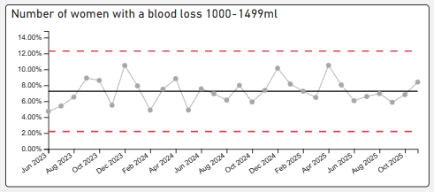
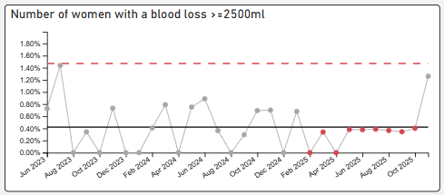

In November, the service experienced a very small number of cases involving blood loss that met the criteria for reportable obstetric haemorrhage. Each of these cases was promptly subjected to a rapid review by the Multi-Disciplinary Team (MDT) to ensure there were no breaches in duty, confirm compliance with management guidance, and identify any early learning opportunities. All cases were appropriately risk assessed and managed, and each occurred in the context of complex birth modes where the likelihood of haemorrhage is inherently higher. Importantly, these events remained within national benchmarking standards.

The NMPA published 2023 data for National benchmarking and reported postpartum haemorrhage incidence as 3.41/1000 births (2.98-3.79). SBUHB rate for postpartum haemorrhage in 2025 was reported as 2.49/1000 births, lower than the National benchmark. This showed a steady reduction from 2024 data, of 3.51/1000 births.

3.6 Perinatal Incident Reporting
Work continues to maintain the improvement in the reduction of overdue open incidents across perinatal services, this includes weekly incident review meetings, rapid reviews of any incident of moderate harm and above, with early learning identified and shared. Significant improvement is noted with regards to open incidents, incident investigation and closure processes. Learning is identified and disseminated regularly through safety alerts where applicable, monthly Risky Business Newsletters, and risk meetings across the perinatal services. Complaint resolution back log has been reduced to just 3 months except cases requiring external review or Coroner’s input. Duty of Candour (DoC) processes are in place and timely. The Legal redress cases are reducing slowly.

Perinatal DoC cases – as at 01.12.2025

Types of incidents – Perinatal Services – 01/10/25-31/12/2025

The highest category of incident is classified under ‘neonates’. The Maternity trigger list refers to the mandatory reporting of incidents within the service under Maternity and Neonatal. A further break down of incidents in relation to these categories can be seen in the below chart.

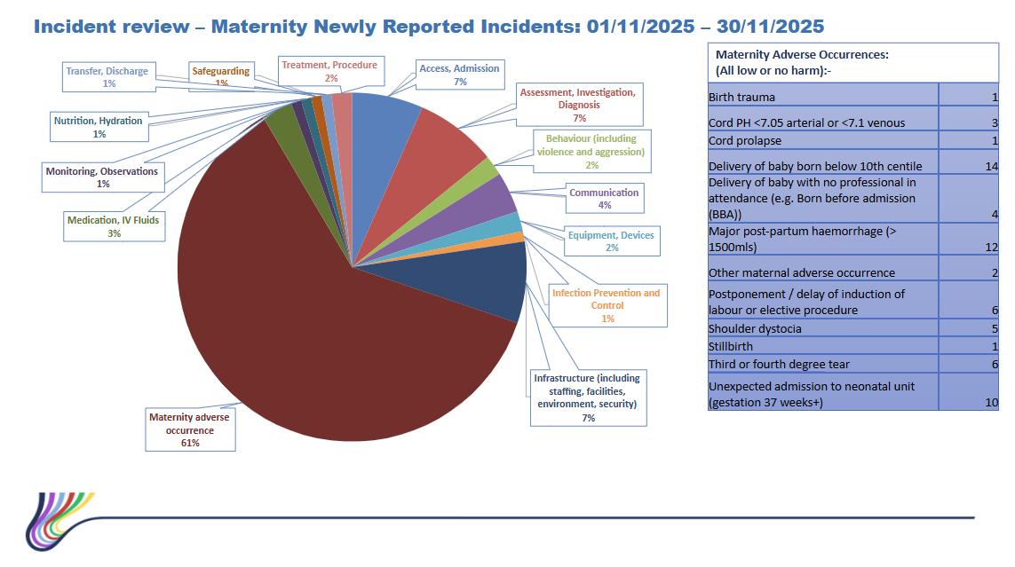

The mandatory reporting of incidents includes unexpected term admission to the neonatal unit and babies born small for gestational age, shoulder dystocia and baby born prior to arrival. All unexpected term admissions to the neonatal unit are reviewed by the perinatal multi-disciplinary team for individual learning and thematic review. Thematic review has identified quality improvement opportunities such as the implementation of ‘ASTRA’ - Avoiding Short Term Respiratory Admissions to the Neonatal unit. The outcome of the ASTRA quality improvement cycle will be reported at Perinatal Committee and reported via this mechanism to board.

3.7 Patient Feedback and Experience
The service continues to capture feedback via friends and family, and we are the pilot site for the NHS core questionnaire. The Core Questionnaire pilot sends a text to users of our services at five points during their pregnancy, the responses are received and responded to by the senior midwifery and nursing team. Where concerns are raised, direct contact is made with the family, either on the ward, or via a telephone call to talk about their experience and we work with the woman and family to ensure improvements are made.

Common themes from patient feedback are around access to services, in particular waiting times within antenatal clinic. An antenatal clinic review is in progress which will consider a number of complex care requirements involving the coordination of several services to streamline and minimise waits for women.

There are currently 13 outstanding Perinatal formal concerns and whilst five are overdue they are in active management. Two are in an external review process, four in final stages of completion and one due to close following a meeting with the women.
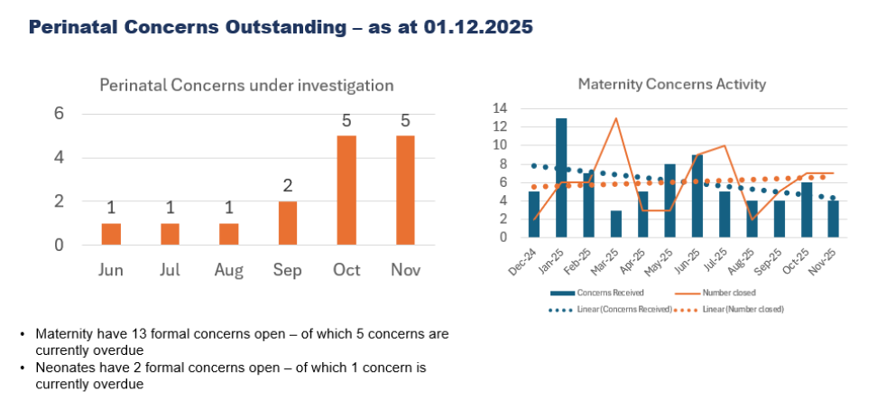

Engagement with Diverse Communities – Maternity Services
Swansea Bay University Health Board’s maternity services are actively progressing initiatives to ensure inclusive, culturally sensitive care informed by lived experiences. Current actions include collaboration with community groups such as the ‘Mums and Toddlers Foundation’ and ‘Chai and Chat’ to gather feedback and strengthen representation in service planning. Work is underway to establish a Black, Asian, and Minority Ethnic (BAME) Advisory Network to embed diverse voices in policy and improvement decisions. Feedback mechanisms, including Civica surveys and outreach sessions, are being expanded with translation support and cultural awareness questions. Staff engagement in equality, diversity, and inclusion (EDI) training and events continues, alongside implementation of fast-track antenatal services for BAME families. Inclusive practices are visible across clinical areas through multilingual signage, diverse educational materials, and access to interpretation services. Future plans include enhanced demographic data collection, culturally inclusive communications, and recruitment of diverse representation within the Maternity Voices Partnership.

3.8 Induction of Labour delays
Delays in induction of labour continue to be monitored and escalated to ensure clinical prioritisation and service requirements to improve flow based on clinical acuity. All delays are Datix reported to ensure any triangulation of any harm as a result. Through this process, no delays reported have resulted in harm.
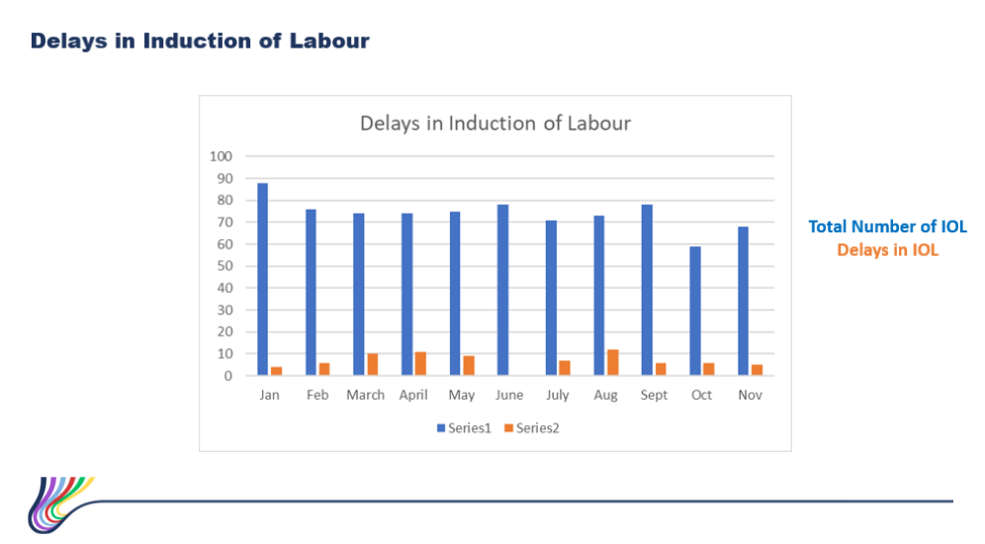

3.9 Workforce
There have been some challenges within the Neonatal medical workforce due to unavailability, this has been mitigated with flexible working arrangements which has meant there has been no gap in service. A Neonatal Consultant was successfully recruited on the 9th of December, with 1 expected return following maternity leave in January.

Obstetric workforce – 2 fixed term gaps for career break and other leave have been covered with no vacancies impacting on services.
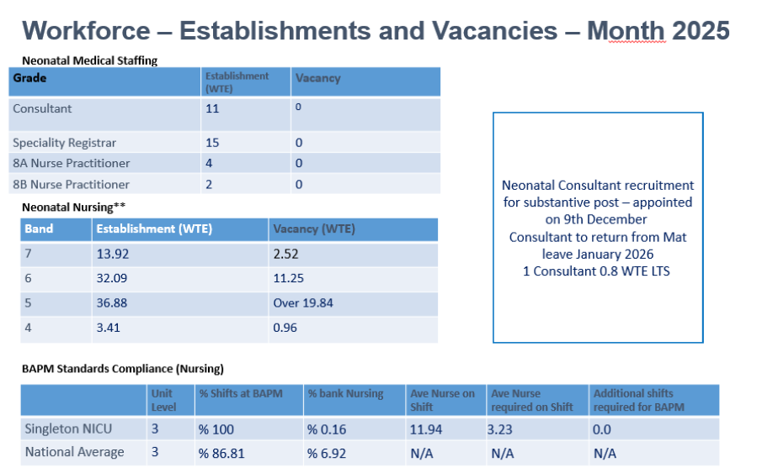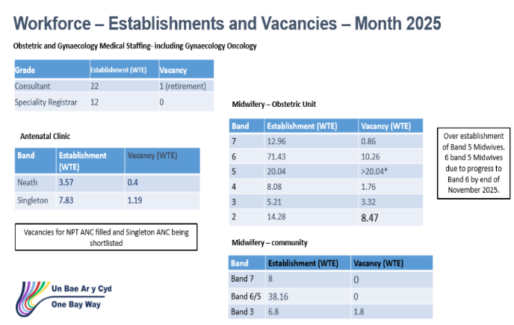
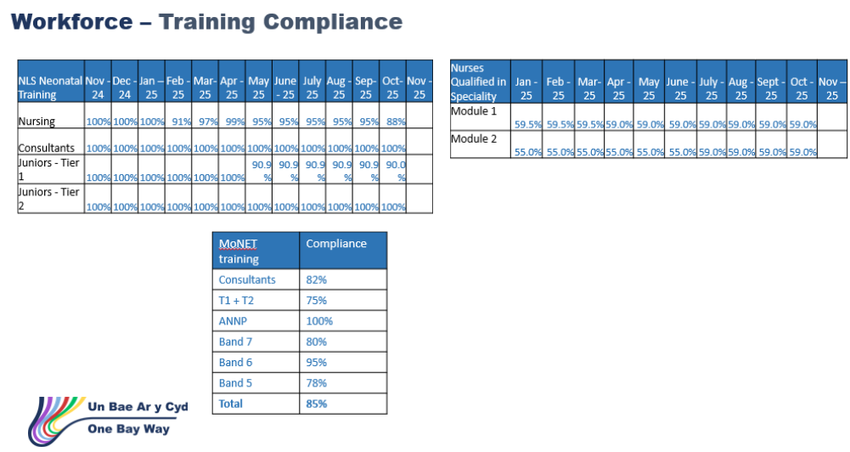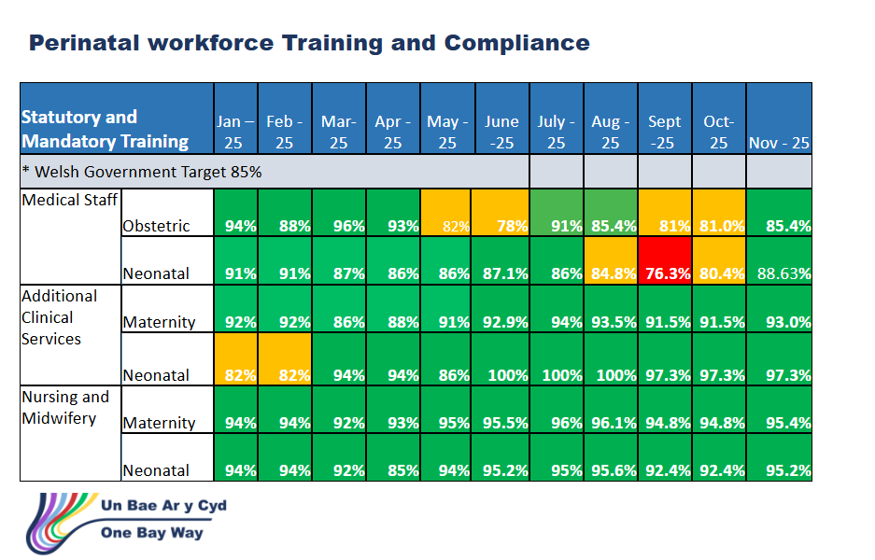
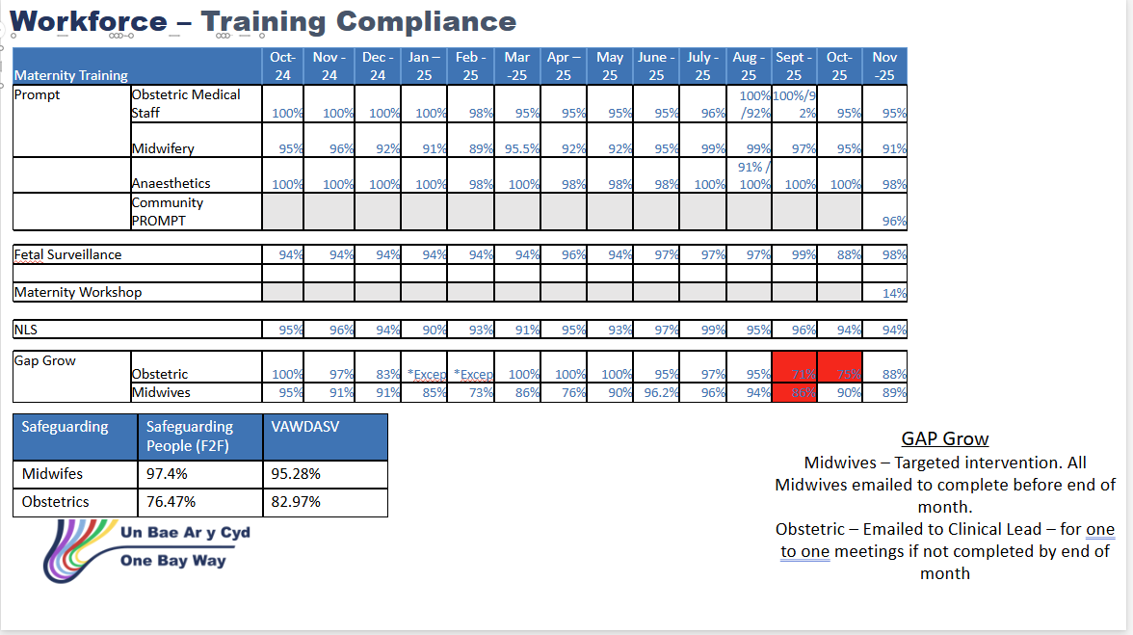

Compliance is improving across the board and individual staff out of compliance have been emailed to complete their mandatory training. Respective line managers will follow this up.

3.10 Infection Prevention and Control
Improvement plans have been put in place to support infection control in ward areas. Matron audits have identified areas that need focus and action plans implemented to improve. This is being benchmarked against the bi-quarterly validations. Infection Control Team corporate inspection continues and any learning identified is being included in the improvement plan which is monitored via the Perinatal Committee. There were 2 infections in Quarter 3, 1 e.Coli on the Obstetric Unit and 1 klebsiella in Neonatal services.

3.11 Neonatal National Audit and Performance (NNAP)/PERIPrem Cymru – context and figures
Summary of NNAP 2024 data and monitoring
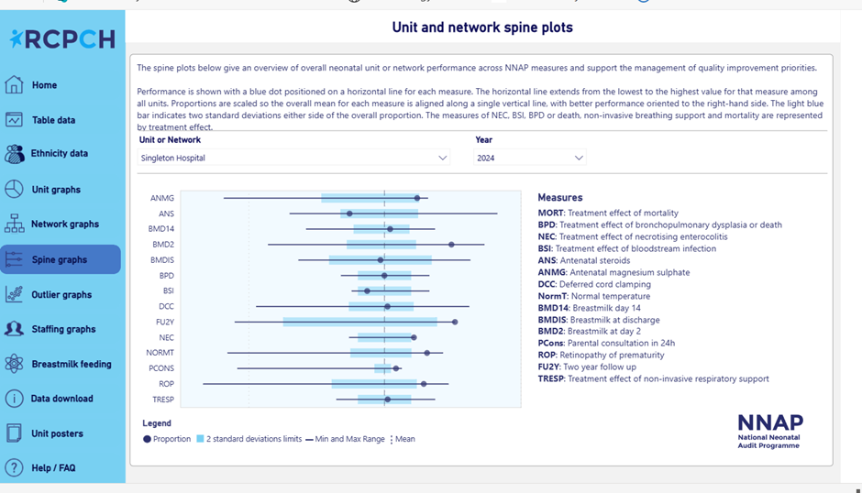

The data above shows the National Neonatal Audit Programme spine plot for Singleton hospital for 2024. This information confirms that we are within expected parameters (within 2 standard deviations, light blue bar) for all measures apart from BMD2 (Breastmilk on day 2), FUY2 (2-year follow-up), NORMT (normal temperature) and ROP (retinopathy screening on time) where we are performing better than expected (positive outliers).

The service is not a negative outlier in any of the measures in 2024. The service is below the mean (but within 2 standard deviations so not significant) in the following areas:

The suboptimal timing of antenatal steroid administration remains a recognised challenge across Wales and the wider UK. This issue is primarily driven by the inherent difficulty in accurately predicting preterm birth and ensuring that steroid administration aligns with the optimal clinical window.

An All-Wales multidisciplinary working group has been established to develop a national strategy to improve practice in this area. This work is being led by Swansea Bay University Health Board, with initial scoping outputs expected by summer 2026.

The forthcoming implementation of the All-Wales Electronic Patient Record (BadgerNet) will further support improvements in clinical decision making. By providing timely, comprehensive access to antenatal and neonatal records, including for women transferred between Health Boards for neonatal cot availability, BadgerNet, will enable clinicians to more accurately assess clinical history and optimise the timing of antenatal steroid administration in the absence of accurate predicative screening.

Bloodstream infection – the data has improved from 15% of babies <32 weeks with bloodstream infections in 2023 to 9.5% in 2024 and a reduction in the treatment effect from 10.5 to 3.6 in 2024. This is excellent progress, having been negative outliers for this measure in 2023. The service remains fully committed to reduction of infection with scrutiny of all cases of positive blood cultures and high priority given to infection prevention and control.

Breastmilk at discharge – our data is very close to the mean with an improvement from 57% in 2023 to 64.3% in 2024. There is a very active and engaged infant feeding team who have successfully achieved UNICEF Baby Friendly Initiative accreditation and the Bliss Silver award in 2025 showing ongoing improvements.

Bronchopulmonary Dysplasia – again, this measure is very close to the mean showing that this is not a significant problem and the service has shown an improvement from the 2023 data. A successful quality improvement project demonstrated a significant improvement in use of non-invasive respiratory support (another NNAP measure) which is a related measure of respiratory care and a protective factor in the development of the condition. We are continuing to monitor this measure and use evidence-based medicine to improve care in this area.

3.12 Avoiding Term Admission into Neonatal services
The service is managing and reviewing term admissions to the neonatal unit in real time and has moved the caseload into business as usual. The principal reason for admission is respiratory distress of the new-born; data analysis shows that 70% of these admissions is following planned caesarean birth. The service implemented a quality improvement project in April of this year in which high flow oxygen is delivered for up to one hour of life prior to assessing if admission to neonatal unit is required. This is carried out at the bedside mitigating any separation of mother and baby. It is too early to assess how successful this programme has been but will be reported following completion of the improvement cycle to board via the Perinatal Committee Report.

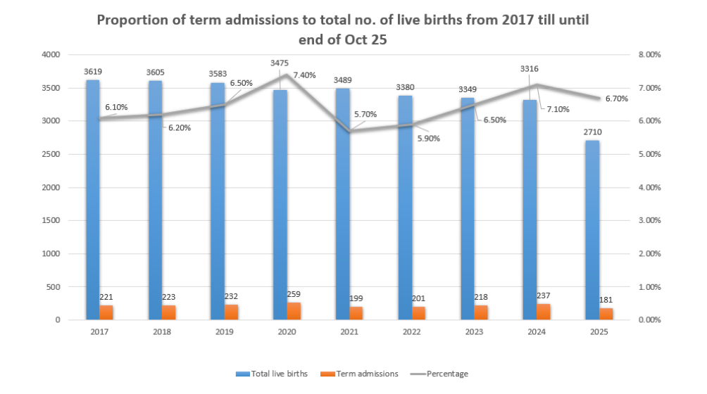
3.13 Risk Register
The perinatal Risk Register governance process and controls is set up to provide a single, controlled view of clinical and operational risks across maternity and neonatal services, ensuring timely mitigation, escalation, and assurance to the Board.

The governance structure and accountability are owned using established roles and functions of the governance process with risk ownership clearly articulated for each area. Control owners and overall accountability for Perinatal Risk governance is delegated to the Head of Midwifery and Director of Midwifery for sign off the register submissions. The Lead Midwife Quality Improvement Practitioner for Maternity/Neonatal Services ensures compliance with policy, supports risk scoring, DATIX quality, and trend analysis.

The Service Group Quality, Safety and Risk Committee receives the register, monitors progress, which is reviewed and updated monthly and escalates to Service Group Quality & Safety Committee/Board as required.

Board is informed and assured having oversight via Perinatal Committee reporting.

Risk assessments > 20 x1
A high scoring risk relating to the full implementation of the Computerised CTG system remains on the register; however, significant progress has been made, and the risk is expected to be resolved the 2nd of February.

The test server was successfully updated on 23 January, with formal testing scheduled for 26–27 January. Subject to successful testing, the system is planned to go live on 2 February. Once implemented, this risk will be closed as the digital platform will provide enhanced monitoring, improved clinical decision support, and greater consistency in fetal surveillance.

The service continues to follow established governance processes throughout implementation to ensure a safe and seamless transition.

Risk assessments >16 x2 scoring 16
Two risks currently score 16 and remain under close management. Both have clear mitigations in place, are monitored through established governance processes, and are not associated with any adverse outcomes.

Risk assessments < 16 x9 scoring less than 16
A review of current maternity and neonatal risks rated below 16 indicates that while several operational challenges remain, all are being actively managed with clear mitigation in place. No issues currently pose an immediate threat to patient safety or service continuity.

3.14 Quality Improvement Approach, Methodology and Programmes
Perinatal services adopt structured Quality Improvement methodology to ensure safe, reliable, evidence-based care for women, babies, and families. The approach is grounded in recognised improvement science frameworks and national priorities, combining local data driven change with strong multidisciplinary collaboration.

The core principles of the Perinatal Quality Improvement (QI) approach are focused on:
1. Understanding the System
Perinatal care is complex and highly interdependent. QI begins with:
- Mapping pathways (antenatal, intrapartum, postnatal and neonatal).
- Identifying variation or gaps in safety and outcomes.
- Listening to service users, including women with lived experience, partners, and advocacy groups.
2. Using Structured Methodology
Most perinatal QI programmes draw from:
- Model for Improvement (IHI), using aim statements and PDSA cycles.
- Human Factors to support improving reliability of clinical systems.
- Safety science which includes early warning systems and escalation frameworks.
3. Data-Driven Decision-Making
Perinatal QI uses:
- Real-time safety dashboards
- Incident and outcome analysis (e.g., DATIX, PMRT, MBRRACE)
- Service user feedback
- Statistical process control (SPC) charts to track change over time
4. Multidisciplinary Collaboration
Teams commonly include midwifery, obstetrics, neonatology, anaesthetics, public health, digital teams, and (critically) women/families.
5. Continuous Learning Culture
QI in perinatal settings supports:
- Daily safety huddles
- Maternity/neonatal safety champions
- Learning from excellence
- Shared learning via the Maternity and Neonatal network

Perinatal Quality Improvement Programmes
Below are some examples QI programmes undertaken within Swansea Bay University Health Board.

1. Reducing Perinatal Mortality and Morbidity
- Saving Babies’ Lives Care Bundle (SBLCB) implementation
  - Improving detection of fetal growth restriction
  - Increasing smoking cessation support
  - Optimising fetal monitoring in labour
- Enhanced surveillance of stillbirths using gap analysis and learning frameworks
- PROMPT training for obstetric emergencies
- Improved induction of labour pathways to reduce delays and variation

2. Safer Maternity and Neonatal Care
- Implementation of MEWS/NEWTT2 to improve early recognition of deterioration
- Maternity Early Warning Chart standardisation across Wales which has been implemented locally.
- Education and training programme (national programme) to improve CTG interpretation and intrapartum fetal monitoring
- Reducing postpartum haemorrhage (PPH) through risk assessment and response bundles
- Improving escalation processes during intrapartum emergencies based on the PROMPT and MONET education programmes

3. Improving Birth Equity and Personalised Care
- Programmes focused on reducing inequities in outcomes for ethnic minority groups and deprived communities
- Continuity of carer model optimisation
- Enhancing shared decision-making applying the BERAIN tool for clinicians and women in:
  - Mode of birth
  - VBAC counselling
  - Induction of labour discussions
- Implementation of our Fast Rack service, an emergency point of entry for women who are pregnant where English is not their first language via Maternity Triage.

4. Neonatal QI Programmes
- Reducing neonatal hypoglycaemia
- Implementing and leading on the PeriPREM Cymru programme aimed at optimisation of pre-term infants with a focus on 10 interventions of which here is an example:
  - Optimising early breast milk provision
  - Improving thermal care pathways
  - Optimising delayed cord clamping and physiological stabilisation
- Reducing admission of term babies to neonatal units through implementation of Avoiding Term Admission to the Neonatal Unit programme (ATAIN)
- ASTRA – a quality Improvement programme designed to test a change of at the bedside PEEP for babies born via cesaerean birth requiring immediate respiratory support with their mothers, assessing whether a long period of respiratory support and the time of transition from in-utero to life outside of the womb prevents admission to the Neonatal Unit.

5. Digital Quality Improvement in Perinatal Care
- Adoption of digital maternity records, BadgerNet electronic patient record
- Real-time digital dashboards for safety metrics
- Improving data quality for submissions to national audits

6. Workforce, Culture and Safety Initiatives
- Just Culture and restorative practice approaches by applying a systems lens to learning
- Staff experience, wellbeing and retention plan (SEWR)
- Team communication and safety culture education and training. Civility in work delivered via the PROMPT training programme
- Multidisciplinary simulation and drills in Neonatal services which now includes Maternity services and teams

3.1.15 National Awards.
Swansea Bay University Health Board’s maternity and neonatal services continue to demonstrate excellence through strong patient validated recognition and organisational accolades. In the past year, the service has secured multiple acknowledgements that reinforce its commitment to high quality, compassionate and continuously improving care.

Our teams received a substantial number of Patient Choice Award nominations, underscoring the trust and gratitude expressed by women, birthing people and families across the region. These nominations reflect exemplary professionalism, safe clinical practice and emotionally intelligent care—core components of the Health Board’s service quality ambition.

- WINNER – NHS Wales Team Culture Award - Perinatal Excellence to Reduce Injury in Premature birth Cymru: Reducing Variation in Evidence-Based Perinatal Optimisation in Wales for 'Pob Babi Bob Tro' – Clinically Led by clinicians from Swansea Bay. The team were also recognised as winners for their outstanding contribution to Healthcare Improvement.
- Shortlisted – NHS Wales Safe Care Award - Improving Patient Safety through Multi-Disciplinary Handover of High-Risk Antenatal Women.
- Shortlisted – Nursing Times Award - Midwife of the Year - Shaunna-Leigh Clarris - Swansea Bay University Health Board for her work aimed at reducing surgical site infections following cesaerean birth.
- Shortlisted – British Association Perinatal Medicine – Outstanding Team Award – Neurodevelopment team, Peer Support team and the ANNP Team.
- WINNER – Neonatal Nursing Awards - Outstanding Team Award – Tissue Team – contributions to the Nano Preterm Skin Care Guidelines.
- Shortlisted – Neonatal Nursing Awards – Outstanding Team – Medicines Management Team.
- WINNER – Chief Nursing Officer for Wales Award – Fastrack Service – Implementation of open emergency access service for women whose first language is not English for concerns in pregnancy. This has been recognised as an exemplar with all Perinatal Teams across Wales asked to implement this service.
- Special recognition – Midwife of the Year – Mariposa Awards – Rebecca Taylor, Swansea Bay University Health Board 2025 presented to pregnancy, baby and child bereavement heroes.

- FINANCIAL IMPLICATIONS
As previously advised, there will be some financial implications because of the recommendations from the Independent Review, these are currently being developed as part of developing the improvement plan.

- RECOMMENDATION

BE ADVISED THAT:
- The Perinatal Improvement Plan Executive Programme Board will develop and monitor improvement plans in response to the Independent Review, All Wales Self-Assessment and other improvement actions, will be triangulated and any gaps will be added to the overall improvement plan.
- Perinatal Improvement Programme Executive Board was held in December 2025, with workstreams agreed, Executive and service Leads assigned. Workstream meetings arranged and outputs will be reported via the Perinatal Improvement Programme Board.
- Perinatal Committee meets monthly and reviews all key metrics for perinatal services.

BE ASSURED THAT:
- The Perinatal Service does not currently have any elements of care that would flag as a Negative Outlier.
- Any stillbirths or neonatal deaths have been reported through the MBRRACE process.
BE ALERTED TO:
- There has been a strong steer nationally that there will be an All Wales maternity triage service developed as a recommendation from the All-Wales Perinatal Assessment. The Perinatal Improvement Plan Executive Programme Board has agreed to pause development of a standalone SBUHB model pending publication of the Assessment (due end of Jan 2026).
- Mitigating action to provide a single point of contact triage phoneline will be complete by February 2026. Calls will be to a single telephone entry point where women will be directed to the appropriate department based on their needs. This process will ensure that all calls for maternity triage are directed to one place.

Governance and Assurance
Link to Enabling Objectives  (please choose) | Supporting better health and wellbeing by actively promoting and empowering people to live well in resilient communities
Link to Enabling Objectives  (please choose) | Partnerships for Improving Health and Wellbeing |  | ☐
Link to Enabling Objectives  (please choose) | Co-Production and Health Literacy |  | ☐
Link to Enabling Objectives  (please choose) | Digitally Enabled Health and Wellbeing |  | ☐
Link to Enabling Objectives  (please choose) | Deliver better care through excellent health and care services achieving the outcomes that matter most to people
Link to Enabling Objectives  (please choose) | Best Value Outcomes and High Quality Care |  | ☐
Link to Enabling Objectives  (please choose) | Partnerships for Care |  | ☐
Link to Enabling Objectives  (please choose) | Excellent Staff |  | ☐
Link to Enabling Objectives  (please choose) | Digitally Enabled Care |  | ☐
Link to Enabling Objectives  (please choose) | Outstanding Research, Innovation, Education and Learning |  | ☐
Health and Care Standards
(please choose) | Staying Healthy |  | ☐
(please choose) | Safe Care |  | ☐
(please choose) | Effective Care |  | ☐
(please choose) | Dignified Care |  | ☐
(please choose) | Timely Care |  | ☐
(please choose) | Individual Care |  | ☐
(please choose) | Staff and Resources |  | ☐
Quality, Safety and Patient Experience
The Perinatal Committee reports directly into Quality and Safety Committee and noted via Service Group Quality, Safety & Risk Group and Senior Leadership Team. Key updates were received via Perinatal Committee and key measures of the high-level information have been included in section 3 of this report
Financial Implications
As previously advised, there will be some financial implications because of the recommendations from the Independent Review, these are currently being developed as part of developing the improvement plan.
Legal Implications (including equality and diversity assessment)
Nil outlined within this report
Staffing Implications
There have been some challenges within the Neonatal medical workforce due to unavailability, this has been mitigated with flexible working arrangements which has meant there has been no gap in service. A Neonatal Consultant was successfully recruited on the 9th December, with 1 expected return following maternity leave in January.

Obstetric workforce – 2 fixed term gaps for career break and other leave have been covered with no vacancies impacting on services.
Report History |  | The Perinatal Committee reports directly into Quality and Safety Committee and noted via Service Group Quality, Safety & Risk Group and Senior Leadership Team. Last reported November 2025.
Appendices |  | Nil

