Meeting Date | 30 July 2026 | Agenda Item | 5.3i
Name of Meeting | SBUHB Board
Report Title | Perinatal Committee Report
Report Author | Kathyrn Greaves – Director of Midwifery  Sujoy Banerjee – Associate Service Group Medical Director - CYPWH
Report Sponsor | Executive Director of Nursing and Patient Experience
Presented by | Elizabeth Rix, Executive Director of Nursing and Patient Experience
Freedom of Information | Open
FoI Closed detail | If closed, choose detail
Impact Assessment Summary Outcome |  | IA Completion date
N/A |  | Click or tap to enter a date.
Purpose of the Report | For Assurance
Report Summary; detailing any action required
The Health Board recognises that every woman, birthing person, baby and family using our perinatal services deserves consistently safe, high-quality and compassionate care.
While most experiences are positive, we are acutely aware that even a single instance where care falls short is one too many. This report is therefore grounded in a commitment to transparency, learning and improvement, ensuring that every voice and every experience continue to shape and strengthen our service.
The purpose of the paper is to provide the Board with an update from the Perinatal Committee providing assurance and information relating to the risks to quality, safety, and patient experience in maternity and neonatal services, with escalation of any key areas of concern.

Key Issues
A Perinatal Improvement Programme has commenced in 4 workstreams headed by an executive member following the recommendations of the oversight panel with a view to implement the recommendations of the external review.

The Perinatal Committee continues to monitor quality, safety and patient engagement and experience outcomes (business as usual) and provides a system of Alert, Advice, Assure to Quality and Safety Committee and Management Board.

Decision / Action required | No
Recommendations
Members are asked to:

Be advised that:
- There has been sustained progress across maternity and neonatal services, with improved governance, strengthened multidisciplinary working, and enhanced safety systems evidenced through HIW findings, workforce compliance, and quality metrics.
- Targeted quality improvement programmes (e.g. ASTRA, bedside respiratory support during delayed cord clamping for preterm births, digital systems such as BadgerNet and computerised CTG) are being implemented to address key drivers of risk and variation.
- Data systems are undergoing a period of transition and validation, and whilst this may impact completeness in the short term, this work is critical to strengthening long-term assurance and insight.
Be assured that:
- Robust governance and oversight arrangements are in place, including real-time monitoring, multidisciplinary review, and clear escalation pathways from ward to Board.
- All risks are actively managed with no overdue actions, with delivery aligned to planned milestones and supported through structured improvement programmes.
- There is clear evidence of learning being translated into practice, with improvements in safety, patient experience, and clinical outcomes supported by ongoing audit, thematic review, and workforce development.
- The HIW improvement plan is approved, published, and actively progressing, with strengthened oversight ensuring delivery and closure of actions.
Be alerted to:
- Ongoing system pressures, including workforce capacity, postnatal flow, and demand related to acuity and mode of birth (particularly caesarean-associated neonatal admissions).
- High-level risks that remain under active management, including paediatric radiology capacity, training delivery constraints (MoNET), and wider service configuration challenges (e.g. two-site working and critical care access).
- Transitional risks associated with digital implementation and national system dependencies, including data quality, survey limitations, and reporting consistency.
- The need to maintain focus on equity of access, consistency of escalation, and timeliness of care, as identified through HIW and internal review processes.

The service continues to provide safe, compassionate and high-quality care, with no immediate safety concerns identified, and a strong focus on continuous improvement.
PERINATAL COMMITTEE REPORT

- INTRODUCTION
The Health Board recognises that every woman, birthing person, baby and family using our perinatal services deserves consistently safe, high-quality and compassionate care.
While most experiences are positive, we are acutely aware that even a single instance where care falls short is one too many. This report is therefore grounded in a commitment to transparency, learning and improvement, ensuring that every voice and every experience continue to shape and strengthen our service.
This report is intended to provide assurance and information relating to the risks to quality, safety, and patient experience in maternity and neonatal services, with escalation of any key areas of concern.

- BACKGROUND
The Perinatal Committee was established in June 2025, to provide assurance to the Board that an evidence based, quality assured, safe, and sustainable service for women, people and babies receiving maternity and neonatal care at Swansea Bay University Health Board.

This report marks the first anniversary of the Perinatal Committee and the establishment of a strengthened ward-to-Board reporting model. Together, these have delivered a step-change in governance, improving visibility, multidisciplinary oversight, and timely escalation of risk.

Over the past year, the Committee has matured into a key assurance forum, strengthening data transparency, supporting shared learning, and enabling more responsive decision-making. The ward-to-Board approach has ensured that the voices of staff, women and families are reflected at executive level, reinforcing a culture of openness, safety and continuous improvement.

This milestone reflects meaningful progress and provides a strong foundation for continued development aligned to national standards and organisational priorities.

The Perinatal Committee reports directly into Quality and Safety Committee and noted via Service Group Quality, Safety & Risk Group and Senior Leadership Team.

Perinatal Committee and Perinatal Improvement Programme Board reporting are aligned to ensure complementary oversight; business-as-usual performance and improvement delivery are reported through respective routes, with shared visibility to Executive and Board to support robust governance and assurance.

- GOVERNANCE AND RISK ISSUES

Key updates from Perinatal Committee
As previously agreed, the following measures are some of the high-level information we review within our perinatal committee.

3.1 Number of births, caesarean section births, and Surgical Site Infection rates

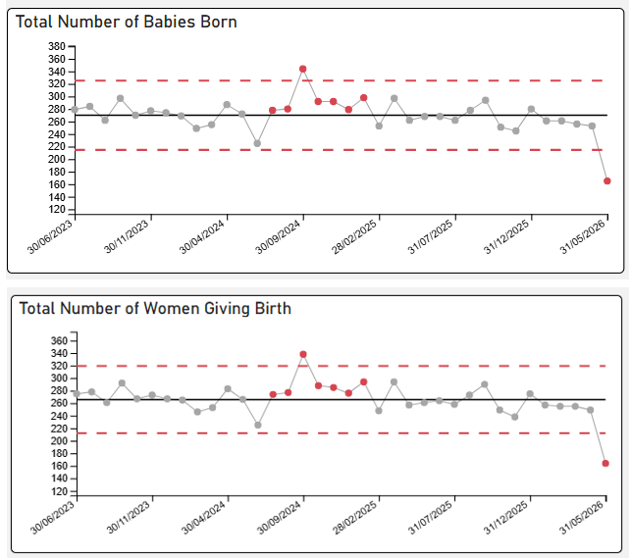
On the 19^{th of} May 2026 maternity Services switched to an Electronic Patient Record – BagderNet. Part month data presented shows the numbers of babies born on WPAS. Data from BadgerNet is going through a process of validation to ensure ongoing accurate data reporting via the dashboard.
May Birth rate
164 Women gave birth.
165 Babies were born.
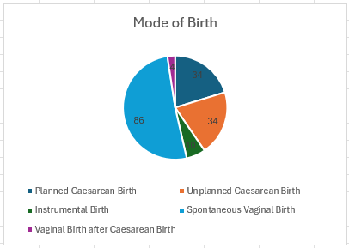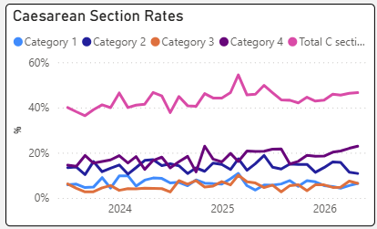
Classification of Caesarean Sections
Elective (planned) – Includes Category 3 and 4
Emergency (unplanned) – Includes Category 1 and 2

On 19 May 2026, Maternity Services successfully transitioned to the BadgerNet Electronic Patient Record system, representing a significant step forward in digital maturity and data-enabled care.

As anticipated during this transition period, the current reporting reflects partial-month activity, with birth data drawn from the legacy WPAS system. Data from BadgerNet is progressing through a structured validation process to ensure accuracy, completeness, and consistency prior to full integration into routine dashboard reporting.

Robust oversight arrangements remain in place, with data quality actively monitored and triangulated to provide continued assurance regarding safety, activity, and operational performance. This is a time-limited position, with full transition to BadgerNet reporting expected by the next reporting period.

There is a temporary risk of reduced data completeness and comparability during the transition between systems. This is being mitigated through enhanced validation processes, continued use of legacy data as a reference point, and strengthened oversight via routine review, ensuring that safety and performance remain closely monitored throughout.

NHS maternity statistics data sets suggest caesarean sections should account for 42% of births (2023/2024), there is a national upward trend in C-Sections with Swansea Bay University Health Board (SBUHB) rates recorded as 43% (as seen above). National Maternity and Perinatal Audit (NMPA) data published in 2025 (reports 2023 data i.e. lags by 2 years) reports UK planned caesarean section rate as 16.4% (15.1-17.9%). SBUHB planned caesarean section rates were 19.87% in 2023 (outlier in NMPA report), 22.85% in 2024 and 25.2% in 2025. This is consistent with an increasing trend of planned C-sections which has been reported nationally. In some parts of the UK this mode of birth has been reported as being higher than vaginal births for the first time in recorded data collection.

In contrast our Emergency C-section rate is not an outlier on NMPA report. This suggests a greater influence of maternal choice in relation to elective C-section as a mode of delivery.

The All-Wales Perinatal Assurance review, The Path to Safer Beginnings in Wales 2026, reported that rates of spontaneous vaginal birth declined since 2016, from 63% to 54% in 2023, also reflecting trends seen in other UK countries. The main contributor to this is the rise in caesarean birth, both planned and unplanned, to a total of 35.2% in 2024 (19.8% unplanned caesarean birth). Around a third of women having induction of labour subsequently had a caesarean birth (29.2% in 2023), like data from other UK countries. Those rates are reflective of the clinical complexities experienced in Swansea Bay.

A C-section working group has been established to provide women with comprehensive and balanced information, enabling them to make fully informed decisions regarding their care. The group provides strategic oversight of elective caesarean section capacity across labour ward and main theatres, ensuring alignment with daily acuity and clinical risk. The group will lead the development of a digitally enabled booking approach, integrated with Badgernet, to support forward planning in advance, optimise utilisation of theatre capacity, and improve equity, safety, and operational resilience through risk-based scheduling.

3.2 Surgical Site Infection:
Surgical Site Infection (SSI) data for all C-section shows a decrease in quarter of the number of infections reported with improvements in compliance of reporting to provide accurate data capture and tracking (Source: Public Health Wales). The service has received Q4 data from the Healthcare Associated Infection, Antimicrobial Resistance & Prescribing Programme [HARP] team. Whilst this shows a small increase in reported SSI’s (within normal variance), based on local intelligence we understand that the agreed pathway for detection and treatment was not consistently followed and have instigated corrective actions to support accurate detection and reporting.

Infection Prevention and Control and Local SSI rates
Infection prevention and control performance across maternity and neonatal services remains strong, with zero reported cases of C. difficile, E. coli, Staphylococcus aureus, and Pseudomonas bacteraemia. A single case of Klebsiella bacteraemia in NICU has been managed through established governance processes.

Surgical Site Infection (SSI) rates show expected variation, with recent months demonstrating improvement following peaks in late 2025. Key learning has focused on strengthening sampling pathways, clarifying clinical ownership, and reinforcing referral processes between primary care and community midwifery services. SSI definitions have been standardised (<14 days), with extended data collection (<28 days) continuing as part of quality improvement.

Current SSI reporting remains reliant on manual data collection and analysis. The April dataset is undergoing review to ensure completeness and accuracy prior to publication within formal reporting.

Overall, there remains robust oversight of infection risks, with ongoing monitoring, learning, and system improvements providing assurance of safe, high-quality care.

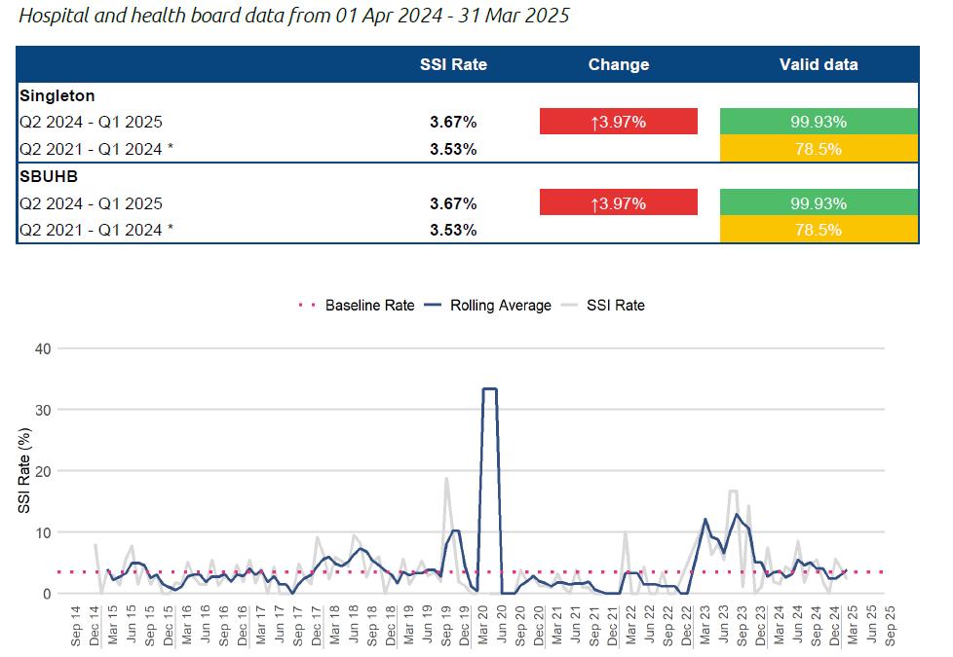

3.3 Induction of Labour delays
Delays in induction of labour continue to be monitored and escalated to ensure clinical prioritisation and service requirements to improve flow based on clinical acuity. All delays are Datix reported to ensure any triangulation of any harm as a result. Through this process of clinical risk assessment and prioritisation, no delays reported have resulted in harm.
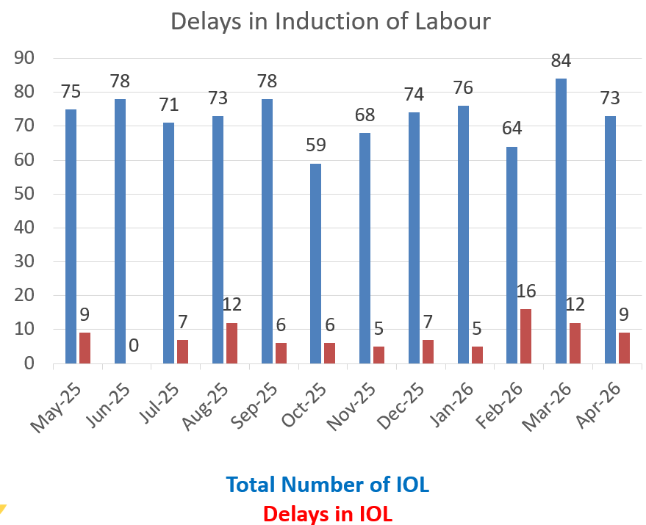
Induction of labour activity has remained stable over the past 12 months, with a low but variable number of reported delays. For May 2026, 14 delayed inductions were recorded.

During this reporting period, data completeness has been impacted by the transition to BadgerNet, with the dataset currently undergoing review and escalation to the Business Intelligence team for validation and dashboard alignment. As such, figures should be interpreted with appropriate caution during this interim phase.

Delays are typically associated with periods of increased clinical acuity. In these circumstances, services prioritise safety through dynamic risk stratification of individual cases, deferring induction only where necessary and resuming activity at the earliest safe opportunity as capacity stabilises.

Oversight of induction delays remains robust through routine clinical and governance review. Work is ongoing to strengthen the pathway through improved risk stratification, process review, and thematic analysis of delays to inform targeted improvement actions.

Overall, there is continued focus on ensuring timely, safe care, with system-wide actions in place to improve flow, enhance data quality, and support sustained improvement.
While there was no clinical harm, it is recognised that delays to induction can negatively impact women’s experience and contribute to increased complaints and concerns. This has been acknowledged and forms part of ongoing improvement work.

Overall, the position demonstrates effective identification, reporting, and review of delays, robust incident governance, and appropriate senior oversight. Controls are in place to ensure continued monitoring of IOL capacity and flow, with a dual focus on maintaining safety and improving women’s experience. The Board can be assured that delays are actively managed, reviewed, and escalated where required, with systems operating as intended.

There are no current safety concerns requiring escalation; effective mitigation and oversight arrangements remain in place during this period of transition and service acuity.

3.4 Extended Perinatal Mortality and Morbidity
All stillbirths, late fetal losses and neonatal deaths are reported to MBRRACE-UK, ensuring robust national surveillance and benchmarking of perinatal outcomes. Each case undergoes detailed internal review, and where appropriate, external scrutiny via the Perinatal Mortality Review Tool (PMRT). This supports identification of modifiable factors, strengthens organisational learning, and enables meaningful engagement with families, who are offered the opportunity to contribute to the review process with a dedicated point of contact.

We recognise that the loss of a baby has a profound and lasting impact on women, families and staff, and remain committed to providing compassionate care alongside robust, safe clinical services that seek to minimise harm and prevent avoidable loss wherever possible.

The most recent published MBRRACE data demonstrates an improving position. The crude perinatal mortality rate reduced from 7.49 per 1,000 births in 2023 to 5.73 per 1,000 births in 2024. The stabilised and adjusted rate for 2024 is 5.46 per 1,000 births, which is in line with the average for comparable UK organisations, indicating a stable and benchmarked performance.

There is no new national data available for this reporting period. MBRRACE reports are published on a lag basis, with 2025 birth data expected in Quarter 3/4 of 2026/27. In the interim, local surveillance and PMRT processes continue to provide ongoing oversight, assurance, and opportunities for continuous learning and improvement.

3.4.1 Stillbirths from January 2026
Between January and May 2026, three stillbirths have been reported, all of which will be included within MBRRACE-UK national reporting in line with established criteria. Each case is subject to detailed review processes to support learning, assurance, and compassionate engagement with families.

The service recognises that the death of a baby is a deeply devastating and life-changing experience for women, families, and the staff who care for them. We remain committed to providing compassionate, personalised support while ensuring robust, safe clinical services that seek to minimise harm and prevent avoidable loss wherever possible.

Based on national rates, a service of this size would expect approximately 12–13 stillbirths annually. The Health Board’s crude stillbirth rate for 2025 has been revised from 3.68 to 3.4 per 1,000 births following MBRRACE review and clarification of a complex case. This represents an improvement compared to 2023, where the rate was 4.79 per 1,000 births (13 stillbirths), indicating a positive trajectory over time.

Overall, the service remains aligned with national reporting requirements, with continued emphasis on learning, compassionate care, and sustained improvement in outcomes.

Learning from Stillbirth review:
A thematic review of stillbirths in 2025 has identified key areas for learning and improvement, with a continued focus on strengthening clinical practice, early recognition of risk, and timely escalation.

The service recognises that the loss of a baby is a profoundly distressing and life-changing experience for women and families. A robust, multidisciplinary approach to case investigation remains a key priority, supporting families to understand why their baby died while ensuring that learning is translated into meaningful improvements in care. Families are actively encouraged and supported to contribute to the review process, including sharing their questions, concerns and reflections, to provide clarity, promote openness, and support compassionate engagement throughout.

The recent MBRRACE 2024 report confirms that the Health Board’s stabilised and adjusted stillbirth rate is 3.54 per 1,000 total births, which is in line with organisations of a similar size across the UK, indicating a stable and benchmarked position. Finalised adjusted rates for 2025 will not be available until Quarter 3/4 of 2027 due to national reporting timelines.

Key areas of learning include:
- Growth surveillance and reduced fetal movements: Reinforcing the need for comprehensive antenatal assessment, including abdominal palpation and updated symphysis–fundal height measurement.
- Antenatal engagement and clinical curiosity: Strengthening responses to non-attendance through personalised care, exploration of barriers, and improved engagement.
- Recognition and escalation of maternal deterioration: Embedding timely review in response to MEWS triggers, supported by the implementation and audit of All Wales MEWS across all relevant clinical areas.

Overall, this thematic work demonstrates a continued commitment to compassionate, family-centred care, robust investigation, and system-wide learning to improve outcomes and reduce avoidable harm.

3.4.2 Neonatal Deaths 2026 with summary statistics from 2025

Between January and May 2026, three neonatal deaths have been reported, two of which meet MBRRACE-UK reporting criteria. The crude neonatal mortality rate for 2025 is 1.23 per 1,000 births. Final validated MBRRACE rates will be available in Quarter 3 2027; however, current intelligence indicates the Health Board is not an outlier.

The recently published MBRRACE 2024 report identifies a stabilised and adjusted neonatal mortality rate of 1.93 per 1,000 live births, which is in line with comparable UK organisations.

Each case has been subject to robust multidisciplinary review. No evidence of unsafe care, recurrent harm, or systemic failure was identified, with all cases categorised as Grade B, where care issues did not impact outcome.

Learning from the 2025 reviews has been identified at a system level, reflecting the complexity of caring for extremely preterm and critically unwell infants. Key areas include strengthening communication and antenatal coordination across Health Boards, maintaining vigilance in high-acuity airway management, and improving consistency in documentation and governance processes. Isolated documentation and prescribing omissions were identified without harm and are being addressed through ongoing quality improvement.

We recognise that every neonatal death represents a profound loss for families. The service remains committed to ensuring compassionate, transparent engagement, alongside rigorous investigation and continuous learning to strengthen care and improve outcomes.

Figure: 11 year running stabilised and adjusted mortality rates for SBUHB including latest published year 2024. Note SBUHB separated from POW in in 2019 resulting in reduction in births attributable to SBUHB (Data source MBRRACE UK)

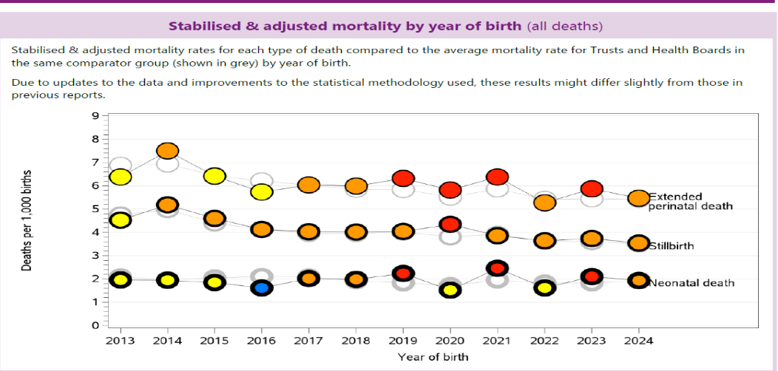

3.4.3 Other observations from the MBRRACE 2024 report:

3.4.3.1 SBUHB Births – MBRRACE 2024 Demographic data capture ​

The local maternity population profile shows some variation when compared to national benchmarks. The proportion of mothers aged under 25 is higher than the UK average (18% vs 13.5%), noting MBRRACE evidence that both younger (<25) and older (>34) maternal age groups are associated with increased perinatal risk.
Mothers accessing care within SBUHB are less likely to live in areas of high socio-economic deprivation compared to the UK population overall.

Ethnicity data completeness remains a limitation, with a high proportion recorded as “not known,” restricting assurance and benchmarking. Improving data quality is a priority, with the implementation of BadgerNet expected to strengthen the accuracy and completeness of ethnicity recording.

In relation to gestational age, the proportion of extremely preterm births (24–27 weeks) is comparable to the UK (0.7% vs 0.4%), while births at 28–31 weeks are higher than the national average (1.3% vs 0.8%). The proportion of post-term births (≥42 weeks) is similar to national levels (2.7% vs 1.1%), requiring continued oversight to ensure optimal timing of birth.

Overall, these factors provide important context for understanding local population risk and inform targeted surveillance and improvement actions.

Population risk factors are understood and actively monitored, with appropriate oversight and targeted actions in place; no immediate concerns requiring escalation.

3.4.3.2 MBRRACE Reporting timeline benchmarking

Timely reporting within 7 working days of still births and late fetal losses increased from 53% to 79% in 2024 when compared to 2023. Similarly, timely reporting for neonatal deaths also increased from 75% to 100% during this period.

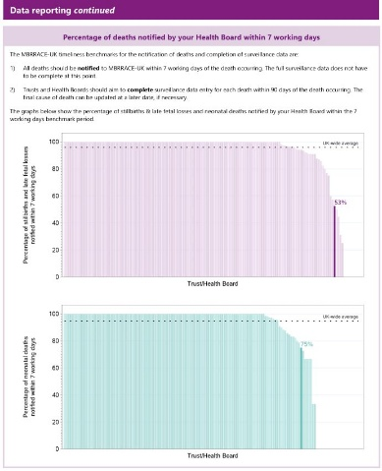
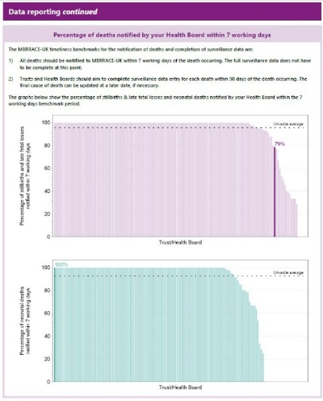

      - MBRRACE data reporting completeness

We are pleased to report that our data reporting completeness for key data items for deaths was 100% for 2024. This was a significant improvement from 2023
2023 2024
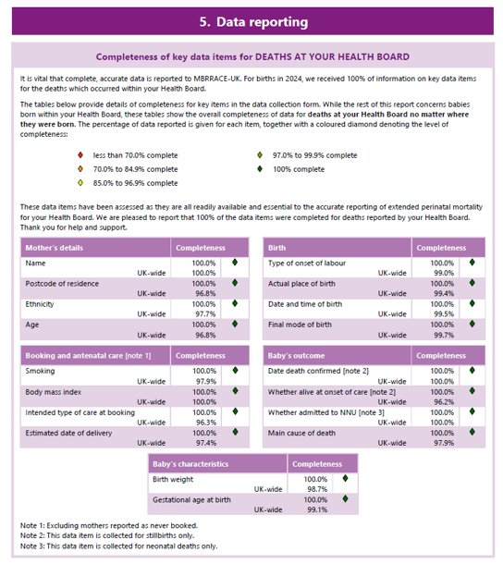
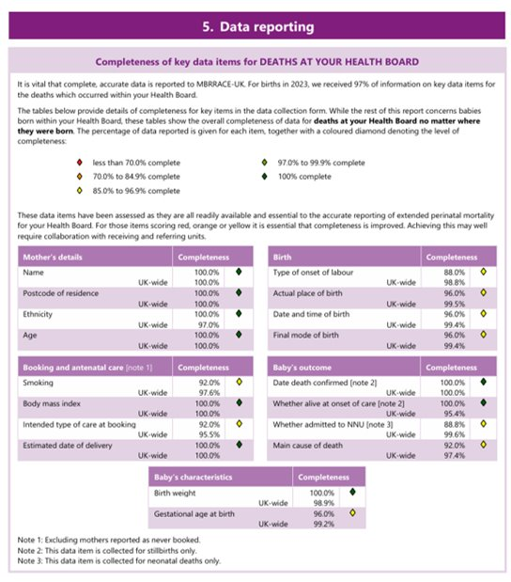

3.5 Hypoxic-Ischemic Encephalopathy (HIE) from January – December 2025

There has been no moderate to severe HIE cases reported January to May 2026.
There is limited data published to allow National benchmarking. Latest published data from National Neonatal Research Database (NNRD) is 4 years out of date (Department of Health, 2021 data). This reports a UK average incidence for Moderate and Severe HIE cases of 1.59/1000 births (1.49-1.70).

Due to the low number of HIE and births in SBUHB a rolling 12-month HIE incidence reporting is more appropriate. This shows that in April 2026 our moderate to severe rolling 12-month HIE rate was 0.94/1000 births. This represents a 72% decrease since its peak in April 2024 of 3.32/1000 births.
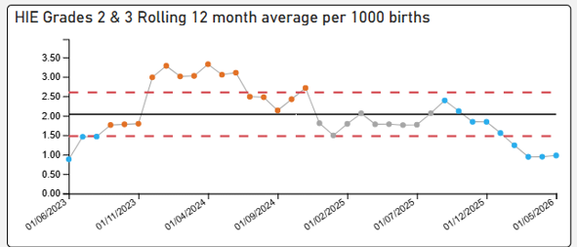
No HIE IN 2026
As seen, there are 7 plots below centre line of 2.1 therefore showing a SHIFT in data. This is a strong example of special cause variation. This data is not impacted my implementation of Maternity BadgerNet
Monitoring will continue
HIE 2 and 3 rolling 12-month average – 0.98

The absolute 2025 HIE rate (Jan-December)
was 1.68/1000 births.

Learning from 2025 HIE reviews: All cases of babies diagnosed with HIE requiring active cooling are subject to robust multidisciplinary review, with joint feedback provided to families as part of a transparent and compassionate process.

Learning from 2025 identified a small number of cases where there were delays in the recognition and escalation of abnormal antenatal Cardiotocograph (CTG) traces. In response, a formal risk assessment was undertaken and escalated via the risk register, supported by an approved and funded business case.

Computerised CTG monitoring has now been implemented within the Obstetric Unit (June 2026), strengthening standardisation, clinical decision-making, and early identification of fetal compromise.

Further learning has highlighted the importance of timely recognition and management of uterine hyperstimulation and avoiding delays in expediting birth. These themes continue to be reinforced through mandatory training, including the Intrapartum Fetal Surveillance study day.

Overall, there is clear evidence that learning has been translated into system improvement, with continued focus on early recognition, timely escalation, and safe intrapartum care.
Learning has been effectively translated into safety improvements, with strengthened monitoring and oversight arrangements in place; no immediate concerns requiring escalation.

3.6 Triage Metrics
BSOTS activity remains consistent, with April 2026 reporting 575 attendances (526 BSOTS; 49 non-BSOTS). Compliance with 15-minute triage is reported at 90.96%, with a small proportion of women seen between 15–30 minutes (6.08%) and over 30 minutes (3.8%).

Attendance patterns remain stable, with the most common reasons including reduced fetal movements (29.3%), abdominal pain (12.6%) and PPROM/SROM (8.7%).

During May 2026, the service transitioned from paper-based audit to a digital BSOTS audit via BadgerNet. Early digital data suggests lower reported compliance (68.6%), likely reflecting differences in data capture and completeness when compared to retrospective paper audit. As such, current performance should be interpreted with caution during this transition phase.

A structured approach is in place to validate and merge datasets, embed the digital audit process, and improve the timeliness and accuracy of recording. This is expected to strengthen real-time oversight, data reliability, and governance going forward.

Triage performance remains stable with no immediate safety concerns; data quality is being actively managed through transition to digital audit, with improved assurance anticipated following validation and full implementation.

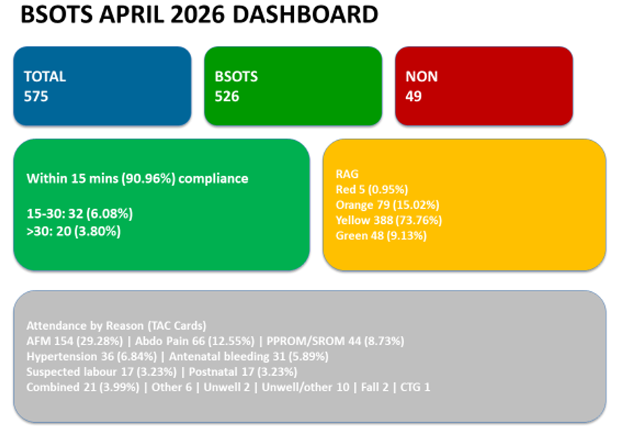

A review identified 17 obstetric delays following initial assessment and risk stratification (yellow and amber). Importantly, there were no associated harm incidents, and outcomes remained safe.

The implementation of a single telephone access point for maternity services, which successfully went live on 3 March 2026, represents a significant step forward in improving the accessibility, coordination, and safety of care for women and families. This new unified contact route streamlines how service users seek advice, report concerns, and access timely clinical support, replacing previously fragmented pathways that could create delays and inconsistency. By centralising triage through a dedicated and clinically supported hub, the service enhances real-time decision-making, ensures equitable access regardless of entry point, and strengthens early identification of risk.

Operational review has identified a combination of data and system challenges alongside frontline service pressures, notably related to call handling capacity and demand at peak times.

From an operational perspective, call volumes have at times exceeded safe handling capacity, resulting in pressure on the shop floor to manage intake, triage calls, and ensure timely assessment of women. This has created challenges in balancing call management with the need to see women promptly. These pressures have been recognised and escalated through established operational routes.

Importantly, service user feedback has been constructive, with women highlighting the benefit of having one clear, direct line of access. A positive improvement has now been implemented, with a single direct contact line in place for service users, improving clarity, accessibility, and user experience.

Overall, while pressures on systems and capacity have been identified, escalation processes are functioning effectively, user experience improvements have already been delivered, and actions are underway with corporate and national support to address underlying data and system limitations. There is ongoing oversight to ensure safety, responsiveness, and learning across the pathway.

Monitoring arrangements are in place, including monthly data review, feedback from community teams, and incorporation of service user voice. Actions to improve awareness, access and consistency, such as wayfinding signage, national Open Access cards, and targeted engagement with under-represented groups, are underway.

The Board can be assured that this improvement programme is being implemented in a controlled manner, with clear governance, ongoing evaluation of effectiveness, and the ability to respond promptly to emerging learning or impacts.

Local Swansea Bay data remains critical in developing a fuller and more accurate understanding of service demand and access across the pathway. Current intelligence is therefore being strengthened through continued local data contribution to complement national reporting and inform improvement work.

Following successful implementation of BadgerNet on 19 May 2026, the service has transitioned to a digital recording and reporting system, providing the foundation for improved data clarity, timeliness, and consistency across pathways.

As expected during this implementation phase, a period of data cleansing and validation is required to ensure accuracy, completeness, and alignment across legacy and digital datasets. This remains a critical priority for the service and is being actively managed to support reliable reporting.

Once embedded, BadgerNet is expected to significantly enhance real-time operational oversight, strengthen data quality, and improve understanding of the system of safety, enabling more responsive and informed decision-making at all levels.

Robust arrangements are in place to oversee data quality during implementation; no immediate concerns regarding safety, with improved assurance anticipated as data validation is completed.

3.7 Third and fourth-degree tears

Twelve-month trend data for 3rd and 4th degree tears demonstrates expected variation, with recent performance indicating a return to levels consistent with normal clinical variation.

Benchmarking remains favourable. The National Maternity and Neonatal Audit (2023) reports a UK incidence of 3.29% (2.60–3.80), and SBUHB’s 2025 rate is 3.37%, within the expected range and representing an improvement from 4.08% in 2024. A slight increase was observed in February 2025 (4.7%); however, overall trend performance remains stable and compares well against national benchmarks, including RCOG guidance.

Episiotomy rates also remain comparatively low, with April reporting a rate of 6.1%, notably below the published England rate of 13.9% (2023/24). Instrumental births, which carry a higher risk of perineal trauma, are subject to detailed review, including audit of episiotomy practice. Findings are routinely monitored and reported through the Maternity Dashboard Scorecard to support transparency and continuous improvement.

Variation reflects case mix, including higher rates among first-time mothers. Enhanced data stratification, including parity analysis, will be developed through BadgerNet to further strengthen insight and targeted improvement.

Ongoing work to improve data reporting and visualisation will support clearer interpretation and sustained oversight.
Performance remains within expected national variation and demonstrates improvement, with no immediate concerns; continued monitoring and enhanced data insight will further strengthen assurance and quality improvement. The Board can be assured that this metric is actively monitored, that earlier interpretation has been validated by subsequent data, and that systems remain in place to identify risk early and respond promptly should further action be required.

Birth Mode | Number 3rd degree | Number 4th degree
Spontaneous vaginal birth | 4 | 0
Spontaneous vaginal birth – labour and birth in a pool | 0 | 0
Instrumental birth Ventose/Forceps | 1 | 0
Failed instrumental birth converted to caesarean birth | 0 | 0

3.8 Postpartum Haemorrhage

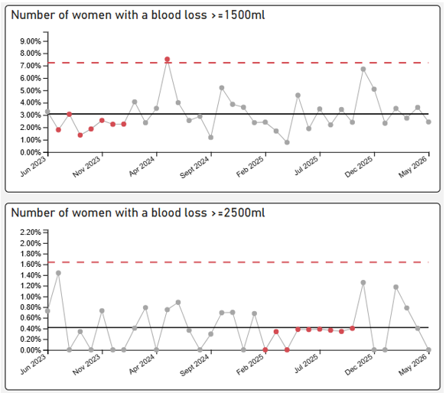
​The NMPA published 2023 data for National benchmarking and reported postpartum haemorrhage incidence as 3.41/1000 births (2.98-3.79). SBUHB rate for postpartum haemorrhage in 2025 was reported as 2.49/1000 births, lower than the National benchmark. This showed a steady reduction from 2024 data, of 3.51/1000 births.
May 2026 – PPH >1500ml rate is 2.44% and PPH >2500ml is 0%

In May 2026, reported cases of obstetric haemorrhage demonstrated expected normal variation. All identified cases were subject to rapid multidisciplinary review, confirming appropriate risk assessment, adherence to clinical guidance, and no evidence of concerns relating to care delivery. Learning is reviewed in real time to support continuous improvement.

Interpretation of current data should be considered within the context of the transition to BadgerNet, with an incomplete dataset during this implementation period. Oversight remains robust throughout this transition, with continued clinical surveillance in place.

Benchmarking against national data remains favourable. The NMPA (2023) reports a UK postpartum haemorrhage rate of 3.41 per 1,000 births (2.98–3.79), compared to SBUHB’s 2025 rate of 2.49 per 1,000 births, demonstrating improvement from 3.51 per 1,000 in 2024.

Overall, the service continues to demonstrate safe management of obstetric haemorrhage, with ongoing monitoring, validation of data, and assurance processes in place.

Performance remains within expected variation and below national benchmarks; robust oversight continues during data transition, with no immediate safety concerns identified.

3.9 Maternal Intensive Care Unit (ICU) Admissions
Robust escalation processes for women requiring higher levels of care remain well established, supported by strong multidisciplinary collaboration between the Perinatal Team, Intensive Care, and Emergency Department. A standard operating procedure ensures timely identification, escalation, and coordinated management for women admitted outside maternity services.

There have been no maternal ICU admissions since September 2024, consistent with expected patterns. One recent ITU admission following caesarean section and postpartum haemorrhage was managed appropriately in line with established protocols, reflecting effective escalation, multidisciplinary working, and continuity of care.

All admissions to higher-acuity environments trigger mandatory DATIX reporting and are subject to comprehensive governance oversight. This is further strengthened by daily Health Board SITREP processes, which provide real-time visibility of women receiving care outside maternity settings and enable oversight and escalation comparable to formal data reporting systems. This ensures timely multidisciplinary review, coordination of care, and senior clinical involvement.

Current reporting should be considered in the context of the transition to BadgerNet, with ongoing data validation to ensure accuracy and completeness. Data quality remains under active management during this period.

Overall, there is clear evidence of effective escalation pathways, strong multidisciplinary working, and robust governance arrangements, ensuring safe care delivery and continuous oversight.
Escalation pathways and governance arrangements remain robust and effective, with no immediate safety concerns; real-time SITREP oversight complements formal reporting, ensuring continued assurance during system transition.

3.10 Perinatal Incident Reporting
Sustained improvement has been achieved in reducing overdue incidents across perinatal services, with strengthened processes supporting timely review, investigation, and closure. Weekly incident review meetings, alongside rapid multidisciplinary review of incidents involving moderate harm and above, ensure early identification of learning and prompt action.

Learning is consistently disseminated through established channels, including safety alerts, the monthly Risky Business newsletter, and regular risk and governance meetings, supporting a culture of openness and continuous improvement across the service.

During the transition to BadgerNet, incident data continues to be actively monitored, with ongoing validation processes in place to ensure accuracy and completeness of reporting. Oversight arrangements remain robust throughout this period.

Overall, there is clear evidence of improved incident governance, strengthened learning systems, and continued focus on embedding timely, high-quality review processes.
Incident management processes are robust and continue to improve, with no immediate concerns; active oversight during system transition ensures continued assurance of safety and governance.

Duty of Candour (DoC) processes are in place and timely. The Legal redress cases are reducing slowly.

Perinatal DoC cases – as of 01.06.2026

A further break down of incidents in relation trigger categories can be seen in the chart below:

Types of incidents – Perinatal Services – 01/05/26 -31/05/2026
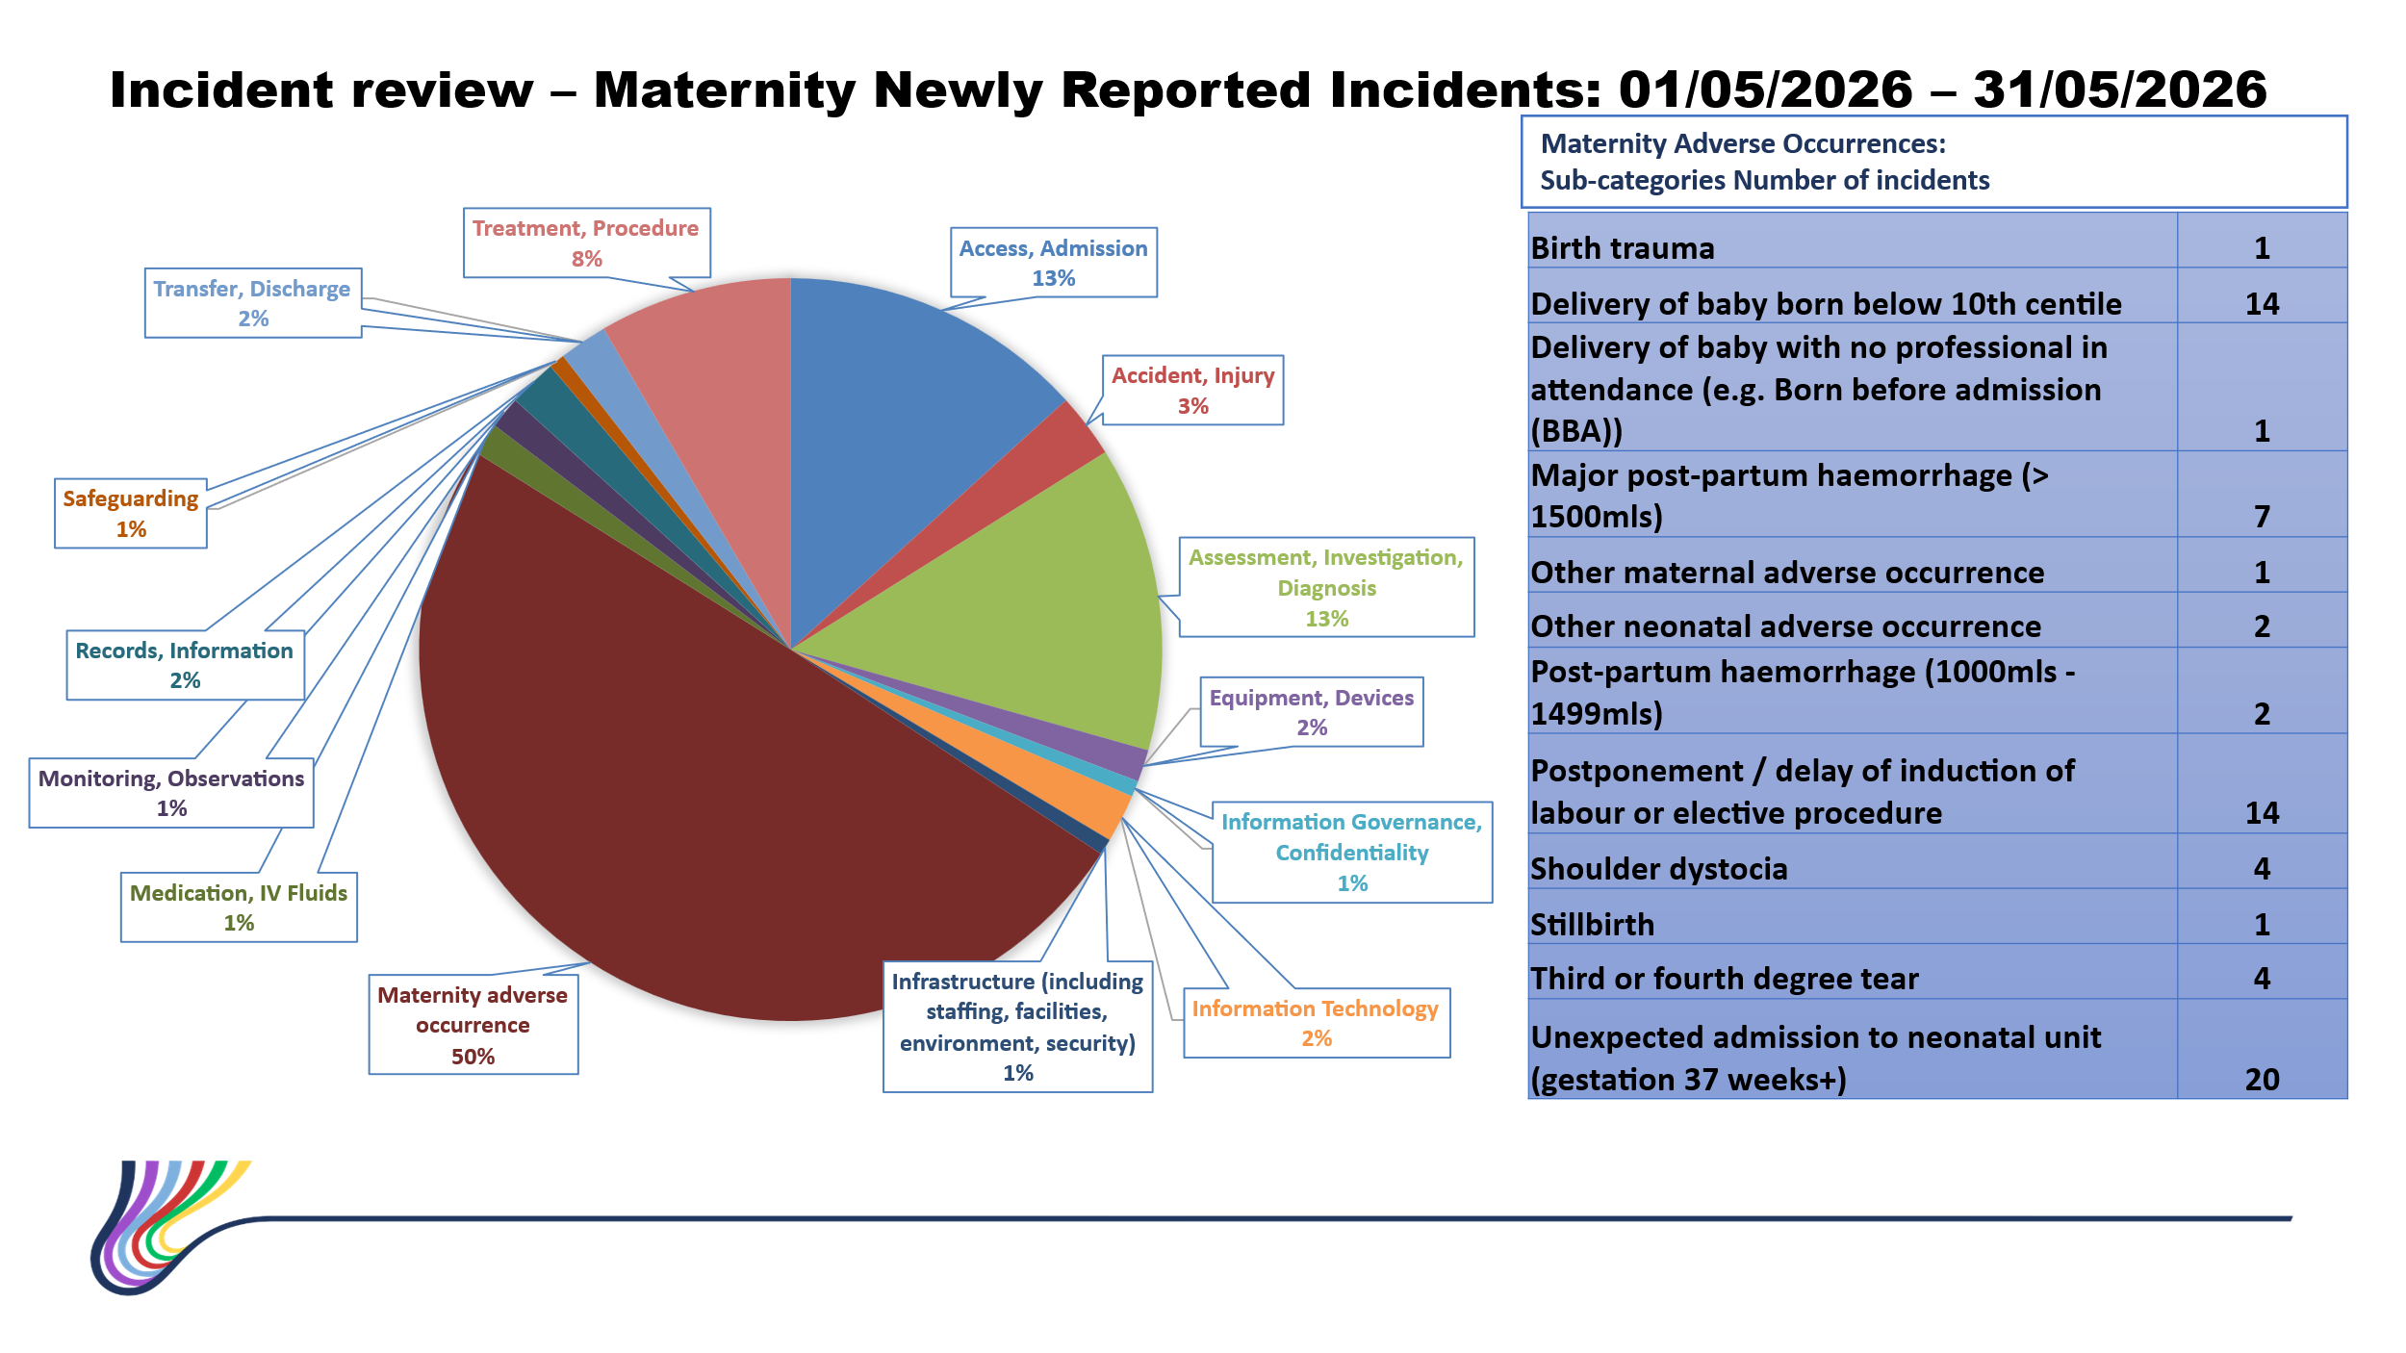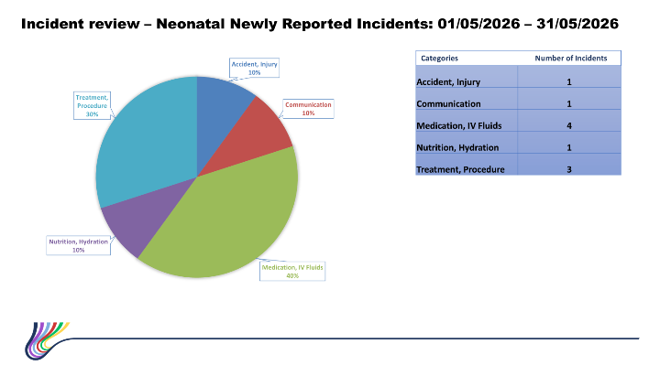

Mandatory incident reporting continues for key perinatal indicators, including unexpected term neonatal admissions, small for gestational age babies, shoulder dystocia, and babies born before arrival. All relevant cases are subject to routine multidisciplinary review, with learning captured at both individual and thematic levels.

A thematic review had identified opportunities for quality improvement, including the introduction of ASTRA (Avoiding Short Term Respiratory Admissions) in April 2025, a targeted intervention aimed at reducing avoidable neonatal respiratory admissions.

An analysis of 12 months of data has been undertaken recently. Unfortunately, the data does not indicate a clear sustained reduction of term admissions to the neonatal unit or the proportion attributable to respiratory causes.

There is month-to-month variation, with some periods of improvement, but this is not consistently maintained.

Respiratory presentations continue to account for a substantial proportion of term admissions, suggesting that further work is required if the aim is to reduce avoidable mother–baby separation.

Further work is underway to identify if the intervention is more effective at certain gestation cut off

During the transition to BadgerNet, data completeness and validation remain a priority, although the Badger data for neonatal admissions shouldn’t be affected. Reporting should therefore be interpreted with consideration of an evolving dataset; however, as a precaution oversight arrangement remain robust, ensuring continued monitoring of safety and emerging trends.

Progress and learning continue to be overseen through Perinatal Committee governance arrangements, with regular updates supporting transparency, continuous improvement, and alignment with the wider system of safety.
Robust reporting and governance processes remain in place, with no immediate safety concerns; ongoing evaluation and data validation will further strengthen assurance as the system embeds.

3.11 Patient Feedback and Experience
Women’s experience continues to be a key component of quality and safety oversight, with multiple mechanisms in place to capture, respond to, and learn from feedback. In May 2026, overall satisfaction through the Friends and Family Test was 87.3%, with consistently positive feedback highlighting compassionate, professional, and responsive care across maternity and neonatal services.

The service continues to respond proactively to feedback, with senior midwifery and nursing teams engaging directly with women and families where concerns are raised, ensuring experiences inform real-time improvement. Common themes relate to access and waiting times within antenatal services; a comprehensive review is underway to streamline pathways and improve coordination for women with complex care needs.

A recent change in radiology systems, with the implementation of the ViewPoint application, has impacted delivery of the NHS Core Maternity Questionnaire (Phases 1 and 2). The system does not currently allow reliable confirmation of an ongoing viable pregnancy following key scan milestones. As a result, the service is not able to confidently issue these surveys at present, to avoid the risk of inappropriate communication following pregnancy loss. This has been appropriately identified, risk assessed, and escalated at an All-Wales level, with national discussion underway to agree a solution.

In the interim, local feedback mechanisms remain robust. Friends and Family Test data, alongside additional experience routes, continue to be actively monitored and triangulated through the Perinatal Women’s Experience Forum. A consolidated action log supports oversight (32 actions, 4 completed), ensuring feedback is translated into meaningful improvement, with progress reviewed through established governance arrangements.

Targeted improvement activity continues, including development of the Neurodiverse Maternity Care Plan and inclusive engagement initiatives such as the Visible Voices project. Communication and engagement through digital platforms are expanding, supporting better access to information and increased service user engagement.

There are currently 8 formal concerns in progress. While 3 are overdue due to case complexity, all are actively managed through appropriate governance processes.

A recent patient story further highlights the impact of compassionate, family-centred care, reinforcing the importance of personalised support and continuity during complex neonatal journeys.
Women’s experience remains positive, with robust mechanisms in place to capture and act on feedback; system risks are promptly identified and escalated, with continued assurance provided through strong governance and alternative feedback routes during national system constraints.

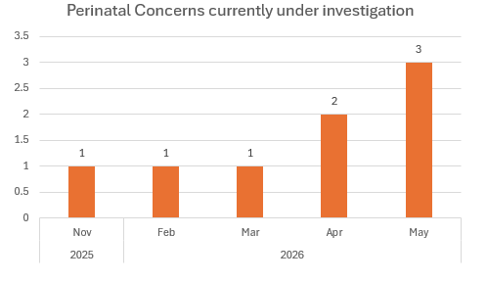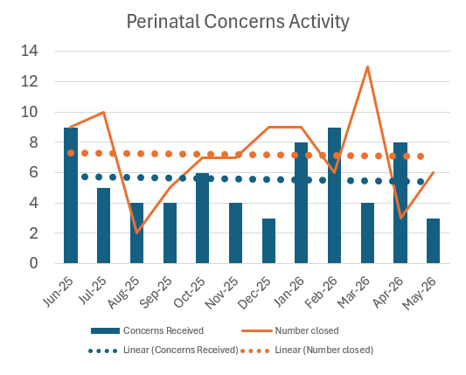
3.11.1 Engagement with Diverse Communities – Maternity Services
Significant progress has been made since the last Board update in strengthening inclusive, culturally responsive maternity care, underpinned by meaningful engagement with women, families and communities.

The service has expanded its approach to co-production, working closely with community partners including Mums and Toddlers Foundation, Chai and Chat, and local advocacy groups to ensure diverse voices shape service design and delivery. This includes targeted outreach to underrepresented communities and plans to establish a BAME Advisory Network to embed lived experience into policy and improvement decisions.

Mechanisms to capture feedback have been strengthened through expanded survey approaches, engagement sessions, and improved accessibility, including use of translation services and culturally informed questioning. These insights are actively informing service development and pathway redesign.

Targeted initiatives demonstrate tangible progress. The Inclusive Caesarean Imagery Project continues to address representation across different skin tones, supported by national partnerships and multidisciplinary collaboration. The Neurodiverse Maternity Care Plan is progressing, informed by direct engagement with families, with a focus on improving personalised care and consistency of practice.

Community engagement has broadened further through the Visible Voices project, local events, and partnership working with voluntary sector organisations. This has enhanced reach, particularly to seldom-heard groups, and strengthened understanding of the needs of diverse populations.

Improved coordination of experience data is also evident, with combined action logs and strengthened governance oversight ensuring that feedback is systematically translated into measurable improvement, with 32 actions currently tracked and progress actively monitored.

Staff capability continues to be supported through ongoing equality, diversity and inclusion training, alongside practical changes within clinical environments, including multilingual information, improved accessibility, and enhanced use of interpretation services.

Overall, this programme of work demonstrates a comprehensive and embedded approach to inclusion, with increasing evidence of impact across service delivery, experience, and engagement.
There is clear evidence of sustained progress in embedding inclusive, person-centred care, with strong community engagement and governance oversight in place; no immediate concerns, with continued development supporting equitable access and experience for all families.

3.11.2 Strengthening Partner Voice and Feedback Mechanisms
- Strong collaborative engagement continues with community partners to support inclusive representation within maternity services, with project naming currently being considered by members of the Mothers and Toddlers Foundation, demonstrating co-production from the outset.
- Inclusive clinical imagery work is progressing, supported by medical photography, to improve representation of caesarean wound healing across diverse skin tones, addressing an identified gap in patient education and equity.
- Creative partnerships are in place with a local artist to develop clinically accurate visual representations of healthy and unhealthy caesarean wounds, supported by ongoing clinical research and professional oversight to ensure safety, accuracy and relevance.
- Grant funding applications have been progressed, including submission to the British Skin Foundation with Skin for All as co-applicant, providing reassurance that sustainability and scalability are being actively explored.
- Clear pathways for implementation have been identified, with potential use across BadgerNet, social media and ward-based resources, ensuring maximised impact and consistency of messaging.
- Liaison arrangements are established with Medical Photography and the Tissue Viability Team, reinforcing robust governance, clinical assurance and multidisciplinary engagement.
- Future integration of real family stories is planned, supporting authentic representation and ensuring lived experience continues to inform service improvement and digital outputs.

Other Updates
Since the previous Board update, significant progress has been made across engagement, digital communication and community partnership work, demonstrating sustained momentum and increasing impact.

The Perinatal Engagement Framework remains aligned to the national programme, with no change in overall position. Progress is expected to accelerate through NHS Performance & Improvement oversight, with assurance provided locally through Consultant Midwife leadership and clear escalation routes to maintain pace and alignment.

The Digital and Social Media Strategy has advanced significantly. Eight educational videos have been developed, with key content now commissioned and filmed, including Bay Birth Unit tours and LSCS/episiotomy information. This work is supporting improved transparency, informed choice and preparedness for families. Further filming across additional sites is planned to enhance equity of access.

The launch of refreshed maternity social media platforms has demonstrated strong early success, with high levels of engagement and no negative interactions recorded. Growth in reach and participation, particularly across bilingual platforms, provides reassurance that digital communication is strengthening connection with families and supporting a listening, responsive approach to care.

Community engagement has broadened and deepened since the last report. New partnerships, including engagement with Chinese in Wales, alongside ongoing collaboration with the Mother & Toddler Foundation, are strengthening culturally responsive care and ensuring diverse voices shape service development. The Visible Voices project continues to progress, widening engagement and enhancing understanding of lived experience across communities.

Governance of experience and engagement has also strengthened. A single, combined maternity experience action log is now in place, improving oversight and accountability, with 32 actions currently tracked and early delivery evidenced. This provides clearer visibility of how feedback is translated into improvement.

Overall, there is clear evidence of a coordinated, multi-channel approach to engagement, with digital, community and governance developments working together to amplify the voice of women and families and support continuous service improvement.

Progress since the last update demonstrates sustained delivery and increasing impact, with strong governance and oversight in place; no immediate concerns, with continued alignment to national programmes and local priorities.
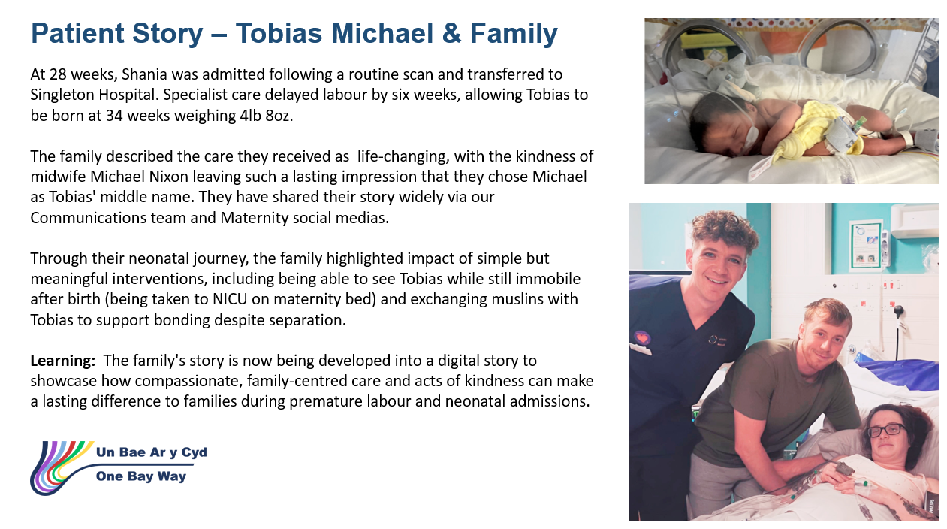

3.12 Workforce
Overall compliance with statutory and mandatory training across perinatal services remains strong, with the majority of staff groups consistently meeting or exceeding the Welsh Government target of 85%. Midwifery, neonatal and wider nursing workforce compliance remains particularly high, generally sustained above 90%, demonstrating good engagement and organisational commitment to maintaining safe, skilled staffing.

Medical workforce compliance has improved over time and is now largely at or above target for obstetric and neonatal staff, although some earlier variation highlights the need for continued focus on maintaining consistency.

Key safety-critical training areas—including PROMPT, fetal surveillance, NLS and safeguarding—continue to show high compliance levels overall. However, some emerging gaps are noted:
- Maternity workshop compliance remains lower following its recent introduction, reflecting the expected lag in uptake during early implementation.
- GROW training compliance for midwives has declined slightly, with current levels below target, requiring targeted action to support recovery.
- Neonatal Life Support (NLS) compliance is largely stable, with scheduled training expected to further strengthen performance.
Specialist training programmes highlight areas for development. Qualified in Specialty (QIS) training remains constrained, with progress impacted by workforce capacity and study leave limitations. MoNET training delivery is currently paused pending national programme review, with resumption planned once guidance is confirmed.

Overall, training compliance demonstrates a stable and improving position, with clear plans in place to address emerging gaps, support new programme implementation, and maintain alignment with national standards.
Workforce training compliance remains strong and broadly compliant with national standards; identified gaps are understood and actively managed, with no immediate safety concerns.
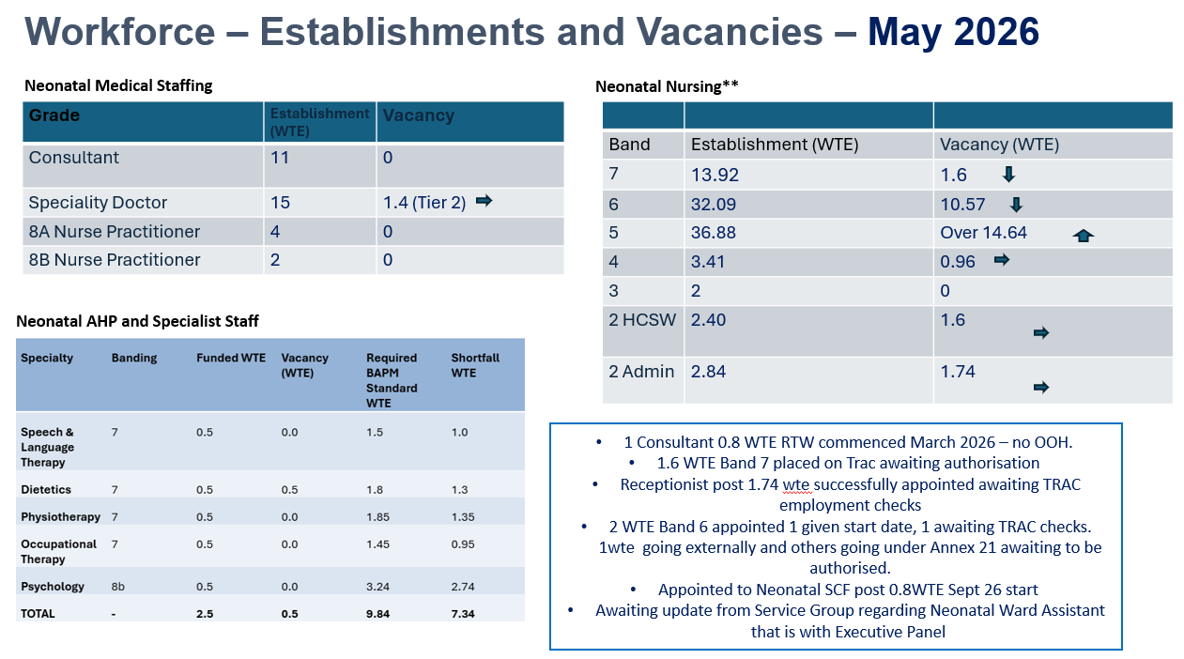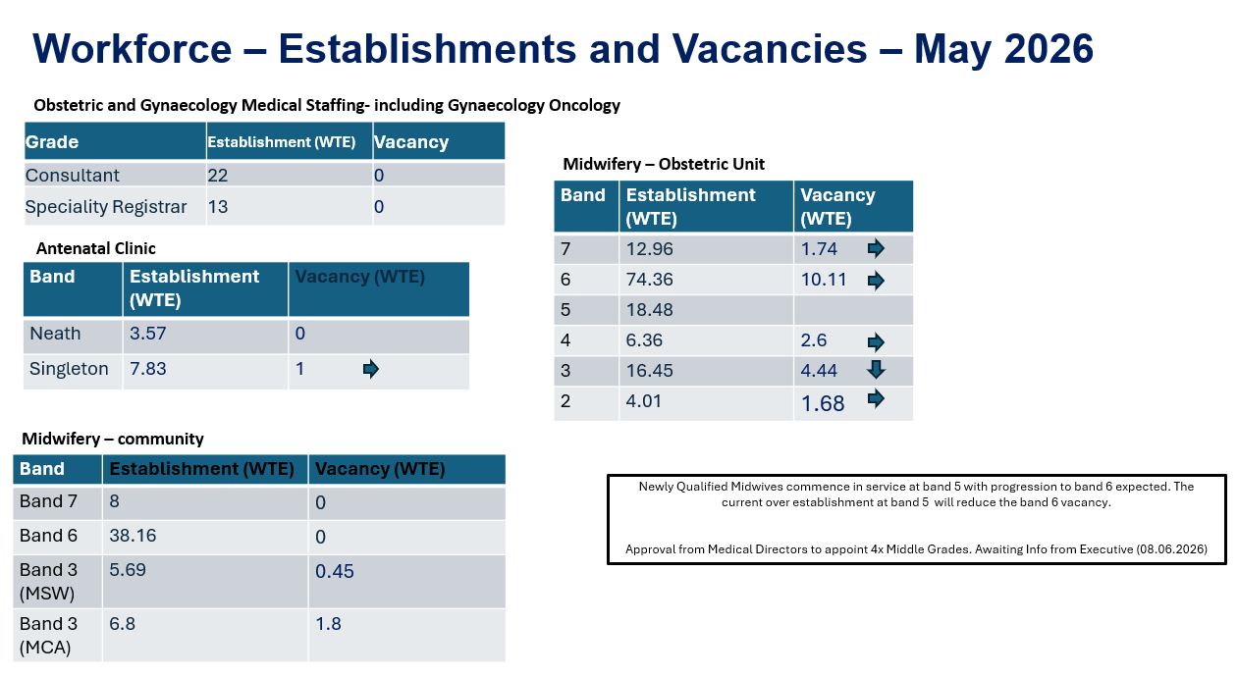
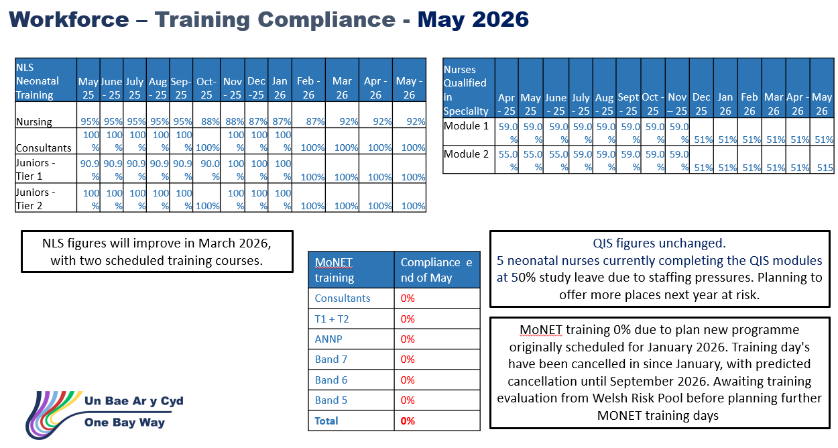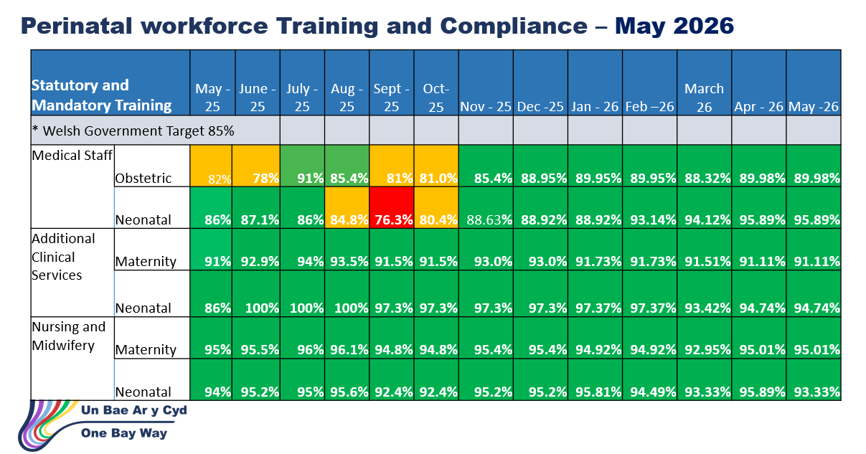

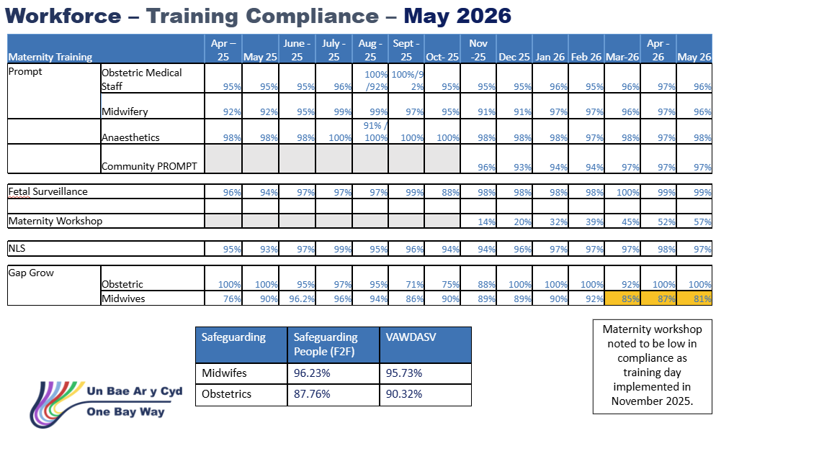

3.13 Infection Prevention and Control
Infection prevention and control performance across maternity services remains strong, with consistently high compliance against national cleaning standards and hand hygiene audits across all clinical areas.

Bi-quarterly IPC validation demonstrates continued progress, particularly within postnatal services, with improvement noted following implementation of targeted action plans. Variability within antenatal and labour ward areas continues to be monitored through structured governance arrangements.

All actions arising from corporate inspection and IPC reviews have been uploaded to AMAT and are actively managed through divisional governance processes. There are no overdue actions. Ongoing actions reflect the scale and sequencing of improvement work required and are being progressed appropriately, with clear ownership and regular review to ensure delivery against agreed milestones.

Current action plans demonstrate significant activity, with a high number of completed actions and a structured programme of ongoing work. This reflects a proactive approach to quality improvement, supported by regular infection control meetings and local operational oversight.

Overall, the service continues to demonstrate a strong position in IPC compliance, with clear evidence of sustained progress, effective governance, and a focus on delivering improvement in line with planned trajectories.

IPC performance remains strong, with no overdue actions; improvement work is progressing as planned, with robust oversight and delivery aligned to agreed milestones and priorities.

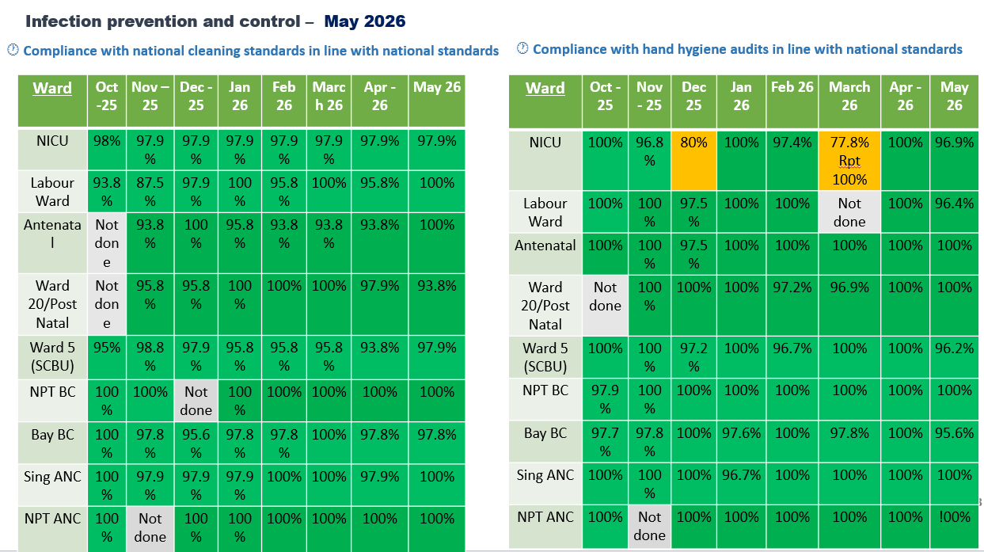

3.14 Neonatal National Audit and Performance (NNAP)/PERIPrem Cymru – context and figures
There are no new updates to report for this period. Performance and audit indicators remain reassuring and consistent with the position outlined in the previous report.

The next formal update from NNAP Cymru is expected toward the end of 2026.

PERIPrem Bundle Optimisation Score:
The PERIPrem bundle optimisation score for May was 79%. While this represents sustained delivery of high-quality care across the pathway, for those babies were dt has been analysed.

Early breastmilk provision (within 6 hours of birth) based on the available May data suggests improvement in early expressed breast milk, rising from 25% in April to 71% in May. However, as the dataset is incomplete and several patients are missing, these results should be interpreted with caution. The apparent improvement is encouraging but should be confirmed once the full data has been collected and validated.

Performance across the PERIPrem pathway remains robust overall, which is reassuring, with the majority of metrics continuing to perform at or above expected levels. This suggests sustained engagement with the pathway and continued delivery of key elements of care across the service.

There are currently three cases where analysis remains pending. This is due to the requirement for manual data collection, input and review, alongside current staff availability. Whilst this creates a short-term delay in full reporting, it does not presently indicate a broader performance concern. Completion of this outstanding analysis will provide a fuller picture and support continued oversight of pathway delivery.

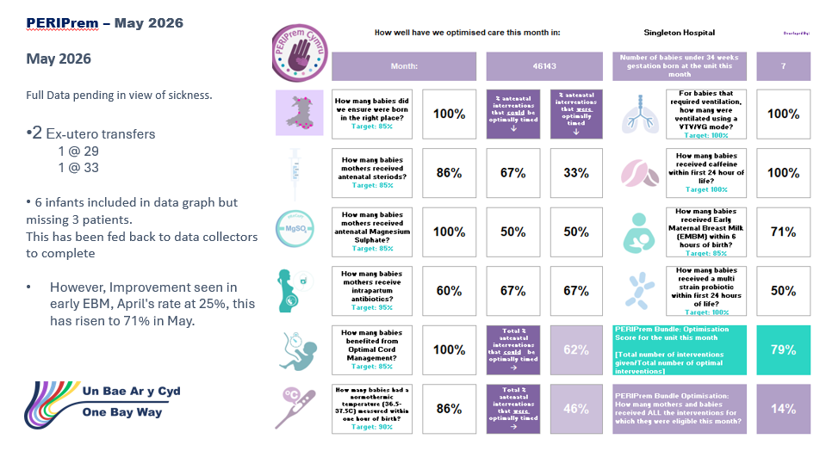

3.15 Avoiding Term Admission into Neonatal services.
Since the previous Board update, neonatal term admissions have been embedded into business-as-usual monitoring, with real-time multidisciplinary review providing continuous oversight, early learning and timely escalation where required.

All-Wales data from The Path to Safer Beginnings (2026) demonstrates that neonatal admission rates have remained stable overall (124.4 per 1,000 live births), despite a reduction in total births. Term babies account for a significant proportion of admissions (45.7 per 1,000), with mode of birth identified as a key influencing factor. Babies born by caesarean section are overrepresented in neonatal admissions (85.3 per 1,000), compared to 38.7 per 1,000 following spontaneous vaginal birth.

Local analysis within SBUHB is consistent with this national position. Respiratory distress remains the principal reason for admission, with approximately 70% of these cases occurring following planned caesarean birth. SBUHB reports 29 per 1,000 neonatal admissions associated with elective caesarean section, reflecting a similar risk profile.

In response, the service has implemented targeted quality improvement interventions focused on improving neonatal transition and reducing avoidable admissions. See ASTRA outcomes in previous section.

Overall, the service demonstrates strong alignment with national insights, proactive identification of modifiable factors, and delivery of targeted improvement work to optimise outcomes and experience.
Neonatal admissions remain consistent with national patterns and are under robust real-time oversight; targeted respiratory improvement initiatives are in place and being actively evaluated, with no immediate safety concerns identified.
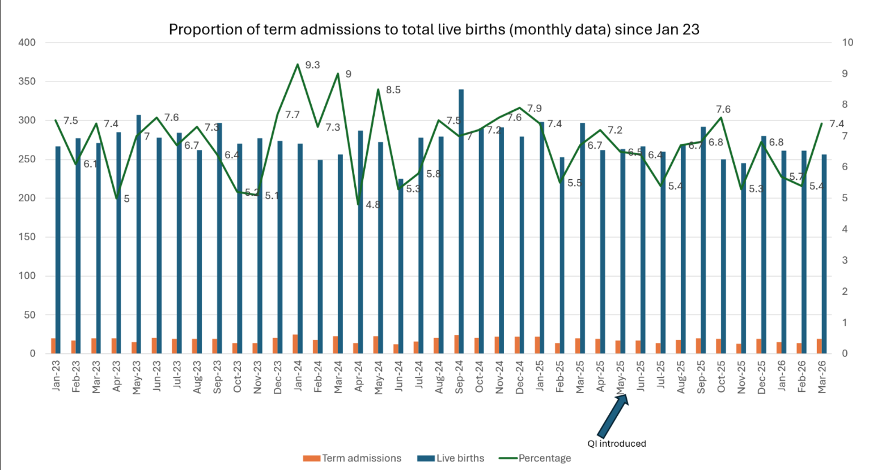
3.16 Risk Register
The Perinatal Risk Register continues to provide a robust, single view of clinical and operational risk across maternity and neonatal services, supported by clear governance, defined ownership, and regular review through established Quality and Safety structures, with escalation to Board via the Perinatal Committee.

Since the previous Board update, there has been continued progress in risk management and mitigation, with strengthened oversight and active management of all risks. Importantly, there are no overdue actions, and all actions are being delivered in line with agreed timelines, reflecting the complexity and sequencing of improvement work.

Current Risk Profile (updated):
- ≥20 (High risks): 3 risks
  - Computerised CTG – now implemented and closed, representing a significant safety improvement
  - Paediatric radiology capacity – remains active and escalated
  - MoNET training delivery – newly escalated and under active management
- Score 16 (Moderate-high): 4 risks
  - Including induction of labour delays, neonatal transport service, weight management service, and blood glucose monitoring (now mitigated and closed following intervention)
- <16 (Low to moderate): 17 risks
  - All remain stable, with clear mitigations in place and no immediate safety concerns

Key Developments Since Last Update:
- Successful implementation and closure of the computerised CTG risk, improving fetal monitoring and clinical decision-making
- Addition of new risks relating to radiology reporting and MoNET training, reflecting proactive identification and escalation
- Continued escalation of the two-site working / critical care configuration risk at corporate level, with strengthened mitigation and strategic planning underway
- Ongoing management of workforce, infrastructure, and pathway risks within established governance frameworks

Overall, the risk profile remains stable and actively managed, with evidence of both risk reduction and proactive identification of emerging risks. Governance arrangements continue to provide strong assurance through regular monitoring, clear accountability, and structured escalation.
The perinatal risk profile is stable, with no overdue actions; risks are appropriately identified, actively managed, and aligned to improvement delivery, providing continued assurance of safe and effective service oversight.

3.17 Quality Improvement Approach, Methodology and Programmes
Perinatal services adopt structured Quality Improvement methodology to ensure safe, reliable, evidence-based care for women, babies, and families. The approach is grounded in recognised improvement science frameworks and national priorities, combining local data driven change with strong multidisciplinary collaboration.

A detailed plan was presented in the January 2026 report to QSC and Board, further updates will be represented in the report as these are formulated and once able to report outcomes and impact. This also applies to any quality improvement programmes which was presented in January.

3.18 National Awards.
Swansea Bay University Health Board’s maternity and neonatal services continue to demonstrate excellence through strong patient validated recognition and organisational accolades. In the past year, the service has secured multiple acknowledgements that reinforce its commitment to high quality, compassionate and continuously improving care.

The Perinatal Committee will continue to receive updates for any nominations and awards achieved by the Perinatal Services and reported via the Perinatal Committee.

3.19 HIW Inspection Summary – Singleton Maternity Services (Feb 2026)
Healthcare Inspectorate Wales (HIW) findings confirm clear and sustained improvement across maternity services, with the formal improvement action plan now approved and the inspection report published. HIW action tracking meetings have been re-established, providing structured oversight to support the monitoring, delivery and formal closure of actions.
The inspection recognised significant progress in key areas, including:
- Strengthened multidisciplinary working and clinical handovers, supported by daily safety huddles
- Improved leadership stability and senior oversight, enhancing accountability and visibility of risk
- Enhanced recognition and escalation of clinical deterioration, including implementation of All-Wales MEWS
- Positive patient experience, with consistent reports of compassionate, respectful care and one-to-one support in labour
- Established safety systems, including infection prevention, medicines management and safeguarding
A number of priority areas for continued focus were identified, including postnatal flow and timeliness of care, workforce pressures, consistency of escalation, equity of access (including the Welsh Active Offer), and equipment processes.
A comprehensive improvement plan addressing all findings is now in place and being actively progressed through established governance arrangements. Immediate assurance has been achieved in relation to equipment safety, with strengthened oversight processes embedded.
Overall, the HIW inspection provides external validation of meaningful progress and strengthened governance, alongside a clear and structured programme of ongoing improvement to address system pressures and further enhance quality and safety.
The HIW improvement plan is approved and actively progressing, with robust oversight arrangements in place; clear evidence of sustained improvement provides assurance, with no immediate safety concerns identified.

4. OPEN AUDIT RECOMMENDATIONS

Open audit recommendations relate primarily to system strengthening rather than concerns about unsafe care.

The Perinatal Committee maintains oversight of a small number of open audit related actions arising from internal reviews, external assurance activity and national audit programmes (including MBRRACE UK and NMPA), together with recommendations emerging from the Independent Review and All Wales Perinatal Assurance processes.

These recommendations are embedded within the Perinatal Improvement Programme and are tracked through established governance arrangements, with clear executive ownership, defined milestones and progress reporting via the Perinatal Improvement Programme Executive Board and Perinatal Committee.

Current open actions focus on:
• strengthening digital infrastructure and interoperability (including implementation of computerised CTG and optimisation of BadgerNet functionality);
• improving reliability and completeness of data capture and reporting (e.g. surgical site infection surveillance and demographic data completeness);
• enhancing consistency of clinical pathways and escalation processes through training, audit and quality improvement activity;
• further embedding learning from audit and review into education, supervision and multidisciplinary practice.

The Board can be assured that there are no outstanding audit recommendations indicating immediate risk to patient safety, and that all open actions are actively managed within the agreed improvement programme, with progress subject to routine scrutiny and escalation through Quality and Safety Committee where required.

5. FINANCIAL IMPLICATIONS
As previously advised, there will be some financial implications because of the recommendations from the Independent Review, these are currently being developed as part of developing the improvement plan.

6. RECOMMENDATION

The Board is advised that:
- There has been sustained progress across maternity and neonatal services, with improved governance, strengthened multidisciplinary working, and enhanced safety systems evidenced through HIW findings, workforce compliance, and quality metrics.
- Targeted quality improvement programmes (e.g. ASTRA, bedside respiratory support, digital systems such as BadgerNet and computerised CTG) are being implemented to address key drivers of risk and variation.
- Data systems are undergoing a period of transition and validation, and whilst this may impact completeness in the short term, this work is critical to strengthening long-term assurance and insight.
The Board is assured that:
- Robust governance and oversight arrangements are in place, including real-time monitoring, multidisciplinary review, and clear escalation pathways from ward to Board.
- All risks are actively managed with no overdue actions, with delivery aligned to planned milestones and supported through structured improvement programmes.
- There is clear evidence of learning being translated into practice, with improvements in safety, patient experience, and clinical outcomes supported by ongoing audit, thematic review, and workforce development.
- The HIW improvement plan is approved, published, and actively progressing, with strengthened oversight ensuring delivery and closure of actions.
The Board is alerted to:
- Ongoing system pressures, including workforce capacity, postnatal flow, and demand related to acuity and mode of birth (particularly caesarean-associated neonatal admissions).
- High-level risks that remain under active management, including paediatric radiology capacity, training delivery constraints (MoNET), and wider service configuration challenges (e.g. two-site working and critical care access).
- Transitional risks associated with digital implementation and national system dependencies, including data quality, survey limitations, and reporting consistency.
- The need to maintain focus on equity of access, consistency of escalation, and timeliness of care, as identified through HIW and internal review processes.
- The service continues to provide safe, compassionate and high-quality care, with no immediate safety concerns identified, and a strong focus on continuous improvement.

Governance and Assurance
Strategic Objectives
Strategic Objectives  (please choose which is impacted) | People of Swansea Bay live healthier, fairer and more prosperous lives | ☐
Strategic Objectives  (please choose which is impacted) | Care is high quality, safe, efficient and delivers the best possible outcomes for people in partnerships | ☐
Strategic Objectives  (please choose which is impacted) | Care is delivered in partnership with our communities in safe and appropriate setting, supported by innovation | ☐
Strategic Objectives  (please choose which is impacted) | The health board is a great place to work where staff feel valued and work together towards a common goal | ☐
Strategic Objectives  (please choose which is impacted) | The health board is a resilient, sustainable and responsible organisation | ☐
Health and Care Standards
Standards (please choose which applies) | Safe Care | ☒
Standards (please choose which applies) | Timely Care | ☒
Standards (please choose which applies) | Effective Care | ☒
Standards (please choose which applies) | Efficient Care | ☒
Standards (please choose which applies) | Equitable care | ☒
Standards (please choose which applies) | Person-centred Care | ☒
Standards (please choose which applies) | Staff and Resources | ☒
Enablers (please choose which applies) | Whole Systems Approach | ☒
Enablers (please choose which applies) | Leadership | ☒
Enablers (please choose which applies) | Workforce | ☒
Enablers (please choose which applies) | Culture | ☒
Enablers (please choose which applies) | Information | ☒
Enablers (please choose which applies) | Learning, Improvement and Research | ☐
Quality, Safety and Patient Experience
The Perinatal Committee reports directly into Quality and Safety Committee and noted via Service Group Quality, Safety & Risk Group and Senior Leadership Team. Key updates were received via Perinatal Committee and key measures of the high-level information have been included in section 3 of this report.
Financial Implications
As previously advised, there will be some financial implications because of the recommendations from the Independent Review, these are currently being developed as part of developing the improvement plan.
Legal Implications (including equality and diversity assessment)
Nil outlined within this report.
Staffing Implications
There have been some challenges within the Neonatal medical workforce due to unavailability, this has been mitigated with flexible working arrangements which has meant there has been no gap in service.

Obstetric workforce – 2 fixed term gaps for career break and other leave have been covered with no vacancies impacting on services.
Long Term Implications (including the impact of the Well-being of Future Generations (Wales) Act 2015)
The work of the Perinatal Committee and the associated Perinatal Improvement Programme has significant positive long-term implications for women, babies, families, staff and the wider population of Swansea Bay.
The actions described within this report align strongly with the Well-being of Future Generations (Wales) Act 2015, particularly in supporting:
A healthier Wales – through sustained focus on improving perinatal safety outcomes, reducing preventable harm, and strengthening early intervention, maternity triage and continuity of care, recognising the lifelong impact of pregnancy, birth and neonatal outcomes on population health.
A more equal Wales – through targeted action to improve equity of access, culturally sensitive care, improved demographic data collection, and engagement with diverse communities to address variation in experience and outcomes.
A Wales of cohesive communities – by strengthening partnership working with families, communities and third-sector organisations, and embedding co-production and lived experience within service design and evaluation.
A resilient Wales – through investment in digital transformation, robust governance arrangements, workforce development and quality improvement capability, enhancing the system’s ability to respond safely and sustainably to future pressures and changing clinical complexity.
A prosperous Wales – by focusing on prevention, quality improvement and system efficiency, reducing avoidable harm, litigation risk and long-term cost associated with poor outcomes, while supporting staff wellbeing, retention and productivity.
Collectively, these actions reflect a long-term, preventative, integrated and collaborative approach, ensuring that perinatal services continue to improve not only immediate safety and experience, but also long-term outcomes for future generations. The Board can be assured that this work supports sustainable service delivery and fulfils the organisation’s statutory duties under the Well-being of Future Generations (Wales) Act.
Report History
The Perinatal Committee reports directly into Quality and Safety Committee and noted via Service Group Quality, Safety & Risk Group and Senior Leadership Team. Last reported April 2026.
Appendices
None.

