Meeting Date | 30 July 2026 | Agenda Item | 5.2
Name of Meeting | SBUHB Board
Report Title | Financial Report – Month 03 2026/27
Report Author | Samantha Moss, Deputy Director of Finance  Gemma Pearson, Finance Business Partner  Crystal Davies, Principal Finance Manager
Report Sponsor | Executive Director of Finance
Presented by | Claire Osmundsen-Little, Interim Director of Finance
Freedom of Information | Open
FoI Closed detail | If closed, choose detail
Impact Assessment Summary Outcome |  | IA Completion date
N/A |  | Click or tap to enter a date.
Purpose of the Report | For Assurance
Report Summary; detailing any action required
The report advises the Board of the Health Board on the financial position for Month 03 2026/27 (June 2026) and risks regarding the current forecast revenue year end outturn and the further actions required to address the delivery of the Annual Plan.

Key Issues
The report invites the Board to discuss the detailed revenue analysis of the financial position for Month 03 2025/26 (June 2026).

The report includes a summary of the key drivers of the revenue position either at Service level or by expenditure type (i.e. Non-Pay/Pay).

Risk have been considered on the basis of the information provided within the report and the score updated where necessary.

The report invites the Board to review the cash position, key balance sheet movements and the capital position.

Whilst the key messages are provided within the main body of the report, the accompanying Annex gives additional information.

Decision / Action required | No
Recommendations
The Board are asked to:

- ACKNOWLEDGE the 2026/27 Financial Plan, and the Health Board’s and WG inability to approve it given the planned deficit of £76.6m
- Consider and comment upon the Health Board’s financial performance for Month 03 2026/27, including cash, capital and balance sheet.
- SUPPORT the implementation of the actions to address the red and pipeline savings gap and assessed position to reach the £76.6m plan.
- DISCUSS the risks to the position at Month 03.
- CONSIDER the latest letter from WG and AGREE next steps.

FINANCIAL REPORT – MONTH 03 2026/27

- INTRODUCTION

The report invites the Board to consider the detailed analysis of the Month 3 (June 2026) revenue financial position, along with Cash and Capital.

- BACKGROUND

The Health Board has two key statutory duties to achieve:

- To submit an Integrated Medium-Term Plan (IMTP) to secure compliance with breakeven over 3 years.
2024/25 3-year plan submitted
2025/26 3-year plan submitted
2026/27 3-year plan submitted
The Health Board plans to achieve a control total of £17m over year 3 as part of its 2026/27 -2028/29 plan and is working on the action necessary to achieve this. Currently it will fail to meet this in 2026/27, as its plan will not breakeven over 3 years.

- To achieve financial breakeven over a rolling three-year period, which commenced on 1st April 2024 and will end on 31st March 2027.
2024/25 Deficit Control Total £43.7m achieved
2025/26 Deficit Control Total £53.2m achieved
2026/27 Deficit Plan Draft £76.6m
The Health Board will fail to achieve this Statutory Duty.

Summary of Performance against Key Financial Targets

Financial KPIs: To ensure that net operating costs do not exceed the revenue resource limit set by Welsh Government | Value  £’000
Reported in-month financial position – deficit/(surplus) | 7.137
Reported cumulative financial position – deficit/(surplus) | 23.311
Capital KPIs: To ensure that costs do not exceed the capital resource limit set by Welsh Government | Value  £’000
Reported year to date financial position – deficit/(surplus) | (0.654)
Forecast outturn financial position – deficit/(surplus) (prior to additional allocations) | (0.900)
PSPP Target: To pay a minimum of 95% of all non NHS creditors within 30 days of receipt of goods or a valid invoice | Value  %
Cumulative year to date % of invoices paid within 30 days (by number) | 97.1%

- FINANCIAL PLAN

The draft Annual Plan submitted to Welsh Government on 31 March 2026 for assessment and scrutiny included a financial assessment, as summarised in the table below:
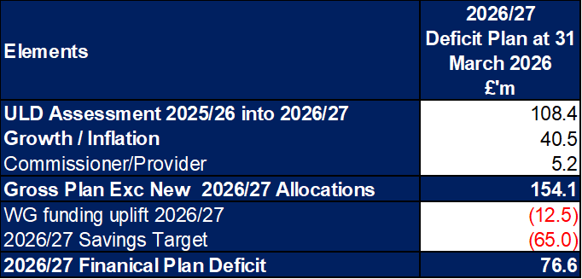

The Health Board accepts that this financial assessment is not acceptable or supportable, either to the Board or to WG, as it does not meet the statutory duties of the Health Board. A strengthened reiteration was submitted to WG 1 July 2026 which included the assessed savings position at that point, with the Health Board continuing its work on finalising the detailed delivery plan in respect of the £65.0m savings target set out in the draft plan submitted in March.
The Health Board’s actual performance against the Planned Deficit and last year’s outturn position is provided in the table below. This table shows that at the end of Month 3 the reported deficit is £7.1m, which is £0.7m above the planned deficit and £2.7m against last year’s outturn. The table provides the reconciliation to £7.1m Month 3 variance, based on a 12th of the £76.6m Deficit Plan compared with a 12th of a £53.2m outturn from 2025/26. The key difference for the purposes of this illustration is the level of non-delivery of savings, as the assumption made for this letter is that, to move the plan from £76.6m to £53.2m requires additional recurrent savings.

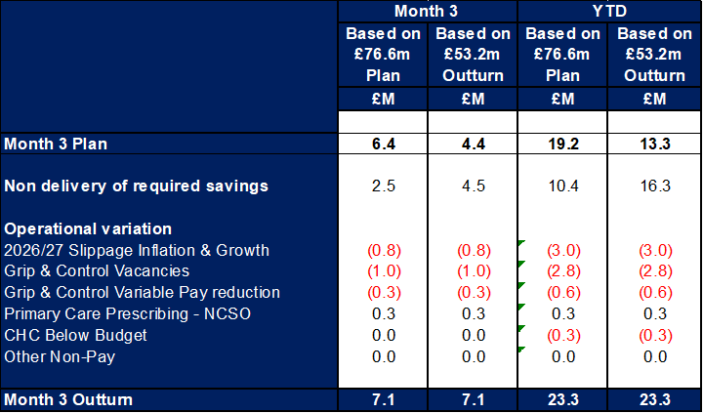

The expectation in June was that the Health Board would be closer to achieving the in-month planned deficit value of £6.4m in Month 3, on the basis that the Health Board ceased the contract with its external strategic support, temporary adult placements numbers were reducing and there would be a reduction in variable pay linked to the transformation of care programme across acute wards. However, the following has impacted the Month 3 position:
- Temporary adult placements– whilst numbers are reducing with 18 at start June reducing by 7 to 11 at end, the reduction in value was only £0.04m, with the most expensive placements remaining.
- CHC Growth – this has increased in MH/LD above planned levels with increases in patient numbers seen Learning Disability and with average cost packages in month increasing for MH patients. Within PCT services group, which the overall number patients in month increased but the costs remained aligned to month 2.
- No Cheaper Stock Obtainable (NCSO) - is the pharmacy reimbursement mechanism used in England and Wales when a medicine listed in the Drug Tariff cannot be obtained at or below the standard reimbursement price, due to shortages or supply problems. The impact of this based on the NCSO/price concession data indicates that impact in June was £0.3m for the Health Board.

Given the financial position, there are further actions in place to mitigate growth and generate further stretched savings. Progress on these plans is overseen by the Recovery & Sustainability Board and work that the Delivery Unit is supporting through weekly ‘Check and Control’ meetings for each thematic workstream. Equally during the month each service group (excluding MHLD which is scheduled for July) undertook a financial escalation meeting whereby each were asked to consider options to deliver a financial balance. The outcome resulted in an additional £6m saving opportunity being added to the tracker.

- BACKGROUND – Financial Performance

FINANCIAL REPORT REVENUE – MONTH 03

At Month 3 there was an In-Month overspend of £7.1m, which is £0.8m worse than the planned deficit of £6.4m (£76.6m/12).

In respect of the overall financial performance, Graph 1 below reflects the actual financial performance in each month, with the orange bars reflecting the performance required to achieve the original plan of £76.6m. Graph 2 outlines the savings delivered to date as the blue bars against the monthly target set (red line), and the orange bars reflect the level of savings required in future months to achieve the £65m target aligned to the £76.6m plan.
Graph 1: Performance Graph 2: Savings
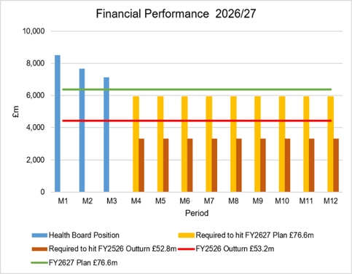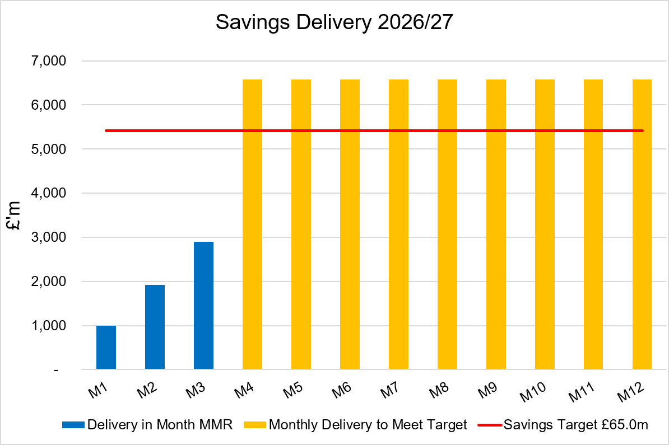

KEY DRIVERS OF THE IN-MONTH POSITION

The key movements from plan of the Month 3 position are summarised in second table reported in Section 1 above. Further detail at a Health Board level of expenditure on Income, Pay and Non-Pay, is provided within Annex 1.

- KEY AREAS OF NOTE

5.1 SAVINGS
Full details on savings are provided Annex 1, but in summary the in-month delivery in Month 3, was £2.9m against a target of £5.4m and remains the key driver of the Health Board overspend. YTD delivery is £5.8m against a target of £16.3m.
Part C Actions
- Part C1: Savings Trackers Red & Corporate Stretch @ 4 September 2025
- Part C2: Savings Trackers Pipeline @ 4 September 2025
- Part C3: In-year impact of the thematic Scheme Summaries (adjusted to avoid double count)
Further Actions
- Additional interventions to close the gap to the original savings plan
  - Exec oversight of variable pay
  - Additional capacity reduction
  - Non pay bans / restrictions

5.2 CAPITAL
The approved Capital Resource Limit (CRL) value issued on 29th May is £54.900m. The approved CRL value includes Discretionary Capital and schemes under the All-Wales Capital Programme.

Outturn Performance

The forecast outturn shows an underspend position of £0.900m in relation to the high-risk schemes listed below. For the three high risk schemes listed below, any slippage that does not form part of the Health Board discretionary funding will be returned to WG, this will have been flagged as part of the ongoing discussions with regard to specific WG funded capital schemes.
Scheme | £m / Risk Level | Narrative
Vascular Hybrid Theatre at Morriston Hospital, Swansea | 0.500 / High | Underspend due to savings on equipment and professional fees through the ModuleCo contract in conjunction with positive progression on the scheme.
Reinstatement of Taith Newydd Low Secure Unit at Glanrhyd, Bridgend | 0.200 / High | Underspend due to a higher level of VAT Recovery confirmed by our VAT advisors EY.
Replacement Diagnostic and Treatment Equipment 2025-26 – Morriston CT 1 | 0.200 / High | Scheme has now completed under allocation.
Regional Cellular Pathology Laboratory – Fees Funding 2026-27 | 0.500 / Medium | SCP appointed (Tilbury Douglas). Likely to be slippage into next year as we await the cashflow - Current indications are that RIBA Stage 4 completes in Q1 27/28.

Capital Disposals
There are no property disposals planned for 2026/27.
5.3 BALANCE SHEET
The key issues in respect of the statement of financial position movements are as follow:

- The inventory value has decreased from £12.968m at the end of March 2026 to £12.714m at the end of June 2026, a decrease of £0.254m.
- There has been an increase in trade receivables from £271.669m at the end of March 2026 to £306.708m at the end of June 2026, an increase of £35.039m. This relates to an increase in NHS Debtors of £1.474m, an increase in the WRP (Welsh Risk Pool) debtor of £28.2m, WGA (Whole Government Accounts) debtor of £1.345m, and other current assets of £3.807m.
- The closing June 2026 cash balance of £3.821m
- The trade and other payables figure saw a decrease from £268.069m at the end of March 2026, to £243.568m at the end of June 2026, a decrease of £1.684m. This comprises a decrease in Accruals and NHS creditors.
- Provisions saw an increase of £23.632m from £216.906m at the end of March 2026 to £240.538m at the end of June 2026. This increase relates to a mixture of legal cases where the quantum values, number and probability has changed.

5.4 CASH
As at the end of June 2026, the Health Board had a cash balance of £3.821m, which is a within tolerance levels for a closing cash balance for the Health Board.

The difference between the £76.6m forecast cash deficit and the Forecast I&E Deficit Cash figure, reflects the £1.434m of Revenue cash to reimburse capital cash, and the movement in the working capital balances.

The cash movements during June 2026 were:
The current assessment of the Capital Resource Limit (CRL) section of the Health Board cashflow, notes that the Health Board will drawing down the majority of the CRL funding until Q4 of 2026/27. The net capital funding position as at M3 is (£1.577m), which includes £1.434m from prior year.

The cash flow is updated daily and a full review of the cash forecast is currently being undertaken monthly, to ensure that any changes to our cash requirements, can be communicated in a timely manner to WG. The cashflow will assume that all anticipated allocations detailed in the annex are received before March 2027, to allow the Health Board to draft cash down within the financial year.

5.5 PUBLIC SECTOR PAYMENT POLICY (PSPP)
The Health Board achieved the 95% PSPP target, with the % of Non-NHS Invoices Paid within 30 Days in Quarter 1 being 97.1% for the quarter.

NHS payment compliance for invoices paid within 30 days was, however, below 95% with the quarterly performance being 87.5%. The Health Board remains focussed on improving PSPP compliance for NHS invoices and ensuring that performance remains above 95% for non-NHS invoices.

5.6 BUDGET SETTING PROCESS
In May budget letters were issued to all 67 identified Senior Leaders along with invites to attend a budget holder training session with additional procurement training. The return of the signed letters and Budget Holder access to the Qliksense finance dashboard is being tracked and reported within Annex 1, Appendix 2-3.

5.7 YEAR END PROCESS
Work on the 2025/26 Statutory Accounts is now complete, with no Uncorrected Misstatements reported by Audit Wales and signed set accounts submitted as per the deadline to WG and the Auditor General for Wales.

- GOVERNANCE AND RISK ISSUES

Two Board level financial risks:

- Achieving financial plan (HBR92) with the key elements as follows: -

- Risk of delivery of savings quantum
- Risk of operational overspend being in excess of funding available agreed via the Financial Plan
- Risk of commitment of reserves (e.g. NICE) being above reserves available.
- Risk of achieving the actions and options outlined in the 2025/26 Financial Recovery & Sustainability Assessment.

Given the improvement needed to the monthly performance and the current status of savings to achieve the draft deficit plan of £76.6m, it is recommended that the Health Board Corporate Risk Register continues to reflect a risk score of 25.

- Availability of capital (HBR93). This risk was re-opened in 2022/23 given the reduction in discretionary capital allocation. Due to the additional capital funding provided during 2024/25 the risk score was reduced to 12. The score was increased in June 2025 to reflect risks regarding Emergency Department and Adult Acute Mental Health. However, following further assessment at start Quarter 4 2025/26 and based on funding received the risk score reduced to 12, which is the recommendation for Q1 2026/27.

For Month 3 the key risks to the delivery of the Deficit Plan reported to WG in the MMR, linked to HBR92 are summarised below:
- Delivery of savings: The Health Board has identified £30.9m of Green and Amber savings (with Red/Pipeline schemes totalling a further £34.1m) and whilst it continues to scrutinise delivery of these via the Recovery & Sustainability Board (chaired by the CEO), the role of the Delivery Unit is to quickly translate these plans to deliverable schemes in year supported by the Finance Team. The table in section 7 demonstrates that the Health Boards assessment is that £28m remain in Red or Pipeline, of which only needs to deliver £24m to achieve the £65m target. Of the full list of £28m, there is a greater level of confidence in £10m (assuming LTA performance remain consistent) and as such £14m have been reflects as risk in the table at this point, which addressed the Planned and Unplanned mitigating actions.
- Non-Delivery Actions to Mitigate Growth/Inflation: Growth pressures above plan level were expected to be mitigated by the identification of mitigating actions in addition to the planned savings delivery. The Health Board acknowledges that this is challenging in the context of the savings position. At end Q1 a review of the assessed risk has been completed and at Month 3 only the risk relating to CHC Growth has been recognised given the increase in month above planned expectations (Total value Risks = £5.5m). All other areas for which the Health Board required actions to mitigate growth which included operational pressures linked to Demand and Secondary Care Drugs have been removed, with Primary Care Prescribing now incorporated within the Primary Care Prescribing – NCSOs line given the data seen in June as referenced in the opening section of this letter.
- Energy Risk provided by NWSSP: not all the energy requirements for 2026/27 have been purchased in advance. The assessment provided by NWSSP on 09/06/26 highlighted a risk of £0.539m, which is 117% increase from previous value. This will be updated based on the data from NWSSP.
- Resident Doctor Contract Changes: the contractual changes will be phased from August 2026 to August 2028. Initial assessment by the Health Board suggested there is a risk of between £2m - £2.5m. A report is being prepared to assess the implications and look at risks and mitigations for Board.
- Primary Care Prescribing (NCSO’s): assuming the current pressures continue for a period of 6 months, based on the data at June.
- Approved Mileage Allowance Payments rate increase: backdated to 1 April 2026 this change increases the rate from £0.45 per mile to £0.55 per mile for the first 10,000 miles. This 20% change could increase cost base by £0.5m, however the Health Board is through Recovery & Sustainability limiting travel to essential only.

- RECOMMENDATION

The Board is asked to:

- ACKNOWLEDGE the 2026/27 Financial Plan, and the Health Board’s and Welsh Government’s inability to approve it given the planned deficit of £76.6m.
- CONSIDER and comment upon the Health Board’s financial performance for Month 03 2026/27 including cash, capital and balance sheet.
- SUPPORT the implementation of the actions to address the red and pipeline savings gap and assessed position to reach the £76.6m plan.
- DISCUSS the risks to the position at Month 03.
- CONSIDER the latest letter from WG and AGREE next steps.

Governance and Assurance
Strategic Objectives
Strategic Objectives  (please choose which is impacted) | People of Swansea Bay live healthier, fairer and more prosperous lives | ☐
Strategic Objectives  (please choose which is impacted) | Care is high quality, safe, efficient and delivers the best possible outcomes for people in partnerships | ☐
Strategic Objectives  (please choose which is impacted) | Care is delivered in partnership with our communities in safe and appropriate setting, supported by innovation | ☐
Strategic Objectives  (please choose which is impacted) | The health board is a great place to work where staff feel valued and work together towards a common goal | ☐
Strategic Objectives  (please choose which is impacted) | The health board is a resilient, sustainable and responsible organisation | ☒
Health and Care Standards
Standards (please choose which applies) | Safe Care | ☐
Standards (please choose which applies) | Timely Care | ☐
Standards (please choose which applies) | Effective Care | ☐
Standards (please choose which applies) | Efficient Care | ☒
Standards (please choose which applies) | Equitable care | ☐
Standards (please choose which applies) | Person-centred Care | ☐
Standards (please choose which applies) | Staff and Resources | ☐
Enablers (please choose which applies) | Whole Systems Approach | ☒
Enablers (please choose which applies) | Leadership | ☐
Enablers (please choose which applies) | Workforce | ☐
Enablers (please choose which applies) | Culture | ☐
Enablers (please choose which applies) | Information | ☐
Enablers (please choose which applies) | Learning, Improvement and Research | ☐
Quality, Safety and Patient Experience
Financial Governance supports quality, safety, and patient experience.

Financial Implications
The Board is reporting a forecast year-end deficit financial outturn.

Legal Implications (including equality and diversity assessment)
No implications

Staffing Implications
No implications

Long Term Implications (including the impact of the Well-being of Future Generations (Wales) Act 2015)
No implications

Report History
Updates on the financial position are provided at every meeting.

Appendices
Annex 1 – Detail on Financial Position @ Mth 3

