Developing a National Clinical Plan for Adult Mental Health Services in Wales

Project Initiation Documentation

Author: Ciara Rogers, National Director for Mental Health, NHS Wales P&I
Owner: Alex Howells Interim Lead CEO for Mental Health (covering for Hayley Thomas)
Date: 29 July 2026 | Version: 4.0
Publication/ Distribution for the PID:

- Strategic Programme for Mental Health Programme Board
- Open Access Mental Health Support Steering Group
- NHS Wales Leadership Group
- Chief Executive Management Team
- NHS Wales Peer Groups
- Welsh Government Mental Health Policy Team
- Welsh Government Capital Team
- NHS Wales Performance and Improvement Mental Health SMT
- NHS Wales Performance and Improvement SDG & SLT
- Welsh Government EDT

Purpose and Summary of Document:

To agree a shared understanding of the objectives, timelines, resources and governance structure in advance of starting the work.

- Project Definition

NHS Wales Leadership Board on 21 May 2026 agreed the work programme to:

- Define and agree the Adult Mental Health Model of Care for Wales, i.e. a national clinical plan, based on the best evidence worldwide, being clear what is delivered locally, regionally and nationally
- From that National Clinical Plan develop and agree an All-Wales inpatient bed model and bed plan for mental health inpatient care

This builds on the work already started under the Mental Health and Well-Being Strategy (2025-2035) on the Open Access Mental Health Support Model and the Mental Health Estates Plan.

It was agreed that a product will be available for Ministers in September 2026. This will be the draft of the model of care and bed plan that will subsequently go to Health Boards to be discussed at board development sessions.

The full final model of care and bed plan will be complete in December 2026.

The purpose of a National Clinical Plan and Bed Model are to:

- Provide the strategic case and economic case for change
- Set the direction for the reorganisation of adult mental health services across Wales to improve access, experience and outcomes in a financially sustainable service model
- Provide the blueprint for NHS Organisations and partners to plan from

Problem Statement

There are two inter-dependant problems:

Our Community Mental Health Model of Care, from the late 1990s / early 2000s, has many services gaps and is no longer fit for purpose even if those gaps were filled. Patching it up won’t resolve the access and quality issues or the demand, capacity and workforce challenges. Even if we filled all our vacancies, problems would persist.

Our inpatient mental health estate would not be tolerated in any other part of the UK. This needs to be resolved. Each Health Board re-providing like for like is unaffordable. But more importantly this risks missing the opportunity to apply the latest evidence to reduce our reliance on inpatient care & improve outcomes and experience.

Early data suggests a reduction in bed-based care is possible from modernising the community mental health model.

- Background and Case for Change

Mental Health need in Wales is:

- High and persistent, affecting a large proportion of the population, 1 in 4 adults and 1 in 6 children in their lifetime.
- Worsening slightly over time, especially among younger people
- Socially unequal, with deprivation a major factor
- Outstripping service capacity, leading to long waiting times

The Mental Health and Well-being strategy 2025 - 2035 (Welsh Government, April 2025) sets a clear and ambitious vision that there will be seamless mental health services, person centred, needs led, guided to the right support first time without delay.

However, the current state is one of demand growth, bed pressures, increasing use of out of area beds, workforce gaps and strain, financial pressures and system inefficiencies. In addition, the mental health estate across Wales is in a poor state of repair and there has been little investment in the digital infrastructure.

This leads to avoidable harm, poor quality healthcare and highly variable experiences and outcomes.

People consistently tell us that their experience of mental health services is:

- A lack of personalised care where people are treated as numbers rather than human beings in need of help, with professionals making decisions without truly understanding their unique situations.
- Significant delays in receiving appropriate care, leading to prolonged suffering and a sense of being ignored or dismissed. There is often limited help and people consistently describe not being ill enough to get into services.

Our model of care is outdated and unable to meet need. Our estate is not fit for purpose. There is a strong call across the sector for meaningful change to the system to ensure everyone receives compassionate, timely, and effective support.

Every Health Board in Wales is experiencing demand and capacity challenges in their Mental Health Services. No Health Board can resolve those alone. There is a requirement to work as a whole system to a national plan to ensure equitable access, experience and outcomes and for consideration of more services to be planned and delivered regionally or nationally to ensure quality and sustainability.

Significant work has taken place over 2025/26, the first year of the new strategy, on the design of an Open Access Mental Health system, based on Stepped Care 2.0. The Quality Statement published by Welsh Government in April 2026 sets out what good looks like with accompanying Core Components and Practice Recommendations published by P&I. In addition, work has taken place on national standards for S136 and for the acute and crisis care offer.

This plan will draw together all of that work and present the strategic and economic case for a fundamental shift to a rights based, person centred, recovery orientated, open access, community offer across the full continuum of care and the potential therefore to reduce the reliance on beds, and consider regionalising some inpatient care in modern fit for purpose facilities.

4. Some of the Latest Evidence

Key Features of Successful Models – Trieste & Lille (WHO Recommended Models) and Stepped Care 2.0

- Community-first mental health care with small local multidisciplinary teams
- Rapid 24/7 access to support through community centres, crisis teams, and home treatment at a sufficient intensity 24/7
- Support is flexible, scales up and down but doesn’t fall away completely
- Recovery-oriented trauma informed approach centred on personal goals and participation in community life
- One At A Time Mindset and One At A Time Therapy (based on single session thinking)
- More availability of directly accessible low intensity options – i.e. self help, apps, guided self-help, peer support, workshops and courses
- Range of same day options based on preference and readiness, not on lengthy professional assessments, diagnosis and symptoms
- Strong focus on human rights, dignity, autonomy, and social inclusion
- Integration with housing, employment, peer support, families, and social services
- RCT on Open Dialogue to publish soon and expected to show improved outcomes and reduced admissions

Outcomes Demonstrated

- Improved clinical and personal recovery outcomes
- Improved staff recruitment, retention and satisfaction
- Reduced or no waiting lists for therapy
- Reduced hospital admissions and emergency presentations
- Reduced bed numbers and shorter inpatient stays
- Fewer incidents involving Police
- Improved safety & reduced incidents
- Higher employment rates and community participation
- Lower suicide rates
- Lower overall mental health system costs

Key Insight

- Better is possible with the resources we have
- Access and care first approaches are key priorities
- This requires significant change in both what is delivered and how it is delivered

- Vision for Wales to be tested through the process

Vision for Wales: There are seamless Mental Health Services – person-centred, needs led and guided to the right support first time, without delay (Welsh Government, 2025).

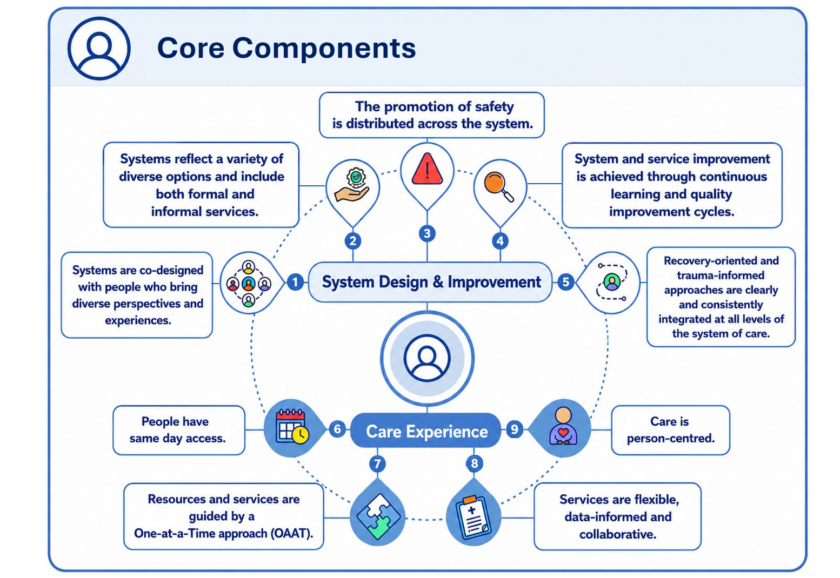

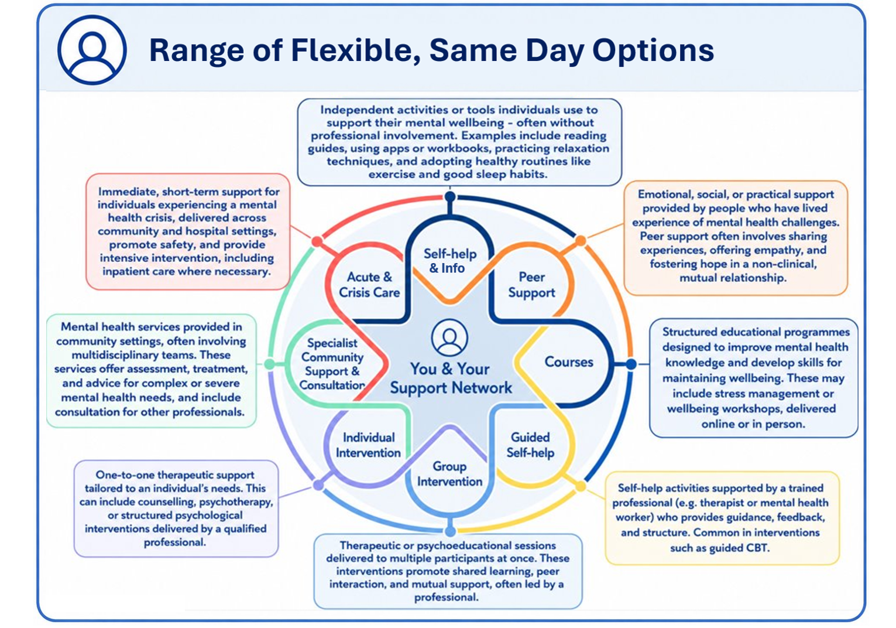

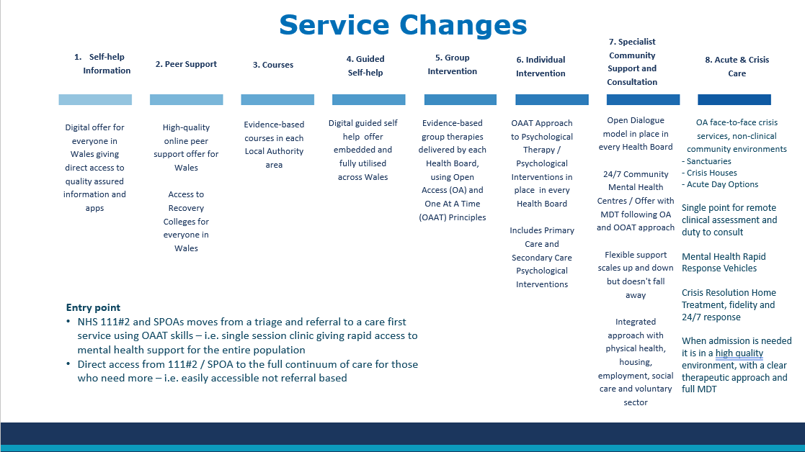

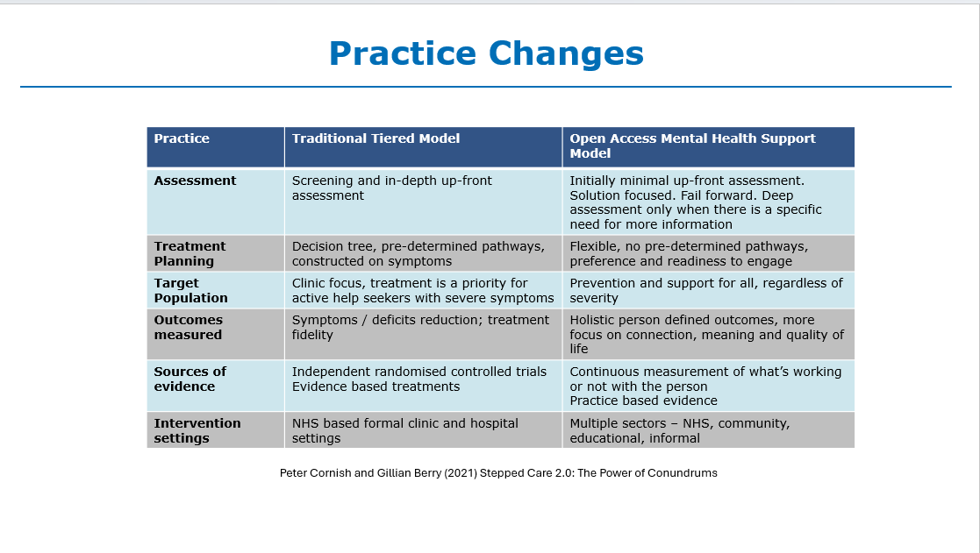

- Scope of the Work

Scope for Model of Care Development

- Adult Mental Health (18 to 65) excluding Forensic
- Full Continuum of Care, primary, secondary and tertiary, community and inpatients, all modalities, all professional groups

Rationale:

Adult Mental Health is where we see overuse of inpatient care and a high number of out of area beds.

JCC have planned work on the Forensic Mental Health Model of Care (low secure and medium secure). Will not duplicate that work but it will be fully aligned.

People with “secondary care” level of need require the full continuum of care and access to low intensity options as well as specialist options.

Primary prevention is out of scope as there is a separate work programme established across Welsh Government and Public Health Wales on whole population well-being. RPBs also undertake work in this area. However, all care delivery models would be expected to maximise prevention and early intervention approaches.

Scope for Inpatient Model & Bed Plan

- All NHS Wales Adult Mental Health inpatient care – all types – excluding secure care facilities

Rationale:

Adult Mental health is where we have potential to reduce the use of inpatient beds by augmenting the community model.

From an estates perspective any co-located Specialised (e.g. Mother & Baby Units or eating disorders units), Children’s, Older People’s and Forensic inpatient estate will need to be considered in parallel to changes to the Adult Mental Health estate as they are often located on the same sites.

Any co-located Learning Disability estate will need to be considered in parallel to changes to the Adult Mental Health estate. LD estate is often located with the Mental Health estate. In some cases, wards serve both populations.
Any change to the NHS Mental Health inpatient estate will impact on the sustainability of NHS Learning Disability inpatient care.

- Approach

We will utilise the NHS Wales P&I draft Substantial Service Change operating framework to underpin the approach. This is based on a number of tested processes from across the UK, aligned to a number of Welsh Government guidance documents, including; Engagement and Consultation on Changes to the Health Service and designed to support the delivery of Regional and National planning and implementation of services.

This provides an operating framework to support multiple organisations to plan and deliver services collaboratively as well as managing any service change as a system, including the key decision points. This service changes will require all parts of each system; from hospitals to primary care, Welsh Government, Local Authorities, through to the voluntary sector; to come together to combine their skills and expertise to agree strategies for change and work collaboratively to deliver substantial service change.

Figure 1: Draft Substantial Service Change Approach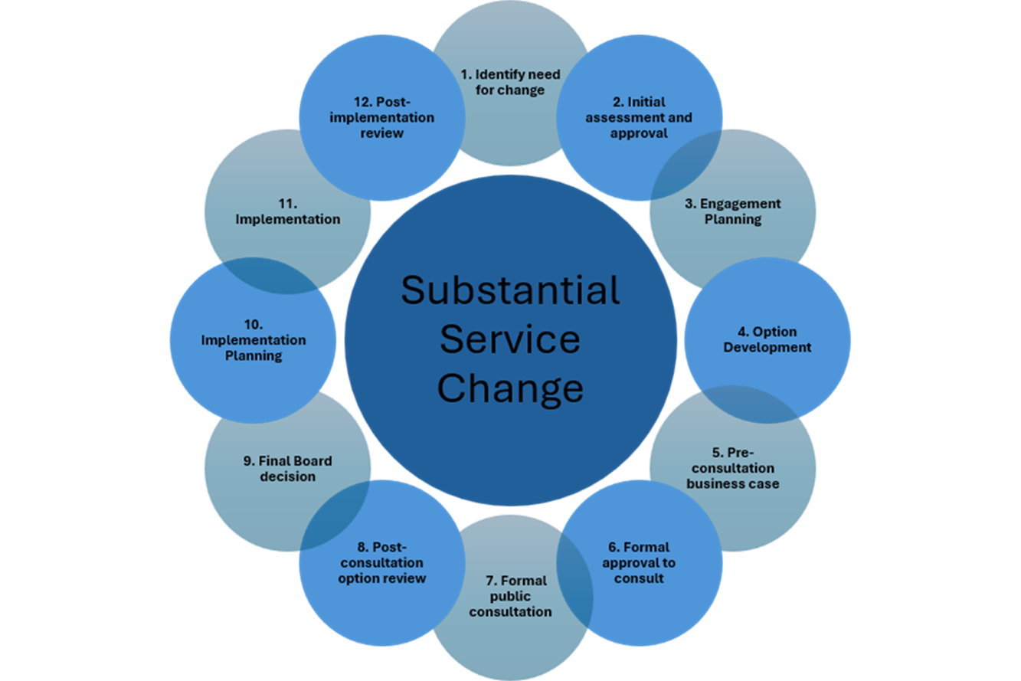
Significant work has already been undertaken in Steps 1, 2 and 3. This work will be reviewed to ensure completeness and address any gaps.
The work will then focus on Step 4 Option Development.

The National Clinical Plan will take the form of a Strategic Outline Case.

This will set out the rationale and evidence for a proposed substantial service change, its primary purpose being to demonstrate that the proposals are necessary, clinically sound and financially viable.

Decision Making Principles

Options will be evaluated based on the following draft decision-making principles to be approved by the Task & Finish group and developed into weighted evaluation criteria.

Strategic fit | Alignment with organisational and national priorities
Demand fit | Meets current and future mental health needs
Quality- STEEP | Clinical and operational risk
Workforce | Recruitment, retention, training requirements
Deliverability | Timescale, dependencies, implementation complexity
Financial impact | Capital, revenue, return on investment
Whole-system impact | Effect on partners and other services
Sustainability | Long-term viability and environmental impact
Preventative approach | Maximises opportunities for prevention and early intervention

- Constraints and Assumptions

Constraints

- Baseline data may not be readily available
- Timescales are relatively tight
- Managing cross organisation and cross sector inputs with competing priorities

Financial Assumptions

- Options should be affordable within the current financial revenue envelope. This will require a shift in resources from inpatients to community and a greater proportion of funding spent on lower intensity options.
- How this shift of resources will take place and if short term investment is needed to make that happen is not in scope of this first phase of work. That will follow in the next phase of work. However, it is likely that some transitional funding will be required.
- It is known that capital investment will be required to deliver the plan.

General Assumptions

- Baseline information that is available will be shared with P&I
- Current work to stabilise the system and make services safe will continue – e.g. patient safety programme, UEC MH daily data collection, actions to reduce the out of area beds, actions to improve hospital flow, actions to reduce package of care delays and actions to improve access to Psychological Therapies.
- The agreed open access demonstrator projects will continue as per the NHS Wales planning guidance.
- There is no change in the expectation that the National Mental Health Performance Metrics as set out in the NHS Wales Performance Framework will be met.
- There is no change to the legal requirements on Health Boards under the Mental Health Act and/or the Mental Health Measure.

- Users and Stakeholders

- Welsh Government EDT and Policy Leads
- NHS CEOs, Executive Teams and Boards
- Mental Health Directorate Leadership Teams
- SPMH and SLT, NHS Wales P&I
- Joint Commissioning Committee MH team
- DHCW MH team
- HEIW MH team
- People with lived experience and their families / carers
- Royal Colleges
- Mental health service staff
- Third sector organisations
- Local authorities

- Governance & Delivery Structure

Programme Team Roles:

- Sponsor: Jacqueline Totterdale, Director General HSCEY WG & NHS Wales CEO
- CEO Lead:Alex Howells, Interim Lead Chief Executive for Mental Health
- SRO & Programme Director: Ciara Rogers, National Director for Mental Health

The project will be governed by the SPMH Programme Board. The Programme Board is Chaired by Alex Howells, Interim Lead NHS Wales CEO for Mental Health.

The SPMH Programme Board reports to NHS Wales Leadership Group.

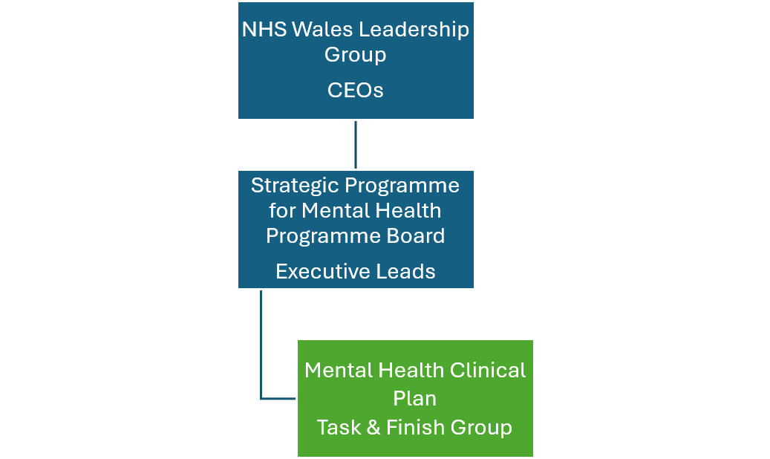

A clinically led task and finish group with the relevant clinical, operational, & lived experience, will be set up under the Programme Board to take forward the work.

The task and finish group will test the Business Case iteratively as it is developed using the existing structures of the SPMH as set out below. These structures include a Lived Experience Advisory Groups and a Stakeholder Reference Group.

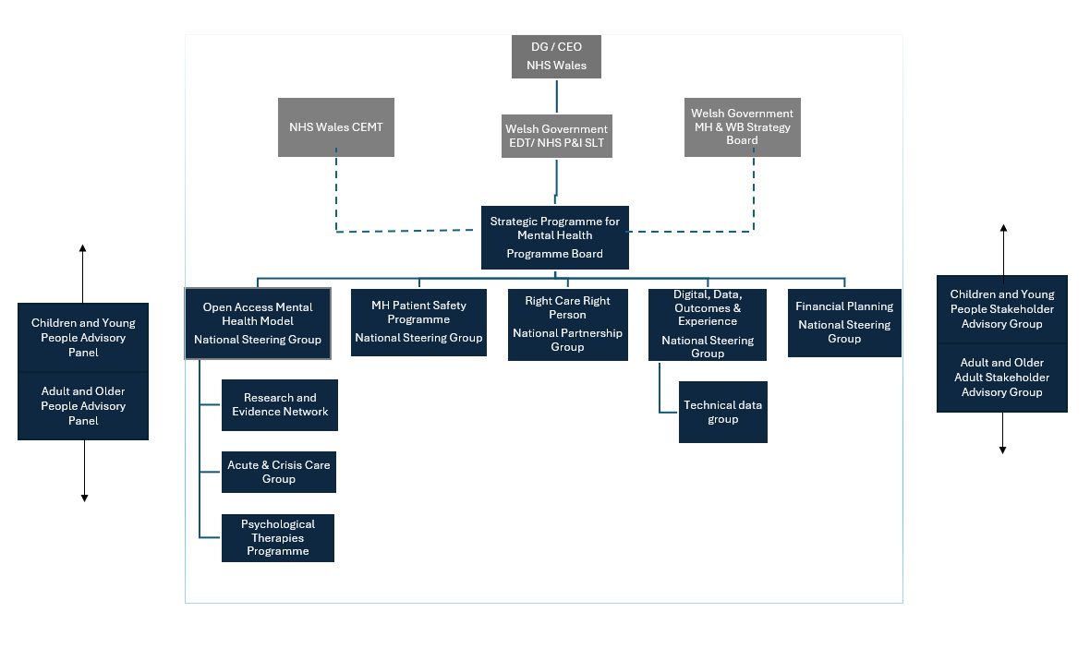

We will follow the best practice guidance in engagement as set out in the draft Substantial Service Change Operating Framework.

Clinically Led Task & Finish Group Members
NHS Reps – Confirmed

- Marie Davies, Executive Director of Planning and Partnerships, SB UHB
- Elaine Lorton, Executive Director of Primary, Community and Mental Health, PTHB
- Alberto Salmoiraghi, Medical Director, Mental Health & Learning Disability BCU UHB
- Andrea Davies, Clinical Director of Psychological Services, CTM UHB
- Rebecca Temple Purcell, Assistant Director of Nursing, Patient Safety, Quality & Experience, HD UHB
- Louise Turner, Mental Health Service Director, AB
- Andy Swinburn, Executive Director of Paramedicine, WAST
- Helen Watkins, Director of Workforce, HEIW
- Lauren Edward, Executive Director AHPs and Health Science

NHS reps to be confirmed

- DoF / Deputy Director of Finance, CAV UHB

Social care

- Jim Widett, MH, LD and ND Lead, Social Care Wales
- Corrine Everett-Guy, Adult Services, Carmarthenshire County Council
- Myfanwy Moran, Head of Adult Services, Newport City Council

Third sector

- Dr Jen Daffin, Director of Relational Practice, Policy and Campaigns, Plattform
- Julian John, Director, Mind Cymru
- Natalie Jones, Director of Operations MHM Wales

Lived Experience

- Sarah Stephens
- Toni Cope

Police

- Chief Superintedant Clark Jones-John, South Wales Police

Members of the task and finish group will be expected to be the link between this work programme and their peer group across Wales and / or their organisation as relevant to their role.

The Task & Finish Group will meet bi-weekly.

All Health Boards are represented on the task and finish group.

NHS Wales P&I Core Delivery Team

An internal P&I delivery team will be established and meet weekly.

- Chair – Ciara Rogers, National Director for Mental Heath
- Lead Editor - Steve Clarke, Clinical Lead and RMN, P&I
- Programme Management - Katie Cole
- Project Support - Melanie Thomas
- Clinical Model & Evidence Base
  - Dr Chris O’Connor, Clinical Lead and Clinical Psychologist, P&I
  - Dr Alberto Salmoiraghi, Clinical Lead and Psychiatrist, P&I
  - Andrea Gray, Head of Mental Health Improvement, P&I
  - Dave Semmens, Assistant Director Performance & Assurance, P&I
- Financial Planning & Modelling - Craig Davies
- Data Analysis & Visualisation - Lloyd Evans
- Communications and Engagement - Gareth Setter
- Workforce Planning & Modelling - HEIW

- Configuration Management (Record Management)

The Strategic Programme for Mental Health, NHS Wales P&I will be responsible for the management of all records and documents for the project.

- Risk Management

P&I risk management framework will be applied.

- Communications Management

Communications will be managed via the SPMH communications routes supported by the P&I Communications Team.

- High Level Programme Plan
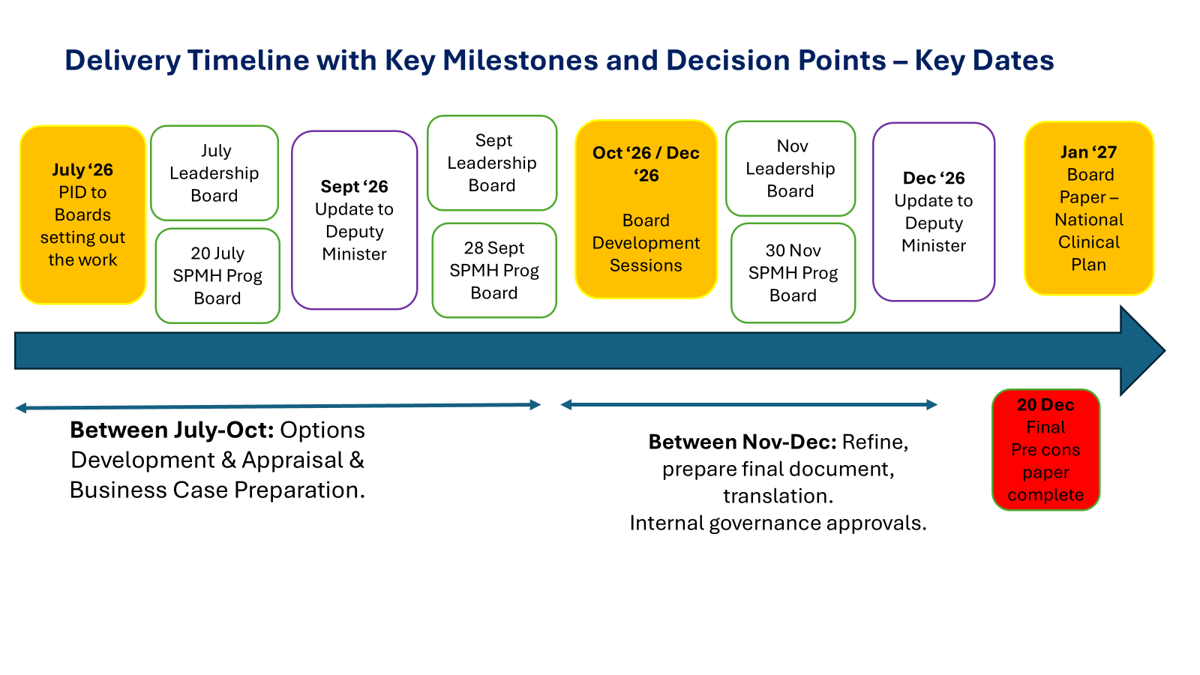

15. Success Measures

The work will be considered successful if it delivers:

- A high-quality, evidence-based National Clinical Plan in the form of a Strategic Outline Case
- Service user, clinical, executive and partner broad consensus on the proposed direction of travel
- Clear articulation of the case for change.
- Defined benefits, risks and implementation considerations
- A document that is ready for wider stakeholder engagement and/or formal consultation as recommended on completion of this work

16. Roles and Responsibilities

Welsh Government

The Cabinet Secretary for Health and Social Care is responsible for the exercise of all powers in the health and social care portfolio. The responsibilities include oversight of NHS Wales; health and social care strategy; NHS Wales Performance and Escalation; Health Protection, Improvement and Public Health; Primary Care; Patient Experience and Social Care.

The Health, Social Care and Early Years Group (HSCEY) in Welsh Government is the department responsible for the NHS and social care. The HSCEY advises the Welsh Government on policies and strategies, including relevant legislation and funding for NHS organisations and other related bodies. The group is headed by the Director General for Health and Social Services, who is also the Chief Executive of NHS Wales. The Chief Medical Officer, Chief Nursing Officer and Chief Social Care Officer are members of the group and support ministers and the Director General in discharging their responsibilities.

Welsh Government will be the final decision maker on the AMH National Clinical Plan.

NHS Wales Performance and Improvement

The dual role of NHS P&I is to:

- Work with the NHS in Wales to deliver better health services and outcomes for patients and the public; and

2) To support Welsh Government in holding NHS Wales organisations to account for the provision of health services.

Developing the AMH National Clinical Plan falls under role 1 i.e. supporting Welsh Government and NHS Wales in the development and delivery of innovative and value-based health policies, strategies, and services which result in improved health outcomes for patients and the public. This is a P&I improvement programme agreed with Welsh Government and the NHS Leadership Board.

NHS Wales P&I will lead and coordinate the development of the AMH National Clinical Plan, overseen by the Clinically Led Task and Finish Group.

NHS Wales Health Boards

NHS Wales Health Boards have a legal duty to plan, fund, and provide healthcare for local residents.

Health Boards will lead the Task and Finish Group overseeing and actively contributing to the development of the AMH National Clinical Plan. Health Boards will be asked to formally consider the plan and the proposed next steps before it is returned to Leadership Board and Welsh Government as a final version.

17. Steps Following on From January 2027

If the plan is supported as clinically sound and financially viable, the next steps will be for NHS Organisations, Welsh Government and partners in line with their statutory accountabilities and responsibilities to take forward the actions to deliver it.

The further steps beyond this phase of work set out in the PID will most likely include:

- Further engagement
- Pre-consultation business cases
- Public consultation
- Updating based on engagement and public consultation
- Detailed implementation planning
- Capital business cases
- Revenue models to support the changes

