Meeting Date | 13th July 2026 |  | Agenda Item
Report Title | Cancer Performance
Report Author | Marisa Bennett, Cancer Performance & Information Manager
Report Sponsor | Hannah Parsons, Assistant Director of Operations, Planned Care.
Presented by | Marisa Bennett
Freedom of Information | Open
Purpose of the Report | The report provides an update on the delivery of the Suspected Cancer Pathway for Swansea Bay UHB patients.
Key Issues | This report will highlight current performance for both backlog and Suspected Cancer Pathway.  Demonstrates by tumour sites current performance to meet 2-week outpatient; 31 day Decision to Treat internal targets and 5 day pathology turnaround.  Identifies key service delivery challenges and mitigating actions.
Specific Action Required  (please choose one only) | Information | Discussion |  | Assurance | Approval
Specific Action Required  (please choose one only) | ☐ | ☐ |  | ☒ | ☐
Recommendations | Members are asked to:  - NOTE the performance and backlog volumes in the main tumour sites.  - NOTE the additional work required to improve both performance and backlog.

Cancer Performance Update
- INTRODUCTION
In October 2022 Welsh Government (WG) initiated the enhanced monitoring (EM) intervention process for the Health Board (HB) due to quality issues relating poor performance and long waiting times. In January 2025 the HB was escalated to targeted intervention (TI) within several areas, including performance against the Suspected Cancer Pathway (SCP).
To progress toward de-escalation, the health board will need to demonstrate three consecutive months at 60% or above, with performance sustained and supported by evidence of continued improvement.
- BACKGROUND

The HB monitors two main metrics for the single cancer pathway:
- % Performance within the 62-day target
- Backlog volumes (patients waiting over 62 days)

Performance 2025/2027

The graph above shows the HB’s SCP performance since April 2025. It represents the patients receiving first definitive treatment (FDT) within the 62-day target against the target of 75%.

The HB reports 54% for May 2026. The reported position demonstrated the number of newly confirmed diagnoses of malignancy, 182, approximately 30% below the 2025 monthly average. Many more patients received first definitive treatment on pathway and within target, however pathology results were outstanding for 163 pathways, and without confirmation of malignancy could not be included within the submission.

Pathology backlogs continue to impact performance and the declining SCP backlog position. An opportunity for resubmission to reflect a corrected performance for Jan-March 2026 will be available in August 2026. Performance is expected to increase from 55% to 61% for January; from 46% to 57% for February; and from 55% to 60% for March.

Backlog

Backlog volumes increased week on week from March 2026 until the end of May (104% growth), there has been a degree of stability over recent weeks.

The table below demonstrates the backlog volume at the 1st July 2026, by tumour site and stage of pathway. Diagnostic volumes are closely related to pathology backlogs.
 | First OPA | Diagnostic One Stop | Diagnostic | Followup | MDM | Treatment | Grand Total
Acute Leukaemia | 0 | 0 | 0 | 0 | 0 | 0 | 0
Brain/CNS | 0 | 0 | 0 | 1 | 0 | 0 | 1
Breast | 0 | 1 | 2 | 0 | 0 | 2 | 5
Children's Cancer | 0 | 0 | 1 | 0 | 0 | 0 | 1
Gynaecological | 19 | 0 | 160 | 13 | 2 | 15 | 209
Haematological | 0 | 0 | 8 | 1 | 0 | 1 | 10
Head and Neck | 0 | 0 | 45 | 5 | 1 | 6 | 57
Lower Gastrointestinal | 0 | 0 | 41 | 6 | 5 | 15 | 67
Lung | 0 | 0 | 6 | 1 | 1 | 7 | 15
Other | 0 | 0 | 2 | 0 | 0 | 1 | 3
Sarcoma | 0 | 0 | 4 | 3 | 1 | 2 | 10
Skin | 2 | 20 | 66 | 16 | 3 | 15 | 122
Upper Gastrointestinal | 0 | 0 | 28 | 5 | 1 | 2 | 36
Urological | 1 | 0 | 48 | 21 | 0 | 15 | 85
Grand Total | 22 | 21 | 411 | 72 | 14 | 81 | 621

Revised Tumour Site Backlog Trajectories have been submitted in line with the HB’s revised Annual Plan.
Backlog | July | August | September | October | November | December | January | February | March
Acute Leuk. | 0 | 0 | 0 | 0 | 0 | 0 | 0 | 0 | 0
Brain/CNS | 1 | 1 | 1 | 1 | 1 | 1 | 1 | 1 | 1
Breast | 4 | 4 | 4 | 4 | 4 | 4 | 4 | 4 | 4
Children's | 0 | 0 | 0 | 0 | 0 | 0 | 0 | 0 | 0
Gynaecological | 139 | 31 | 19 | 12 | 7 | 2 | 2 | 2 | 2
Haematological | 12 | 12 | 6 | 6 | 6 | 6 | 6 | 6 | 6
Head and Neck | 35 | 12 | 5 | 5 | 5 | 5 | 5 | 5 | 5
Lower GI | 76 | 62 | 47 | 47 | 47 | 47 | 47 | 47 | 47
Lung | 20 | 15 | 12 | 10 | 6 | 4 | 4 | 4 | 4
Other | 1 | 1 | 1 | 1 | 1 | 1 | 1 | 1 | 1
Sarcoma | 10 | 6 | 4 | 4 | 4 | 4 | 4 | 4 | 4
Skin | 125 | 100 | 75 | 0 | 0 | 0 | 0 | 0 | 0
Upper GI | 29 | 16 | 4 | 4 | 4 | 4 | 4 | 4 | 4
Urological | 92 | 55 | 41 | 30 | 30 | 29 | 25 | 25 | 25
Total | 545 | 317 | 220 | 125 | 116 | 107 | 104 | 104 | 104

- RECOVERY PLANS
The Health Board continues to focus efforts on the front end of pathway. Pathway milestones previously identified to further improve the SCP performance that we are monitoring are:

- First outpatient attendance must be within two weeks of receipt of referral.

The Planned Care Vitals Dashboard is used to report the waits based on activity within any month; this does not reflect patient choice/unavailability. Notable increase in the median days wait is seen in Gynaecology; Dermatology; Plastic Surgery and Urology for both outpatients and haematuria.

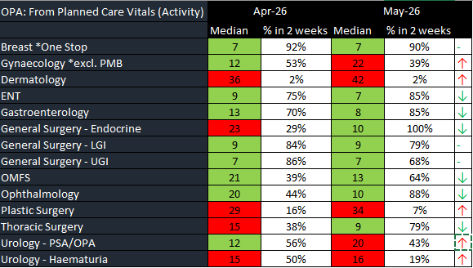

- That decision to treat must be attained by day 31 of pathway

The chart below demonstrates the median wait days from suspicion to decision to treat from April 2025 to May 2026 for closed (treated) pathways and percentage meeting 31 days. The waits for Jan 26 – May 26 are subject to correction at resubmission; in particular waits from February onwards are negatively impacted by the low overall volumes treated, in particular for skin, as such we should expect to see a reduction in the median wait/increase in %.

This measure essentially concludes the diagnostic phase of the SCP. Supporting improvement in this measure must be access to timely diagnostics and pathology turnaround times has contributed to pathway waits across all tumour sites which brings in a third measure.

- That cellular pathology reports will be available within 5 days

Information not available within current local Cellular Pathology Dashboard or All Wales Cellular Pathology Dashboard. Enquiries have been made with DHCW regarding LIMS2 data missing from the All Wales Dashboard.

Radiology

Information not available within current local Radiology Dashboard. Ongoing work to bring in the data from the new system.
Endoscopy
The USC/USC STT endoscopic median waits in May were: 13 days for OGD; 15 days for Flexi-sigmoidoscopy and 16 days for Colonoscopy, noting these are unadjusted waits. Waits exceeding 2 weeks are due to patient choice, unable to contact or medical reasons.

- TUMOUR SITE OVERVIEW

Performance and Backlog graphs for each tumour site are shown below. Backlog trajectories have been revised from end of July 2026 through to the end of the financial year.

Gynaecological
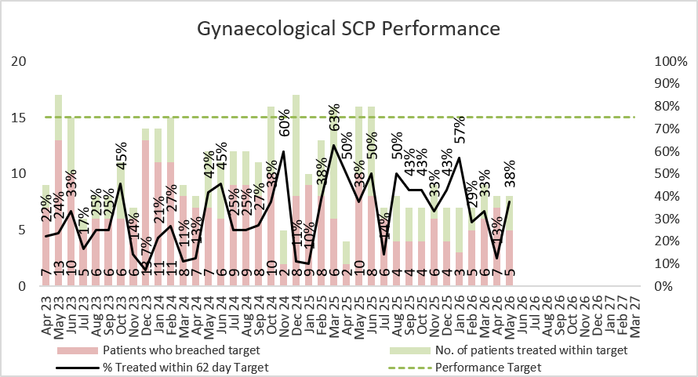 | 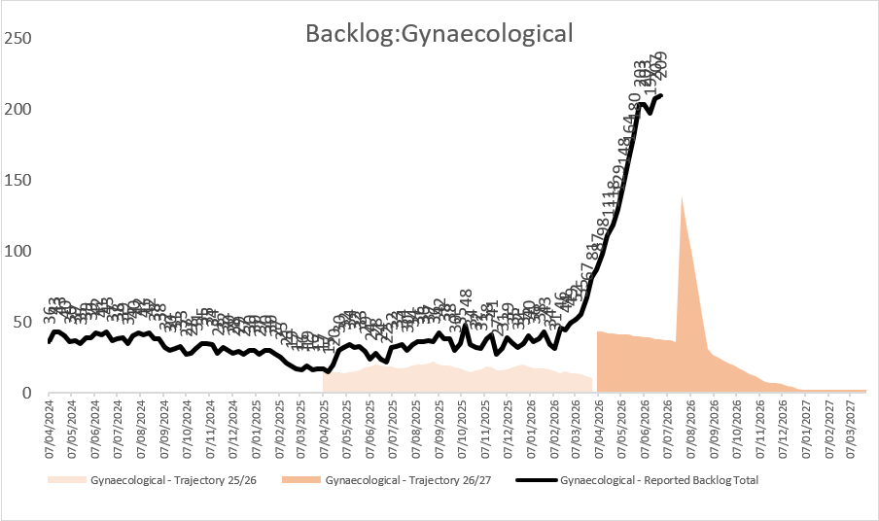
Urological
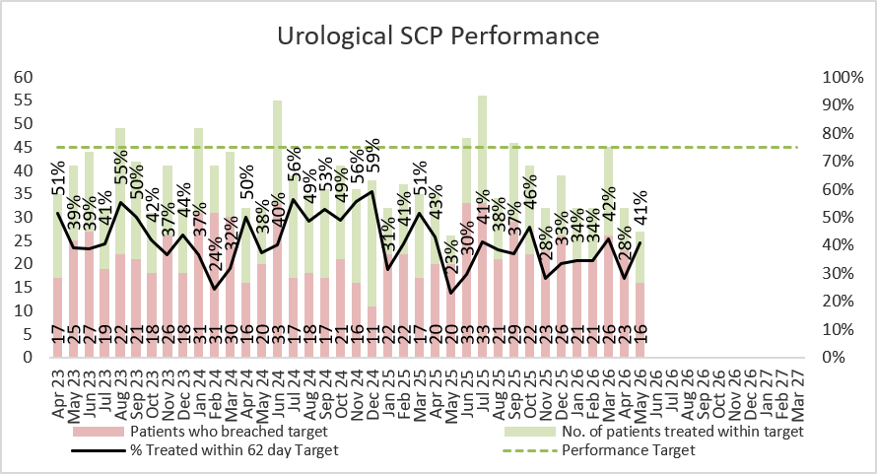 | 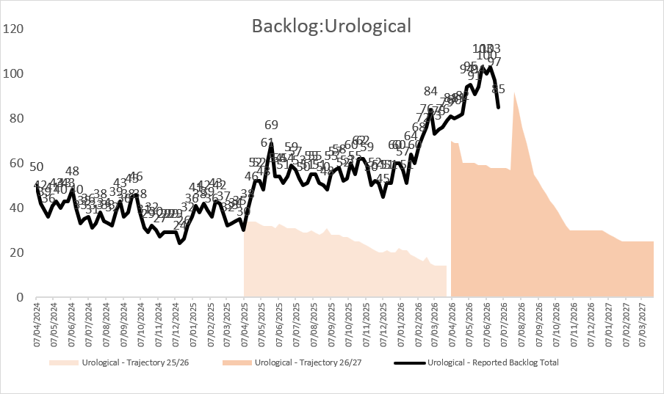
Lower GI
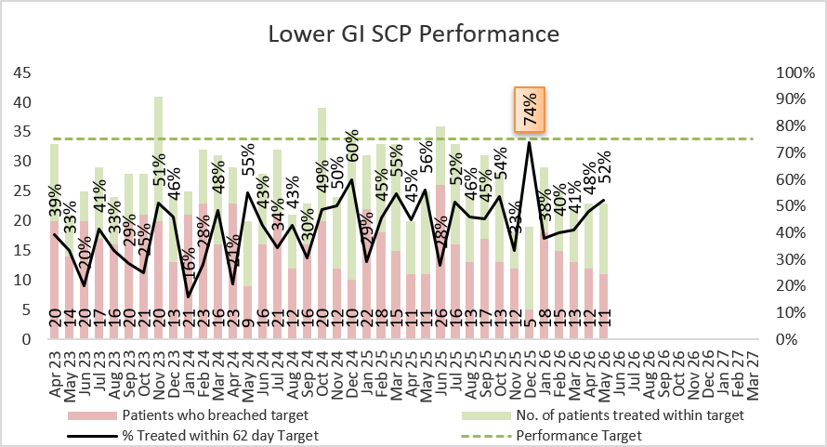 | 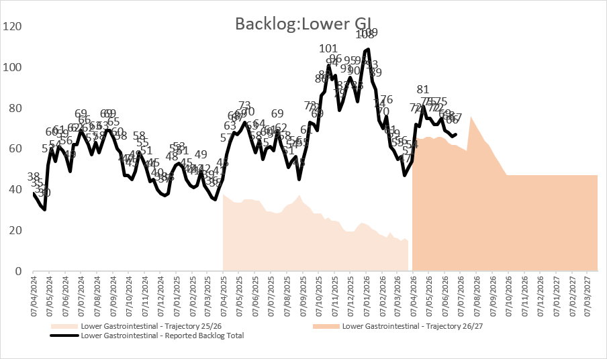
Skin
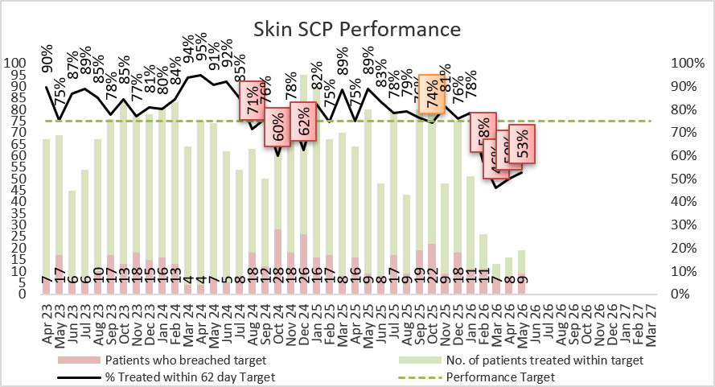 | 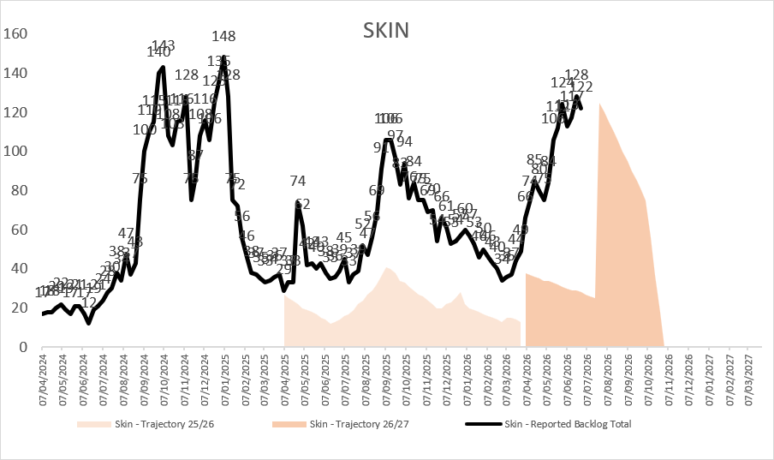

Lung
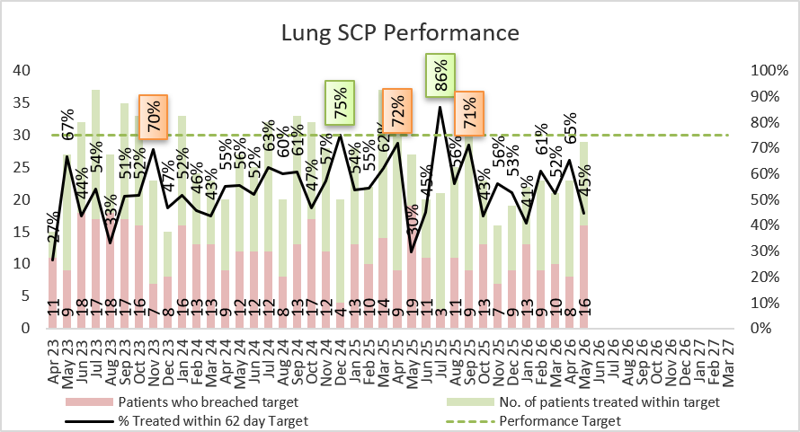 | 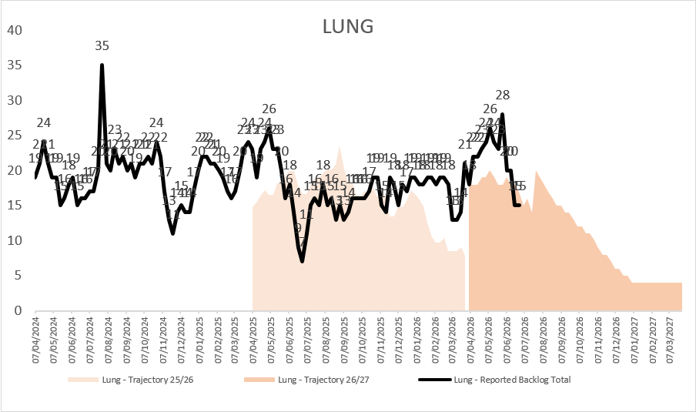
Breast
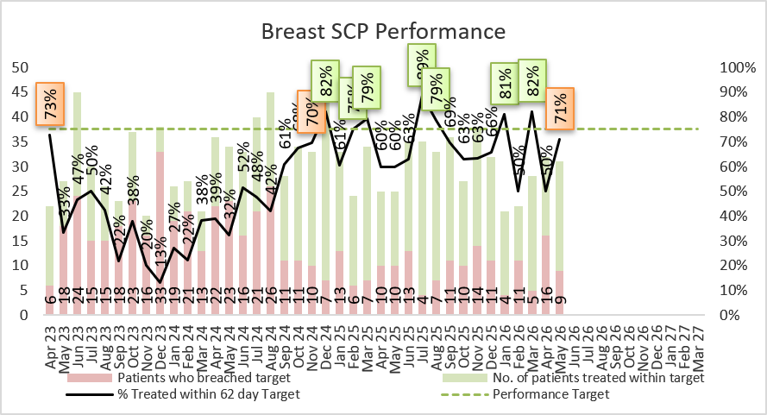 | 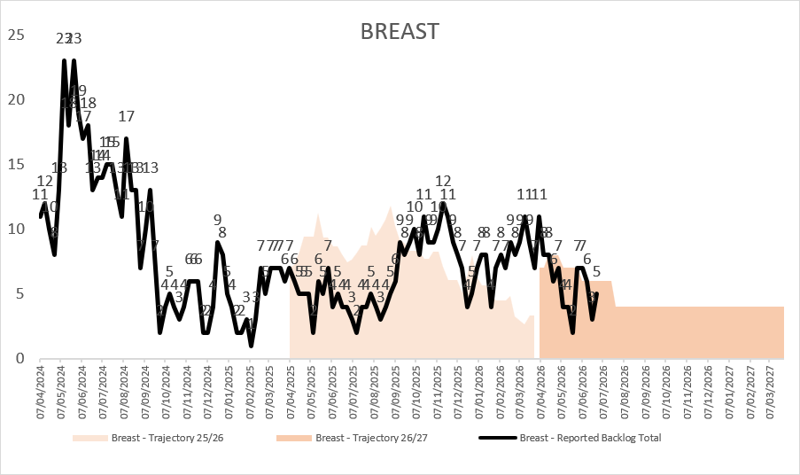

- RECOMMENDATION

Tumour site improvement plans are critical to support and drive improvement across all sites. The top 6 tumour groups of: Breast, Lung, Urology, Lower GI, Gynaecology and Skin and prepared plans, initial feedback has been provided to services for refinement and assurance that the planned actions will deliver the required improvement. Fortnightly tumour site meetings, to include clinical and service leads are being scheduled from 17th July for monitoring and oversight.

Development of improvement plans for the remaining tumour groups of Haematology, Head & Neck, Upper GI and Sarcoma have been requested by the 31st July 2026.

CPIG is asked to:
- NOTE the performance and backlog volumes in the main tumour sites including the development of site-specific improvement plans.

Governance and Assurance

Link to Enabling Objectives  (please choose) | Supporting better health and wellbeing by actively promoting and empowering people to live well in resilient communities
Link to Enabling Objectives  (please choose) | Partnerships for Improving Health and Wellbeing |  |  | ☒
Link to Enabling Objectives  (please choose) | Co-Production and Health Literacy |  |  | ☐
Link to Enabling Objectives  (please choose) | Digitally Enabled Health and Wellbeing |  |  | ☒
Link to Enabling Objectives  (please choose) | Deliver better care through excellent health and care services achieving the outcomes that matter most to people
Link to Enabling Objectives  (please choose) | Best Value Outcomes and High Quality Care |  |  | ☒
Link to Enabling Objectives  (please choose) | Partnerships for Care |  |  | ☒
Link to Enabling Objectives  (please choose) | Excellent Staff |  |  | ☒
Link to Enabling Objectives  (please choose) | Digitally Enabled Care |  |  | ☒
Link to Enabling Objectives  (please choose) | Outstanding Research, Innovation, Education and Learning |  |  | ☐
Health and Care Standards
(please choose) | Staying Healthy |  |  | ☐
(please choose) | Safe Care |  |  | ☒
(please choose) | Effective Care |  |  | ☒
(please choose) | Dignified Care |  |  | ☐
(please choose) | Timely Care |  |  | ☒
(please choose) | Individual Care |  |  | ☐
(please choose) | Staff and Resources |  |  | ☒
Quality, Safety and Patient Experience
Accurate, comprehensive demand and capacity plans can increase safety and quality whilst reducing risk and can lead to efficiency gains within clinical services. They will also facilitate more timely treatment of patients and enhance patient experience.

Financial Implications
There are no direct financial implications associated with this paper. Inputs (additional activity) into the demand and capacity models are funded via Recovery Money. However, the outputs from the modelling will inform the development of the Health Board’s IMTP and financial plans for sustainable services.

Legal Implications (including equality and diversity assessment)
There are no legal implications to consider.

Staffing Implications
There are no immediate staffing implications as a result of this paper but there is a need to be mindful that this is a very specialist area and we need to build robust and sustainable capacity in this area.

Long Term Implications (including the impact of the Well-being of Future Generations (Wales) Act 2015)
Report History
Appendices

