Meeting Date | 30 July 2026 | Agenda Item | 4.3
Name of Meeting | SBUHB Board
Report Title | Cancer Improvement Programme: A Whole-System Approach to Improving Cancer Outcomes, Performance and Sustainability
Report Author | Hannah Parsons, Assistant Director of Operations, Planned Care & Cancer
Report Sponsor | Chief Operating Officer
Presented by | Dr, Raj Krishnan, Executive Medical Director
Freedom of Information | Open
FoI Closed detail | If closed, choose detail
Impact Assessment Summary Outcome |  | IA Completion date
Overall, the proposal is expected to have a positive impact by strengthening governance and coordination of cancer improvement. No significant adverse impacts have been identified at this stage. Detailed Integrated Impact Assessments will be undertaken for future service changes where required. |  | 10 July 2026
Purpose of the Report | For Endorsement
Report Summary; detailing any action required
The purpose of this paper is to:

- provide an update on progress against the Single Cancer Pathway (SCP) Improvement Plan presented to Executive Board in June 2026 (Appendix 1), including progress in the development of tumour-site improvement plans and other priority recovery actions;
- present the proposed Swansea Bay Cancer Improvement Framework, developed following the Cancer Improvement Workshop held in March 2026, as the strategic organising framework for cancer improvement activity across the Health Board;
- outline the case for establishing a formal Executive-sponsored Cancer Improvement Programme to coordinate delivery of improvement activity across the whole cancer pathway; and
- seek Board endorsement of the proposed programme approach and governance arrangements.

Key Issues
- Cancer outcomes and SCP performance require sustained organisational focus and a whole-system approach to improvement.
- Progress has been made against the June 2026 SCP Improvement Plan, including development of tumour-site improvement plans.
- A Cancer Improvement Framework has been developed to provide a coherent structure for coordinating cancer improvement activity across the Health Board.
- It is proposed that cancer is elevated to a formal Executive-sponsored Improvement Programme, aligning with existing Health Board improvement programmes and emerging national direction.
Decision / Action required | Choose requirement
Recommendations
Members are asked to:

- CONSIDER the progress made since the June 2026 Executive Board paper in developing the Health Board's approach to cancer improvement, including the development of tumour-site improvement plans and other supporting workstreams.
- RECOGNISE the need to build on the immediate recovery actions set out within the Single Cancer Pathway Improvement Plan through a broader, coordinated approach to improving cancer outcomes.
- ENDORSE the proposed Cancer Improvement Framework as the organising structure for the Health Board's Cancer Improvement Programme.
- APPROVE the establishment of a formal Executive-sponsored Cancer Improvement Programme, with the Medical Director acting as Executive Sponsor.
- SUPPORT the development of a Programme Initiation Document, setting out the detailed governance arrangements, programme support requirements and implementation plan for future consideration by the Board.

CANCER IMPROVEMENT PROGRAMME: A WHOLE-SYSTEM APPROACH TO IMPROVING CANCER OUTCOMES, PERFORMANCE AND SUSTAINABILITY

- INTRODUCTION
Executive Board received the Health Board's Single Cancer Pathway (SCP) Improvement Plan in June 2026, setting out the immediate actions required to improve cancer pathway performance and committing to further work to strengthen delivery, including the development of tumour-site improvement plans (Appendix1).
This paper provides an update on progress against those commitments. It also sets out a broader proposal that has been developing in parallel following the Cancer Improvement Workshop held in March 2026.
The workshop concluded that, whilst improving SCP performance remains a priority, the wider challenges facing cancer services require a more coordinated organisational approach. The paper therefore seeks Board support to establish a formal Cancer Improvement Programme, to provide strategic oversight of cancer improvement across the Health Board.
- BACKGROUND

2.1 Developing a Whole System Approach to Cancer Improvement

Improving cancer outcomes has been a long-standing priority for the Health Board. Whilst much of the recent focus has rightly been on recovering Single Cancer Pathway (SCP) performance, there has also been increasing recognition that sustainable improvement requires a broader view of cancer services.

In March 2026, the Health Board brought together more than 90 colleagues from across clinical and operational disciplines, as well as third sector partners and NHSP&I representatives, for a Cancer Improvement Workshop. The purpose of the workshop was to step back from day-to-day operational pressures and consider what would be needed to improve cancer outcomes over the longer term.

The workshop identified a number of recurring themes. Whilst timely diagnosis and treatment remain fundamental, participants recognised that outcomes are influenced by much wider factors including prevention and screening, earlier diagnosis, diagnostic capacity, workforce, access to treatment, recovery and survivorship including personalised care and long term follow up, prehabilitation and rehabilitation, and PEOLC. It also highlighted the interdependencies between cancer, diagnostics and planned care, and the need for improvement activity to be considered as a whole rather than through individual services or pathways.

Following the workshop, work began to develop a Cancer Improvement Framework to provide a clear structure for this wider programme of work. This has progressed alongside the operational work to recover SCP performance and has continued to evolve through discussions with clinical teams, tumour-site leads, and national colleagues.

The direction of travel nationally has since reinforced this approach. The emerging NHS Wales Cancer Programme places increasing emphasis on improving outcomes through integrated planning across cancer, diagnostics and planned care, supported by stronger governance, demand and capacity planning, and greater use of data to support improvement. The work already underway within Swansea Bay is consistent with this direction and provides an opportunity to align local improvement activity with national priorities.

2.2 Progress since the June SCP Improvement Plan

In June 2026, Executive Board received the Health Board's SCP Improvement Plan, setting out the immediate actions required to improve cancer pathway performance and support delivery of the agreed recovery trajectory.

The paper recognised that immediate operational recovery remained the priority and committed to further work in a number of areas, to strengthen assurance regarding delivery. This included the development of tumour-site improvement plans, continued implementation of the Cellular Pathology Recovery Plan, further diagnostic improvement actions and enhanced monitoring of first outpatient waits and treatment intervals.

Since June, progress has continued across each of these areas.

The HB reports 54% for May 2026 (appendix 2). The reported position demonstrated the number of newly confirmed diagnoses of malignancy (182), approximately 30% below the 2025 monthly average. Many more patients received first definitive treatment on pathway and within target, however pathology results were outstanding for 163 pathways, and without confirmation of malignancy could not be included within the submission.

Whilst May's reported performance exceeds the planned trajectory of 48%, the ongoing Cellular Pathology backlog continues to affect the reliability of monthly SCP reporting. Delays in confirming malignancy mean that completed pathways cannot always be included within the monthly submission, creating variability in reported performance and reducing confidence in month-on-month trends until the backlog has been addressed.

Tumour-site improvement plans

Tumour-site improvement plans have now been developed across the priority tumour pathways, providing a more detailed understanding of the actions required to support recovery.

Across the tumour-site plans, there is increasing emphasis on demand management, pathway redesign, productivity, optimisation of existing capacity and delivery of measurable improvements in performance, alongside targeted investment where this is supported by a clear evidence base. This reflects the Health Board's expectation that sustainable improvement should be driven through service redesign and optimal use of existing resources wherever possible.

The plans will continue to be refined through dedicated tumour-site review meetings, with implementation monitored through CPIG and, subject to Board approval, the proposed Cancer Improvement Programme.

Cellular Pathology Recovery

Implementation of the Cellular Pathology Recovery Plan continues in line with the agreed recovery programme. Progress is being monitored through established governance arrangements, recognising the critical role that pathology plays in supporting timely diagnosis and treatment.

Collectively, these actions strengthen assurance regarding delivery of the immediate recovery plan whilst establishing a stronger foundation for the longer-term Cancer Improvement Programme described later in this paper.

  - Why we now need to develop a broader approach

The work undertaken over recent months has reinforced that recovering SCP performance, whilst essential, is only one part of improving cancer services.

Demand for Cancer services continues to grow. More people are being referred on suspected cancer pathways, more people are receiving treatment, and patients are often living longer with increasingly complex treatment needs. These changes are placing pressure across the whole pathway, from diagnostics through to treatment and follow-up.

Population health and outcomes

Alongside the operational challenges described above, public health intelligence highlights a significant opportunity to improve cancer outcomes across the population served by Swansea Bay.

Whilst outcomes continue to improve for many cancers, important variation remains in cancer incidence, stage at diagnosis, survival and screening uptake between tumour types and across different population groups. The evidence demonstrates that deprivation remains one of the strongest determinants of cancer outcomes, influencing both the likelihood of developing cancer and the opportunity to achieve good outcomes following diagnosis.

The infographic overleaf summarises a number of the key population health challenges identified for Swansea Bay. Lung cancer remains the leading cause of cancer death, with approximately three-quarters of cases diagnosed at an advanced stage when curative treatment is less likely. Bowel cancer remains the second leading cause of cancer mortality, with survival outcomes below the Welsh average and little improvement over the last decade. Screening uptake also varies considerably across the Health Board, with bowel screening uptake more than 16 percentage points lower in the most deprived communities than in the least deprived. Collectively, these findings demonstrate the continuing impact of health inequalities on cancer outcomes across Swansea Bay.

Infographic: Key Population Health Challenges for Swansea Bay

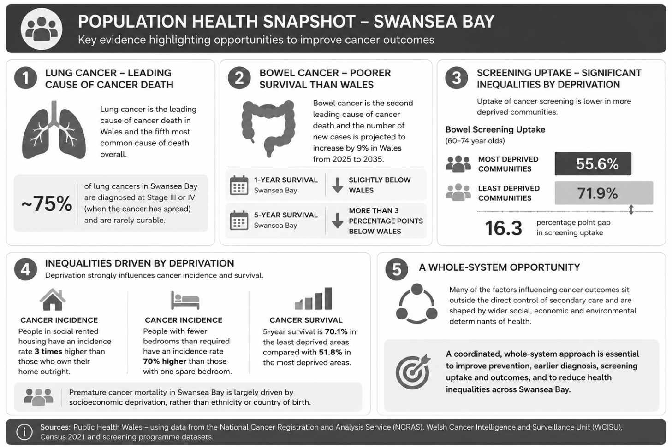

The evidence also demonstrates that many of the factors influencing cancer outcomes sit outside the direct control of secondary care and are shaped by wider social, economic and environmental determinants of health. Whilst timely diagnosis and treatment remain fundamental, improving outcomes will also require continued focus on prevention, earlier diagnosis, increasing uptake of screening programmes, reducing unwarranted variation in care and ensuring equitable access to services regardless of where people live or their socioeconomic circumstances.

Work undertaken across the South West Wales Cancer Centre has similarly identified longer-term challenges extending beyond operational performance, including workforce sustainability, increasing demand for oncology services, treatment capacity, equitable access to personalised care, research and innovation, and the need to plan services on a regional basis. These challenges require collaboration across organisational and professional boundaries and cannot be addressed through pathway recovery alone.

Nationally, the direction of travel is consistent. The emerging NHS Wales Cancer Programme places increasing emphasis on prevention, population health, diagnostics, cancer treatment, research and innovation, supported by stronger programme governance and closer integration with planned care and diagnostics.

Taken together, these factors reinforce the need for a coordinated whole-system approach to cancer improvement. Whilst significant improvement activity is already underway across Swansea Bay, it is currently delivered through multiple workstreams and governance arrangements. Bringing this work together through a single Cancer Improvement Programme will strengthen oversight, improve accountability and provide a clearer line of sight between improvement activity and the outcomes that matter most to the population we serve.

Clinical research and innovation

Clinical research is recognised as an important contributor to improving the quality of cancer care and patient outcomes. Evidence demonstrates that patients treated in research-active organisations experience better outcomes, regardless of whether they personally participate in a clinical trial.

Work undertaken by the South West Wales Clinical Research Pathways Task and Finish Group has highlighted opportunities to strengthen regional collaboration, improve equitable access to clinical trials and develop the workforce and infrastructure required to support research across South West Wales. These ambitions align closely with the proposed Cancer Improvement Programme and will be reflected within the Programme's workstreams and Annual Cancer System Plan.

Nationally, the direction of travel is similar. The emerging NHS Wales Cancer Programme recognises that improving cancer outcomes requires closer alignment between cancer, diagnostics and planned care, supported by stronger governance and more coordinated delivery arrangements.

Taken together, these factors suggest that the Health Board now has an opportunity to build on the immediate recovery work already underway by adopting a more coordinated approach to cancer improvement. The challenge is not that there is insufficient activity; rather, it is that the activity is spread across a number of programmes, workstreams and governance arrangements. Bringing this work together under a single programme would provide greater oversight, strengthen accountability and make it easier to demonstrate the collective impact on outcomes.

2.4 Why a Formal Cancer Improvement Programme is Required

The Health Board already uses formal improvement programmes where delivery depends on sustained collaboration across multiple services and professional groups. The Mental Health and Perinatal Improvement Programmes are examples of this approach, providing executive oversight, dedicated programme support and a clear structure for coordinating improvement.

Cancer now presents a similar organisational challenge and thus, could benefit from a similar programme structure as demonstrated below:

Characteristics of Executive-sponsored Improvement Programmes | Cancer
Cross-organisational delivery | ✓
Multiple clinical specialties | ✓
Long-term transformation | ✓
Executive sponsorship | Proposed
Dedicated programme support | Proposed

Significant improvement activity is already underway across Swansea Bay. However, it is currently delivered through multiple workstreams and governance arrangements.

Establishing a formal Cancer Improvement Programme would bring this work together, providing clearer oversight and stronger accountability.

Given the scale of the challenge and the strategic importance of cancer, it is proposed that the Programme is established as a formal Executive-sponsored Improvement Programme, with the Medical Director acting as Executive Sponsor.

  - Proposed Cancer Improvement Programme

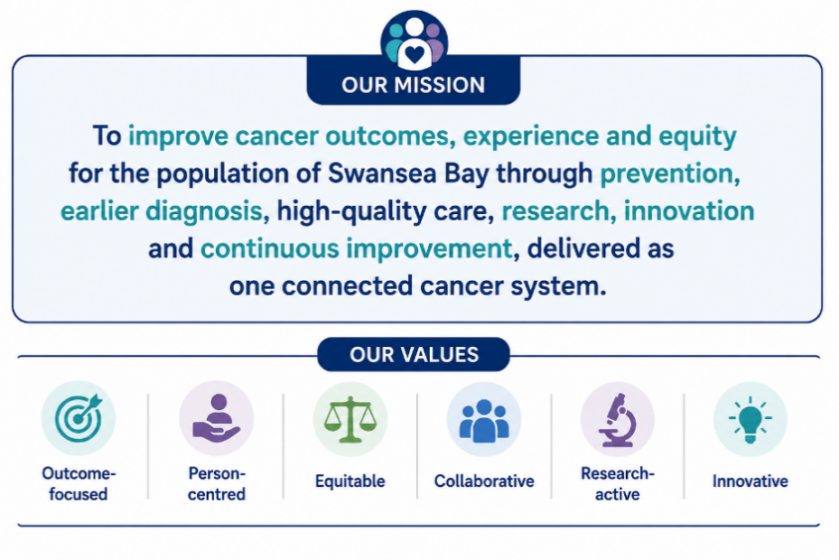

The Cancer Improvement Programme will seek to deliver sustained improvement across five domains:

- Better cancer outcomes for the population served by Swansea Bay.
- Timely access to diagnosis and treatment.
- Reduce unwarranted variation and improve equitable access to high-quality cancer care and clinical research.
- Sustainable cancer services able to meet future demand.
- Improved assurance through coordinated programme governance.

The proposed Cancer Improvement Programme provides the mechanism through which the Health Board can bring together its existing cancer improvement activity whilst creating the capacity to address the wider challenges described earlier in this paper.

It builds on the work already underway through the SCP Improvement Plan, whilst also recognising that improving cancer outcomes will require sustained attention over a number of years. The programme is therefore intended to provide continuity, ensuring that immediate recovery actions are delivered whilst maintaining focus on the longer-term improvements needed across the cancer pathway.

The Programme will be underpinned by a Cancer Improvement Framework. The Framework provides a simple structure for organising improvement activity and ensuring that related workstreams are aligned around a common purpose. It is not intended to replace existing plans or governance arrangements; rather, it provides an overarching framework through which improvement activity can be coordinated, monitored and supported.

The Framework has been developed from the themes emerging from the March Cancer Improvement Workshop, subsequent tumour-site planning, discussions and the emerging national approach to cancer improvement. It reflects the breadth of activity required to improve outcomes for the population served by Swansea Bay and provides a structure that can evolve as local priorities and national expectations develop.

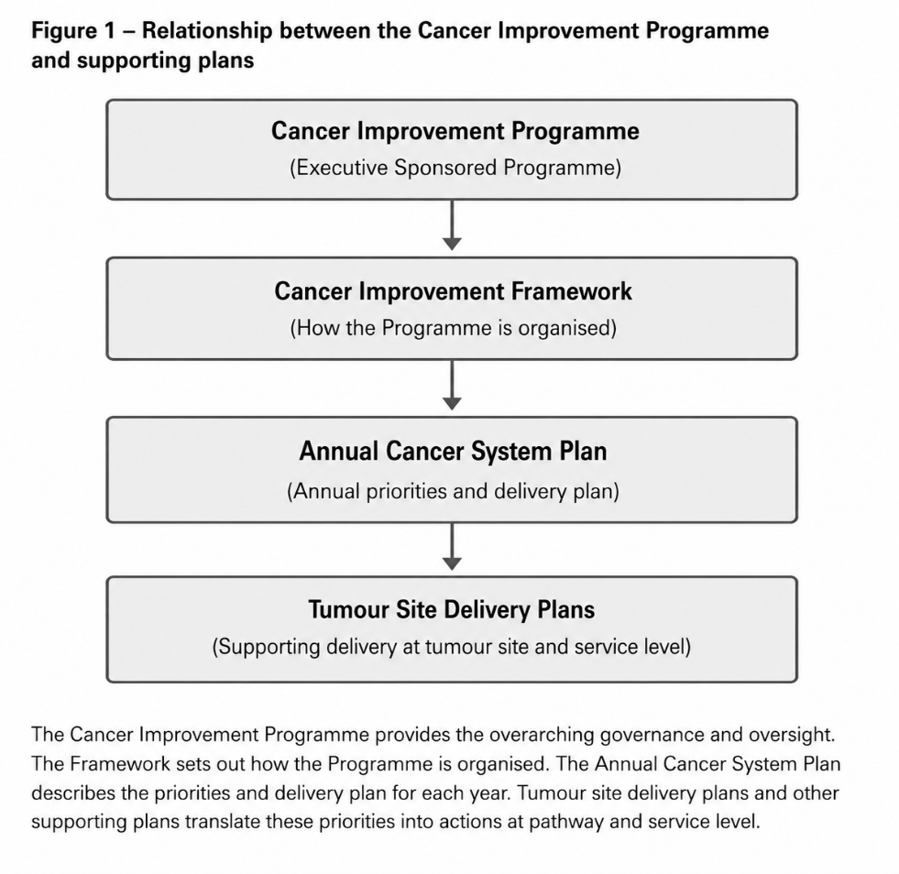
The Framework identifies five priorities that, collectively, reflect the areas where the Health Board can have the greatest impact on cancer outcomes. Together, they bring immediate recovery work together with the longer-term improvements and will represent the key programme workstreams.

Programme Priority | Purpose
Prevention and Earlier Diagnosis | Improve outcomes through prevention, screening, earlier diagnosis and timely referral into cancer pathways.
Diagnostics and Timely Access | Improve access to diagnostics, reduce delays across pathways and strengthen patient flow from referral to treatment.
Tumour Site Improvement | Deliver focused improvement within priority tumour pathways, reducing unwarranted variation and supporting delivery of the SCP Improvement Plan.
Sustainable Services, Research and Innovation | Ensure oncology, surgical and wider treatment services remain capable of meeting future demand through workforce planning, capacity development and regional collaboration. Support innovation and clinical research to improve patient outcomes, widen access to clinical trials and strengthen the sustainability of cancer services.
Personalised Care and Living Well with and Beyond Cancer | Improve patient experience by strengthening personalised care, prehabilitation and rehabilitation, survivorship and palliative and end-of-life care.

Programme Scope and Timescale

It is important to distinguish this programme from the Health Board's existing SCP Improvement Plan.

The SCP Improvement Plan remains the vehicle through which immediate operational recovery is being delivered, including implementation of tumour site improvement plans, pathway optimisation and actions to improve delivery of the national cancer performance standards over the next 12–24 months.

By contrast, the Cancer Improvement Programme is a longer-term strategic programme, intended to reshape how cancer services are designed and delivered over the next 5–10 years. It will establish the future operating model for cancer services, ensuring they remain clinically sustainable, resilient and capable of meeting future demand while supporting improvements in patient outcomes.

Programme Enablers

These priorities will be supported by a number of cross-cutting enablers that underpin delivery across the whole programme:

- Workforce planning
- Research and innovation
- Digital systems and data
- Quality improvement capability
- Partnership working and engagement

The detailed actions that sit beneath each priority will continue to be described through the annual Cancer system plan. This approach allows the Programme to respond to emerging priorities whilst maintaining a consistent strategic direction over time.

The Cancer Improvement Programme will continue to evolve alongside the Health Board's emerging Clinical Services Plan and refreshed Clinical Strategy, ensuring that future service developments are aligned with the wider strategic direction of the organisation.

Intended Benefits and Outcomes

The programme is intended to deliver measurable improvements in both patient experience and clinical outcomes through:

- Earlier diagnosis and faster progression through cancer pathways.
- Reduced waits from referral to diagnosis and treatment.
- More consistent achievement of the 62-day cancer standard.
- Reduced unwarranted variation between tumour sites.
- More timely access to diagnostics and specialist treatment.
- Improved patient communication and experience throughout the pathway.
- More sustainable multidisciplinary services through redesigned pathways, workforce optimisation and digital enablement.
- A stronger culture of continuous improvement, supported by robust performance management and clinical ownership.

  - Delivering the Programme

The proposed Cancer Improvement Programme is intended to provide a consistent approach to improving cancer outcomes over the medium to long term, whilst retaining sufficient flexibility to respond to changing local priorities and national direction.

The Programme is not intended to replace existing operational delivery arrangements. Responsibility for delivery will remain with services, tumour-site teams and existing clinical and operational groups. The role of the Programme is to provide overall coordination, maintain strategic oversight and ensure that improvement activity is aligned to a shared set of priorities and expected outcomes.

The Programme will be underpinned by the Cancer Improvement Framework described in this paper and delivered through an Annual Cancer System Plan. The Annual Plan will set out the priorities, milestones and expected outcomes for each year and will be supported by tumour-site delivery plans and other service-specific improvement plans, where appropriate.

This approach recognises that improving cancer outcomes is not a single-year recovery exercise. It requires sustained improvement over time, supported by clear governance, robust planning and regular review. The Programme will therefore provide a mechanism for bringing together operational recovery, service development and longer-term transformation within a single programme of work.

Subject to Board approval, the next phase of work will focus on establishing the Programme, confirming governance arrangements, developing an implementation plan and identifying the programme support required to enable delivery We will mobilise existing expertise from across operational, clinical, transformation, performance, digital and improvement teams to establish the programme. Existing capability will be aligned into a single programme structure, ensuring delivery is supported by experienced staff while making best use of available organisational resources. This will be brought back to the Board for consideration through a Programme Initiation Document.

As the programme matures, any additional capacity requirements will be considered through normal governance arrangements where necessary.

Figure 2. Programme Development Roadmap

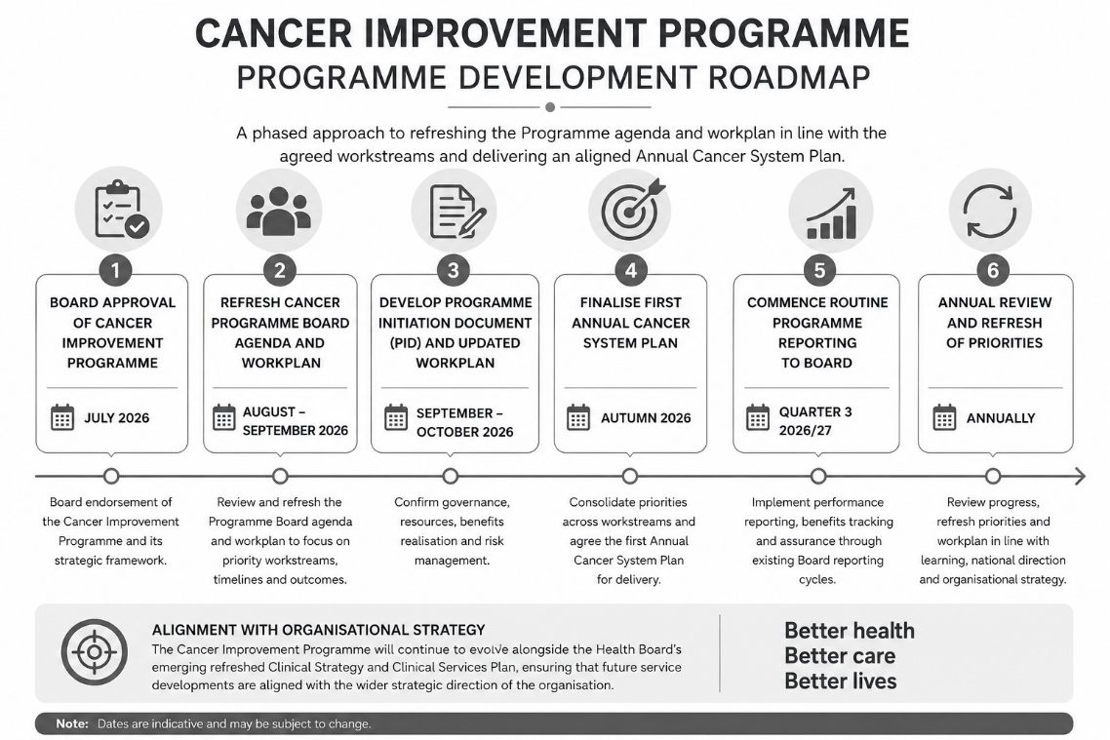

- GOVERNANCE AND RISK ISSUES

Governance

The proposed Cancer Improvement Programme has been designed to strengthen, rather than replace, existing governance arrangements for cancer services. It provides an overarching programme through which existing improvement activity can be coordinated, whilst retaining established operational, clinical and corporate accountability.

Subject to Board approval, it is proposed that the Programme is established as a formal Executive-sponsored Improvement Programme. It is recommended that the Medical Director acts as Executive Sponsor, reflecting the Programme's primary focus on improving clinical outcomes, quality and patient experience. Operational leadership would continue through the Chief Operating Officer and Programme Leads, ensuring close alignment between strategic oversight and operational delivery

Figure 3. Governance and Reporting Arrangements

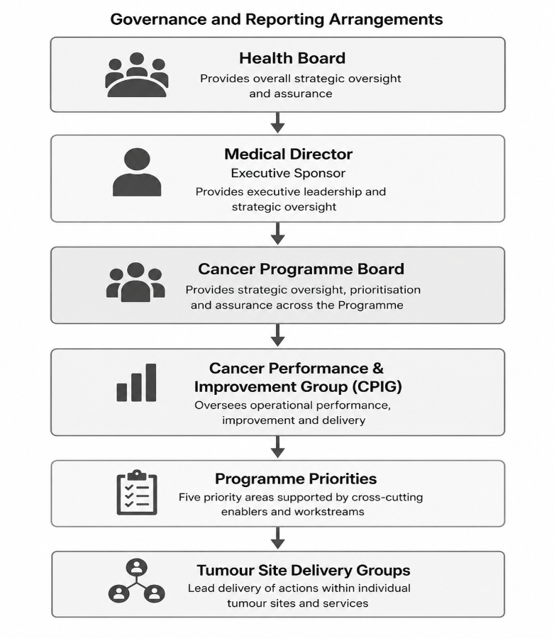

The Programme will work through existing governance structures wherever possible. Existing groups, including the Cancer Performance and Improvement Group (CPIG), tumour-site groups and service-specific delivery groups, will continue to lead operational delivery.

Cancer Programme Board will provide oversight, monitor progress and ensure that improvement activity remains aligned to the Health Board's strategic priorities.

The Programme will also strengthen the Health Board's ability to align local improvement activity with the emerging NHS Wales Cancer Programme and with related work across diagnostics and planned care.

Risk

Strategic Risk

The Health Board's Corporate Risk Register identifies Access to Cancer Care (Risk 110) as a principal corporate risk, recognising the consequences of insufficient workforce and capacity to deliver timely diagnosis and treatment, with the potential for poorer outcomes, patient harm and reduced patient experience.

Similarly, the Strategic Risk Register identifies Cancer Care (SRR-5) as a strategic organisational risk, reflecting the scale of the challenge facing the Health Board and the need for a coordinated organisational response.

The proposed Cancer Improvement Programme is intended to strengthen the Health Board's response to these risks by bringing together improvement activity within a single programme of work, providing clearer oversight of delivery, improving organisational coordination and strengthening assurance to the Board.

Whilst the Programme will not remove these risks in isolation, it provides a structured mechanism through which mitigation can be coordinated, progress monitored and delivery assured.

Equality

Improving equity is a fundamental principle of the proposed Programme.

The Programme seeks to improve outcomes for the population served by Swansea Bay through earlier diagnosis, more consistent pathways, improved access to timely treatment and greater focus on personalised care. Individual workstreams developed through the Programme will continue to be subject to the Health Board's established governance arrangements, including Equality Impact Assessment where appropriate.

- OPEN AUDIT RECOMMENDATIONS

There are a number of open audit recommendations relating to the Health Board's arrangements for monitoring and reporting cancer improvement activity.

In particular, previous audit work identified opportunities to strengthen programme governance by ensuring that improvement plans consistently include clear ownership, defined timescales, measurable outcomes and routine reporting of progress and realised benefits.

The proposed Cancer Improvement Programme directly supports these recommendations by establishing a more structured programme approach to planning, delivery and oversight. The development of an Annual Cancer System Plan, supported by tumour-site delivery plans and regular programme reporting, will provide greater consistency in the way improvement activity is planned, monitored and reported to the Board.

In addition, Audit Wales is currently undertaking a review of cancer services across NHS Wales. At the time of writing, the final report has not been received. Any recommendations arising from this review will be considered through the Cancer Improvement Programme and incorporated into future programme plans as appropriate.

- FINANCIAL IMPLICATIONS
The establishment of the Cancer Improvement Programme does not, in itself, create a direct financial commitment.
The Programme has been developed to provide greater coordination and oversight of improvement activity that is already underway across the Health Board. Delivery of many of the proposed workstreams will therefore be supported through existing operational teams, services and programmes.
However, effective delivery of a programme of this scale will require dedicated programme management and improvement support. This reflects the approach adopted for other Executive-sponsored improvement programmes within the Health Board and will be important to ensure that improvement activity is coordinated, monitored and evaluated consistently over time.
The resource requirements to support the Programme, together with any associated funding implications, will be developed as part of the Programme Initiation Document and brought back to the Board for consideration following approval of the Programme.
Where improvement initiatives require additional investment, these will continue to be considered through the Health Board's established planning, business case and financial approval processes.

- RECOMMENDATION

Members are asked to:
- CONSIDER the progress made since the June 2026 Board paper in developing the Health Board's approach to cancer improvement, including the development of tumour-site improvement plans and other supporting workstreams.
- RECOGNISE the need to build on the immediate recovery actions set out within the Single Cancer Pathway Improvement Plan through a broader, coordinated approach to improving cancer outcomes.
- ENDORSE the proposed Cancer Improvement Framework as the organising structure for the Health Board's Cancer Improvement Programme.
- APPROVE the establishment of a formal Executive-sponsored Cancer Improvement Programme, with the Medical Director acting as Executive Sponsor.
- SUPPORT the development of a Programme Initiation Document, setting out the detailed governance arrangements, programme support requirements and implementation plan for future consideration by the Board.

Governance and Assurance
Strategic Objectives
Strategic Objectives  (please choose which is impacted) | People of Swansea Bay live healthier, fairer and more prosperous lives | ☒
Strategic Objectives  (please choose which is impacted) | Care is high quality, safe, efficient and delivers the best possible outcomes for people in partnerships | ☒
Strategic Objectives  (please choose which is impacted) | Care is delivered in partnership with our communities in safe and appropriate setting, supported by innovation | ☒
Strategic Objectives  (please choose which is impacted) | The health board is a great place to work where staff feel valued and work together towards a common goal | ☒
Strategic Objectives  (please choose which is impacted) | The health board is a resilient, sustainable and responsible organisation | ☒
Health and Care Standards
Standards (please choose which applies) | Safe Care | ☒
Standards (please choose which applies) | Timely Care | ☒
Standards (please choose which applies) | Effective Care | ☒
Standards (please choose which applies) | Efficient Care | ☒
Standards (please choose which applies) | Equitable care | ☒
Standards (please choose which applies) | Person-centred Care | ☒
Standards (please choose which applies) | Staff and Resources | ☒
Enablers (please choose which applies) | Whole Systems Approach | ☒
Enablers (please choose which applies) | Leadership | ☒
Enablers (please choose which applies) | Workforce | ☒
Enablers (please choose which applies) | Culture | ☒
Enablers (please choose which applies) | Information | ☒
Enablers (please choose which applies) | Learning, Improvement and Research | ☒
Quality, Safety and Patient Experience
The proposed Cancer Improvement Programme seeks to improve the quality, safety and experience of cancer care by strengthening organisational oversight of improvement activity across the whole pathway. It provides a more coordinated approach to improving outcomes, reducing unwarranted variation, supporting earlier diagnosis and ensuring that improvement activity remains focused on delivering safe, effective and person-centred care.

Financial Implications
The establishment of the Programme does not create an immediate financial commitment. It provides a governance framework through which existing improvement activity can be better coordinated. Delivery of the Programme will require dedicated programme support and associated resource, which will be considered as part of the development of a Programme Initiation Document. Any future investment requirements will be subject to the Health Board's established planning and financial approval processes.

Legal Implications (including equality and diversity assessment)
There are no specific legal implications arising directly from the recommendations contained within this paper. The proposed Programme supports the Health Board's statutory responsibilities to improve the quality, safety and effectiveness of healthcare services. Equality Impact Assessments will be undertaken, where required, as individual workstreams and service changes are developed.

Staffing Implications
The Programme is intended to strengthen coordination of improvement activity rather than create new operational responsibilities. Delivery will continue through existing clinical and operational teams. Subject to Board approval, work will be undertaken to determine the programme management resource required to support delivery.
Long Term Implications (including the impact of the Well-being of Future Generations (Wales) Act 2015)
The Programme supports the Well-being of Future Generations (Wales) Act by adopting a long-term approach to improving cancer outcomes, recognising the need to work across organisational boundaries and in partnership with patients, communities and other organisations. The Programme reflects the five ways of working through its emphasis on prevention, collaboration, integration, involvement and long-term planning. Consideration of the Welsh Language and equality impacts will form part of the development of individual workstreams.
Report History
- March 2026 – Cancer Improvement Workshop (multi-disciplinary workshop involving over 90 participants).
- June 2026 – Executive Board received the Single Cancer Pathway Improvement Plan and requested further updates on tumour-site improvement planning.
- July 2026 – Cancer Performance and Improvement Group (CPIG) considered the proposed Cancer Improvement Programme and Framework prior to Board submission.
- July 2026 – Board consideration of the proposed Cancer Improvement Programme.
Appendices
Appendix 1 - Single Cancer Improvement Plan
Appendix 2 – Current Cancer Performance Update

