Child Poverty Briefing – Swansea Bay University Health Board

This brief covers a number of elements of child poverty and brings together emails and other documents in one place. I’ve tried to highlight where colleagues from across the Health Board are involved. There is much evidence around the impact of child poverty on health inequalities. Key organisations are the Joseph Rowntree Foundation and the Bevan Commission. Their latest publicly available reports are below.

The Public Health team has been involved in a number of measures to specifically tackle child (and wider) poverty. Public Health manages a number of Welsh Government/Public Health Wales programmes for healthy schools and pre-schools. They are universal programmes but schools are prioritised according to the Welsh Index of Multiple Deprivation.

Welsh Government
- The Public Health team provided a consultation response to the draft Welsh Government Child Poverty Strategy and have attended subsequent update meetings. They have also supported colleagues within the Health Board and local authorities for Welsh Government Child Poverty Grants. The Arts and Heritage Team, Quality and Safety Department at SBUHB were successful (Melanie Wotton/Johan Skre) in the 2025 round.

Swansea
- Previous DDPH was a member of the Swansea Poverty Truth Commission.
- There has been a wide range of consultation and engagement with Swansea Council and the Wales Centre for Public Policy (WCPP) who have been leading research work on poverty stigma in Swansea. Both Planning and Public Health have been engaged in the co-creation consultation sessions, representing the Health Board. A response from Public Health is attached alongside notes from the workshops.
- A formal Public Health response was submitted to Swansea Council on their draft Tackling Poverty Strategy and was well received: “I just wanted to thank you again for your consultation response on the Tackling Poverty Strategy. Yours in particular gave me the lever I needed to make some significant changes and bring it in line with what a good practice TP strategy should look like.” The strategy development is still in progress but it is anticipated it will be at adoption stage at some point from September. The recommendations from the work with WCPP will also be worked into the action plan.
- The launch of the Voices of Swansea: Challenging poverty stigma together research will take place on Tuesday 19 May with Public Health attendance. Public Health will also attend the Poverty Stigma Insight Network Meeting.
- Public Health are part of the Swansea Poverty Partnership Forum.

Neath Port Talbot
- As part of the NPT Public Services Board (PSB), there is a Cost of Living & Poverty Prevention Partnership (COLPP) Steering Group, which Public Health attends. The focus of this group is child poverty and financial wellbeing and wider determinants of families. They have developed an action plan which focuses on a set of practical actions that aim to reduce child poverty and support families. The most recent Highlight Report is below.
- The COLPP is working towards alignment with the work of the PSB’s Early Years, Children and Young People’s Plan (2024-2029). The implementation of this plan is through five priorities:
  - Supporting our youngest children to be healthy and ready to learn – Public Health, Planning, Midwifery, Health Visiting and Speech and Language Therapy involvement. Focus for 2026 – breastfeeding in the Afan Cluster, SLT, pre-school to school transition. Co-chair – Planning.
  - Children, young people and their families are able to access the right support at the right time with positive outcomes.
  - Children and young people access an education that inspires them to learn and develop the skills they need for the future they want – Public Health
  - Children and young people are listened to, and they have opportunities to be actively involved in decision-making – BAYouth
  - All children and young people are supported to be physically healthy and feel mentally and emotionally strong – Public Health, Planning, CAMHS, School Nursing, Lighthouse, Community Psychology. Focus is: 1.How key adults (staff, volunteers, families) can best support children and young people’s mental health and emotional wellbeing; 2. Improving access to play and physical activities; and 3.Establishing a well-panned pathway of support to meet children and young people’s mental health and emotional wellbeing needs (with Regional Planning Board). Co-chair SBUHB DECLO.
Each group is viewed through the lens of inequalities.
- The Child Poverty Action Group (CAPG) has also been running a pilot in NPT on the cost of the school day. Schools and school staff | CPAG and attached.

Partnerships
- Across the two PSBs, Public Health and Planning have agreed a set of Early Years Principles to reduce inequalities. Deprivation is always a consideration in all activity.
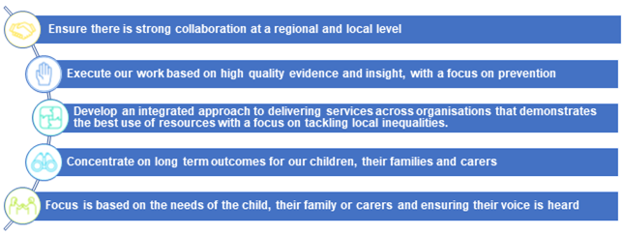
- The new Data Cymru PSB Wellbeing Data Dashboards also measure child poverty through relative child poverty (age), relative child poverty (sex) and workless households. These can be measured for Swansea, Neath Port Talbot and Swansea Bay:
  - Local Wellbeing Data Swansea - Data Cymru
  - NPT Public Services Board.

Contact: Lynnette Thomas, Assistant Director – Health Improvement and Wider Determinants
6 May 2026

