Agenda Item
x.x

Joint Commissioning Committee

Joint Commissioning Committee Governance Framework

Dyddiad y Cyfarfod /  Date of Meeting | Click or tap to enter a date.
Statws Cyhoeddi / Publication Status | Open/ Public
Awdur yr Adroddiad / Report Author | Aaron Fowler, Committee Secretary NWJCC
Cyflwynydd yr Adroddiad / Report Presenter | Aaron Fowler, Committee Secretary NWJCC
Noddwr yr Adroddiad /  Report Sponsor | Ian Green, Chair of the NWJCC

Pwrpas yr Adroddiad /  Report Purpose | For Approval

Engagement (internal/external) undertaken to date
(including receipt /consideration at Committee/Group)
Committee/Group/Individuals | Date | Outcome
ToR - Quality Safety and Outcomes (QSOC) Sub-Committee | 23 February 2026 | Endorsed  Feedback assisted in developing the drafts
ToR - Planning Performance and Finance (PPF) Sub-Committee | 26 February 2025 | Endorsed  Feedback assisted in developing the drafts
PPF and QSOC ToR - Joint Commissioning Committee | 17 March 2026 | The JCC Endorsed the updated ToR
Senior Leadership Team NWJCC and HB Director of Corporate Governance Draft Standing Orders and Standing Financial Instructions | 13 April 2026 | Feedback received and assisted in finalising the documents
Joint Committee - Draft Standing Orders and Standing Financial Instructions | 26 May 2026 | To be Approved

- SITUATION
The purpose of this report is to present the NHS Wales Joint Commissioning Committee’s (JCC) updated governance framework. In accordance with the JCC scheme of delegation and reservation of powers, approval of the Joint Committees governance framework is reserved to Local Health Boards (LHBs).

- BACKGROUND
The Governance Framework for the JCC contains several key components which, combined, set out the legislative framework, constitution and ways of working for the JCC in its operations and handling of business. These documents are an integral part of the wider governance framework of LHBs and have been developed within that context.

The Governance Framework of the JCC contains the following.

Figure 1 – JCC Governance Framework

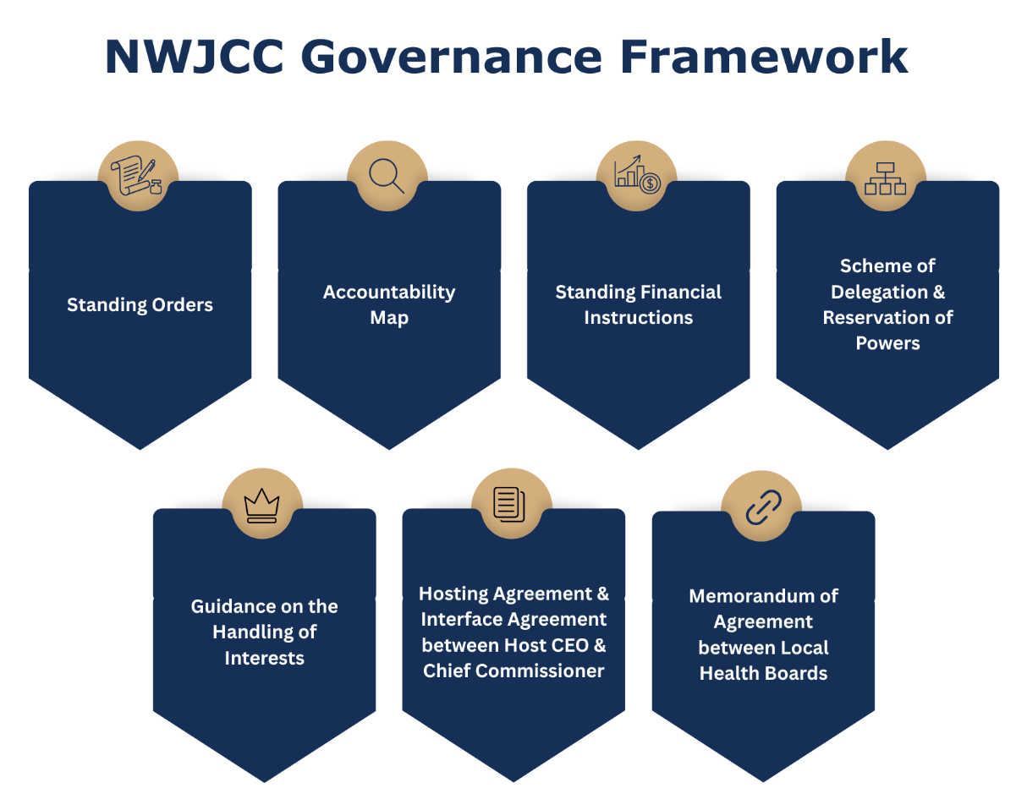

  - Standing Orders and Standing Financial Instructions
The Seven LHBs approved the JCC Standing Orders (SOs) and Standing Financial Instructions (SFIs) in March 2024. There were subsequently adopted by the Joint Committee at its inaugural meeting on 8 April 2024 following which they were included as a schedule to each of the Health Boards (HBs) own SOs and have effect as if incorporated within them.

During October 2025, WG issued updated Model Standing Orders for the NWJCC. The purpose of these amendments was to ensure consistency relating to the timescales for the publication of board and committee agendas and papers. Updates to the JCC’s Standing Orders to incorporate these changes were approved at the November 2025 Joint Committee meeting.

A further review of the NWJCC Governance Framework commenced during Q3 of 2025-2026. Attached at Appendix 1 is a table of the proposed amendments to the Standing Orders. The changes are largely administrative in nature and seek to either re-format or re-define the content of each document, or update sections to reflect operational reality. The changes to the Standing Financial Instructions are also mainly administrative. The more substantial updates include the following.

- Section 11 (highlighted in blue) replaced for the updated Procurement Regulations (including Schedule 1) and updated references for NWJCC/JCCT.
- Addition of a debt recovery paragraph in section 9 to reflect current processes.

Attached as Appendices 2 and 3 are tracked changes versions of the Standing Orders and Standing Financial Instructions for approval.

  - Scheme of Delegation and Reservation of Powers
The NWJCC’s Scheme of Reservation and Delegation of Powers forms an annex to the NWJCC’s SOs, which form a schedule to each HBs own SOs and have effect as if incorporated within them. The Scheme of Delegation and Reservation of Powers, sets out in the context of the NWJCC’s business:
- Those matters reserved for HBs;
- Those matters delegated from HBs and reserved for the NWJCC; and
- Those matters further delegated from the NWJCC to the Chief Commissioner (and other Officers as appropriate).

The Scheme of Delegation was approved by the JCC in May 2025 and was subsequently approved by Health Boards in July 2025. At present no changes are proposed to these documents.

  - The Hosting Agreement (HA) and memorandum of Agreement (MoA)
The Hosting Agreement (HA) and the Memorandum of Agreement (MoA) were endorsed by the Joint Committee on 17 September 2024 and were approved by the seven HBs at their September 2024 Board meetings. The governance arrangements within the Hosting arrangement have been working effectively. There is regular dialogue between the JCC and officers at Cwm Taf University Health Board (CTMUHB), complemented by more formal meetings between the two Accountable Officers where the Hosting Arrangements are discussed.
A formal review of the Hosting Agreement is scheduled during Q1 of 2026/27.

  - Accountability Map and Guidance on the Handling of Interests
The Accountability Map outlining the formal accountabilities and relationships between Welsh Government, LHBs, CTMUHB (as the JCC Host Body), the JCC and its Team; and the Guidance on the Handling of Interests which sets out the arrangements for the appropriate handling of declarations of interests within the NWJCC’s business, were both received by the Joint Committee at its inaugural meeting on 8 April 2024. The Guidance on the Handling of Interests has been updated and minor changes have been proposed in track and attached at Appendix 4. No changes are proposed to the Accountability Map.
Appendices 1-4 will be presented to the May 2026 JCC meeting for endorsement.

  - JCC SUB-COMMITTEE STRUCTURE
Paragraph 5.5 of the NWJCC Standing Orders states that the Joint Committee shall determine, for agreement by Health Boards, a joint sub-Committee structure that meets its own advisory and assurance needs and in doing so the needs of the constituent Health Boards.

Paragraph 5.8 of the Standing Orders states that “As a minimum, it shall ensure that there are joint sub-Committee arrangements which cover the following aspects of Joint Committee business:
- Audit and Risk
- Quality, Safety and Outcomes
- Planning and Performance”

The NWJCC Sub-Committee structure was established in January 2025 with the introduction of the Quality, Safety and Outcomes (QSOC) and Planning, Performance and Finance (PPF) Sub-Committees. The NWJCC’s Audit and Risk assurance arrangements are serviced by the CTMUHB Hosted Bodies Audit, Risk and Assurance Committee.

Figure 2 –JCC Sub-Committee Structure

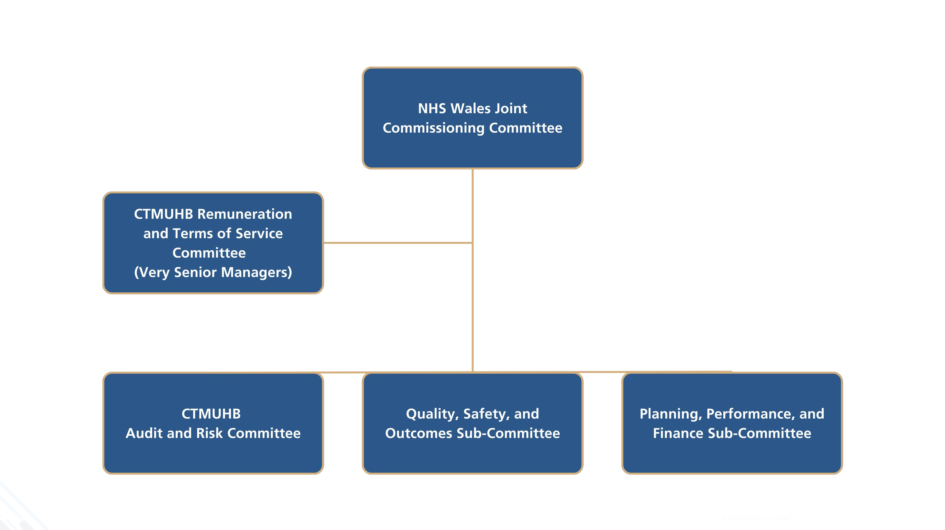

Sub-Committee Terms of Reference are subject to annual review (Para 16.1 of the respective ToR). Following a full year of operation, consideration has therefore been given to the content of the QSOC and PPF ToR, and how they align with the NWJCC’s governance framework and operational structure.
Updated QSOC and PPF ToR are presented at Appendix 5 and Appendix 6 for final approval, having previously been endorsed by the NWJCC Sub-Committees and Joint Committee. Proposed changes are detailed in track.

- ASSESSMENT
Objectives / Strategy
Dolen i Amcan (au) Strategol CBC /  Link to JCC Strategic Objectives(s) | Ensure Quality
Dolen i Ddeddf Llesiant Cenedlaethau'r Dyfodol – Nodau Llesiant /  Link to Wellbeing of Future Generations Act – Wellbeing Goals  150623-guide-to-the-fg-act-en.pdf (futuregenerations.wales) | A Resilient Wales
If more than one applies please list below:
A Healthier Wales
A More Equal Wales
Dolen i Hwyluswyr Ansawdd  (Canllawiau Statudol Dyletswydd Ansawdd (llyw.cymru)) /  Link to Enablers of Quality  (Duty of Quality Statutory Guidance (gov.wales)) | Whole-systems Perspective
 | If more than one applies please list below:
Dolen i Feysydd Ansawdd  (Canllawiau Statudol Dyletswydd Ansawdd (llyw.cymru)) /  Link to Domains of Quality  (Duty of Quality Statutory Guidance (gov.wales)) | Effective
If more than one applies please list below:
Person Centred
Timely
Safe
Effaith Amgylcheddol/ Cynaliadwyedd (5R) /  Environmental /Sustainability Impact (5Rs) | No - Not Applicable
 | If more than one applies please list below:

Impact Assessment
Ansawdd  Ydych chi wedi ymgymryd â Sgrinio Asesiad o’r Effaith ar Ansawdd? /  Quality  Have you undertaken a Quality Impact Assessment Screening? | Yes: ☐ | No: ☒
 | Outcome: | If no, please include rationale below:  N/A
Cydraddoldeb  Ydych chi wedi ymgymryd â Sgrinio Asesiad o'r Effaith ar Gydraddoldeb? /  Equality  Have you undertaken an Equality Impact Assessment Screening? | Yes: ☐ | No: ☒
 | Outcome: | If no, please include rationale below:  N/A
Cyfreithiol / Legal | There are no specific legal implications related to the activity outlined in this report.
Enw da / Reputational | There is no direct impact on the reputation of the Joint Committee as a result of the activity outlined in this report.
Effaith Adnoddau  (Pobl /Ariannol) /  Resource Impact  (People / Financial) | There is no direct impact on resources as a result of the activity outlined in this report.

- RECOMMENDATIONS

Board Members are asked to Approve:
- the updated Standing Orders for the JCC (Appendix 2) [subject to formal approval by the NWJCC at the Joint Committee meeting of the 26 May 2026] [following approval at the Joint Committee meeting of the 26 May 2026].
- the updated Standing Financial Instructions (SFIs) for the JCC (Appendix 3). [subject to formal approval by the NWJCC at the Joint Committee meeting of the 26 May 2026] [following approval at the Joint Committee meeting of the 26 May 2026].
- the updated Guidance on the Handling of Interests (Appendix 4).
- the updated terms of reference (ToR) for the JCC Quality, Safety and Outcomes Sub-Committee (Appendix 5); and
- the updated terms of reference (ToR) for the JCC Planning, Performance & Finance Sub-Committee (Appendix 6).

- NEXT STEPS

Following approval, the revised JCC Governance Framework will be published on the NWJCC website, and all hyperlinks within the associated documents will be updated to reference these approved materials.

