Meeting Date | 28 May 2026 | Agenda Item | 4.6
Name of Meeting | SBUHB Board
Report Title | Perinatal Committee Report
Report Author | Kathyrn Greaves – Director of Midwifery  Sujoy Banerjee – Associate Service Group Medical Director - CYPWH
Report Sponsor | Executive Director of Nursing and Patient Experience
Presented by | Elizabeth Rix, Executive Director of Nursing and Patient Experience
Freedom of Information | Open
FoI Closed detail | If closed, choose detail
Impact Assessment Summary Outcome |  | IA Completion date
N/A |  | Click or tap to enter a date.
Purpose of the Report | For Assurance
Report Summary; detailing any action required
The Health Board recognises that every woman, birthing person, baby and family using our perinatal services deserves consistently safe, high-quality and compassionate care.
While most experiences are positive, we are acutely aware that even a single instance where care falls short is one too many. This report is therefore grounded in a commitment to transparency, learning and improvement, ensuring that every voice and every experience continue to shape and strengthen our service.
The purpose of the paper is to provide the Board with an update from the Perinatal Committee providing assurance and information relating to the risks to quality, safety, and patient experience in maternity and neonatal services, with escalation of any key areas of concern.

Key Issues
A Perinatal Improvement Programme has commenced in 4 workstreams headed by an executive member following the recommendations of the oversight panel with a view to implement the recommendations of the external review.

The Perinatal Committee continues to monitor quality, safety and patient engagement and experience outcomes (business as usual) and provides a system of Alert, Advice, Assure to Quality and Safety Committee and Management Board.

Decision / Action required | No
Recommendations
Members are asked to:

BE ADVISED THAT:
- The Perinatal Improvement Plan Executive Programme Board has developed and will continue to monitor improvement plans in response to the Independent Review, All Wales Self-Assessment and other improvement actions, have been triangulated and added to the overall improvement plan.
- Perinatal Improvement Programme Executive Board continues to track progress against the improvement plan.
- Perinatal Committee meets monthly and reviews all key metrics for perinatal services.
BE ASSURED THAT:
- The Perinatal Service does not currently have any elements of care that would flag as a Negative Outlier.
- Any stillbirths or neonatal deaths have been sensitively reported through the MBRRACE (Mothers and Babies: Reducing Risk through Audits and Confidential Enquiries) process to support learning and improve future care.
- The MBRRACE 2024 perinatal surveillance analysis and benchmarking for SBUHB is presented in this report and represent an improvement from previous years.
BE ALERTED TO:
- Mitigating action to provide a single point of contact triage phoneline was achieved on 3rd March 2026.

PERINATAL COMMITTEE REPORT

- INTRODUCTION
The Health Board recognises that every woman, birthing person, baby and family using our perinatal services deserves consistently safe, high-quality and compassionate care.
While most experiences are positive, we are acutely aware that even a single instance where care falls short is one too many. This report is therefore grounded in a commitment to transparency, learning and improvement, ensuring that every voice and every experience continue to shape and strengthen our service.
This report is intended to provide assurance and information relating to the risks to quality, safety, and patient experience in maternity and neonatal services, with escalation of any key areas of concern.

- BACKGROUND

The Perinatal Committee was established in June 2025, to provide assurance to the Board that an evidence based, quality assured, safe, and sustainable service for women, people and babies receiving maternity and neonatal care at Swansea Bay University Health Board.

The Perinatal Committee reports directly into Quality and Safety Committee and noted via Service Group Quality, Safety & Risk Group and Senior Leadership Team.

The Perinatal Committee focuses on the business-as-usual activities provided across our perinatal services. Matters relating to the Perinatal Improvement Plan are reported separately via the Perinatal Improvement Programme Board and into Management Board.

- GOVERNANCE AND RISK ISSUES

Key updates from Perinatal Committee
As previously agreed, the following measures are some of the high-level information we review within our perinatal committee.

3.1 Number of births, caesarean section births, and Surgical Site Infection rates

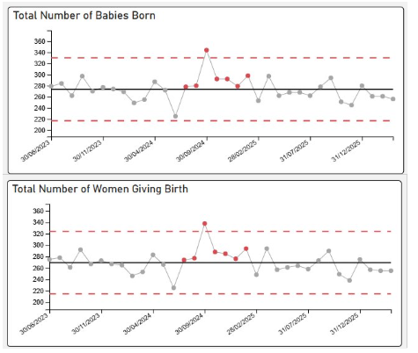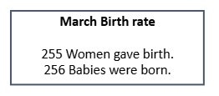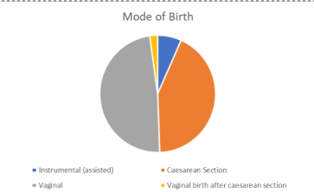
Classification of Caesarean Sections
Elective – Includes Category 3 and 4
Emergency – Includes Category 1 and 2
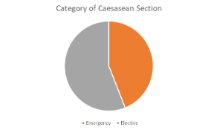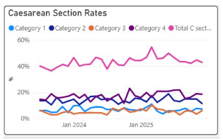

NHS maternity statistics data sets suggest caesarean sections should account for 42% of births (2023/2024), there is a national upward trend in C-Sections with Swansea Bay University Health Board (SBUHB) rates recorded as 43% (as seen above). National Maternity and Perinatal Audit (NMPA) data published in 2025 (reports 2023 data i.e. lags by 2 years) reports UK planned caesarean section rate as 16.4% (15.1-17.9%). SBUHB planned caesarean section rates were 19.87% in 2023 (outlier in NMPA report), 22.85% in 2024 and 25.2% in 2025. This is consistent with an increasing trend of planned C-sections which has been reported nationally. In some parts of the UK this mode of birth has been reported as being higher than vaginal births for the first time in recorded data collection.

In contrast our Emergency C-section rate is not an outlier on NMPA report. This suggests a greater influence of maternal choice in relation to elective C-section as a mode of delivery.

The All-Wales Perinatal Assurance review, The Path to Safer Beginnings in Wales 2026, reported that rates of spontaneous vaginal birth declined since 2016, from 63% to 54% in 2023, also reflecting trends seen in other UK countries. The main contributor to this is the rise in caesarean birth, both planned and unplanned, to a total of 35.2% in 2024 (19.8% unplanned caesarean birth). Around a third of women having induction of labour subsequently had a caesarean birth (29.2% in 2023), like data from other UK countries. Those rates are reflective of the clinical complexities experienced in Swansea Bay.

A C-section working group has been established to provide women with comprehensive and balanced information, enabling them to make fully informed decisions regarding their care. The group provides strategic oversight of elective caesarean section capacity across labour ward and main theatres, ensuring alignment with daily acuity and clinical risk. The group will lead the development of a digitally enabled booking approach, integrated with Badgernet, to support forward planning in advance, optimise utilisation of theatre capacity, and improve equity, safety, and operational resilience through risk-based scheduling.

3.2 Surgical Site Infection:
Surgical Site Infection (SSI) data for all C-section shows a decrease in quarter of the number of infections reported with improvements in compliance of reporting to provide accurate data capture and tracking (Source: Public Health Wales). The service has received Q4 data from the Healthcare Associated Infection, Antimicrobial Resistance & Prescribing Programme [HARP] team. Whilst this shows a small increase in reported SSI’s (within normal variance), based on local intelligence we understand that the agreed pathway for detection and treatment was not consistently followed and have instigated corrective actions to support accurate detection and reporting.

Local SSI rates
There was a further decrease in the SSI rate for December 2025 of 6.48% from 7.29% in November.​ Reporting of these measures is currently reliant on a manual data collection process, which is vulnerable to workforce availability. Recent staff absences have impacted our ability to undertake the detailed review and analysis required, and as a result data for January, February and March remains outstanding.
We are actively exploring a sustainable electronic solution to improve reliability, reduce manual burden and strengthen analytical assurance. Once capacity is restored, the outstanding data will be retrospectively reviewed and reported within future Perinatal Committee reports.

Active work continues to strengthen the primary pathway for postnatal assessment of surgical site infections, following previously reported concerns regarding sampling within Primary Care.

A review of current practice had identified that most wound swabs associated with postnatal infections are currently undertaken in Primary Care rather than by Community Midwives. As a result, presenting symptoms and the adequacy of wound assessment and preparation prior to sampling are not consistently visible to maternity services, leading to variability in data quality and the potential for delays in optimal management.

Improvements are anticipated through the ability to undertake postnatal review via Maternity Triage using the Birmingham Symptom-Specific Obstetric Triage System. This will support women being directed to maternity services in the first instance for assessment, enabling more consistent clinical review, improved oversight of symptom presentation and wound assessment, and strengthened surveillance and reporting of postnatal surgical site infections.

Public Health Wales Healthcare Associated Infection, Antimicrobial Resistance & Prescribing Programme (HARP) team have confirmed that the definition of SSI and parameters for reporting have been standardised to <14 days. Therefore, the service to report SSI <14 days from January 2026. To continue data collection for <28 days until January 2026 due to ongoing Quality Improvement (QI) project.​

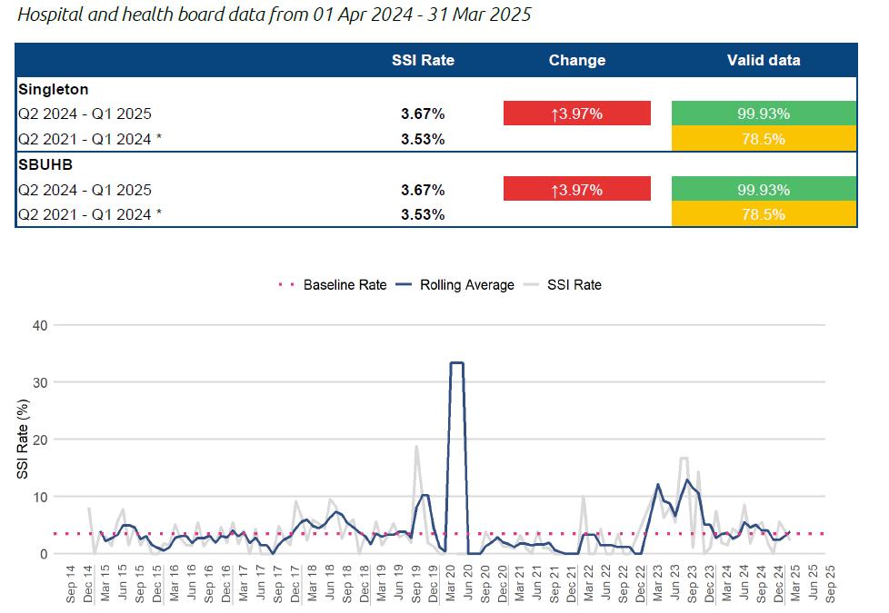

3.3 Extended Perinatal Mortality and Morbidity
All stillbirths, late fetal losses and neonatal deaths are reported via Mothers and Babies: Reducing Risk through Audits and Confidential Enquiries (MBRRACE). MBRRACE’s purpose is to identify patterns, causes, and preventable factors in maternal and perinatal mortality and morbidity.

All cases receive internal, and where indicated, external investigation using the Perinatal Mortality Review Tool (PMRT) to identify any modifiable causes to support families understand the causes of the death and to support both local and national learning for improvement. Families are encouraged to engage with this process and have an assigned point of contact, who welcomes questions to be included within the review.

The crude rate for Perinatal deaths in 2023 from MBRRACE was 7.49/1000 births with a stabilised and adjusted rate of 5.87 (95% CI at 4.84-7.76). In 2024 the crude rate was 5.73/1000 births which is lower than previous years. MBRRACE has recently published the 2024 benchmarked data. SBUHB stabilised & adjusted extended perinatal mortality rate is 5.46 per 1,000 total births. This is around the average for similar Trusts & Health Boards in the UK.

MBRRACE report data in quarter 3/4 2026/27 each year when we will receive data for births in 2025.

3.3.1 Stillbirths from March 2026
There has been only 1 stillbirth reported January – March quarter. All stillbirths are included in the MBRRACE reporting data based on reporting criteria. The service recognises that the death of a baby is an unimaginable and life altering tragedy for families, and each case represents an event of profound emotional impact. We approach every incident with the utmost sensitivity, acknowledging the depth of grief experienced by parents and the wider family, as well as the significant effect felt by the staff involved. Based on current UK stillbirth rates, a service of our size would sadly be expected to experience approximately 12–13 stillbirths each year. Each of these represents an immeasurable loss, and we remain committed to responding with the utmost compassion, care, and timely support for every family affected.

The Health Board’s previously reported crude stillbirth rate for 2025 was 3.68 per 1,000 births. However, this has since been updated to a lower incidence of 3.4 per 1000 total births following discussion with MBRRACE and clarification around a complex presentation of a stillbirth. For context, Swansea Bay’s crude stillbirth rates for 2023, based on 13 stillbirths, were 4.79 per 1,000 births.

Learning from Stillbirth review:
A thematic review of stillbirths in 2025 identified several learning points.

- The need to ensure that where growth surveillance is undertaken using symphysis–fundal height measurements, a full antenatal assessment incorporating abdominal palpation and an updated SFH measurement must be completed for women presenting with altered fetal movements.

- The importance of maintaining clinical curiosity in situations where there is poor attendance at antenatal appointments, ensuring that potential reasons and barriers are explored. Following this, the service implemented an updated guidance for the non-attendance of antenatal appointments. This guidance ensures individualised care for women, exploring the barriers and guidance for professionals in improving engagement.

- In addition, the review emphasised the requirement for timely escalation and obstetric review when MEWS triggers occur, to support early recognition and management of maternal deterioration. This has coincided with the introduction of the All Wales MEWS and is being audited and implemented in all clinical areas where a pregnant women or birthing person will attend.

MBRRACE 2024 report has just been published and SBUHB stabilised & adjusted stillbirth rate for 2024 is 3.54 per 1,000 total births. This is around the average for similar Trusts & Health Boards in the UK.
Finalised stabilised, adjusted rates for 2025 data from MBRRACE will not be available until quarter 3/4 of 2027.

3.3.2 Neonatal Deaths 2026 with summary statistics from 2025

There have been 3 neonatal deaths reported January - March quarter of 2026, 2 of which fit the criteria for MBRRACE reporting.

The Health Board’s crude neonatal death rate for 2025 is 1.23 per 1,000 births. Finalised crude, stabilised and adjusted rates from MBRRACE will not be available until quarter 3 of 2027, although at this stage there is no indication that our position will be an outlier.

Learning themes from the 2025 neonatal deaths have been collated into a thematic report.

Robust multidisciplinary case reviews have been undertaken. No single theme indicating unsafe care, poor professional practice, or systemic failure was identified. Importantly, there were no findings of recurrent harm or patterns of unsafe practice.
All cases reviewed were categorised as Grade B – care issues which were not considered to have made any difference to the outcome for the baby.

The reviews have, however, highlighted a number of system-level learning opportunities. These reflect the inherent complexity and technical risk associated with the care of extremely preterm and critically unwell infants, rather than deficiencies in care delivery. The identified learning themes present opportunities to further strengthen quality, consistency and governance. These relate to:

- Communication and antenatal coordination across neighbouring health boards
- Heightened vigilance in neonatal airway management in high-acuity settings
- Documentation and governance processes, including consistency, timeliness and recording standards

Isolated documentation and prescribing oversights were noted without patient harm and will inform ongoing quality improvement work.

Overall, the reviews provide assurance regarding the safety of care delivered while highlighting opportunities to further strengthen systems, processes and governance.

MBRRACE 2024 report has just been published SBUHB stabilised & adjusted neonatal mortality rate is 1.93 per 1,000 live births. This is around the average for similar Trusts & Health Boards.
Every neonatal death represents an immeasurable loss for families, and we remain committed to approaching each case with compassion, transparency, and a determination to learn and continually strengthen the care we provide.

Figure: 11 year running stabilised and adjusted mortality rates for SBUHB including latest published year 2024. Note SBUHB separated from POW in in 2019 resulting in reduction in births attributable to SBUHB (Data source MBRRACE UK)

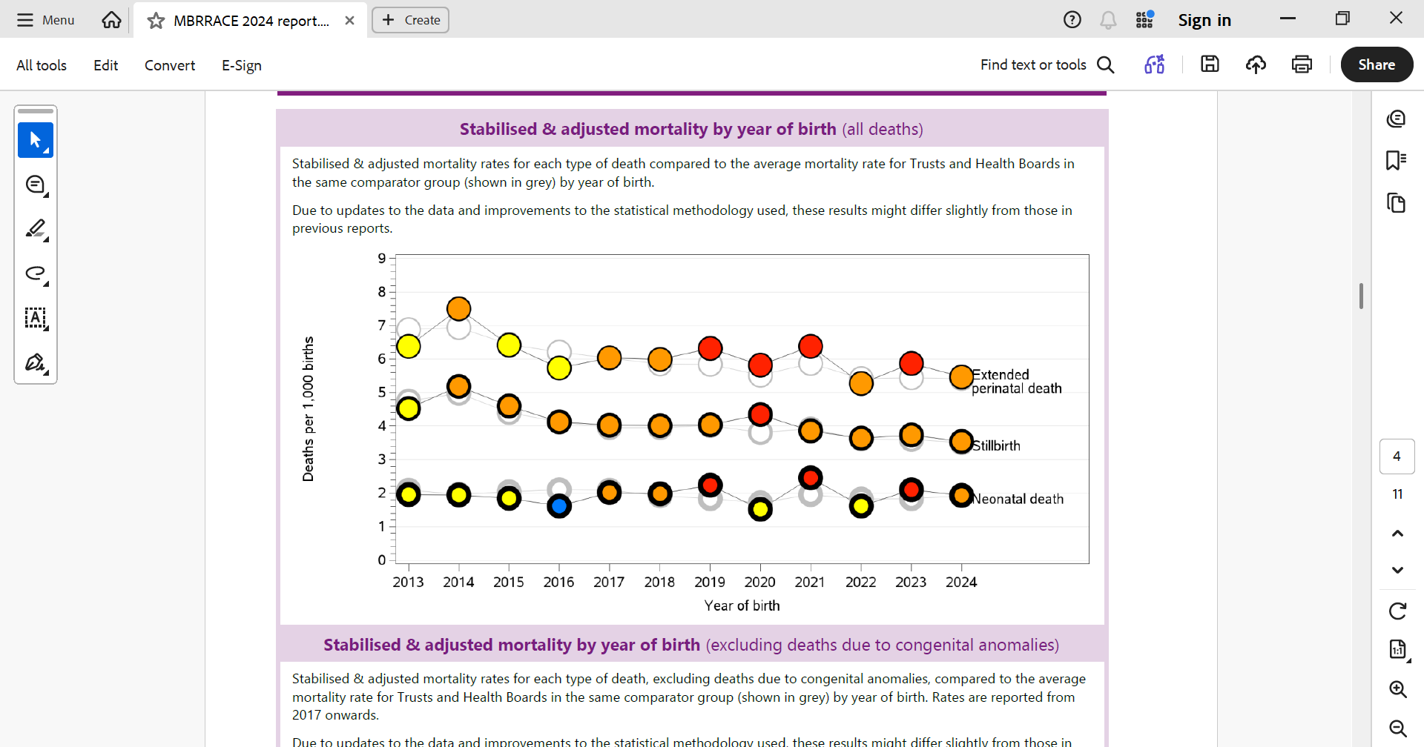

3.33 Other observations from the MBRRACE 2024 report:

3.331 SBUHB Births – MBRRACE 2024 Demographic data capture ​

Age of mother ​

The proportion of mothers under the age of 25 was higher than that of the UK 18% vs 13.5% -National MBRRACE-UK Perinatal mortality Surveillance report was shown that mortality rates were higher for babies born to mothers under 25 years and over 34 years compared to those between 25 to 34 years old. ​

Socio-economic deprivation​

The mothers giving birth in SBUHB were considerably less likely to live in areas of high deprivation than those giving birth across the UK as a whole. ​

Ethnicity ​

White ethnicity was considerably lower than that of the UK 1% vs 30.9% - however, 92.4% of the baby's ethnicity was reported as not known. (This is an area of improvement that will be focused on within the governance team going forward) ​

Gestational age ​

Infants born between 24 to 27 weeks gestational age 0.7%, similar to the 0.4% seen in the UK as a whole. However, there was a higher percentage of babies born at 28-31 weeks compared with the national average: 1.3% vs 0.8% ​

In addition, 2.7% were born post-term (42 weeks or greater) a similar percentage to the UK average of 1.1% ​

3.332 MBRRACE Reporting timeline benchmarking

Timely reporting within 7 working days of still births and late fetal losses increased from 53% to 79% in 2024 when compared to 2023. Similarly timely reporting for neonatal deaths also increased from 75% to 100% during this period.

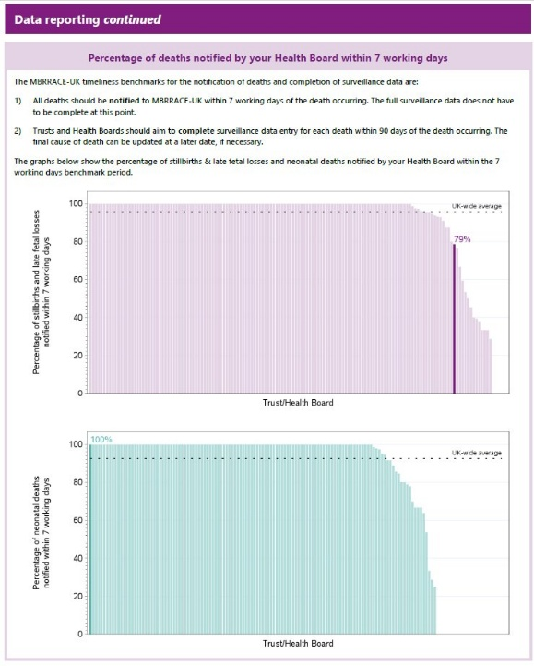
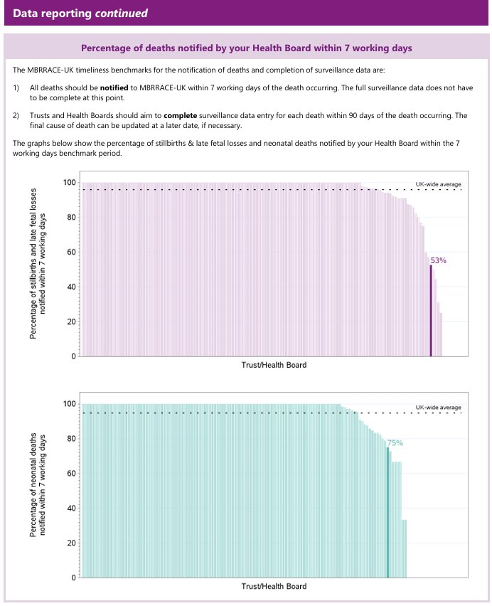

  - MBRRACE data reporting completeness

We are pleased to report that our data reporting completeness for key data items for deaths was 100% for 2024. This was a significant improvement from 2023

2023 2024
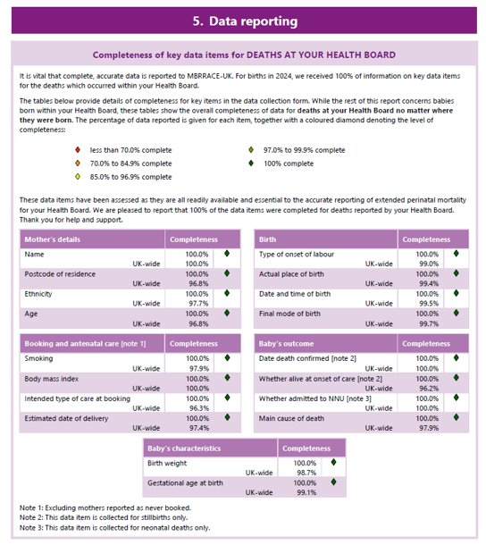
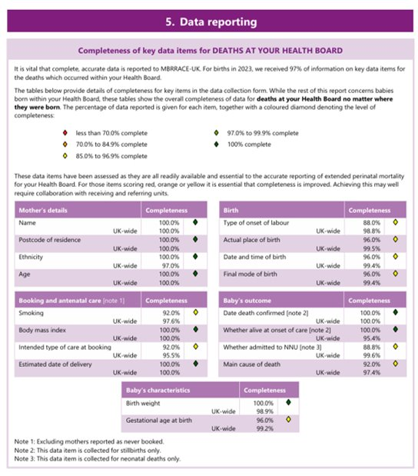

3.4 Hypoxic-Ischemic Encephalopathy (HIE) from January – December 2025

There has been no moderate to severe HIE cases reported in 2026.

There is limited data published to allow National benchmarking. Latest published data from National Neonatal Research Database (NNRD) is 4 years out of date (Department of Health, 2021 data). This reports a UK average incidence for Moderate and Severe HIE cases of 1.59/1000 births (1.49-1.70).

Due to the low number of HIE and births in SBUHB a rolling 12-month HIE incidence reporting is more appropriate. This shows that in March 2026 our moderate to severe rolling 12-month HIE rate was 0.94/1000 births. This represents a 72% decrease since its peak in April 2024 of 3.32/1000 births.
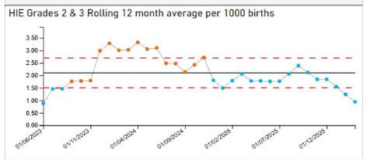
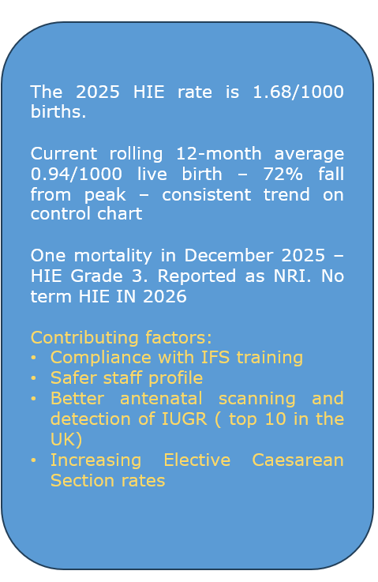

The absolute 2025 HIE rate (Jan-December) was 1.68/1000 births.

Learning from 2025 HIE reviews: All cases in which a baby is diagnosed with HIE and undergoes active cooling are reviewed by the Perinatal team, with a joint review also provided to the family.

Learning from the review of HIE cases in 2025 identified three instances where there was a delay in the recognition and escalation of an abnormal antenatal CTG. This theme had initially emerged at the end of 2024, prompting the service to undertake a risk assessment for the implementation of computerised CTG monitoring. The risk assessment was subsequently placed on the risk register with a score of 20, and a business case was developed and approved, with funding now secured. The computerised CTG system is currently undergoing testing, with iterative feedback being provided to the supplier to ensure system safety prior to implementation.

Additional learning from the reviews included the need for timely recognition and management of uterine hyperstimulation and the avoidance of delays in expediting birth; these themes continue to be incorporated into mandatory professional training through case studies presented within the Intrapartum Fetal Surveillance study day.

3.4 Triage Metrics
Birmingham Symptom Specific Obstetric Triage System (BSOTS) is the Maternity services emergency department to support women experiencing concerns or urgent complications with their pregnancy or postnatal period. The following metrics help the system understand how effective, efficient, timely and safe our triage system is in responding to these.

In February 483 women were reviewed in triage and assessed for ongoing care requirements in comparison to 546 women in January a decrease of 11% on the number of women reviewed in January.

Initial trigae within 15 minutes, standard is 90% - rate in February 92.2% which is a maintained position against the compliance in January of 93.2%.
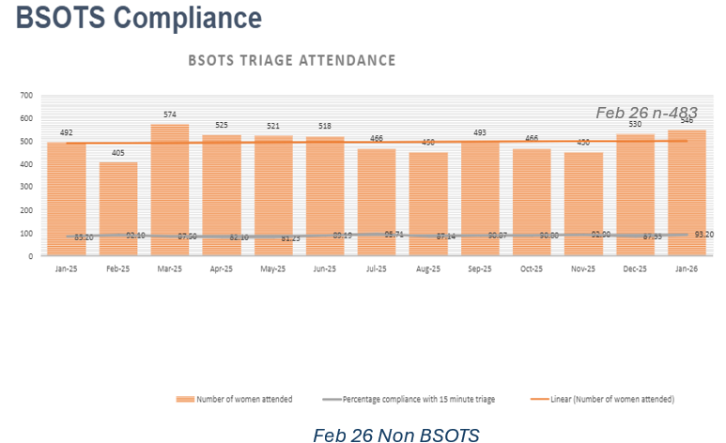

Category | Category description | Number and percentage of total cases in month
Red | Number of women requiring ongoing immediate care | 3 (0.6%)
Orange | Number of women requiring ongoing care within 15 minutes | 56 (12.1%)
Yellow | Number of women requiring ongoing care within 1 hour | 347 (74.9%)
Green | Number of women requiring ongoing care within 4 hours | 34 (7.3%)
Uncoded cases |  | 23 (5%)

February showed a deteriorated position for uncoded cases when compared to January. However, there is ongoing efforts to ensure staff are required to code all cases but overall this report recognises the significant improvement on previous reporting.

There were 6 incidents reported due to delays following initial assessment and risk stratification for yellow, amber, and red pathways. There were no ‘harm incidents’ because of these delays.

There were 4 medical breaches noted. Caution is advised when interpreting this data due to known inconsistencies associated with the transition to the All-Wales data collection tool. A macro fault has been identified, which is being investigated and addressed and may have affected the accuracy of recorded breaches. Further updates will be provided once the technical issue has been resolved and data validation is complete.

The implementation of a single telephone access point for maternity services, which successfully went live on 3 March 2026, represents a significant step forward in improving the accessibility, coordination, and safety of care for women and families. This new unified contact route streamlines how service users seek advice, report concerns, and access timely clinical support, replacing previously fragmented pathways that could create delays and inconsistency. By centralising triage through a dedicated and clinically supported hub, the service enhances real-time decision-making, ensures equitable access regardless of entry point, and strengthens early identification of risk.

This development not only improves user experience but also supports staff by reducing duplication, clarifying escalation processes, and enabling more effective deployment of clinical resources. The early operational feedback demonstrates clear potential for improved outcomes, service efficiency, and alignment with national maternity safety recommendations.

Reporting of data has been slightly delayed as staff capacity is temporarily redirected to support the safe go-live and implementation of the BadgerNet digital maternity record. This work was prioritised to ensure continuity of care and patient safety during a significant service change.

Implementation of the Open Access to Triage model continues, supported by staff education, strengthened community engagement, and preparations for Phase 2 go-live on 19 May via BadgerNet. Early data demonstrates appropriate uptake of registration, with no unintended demand or inappropriate access to triage identified to date.

Monitoring arrangements are in place, including monthly data review, feedback from community teams, and incorporation of service user voice. Actions to improve awareness, access and consistency, such as wayfinding signage, national Open Access cards, and targeted engagement with under-represented groups, are underway.

The Board can be assured that this improvement programme is being implemented in a controlled manner, with clear governance, ongoing evaluation of effectiveness, and the ability to respond promptly to emerging learning or impacts.
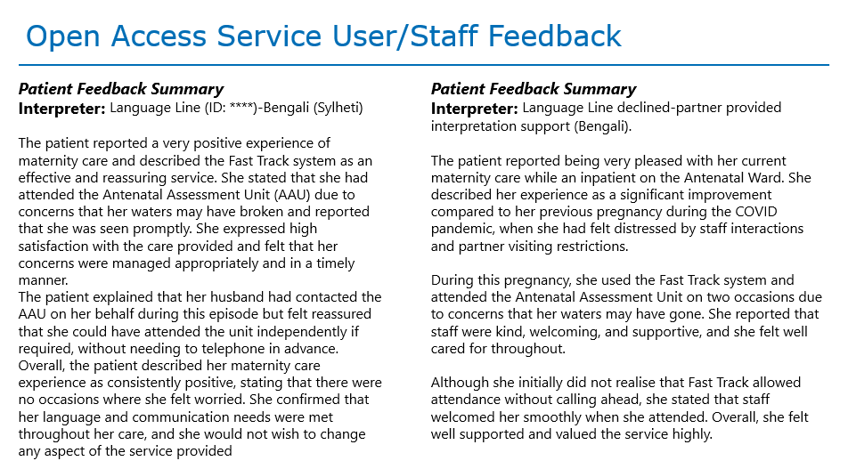

3.5. Third and fourth-degree tears

Latest data published by the National Maternity and Neonatal Audit (NMPA, 2023 data) reports a UK incidence of 3.29% (2.60-3.80) for 3rd and 4th degree perineal tear. Reviewing 2025 data, SBUHB would have a rate of 3.37% of live births which is within the 95% confidence limit for the UK data and represents a reduction from 4.08% reported in 2024. This figure can be as high as 6% for first time mothers. SBUHB do not currently stratify data by parity, but this will be a future consideration with the implementation of BadgerNet.

The NHS Wales data dictionary has been consulted and confirms how the calculation should be made. Using this data standard to calculate 3rd/4th degree tears the rate for February 2025 is 4.7%, a slight increase. When trend data is benchmarked against national data, SBUHB performs well. The Royal College of Obstetricians and Gynaecologist reports a national rate of 2.9%. (Green Top Guideline No.29).

Episiotomy rate for March in SBUHB was 7.06%. National data for all births in the UK is not collected via the National Maternity Perinatal Audit. However, according to the NHS Maternity Statistics, England for 2023/24, the rate of vaginal births with episiotomy was 13.9%. The use of instruments at birth carries a higher risk of sustaining perineal trauma. All instrumental births are subject to thorough review, including an audit of elective episiotomy practice. These findings are carefully monitored and reported through the Maternity Dashboard Scorecard, ensuring transparency, learning, and continuous improvement in the safety and quality of care we provide.

Birth Mode | Number 3rd degree | Number 4th degree
Spontaneous vaginal birth | 10 | 0
Spontaneous vaginal birth – labour and birth in a pool | 0 | 0
Instrumental birth Ventose/Forceps | 1 | 0
Failed instrumental birth converted to caesarean birth | 0 | 0

An increase in third-degree tears following spontaneous vaginal birth has been identified. Review to date has not highlighted any consistent themes or indicators of unsafe practice, and the variation observed is considered likely to represent statistical fluctuation rather than a change in care quality.

This position has, however, appropriately prompted enhanced monitoring. The service will continue to closely observe trends and has governance arrangements in place to initiate detailed review should this pattern persist or escalate.

The Board can be assured that this metric is being actively monitored, with systems in place to identify emerging risk and respond promptly should further action be required.

3.6 Postpartum Haemorrhage

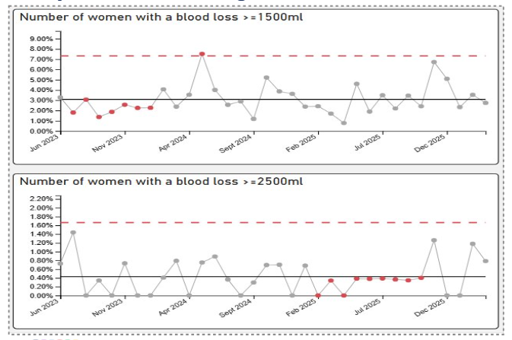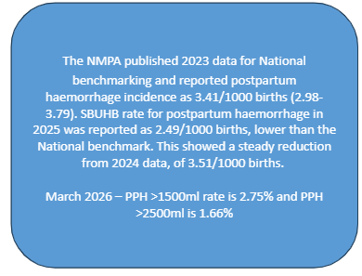
In March 2026, the service saw normal variation in the number of cases involving blood loss that met the criteria for reportable obstetric haemorrhage. All cases were subjected to a rapid review by the Multi-Disciplinary Team (MDT) to ensure there were no breaches in duty, confirm compliance with management guidance, and identify any early learning opportunities. All cases were appropriately risk assessed and managed. Importantly, these events remain within national benchmarking standards.

The NMPA published 2023 data for National benchmarking and reported postpartum haemorrhage incidence as 3.41/1000 births (2.98-3.79). SBUHB rate for postpartum haemorrhage in 2025 was reported as 2.49/1000 births, lower than the National benchmark. This showed a steady reduction from 2024 data, of 3.51/1000 births.

3.7 Maternal Intensive Care Unit (ICU) Admissions
In line with the Maternity Services Standard Operating Procedures (SOPs) for Escalation, Incident Reporting, and Maternal Deterioration, I can confirm the following assurance regarding admissions to higher acuity care:

- Maternal ICU Activity
There have been no obstetric maternal Intensive Care Unit (ICU) admissions since September 2024. This remains within expected parameters and is monitored through established safety and escalation systems.

- Mandatory DATIX Reporting and Governance Oversight
In accordance with the Health Board’s Standard Operating Procedure (SOP) for Incident Reporting and Investigation, all maternal transfers to higher-acuity settings (HDU/ICU/CCU or external clinical areas) trigger mandatory DATIX submission.

This ensures:
- immediate visibility to senior midwifery and clinical teams
- appropriate triage for review
- inclusion in weekly maternity governance meetings
- escalation through the Service Group Quality & Safety process if required.

- Daily SitRep Monitoring and Cross Service Patient Tracking

As outlined in the Operational Escalation and Daily Safety Huddle SOP, all women admitted outside maternity services are actively tracked through the daily Health Board SITREP process.
This provides:
- Real time identification of any obstetric patient in nonmaternity clinical areas
- Coordinated multidisciplinary response.
- Timely involvement of obstetricians, anaesthetics, and senior midwifery leadership
- Assurance that women receive care supported by the appropriate clinical expertise.

- Clinical Oversight and Escalation Pathway

Any maternal admission to a higher level of care is subject to:
- Senior midwifery oversight
- Consultant obstetric review
- Escalation to the Director of Midwifery and on-call obstetric consultant where indicated.
- Review against the Maternal Early Warning Score (MEWS) pathway and deterioration SOP.

These arrangements ensure robust surveillance and prompt escalation in line with national maternity safety expectations.

Assurance to the Health Board

Combined, these processes provide clear assurance that maternal admissions are:
- safely monitored
- subject to appropriate governance
- reviewed through the established quality and safety framework.
- supported by coordinated multidisciplinary care

This systematic approach maintains strong oversight and enables early identification of any emerging risk.
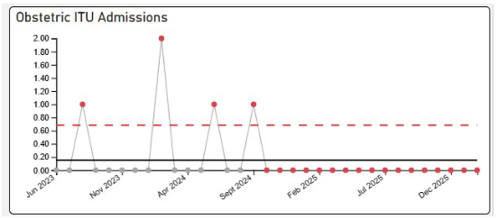

There was one delivery in ED area in March 2026, which was managed well by MDT team of midwives, obstetric and ED consultant, and paediatrician. Both baby and mother had a good outcome. This was an excellent example of cross site joined up working with excellent communication between the teams.

3.8 Perinatal Incident Reporting
Work continues to maintain the improvement in the reduction of overdue open incidents across perinatal services, this includes weekly incident review meetings, rapid reviews of any incident of moderate harm and above, with early learning identified and shared. Significant improvement is noted with regards to open incidents, incident investigation, and closure processes. Learning is identified and disseminated regularly through safety alerts where applicable, monthly Risky Business Newsletters, and risk meetings across the perinatal services. Complaint resolution back log has been reduced to just 3 months except cases requiring external review or Coroner’s input. Duty of Candour (DoC) processes are in place and timely. The Legal redress cases are reducing slowly.

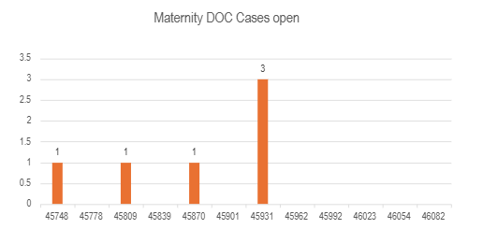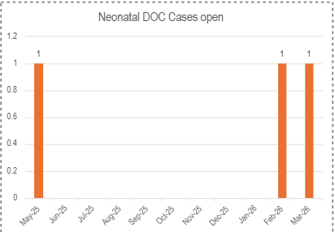

A further break down of incidents in relation trigger categories can be seen in the chart below:

Types of incidents – Perinatal Services – 01/10/25-31/12/2025

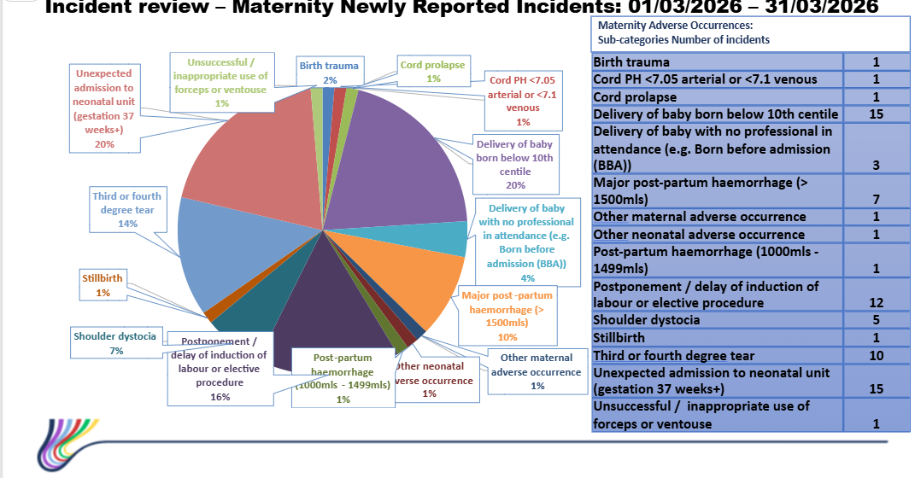
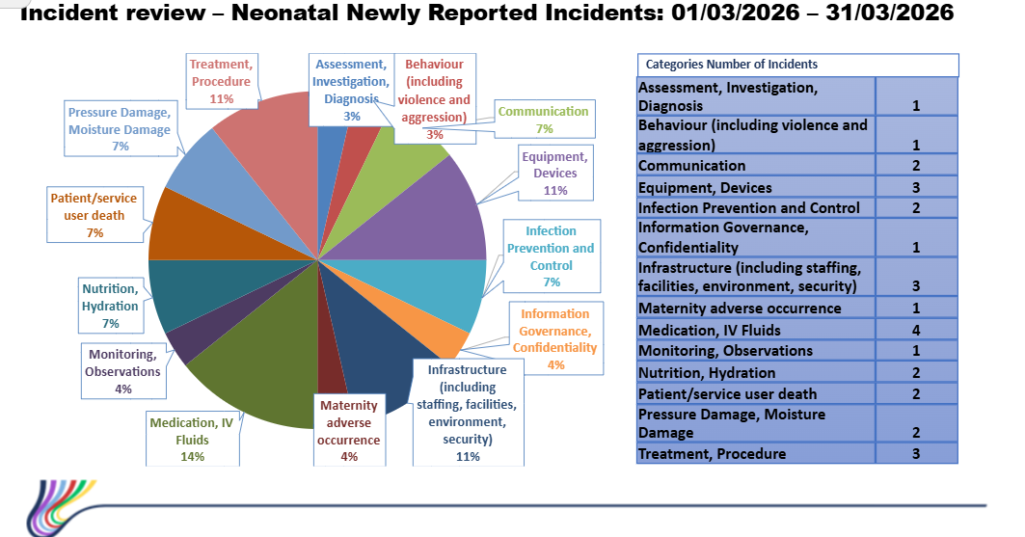

Mandatory incident reporting continues for key perinatal indicators, including unexpected term admissions to the neonatal unit, babies born small for gestational age, shoulder dystocia, and babies born before arrival. All unexpected term neonatal admissions are routinely reviewed through the Perinatal Multi-Disciplinary Team, with learning captured at both individual case and thematic level.

Thematic review has identified opportunities for quality improvement, including the implementation of ASTRA (Avoiding Short-Term Respiratory Admissions to the Neonatal Unit). ASTRA has been introduced as a targeted quality improvement intervention aimed at reducing avoidable short-term neonatal respiratory admissions.

At this early stage, there is insufficient data to determine the full impact of ASTRA, and outcome trends continue to be monitored. The programme therefore remains within an active evaluation phase, with effectiveness assessed through ongoing review rather than definitive conclusions at this point.

Oversight is maintained through Perinatal Committee governance arrangements, where progress, learning and emerging impact will continue to be reviewed. Updates will be provided to the Board through this route as further data becomes available and the quality improvement cycle matures.

3.9 Patient Feedback and Experience
The service continues to capture feedback via friends and family, and we were the pilot site for the NHS core questionnaire. The Core Questionnaire pilot sends a text to users of our services at five points during their pregnancy, the responses are received and responded to by the senior midwifery and nursing team. Where concerns are raised, direct contact is made with the family, either on the ward, or via a telephone call to talk about their experience and we collaborate with the woman and family to ensure improvements are made.

Common themes from patient feedback are around access to services, in particular waiting times within antenatal clinic. An antenatal clinic review is in progress which will consider several complex care requirements involving the coordination of several services to streamline and minimise waits for women.

Radiology Services are progressing with a national rollout of a new pregnancy imaging system (ViewPoint). Under the previous system (RADIS), confirmation of a viable pregnancy at the 20‑week anomaly scan enabled a safeguard trigger for issuing the Phase 1 Maternity Patient Experience Survey.

The replacement system does not currently support extraction of this confirmation data. As a result, there is no robust mechanism to validate pregnancy viability prior to survey distribution, creating a potential patient experience and safety risk should surveys be issued following a non‑viable pregnancy.

This risk was identified during live implementation of Viewpoint and BadgerNet and was not anticipated during pre‑implementation planning. The issue has been formally escalated to NHS Performance and Improvement, and a national meeting will be convened to agree a resolution, recognising this as an All‑Wales issue.

In the interim, safeguards are being maintained locally while a national solution is progressed. The Board can be assured that the risk has been identified promptly, escalated appropriately, and is subject to active national oversight.

While the NHS Core Maternity Patient Experience Survey is currently subject to national system limitations, additional mechanisms for capturing and responding to women’s experience remain robust and active.

Friends and Family Test feedback and other experience data sources continue to be received and are routinely reviewed through the Perinatal Women’s Experience Forum. This forum provides multidisciplinary oversight of all service-user feedback and works collaboratively with teams to ensure that women, staff and communities are informed about how experiences are shaping learning and improvement.

A comprehensive monthly women’s experience report is produced and shared across maternity and neonatal services, supporting continuous learning, service improvement and assurance. This ensures that women’s voices continue to inform quality and safety oversight while national solutions for the Core Questionnaire are progressed.

Progress continues in development of the Neurodiverse Maternity Care Plan, informed by meaningful engagement with local families and service users. Feedback highlights strong support for the personalised approach and its potential to significantly improve pregnancy, birth and postnatal experiences.

Review of feedback and professional insight has identified opportunities to refine the pathway and strengthen implementation, including clearer guidance, improved staff understanding, and enhanced consistency of use. Ongoing engagement with families remains central to this work.

Further development and assurance activity will continue through established governance routes, with monitoring of effectiveness and continued co‑production underpinning service improvement.

There are currently 8 outstanding Perinatal formal concerns and whilst two are overdue they are in active management and lengthy due to the complexity of the cases. One is in an external review process, and 1 is awaiting breach in duty memo.
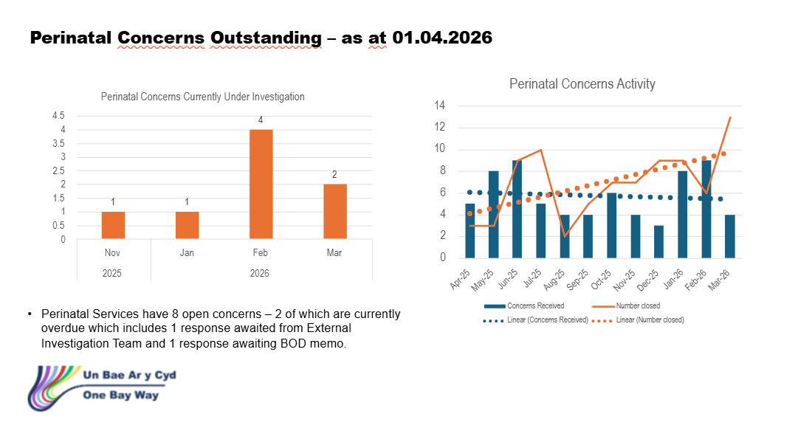

3.9.1 Engagement with Diverse Communities – Maternity Services
Swansea Bay University Health Board’s maternity services are actively progressing initiatives to ensure inclusive, culturally sensitive care informed by lived experiences. Current actions include collaboration with community groups such as the ‘Mums and Toddlers Foundation’ and ‘Chai and Chat’ to gather feedback and strengthen representation in service planning. Work is underway to establish a Black, Asian, and Minority Ethnic (BAME) Advisory Network to embed diverse voices in policy and improvement decisions. Feedback mechanisms, including Civica surveys and outreach sessions, are being expanded with translation support and cultural awareness questions. Staff engagement in equality, diversity, and inclusion (EDI) training and events continues, alongside implementation of fast-track antenatal services for BAME families. Inclusive practices are visible across clinical areas through multilingual signage, diverse educational materials, and access to interpretation services.

Future plans include enhanced demographic data collection, culturally inclusive communications, and recruitment of diverse representation within the Maternity Voices Partnership. Our engagement strategy will include a strengthened focus on the experiences of partners and fathers. The service has already implemented changes in response to feedback from women and their partners, particularly in improving access and support for those undergoing induction of labour.

Our Womens Experience Midwife continues to strengthen partner inclusion within the perinatal pathway, recognising the vital role that fathers and co-parents play in the wellbeing of mothers, babies, and families. Key developments include:

3.9.2 Strengthening Partner Voice and Feedback Mechanisms
- Friends and Family Test (FFT): Fathers are actively encouraged to provide feedback through the FFT. Their comments are routinely reviewed, and themes are shared through the Women’s Experience Forum to support continuous learning and improvement.
- Local Engagement: Findings from the Sketty MOSC survey of fathers have been presented at the Women’s Experience Forum, enabling a service wide response and informing planning across maternity services.
- Partner Focused Learning and Staff Development: we developed a father’s lived experience story, focusing on neurodivergence in the perinatal journey. This resource is now used in staff education to deepen understanding of diverse family needs and enhance inclusive communication and support.
- Promoting Partner Participation in Postnatal Activities: Fathers are welcomed and encouraged to attend local mother-and-baby classes, ensuring they have equitable access to support, information, and bonding opportunities.

3.10 Induction of Labour delays
Delays in induction of labour continue to be monitored and escalated to ensure clinical prioritisation and service requirements to improve flow based on clinical acuity. All delays are Datix reported to ensure any triangulation of any harm as a result. Through this process of clinical risk assessment and prioritisation, no delays reported have resulted in harm.
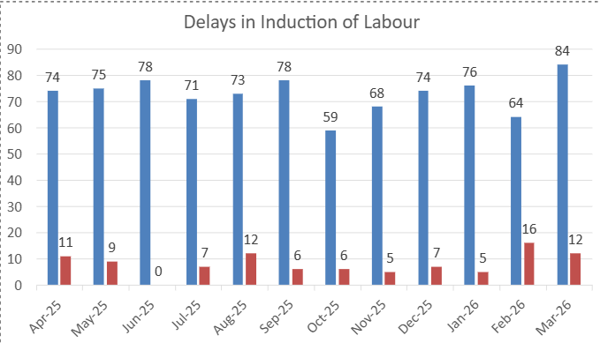
A review of reported incidents relating to induction of labour identified delays in transferring some women for continued augmentation within 24 hours. These delays occurred during periods of high clinical acuity, where workforce availability and competing service pressures affected the timeliness of transfers.

All induction of labour are risk assessed using a standardised tool at booking and a diary maintained. Any subsequent suspension or delays are also risk assessed by a MDT team on labour ward and records uploaded to a shared drive. The risk assessment documentation and audit for IOL booking and delays will be streamlined digitally following full implementation of Badgernet

All episodes of delayed induction of labour were appropriately reported and reviewed. Importantly, no harm was identified because of these delays. However, it is recognised that delays in induction of labour can have a negative impact on women’s experience, contributing to anxiety, distress, and an increase in complaints and concerns, even where clinical outcomes remain safe.

Alongside these service pressures, the implementation of the BadgerNet digital maternity record has required a significant programme of staff training. Since January 2026, training has been delivered across all staff groups, registered and unregistered, to ensure safe, consistent, and effective use of the system. While essential for long‑term improvements in quality, safety, and women’s experience, this training commitment has temporarily reduced available staffing capacity, contributing to short‑term operational pressures.

The organisation remains committed to ensuring that staff are appropriately trained and supported to use digital systems safely. This investment is fundamental to delivering a single, high‑quality digital pregnancy record, improving communication, continuity of care, and patient experience, while strengthening clinical safety and governance. Ongoing learning from these reviews will continue to inform workforce planning, training delivery, and service resilience, with women’s safety, dignity, and experience at the centre of all improvement actions.

3.11 Workforce
There have been some challenges within the Neonatal medical workforce due to unavailability, this has been mitigated with flexible working arrangements which has meant there has been no gap in service. A Neonatal Consultant was successfully recruited on the 9th of December and Neonatal Consultant has returned following maternity leave in January 2026. Another neonatal consultant has returned to work following sickness in March 2026.

Obstetric workforce – 2 fixed term gaps for career break and other leave have been covered with locum appointments with no vacancies impacting on services. The process to recruit substantive consultants are underway. A review of workforce is also currently being undertaken to identify the best, safe and efficient model.

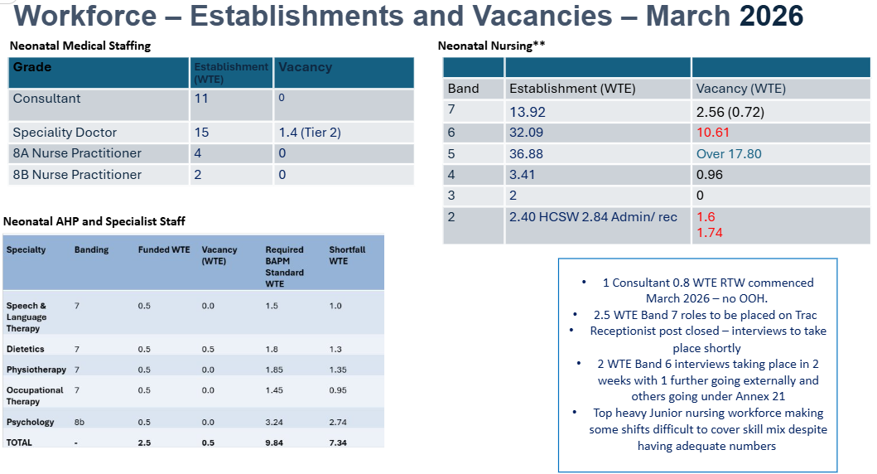
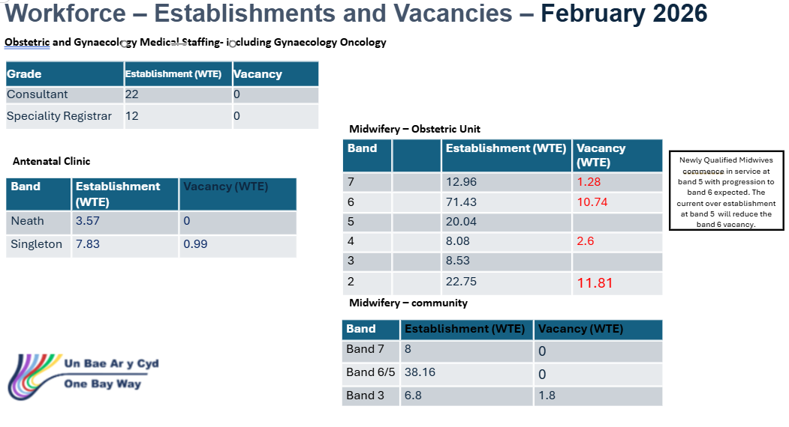
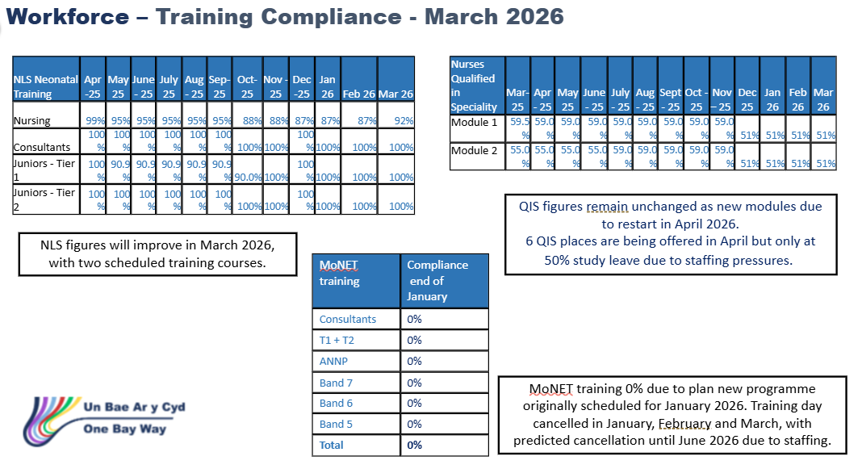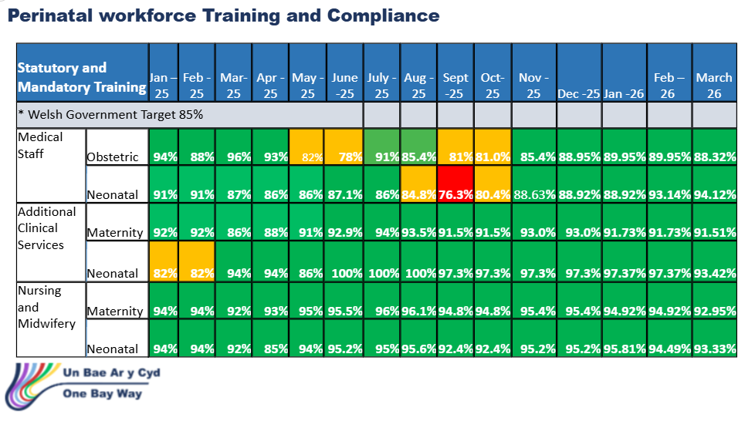
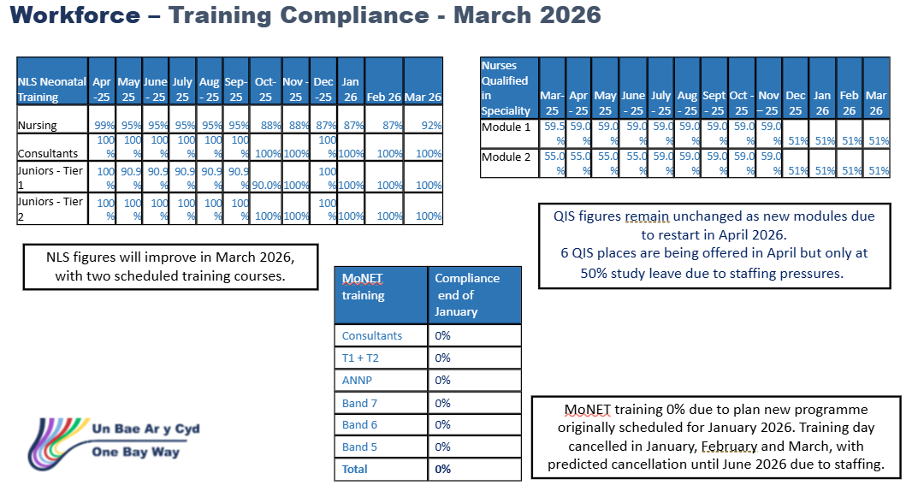

Compliance is improved across the board, where staff have been unable to maintain compliance they have been emailed to understand what support is required. Respective line managers have been following this up to support maintenance of compliance within expected thresholds.

3.12 Infection Prevention and Control
Improvement plans have been put in place to support infection control in ward areas. Matron audits have identified areas that need focus and action plans implemented to improve. This is being benchmarked against the bi-quarterly validations. Infection Control Team corporate inspection continues, and any learning identified is being included in the improvement plan which is monitored via the Perinatal Committee. There was 1 blood culture positive infection in Quarter 1 of 2026 within neonatal services. The organism identified was Staph Aureus.

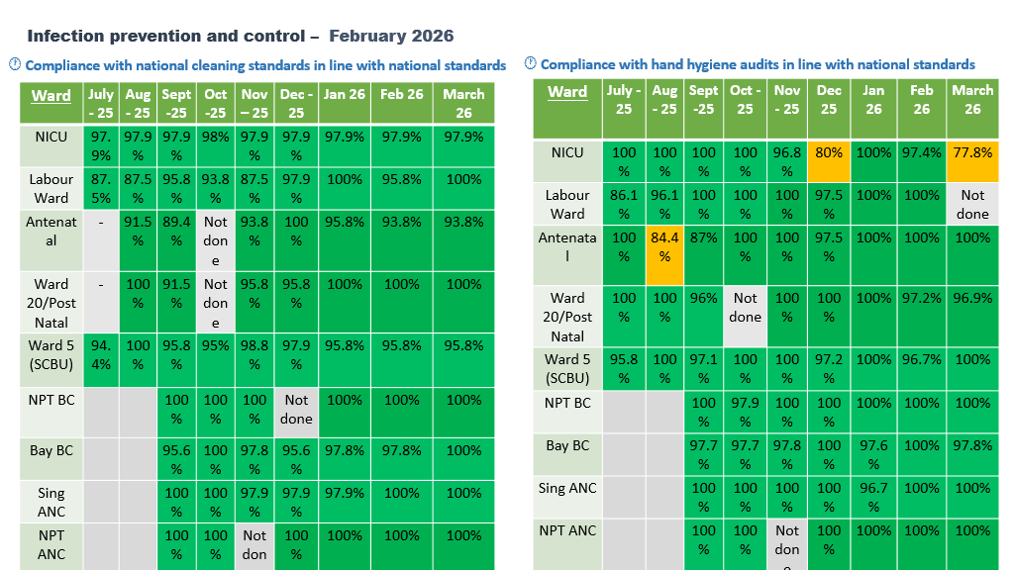
Whilst there had been a reported decrease in compliance with hand hygiene audit in NICU, coinciding with the induction of new rotational staff in March. This is despite IPC training being a standard item for induction. A safety brief has been circulated, and a subsequent spot check audit showed an improved position to 100%. This will continue to be monitored, and a zero-tolerance position has been reinforced.

3.13 Neonatal National Audit and Performance (NNAP)/PERIPrem Cymru – context and figures
There are no new updates to report for this period. Performance and audit indicators remain reassuring and consistent with the position outlined in the previous report.

The next formal update from NNAP Cymru is expected toward the end of 2026.

PERIPrem Bundle Optimisation Score:
The PERIPrem bundle optimisation score for March was 44%. While this represents sustained delivery of high-quality care across the pathway, there are elements where a reduced score was noted. On review, some of these reductions may be attributed to ex-utero transfers, with babies born in other Health Boards impacting local performance metrics.

Early breastmilk provision (within 6 hours of birth) experienced a decrease in usual performance; however, the team achieved 100% early expressing rates, though no breastmilk was obtained within the timeframe.

Performance remains robust overall, but the decline in the optimisation score highlights areas for focused improvement and potential review of cross-Health Board transfer impacts.

Performance remains robust overall across the PERIPrem pathway, which remains reassuring, with most metrics performing at or above expected levels. Areas with minor variation relate to small cohort size rather than systemic issues. The service continues to demonstrate strong adherence to evidence based neonatal optimisation measures.
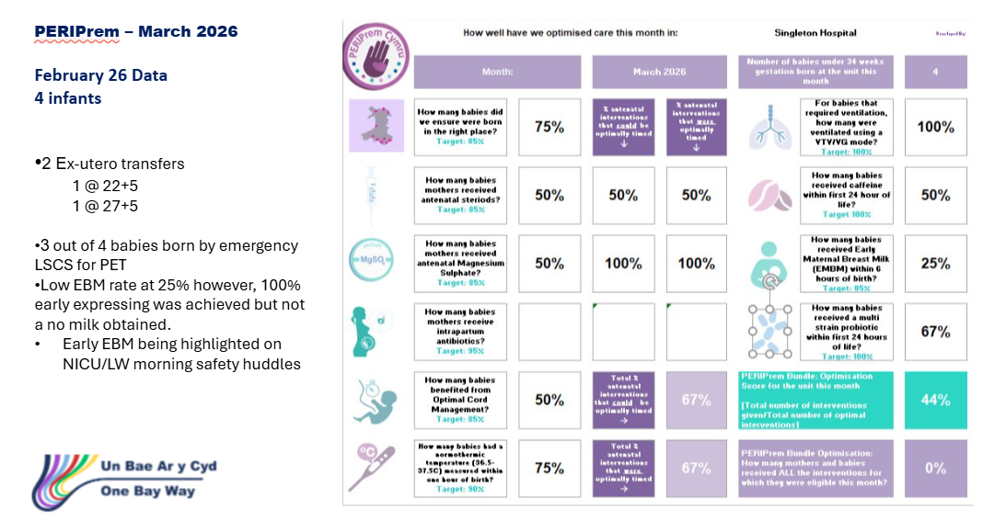

3.14 Avoiding Term Admission into Neonatal services.
The service is managing and reviewing term admissions to the neonatal unit in real time and has moved the caseload into business as usual. The principal reason for admission is respiratory distress of the new-born; data analysis shows that 70% of these admissions is following planned caesarean birth. The service implemented a quality improvement project in April of this year in which high flow oxygen is delivered for up to one hour of life prior to assessing if admission to neonatal unit is required. This is conducted at the bedside mitigating any separation of mother and baby. It is too early to assess how successful this programme has been but will be reported following completion of the improvement cycle to board via the Perinatal Committee Report.

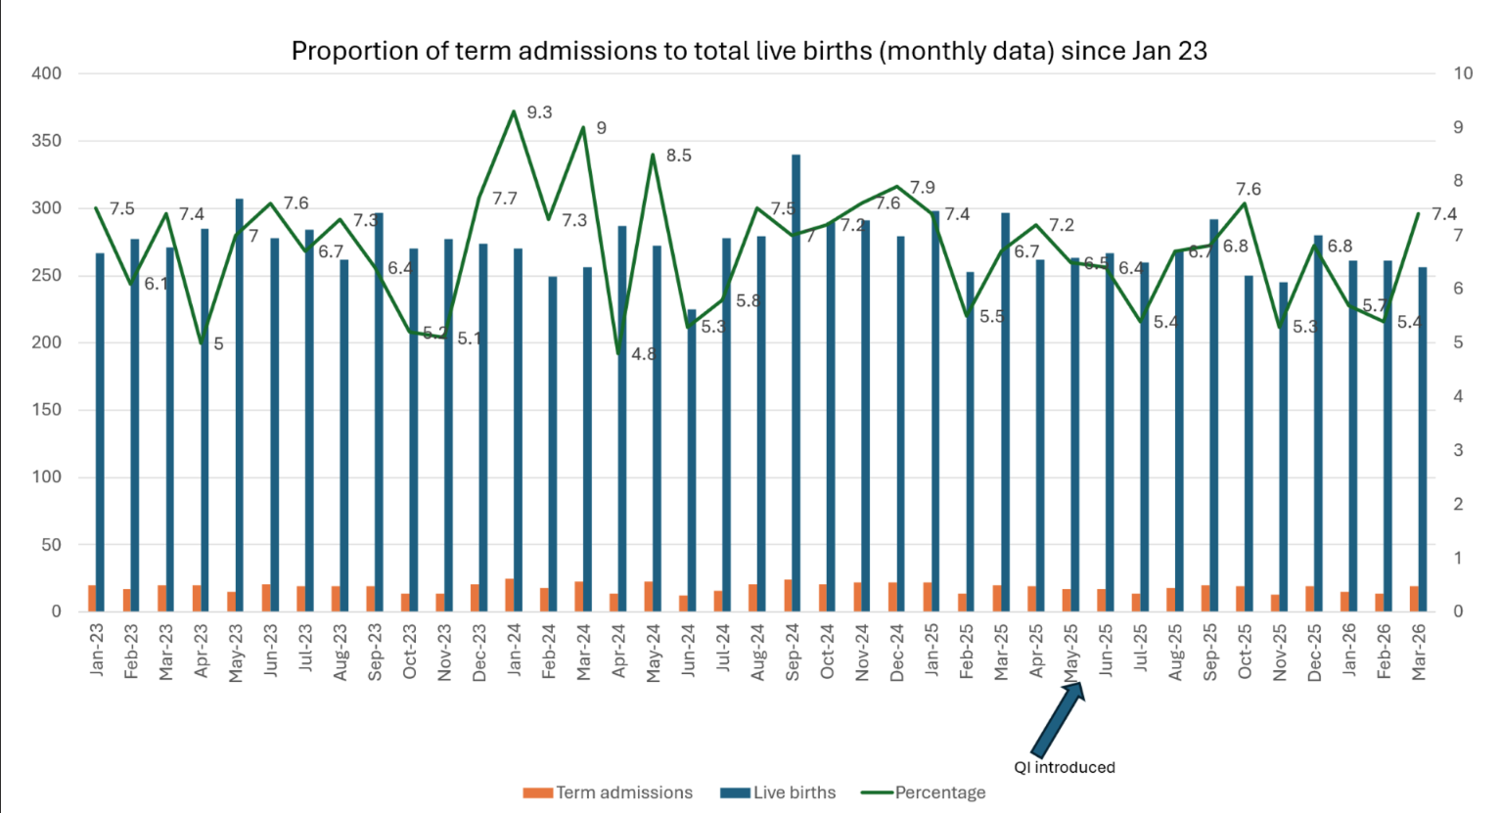

The All-Wales Perinatal Assurance review, The Path to Safer Beginnings in Wales 2026, reported that the rate of babies admitted to neonatal units (124.4 per 1000 live births) has remained constant since 2021, although the actual number has fallen from 3234 to 3112 because of the decline in the birth rate. Just over 30/1000 of these were babies born below 32 weeks’ gestation, with 36.5/1000 at 32-36 weeks’ gestation. The remainder were term (37 weeks and over) admissions (45.7/1000). Babies born by unplanned caesarean and subsequently admitted to the neonatal unit were over-represented; 85.3/1000 babies born by caesarean, compared with 38.7/1000 babies born by spontaneous vaginal birth. In SBUHB 29/1000 neonatal admissions were from elective section births

3.15 Risk Register
The perinatal Risk Register governance process and controls is set up to provide a single, controlled view of clinical and operational risks across maternity and neonatal services, ensuring timely mitigation, escalation, and assurance to the Board.

The governance structure and accountability are owned using established roles and functions of the governance process with risk ownership clearly articulated for each area. Control owners and overall accountability for Perinatal Risk governance is delegated to the Head of Midwifery and Director of Midwifery for sign off the register submissions. The Lead Midwife Quality Improvement Practitioner for Maternity/Neonatal Services ensures compliance with policy, supports risk scoring, DATIX quality, and trend analysis.

The Service Group Quality, Safety and Risk Committee receives the register, monitors progress, which is reviewed and updated monthly and escalates to Service Group Quality & Safety Committee/Board as required.

Board is informed and assured having oversight via Perinatal Committee reporting.

Risk assessments > 20 x2.
A high-scoring risk relating to the full implementation of the Computerised Cardiotocograph (CTG) system remains on the risk register. While progress has been made, planned deadlines have not been met, and the issue is not yet resolved.

Although the test environment was updated, further testing has not yet provided satisfactory assurance. The service is therefore awaiting re-testing and resolution with the system supplier before implementation can safely proceed. As a result, the system has not gone live and the risk remains active.

The risk will not be closed until full functionality, reliability and clinical safety have been confirmed through successful testing. Once implemented, the digital CTG platform is expected to enhance fetal monitoring, improve clinical decision-making and increase consistency of fetal surveillance.

In the interim, established governance and safety processes remain in place, and the implementation continues to be closely overseen while work with the supplier progresses.

A new risk score relating to Neonatal and Paediatric radiology reporting requirements has been added to the risk register since the last reporting period.
A suitable mitigation and supplier solution has been established for neonatal radiology reporting, providing assurance for this element of the pathway.

However, outstanding requirements remain for Paediatric services, and work is continuing to address these with relevant stakeholders.

The risk will remain live until full mitigations are in place across both neonatal and paediatric pathways. Oversight is maintained through established governance arrangements, with further updates provided as outstanding elements are resolved.

Risk assessments >16 x 2.
Two risks currently score 16 and remain under close management. Both have clear mitigations in place, are monitored through established governance processes, and are not associated with any adverse outcomes.

Risk assessments < 16 x 9 scoring less than 16.
A review of current maternity and neonatal risks rated below 16 indicates that while several operational challenges remain, all are being actively managed with clear mitigation in place. No issues currently pose an immediate threat to patient safety or service continuity.

3.16 Quality Improvement Approach, Methodology and Programmes
Perinatal services adopt structured Quality Improvement methodology to ensure safe, reliable, evidence-based care for women, babies, and families. The approach is grounded in recognised improvement science frameworks and national priorities, combining local data driven change with strong multidisciplinary collaboration.

A detailed plan was presented in the January 2026 report to QSC and Board, further updates will be represented in the report as these are formulated and once able to report outcomes and impact. This also applies to any quality improvement programmes which was presented in January.

3.17 National Awards.
Swansea Bay University Health Board’s maternity and neonatal services continue to demonstrate excellence through strong patient validated recognition and organisational accolades. In the past year, the service has secured multiple acknowledgements that reinforce its commitment to high quality, compassionate and continuously improving care.

The Perinatal Committee will continue to receive updates for any nominations and awards achieved by the Perinatal Services and reported via the Perinatal Committee.

- OPEN AUDIT RECOMMENDATIONS

Open audit recommendations relate primarily to system strengthening rather than concerns about unsafe care.
The Perinatal Committee maintains oversight of a small number of open audit-related actions arising from internal reviews, external assurance activity and national audit programmes (including MBRRACE-UK and NMPA), together with recommendations emerging from the Independent Review and All-Wales Perinatal Assurance processes.
These recommendations are embedded within the Perinatal Improvement Programme and are tracked through established governance arrangements, with clear executive ownership, defined milestones and progress reporting via the Perinatal Improvement Programme Executive Board and Perinatal Committee.
Current open actions focus on:
- strengthening digital infrastructure and interoperability (including implementation of computerised CTG and optimisation of BadgerNet functionality);
- improving reliability and completeness of data capture and reporting (e.g. surgical site infection surveillance and demographic data completeness);
- enhancing consistency of clinical pathways and escalation processes through training, audit and quality improvement activity;
- further embedding learning from audit and review into education, supervision and multidisciplinary practice.
The Board can be assured that there are no outstanding audit recommendations indicating immediate risk to patient safety, and that all open actions are actively managed within the agreed improvement programme, with progress subject to routine scrutiny and escalation through Quality and Safety Committee where required.

- FINANCIAL IMPLICATIONS

As previously advised, there will be some financial implications because of the recommendations from the Independent Review, these are currently being developed as part of developing the improvement plan.

- RECOMMENDATION

Members are asked to:
BE ADVISED THAT:
- The Perinatal Improvement Plan Executive Programme Board has developed and will continue to monitor improvement plans in response to the Independent Review, All Wales Self-Assessment and other improvement actions, have been triangulated and added to the overall improvement plan.
- Perinatal Improvement Programme Executive Board continues to track progress against the improvement plan.
- Perinatal Committee meets monthly and reviews all key metrics for perinatal services.
BE ASSURED THAT:
- The Perinatal Service does not currently have any elements of care that would flag as a Negative Outlier.
- Any stillbirths or neonatal deaths have been sensitively reported through the MBRRACE (Mothers and Babies: Reducing Risk through Audits and Confidential Enquiries) process to support learning and improve future care.
- The MBRRACE 2024 perinatal surveillance analysis and benchmarking for SBUHB is presented in this report and represent an improvement from previous years.
BE ALERTED TO:
- Mitigating action to provide a single point of contact triage phoneline was achieved on 3rd March 2026.

Governance and Assurance
Strategic Objectives
Strategic Objectives  (please choose which is impacted) | People of Swansea Bay live healthier, fairer and more prosperous lives | ☐
Strategic Objectives  (please choose which is impacted) | Care is high quality, safe, efficient and delivers the best possible outcomes for people in partnerships | ☐
Strategic Objectives  (please choose which is impacted) | Care is delivered in partnership with our communities in safe and appropriate setting, supported by innovation | ☐
Strategic Objectives  (please choose which is impacted) | The health board is a great place to work where staff feel valued and work together towards a common goal | ☐
Strategic Objectives  (please choose which is impacted) | The health board is a resilient, sustainable and responsible organisation | ☐
Health and Care Standards
Standards (please choose which applies) | Safe Care | ☒
Standards (please choose which applies) | Timely Care | ☒
Standards (please choose which applies) | Effective Care | ☒
Standards (please choose which applies) | Efficient Care | ☒
Standards (please choose which applies) | Equitable care | ☒
Standards (please choose which applies) | Person-centred Care | ☒
Standards (please choose which applies) | Staff and Resources | ☒
Enablers (please choose which applies) | Whole Systems Approach | ☒
Enablers (please choose which applies) | Leadership | ☒
Enablers (please choose which applies) | Workforce | ☒
Enablers (please choose which applies) | Culture | ☒
Enablers (please choose which applies) | Information | ☒
Enablers (please choose which applies) | Learning, Improvement and Research | ☐
Quality, Safety and Patient Experience
The Perinatal Committee reports directly into Quality and Safety Committee and noted via Service Group Quality, Safety & Risk Group and Senior Leadership Team. Key updates were received via Perinatal Committee and key measures of the high-level information have been included in section 3 of this report.
Financial Implications
As previously advised, there will be some financial implications because of the recommendations from the Independent Review, these are currently being developed as part of developing the improvement plan.
Legal Implications (including equality and diversity assessment)
Nil outlined within this report.
Staffing Implications
There have been some challenges within the Neonatal medical workforce due to unavailability, this has been mitigated with flexible working arrangements which has meant there has been no gap in service. Obstetric workforce – 2 fixed term gaps for career break and other leave have been covered with no vacancies impacting on services.
Long Term Implications (including the impact of the Well-being of Future Generations (Wales) Act 2015)
The work of the Perinatal Committee and the associated Perinatal Improvement Programme has significant positive long-term implications for women, babies, families, staff and the wider population of Swansea Bay.
The actions described within this report align strongly with the Well-being of Future Generations (Wales) Act 2015, particularly in supporting:
A healthier Wales – through sustained focus on improving perinatal safety outcomes, reducing preventable harm, and strengthening early intervention, maternity triage and continuity of care, recognising the lifelong impact of pregnancy, birth and neonatal outcomes on population health.
A more equal Wales – through targeted action to improve equity of access, culturally sensitive care, improved demographic data collection, and engagement with diverse communities to address variation in experience and outcomes.
A Wales of cohesive communities – by strengthening partnership working with families, communities and third-sector organisations, and embedding co-production and lived experience within service design and evaluation.
A resilient Wales – through investment in digital transformation, robust governance arrangements, workforce development and quality improvement capability, enhancing the system’s ability to respond safely and sustainably to future pressures and changing clinical complexity.
A prosperous Wales – by focusing on prevention, quality improvement and system efficiency, reducing avoidable harm, litigation risk and long-term cost associated with poor outcomes, while supporting staff wellbeing, retention and productivity.
Collectively, these actions reflect a long-term, preventative, integrated and collaborative approach, ensuring that perinatal services continue to improve not only immediate safety and experience, but also long-term outcomes for future generations. The Board can be assured that this work supports sustainable service delivery and fulfils the organisation’s statutory duties under the Well-being of Future Generations (Wales) Act.
Report History
The Perinatal Committee reports directly into Quality and Safety Committee and noted via Service Group Quality, Safety & Risk Group and Senior Leadership Team. Last reported April 2026.
Appendices
None.

