Meeting Date | 24 September 2025 | Agenda Item | 6.2
Name of Meeting | SBUHB Board
Report Title | Workforce Resilience Report - Improving Staff Wellbeing and Reducing Sickness Absence
Report Author | Paul Dunning, Professional Head of Staff Health and Wellbeing
Report Sponsor | Executive Director of Workforce and Organisational Development
Presented by | Tina Ricketts, Executive Director of Workforce and Organisational Development
Freedom of Information | Open
FoI Closed detail | If closed, choose detail
Impact Assessment Summary Outcome |  | IA Completion date
 |  | Click or tap to enter a date.
Purpose of the Report | For Assurance
Report Summary; detailing any action required
To provide the Board with assurance regarding the significant programme of work underway to support the organisational objective of improving staff wellbeing and resilience, including addressing high sickness absence.
To outline the findings from the recent Best Practice Review and current related workforce data and seek approval of a series of strategic workstreams aimed at addressing the root causes of absence to deliver sustainable improvements in workforce attendance, wellbeing and organisational performance.

Key Issues
- A comprehensive improvement programme is underway, including leadership development, work-related stress prevention, musculoskeletal health support and attendance management initiatives. Despite this, sickness absence remains high at 8.22% in July 2026 (in-month) so further focused action is being undertaken to support staff presenteeism and address continued high levels of staff absence from work.
- Sickness absence is estimated to have cost the Health Board approximately £41.7 million between August 2025 to July 2026. It is a key factor in the slow progress with reducing variable pay to withing the parameters set out in the recovery and sustainability programme.
- Staff absence is driven by several factors – including challenging operational environments – pressurised service areas and cultural challenges.
- Mental health and musculoskeletal conditions remain the leading causes of long-term sickness absence.
- Leadership and line management capability and capacity are key factors in reducing absence and improving staff wellbeing.
Decision / Action required | Yes
Recommendations
Members are asked to:
- CONSIDER the work undertaken to date reducing sickness absence and improving attendance management arrangements.
- RECEIVE ASSURANCE that a comprehensive programme of work is in place addressing both attendance management and wider organisational determinants of absence.
- APPROVE the proposed strategic workstreams and cross-organisational approach to improve staff wellbeing and reduce sickness absence.
WORKFORCE RESILIENCE REPORT - IMPROVING STAFF WELLBEING AND REDUCING SICKNESS ABSENCE

- INTRODUCTION
This report sets out the Health Board’s approach to reducing sickness absence and improving workforce wellbeing by addressing both attendance management processes and the wider organisational, workforce and population health factors that influence attendance at work. It provides assurance on progress made to date, presents evidence from organisational data and the multi-disciplinary Best Practice Review, identifies key governance risks and outlines a programme of actions designed to deliver sustainable improvements in workforce attendance, staff wellbeing and organisational performance.

High performing organisations generally experience lower levels of staff absenteeism due to sickness and higher staff engagement scores. These are priorities for the Health Board and align with our strategic objective of being a great place to work and ensuring we achieve service and financial sustainability.

- BACKGROUND
Reducing sickness absence within the Health Board remains a complex challenge influenced by factors both within and beyond the workplace. As a major employer serving communities with high levels of deprivation and long-term illness and health inequalities, many of our staff experience the same health challenges as the population they care for. Access to timely healthcare can also be impacted by NHS waiting lists, potentially delaying diagnosis, treatment and recovery.

The Health Board has a 12-month rolling sickness absence rate of 7.4%, which is 0.9 percentage points higher than the NHS Wales average of 6.5% and is the third highest rate in Wales, behind only WAST (8.1%) and Cwm Taf Morgannwg UHB (7.6%). While Swansea Bay's turnover rate of 7.8% is broadly in line with the NHS Wales average of 7.6%, our sickness absence rate remains above the national average, indicating a continuing challenge in reducing workforce absence.

Wider societal and workforce factors continue to affect employee health and attendance, including cost of living pressures, caring responsibilities, mental health concerns, an ageing workforce and increasing service demands and changing public expectations. These pressures have been further amplified by organisational change, operational pressures and the continued challenge of delivering services within a sustainable financial environment.

The Health Board’s multidisciplinary Best Practice Review concluded that sickness absence should not be viewed solely as an attendance management issue. Whilst effective attendance management processes remain important, evidence suggests that sustained reductions in sickness absence require a broader organisational response that addresses workforce wellbeing, leadership capability, staff engagement, organisational culture, workload pressures and workforce capacity.

Over the last year the Health Board has delivered a significant programme of work to improve attendance, including strengthened governance arrangements, Service Group improvement plans, attendance audits, hotspot reviews, manager training, enhanced performance oversight and continued service developments within Occupational Health and Staff Wellbeing services.

This work directly supports delivery of the Health Board's Organisational Strategy, People Strategy and Annual Plan by supporting improvements to workforce availability, strengthening compassionate leadership, supporting staff wellbeing and contributing to safe and sustainable service delivery. This reflects our organisation values of caring for each other, working together and always improving.

We need to build on the approaches already underway and build to enhance them, targeting support and trialling new approaches to ensure we see more rapid and sustainable improvements.

- GOVERNANCE AND RISK ISSUES
Long-term sickness absence continues to account for most of the time lost and remains the principal driver, whilst short-term absence has varied between 1.5% and 2.55%. ESR data continues to identify stress, anxiety and depression as the major contributor to sickness absence, accounting for 34% of long-term absence and 4% of short-term absence. Musculoskeletal conditions account for 12% of long-term absence (back problems 3% and other musculoskeletal problems 9%).
Sustainable improvement will therefore depend largely on reducing long-term absence through prevention/earlier intervention, effective case management and timely rehabilitation support.

Table 1. Sickness FTE % by Month
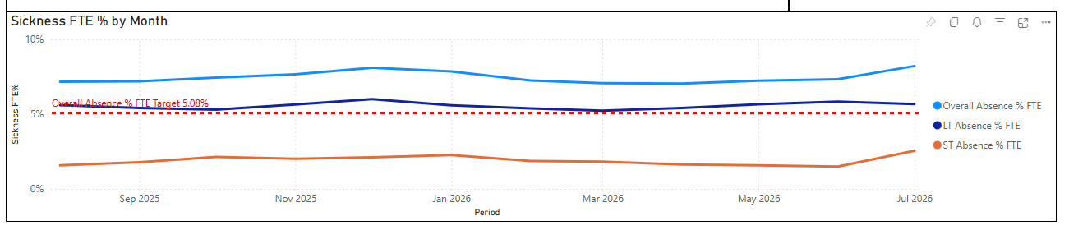
The increase in July 2026 sickness absence to 8.22% may have been influenced by periods of extreme heat. More than 2,500 responses were received to the Health Board’s Heat Impact Survey, indicating possible significant workforce impact due to heat related issues including sleep disruption, fatigue, dehydration and exacerbation of existing health conditions. Early indications suggest that other NHS organisations experienced similar challenges during this period.
A range of workforce intelligence indicators suggest increasing organisational pressure; employee relations activity has increased substantially over the last year (see Table 2). These trends may indicate growing workplace pressures, conflict and management challenges and can be viewed as indicators of organisational health.
Table 2. Employee Relations Cases 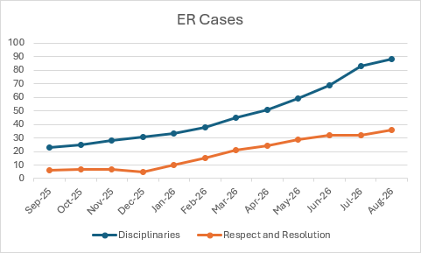
The 2025 NHS Wales Staff Survey identified strengths in team working and line management but reported deterioration in work-life balance, development opportunities and health and safety climate. Although burnout levels reduced compared with 2024, findings continue to highlight pressures affecting staff wellbeing, engagement and experience.
Demand for Occupational Health and Staff Wellbeing services has increased significantly, reflecting growing workforce health needs. Staff Wellbeing referrals continue to rise by around 14% annually, with approximately 75% relating to mental health and emotional wellbeing. Evaluation data demonstrates the effectiveness of early intervention, with 53% of referrals accessing support while at work and 70% reporting it helped them remain in work. Among the 47% referred during sickness absence, 82% believed the service supported an earlier return to work. Additionally, 59% of staff accessing support while in work reported improved productivity. Other preventative initiatives include the Staff Trauma Support Pathway, TRiM, Staff Health Checks and support for carers.
Occupational Health referrals have also increased substantially and now exceed available service capacity, resulting in breaches of some Welsh Government performance targets. This demonstrates greater utilisation of support services but also highlights capacity pressures that may affect timely intervention, rehabilitation and return-to-work support.
Evidence from higher-performing organisations suggests that sustainable reductions in sickness absence are supported by strong leadership, compassionate management, effective workforce planning, rapid access to wellbeing services, high employee engagement and positive workplace cultures.
Sickness absence remains one of the most significant workforce risks facing the Health Board, impacting service delivery, workforce sustainability, financial performance, patient experience and staff wellbeing.
The principal risks requiring Board oversight are:
- Continued high sickness absence impacting workforce availability, service delivery and organisational performance.
- Increasing workforce pressures resulting from vacancies, workload demand and the loss of organisational knowledge and experience.
- Organisational change occurring within an environment of increasing employee relations activity, workforce pressure and uncertainty.
- Increasing demand for Occupational Health and Staff Wellbeing services resulting in capacity pressures and breaches of key performance indicators.
- Persistently elevated levels of stress-related and musculoskeletal absence despite evidence-based, targeted interventions.
- Inconsistent management capability, reducing the effectiveness of early intervention and preventative support.
- Failure to address the wider determinants of attendance, limiting the effectiveness of traditional attendance management approaches.
- Climate-related risks, including future extreme weather events affecting staff health and attendance.

The review highlighted that sickness absence is frequently symptomatic of wider organisational challenges rather than solely individual health issues. Failure to address these wider factors risks ongoing absence, increased presenteeism, reduced productivity, use of temporary staffing solutions, deterioration in staff engagement and continued pressure on service delivery, further exacerbating increased sickness absence.
Strong evidence demonstrates that good line management is a key determinant of employee health and wellbeing, with supportive managers associated with lower sickness absence, improved employee engagement and better organisational outcomes. Variability in management practice therefore represents a significant organisational risk. The recently introduced NHS Leadership and Management Framework Leadership and Management Framework provides an important opportunity to strengthen leadership capability and address factors associated with sickness absence and supports and embeds the evidence-base that ‘good work is good for health’.

Strategic Aim and Outcomes
In response to the above, a strategic sickness absence reduction programme is proposed that will include several strategic, cross-organisational workstreams aimed at creating a healthier, more resilient workforce and deliver a sustained reduction in sickness absence without compromising fairness, inclusion or staff trust. The programme will pursue five outcomes: (1) achieve the 2026/27 breakthrough objective of below 6.09%, supported by Service Group trajectories; (2) reduce long-term lost time and recurrence; (3) improve timely return-to-work conversations, case reviews and workplace adjustments; (4) reduce stress-related and musculoskeletal absence in identified hotspots; and (5) reduce avoidable variable-pay and productivity costs attributable to absence.
To underpin this, our intentional cultural change programme is strategically aligned to the formation of the care groups and will support the Health Board in building a high-performing, compassionate and values-driven culture. The programme combines leadership development, quality improvement methods and staff engagement to strengthen trust between leaders and staff, improve psychological safety and speaking-up practices. It will also enhance learning and continuous improvement and empower teams to take ownership of local solutions. Through clear accountability, coaching-focused leadership and data-driven decision-making, the programme aims to create sustainable organisation-wide cultural change that will improve staff experience, outcomes for patients and the communities we serve.

It is suggested this programme will form part of the recovery & sustainability programme and be overseen by the workforce programme board and will deliver:
- Focused operational grip: monthly executive review of the highest-absence services, with recovery trajectories, case-level assurance and rapid escalation of barriers.
- Long-term absence pathway: early manager contact, timely occupational health input, multidisciplinary review of complex cases, adjustment passports, phased return and redeployment where appropriate.
- Manager standard: mandatory capability development, practical toolkits, coaching and quality assurance of return-to-work and formal review conversations.
- Stress prevention: application of the work-related stress risk assessment at team level, using workload, control, support, relationships, role and change as the core diagnostic domains.
- Musculoskeletal prevention and rehabilitation: improved access to ergonomic assessment, manual-handling refreshers after prolonged absence, rapid access to physiotherapy and role-specific rehabilitation.
- Data and digital improvement: improve ESR coding completeness, automate prompts and dashboards, and complete an options appraisal for a digital attendance management solution before any procurement decision.

Delivery will be evidence-led, compassionate and equitable; focused on prevention and early intervention, owned by operational leaders, delivered in social partnership, targeted according to risk and need and governed through transparent measures of outcome, process, experience and financial benefit. The programme will include targeted action to support ward managers to manage daily sickness absence. The Delivery Unit are currently scoping a time-limited digital workforce management solution that provides a single point of access to report absence on day one. If implemented, it will help managers proactively monitor, manage and reduce sickness absence by providing real-time absence reporting with related policy prompts. It enables early intervention for musculoskeletal and mental health-related absences, enhanced manager accountability, stronger policy compliance and better workforce intelligence to support staff wellbeing and service delivery. It is anticipated this would take 3-6 months to implement and supports the strategic objectives of being a great place to work and enabling sustained improvements in staff wellbeing/reducing sickness absence. We are also scoping out a model that will enable a centralised team to provide an initial response to absence reporting to identify opportunities to keep staff in work and prevent absence.

Strategic Programme
Eight workstreams will operate within four connected programme pillars. This consolidation reduces duplication and ensures that each intervention contributes directly to agreed outcomes. Each workstream will have an executive sponsor, accountable lead, baseline, trajectory, milestones, dependencies, equality considerations and quantified benefits. Service Groups will translate the corporate framework into local improvement plans for their highest-risk areas.

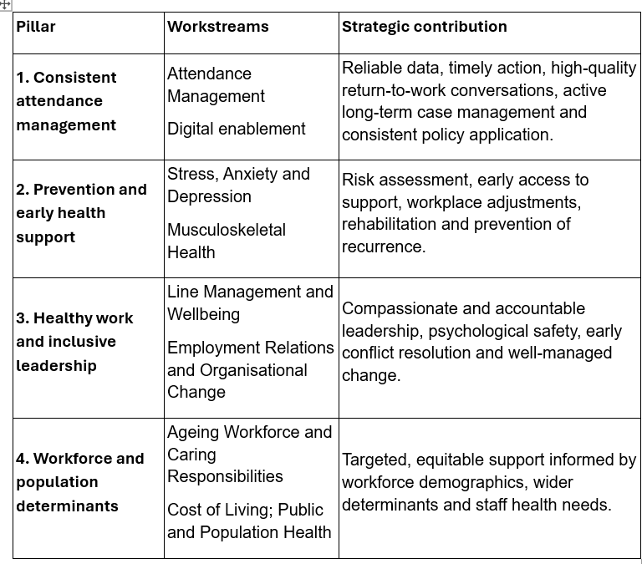

Governance, Delivery and Accountability
The Executive Director of Workforce and OD will act as Senior Responsible Owner, supported by an executive programme board with operational, workforce, finance, occupational health, public health, digital, staff-side and equality representation. Service Group triumvirates will own local delivery and benefits. Progress will be reported monthly to the Executive Team, quarterly to the Workforce and OD Committee, and to the Board through the integrated performance framework. Material risks will be linked to the Board Assurance Framework and escalated through existing performance arrangements.

Action plan for delivery
Confirm and implement model for sickness absence reduction | Oct  2026 | Executive Director of Workforce and OD with Service Group Directors | Define trajectories in place with monthly reporting by Service Group and cost-centre category
Procure digital attendance management tool | Oct 2026 | Executive Director of Workforce and OD & Head of delivery Unit | Project management plan and evaluation.
Undertake scoping for central absence reporting team | Oct 2026 | Executive Director of Workforce and OD | Scope evidence base for centralised reporting absence management team and pilot
Complete review of all priority long-term sickness absence cases | Oct/ Nov 2026 | HR Business Partners with Service Group leadership teams | priority cases classified with clear next actions, barriers, assurance rating and escalation route.
Implement strengthened short-term sickness review and core controls | Dec 2026 | Service Group Directors and line managers, supported by Workforce and OD | Return-to-work compliance, sickness tracker completion and trigger management reported monthly.
Launch targeted stress, wellbeing and musculoskeletal prevention interventions in hotspot areas | Dec 2026 | Occupational Health and Staff Wellbeing with Service Group leadership teams | Evidence of interventions in the highest-risk areas and reporting on uptake, impact and barriers.
Provide Board update on delivery, impact and residual risk against March 2027 breakthrough objective | Jan 2027 | Executive Director of Workforce and OD | Board receives trajectory, assurance rating, benefits assessment and recommended next phase.

Other considerations related to the programme:
- Rapid access to treatment: explore faster access to physiotherapy, diagnostics, talking therapies and selected planned care where delayed treatment is prolonging absence, subject to clear clinical and equality criteria.
- Stay-at-work service: provide early self-referral and manager-referral support for staff at risk of absence, combining rapid functional assessment with a personalised support plan.
- Complex-case multidisciplinary panels: introduce time-limited reviews for prolonged or complex cases involving managers, Workforce, Occupational Health and relevant clinical expertise, with agreed decision points and escalation routes.
- Return-to-work coordination: assign a named coordinator for selected long-term cases and use individual plans covering duties, hours, adjustments, reviews and relapse prevention.
- Reasonable-adjustment passport: create a portable record of agreed adjustments to support individuals if they transfer to other departments within the Health Board. This will also include transfer of specialist equipment.
- Healthy roster and fatigue review: examine consecutive shifts, night work, overtime, missed breaks, annual leave and short-notice changes in priority services.
- Post-incident recovery protocol: establish consistent follow-up after violence, trauma, serious incidents or difficult employee-relations processes, including immediate support, delayed check-in and escalation where required.
- Hotspot team recovery interventions: undertake short diagnostic reviews of workload, vacancies, leadership, rostering, conflict, facilities and staff experience, followed by co-designed 90-day recovery plans.
- Manager practice accreditation: assess managers’ ability to apply policy, hold supportive conversations, assess work-related stress and implement adjustments, rather than relying on training attendance alone.
- Independent case-quality audits: sample cases quarterly to test timeliness, quality of contact, adjustment consideration, equality compliance and employee experience.
- Return-to-work experience measure: use a short confidential survey following return to identify themes and variation by service and workforce group.
Key Governance Risks
The principal risks requiring Board oversight are:
- Continued high absence affecting workforce availability, service delivery, quality and financial performance.
- Organisational change, workforce shortages and workload pressures increasing stress, conflict and absence.
- Variable management capability leading to inconsistent early intervention, staff experience and policy application.
- Stress-related and musculoskeletal absence remaining persistently high despite targeted support.
- Wider health, demographic and environmental factors limiting the impact of attendance-management measures alone.

Mitigating Actions
Mitigation will be delivered through the four programme pillars, phased implementation, Service Group recovery plans, strengthened leadership and management practice, targeted health interventions, improved data and regular executive and Board assurance.

- OPEN AUDIT RECOMMENDATIONS
Any open audit recommendations relating to attendance management, workforce data, occupational health or managerial compliance will be mapped into the programme during mobilisation. Internal Audit should be invited to advise on the assurance framework and, if appropriate, undertake a follow-up review once controls are embedded.

- FINANCIAL IMPLICATIONS
Sickness absence continues to have a major financial impact through lost productivity, temporary staffing, service disruption and management time. Workforce Dashboard data estimates sickness absence cost the Health Board £41.7 million between August 2025 and July 2026. This represents a significant opportunity cost. A 1% reduction in sickness absence could save around £5.96 million annually, while a 2% reduction could release approximately £11.9 million, alongside increasing workforce capacity and service resilience.
A financial baseline and benefits-realisation plan will be developed during mobilisation of the above programme of work, covering intervention costs, productive time recovered and reductions in bank and agency spending. Existing resources will be prioritised and any requirement for additional investment, such as digital solutions or clinical support, will be subject to a separate business case and affordability assessment, including equality impacts and expected return on investment.

- RECOMMENDATION
Members are asked to:
- CONSIDER the work undertaken to date reducing sickness absence and improving attendance management arrangements.
- RECEIVE ASSURANCE that a comprehensive programme of work is in place addressing both attendance management and wider organisational determinants of absence.
- APPROVE the proposed strategic workstreams and cross-organisational approach to improve staff wellbeing and reduce sickness absence.

Governance and Assurance
Strategic Objectives
Strategic Objectives  (please choose which is impacted) | People of Swansea Bay live healthier, fairer and more prosperous lives | ☒
Strategic Objectives  (please choose which is impacted) | Care is high quality, safe, efficient and delivers the best possible outcomes for people in partnerships | ☐
Strategic Objectives  (please choose which is impacted) | Care is delivered in partnership with our communities in safe and appropriate setting, supported by innovation | ☐
Strategic Objectives  (please choose which is impacted) | The health board is a great place to work where staff feel valued and work together towards a common goal | ☒
Strategic Objectives  (please choose which is impacted) | The health board is a resilient, sustainable and responsible organisation | ☐
Health and Care Standards
Standards (please choose which applies) | Safe Care | ☐
Standards (please choose which applies) | Timely Care | ☐
Standards (please choose which applies) | Effective Care | ☐
Standards (please choose which applies) | Efficient Care | ☐
Standards (please choose which applies) | Equitable care | ☐
Standards (please choose which applies) | Person-centred Care | ☐
Standards (please choose which applies) | Staff and Resources | ☒
Enablers (please choose which applies) | Whole Systems Approach | ☐
Enablers (please choose which applies) | Leadership | ☒
Enablers (please choose which applies) | Workforce | ☒
Enablers (please choose which applies) | Culture | ☒
Enablers (please choose which applies) | Information | ☐
Enablers (please choose which applies) | Learning, Improvement and Research | ☐
Quality, Safety and Patient Experience
Reducing sickness absence and strengthening workforce wellbeing will improve workforce availability, continuity of care and team stability, supporting safer and high-quality services/outcomes for patients.

Financial Implications
As explained in the paper
Legal Implications (including equality and diversity assessment)
The recommendations within this report support the Health Board's statutory responsibilities to provide a safe working environment, promote employee health and wellbeing, manage attendance fairly and consistently and comply with relevant employment, health and safety, equality and data protection legislation
Staffing Implications
This report has significant workforce implications, as reducing sickness absence and improving attendance at work will increase workforce availability, reduce pressure on teams, improve continuity of service delivery and support the Health Board's ability to meet operational demands.
Long Term Implications (including the impact of the Well-being of Future Generations (Wales) Act 2015)
This report supports the Well-being of Future Generations (Wales) Act 2015 by adopting a long-term, preventative and collaborative approach to reducing sickness absence and improving workforce wellbeing. The proposed actions focus on addressing the root causes of absence, strengthening leadership and management capability, improving staff health and wellbeing, and enhancing organisational resilience to deliver sustainable benefits for the workforce, patients and the wider Health Board.
The report demonstrates the Five Ways of Working through:
- Long-term: Focusing on sustainable reductions in sickness absence by addressing workforce health, organisational culture, leadership capability and workforce wellbeing rather than solely attendance management processes.
- Prevention: Investing in early intervention, Occupational Health, Staff Wellbeing services, mental health support and preventative initiatives to reduce future absence and improve workforce resilience.
- Integration: Aligning attendance improvement activity with the Organisational Strategy, People Strategy, Annual Plan, workforce wellbeing objectives and service delivery priorities.
- Collaboration: Promoting partnership working across Workforce, Occupational Health, Staff Wellbeing, Public Health, Staff-side representatives and operational services to address the wider determinants of attendance.
- Involvement: Utilising staff survey findings, workforce intelligence, focus groups and employee feedback to ensure that improvement actions are informed by staff experience and organisational need.
Collectively, these approaches support the Health Board's contribution to a healthier, more resilient workforce and the wider wellbeing goals for Wales.
Report History
Annual report to Board.
Appendices
None

