Meeting Date | 24 September 2026 | Agenda Item | 5.5i
Name of Meeting | SBUHB Board
Report Title | Perinatal Committee Report
Report Author | Kathyrn Greaves – Director of Midwifery  Sujoy Banerjee – Associate Service Group Medical Director - CYPWH
Report Sponsor | Executive Director of Nursing and Patient Experience
Presented by | Elizabeth Rix, Executive Director of Nursing and Patient Experience
Freedom of Information | Open
FoI Closed detail | If closed, choose detail
Impact Assessment Summary Outcome |  | IA Completion date
The report demonstrates continued progress in strengthening governance, quality, safety and patient experience across maternity and neonatal services. Robust assurance arrangements remain in place, with no immediate patient safety concerns identified. Residual risks relating to workforce sustainability, specialist capacity and digital transition continue to be actively managed through established governance structures. The Committee can take moderate assurance that effective controls, improvement programmes and mitigation plans are in place to support ongoing quality and service resilience. |  | 18 August 2026
Purpose of the Report | For Assurance
Report Summary; detailing any action required
The Health Board recognises that every woman, birthing person, baby and family using our perinatal services deserves consistently safe, high-quality and compassionate care.
While most experiences are positive, we are acutely aware that even a single instance where care falls short is one too many. This report is therefore grounded in a commitment to transparency, learning and improvement, ensuring that every voice and every experience continue to shape and strengthen our service.
The purpose of the paper is to provide the Board with an update from the Perinatal Committee providing assurance and information relating to the risks to quality, safety, and patient experience in maternity and neonatal services, with escalation of any key areas of concern.

The August Perinatal Committee report provides an update on quality, safety, patient experience, workforce, governance and service sustainability using July 2026 data. The service continues to operate safely with robust governance arrangements in place, although residual risks remain in relation to workforce sustainability, specialist capacity, digital reporting transition and timeliness of complex review processes. Positive assurance is demonstrated through maintained service delivery, strong training compliance across most staff groups, effective infection prevention controls, structured incident and mortality review processes, active patient engagement and mature risk oversight.
Key Issues
Perinatal Services continue to provide safe care with robust governance, quality assurance and improvement arrangements in place across maternity and neonatal services. July performance demonstrates positive assurance in relation to infection prevention and control, statutory and mandatory training compliance, mortality review processes, patient experience activity and risk oversight. The service remains focused on learning, continuous improvement and the delivery of safe, compassionate and evidence-based care.

The Committee should note that several risks remain under active management, primarily relating to workforce sustainability, specialist service capacity, timeliness of some review processes and the ongoing transition to BadgerNet reporting. Whilst mitigating actions are in place and services continue to operate safely; these risks require continued oversight through established governance and escalation arrangements.

Overall, the Committee can take moderate assurance that effective controls are in place, key risks are understood and actively managed, and improvement activity continues across all domains of the Perinatal Quality and Safety Framework.
Decision / Action required | Yes, Impact Assessment included
Recommendations
Members are asked to:

BE ADVISED THAT;
- Perinatal Services continue to provide safe care within a context of ongoing workforce fragility, specialist capacity constraints, digital transition and wider system dependencies.
- July 2026 data demonstrate areas of positive assurance, including maintained service delivery, strong training compliance across most workforce groups, effective infection prevention arrangements and active governance oversight.
- Digital reporting remains in transition following BadgerNet implementation, and some metrics should continue to be interpreted with caution while data validation and reporting optimisation are completed.
BE ASSURED THAT;
- Governance arrangements remain in place across maternity and neonatal services, with incident review, mortality review, patient experience, risk management and improvement activity monitored through established structures.
- Infection prevention and control performance remains strong, with no reported C. difficile, E. coli, Staphylococcus aureus or Pseudomonas bacteraemia cases in July across maternity and neonatal services.
- Patient feedback continues to be actively reviewed and used to inform service improvement, with positive feedback evident alongside clear themes for improvement.
- The proposed serial growth scan pathway would preserve enhanced surveillance for women and babies with identified or emerging clinical concerns.
BE ALERTED TO;
- Ongoing workforce sustainability risks across maternity, neonatal nursing and neonatal medical rotas.
- Ongoing specialist service risks, including paediatric radiology support, MoNET training, neonatal transport and sonography capacity.
- Review timeliness pressures in relation to incidents, ATAIN reviews, PMRT reports and concerns where external dependencies or senior approval are required.
- The need to maintain careful oversight of digital data quality during the transition to BadgerNet-enabled reporting.

The service continues to provide safe, compassionate and high-quality care, with no immediate safety concerns identified, and a strong focus on continuous improvement.

PERINATAL COMMITTEE REPORT

- INTRODUCTION
The Health Board recognises that every woman, birthing person, baby and family using our perinatal services deserves consistently safe, high-quality and compassionate care.
While most experiences are positive, we are acutely aware that even a single instance where care falls short is one too many. This report is therefore grounded in a commitment to transparency, learning and improvement, ensuring that every voice and every experience continue to shape and strengthen our service.
This report is intended to provide assurance and information relating to the risks to quality, safety, and patient experience in maternity and neonatal services, with escalation of any key areas of concern.

- BACKGROUND

The Perinatal Committee was established in June 2025, to provide assurance to the Board that an evidence based, quality assured, safe, and sustainable service for women, people and babies receiving maternity and neonatal care at Swansea Bay University Health Board.

This report marks the first anniversary of the Perinatal Committee and the establishment of a strengthened ward-to-Board reporting model. Together, these have delivered a step-change in governance, improving visibility, multidisciplinary oversight, and timely escalation of risk.

Over the past year, the Committee has matured into a key assurance forum, strengthening data transparency, supporting shared learning, and enabling more responsive decision-making. The ward-to-Board approach has ensured that the voices of staff, women and families are reflected at executive level, reinforcing a culture of openness, safety and continuous improvement.

This milestone reflects meaningful progress and provides a strong foundation for continued development aligned to national standards and organisational priorities.

The Perinatal Committee reports directly into Quality and Safety Committee and noted via Service Group Quality, Safety & Risk Group and Senior Leadership Team.

Perinatal Committee and Perinatal Improvement Programme Board reporting are aligned to ensure complementary oversight; business-as-usual performance and improvement delivery are reported through respective routes, with shared visibility to Executive and Board to support robust governance and assurance.
- GOVERNANCE AND RISK ISSUES

Key updates from Perinatal Committee
As previously agreed, the following measures are some of the high-level information we review within our perinatal committee.

Data quality note: Following implementation of the BadgerNet Electronic Patient Record system in May 2026, further progress has been made in validating performance metrics and strengthening reporting arrangements. Some indicators continue to require quality assurance and reconciliation whilst reporting systems mature. Existing governance and operational oversight arrangements remain in place to provide assurance during this transition period.

Summary
Theme | Position | Assurance | Rationale
Clinical Outcomes | Stable | Moderate | Strong clinical outcomes are demonstrated across available indicators. Assurance is moderated by the limited availability of national benchmarking data for some metrics; however, local trend analysis and governance oversight provide confidence in performance.
Safety & Governance | Stable | Moderate | Robust governance arrangements operating effectively; some review timeliness and audit actions remain.
Experience & Engagement | Improving | Moderate | Strong engagement and improvement mechanisms in place; ongoing themes continue to require monitoring.
Workforce & Training | Stable with Risks | Moderate | Training compliance is positive; workforce sustainability and specialist capacity remain strategic risks.
Quality Improvement | Improving | Moderate | Improvement programmes are progressing well, but benefits continue to be realised and embedded.
Digital Transformation | Progressing | Moderate | Successful implementation of BadgerNet, with ongoing work required to achieve full reporting maturity.

The Perinatal Committee can provide Moderate Assurance across maternity and neonatal services. Evidence demonstrates that governance arrangements, quality management systems, risk management processes and improvement programmes are operating effectively and continue to support safe care delivery. Positive assurance is demonstrated through favourable clinical outcomes, robust mortality and incident review processes, effective infection prevention controls, active patient engagement and sustained quality improvement activity.

Residual risks remain in relation to workforce sustainability, specialist workforce capacity, sonography provision, digital reporting maturity and the timeliness of some review processes. These risks are well understood, subject to active mitigation and regularly monitored through established governance structures. The Committee is satisfied that current controls are appropriate and effective, but further improvement activity is required before Significant Assurance could reasonably be claimed.

Understanding the Assurance Levels
The Perinatal Committee has adopted a structured assurance methodology informed by the Healthcare Improvement Scotland Assurance Framework. Assurance ratings are assigned based on the strength of evidence available, the effectiveness of controls in place, and the level of residual risk remaining after mitigation.

Assurance Level | What this means
Significant Assurance | Strong evidence from multiple sources demonstrates that systems and controls are achieving their intended purpose. Any residual risks are low and do not materially affect delivery of safe, effective services.
Moderate Assurance | Controls are operating effectively and key risks are understood and actively managed. However, residual risks remain that require ongoing monitoring, mitigation and reporting.
Limited Assurance | Some controls are in place, but significant gaps, weaknesses or unresolved risks remain. Further action and closer oversight are required.
No Assurance | There is insufficient evidence to demonstrate that controls are effective or that risks are managed appropriately. Immediate action is required.

3.1 Number of births, caesarean section births, and Surgical Site Infection rates

What are we measuring?
The proportion of babies born by planned and emergency caesarean section. Monitoring birth mode helps us understand clinical complexity, women's choices and service demand.
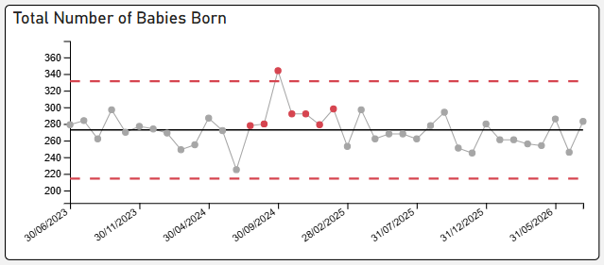
July Birth rate
277 Women gave birth.
284 Babies were born.

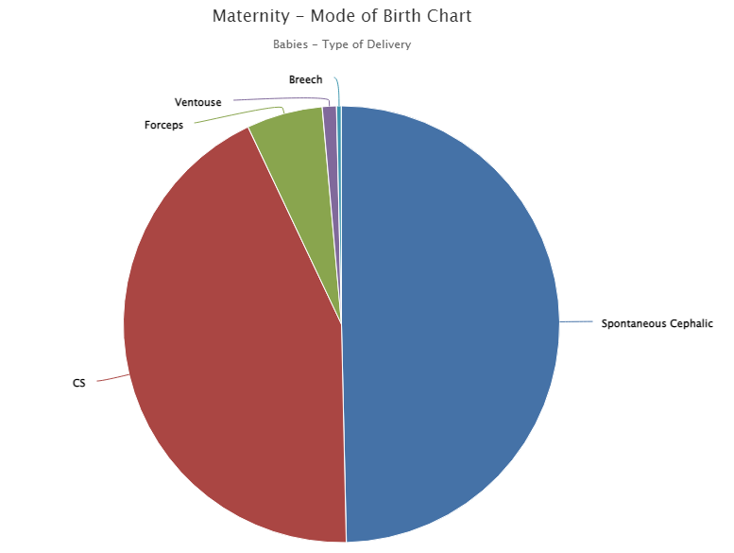
16
5.6%
141
49.6%
123
43%
1
3
N.B. At this time we are unable to split the cesaerean section data by planned and unplanned until validation of Badger data has completed. Expected by end of August 2026.

How are we performing?
The Health Board's overall caesarean section rate is 43%, which is consistent with national trends showing increasing rates of planned caesarean birth across the UK. Emergency caesarean section rates remain in line with national expectations. Following implementation of the BadgerNet electronic patient record, there is a temporary pause in the publication of some dashboard metrics whilst data mapping, validation and reporting processes are refined. This reflects the complexity of the new dataset and the transition from legacy systems to a digital platform. Work is progressing at pace with Digital colleagues to restore full reporting capability and provide assurance that future metrics accurately reflect service activity, demand, capacity, quality and outcomes. In the interim, existing governance arrangements and local monitoring processes remain in place to support operational oversight and risk management.

What are we doing to improve?
A dedicated Caesarean Section Working Group is overseeing capacity, reviewing pathways and developing a new BadgerNet-enabled booking system to support informed choice, improve planning and strengthen safety.

Board Assurance
The service continues to monitor birth choices, clinical outcomes and theatre capacity closely, with no immediate safety concerns identified.

3.2 Surgical Site Infection:

What are we measuring?
Surgical site infections following caesarean birth.
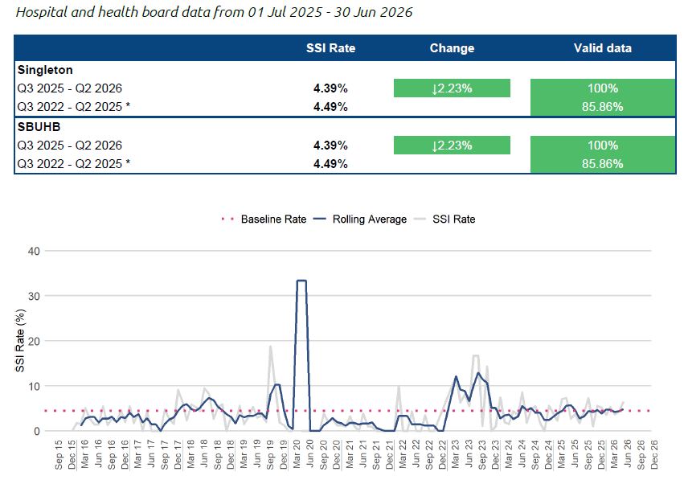
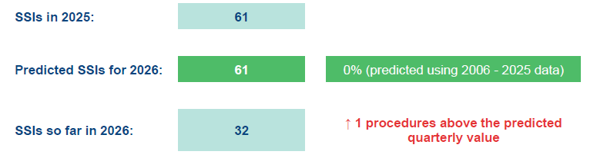
How are we performing?
Infection rates remain low and overall infection prevention performance across maternity and neonatal services remains strong. No cases of C. difficile, E. coli, Staphylococcus aureus or Pseudomonas bacteraemia were reported during this period.

What are we doing to improve?
Work has focused on improving infection surveillance, strengthening referral pathways and standardising infection reporting processes.

Board Assurance
Robust infection control measures are in place, with ongoing monitoring and learning supporting safe care delivery.
3.3 Induction of Labour delays
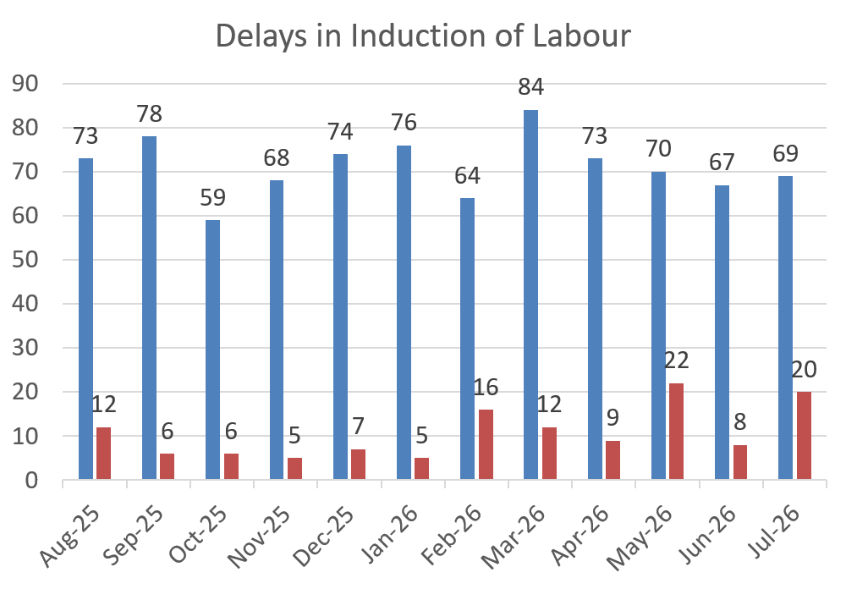
What are we measuring?
The number of women who experience delays when induction of labour is planned.

How are we performing?
A small number of induction delays continue to occur, usually during periods of high clinical demand. No reported delays during this period resulted in clinical harm or incidents.

What are we doing to improve?
The service continues to review delays, improve risk assessment processes and strengthen patient flow across maternity services. Learning from incidents and feedback is informing ongoing improvement work.

Board Assurance
Delays are actively monitored and managed, with senior oversight and escalation processes in place to maintain safe care.

3.4 Extended Perinatal Mortality and Morbidity
All stillbirths, late fetal losses and neonatal deaths are reported to MBRRACE-UK, ensuring robust national surveillance and benchmarking of perinatal outcomes. Each case undergoes detailed internal review, and where appropriate, external scrutiny via the Perinatal Mortality Review Tool (PMRT). This supports identification of modifiable factors, strengthens organisational learning, and enables meaningful engagement with families, who are offered the opportunity to contribute to the review process with a dedicated point of contact.

We recognise that the loss of a baby has a profound and lasting impact on women, families and staff, and remain committed to providing compassionate care alongside robust, safe clinical services that seek to minimise harm and prevent avoidable loss wherever possible.

The most recent published MBRRACE data demonstrates an improving position. The crude perinatal mortality rate reduced from 7.49 per 1,000 births in 2023 to 5.73 per 1,000 births in 2024. The stabilised and adjusted rate for 2024 is 5.46 per 1,000 births, which is in line with the average for comparable UK organisations, indicating a stable and benchmarked performance.

There is no new national data available for this reporting period. MBRRACE reports are published on a lag basis, with 2025 birth data expected in Quarter 3/4 of 2026/27. In the interim, local surveillance and PMRT processes continue to provide ongoing oversight, assurance, and opportunities for continuous learning and improvement.

3.4.1 Stillbirths from January 2026

The service recognises that the death of a baby is a deeply devastating and life-changing experience for women, families, and the staff who care for them. We remain committed to providing compassionate, personalised support while ensuring robust, safe clinical services that seek to minimise harm and prevent avoidable loss wherever possible.

What are we measuring?
Stillbirths and neonatal deaths, alongside learning from reviews of each baby's care.

How are we performing?
Nationally reported data shows the Health Board's perinatal mortality rates remain in line with comparable organisations and have improved over recent years. Between January and June 2026, three stillbirths and four neonatal deaths were reported, of which two were inborn (babies born in Swansea) which is expected for a service of this size and complexity. The Health Board stillbirth crude rate for 2025 is 3.7 per thousand births and our 12-month rolling crude rate (August 2025 – July 2026) is 2.6 per 1000 births. 2025 crude Neonatal death rate 1.23/1000 and rolling crude 12-month crude rate is 1.63 per 1000 births. Routine validation of mortality data remains ongoing. As a result, the reported 12-month crude mortality rate remains provisional and may be subject to revision following completion of the data assurance process.

Every case undergoes detailed multidisciplinary review, and families are supported throughout the process.

What are we doing to improve?
Learning from reviews continues to strengthen care through improved fetal growth surveillance, escalation of maternal deterioration and clinical decision-making. Computerised fetal monitoring and enhanced training have also been introduced. Whilst limitations in external participation within clinical reviews are recognised across Wales, the Health Board continues to actively pursue opportunities to strengthen externality through collaboration with regional and national partners. This remains an important area of development to support robust assurance, independent challenge and continuous improvement.

Board Assurance
The service remains committed to compassionate family engagement, robust investigation and continuous learning to reduce avoidable harm.

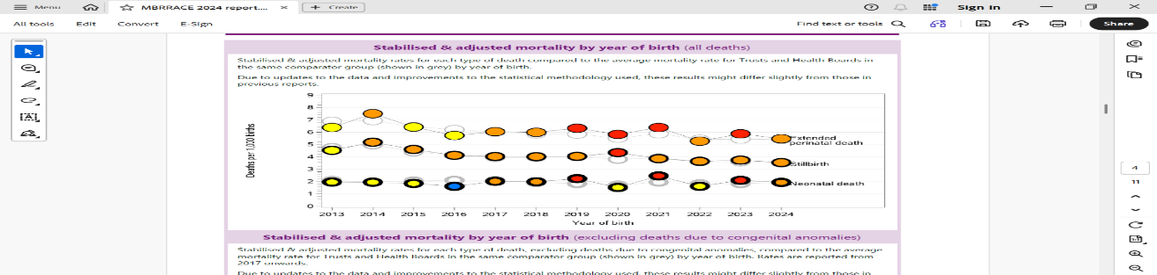
Figure: 11 year running stabilised and adjusted mortality rates for SBUHB including latest published year 2024. Note SBUHB separated from POW in in 2019 resulting in reduction in births attributable to SBUHB (Data source MBRRACE UK)

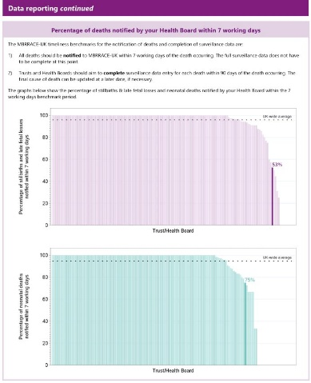
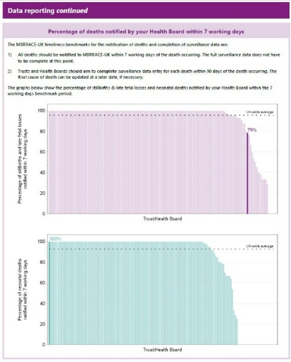

2023 2024
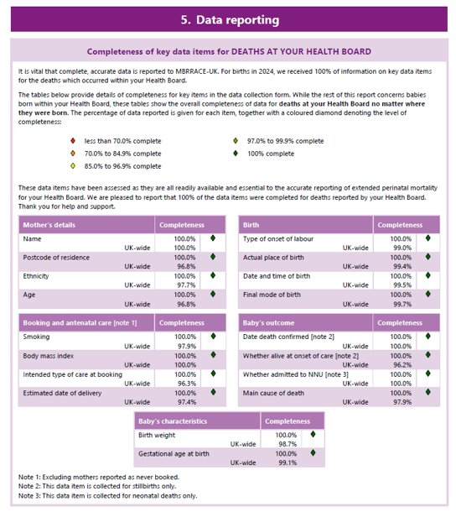
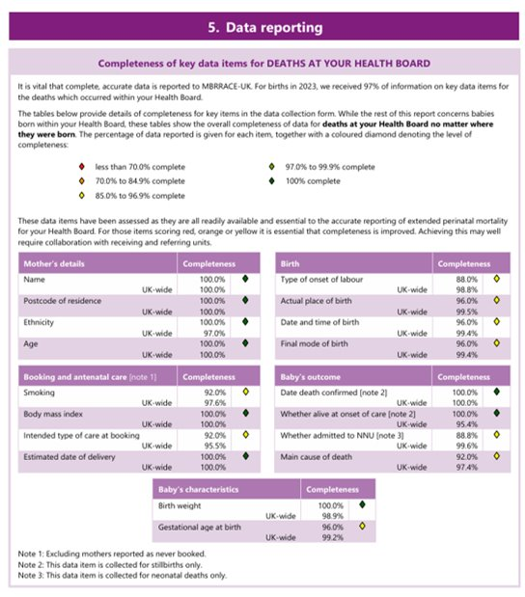

3.5 Hypoxic-Ischemic Encephalopathy (HIE) from January – December 2025

What are we measuring?
Hypoxic-Ischaemic Encephalopathy (HIE) is a rare but serious condition caused by reduced oxygen supply to a baby around the time of birth. Monitoring HIE helps us understand how effectively we identify and respond to babies who may be at risk during labour and birth.

How are we performing?
Incidence of moderate and severe hypoxic ischaemic encephalopathy (HIE) has remained low during 2026 to date, with ongoing review through established governance processes.

The Health Board's rolling 12-month HIE rate has reduced significantly over the past two years and remains below previously reported national rates, demonstrating sustained improvement in this important safety measure.

What are we doing to improve?
Every case of HIE is reviewed through a multidisciplinary process to identify learning and improvement opportunities. Learning from previous reviews has led to the implementation of computerised CTG monitoring, enhanced fetal surveillance training, and strengthened escalation processes to support the early recognition of fetal compromise and timely decision-making in labour.

Board Assurance
Learning continues to be translated into practice through targeted safety improvements, with ongoing monitoring and oversight supporting the delivery of
safe, high-quality maternity care.

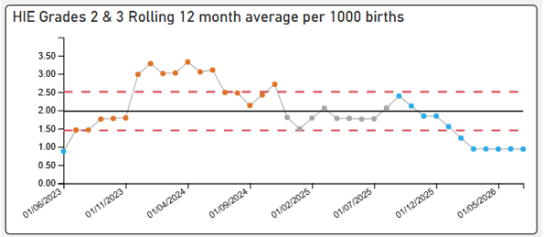
HIE IN 2026
As observed, there are 8 plots below centre line of 2.1 therefore showing a SHIFT in data. This is a strong example of non-random variation; suggesting the system is being influenced by something other than just common cause.
This data is not impacted by implementation of Maternity BadgerNet
Monitoring will continue
HIE 2 and 3 rolling 12-month average – 0.94/1000

The absolute 2025 HIE rate (Jan-December)
were 1.68/1000 births.

3.6 Triage Metrics

What are we measuring?
We monitor how quickly women are assessed when they contact or attend maternity triage services. Timely assessment is important to ensure women receive the right advice, care and treatment when they need it.

How are we performing?
Since implementation in November 2024 our BSOTS compliance for initial review has been stable at or above the performance criteria of >90%. Demand for triage services remains high and attendance levels are stable. Most women continue to be assessed within the expected timeframe, 77% of women met the 15-minute triage standard in June 2026. This is understood to reflect a combination of operational pressures, increased demand associated with the Single Point of Access model, and the transition to BadgerNet digital reporting. June represents the first full month of reporting through BadgerNet, and ongoing data validation work is underway. The service has recognised and escalated these challenges, with targeted operational and digital actions in place to improve performance oversight, data quality and timely access to care.

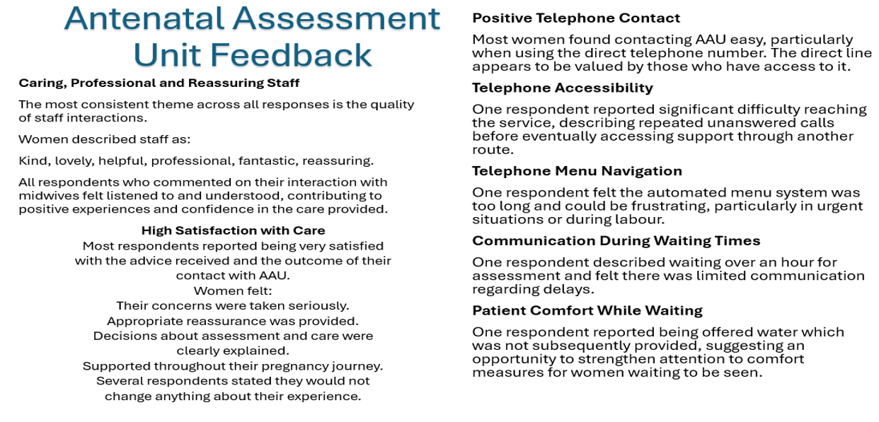

What are we doing to improve?
The service has introduced a single point of telephone access for maternity care, making it easier for women to access advice and support. Work is ongoing to improve call handling capacity, strengthen digital reporting, validate data quality and better understand demand across the service. Feedback from women and families is also being used to inform service improvements.

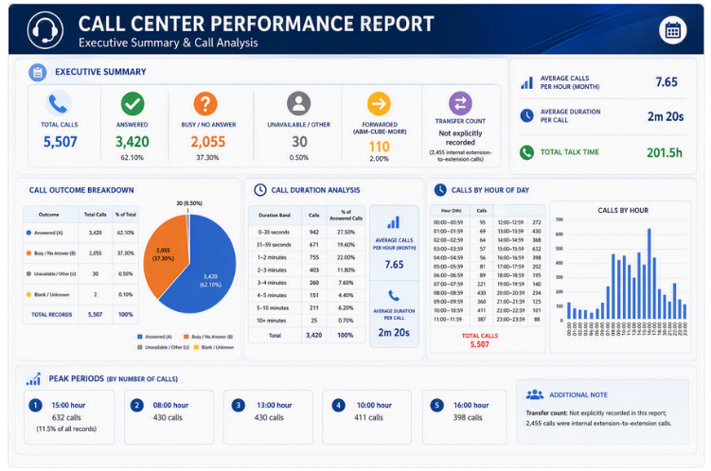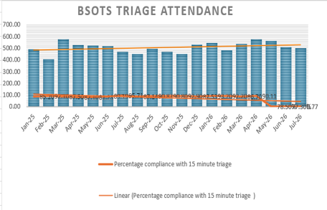
Board Assurance
Maternity triage services continue to provide safe and timely assessment of women, supported by robust clinical oversight, improved access arrangements and ongoing service improvement activity.
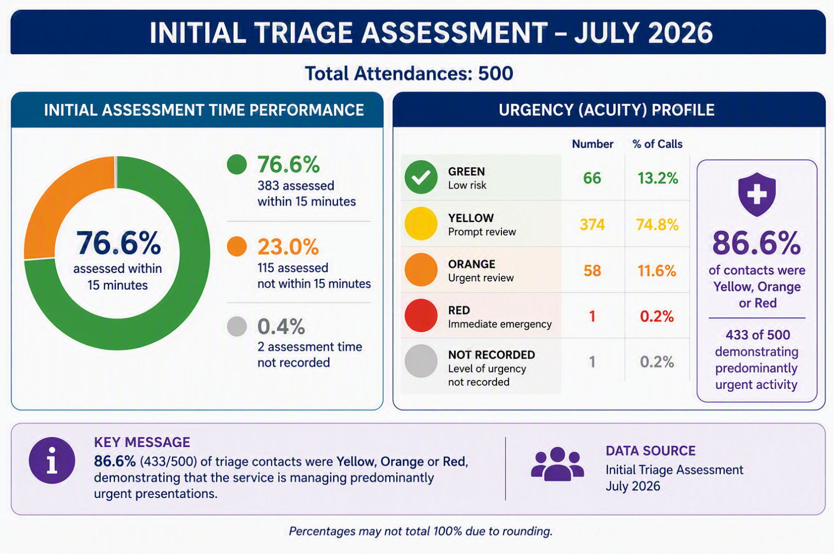
3.7 Third and fourth-degree tears

What are we measuring?
We monitor severe perineal tears that can occur during vaginal birth. These injuries can have a significant impact on a woman's physical recovery and wellbeing, making prevention, early identification and treatment important measures of maternity care quality.

How are we performing?
Performance remains within the expected national range and has improved compared to the previous year. The Health Board's rate in 2025 was 3.37%, compared with 4.08% in 2024, and remains consistent with national benchmarking data. Recent variation is within normal expected limits and there are no current concerns regarding performance.

What are we doing to improve?
The service continues to review all severe tears and monitor trends through the Maternity Dashboard. Audit work focuses on births associated with a higher risk of perineal trauma, including instrumental births, to support learning and identify opportunities for improvement. The services compliance with PROMPT training for these births remains at or above expected compliance rates. The introduction of BadgerNet will provide enhanced data analysis, helping the service better understand risk factors and target improvement activity.

Board Assurance
Performance is improving and remains in line with national expectations. Ongoing monitoring, audit and quality improvement work provide assurance that risks are identified early, and learning is translated into practice.

3.8 Postpartum Haemorrhage

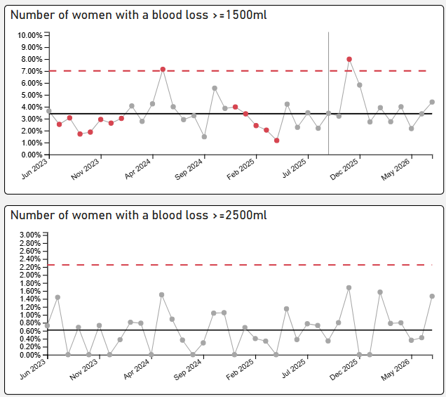
​The NMPA published 2023 data for National benchmarking and reported postpartum haemorrhage incidence as 3.41/1000 births (2.98-3.79). SBUHB rate for postpartum haemorrhage in 2025 was reported as 2.49/1000 births, lower than the National benchmark. This showed a steady reduction from 2024 data, of 3.51/1000 births.
July 2026 – PPH >1500ml rate is 4.41% and PPH >2500ml is 1.47%

What are we measuring?
We monitor cases of significant bleeding following birth, known as postpartum haemorrhage (PPH). This is an important measure of maternity safety as severe bleeding can have a significant impact on a woman's recovery and, in rare cases, can become life-threatening if not recognised and treated promptly.

How are we performing?
Performance remains favourable when compared with national benchmarks. The Health Board's postpartum haemorrhage rate reduced from 3.51 per 1,000 births in 2024 to 2.49 per 1,000 births in 2025, which is below the latest published national rate. During this reporting period, all identified cases were reviewed and managed appropriately, with no concerns identified regarding the quality of care provided.

What are we doing to improve?
All cases of significant postpartum haemorrhage continue to be reviewed through established multidisciplinary governance processes to identify learning opportunities and support continuous improvement. Ongoing monitoring, clinical surveillance and the transition to enhanced digital reporting through BadgerNet will strengthen oversight and support further improvements in the quality and reliability of data.

Board Assurance
The service continues to demonstrate safe management of postpartum haemorrhage, with performance remaining below national benchmarks and robust monitoring, review and assurance arrangements in place.
Performance remains within expected variation and below national benchmarks; robust oversight continues during data transition, with no immediate safety concerns identified.

3.9 Maternal Intensive Care Unit (ICU) Admissions

What are we measuring?
We monitor the number of women who require admission to an Intensive Care Unit (ICU) or other higher-acuity care settings during pregnancy or after birth. This helps us understand the severity of maternal illness and provides assurance that women who become seriously unwell receive timely specialist care.

How are we performing?
Maternal intensive care admissions remain rare. There have been no maternal ICU admissions since September 2024. One recent admission following caesarean birth and significant postpartum haemorrhage was managed appropriately, with established escalation and clinical care processes followed throughout.

What are we doing to improve?
The service maintains clear pathways for identifying and escalating women who require higher levels of care, supported by close collaboration between maternity, intensive care and emergency care teams. All admissions are reviewed through established governance processes to identify learning and ensure continuous improvement. Real-time monitoring arrangements provide additional oversight of women receiving care outside maternity services.

Board Assurance
Robust joint SOP embedded in practice, escalation pathways, effective multidisciplinary working and strong governance arrangements provide assurance that women requiring critical care receive safe and timely treatment, with no immediate concerns identified.

3.10 Learning from Safety Incidents

What are we measuring?
Safety incidents, investigations, learning outcomes and implementation of improvement actions.

How are we performing?
Incident reporting continues to demonstrate a positive culture of openness and learning. Governance processes remain robust and there has been continued improvement in the review and closure of incidents.
Learning themes remain broadly consistent with previous reporting and relate to communication, escalation, clinical documentation, care pathway compliance and service pressures.

What are we doing to improve?
Learning continues to be disseminated through governance forums, safety huddles, multidisciplinary reviews, professional leadership meetings and education programmes. Improvement actions are monitored through established governance processes to ensure sustainable practice change.

Board Assurance
The Committee can be assured that incidents continue to be identified, reviewed and acted upon appropriately, with evidence of learning being translated into service improvement.

Perinatal DoC cases – as of 01.06.2026

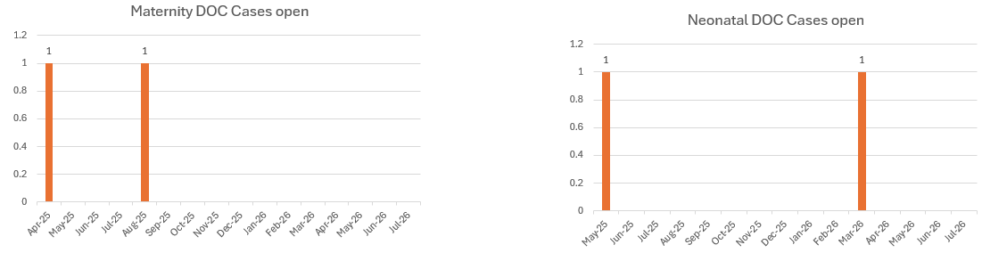
A further break down of incidents in relation trigger categories can be seen in the chart below:

Types of incidents – Perinatal Services – 01/05/26 -31/05/2026
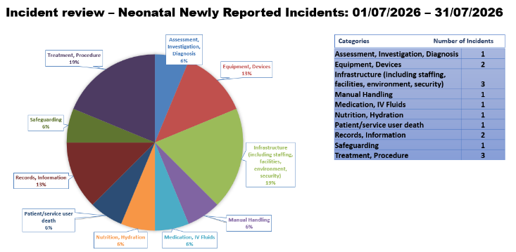
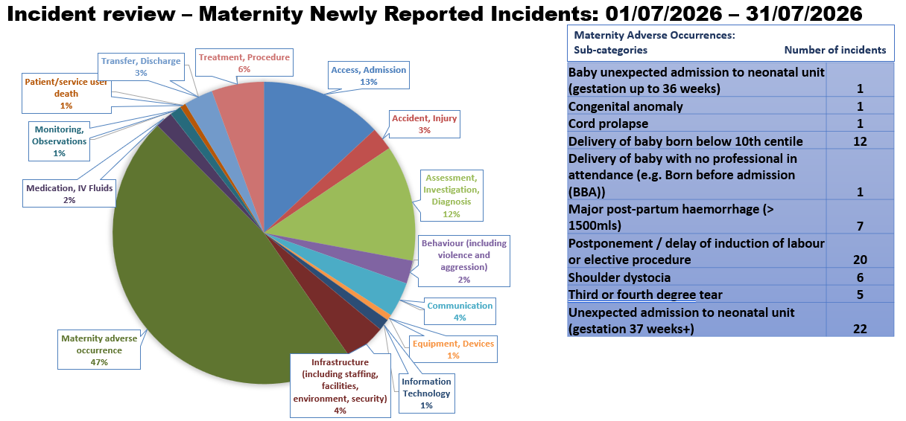

3.11 Patient Feedback and Experience

Patient Feedback and Experience

What are we measuring?

Feedback from women, families and partners regarding their experiences of maternity and neonatal care.

How are we performing?
Overall patient feedback remains positive, with women and families consistently describing care as compassionate, professional and supportive.
Themes identified through patient feedback continue to relate to communication, waiting times, induction of labour experience, postnatal care and access to services.

What are we doing to improve?
A coordinated patient experience improvement programme remains in place with actions linked to feedback themes. Work continues through the Maternity Experience Action Plan, community engagement activity and targeted service improvement initiatives.

Board Assurance
The service continues to actively seek, listen to and respond to feedback, ensuring that the voices of women and families directly influence service development and improvement.
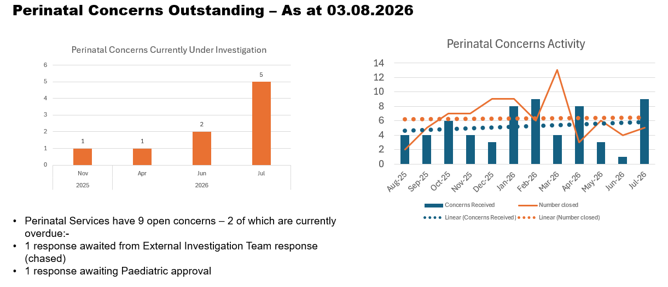
3.11.1 Engagement with Diverse Communities – Maternity Services

What are we measuring?
How well maternity and neonatal services listen to, understand and respond to the needs of people from all communities, particularly those who may experience poorer outcomes or barriers to accessing care.

How are we performing?
Partnerships with community organisations continue to grow, helping the service engage with a broader and more diverse range of women and families. Feedback from communities is increasingly informing service development, with improvements in accessibility, representation and inclusive care approaches.

What are we doing to improve?
The service is expanding engagement with underrepresented communities, strengthening culturally responsive care, improving access to information and developing targeted initiatives to support inclusion. This work is helping to ensure that services are designed with, rather than for, the communities they serve.

Board Assurance
The service demonstrates a strong commitment to reducing inequalities and improving equity of access, experience and outcomes, supported by meaningful engagement, co-production and ongoing improvement activity.

3.11.2 Equity, Inclusion and Community Engagement

What are we measuring?
How effectively we engage with diverse communities, partners and families to ensure maternity and neonatal services are inclusive, representative and shaped by lived experience.

How are we performing?
Engagement activity has continued to expand, with new and strengthened partnerships helping to ensure a broader range of voices contribute to service improvement. Community engagement has increased through initiatives such as Visible Voices and partnerships with organisations including the Mothers and Toddlers Foundation and Chinese in Wales. Digital engagement has also grown, with refreshed social media platforms and educational resources helping families access information and support more easily.

What are we doing to improve?
We are continuing to strengthen opportunities for co-production and participation. Current work includes the development of inclusive educational resources, culturally representative clinical imagery, expansion of digital engagement platforms, and the development of projects to improve representation and personalised care. Feedback from women, families and community partners is being used to inform service design, communication and improvement priorities. Governance arrangements have also been strengthened through a single maternity experience action log that tracks and monitors actions arising from engagement activity.

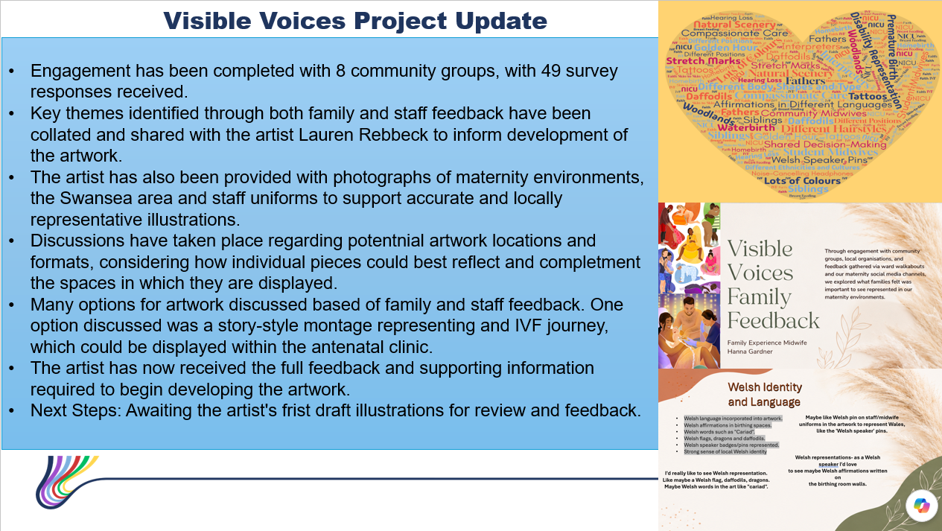

Board Assurance
There is increasing evidence that women, families and community partners are influencing service development and improvement. Strong governance, growing community partnerships and a coordinated engagement approach provide assurance that equity, inclusion and lived experience remain central to service delivery and future planning.

Engagement Spotlight – Strengthening Partner Voice
In collaboration with community organisations and families, the service is developing more inclusive patient information and educational resources. This includes work to improve the representation of caesarean wound healing across diverse skin tones, supported by clinical experts, community partners and people with lived experience. The project demonstrates our commitment to co-production, health equity and ensuring information reflects the diverse communities we serve. Plans are in place to make these resources available through digital platforms, BadgerNet and clinical environments.

3.12 Digital Transformation – BadgerNet
What are we measuring?
The implementation and maturity of the BadgerNet Electronic Patient Record and the quality of performance reporting.

How are we performing?
BadgerNet implementation continues to progress successfully. Data validation and reporting development remain ongoing, reflecting the complexity of transitioning from legacy systems to a fully digital environment.

Some performance indicators continue to require validation and should therefore be interpreted with caution during this transitional phase.

What are we doing to improve?
Work continues with Digital Services and system suppliers to enhance data quality, reporting functionality and dashboard development. Additional validation processes have been implemented to strengthen confidence in future metric reporting.

Board Assurance
The Committee can be assured that governance arrangements remain robust throughout the digital transition and that existing safety, quality and operational oversight processes continue to provide assurance.

3.13 A Skilled and Supported Workforce

What are we measuring?
How we ensure staff receive the training, education and support needed to provide safe, compassionate and effective care.

How are we performing?
Most maternity and neonatal staff continue to complete the training required for their role, with compliance levels remaining above national expectations in most areas. This provides assurance that women and babies are cared for by teams with the knowledge and skills required to respond to both routine and complex situations.

What are we doing to improve?
We continue to invest in staff development through simulation, specialist education, leadership development and mandatory training programmes. Where gaps are identified, targeted improvement plans are put in place to support teams and ensure compliance is restored quickly.

Board Assurance
Our workforce continues to demonstrate a strong commitment to learning and professional development, helping to ensure women, babies and families receive safe, high-quality care delivered by skilled and competent teams.

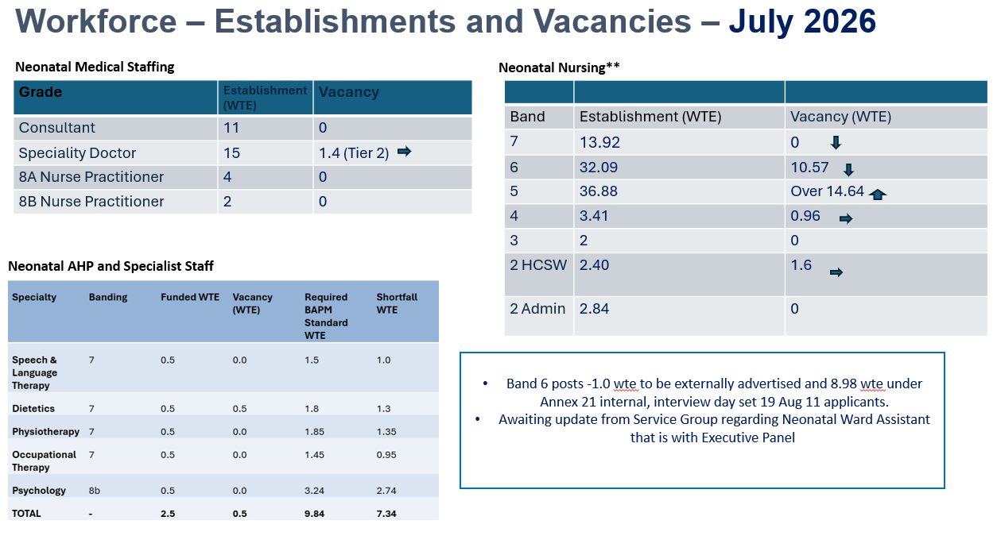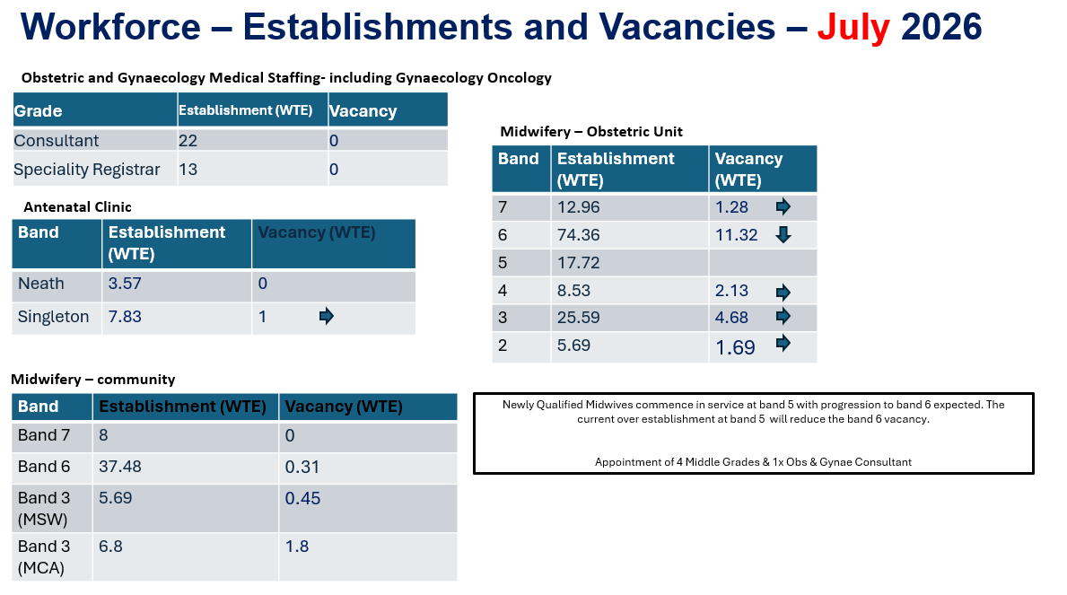
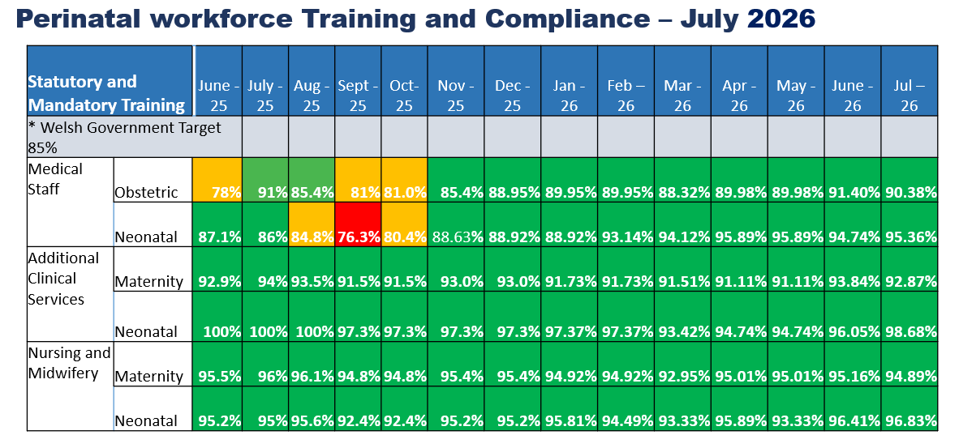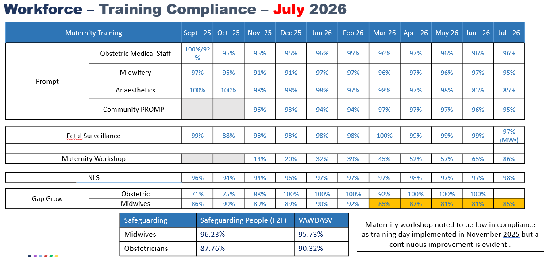
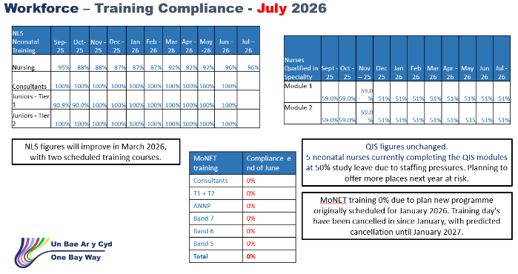

3.14 Workforce Sustainability and Service Resilience
What are we measuring?
The availability, capability and sustainability of the maternity and neonatal workforce required to deliver safe care.

How are we performing?
Workforce challenges remain the most significant operational risk facing perinatal services. Vacancy levels, workforce unavailability and specialist workforce dependencies continue to place pressure on service delivery, although mitigation plans remain effective and no immediate safety concerns have been identified.

Recruitment activity continues across maternity, neonatal and specialist workforce groups. Temporary staffing arrangements, flexible deployment and risk-based escalation processes continue to support safe service delivery.

What are we doing to improve?
The service continues to progress recruitment activity, workforce planning initiatives and targeted retention programmes. Work is also underway to strengthen workforce sustainability through development of temporary staffing solutions, enhanced training opportunities and longer-term workforce planning aligned to service demand.

Board Assurance
Whilst workforce sustainability remains a significant organisational risk, mitigation measures remain effective and services continue to operate safely with appropriate governance, escalation and oversight arrangements in place.

3.15 Safe Care Environments

What are we measuring?
How effectively we prevent and control infection across maternity and neonatal services to keep women, babies, families and staff safe.

How are we performing?
The service continues to perform well against infection prevention standards, with high levels of compliance and no significant infection concerns identified during this reporting period. Audit results demonstrate continued improvement and sustained focus on maintaining safe clinical environments.

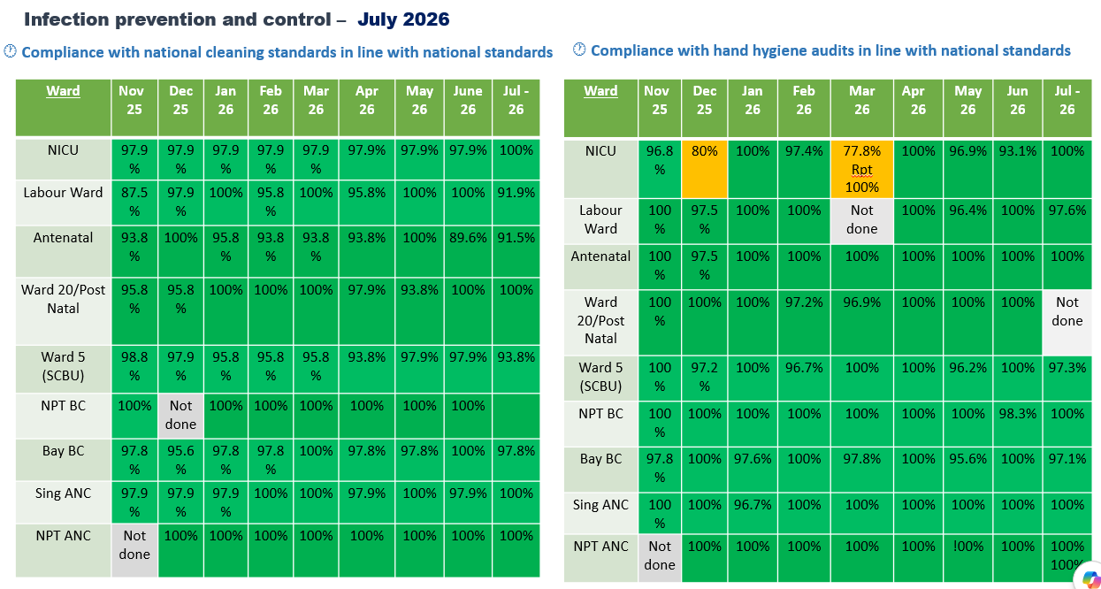

What are we doing to improve?
We continue to monitor infection prevention practices through regular audits, staff training and improvement programmes. Where opportunities for improvement are identified, actions are implemented promptly and monitored through established governance arrangements. A recent audit identified a significant deterioration in compliance within an area that has historically demonstrated consistently strong performance. This result is recognised as an outlier when viewed against previous assurance activity and does not reflect the ward's usual standards. A detailed review has been undertaken to understand the factors contributing to this variation, and a targeted improvement plan has been implemented. Enhanced leadership oversight, increased audit frequency, spot-checks, and focused reinforcement of expected standards are now in place to provide assurance that improvements are being embedded and sustained. The position will continue to be closely monitored through established governance arrangements and reported through the assurance framework.

Board Assurance
Strong infection prevention arrangements remain in place, providing assurance that women and babies continue to receive care in safe and well-managed clinical environments.

3.16 Neonatal National Audit and Performance (NNAP)/PERIPrem Cymru – context and figures

What are we measuring?
NNAP and PERIPrem Cymru provide assurance on the quality and consistency of care delivered to preterm and vulnerable babies. These measures assess whether babies receive evidence-based interventions known to improve neonatal outcomes, including delivery of the PERIPrem optimisation bundle and timely provision of breastmilk following birth. They help us understand how effectively the neonatal service delivers key elements of high-quality neonatal care and identify opportunities for improvement.

How are we performing?
There are no new NNAP audit findings to report this period, and performance remains consistent with previous reporting. The next formal NNAP Cymru update is expected later in 2026. Current PERIPrem performance remains reassuring, with most pathway measures continuing to perform at or above expected levels, demonstrating sustained delivery of evidence-based care. The PERIPrem bundle optimisation score for June was 74%, reflecting continued strong performance across the neonatal pathway. Early breastmilk provision within six hours of birth increased from 71% in May to 50% in June based on available data; however, these results should be interpreted cautiously as data collection remains incomplete and further validation is required. Overall, performance remains robust and there is no indication of a wider performance concern currently.

What are we doing to improve?
The service continues to actively monitor performance across all NNAP and PERIPrem measures and reviews cases through established governance arrangements. Work is ongoing to complete outstanding case analysis, strengthen data collection processes and improve reporting completeness following recent data transitions. Focus continues to be placed on optimising delivery of the PERIPrem care bundle and improving early breastmilk provision for preterm babies. This work will provide more comprehensive assurance regarding pathway performance and support identification of any additional improvement opportunities.

Board Assurance
Performance across the neonatal optimisation pathway remains strong and consistent with previous reporting. Most care measures continue to perform at or above expected levels, providing assurance that evidence-based neonatal interventions are being delivered reliably. Whilst some data validation and outstanding case review remain in progress, there are currently no concerns indicating deterioration in care quality, and robust governance arrangements remain in place to monitor performance and support ongoing improvement.

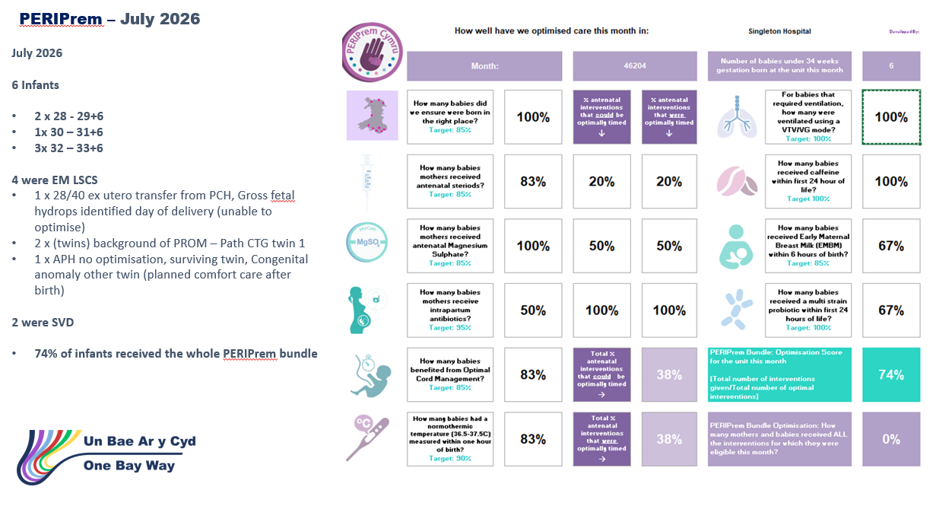

3.17 Avoiding Term Admission into Neonatal services.

What are we measuring?
We monitor the number of babies born at term who require admission to the neonatal unit. Reducing avoidable admissions is important as it helps keep mothers and babies together, supports early bonding and breastfeeding, and ensures neonatal care is focused on babies who require specialist support.

How are we performing?
The service continues to review term admissions in real time, and the monitoring process has now moved into business-as-usual governance arrangements. Analysis shows that respiratory distress remains the most common reason for admission, with approximately 70% of these admissions occurring in babies born following planned caesarean birth. This has provided valuable insight into the main drivers of neonatal admission and supports targeted improvement activity.

What are we doing to improve?
A focused quality improvement programme has been implemented to reduce avoidable neonatal admissions related to respiratory distress. Since April, babies requiring respiratory support following birth have been offered high-flow oxygen therapy at the bedside for up to one hour before a decision is made regarding neonatal admission. This approach aims to support babies in remaining with their mothers wherever it is safe to do so, reducing unnecessary separation and improving the early family experience. The service continues to review admissions, analyse contributing factors and identify further opportunities for improvement.

Board Assurance
The service has a clear understanding of the key drivers of term neonatal admission and has implemented targeted improvement actions to address them. Real-time monitoring, routine review and focused quality improvement activity provide assurance that avoidable admissions are being actively addressed, with a continued focus on keeping mothers and babies together whenever clinically appropriate.
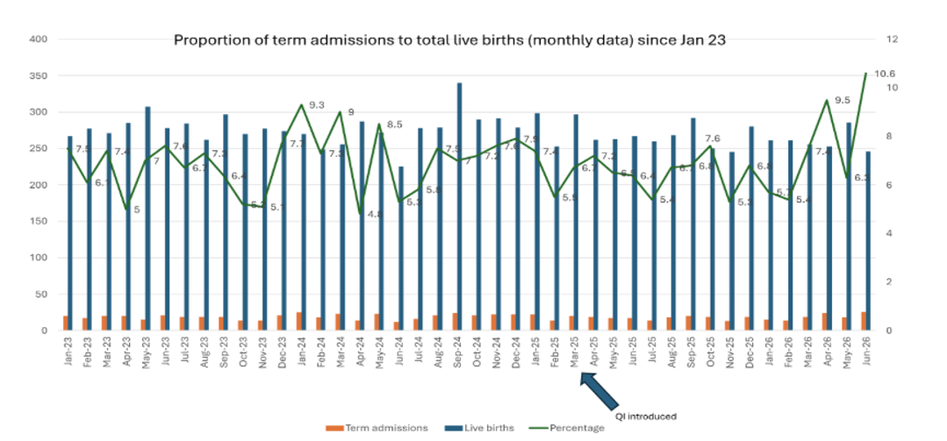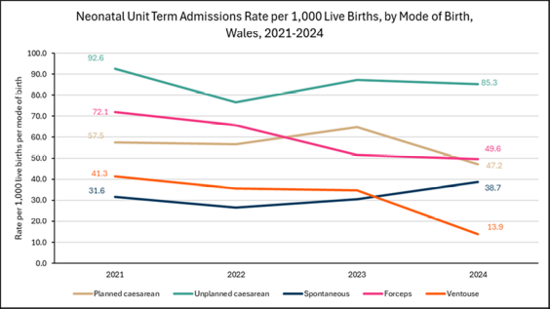
3.18 Risk Register

What are we measuring?
Strategic and operational risks affecting maternity and neonatal services.

How are we performing?
The risk profile remains stable with risks reviewed routinely through established governance processes. Key risks continue to relate to workforce sustainability, specialist workforce capacity, neonatal medical staffing, sonography capacity, national training dependencies and service demand.

A new risk relating to ultrasound surveillance capacity has been added to reflect increasing demand and workforce pressures.

What are we doing to improve?
Mitigation plans remain in place for all principal risks and continue to be monitored through Perinatal Committee, Quality and Safety Committee and Perinatal Improvement Programme governance arrangements.

Board Assurance
The Committee can be assured that risks are well understood, appropriately escalated and actively managed through established governance structures.

3.19 Quality Improvement Approach, Methodology and Programmes
Perinatal services adopt structured Quality Improvement methodology to ensure safe, reliable, evidence-based care for women, babies, and families. The approach is grounded in recognised improvement science frameworks and national priorities, combining local data driven change with strong multidisciplinary collaboration.

A detailed plan was presented in the January 2026 report to QSC and Board, further updates will be represented in the report as these are formulated and once able to report outcomes and impact. This also applies to any quality improvement programmes which was presented in January.

3.20 National Awards.
Swansea Bay University Health Board’s maternity and neonatal services continue to demonstrate excellence through strong patient validated recognition and organisational accolades. In the past year, the service has secured multiple acknowledgements that reinforce its commitment to high quality, compassionate and continuously improving care.

A multi-disciplinary and multi-professional team at Swansea Bay have been shortlisted for their work on psychological safety and speaking up in maternity services. The team developed a practical workshop based on feedback from the clinical teams to address an important area of patient safety. The HSJ Awards area prestigious national patient safety awards and we are delighted that the work of this team has been recognised and considered for these awards.

Ther work spanned working at two points in a professional’s journey: bringing student midwives and medical students together through interprofessional simulation crating a space within our existing muti professional workforce education to explore civility, hierarchy, psychological safety, active bystander approaches and speaking up. The team also drew on service-user experience with input from the Maternity, Neonatal Voices Partnership to bring the perspective of women and birthing people in the educational work.

Early evaluation f their work form our teams has been encouraging, including around confidence to speak up, communication and perceptions and being heard when it matters.

3.21 HIW Inspection Summary – Singleton Maternity Services (Feb 2026)
What are we measuring?
We monitor progress against findings and recommendations arising from Healthcare Inspectorate Wales (HIW) inspections. This includes assessing compliance with regulatory requirements, monitoring delivery of improvement actions and ensuring that learning is translated into sustainable improvements in safety, quality, governance and patient experience. The aim is to provide assurance that services continue to improve and meet the standards expected by women, babies, families and regulators.

How are we performing?
The HIW improvement plan has been approved, published and is actively progressing through established governance arrangements. Inspection findings identified several strengths across maternity and neonatal services, alongside opportunities for improvement, many of which were already recognised through existing governance and quality processes. Progress continues to be demonstrated across governance, workforce compliance, risk management, escalation arrangements and quality improvement activity. Oversight of actions has been strengthened through the ward-to-Board reporting model and Perinatal Committee governance arrangements.

What are we doing to improve?
A comprehensive improvement programme is in place to deliver the HIW action plan. This includes strengthening governance systems, enhancing quality management processes, improving escalation arrangements, developing workforce capability, embedding learning through audit and review, and improving consistency of care and documentation. Delivery is supported through the Perinatal Improvement Programme, Perinatal Committee, Quality and Safety Committee and wider Health Board governance structures. Progress is routinely monitored, with actions tracked against agreed milestones and subject to executive oversight.

Board Assurance
The Board can be assured that the HIW improvement plan is actively progressing and supported by strengthened governance, oversight and accountability arrangements. There is clear evidence that inspection findings have been incorporated into existing improvement programmes, with learning translated into measurable changes across maternity and neonatal services. No overdue actions have been identified, and ongoing monitoring provides assurance that improvements are being embedded into routine practice and service delivery.

- OPEN AUDIT RECOMMENDATIONS

Open audit recommendations relate primarily to system strengthening rather than concerns about unsafe care.

The Perinatal Committee maintains oversight of a small number of open audit related actions arising from internal reviews, external assurance activity and national audit programmes (including MBRRACE UK and NMPA), together with recommendations emerging from the Independent Review and All Wales Perinatal Assurance processes.

These recommendations are embedded within the Perinatal Improvement Programme and are tracked through established governance arrangements, with clear executive ownership, defined milestones and progress reporting via the Perinatal Improvement Programme Executive Board and Perinatal Committee.

Current open actions focus on:
• strengthening digital infrastructure and interoperability (including implementation of computerised CTG and optimisation of BadgerNet functionality);
• improving reliability and completeness of data capture and reporting (e.g. surgical site infection surveillance and demographic data completeness);
• enhancing consistency of clinical pathways and escalation processes through training, audit and quality improvement activity;
• further embedding learning from audit and review into education, supervision and multidisciplinary practice.

The Board can be assured that there are no outstanding audit recommendations indicating immediate risk to patient safety, and that all open actions are actively managed within the agreed improvement programme, with progress subject to routine scrutiny and escalation through Quality and Safety Committee where required.

- FINANCIAL IMPLICATIONS
As previously advised, there will be some financial implications because of the recommendations from the Independent Review, these are currently being developed as part of developing the improvement plan.

- RECOMMENDATION

BE ADVISED THAT;
- Perinatal Services continue to provide safe care within a context of ongoing workforce fragility, specialist capacity constraints, digital transition and wider system dependencies.
- July 2026 data demonstrate areas of positive assurance, including maintained service delivery, strong training compliance across most workforce groups, effective infection prevention arrangements and active governance oversight.
- Digital reporting remains in transition following BadgerNet implementation, and some metrics should continue to be interpreted with caution while data validation and reporting optimisation are completed.
BE ASSURED THAT;
- Governance arrangements remain in place across maternity and neonatal services, with incident review, mortality review, patient experience, risk management and improvement activity monitored through established structures.
- Infection prevention and control performance remains strong, with no reported C. difficile, E. coli, Staphylococcus aureus or Pseudomonas bacteraemia cases in July across maternity and neonatal services.
- Patient feedback continues to be actively reviewed and used to inform service improvement, with positive feedback evident alongside clear themes for improvement.
- The proposed serial growth scan pathway would preserve enhanced surveillance for women and babies with identified or emerging clinical concerns.
BE ALERTED TO;
- Ongoing workforce sustainability risks across maternity, neonatal nursing and neonatal medical rotas.
- Ongoing specialist service risks, including paediatric radiology support, MoNET training, neonatal transport and sonography capacity.
- Review timeliness pressures in relation to incidents, ATAIN reviews, PMRT reports and concerns where external dependencies or senior approval are required.
- The need to maintain careful oversight of digital data quality during the transition to BadgerNet-enabled reporting.
DECISION REQUIRED;
- To approve the revised serial fetal growth surveillance pathway from routine 3-weekly to 4-weekly scanning for women on a routine surveillance pathway where there is no identified clinical concern for fetal wellbeing.
- To approve the amendment to smoking-related growth scan eligibility so that serial growth surveillance is offered to women identified as smokers at booking, rather than based on smoking status at conception.
- To support the introduction of uterine artery Doppler assessment at the routine 20-week fetal anomaly scan, subject to workforce training, competency assessment and operational implementation arrangements.
- To note that recruitment to vacant sonography capacity must continue and that the pathway change should not be interpreted as justification for establishment reduction.

The service continues to provide safe, compassionate and high-quality care, with no immediate safety concerns identified, and a strong focus on continuous improvement.

Governance and Assurance
Strategic Objectives
Strategic Objectives  (please choose which is impacted) | People of Swansea Bay live healthier, fairer and more prosperous lives | ☒
Strategic Objectives  (please choose which is impacted) | Care is high quality, safe, efficient and delivers the best possible outcomes for people in partnerships | ☒
Strategic Objectives  (please choose which is impacted) | Care is delivered in partnership with our communities in safe and appropriate setting, supported by innovation | ☒
Strategic Objectives  (please choose which is impacted) | The health board is a great place to work where staff feel valued and work together towards a common goal | ☒
Strategic Objectives  (please choose which is impacted) | The health board is a resilient, sustainable and responsible organisation | ☒
Health and Care Standards
Standards (please choose which applies) | Safe Care | ☒
Standards (please choose which applies) | Timely Care | ☒
Standards (please choose which applies) | Effective Care | ☒
Standards (please choose which applies) | Efficient Care | ☒
Standards (please choose which applies) | Equitable care | ☒
Standards (please choose which applies) | Person-centred Care | ☒
Standards (please choose which applies) | Staff and Resources | ☒
Enablers (please choose which applies) | Whole Systems Approach | ☒
Enablers (please choose which applies) | Leadership | ☒
Enablers (please choose which applies) | Workforce | ☒
Enablers (please choose which applies) | Culture | ☒
Enablers (please choose which applies) | Information | ☒
Enablers (please choose which applies) | Learning, Improvement and Research | ☒
Quality, Safety and Patient Experience
The Perinatal Committee reports directly to the Quality and Safety Committee and is noted through Service Group Quality, Safety and Risk Group and Senior Leadership Team governance arrangements.
The Committee continues to receive assurance relating to clinical outcomes, safety, patient experience, workforce, governance, risk and service sustainability. The Committee remains assured that established governance arrangements support oversight of quality, safety and patient experience across maternity and neonatal services.
Financial Implications
Whilst no immediate financial implications arise directly from this report, several areas continue to have potential resource implications, including workforce sustainability, implementation of the Perinatal Improvement Programme, digital transformation activities and ultrasound service capacity. Recruitment to vacant sonography and specialist workforce posts remains essential to support long-term service sustainability.
Legal Implications (including equality and diversity assessment)
No specific legal implications are identified within this report.
The proposed amendments to the Serial Growth Scan Surveillance Pathway have been developed following review of available evidence, benchmarking and risk assessment processes. Equality and Quality Impact Assessments have been completed or are being progressed through the appropriate governance arrangements.
Staffing Implications
Workforce sustainability remains one of the principal risks for maternity and neonatal services. Challenges remain in relation to maternity, neonatal and specialist workforce capacity, including sonography services, neonatal medical staffing and recruitment to substantive vacancies.

Mitigations remain in place, including flexible deployment, temporary staffing solutions, recruitment activity and workforce planning. No current staffing risks require escalation beyond existing governance arrangements; however, workforce sustainability remains subject to ongoing monitoring and oversight.
Long Term Implications (including the impact of the Well-being of Future Generations (Wales) Act 2015)
The work of the Perinatal Committee and Perinatal Improvement Programme continues to deliver significant long-term benefits for women, babies, families, communities and staff.
The actions contained within this report contribute to:

A Healthier Wales
Through continued focus on reducing avoidable harm, improving maternity and neonatal outcomes, strengthening fetal surveillance, enhancing patient experience and supporting earlier intervention.

A More Equal Wales
Through targeted engagement with diverse communities, reduction of health inequalities, culturally responsive care and equitable access to services.

A Wales of Cohesive Communities
Through co-production, enhanced patient engagement, partnership working and incorporation of lived experience into service development.

A Resilient Wales
Through workforce sustainability planning, digital transformation, strengthened quality management systems, improvement science and robust governance arrangements.

A Prosperous Wales
Through prevention, quality improvement, efficient use of resources, reduction of avoidable harm and development of sustainable service models that support long-term healthcare value.
Collectively, the improvement activity described within this report reflects a preventative, collaborative and long-term approach to improving outcomes for women, babies and families whilst supporting sustainable service delivery and fulfilling the organisation's responsibilities under the Well-being of Future Generations (Wales) Act 2015.
Report History
The Perinatal Committee reports directly to the Quality and Safety Committee and is noted through Service Group Quality, Safety and Risk Group and Senior Leadership Team governance arrangements.

Previous report: July 2026
Current report: August 2026
Appendices
Appendix 1: August Perinatal Dashboard (July 2026 Data)
Appendix 2: Review of Serial Growth Scan Surveillance Pathway (Decision Paper)

