Meeting Date | 24 September 2026 | Agenda Item | 5.3
Name of Meeting | SBUHB Board
Report Title | Financial Report – Month 05 2026/27
Report Author | Samantha Moss, Deputy Director of Finance  Gemma Pearson, Finance Business Partner  Crystal Davies, Principal Finance Manager
Report Sponsor | Executive Director of Finance
Presented by | Claire Osmundsen-Little, Interim Director of Finance
Freedom of Information | Open
FoI Closed detail | If closed, choose detail
Impact Assessment Summary Outcome |  | IA Completion date
N/A |  | Click or tap to enter a date.
Purpose of the Report | For Assurance
Report Summary; detailing any action required
The report advises the Board of the Health Board on the financial position for Month 05 2026/27 (August 2026, risks regarding the current forecast revenue year end outturn and the further actions required to address the delivery of the Annual Plan.
Key Issues
The report invites the Board to discuss the detailed revenue analysis of the financial position for Month 05 2025/26 (August 2026).

The report includes a summary of the key drivers of the revenue position either at Service level or by expenditure type (i.e. Non-Pay/Pay).

The report invites the Board to consider the cash position, key balance sheet movements and the capital position.

Risk has been considered, on the basis of the information provided within the report, and the score updated where necessary.

Whilst the key messages are provided within the main body of the report, further information including the financial recovery assumptions are is provided within the accompanying Annex

Decision / Action required | No
Recommendations
Members are asked to:

- ACKNOWLEDGE the 2026/27 Financial Plan, and the inability of the Health Board and Welsh Government to approve it, given the planned deficit of £76.6m
- Consider and comment on the financial performance for Month 05 2026/27, including cash, capital and balance sheet.
- SUPPORT the implementation of the actions to address the red and pipeline savings gap and assessed position to reach the £76.6m plan.
- DISCUSS the risks to the position at Month 05.

FINANCIAL REPORT – MONTH 05 2026/27

- INTRODUCTION

The report invites the Board to consider the detailed analysis of the Month 5 (August 2026) revenue financial position, along with Cash and Capital.

- BACKGROUND

The Health Board has two key statutory duties to achieve:

- To submit an Integrated Medium-Term Plan (IMTP) to secure compliance with breakeven over 3 years.
2024/25 3-year plan submitted
2025/26 3-year plan submitted
2026/27 3-year plan submitted
The Health Board plans to achieve its target control total of £17m deficit, as part of its 2026/27 -2028/29 plan and is working on the action necessary to achieve this. Currently it will fail to meet this in 2026/27 as its plan will not breakeven over 3 years.

- To achieve financial breakeven over a rolling three-year period, which commenced on 1st April 2024 and will end on 31st March 2027.
2024/25 Deficit Control Total £43.7m achieved
2025/26 Deficit Control Total £53.2m achieved
2026/27 Deficit Plan Draft £76.6m
The Health Board will fail to achieve this Statutory Duty.

Summary of Performance against Key Financial Targets

Financial KPIs: To ensure that net operating costs do not exceed the revenue resource limit set by Welsh Government | Value  £’000
Reported in-month financial position – deficit/(surplus) | 6.001
Reported cumulative financial position – deficit/(surplus) | 35.266
Capital KPIs: To ensure that costs do not exceed the capital resource limit set by Welsh Government | Value  £’000
Reported year to date financial position – deficit/(surplus) | (1.152)
Forecast outturn financial position – deficit/(surplus) (prior to additional allocations) | (4.010)
PSPP Target: To pay a minimum of 95% of all non NHS creditors within 30 days of receipt of goods or a valid invoice | Value  %
Cumulative year to date % of invoices paid within 30 days (by number) | 96.7%

- FINANCIAL PLAN

The Annual Plan submitted to Welsh Government on 31st March 2026 for assessment and scrutiny included a financial assessment, as summarised in the table below:
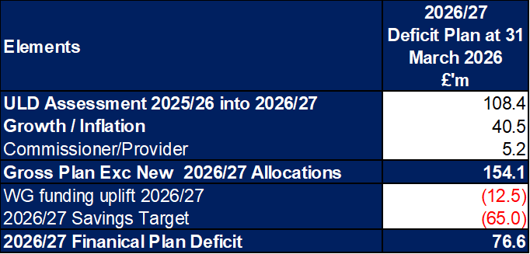

The Health Board accepts that this financial assessment is not acceptable or supportable for Welsh Government and does not meet the statutory duties of the Health Board. A strengthened reiteration was submitted to Welsh Government 1 July 2026 which included the assessed savings position at that point, with the Health Board continuing its work on finalising the detailed delivery plan in respect of the £65.0m savings target set out in the draft plan submitted in March along with mitigations to the recognised £10m risks.
The Health Board’s actual performance against the planned deficit shows that at the end of Month 5 the reported deficit in-month is £6.0m, which is £0.4m below the planned position. The table below provides the reconciliation of £6.0m Month 5 variance and the split between performance against operational budget and performance against savings target, with the second table reconciling the movements both in-month and YTD.
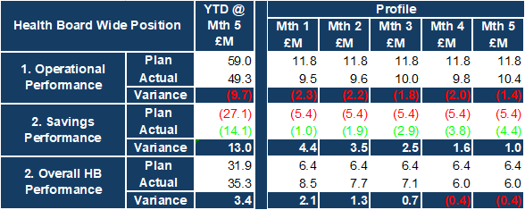

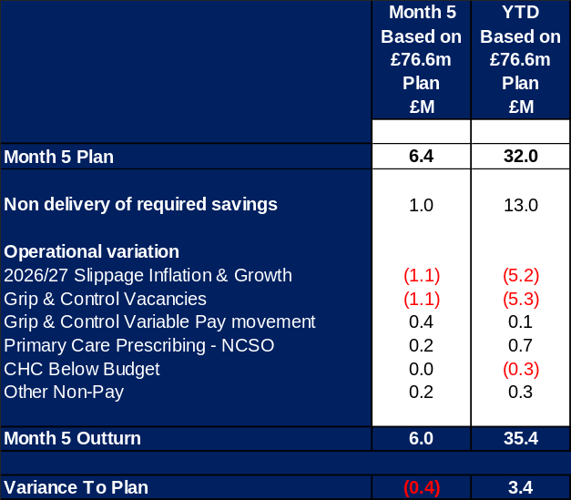

Cumulatively the Health Board is operating above the £76.6m deficit plan by £3.4m at the end of Month 5. Certainty on the delivery of the balance of savings of £23.7m is essential and hence the need to strengthen the pipeline and continue the reduction in expenditure in future months.

Given the financial position, actions to mitigate growth and generate further stretched savings are being undertaken. Progress on these plans are part of the Recovery & Sustainability Board and work that the Delivery Unit is supporting.

- BACKGROUND – Financial Performance

FINANCIAL REPORT REVENUE – MONTH 05

At Month 5 there was an In-Month overspend of £6.0m, which is £0.4m better than the planned deficit of £6.4m (£76.6m/12).

With regard to the overall financial performance, Graph 1 below reflects the actual financial performance in each month, with the orange bars reflecting the performance required to achieve the original plan of £76.6m. Graph 2 outlines the savings delivered to date as the blue bars against the monthly target set (red line), and the orange bars reflect the level of savings required in future months to achieve the £65m target aligned to the £76.6m plan.
Graph 1: Performance Graph 2: Savings
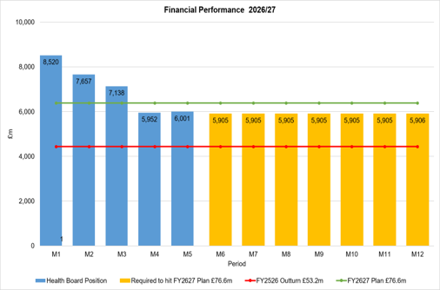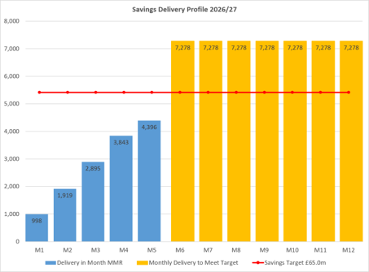

KEY DRIVERS OF THE IN-MONTH POSITION

The key movement from plan of the Month 5 position are summarised in second table reported in Section 1 above. Further detail at a Health Board level of expenditure on Income, Pay and Non-Pay, is provided within Annex 1.

- KEY AREAS OF NOTE

5.1 SAVINGS DELIVERY
Full details on savings are provided Annex 1, but in summary the in-month delivery in Month 5, was £4.4m against a target of £5.4m and remains the key driver of the Health Board overspend. YTD delivery is £14.1m against a target of £27.1m.
Part C Actions
- Part C1: Savings Trackers Red & Corporate Stretch @ 4 September 2025
- Part C2: Savings Trackers Pipeline @ 4 September 2025
- Part C3: In-year impact of the thematic Scheme Summaries (adjusted to avoid double count)
Further Actions
- Additional interventions to close the gap to the original savings plan
  - Exec oversight of variable pay
  - Additional capacity reduction
  - Non pay bans / restrictions

5.2 CAPITAL
The approved Capital Resource Limit (CRL) value issued on 2nd September is £55.697m. The approved CRL value includes Discretionary Capital and schemes under the All-Wales Capital Programme.

Outturn Performance
The forecast outturn shows an underspend position of £4.010m in relation to the high-risk schemes below.
Scheme | £m / Risk Level | Narrative
HCF - Dan y Deri | 2.000 / High | We raised the risk to high in the month 4 returns and formally requested the return of £2m this year, to be re-provided next year. Following discussions with the WG Capital & Estates team, we are liaising with the West Glamorgan RPB and WG HCF team to facilitate this CRL adjustment.
Vascular Hybrid Theatre at Morriston Hospital, Swansea | 0.950 / High | Following on from a previous return of funding in the in the M3 MMR and discussions at the CRM, we can now confirm further savings as the scheme nears completion. Savings on the roof top plant unit, due to design amendments enabling fitting on to a smaller footprint. Re-engineering around AHU/fire suppression also enabled savings. Due to some uncertainty of the ground works, costs were included in the business case but not required. The main works following delivery of the modular units to site was completed in late August and we are currently progressing through commissioning and imaging equipment installation. Due to the fortunate weather conditions during the modular install, there were less abortive visits than anticipated. Overall, the scheme has been very positive.
Reinstatement of Taith Newydd Low Secure Unit at Glanrhyd, Bridgend | 0.400 / High | Following on from a previous return of funding in the M3 MMR and discussions at the CRM, we can now confirm this scheme will be further underspent following confirmation that renewal of fibre cable was not required. Working with NWSSP-SES, we were able to amend the sprinkler package to reduce the amount of works required, while retaining resilience.
Replacement Diagnostic and Treatment Equipment 2025-26 | 0.420 / High | Following on from the M4 MMR, we can now confirm this scheme will be underspent following the receipt of tenders and the cost of the machine was lower than expected. Work is due to start on site in September.
Digital X-Ray Rooms, Morriston Hospital | 0.240 / High | Following on from the M4 MMR, we can now confirm this scheme will be underspent following the receipt of tenders. Work is due to start on site in September.

Any variances are linked to planned contributions from discretionary and in some instances payback of prior year fees.
Capital Disposals
There are no property disposals planned for 2026/27.
5.3 BALANCE SHEET
The key issues in respect of the statement of financial position movements are as follow:

- The inventory value has increased from £12.786m at the end of July 2026 to £12.812m at the end of August 2026, an increase of £0.026m.

- There has been an increase in trade receivables from £308.823m at the end of July 2026 to £320.278m at the end of August 2026, an increase of £11.455m. This relates to an increase in NHS Debtors of £9.222m, an increase in the WRP (Welsh Risk Pool) debtor of £5.472m, a decrease in WGA (Whole Government Accounts) debtor of £0.366m, a decrease in VAT debtor of £1.773m and a decrease in other current assets of £1.483m.

- The closing August 2026 cash balance of £5.663m

- The trade and other payables figure saw a decrease from £237.035m at the end of July 2026, to £230.098m at the end of August 2026, a decrease of £6.937m. This comprises a decrease in Accruals and RBNI (receipted but not invoiced).

- Provisions saw an increase of £5.217m from £238.913m at the end of July 2026 to £244.130m at the end of August 2026. This increase relates mainly to Clinical Negligence of £5.829m, a decrease of £0.265m and £0.288m in Redress and defence fees respectively.

5.4 CASH
As at the end of August 2026, the Health Board had a cash balance of £5.663m, which is within a reasonable tolerance for the Health Board.

The forecast cash deficit is £75m. The difference between the £75m forecast cash deficit and the Forecast I&E deficit plan/cash figure, reflects the £1.434m of Revenue cash to reimburse capital cash, and the movement in the working capital balances.

The cash movements during August 2026 were:
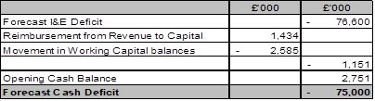
In order to manage the balance of cash between Revenue and Capital, we have been drawing down CRL funding in such a way, as to ensure that it not only clears any prior “owing” between Revenue and Capital, but also to ensure that we are no drawing down ahead of need. We are managing this on a monthly basis. The net capital cumulative funding position as at M5 is £2.190m.

The cash flow is currently updated daily and a full review of the cash forecast is currently being undertaken monthly, to ensure that any changes to our cash requirements, can be communicated in a timely manner to WG.

The Health Board awaits the annual technical guidance from WG on the process for requesting Strategic and Working Capital Cash during Q3/Q4 of 2026/27.

5.5 PUBLIC SECTOR PAYMENT POLICY (PSPP)
The Health Board achieved the 95% PSPP target, with the % of Non-NHS Invoices Paid within 30 Days as at Month 5 being 96.7%.

NHS payment compliance for invoices paid within 30 days was, however, below 95% with the performance at Month 5 being 88.2%. The Health Board remains focussed on improving PSPP compliance for NHS invoices and ensuring that performance remains above 95% for non-NHS invoices.

5.6 FURTHER FOCUS IN MONTH TO SUPPORT 2026/27 OUTTURN
The financial recovery requires as a minimum recurrent savings of £65m within this financial year. At month 5 total savings totalled £41.3m of which £29.4m are recurrent and this translates into £39m full year recurrent savings leaving a gap of £16m yet to substantiate this year. To outturn as a minimum with a £76.6m deficit and close the gap in recurrent savings the following three area of increased focus are being taken;

- Continue to convert £25m identified opportunities and monitor delivery supported by the delivery unit. Prioritising the recurrent savings gap.

- Maintain operational spend grip and control with weekly run rate oversight supported by weekly limits for both Pay and Non Pay.

- To start the translation of the opportunities list for 2027/28 delivery.

The actions will be supported by additional scrutiny of absence with new approaches being considered to manage absence and improve staff well-being.

5.7 TACKLING THE DEFICIT AND RECOVERY PLAN TO BALANCE
During the month, a detailed financial analysis has been undertaken to update the calculation on the current underlying financial gap. To identify the areas of productivity improvement to set out a clear financial recovery plan to balance. The detailed work outlining our deficit drivers and the key themes that will need to be transformed to improve quality, productivity and sustainability of the way that care is delivered in SBUHB. This demonstrated the need for radical redesign and reprioritisation of services and the role of improving asset utilisation and digitalise delivery. The choices and options for consideration are being further development for further consideration and discussion by the Board in the October Board Development session; and share with and discuss with NHS P&I and Welsh Government over the next quarter to inform the plan for 2027/28.

5.8 BUDGET SETTING PROCESS
In May budget letters were issued to all 67 identified Senior Leaders along with invites to attend a budget holder training session with additional procurement training. The return of the signed letters and Budget Holder access to the Qliksense finance dashboard is being tracked and reported within Annex 1, Appendix 2-3.

- GOVERNANCE AND RISK ISSUES

Two Board level financial risks:

- Achieving financial plan (HBR92) with the key elements as follows: -

- Risk of delivery of savings quantum
- Risk of operational overspend being in excess of funding available agreed via the Financial Plan
- Risk of commitment of reserves (e.g. NICE) being above reserves available.
- Risk of achieving the actions and options outlined in the 2025/26 Financial Recovery & Sustainability Assessment.

Given the improvement needed to the monthly performance and the current status of savings to achieve the draft deficit plan of £76.6m, it is recommended that the Health Board Corporate Risk Register continues to reflect a risk score of 25.

- Availability of capital (HBR93). This risk was re-opened in 2022/23 given the reduction in discretionary capital allocation. Due to the additional capital funding provided during 2024/25 the risk score was reduced to 12. The score was increased in June 2025 to reflect risks regarding Emergency Department and Adult Acute Mental Health. However, following further assessment at start Quarter 4 2025/26 and based on funding received the risk score reduced to 12, which is the recommendation for Q2 2026/27.

For Month 5 the key risks to the delivery of the Deficit Plan reported to WG in the MMR, linked to HBR92 are detailed below:
- Delivery of savings: The Health Board has identified £41.3m of Green and Amber savings and whilst it continues to scrutinise delivery of these via the Recovery & Sustainability Board (chaired by the CEO), the role of the Delivery Unit is to quickly translate these plans to deliverable schemes in year supported by the Finance Team. The Health Boards has also identified further opportunities (currently in Red or Pipeline, to support the delivery of the £65m target). Combining the Green/Amber and those remaining Red/Pipeline, there is a greater level of confidence in total delivery of £54m savings (85%) (assuming LTA performance remains consistent) and as such £10m has been reflected as risk in the table at this point on planned mitigations yet to be finalised, with £3.6m on unplanned mitigations requiring redress.
- Non-Delivery Actions to Mitigate Growth/Inflation: Growth pressures above plan level were expected to be mitigated by the identification of mitigating actions in addition to the planned savings delivery. The Health Board acknowledges that this is challenging in the context of the savings position. At end Q1 a review of the assessed risk has been completed, following a Month 5 outturn position of £2.1m relating to CHC we have estimated the total remaining risk for CHC in 2026/27 is £2.9m.
- Energy Risk provided by NWSSP: Not all the energy requirements for 2026/27 have been purchased in advance. The assessment provided by NWSSP on 07/09/26 highlighted a risk of £0.798m, which is an increase from previous risk of £0.498m. This will be updated based on the data from NWSSP, however the Health Board is not yet seeing these pressures materialise within the position.
- Resident Doctor Contract Changes: The contractual changes will be phased from August 2026 to August 2028. Initial assessment by the Health Board suggested there is a risk of between £2m – £2.5m. A report is being prepared to assess the implications and look at risks and mitigations for Board.
- Primary Care Prescribing (NCSO’s): Assuming the current pressures, which have seen an increase of £0.236m per month from previous financial year continue for remaining 7 months of 2026/27, the total pressure from NCSO is £2.6m.
- NEW Month 5 GPOOH National Pay and Terms of Engagement Framework: There are currently no standardised national terms and conditions governing the engagement of GPs working in Out of Hours services across NHS Wales. This has contributed to variation in rates of pay, competition between organisations, and increasing employment tribunal risk, particularly in relation to worker status and holiday pay claims. In response, a national tripartite process involving NHS Wales Employers, Welsh Government and the British Medical Association (BMA) have developed draft worker terms of engagement, a proposed national pay scale, worker enhancement rates, a consultancy agreement for contractors, and a revised employment status assessment process. The initial assessment of this by the HB has indicated a potential cost pressure of £0.176m, which is above the Annual Plan assumptions.
- NEW Out of Area Placements (Temporary Adult Mental Health placements: Original £76.6m plan had an assumed level of Out of Area Mental Health Placements, which would taper off to zero during Q3 of 2026/27. During the opening 4 months of 2026/27 the number of patients had reduced to 9, which is below the target of 11 recognised by WG. However, during August there was a stepped increase in the numbers of patients requiring Out of Area Placements, with the majority detained under the Mental Health Act. During August the number reached a peak of 32. Since then the MH/LD Service Group have been working on supporting discharge and by the last week of August there were plans in place to discharge 13 during September. However, this level remains above the level within the original plan. With the Health Board unlikely to reach the original financial planning assumptions of zero and assuming the levels will not be lower than 11 at any point in the remainder of 2026/27 an indicative value for the risk, above the original planning assumption has now been included in the MMR. This is based on an average of 11 patients per month above plan at a cost of £1k per day. This will be reviewed monthly basis on the number of admissions and planned discharges untaken within each month.

- RECOMMENDATION

Members are asked to:

- ACKNOWLEDGE the 2026/27 Financial Plan, and the inability of the Health Board and Welsh Government to approve it, given the planned deficit of £76.6m
- Consider and comment on the financial performance for Month 05 2026/27, including cash, capital and balance sheet.
- SUPPORT the implementation of the actions to address the red and pipeline savings gap and assessed position to reach the £76.6m plan.
- DISCUSS the risks to the position at Month 05.

Governance and Assurance
Strategic Objectives
Strategic Objectives  (please choose which is impacted) | People of Swansea Bay live healthier, fairer and more prosperous lives | ☐
Strategic Objectives  (please choose which is impacted) | Care is high quality, safe, efficient and delivers the best possible outcomes for people in partnerships | ☐
Strategic Objectives  (please choose which is impacted) | Care is delivered in partnership with our communities in safe and appropriate setting, supported by innovation | ☐
Strategic Objectives  (please choose which is impacted) | The health board is a great place to work where staff feel valued and work together towards a common goal | ☐
Strategic Objectives  (please choose which is impacted) | The health board is a resilient, sustainable and responsible organisation | ☒
Health and Care Standards
Standards (please choose which applies) | Safe Care | ☐
Standards (please choose which applies) | Timely Care | ☐
Standards (please choose which applies) | Effective Care | ☐
Standards (please choose which applies) | Efficient Care | ☒
Standards (please choose which applies) | Equitable care | ☐
Standards (please choose which applies) | Person-centred Care | ☐
Standards (please choose which applies) | Staff and Resources | ☐
Enablers (please choose which applies) | Whole Systems Approach | ☒
Enablers (please choose which applies) | Leadership | ☐
Enablers (please choose which applies) | Workforce | ☐
Enablers (please choose which applies) | Culture | ☐
Enablers (please choose which applies) | Information | ☐
Enablers (please choose which applies) | Learning, Improvement and Research | ☐
Quality, Safety and Patient Experience
Financial Governance supports quality, safety, and patient experience.

Financial Implications
The Board is reporting a forecast year-end deficit financial outturn.

Legal Implications (including equality and diversity assessment)
No implications

Staffing Implications
No implications

Long Term Implications (including the impact of the Well-being of Future Generations (Wales) Act 2015)
No implications

Report History
Updates on the financial position are provided at every meeting.

Appendices
Annex 1 – Detail on Financial Position @ Month 5
Summary Tackling Deficit Main Board

