Appendix 1 – Learning Disability Division Assurance information
Welsh Government have recently set out new metrics for learning disability services. As new metrics the measures have not completed an information governance process nationally so data is not publicly available for comparisons.

Annual Health Checks
Invitations for Annual Health Checks of people on the learning disability register held in primary care practices is a contractual obligation
To strengthen oversight, Primary Community and Therapies service Group have access to monthly AHC performance data, which gives a more regular view of activity and variation across practices. This is reviewed routinely and follow up happens with practices where there are lower levels of performance or any significant variation through normal contractual processes.
Current performance is at 56%.
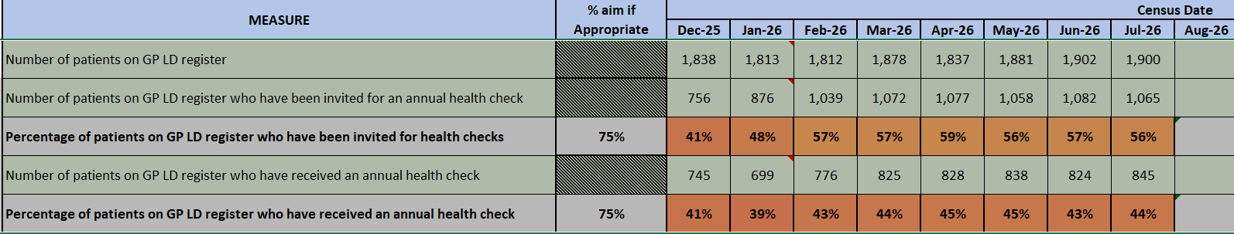

Health Equality Framework (HEF+)
This is an outcome measure used to track and audit health inequalities. Health boards report the total number of eligible individuals with a valid HEF+ profile to monitor how effectively services reduce avoidable health gaps. Implementation is tied to a new app to digitalise completion and reporting which is being prepared by Digital Services for practitioners to use. Trajectories have been developed for the next 6 months to hit 80% target by the end of the year.
Welsh Government guidance for HEF states that not all patients in specialist services require the completion of a HEF and currently SBUHB are working with NHSP&I for improvement from the current baseline of 18% which has been the same figure in the first quarter but will increase from quarter 3 with the digital app available.
Specialist Inpatient & Pathway Metrics
Census data is monitored closely via Digital Health and Care Wales (DHCW) as part of the aim to prevent long-term hospital stays and institutionalisation. This consists of:
- Quarterly submissions of data on patients with a learning disability in specialist learning disability or mental health hospital units across Wales and England.
- Pathway of Care delays and in particular patients delayed in excess of 6 months
- Monitoring the exact headcount of individuals actively accepted into adult Specialist Learning Disability services (such as Community Learning Disability Teams and Intensive Support Teams).
We have not received feedback on the July 2026 census but from April’s data
- 100% compliance with patients having the next steps in their pathway identified.
- 90% compliance with patients having estimated discharge dates and care coordination.
Pathway of Care Delays currently stand at [7] across the three Health Board areas, none of which relate to residents of the SBUHB area.
[2] patients are currently delayed in their discharge beyond 6 months.
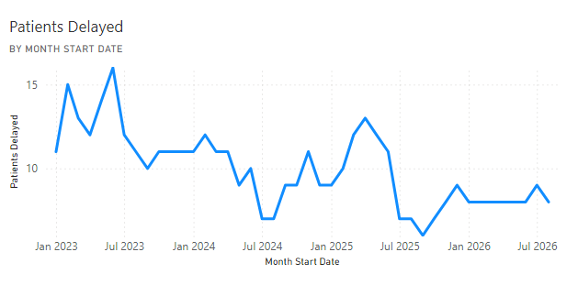

Patient experience
Direct family and friends feedback is often overwhelmingly positive, with good or very good in the main being the most likely response. We report on people's experience in the monthly quality and safety report and act on feedback through compliments or complaints in a timely way. Sharing learning across the division and service group as appropriate.
When we do receive complaints, they can be complex and sometimes require a co-ordinated MDT response, due to the ongoing complexity of a small number of complaints within the division we have been working together with the HB listening to people team to set some boundaries and agree consistent approaches. A specific meeting has been set up to allow designated time for discussion with legal and listening to people. Common themes of complaints: commissioning or assessment processes, CHC decision making, therapeutic offer not in line with family expectations or previous provider assessments, communication, consistency and delays in discharge.
The health board recently engaged in a pilot on the recording of restrictive practices through datix which has now been rolled out across all health boards in Wales for learning disability services. Restrictions can be used in inpatient and community services. Within inpatient area the use of restrictive practice is more likely used in response to escalating behaviour, with an aim of keeping people safe during an incident. It may include the use of seclusion or physical interventions. This is always managed in a least restrictive approach in line with personalised, positive behaviour support plan, care plans and risk assessments. Community restrictive practice generally relates to the use of planned holds and techniques which enable access to health interventions and needs, e.g. holding for examination and investigations. This is managed in a graded, least to most restrictive approach in line with MDT recommendations, care plans and risk assessments.
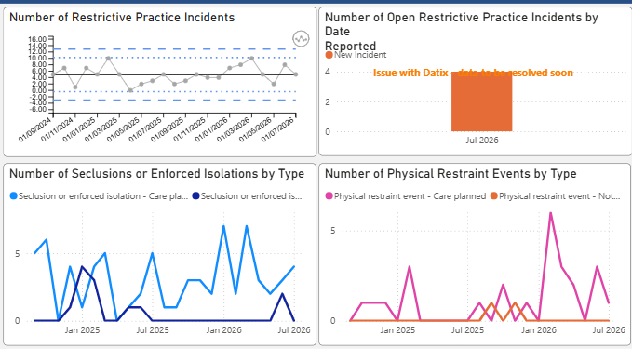
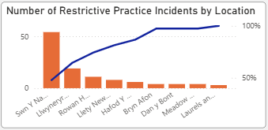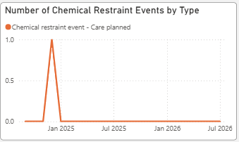

Mental Health (Wales) Measure 2010
Care and Treatment Plan compliance is generally on target across the three health board areas, where this drops, this is usually due to temporary instability in a team and quickly gets back to target. The directorate managers work closely with the clinical managers to focus support and target compliance.
IPC
There are environmental challenges associated with infection prevention and control in learning disability services, the environments are not set up with some of the requirements expected in a hospital/health setting, e.g. Having a sluice or being bare below the elbows (this can present difficulty when working with people who challenge by biting, scratching, pulling at others arms etc). People sometimes live in our services, and they have a homely feel, meal preparation and laundry tasks should be facilitated using an active support model, this can mean that some parts of our service require exceptions to be made related to policy. This is always appropriately considered with representatives from the IPC team.
We have consistently encouraged and supported a number of peer vaccinators across learning disability sites, as many of the areas are rural and not closely located, being able to empower our staff in the services to be vaccinated locally and to vaccinate their peers is helpful to the management of flu and reduce risks to our vulnerable patient group.

Falls
The division report small numbers of falls per month (approximately 4), often the falls are of those who are known to be at risk of falling, they are often low or no harm. All falls are investigated appropriately and care plans, risk assessments and guidelines reviewed. Commonalities: falls at night, when toileting, people who are known to be at risk of falls when in the community, e.g. accessing vehicles. Learning is reinforced with actions related to observations, education, communication with patients and reinforcing prescribed equipment and recommendations.
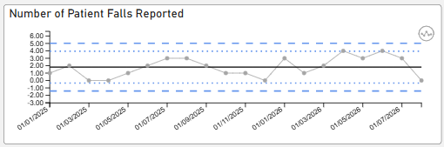
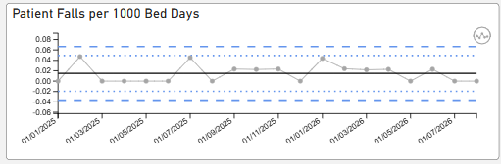
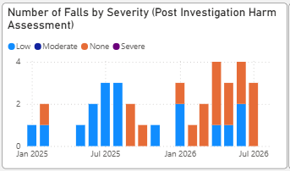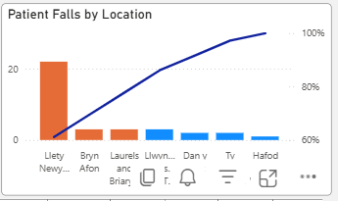
Mortality reviews
The service has embedded learning disability reviews directly into the NHS Wales Mortality Review Process to address findings that individuals with a learning disability die, on average, 20 years earlier than the general population.

Workforce
The resilience of our teams, their creativity, person centredness and passion for the services they provide and the people they support is something we are proud of as a service. We have an open communication system where we support staff to feel safe to speak up and raise concerns directly. We have good retention across the service, many staff request a retire and return option and work flexibly across the service, picking up bank contracts and supporting stability where possible. We are mindful of the impact of the modernisation work on staff morale and while there is excitement about future opportunities for the workforce and our service users there is also uncertainty. Learning from the recent staff survey encouraged us to demonstrate care and compassion towards each other, taking time to celebrate and thank staff has been highlighted as an action we need to encourage.
PADRs
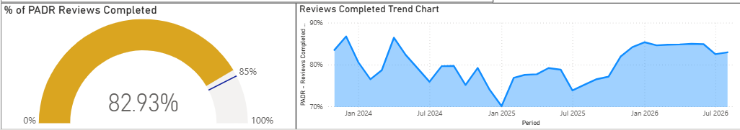
Sickness
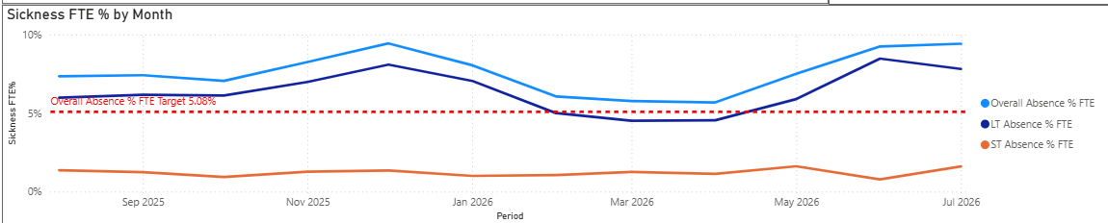
Mandatory Training
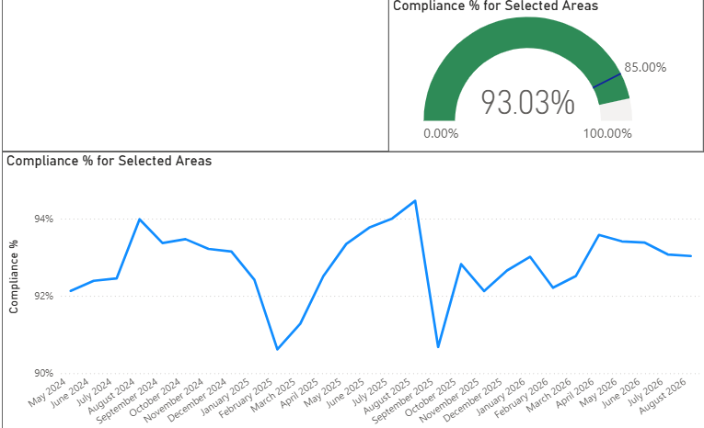
Rolling turnover
