

Your ref: | 24071
Our ref: | 202407678/EW/SW
Date: | 27 August 2026

Ask for: | Elaine Williams
 | 01656 641164
 | Elaine.Williams@ombudsman.wales

Ms Abigail Harris Chief Executive
Swansea Bay University Health Board Headquarters
One Talbot Gateway Baglan Energy Park Baglan
Port Talbot SA12 7BR

By email only abigail.harris7@wales.nhs.uk SBU.Listening2you@wales.nhs.uk

Dear Ms Harris

Complaint made to the Ombudsman by Mr W
Thank you for the letter dated 11 August from Liz Rix, Executive Director of Nursing and Patient Experience. I am very pleased that the Health Board has agreed to accept the recommendations in my draft report. I note that the Health Board requested an extension to the deadline for the following recommendation:

c) Provide evidence that training has been developed that specifically addresses the failings of Mr W’s case and a confirmed timescale for its implementation.

I have agreed to extend the deadline for this recommendation to 12 weeks and the report has been updated to reflect this.
I now enclose a copy of my final report, which has been issued under section 28 of the Public Services Ombudsman (Wales) Act 2019 (“the Act”). It has been anonymised to protect the privacy of the complainant and of individual officers of the Health Board. A copy of this letter and the report will be emailed to the contact officer. A copy of the report has also been sent to the complainant, the

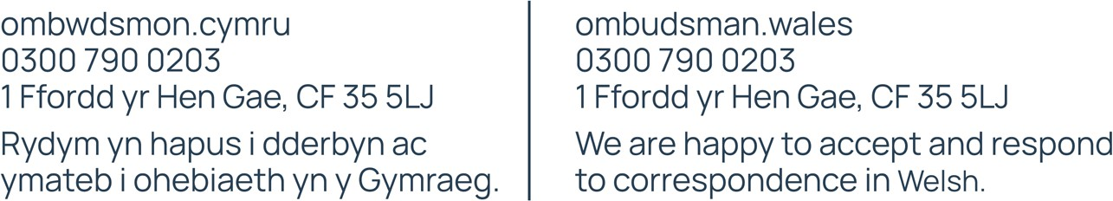
Page 1 of 2

Chair of Board, Healthcare Inspectorate Wales and the Cabinet Secretary for Health and Care. I do not propose to provide a hard copy version unless you wish to have one.
I now come to what is required of the Health Board in relation to my report. Under section 29 of the Act, I am entitled to publicise this Special Report and provide a copy of the published report, or any part of it, to any person who requires it. I am also entitled, should I choose, to publicise by way of a press notice and to require you to reimburse me for the cost of such notice (by section 29(3) of the Act).

However, in this instance, I am content for you to place a prominent notice and a link to the full text of the Special Report on the Health Board’s website. Please let my office know, as soon as possible, what steps you have taken to comply with this requirement.

I would draw your attention to the fact that, in accordance with my normal practice, I will be sending a copy of the report to relevant MSs/MPs and media organisations 1 week after the date of this letter. A week’s embargo on publication of details of the report will be attached to the copy sent to the media, but you should be aware of the possibility that you could receive enquiries from journalists about this matter in the meantime.
In addition, I shall be placing the report on my own website 2 weeks after the date of this letter. It would be helpful if you could also have regard to this date,
10 September, when uploading the report to your own website.
I now expect the Health Board to implement my recommendation within the timescales agreed. Please provide evidence to confirm that the recommendations have been carried out within the timescales set out in the report. Unless it is not practical to do so, this evidence should be emailed to caseinfo@ombudsman.wales
Yours sincerely

Michelle Morris
Ombwdsmon Gwasanaethau Cyhoeddus | Public Services Ombudsman Enc. Final Special Report

Page 2 of 2

