Cais Rhyddid Gwybodaeth / Freedom of Information request
Ein Cyf / Our Ref: 26-G-055
Dyddiad / Date: 07 August 2026

Thank you for your request for information. Please find below our response.
Please note that the information we have provided reflects the period January to June 2026.
Request and response:
- How many patients were initiated on Ruxolitinib (Jakavi) in the past 6 months for the following conditions? (Patients are classed as initiated if they have not received any of the above treatments in the previous 6 months)

- Myelofibrosis (ICD10 code D47.4) – 17 patients
- Polycythaemia Vera (ICD10 code D45) – 5 patients
- Graft vs Host Disease (GvHD) (ICD10 code T86.0 or D89.8) (SNOMED Code: SCTID: 234646005) – 0 patients

- How many patients were initiated with the following regimens for any condition in the past 6 months? (Patients are classed as initiated if they have not received any of the above treatments in the previous 6 months)

- Momelotinib - <5* patients
- Fedratinib – 0 patients

- How many patients were treated in the past 6 months for Polycythaemia Vera (ICD10 code D45) with?

- Hydroxycarbamide – 21 patients
- Interferon therapy - <5* patients

- Of the myelofibrosis (ICD10 D47.4) patients receiving the following treatments in the past 6 months, please indicate how many were receiving their first systemic therapy

(First systemic therapy = patient has not previously received any drug treatment for myelofibrosis, including hydroxycarbamide, interferon therapy, JAK inhibitors, or other systemic therapy. Excludes a watch and wait approach.)

Treatment | First systemic therapy | Received prior systemic therapy
Ruxolitinib (Jakavi) | <5* | 10
Fedratinib (Inrebic) | 0 | 0
Momelotinib (Omjjara) | <5* | 5

* Where fewer than 5 has been indicated we are unable to provide you with the exact number of patients as due to the low numbers, there is a potential risk of identifying individuals if this was disclosed. We are therefore withholding this detail under Section 40(2) of the Freedom of Information Act 2000. This information is protected by the General Data Protection Regulation (GDPR) and Data Protection Act 2018 and its disclosure would be contrary to the data protection principles and constitute as unfair and unlawful processing in regard to Articles 5, 6, and 9 of GDPR. This exemption is absolute and therefore there is no requirement to apply the public interest test.
I hope this information is helpful. If you require anything further, please contact us at FOIA.Requests@wales.nhs.uk.
Under the terms of the Health Board’s Freedom of Information policy, individuals seeking access to recorded information held by the Health Board are entitled to request internal review of the handling of their requests. If you would like to complain about the Health Board’s handling of your request, please contact me directly at the address below or register your complaint via FOIA.Requests@wales.nhs.uk.
If after Internal Review you remain dissatisfied you are also entitled to refer the matter to the information commissioner at the Information Commissioner’s Office (Wales), 2nd Floor, Churchill House, Churchill Way, Cardiff, CF10 2HH. Telephone Number: 0330 414 6421.
Yours sincerely
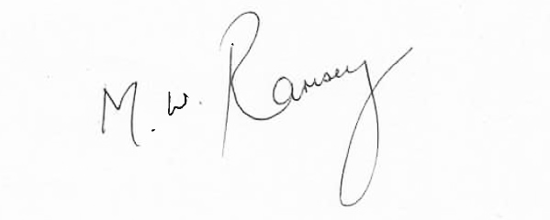
Mark Ramsey
Interim Medical Director
pp. Hazel Lloyd
Director of Corporate Governance

