Cais Rhyddid Gwybodaeth / Freedom of Information request
Ein Cyf / Our Ref: 26-G-
Dyddiad / Date: 05 August 2026

Thank you for your request for information. Please find below our response.
Request and response:
Q1. Within your health board, how many patients have been treated in the past 3 months (1st May-31st July 2026) for head and neck cancer (squamous cell carcinoma) with the following?
- Surgery only 10 patients starting the pathway in SBUHB and receiving first definitive treatment in the last 3 months.
- Radiotherapy only 9
- Surgery + Radiotherapy <5*
- Carboplatin (only or in combination with 5-FU) – not available**
- Cisplatin (only or in combination with 5-FU) – not available**
- Cetuximab with/without chemotherapy – not available**
- Cetuximab with radiotherapy – not available**
- Pembrolizumab monotherapy – not available**
- Pembrolizumab with chemotherapy – not available**
- Nivolumab – not available**
- Docetaxel (only or in combination with 5-FU) – not available**
- Fluorouracil (5FU) monotherapy – not available**
- Any other chemotherapy (without radiotherapy) – not available**
- Any other chemotherapy (with radiotherapy) please see below:
<5* patients received surgery, radiotherapy and chemotherapy.
17 patients received radiotherapy and chemotherapy
It is possible that some additional patients may have had surgery prior to radiotherapy, but this hasn`t been indicated on the radiotherapy booking request.

Q2. Could you please provide the number of patients treated in the past 3 months with the following agents for metastatic head and neck cancer (squamous cell carcinoma)?
- Cetuximab with/without chemotherapy – not available**
- Pembrolizumab monotherapy – not available**
- Pembrolizumab with chemotherapy – not available**
- Nivolumab – not available**
- Docetaxel (only or in combination with 5-FU) – not available**
- Any other chemotherapy (without radiotherapy) – not available**
- Any other chemotherapy (with radiotherapy) – not available**

Q3. How many patients who received Pembrolizumab for head and neck cancer (squamous cell carcinoma) in the last 3 months, received:
- Treatment every 3 weeks (200mg, Q3W) – not available**
- Treatment every 6 weeks (400mg, Q6W) – not available**

Q4. Could you please provide the number of patients treated in the past 3 months with the following agents for locally advanced head and neck cancer (squamous cell carcinoma)?
- Pembrolizumab monotherapy – not available**

*Where fewer than 5 has been indicated we are unable to provide you with the exact number of patients as due to the low numbers, there is a potential risk of identifying individuals if this was disclosed. We are therefore withholding this detail under Section 40(2) of the Freedom of Information Act 2000. This information is protected by the General Data Protection Regulation (GDPR) and Data Protection Act 2018 and its disclosure would be contrary to the data protection principles and constitute as unfair and unlawful processing in regard to Articles 5, 6, and 9 of GDPR. This exemption is absolute and therefore there is no requirement to apply the public interest test.

**This information is not held centrally. To obtain this information would involve a manual trawl and search of records which we have estimated would significantly exceed the 18 hours limit set down by the FOI Act as the reasonable limit. Section 12 of the FOI Act and The Freedom of Information and Data Protection (Appropriate Limit and Fees) Regulation 2004 provides that we are not obliged to spend in excess of 18 hours in any sixty day period locating, retrieving and identifying information in order to deal with a request for information and therefore we are withholding this information at this time.
I hope this information is helpful. If you require anything further, please contact us at FOIA.Requests@wales.nhs.uk.
Under the terms of the Health Board’s Freedom of Information policy, individuals seeking access to recorded information held by the Health Board are entitled to request internal review of the handling of their requests. If you would like to complain about the Health Board’s handling of your request, please contact me directly at the address below or register your complaint via FOIA.Requests@wales.nhs.uk.
If after Internal Review you remain dissatisfied you are also entitled to refer the matter to the information commissioner at the Information Commissioner’s Office (Wales), 2nd Floor, Churchill House, Churchill Way, Cardiff, CF10 2HH. Telephone Number: 0330 414 6421.
Yours sincerely
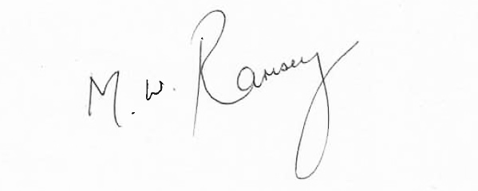
Mark Ramsey
Interim Medical Director
pp. Hazel Lloyd
Director of Corporate Governance

