Cais Rhyddid Gwybodaeth / Freedom of Information request
Ein Cyf / Our Ref: 26-G-038
Dyddiad / Date: 07 August 2026

Thank you for your request for information. Please find below our response.
Request and response:

Please provide the following information under the Freedom of Information Act for the most recent 24-month period (June 2024-June 2026):
- Total usage (units/ampoules) of acetylcholine chloride for intraocular irrigation.
A breakdown of usage by product, including:
- MIPHTEL 20mg
- Any other branded or unbranded acetylcholine chloride products
ACETYLCHOLINE CHLORIDE (MIOCHOL-E) (UNLICENSED) 20 mg Intraocular Irrigation | ACETYLCHOLINE CHLORIDE (MIPHTEL) 20 mg Intraocular Irrigation | Grand Total
18 | 8 | 26

- How many units of MIPHTEL were purchased/used, and from which suppliers (e.g., AAH, Alliance, Healthnet Homecare, Nordic Pharma).
Usage figures provided in the table above. Supplier detail below;
- ACETYLCHOLINE CHLORIDE (MIOCHOL-E) (UNLICENSED) 20 mg Intraocular Irrigation.
Product has been purchased from Alium Medical and Clinigen Healthcare LTD (IDIS)

- ACETYLCHOLINE CHLORIDE (MIOCHOL-E) 20 mg Intraocular Irrigation
Product has been purchased from AAH

- ACETYLCHOLINE CHLORIDE (MIPHTEL) 20 mg Intraocular Irrigation
Product has been purchased from AAH

- Details of any alternative products used for intraoperative miosis when acetylcholine chloride is required.
Not applicable
- Whether the Health Board uses or sources any generic versions of acetylcholine chloride; if so, please provide product name, supplier, and usage.
Not applicable
- Any supply issues experienced with MIPHTEL or acetylcholine chloride in the last 24 months.
None in the last 24 months
- Please can you provide the email and the named person for pharmacy Procurement
Pharmacy contracting is done by the National Sourcing Team in NHS Wales Shared Services Partnership (NWSSP). You will need to contact them for this information NWSSPProcurement.MedicalTeam@wales.nhs.uk.
I hope this information is helpful. If you require anything further, please contact us at FOIA.Requests@wales.nhs.uk.
Under the terms of the Health Board’s Freedom of Information policy, individuals seeking access to recorded information held by the Health Board are entitled to request internal review of the handling of their requests. If you would like to complain about the Health Board’s handling of your request, please contact me directly at the address below or register your complaint via FOIA.Requests@wales.nhs.uk.
If after Internal Review you remain dissatisfied you are also entitled to refer the matter to the information commissioner at the Information Commissioner’s Office (Wales), 2nd Floor, Churchill House, Churchill Way, Cardiff, CF10 2HH. Telephone Number: 0330 414 6421.
Yours sincerely
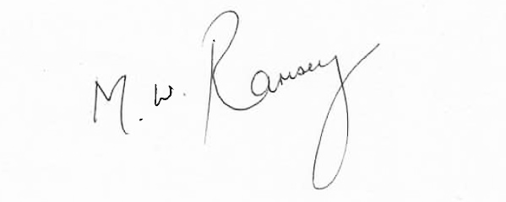
Mark Ramsey
Interim Medical Director
pp. Hazel Lloyd
Director of Corporate Governance

