Cais Rhyddid Gwybodaeth / Freedom of Information request
Ein Cyf / Our Ref: 26-A-071
Date:

You asked:
For each freestanding midwifery unit (FMU) and alongside midwifery unit (AMU) operated by Swansea Bay University Health Board, please provide the following information as routinely collected, in aggregated form, for the most recent five complete calendar years (or the longest period held if shorter):
Swansea Bay University Health Board (SBUHB) provides the following information in response to your request regarding transfers from midwifery-led settings.
The Health Board operates an Alongside Midwifery Unit (Singleton – Bay Birth Unit) and a Freestanding Midwifery Unit (Neath Port Talbot Birth Centre).
The FMU at Neath Port Talbot closed for three years and reopened in mid-September 2024. Therefore the data for this unit is only available for part of 2024 and for 2025.
Data is provided for the most recent periods held in a usable, aggregated format within the statutory cost limits of the Freedom of Information Act.
Please further note that variations in data recording, use of free-text fields, and incomplete timestamp entries limit standardisation across datasets.

- Number of transfers from FMUs and AMUs:
- Broken down by parity (nulliparous / multiparous), where held
- Broken down by stage:
  - Intrapartum
  - Immediate postnatal
  - Neonatal
AMU (Singleton):
Transfer activity is not recorded with breakdowns by parity and stage.
Intrapartum transfer rates ranged between 22–28%
Postnatal transfers between 8–10% across 2024–2025.
FMU (Neath Port Talbot Birth Centre):
Total transfer rates (intrapartum/postnatal/neonatal for all parity) is around 31%
2024 (16/09–31/12): 25 transfers – intrapartum (14), postnatal (7), neonatal (4).
2025 (to 30/09): 43 transfers – intrapartum (23), postnatal (12), neonatal (8).
Parity breakdown is recorded within the dataset, with the majority of intrapartum transfers occurring in nulliparous women.

- Reason for transfer, using the Health Board’s existing categories (e.g. request for epidural, slow progress, fetal concerns, maternal concerns, emergency).
AMU data is recorded using standard categories including
- slow progress
- fetal concerns
- maternal request for analgesia
- maternal clinical concerns.

FMU data is recorded as free text and has been grouped into the following broad categories:
- fetal concerns
- maternal concerns
- slow progress/dystocia
- neonatal concerns
- maternal request for analgesia
The most common reason for transfer from both MU’s is slow progress of labour/labour dystocia
- Mode of transfer, where recorded (e.g. ambulance, private car, internal transfer).
AMU:
Mode of transfer is not consistently recorded in structured datasets but will always be on foot or wheelchair/bed.
FMU:
The majority of transfers occur via 999 ambulance. Alternative modes include internal transfer services (Urgent Care Service), taxi with midwife and private car.

- Timing metrics, where these are routinely monitored or audited, including:
- Time from decision to transfer to departure from the midwifery-led setting
- Time from departure to arrival at the obstetric unit
- Time from arrival to first medical review
(Please provide averages, medians, or ranges as held.)

AMU:
Departure to arrival times range from approximately 9–11 minutes, with time to first obstetric review typically 22–27 minutes.
FMU:
2024:
Decision to departure (median 60 mins)
Departure to arrival (median 32 minutes).
2025:
Decision to departure (median 47 mins)
Departure to arrival (median 30 minutes)
Arrival to review (median 24.5 minutes).
Please note that some timing fields are incomplete or recorded as ‘not available’, and results are reported as held.

- Birth outcomes following transfer, including:
- Whether birth occurred within 1 hour of arrival at the obstetric unit
- Mode of birth (e.g. spontaneous vaginal birth, instrumental birth, caesarean section), where held in transfer audits
AMU:
Birth within one hour of transfer is routinely recorded.
FMU:
2024:
<5* intrapartum transfers resulted in birth within one hour (of 14 recorded cases).
2025:
5 intrapartum transfers resulted in birth within one hour (of 23 recorded cases).
Modes of birth following transfer include spontaneous vaginal birth, instrumental birth, and caesarean birth.

- Clinical outcomes, including:
- Number of transfers associated with an adverse clinical outcome, as defined by the Health Board
Please note that primary perinatal outcome defined as intrapartum stillbirth, early neonatal death, meconium aspiration, Grade 2/3 hypoxic ischaemic encephalopathy and fractures of the humorous/clavicle
Outcomes for women planning to birth in Neath Port Talbot Birth Centre (NPBC FMU), disaggregated into parity, against outcomes of Birthplace (2011) by percentage.
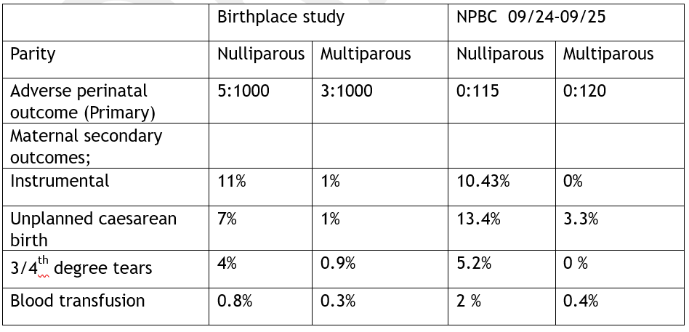
- Number of transfers reviewed as part of a serious incident review or equivalent governance process
Nil

- Copies of, or links to, any internal audit reports, dashboards, or annual summaries used by the Health Board to monitor transfers from midwifery-led settings during the period requested.
I can confirm that the health board does hold an internal transfer database for monitoring transfers from midwifery led settings. However, we are unable to provide you with these files as due to the level of detail relating to individual patients held within, there is a potential risk of identifying the individual if this was disclosed. Therefore, the data is classed as personal data as defined under the General Data Protection Regulation (GDPR) and Data Protection Act 2018 and its disclosure would be contrary to the data protection principles and constitute as unfair and unlawful processing in regard to Articles 5, 6, and 9 of GDPR. We are therefore withholding this detail under Section 40(2) of the Freedom of Information Act 2000. This exemption is absolute and therefore there is no requirement to apply the public interest test.

Transfers from midwifery-led settings are not subject to formal audit processes, as there is no national formal standard for benchmarking.
Please find attached the template audit forms used for transfer monitoring, however we are unable to provide you with any completed versions due to patient confidentiality as referred to above.
- A brief description of:
- The definitions used by the Health Board for “transfer”
A transfer is defined as the movement of a woman and/or baby from a midwifery-led setting to an obstetric unit for clinical assessment or intervention.
- Any known limitations in the data (e.g. changes in recording practice, digital vs paper tools)
Please note that that there were no births in the FMU September 2021 - 16th September 2024 due to closure.
Variations in data recording, use of free-text fields, and incomplete timestamp entries limit standardisation across datasets.

I hope this information is helpful. If you require anything further, please contact us at FOIA.Requests@wales.nhs.uk.
Under the terms of the Health Board’s Freedom of Information policy, individuals seeking access to recorded information held by the Health Board are entitled to request internal review of the handling of their requests. If you would like to complain about the Health Board’s handling of your request, please contact me directly at the address below or register your complaint via FOIA.Requests@wales.nhs.uk.
If after Internal Review you remain dissatisfied you are also entitled to refer the matter to the information commissioner at the Information Commissioner’s Office (Wales), 2nd Floor, Churchill House, Churchill Way, Cardiff, CF10 2HH. Telephone Number: 0330 414 6421.
Yours sincerely

Hazel Lloyd
Director of Corporate Governance

