Cais Rhyddid Gwybodaeth / Freedom of Information request
Ein Cyf / Our Ref: 26-A-046

You asked:
Please see below a Freedom of information request regarding major trauma care within Wales:
Examples of MTC, TU, RTU, LEH:
- Major Trauma Centre
  - University Hospital Wales
  - Southmead Hospital
  - Queen Elizabeth Hospital
  - University Hospital Stoke
  - Aintree University Hospital
- Trauma Unit
  - Glangwili Hospital
  - Morriston Hospital
  - Princess of Wales Hospital
  - Prince Charles Hospital
  - The Grange Hospital
  - Bristol Royal Infirmary
  - Gloucester Royal Hospital
  - Hereford County Hospital
  - Royal Shrewsbury Hospital
  - Wrexham Maelor Hospital
  - Countess of Chester Hospital
  - Glan Clwyd Hospital
  - Ysbyty Gwynedd
- Rural Trauma Unit
  - Withybush General Hospital
  - Bronglais Hospital

- Number of patients per county in Wales aged 18 and over in 2024 who meet major trauma criteria and were attended by EMRTS.
1088 patients
- Number of the above patients per county who received the below critical care resources as the most advanced resource on scene:
- EMRTS HEMS – 702 patients
- EMRTS car Doctor-led – 161 patients
- EMRTS car Paramedic-led - 225 (nb. Critical Care Practitioners which include Nurses)
- Average time to arrival from 999 call for each of the above resources per county. If time from 999 is not held then time from EMRTS activation.
- EMRTS HEMS – 41 minutes average
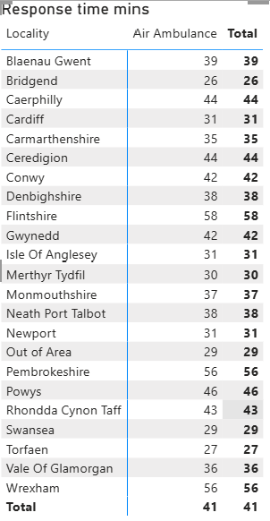
- EMRTS car Doctor-led - 39 minutes average
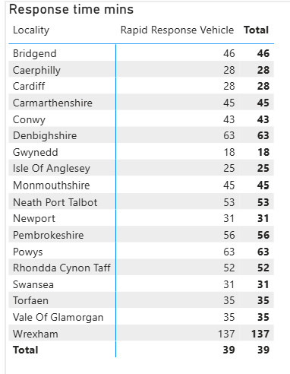
- EMRTS car Paramedic-led - 44 minutes average (nb. Critical Care Practitioners which include Nurses)
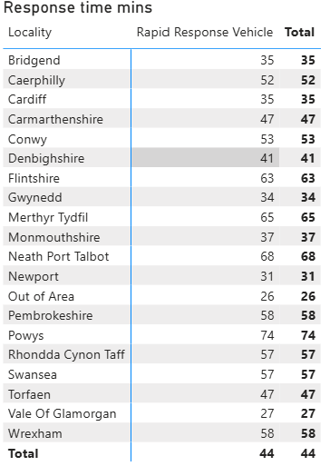
- Number of the above patients per county who were transported directly to the below destinations (non-exhaustive examples of these have been included below to help identify):
- Major Trauma Centre
- Trauma Unit
- Rural Trauma Unit
- Local Emergency Hospital
Locality | Major Trauma Centre | Rural Trauma Unit | Trauma Unit | Local Emergency Hospital
Blaenau Gwent | 8 | 0 | 9 | 0
Bridgend | 13 | 0 | 21 | 0
Caerphilly | 35 | 0 | 17 | 0
Cardiff | 89 | 0 | 36 | 0
Carmarthenshire | 8 | 8 | 76 | 0
Ceredigion | <5* | <5* | 29 | 0
Conwy | <5* | 0 | 29 | 0
Denbighshire | 8 | 0 | 20 | 0
Flintshire | 26 | 0 | 20 | 0
Gwynedd | 38 | 0 | 29 | 0
Isle Of Anglesey | <5* | 6 | 33 | <5*
Merthyr Tydfil | 8 | 0 | 11 | 0
Monmouthshire | 14 | <5* | 31 | 0
Neath Port Talbot | 26 | 0 | 14 | 0
Newport | 18 | 0 | 49 | 0
Out of Area | 10 | 0 | 10 | 0
Pembrokeshire | 34 | 0 | 8 | 0
Powys | 0 | 0 | 13 | 0
* Where fewer than 5 has been indicated we are unable to provide you with the exact number of patients as due to the low numbers, there is a potential risk of identifying individuals if this was disclosed. We are therefore withholding this detail under Section 40(2) of the Freedom of Information Act 2000. This information is protected by the General Data Protection Regulation (GDPR) and Data Protection Act 2018 and its disclosure would be contrary to the data protection principles and constitute as unfair and unlawful processing in regard to Articles 5, 6, and 9 of GDPR. This exemption is absolute and therefore there is no requirement to apply the public interest test.
- Average time from 999 to arrival at the destination hospital for each county for the above patients. If time from 999 is not held then time from EMRTS activation.
Locality | Average of Call to hospital (HH:MM:SS)
Blaenau Gwent | 01:35:07
Bridgend | 01:37:16
Caerphilly | 01:34:57
Cardiff | 00:56:58
Carmarthenshire | 01:27:46
Ceredigion | 01:51:46
Conwy | 01:41:34
Denbighshire | 01:47:45
Flintshire | 01:23:02
Gwynedd | 01:22:17
Isle Of Anglesey | 01:26:59
Merthyr Tydfil | 01:37:13
Monmouthshire | 01:40:32
Neath Port Talbot | 01:45:07
Newport | 01:30:12
Out of Area | 01:27:20
Pembrokeshire | 01:48:14
Powys | 01:41:08
Rhondda Cynon Taff | 01:28:16
Swansea | 01:29:44
Torfaen | 01:38:23
Vale Of Glamorgan | 01:18:14
Wrexham | 01:32:21

_____________________________________________________________

