Local Health Board Assessment of Readiness for 45-Minute Automatic Ambulance Patient Handover

Instructions:
- Complete all sections with concise, evidence-based responses.
- Consider as part of your ‘Discharge Winter Sprint Fortnight’ preparations.
- Return the completed template to UrgentAndEmergencyCare.GovernmentBusiness@gov.wales by 5 December 2025.
Section | Item | LHB Response
State of readiness
Current performance | Provide data on performance against 15-minute and 45-minute handover targets | 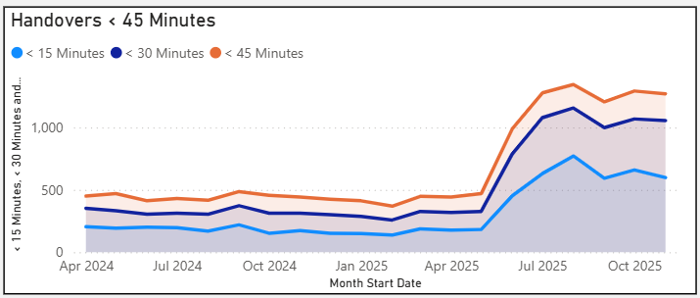
Immediate risks to delivery | Identify risks across emergency departments and inpatient areas (including infection prevention and control, health and safety) | - ED Demand: There has been a 12% increase in ED attends since October 2025, and a 21% increase since January 2025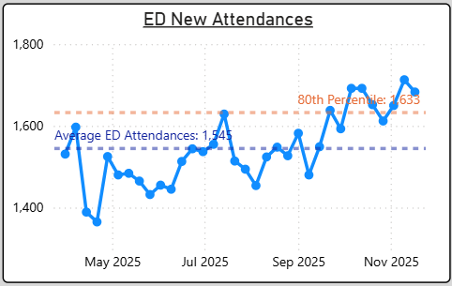  - ED Ambulance Attends: There has been a 10.2% increase in Ambulance Attendances since October 2025.  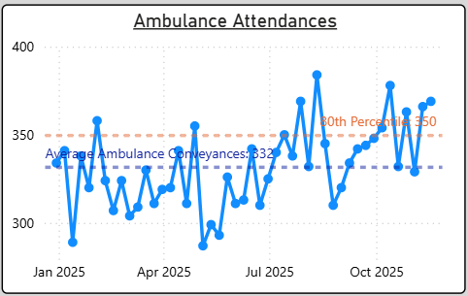  - Recent GIRFT SEDIT data indicates a high level of delay related harm both nationally and locally.  - ED capacity and design recognised as sub-optimal in terms of departmental flow and capacity.  - When all system escalation actions completed, the risk is held in ED which has a direct correlation to patient harm reported through SI’s and Datix – including inability to physically access patients due to crowding, no physical space to resuscitate patients, obstruction to essential equipment & access.  - Further moral injury to staff working in ED  - Infection outbreaks resulting in reduced bed capacity (currently 13 beds out of use and loss of associated YNP spaces)  - Number of clinically optimised patients and associated bed days consumed impacting system flow, particularly on Morriston site – (HB plan to decant 30 patients off the Morriston site to Singleton with a different workforce model, MDT approach to expedite flow).
Discharge planning | Outline capacity for discharge planning (complex vs. simple cases; weekend performance) | - Integrated discharge hub in place and adopting trusted assessment model of discharge at front doors including ED/AMU/OPAU.  - System largely reliant on ‘assess to discharge’ model with multiple assessments undertaken in hospital beds.  - Limited reablement capacity resulting in backlog of Pathway 1 patients in hospital.  - Pathway 3 challenges due to ‘top-up’ fee arrangements resulting in prolonged lengths of stay.  - Reviewing Pathway 2 arrangements through partnership process mapping events pre-Christmas aimed at redesigning the pathway, defining the Pathway 2 bed pools with clear eligibility criteria and reducing length of stay for this patient cohort.
Surge capacity and mitigation plans | Describe plans for delivery of care in undesignated or non-clinical environments (including surge capacity planning) | - Surge capacity delivered using capacity that would usually close out of hours and weekends such as OPAU, Theatre Admissions Unit.  - The transfer of 30 clinically optimised patients from the Morriston site is aimed at reducing reliance on AMU surge to improve patient experience and flow.  - ‘Your Next Patient’ part of the core operating model which provides circa 41 spaces HB wide to accelerate placement of patients into the appropriate specialty beds earlier in their pathway.  - Recent opening of Glyn Nedd, LA funded Pathway 2 bed pool thus increasing the total bed pool across the Health and Social Care footprint.
Community and wider system considerations
Engagement | Detail engagement with local clinical teams | - Communications team active in the community to promote Winter initiatives aimed at signposting patients to appropriate services.  - Increasing the availability of communications in community services such as dentists, GP practices in addition to the range of communications available via social media.  - Frequent opportunities for integrated discussion with Health and Social Care partners through established forums in the Regional Partnership space.  - Strong engagement with WAST as part of daily operations and through joint programmes of work.  - Specific Winter messages in pipeline both staff and public facing
Service delivery | Assess impact on community services and social care | - Increased demand on community services as admission avoidance opportunities are maximised.  - Impact on social care partners as need to decrease the clinically optimised patient numbers held in acute beds.  - Predictable increase in demand into GMS services with generally increased urgent primary care demand into UPCC/GPooH services.
Governance and Escalation | Explain local governance and escalation mechanisms | - There are daily safety huddles in place that occur up to three times daily. System representation on calls with clear escalation actions defined for all levels of escalation.  - Weekly escalation meetings in place with LA partners in relation to the Clinically Optimised patient cohort with agreed escalation actions.  - Formal reporting of UEC measures into the UEC Board and in the Community and Older Persons Board in the Regional partnership.  - Granular statistical process control of key system metrics reviewed weekly.
Support requirements
Resources | Specify any data/analytics, programme management, or additional resource requirements | - Winter dashboard developed aligned to the Early and Weekend Discharge Winter Sprint Fortnight measures.  - Access available to Business Intelligence dashboards that cover the UEC service scope, clinically optimised patient cohort and in-patient measures.  - Limited availability to system data due to fragmented digital systems – therefore pathway management and tracking of patients across services is not available.  - Extensive programme of work ongoing across the UEC pathway with bespoke work on the clinically optimised patient pathways and workforce models – Deloitte supporting in the short term. Ongoing programme management resource would be beneficial but is currently unavailable.
Implementation option (please confirm with an X and narrative where relevant)
All-Wales launch in December/January
Selective launch (ready sites or underperforming sites only)
Flexible and phased approach with implementation by the end of January 2026 |  | X – refer to narrative below.
Timing, risks, lead executive
Your preferred launch timing: December or January. |  | January 26 - movement of 30 clinically optimised patients from Morriston to Singleton with a revised operating model aimed at increasing flow would be a key enabler to delivery.
Any dependencies or risks requiring escalation |  | - Clinically optimised patient position  - IPC capacity impact during Winter
Named executive lead(s) for coordination |  | Deb Lewis, Chief Operating Officer SBUHB

