Cais Rhyddid Gwybodaeth / Freedom of Information request
Ein Cyf / Our Ref: 26-A-009

You asked:
We would like to understand the volume of implantable ports purchased and which clinicians/clinical areas these are implanted and would be most grateful if you could kindly provide the information requested below:
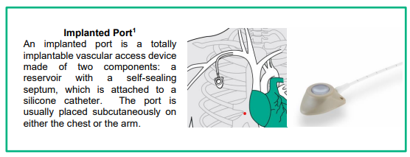

- Has your organisation purchased implantable ports in the last 3 years?
Yes, I can confirm that Swansea Bay University Health Board have purchased implantable ports in the last 3 years (2022-2025).
- If yes to Question 1, please can you kindly provide a purchasing export report detailing the following relevant to implantable ports for the time periods stated and name the files according to the financial year, including all supply routes.
- Manufacturer
- Brand
- Product Code
- Description
- Volume (in pieces)
- Supply route for example, Direct, NHS Supply Chain etc
Time Periods
- 1st April 2022-31st March 2023
- 1st April 2023-31st March 2024
- 1st April 2024-31st March 2025

Please see attached.
Please note there were no orders for April 22 – March 23. All orders are direct purchases with the supplier.

- If yes to Question 1, please mark with an ‘x’ which clinicians/clinical areas implant ports:
Surgeons
Anaesthetics | x
Interventional Radiology
Vascular Access Nurses
Other (please state)

_____________________________________________________________

