SBUHB COSHH Risk Assessment Form

Ref:

This assessment only addresses the risk of harm to health from possible exposure to the substances listed. Additional risk assessments may be required to control the risk from other hazards e.g. electrical equipment etc. associated with work.

Location of this COSHH Assessment | Theatre Department

What will the chemical(s) be used for? | Storage and adding formalin to tissue samples requiring histology investigations

What is (are) the names of the chemical involved in the process/this assessment | Formalin10% neutral buffered - updated safety data sheet available on file

Symbol | Description | Tick | Symbol | Description | Tick
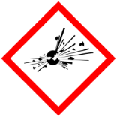 | Explosive, self-reactive, organic peroxides |  | 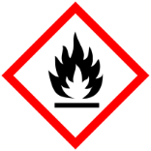 | Highly flammable
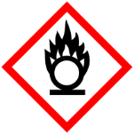 | Oxidising gases, liquids and solids |  | 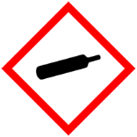 | Gases under pressure
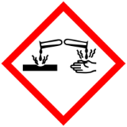 | Corrosive (causes severe skin burns and eye damage), serious eye damage. |  | 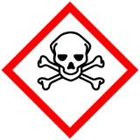 | Acute toxicity, Very Toxic (fatal), Toxic etc.
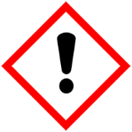 | Harmful skin irritant , serious eye irritant, skin sensitization | X | 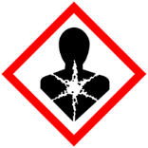 | Respiratory sensitiser, mutagen, carcinogen, reproductive toxicity | X
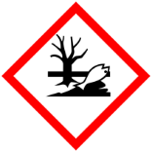 | Hazardous to the aquatic environment |  |  | Acute toxicity, Very Toxic (fatal), Toxic etc.

Who might be exposed? (tick or complete all relevant boxes)
Staff using the chemical | X | Persons in close proximity etc. |  | Visitors  Patients |  | Others

At what stage might exposure take place? (tick or complete all relevant boxes
Transportation |  | Preparation for use |  | Actual use | X | Finishing e.g. rinsing
Waste disposal |  | Spillage | X | Accessed by patients etc. |  | Inadequate/Insecure storage
Other
(describe)

How will exposure be prevented or controlled?
Symbol | Description | Tick | Symbol | Description | Tick
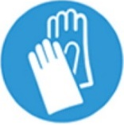 | Gloves | x | 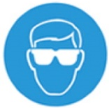 | Eye protection (EN166) standard – decontaminate between use | x
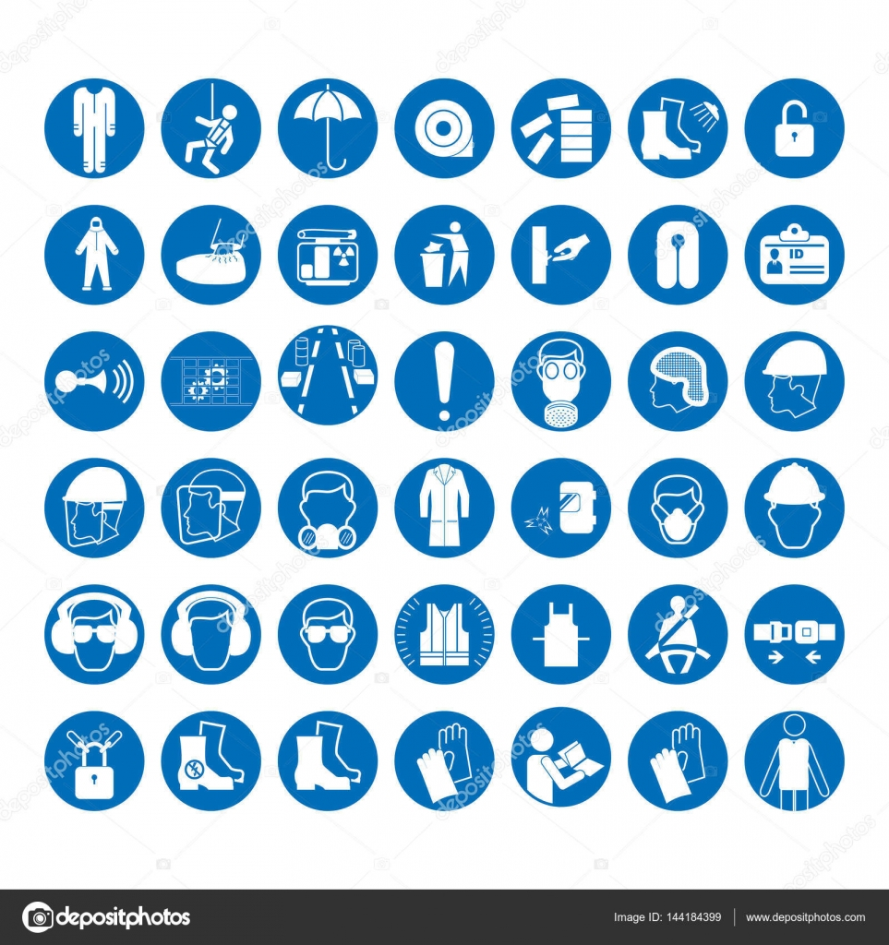 | Apron | x | 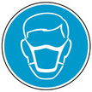 | Reusable Face mask with ABEK1P3 Filteration | x
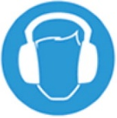 | Ear protection |  | 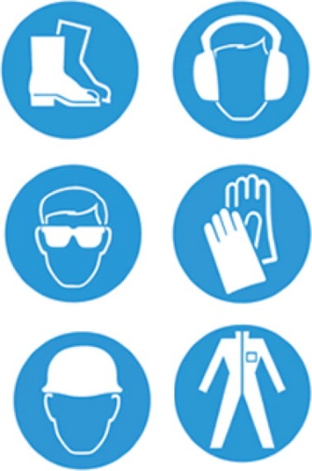 | Hard hat
 | Hi Viz |  |  | Hand Hygiene (before and after use)
 | Avoid skin contact | x | 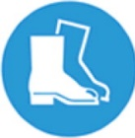 | Safety Footwear
Other (describe) |  |  | Other (describe)
Other (describe) |  |  | Other (describe)

How will expose be prevented or controlled? (tick or complete all relevant boxes)
Procedure/SOP/  Instructions | x | Containment  (fume cabinet) |  | Good general ventilation | x | Local Exhaust Ventilation
Use by competent staff only | x | Lockable cabinet/stores |  | Health surveillance. |  | Spillage procedure | x
Other (describe) |  | - Staff awareness  - Ensure containers and transportation bags are intact – link in with Histology Health and safety lead  - Adherence to Pathology transport policy  - Spill kits kept in every pharmacy room within theatres and replenished when utilised

Other Comments to support this assessment

In the event of:
SPILLAGE | Spill kits available in all theatre Department – contact histology for advice if required  Is spillage is more than 5 litres – evacuation of the area -contact Health and Safety team and contact the Fire Service for assistance
FIRST AID | Carry out first aid at the scene as necessary – refer staff to occupational health for follow up as required
FIRE | Activate Fire Policy – if able use dry chemical or carbon dioxide extinguishers

Please tick the residual risk level identified from the Health Board risk matrix:

Minor | x | Moderate |  | Major |  | Critical

Date of Assessment
Assessor(s) (print name and job title)
Assessor(s) signature

Date of Assessment Review
Assessor(s) (print name and job title)
Assessor(s) signature

