
Sexual Health Services Review – Patient Engagement
Swansea Bay Sexual Health Service offers contraception (preventing pregnancy), testing and treatment for Sexually Transmitted Infections (STIs), and support and counselling. These services are free and available to everyone and services are confidential.
You are able to get:
- information and provision of different types of contraception
- emergency contraception, pill and coil
- advice on STIs and how to protect yourself
- pre-exposure prophylaxis (PrEP)
- post-exposure prophylxis (PEP)
- prophylaxis vaccinations for men who have sex with men, hepatitis A, B, human papillomavirus (HPV), smallpox vaccination to protect against monkeypox
- testing and treatment for STIs and HIV
- support after sexual assault
- pregnancy advisory services (terminations)
- counselling for sexual problems (psychosexual counselling)
We will be looking at how we provide Sexual Health Services in the future for our patients and want to understand
- are our services easy to get to / access?
- how can we improve our future services?
It is important we understand what our services are like from a patient perspective.
The Patient Engagement will take place from Friday, 25th August, 2023 to Friday, 6th October, 2023.

You can access a copy of the Questionnaire by clicking on either the link or QR code below:

https://forms.office.com/e/mBsV9FhNwu

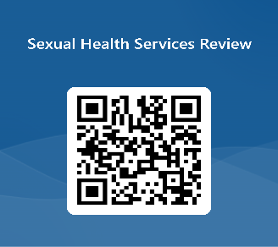

Thank you for taking the time to complete this questionnaire.

