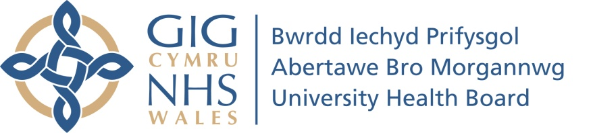

Meeting Date | 12th December 2023 |  | Agenda Item |  |  | 3.1
Report Title | Retention Deep Dive
Report Author | Guy Holt Associate Head of HR
Report Sponsor | Debbie Eyitayo Director of Workforce and OD
Presented by | Sharon Vickery Assistant Director of Workforce
Freedom of Information | Open
Purpose of the Report | To provide the Workforce, OD and Digital Committee with insight into the staff retention performance of the Health Board in comparison to national rates and peer organisations. Additionally to provide detail from across the Health Board of activity aimed at facilitating good staff retention and the plans we have going forward to continue this work.
Key Issues | To provide the Workforce, OD and Digital Committee assurance that the Health Board continues to take proactive and innovative actions to maintain good staff retention in the current context and to promote SBUHB as a place to work good place to work.
Specific Action Required  (please one only) | Information | Discussion |  | Assurance | Approval
Specific Action Required  (please one only) |  |  |  | x
Recommendations | The Workforce, OD and Digital Committee is asked to note:  - The contents of this retention deep dive and the plans for retention activity moving forward

RETENTION DEEP DIVE

- INTRODUCTION

The purpose of this paper is to provide a deep dive into staff retention activity and future plans in SBUHB,

- BACKGROUND

‘A Healthier Wales: Our Workforce Strategy for Health and Social Care’ sets out the ambition to have a motivated, engaged and valued health and social care workforce with the capacity, competence and confidence to meet the needs of the people of Wales. It states “The most cost-effective way to ensure NHS Wales has the staff we need in the future is to support and retain the people we already employ. Many of our future workforce are with us today, and retaining our workforce is as important as recruiting”

Over the last 2 years we have heavily focussed on recruiting into our most difficult to fill posts and posts where we have significant vacancies. This work has resulted in a significant reduction in areas such as Band 5 general nursing and Band 2 ward based HCSW’s as well as certain medical specialty vacancies. This focus is helping to reduce our spend on agency staff and we are predicted to save circa £10m in agency costa by the end of 2023/24. However if we fail to focus attention on ensuring we have strategies in place to help retain our existing and new staff we risk reversing the excellent work achieved to date.

What is Staff Retention?

Employee retention basically refers to the ability of an employer to manage and avert unwanted employee turnover. Retaining key staff, while maintaining a healthy turnover, is important for efficiency. No employer wants to lose skilled and experienced staff; however, new people can bring a fresh perspective, new ideas and ways of working, and additional expertise to the workplace.

Measuring staff turnover/retention

The Chartered Institute of Personnel and Development (CIPD) states retention refers to the number of retained employees, measured as the proportion of employees with a specified length of service, (typically one year or more) expressed as a percentage of overall workforce.

The term is used broadly to cover all leavers, voluntary and involuntary, including those who resign, retire or are made redundant, in which case it’s describing overall, or ‘crude’, employee turnover.

Annual labour turnover rate = (Employees who left during the year/ Average number of employees for the year) x 100

An alternative approach is via stability index. This indicates the retention rate of employees.

Like turnover rates, this can be used across an organisation as a whole or for a particular part of it. The usual calculation for the stability index is:

Number of staff with service of one year or more x 100
Total number of staff in post one year ago

The advantage of the stability index is that it has a more positive focus in that it measures the number of staff we have retained rather than the number that have left.

What does the data tell us?

In the Labour Turnover Rates report 2023 by Cendex, the overall total labour turnover rate for public sector organisations over the year to July 2023 stood at 18.5%.

A NHS (Wales) Workforce data briefing produced by the Auditor General for Wales in September 2023 evidenced (see 1 below) that staff turnover at an all-Wales level had increased in recent years, with a peak in 2021-22 linked in part to staff on short-term contracts employed during the pandemic. However by 22/23 rates had reduced to under 9%. This briefing also provided turnover rates across NHS Wales organisations for 2022/23 (see 2 below) This shows that in comparison to our peer organisations we were performing well at just over 10% vs the worst performing Health Board at nearly 20%

- All Wales staff turnover as of March of each 2. Staff turnover by organisation 2022/23
financial year

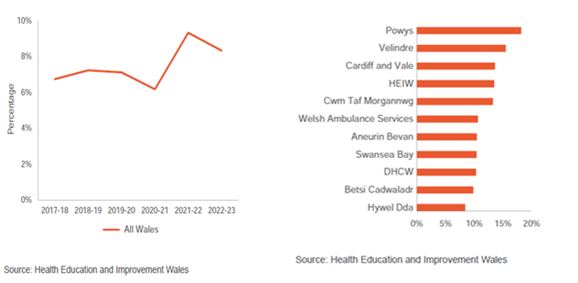
Note: individual organisation staff turnover is higher than all Wales because a staff member may move from one organisation in Wales and join another in Wales. This would count as turnover for an individual body. It would not count as turnover at an all-Wales level. All Wales turnover only includes staff leaving NHS Wales completely.

The data used in this section covers the last four full years between 1st April 2019 and 31st March 2023. In addition the first 7 months data of 23/24 is provided. For consistent annual comparisons this section will compare full year data however the most recent data has been provided to give an insight into what year ending 31st March 24 performance may look like especially as the most recent months data will yet to be finalised due to late termination form submissions and processing etc.
Chart 1 provides monthly Labour Turnover Percentages (LTR) for the reporting period in order to begin identifying patterns or trends. True turnover rates were used for the purpose of this report. Using rolling turnover rates which incorporates the previous 12-month headcount and leaver data would have included staff leaving the Health Board during the Bridgend Boundary change and significantly skew the figures particularly in year 1 (2019/20).
The chart shows that whilst the overall annual turnover rate increased consistently between 1st April 2019 and 31st March 22 the year 2022/23 saw the first reduction in this trend in 3 years and if the average monthly trend for the remainder of 2023/24 remains the same the end of the year will likely see a similar turnover rate to last year or slightly less.

Chart 1 - HB Wide Full year Turnover rates (accumulative and monthly average) 2019 – 2023
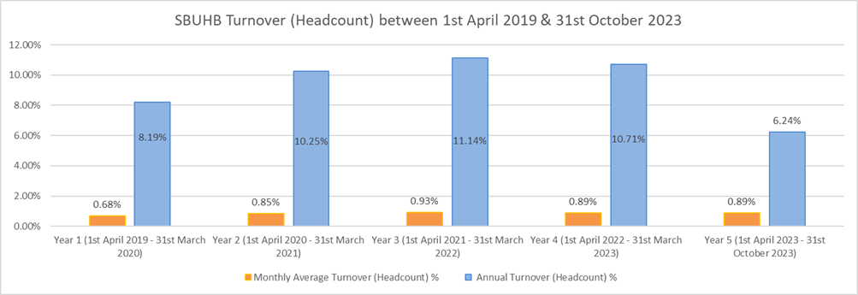
As already mentioned above another way to present retention performance is via a Stability Index in Table 1 below this index figure is shown for the period between 1st April and 31st October. This shows that 13,837 Employees were in post at the start of the period, with 13,403 remaining at the end meaning 96.86% of employees were retained within this period.
Table 1 - Labour Stability Index 1st April 2023 – 31st October 2023
 |  | Start | End | Remain | Index
130 Swansea Bay University Local Health Board | Headcount | 13,837 | 14,075 | 13,403 | 96.86%
130 Swansea Bay University Local Health Board | Assignment Count | 13,991 | 14,223 | 13,530 | 96.71%

A further analysis below has been undertaken to assess turnover rate by staff group to understand if there are any particular trends and patterns. Chart 2 displays annual turnover percentage Headcount Labour Turnover Rate for each staff group during the reporting period. For the last full year 2022/23 the majority of the staff groups remained generally static however the most significant reduction was in the Nursing and Midwifery (N&M) group which saw a 2.5% decrease in annual turnover compared to the previous full year 21/22. In contrast the staff group that saw the largest increase was Admin and Clerical (A&C) this being a 3% increase compared to the previous full year 21/22. For noting for 2023/24 there appears likely to be a significant increase in Medical & Dental (M&D) staff group turnover.
Chart 2
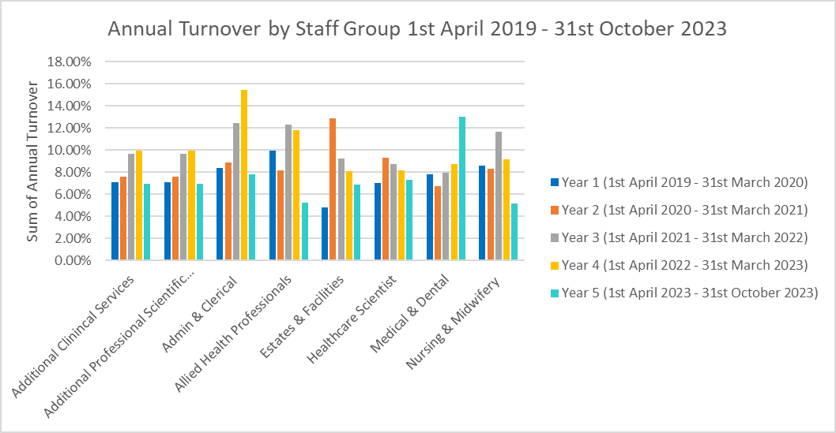

A further analysis has been undertaken to assess turnover rate for each Service Group to understand where staff are leaving from and identify trends and patterns. Chart 3 displays annual percentage labour turnover rate for each service group during the reporting period.

Each of the clinical Service Groups experienced their highest accumulative annual turnover during 2021/22 with Primary Care, Communities and Therapies Group displaying significant increases of on the previous year. Similar increases occurred in Neath Port Talbot Singelton, Mental Health and Learning Disabilities and Morriston. It’s worth noting that turnover in these service groups dropped in 2020/21 compared to 2019/20 which may account partly for the large increases in 2021/2. The drop in turnover 2020/1 compared to the previous year may be due to the increase in staff recruitment in response to the COVID pandemic and existing staff wishing to delay leaving the Health Board to assist in the Health Board’s response.
Turnover in corporate areas did not follow a similar pattern, peaking during 2020/21 which will distort overall Health Board turnover rates for the period 2020/21. Key events which contributed to this are the end of fixed term contracts of Nursing and Medical Students who were employed to assist the Health Board’s response to the COVID pandemic. These temporary staff were positioned under the Strategy Directorate and end of fixed term contract leavers peaked during May, July and August 2021 and continued throughout the reporting period. Whilst 2021/22 did not hit the peaks of the previous year, turnover rate continued to be high during 2021/22 which further analysis shows is not solely related to staff temporarily employed with assist in the response to COVID.
Figures for the last full year to end March 23 show an improvement in retention across all groups, the best improvement being in NPTS group at over 1.50%. A slight increase was observed in PCT (0.28%) and Corporate saw the largest increase in turnover of almost 2%.
Chart 3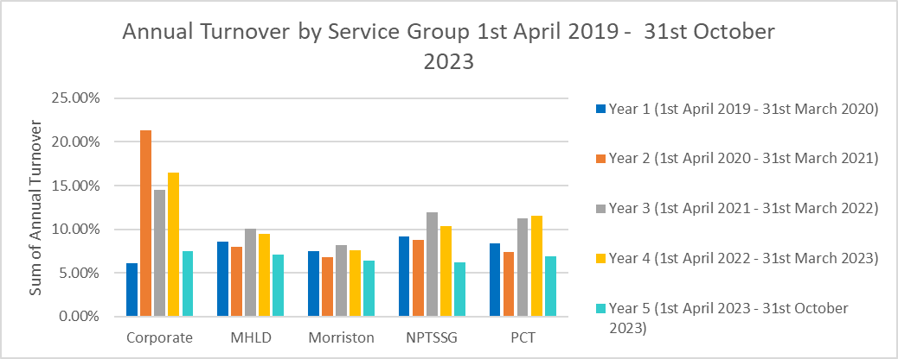
Chart 4 below focuses on understanding why staff are leaving the Health Board, It provides a summary of all leavers in each financial year between 1st April 2019 and 31st March 2023 and the Reason for Leaving the Health Board as recorded on ESR. It also provides the same data for the first seven months of the current financial year.
From this data we can see that Leavers by Retirement Age account for by far the highest number of leavers during the period accounting for 25% of all leavers in the last full financial year 2022/23 and is 5% less than in 2021/22.
In addition we have seen a general increase in the number of individuals deciding to retire (access their NHS pension) and return in 2022/23 compared to 2021/22 (see Chart 5 below)
There was also a decrease of Voluntary Resignation Other/Not Known of 3% across the same financial years. Some of this may have been driven by a push to provide a defined reason when completing termination forms.
Chart 4 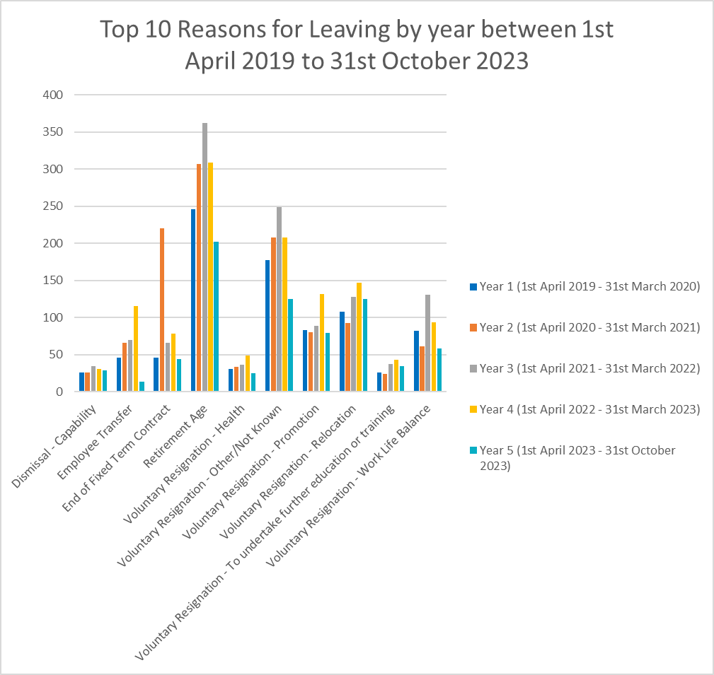

Chart 5
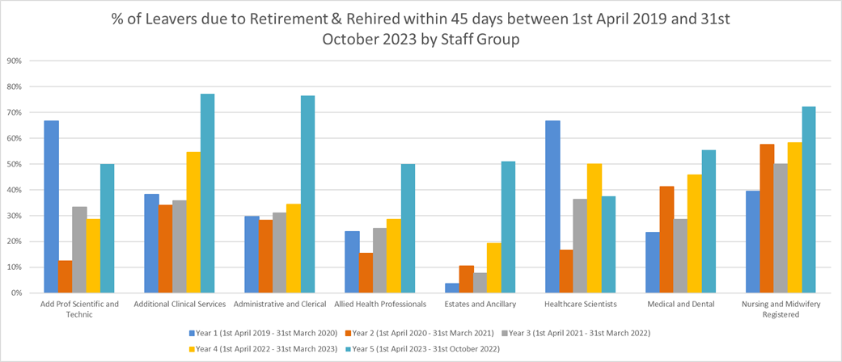
NB – The majority of R&R new starters occur at the beginning of the financial year whilst the majority of staff retiring occurs at the end of the financial year, which causes the higher % rates seen in year 5
General Conclusions
- Whilst turnover increased year on year for the three years to end 2022, retention rates improved in 2022/23 by circa 0.5% and currently the trend for 2023/24 looks to remain broadly the same or slightly improved again. In this regard in comparison to our peer organisations and the national picture our overall turnover rate is generally positive and stable. This picture is further backed up by our Stability Index performance for the first seven months of 23/24.
- There has been a significant improvement in Nursing & Midwifery retention rates in 2022/23 compared to the previous year some of which may be helped by the increased numbers of nurses recruited over this period and have remained employed. This improvement should be further maintained by the implementation of the Nursing Retention Plan.
- Administration & Clerical turnover has seen a significant increase in the two years since end of 2021. The majority of this is likely driven by the higher than average turnover rates across the Corporate group of which a large proportion is made of Administration & Clerical staff. This requires further analysis to pinpoint specific areas of higher than average turnover.
- Retirement remains the highest reason for leaving the Health Board in 2022/23 although numbers have decreased compared to the previous year and numbers of retire and returns have increased. This is likely driven by a number of factors such as more pro-active policy on retire and return process, NHS pension changes, increasing statutory pension age, cost of living crisis. Assuming no changes to these examples are likely in the near future it is likely this trend will continue.
- Although reducing, Voluntary Resignation Other/Not Known remains a high reason for leaving recorded in ESR and requires further work with managers to provide more specific reasons for leaving.
What have we been doing to date?

As previously reported as part of our Recruitment and Retention group work four task and finish groups were established looking at each of the following priority areas, identified from our internal detailed retention data report conducted at the end of 2022:

- Mentorship/buddy scheme for new starters.
- Stay interview framework
- Improving flexibility for staff
- Feed into management experience and development the critical importance they play in good staff experience and engagement.

The first three groups above have reported back with some quick wins identified. Work is now ongoing to commence implementation of some of the quick wins and how best to take some of the longer term actions forward. The final area above will now be picked up as part of the Big Conversation action plan as this area has also been identified as part of that work as an opportunity for improvement

These retention areas also form part of our GMO’s for 23/24 and progress will be reported through the established update process for this years GMO’s.

In addition, research further demonstrates that retention of staff is affected by many factors. This includes external factors such as pay, terms and conditions, pensions, which are set by government, and a range of internal factors which affect how staff experience work. In this regard the focus of the recently launched HEIW Retention Programme is on how staff experience work, recognising the multiplicity of factors that affect this including staff engagement; flexible working; wellbeing; leadership and culture; CPD; career pathways.
Based on this we need to look deeper to fully understand and appreciate the whole picture of work across themes identified in the HEIW Retention Programme that is happening within different parts of the Health Board, including specific examples of practical implementation, which contribute to maintaining good rates of retention.

Flexible Working

- Flexible Working Steering Group has been established with representation from Union Representatives, Service Groups and Corporate functions. This group will be;
  - capturing best practice examples of flexibility from across the health board.
  - identifying areas that have experienced difficulty in accommodating flexible working requests and exploring why and lessons that can be learnt
  - promoting the response of ‘why not ?’ to any applications of flexibility requested short term or long term
  - Identifying enablers and benefits to support further Flexible Working
  - Developing a self-rostering pilot
- New all Wales Flexible Working policy (based on Swansea Bay previous policy) due to be adopted.
- Within Psychology identifying and balancing flexible working opportunities with service demands.
- Perinatal community team trialled flexible working for nurses who had all made various flex working requests ranging from caring responsibilities, child care demands improving mental health and wellbeing, it was agreed that all could work their contracted fulltime hours compressed to 4 working days.
- A full time clinical manager needed an adjustment to help them cope, hours were condensed over 4 days, and used the time outside of the core hours for admin and operational planning.
- A member of ward staff within Mental Health, retired and returned to their post last year was initially working a full time, she requested a reduction in her contracted hours, due to 30 hour contract, the member of staff was supported to work 3 shifts per week, this resulted in an improvement in her wellbeing and work life balance.
- Within CAMHS most staff worked a 9am-5pm Monday to Friday shift pattern. This was having an impact upon work life balance. In addition the service was finding that there was a demand for appointments post 3pm. They implemented a condensed working pattern of a 4 day week. This was offered to all nursing staff and some, but not all staff members in each team took the offer. This has had a shared benefit for patients as each team is now able to offer a 4pm appointment and staff report an improved work life balance.

Health and Wellbeing

- Timely access to Occupational Health - to support managers and staff with advice to support staff in a return to work/supporting health in work.
- Timely access to mental health and physiotherapy support for staff
- Stress risk assessment training - for managers to help support staff in work
- A range of menopause support for staff and managers to enable a supportive workplace.
- Supporting staff health and wellbeing, by establishing Service group wellbeing and engagement groups that create a dedicated forum in which proactive and engaging discussions around staff wellbeing can be held. Supporting health and wellbeing events such as, staff wellbeing week, health promotions, wellbeing newsletters.
- Providing targeted to support to areas that have undergone particular hardship, such as ITU at Morriston where staff experienced the loss of 2 staff members within the space of 2 weeks.
- Using the TRIM approach for teams who have experienced traumatic incidents ensuring that individuals and teams have access to the necessary support they need to recover from these experiences.
- Appointment of MH&LD Staff Counsellor based within the service. It was identified by funding and appointing their own staff counsellor it meant that they could target departments where additional support was required through individual counselling or group support immediately dependent on the need, this has not removed the use of the Occupational health service but has enhanced our offer and level of responsiveness for our staff and is viewed has a positive addition.
- Staff Wellbeing Questionnaire - MH&LD contacted over 200 Nurses who had been absent with stress / anxiety over a 12 month period including those who had left the organisation and those in employment, they advised staff that we were keen to learn from their experience, in order to best support staff going forward. This has contributed to their sickness absence levels decreasing from 11% in July 2022 to 6% and the number of resignations have decreased.

Leadership, CPD and Career pathways

- Supporting workforce re-design by reviewing roles such as HCSW pathways, introducing Assistant practitioner trainee B3 posts into structures. Supporting workforce re-design to enable MDT working, successfully achieved within the new AMSR model, NPT hybrid therapy/HCSW roles.
- Numerous examples across the Health Board where we have developed career pathways in services where nationally the NHS finds it challenging to recruit into specialist roles. i.e. in Medical Physics and Clinical Engineering they are successfully using ‘Annex 21’ to develop attractive training roles.
- In Pathology we are supporting staff from Support Workers through to Biomedical Scientists. The service have worked with HEIW to develop the Healthcare Science Apprentice pathway and SBUHB have developed almost all of the resources for the new Level 4 Diploma in Healthcare Science (for Pathology staff). SBUHB Cell Path have had apprentices completing the Level 3 Diploma in Pathology Support (now named the Level 3 Diploma in Healthcare Science) for a number of years and they will offer the Level 3 Diploma in Healthcare Science. The service assists their Support Workers to undertake the Institute of Biomedical Science (IBMS) qualifications. Completion of these provides eligibility to apply for band 3 and band 4 posts respectively.
- The Graduate Gateway Programme is our own, unique, two-year development programme during which we work closely with individuals to tailor their experiences and explore the endless possibilities that Swansea Bay has to offer. The programme has a high success rate, with all participants successfully gaining a permanent role in the NHS before the end of the programme, with approximately 90% choosing to remain in Swansea Bay.
- Launch of the Nursing & Midwifery Academy in September 2023, paving the way for significant improvements in staff development and retention. The Academy builds on the strong foundations of existing nurse training and development offerings and will take training opportunities to a new level, supporting our nurses and midwives academically and helping them increase their life skills and develop as individuals.
- New Matron Development Forum and Ward Manager/Clinical Leader Programme developed and launched ensuring that we are investing in and supporting our aspiring nursing staff to be the best they can be.
- Talent Development – Following on from the roll out of the Tier 1-3 Talent Management Scheme, we are working towards an approach to roll this out so that all staff benefit from talent conversations, and as an organisation we can consider succession planning as we ‘grow our own’. Pilots are currently underway within Finance and supporting Corporate Nursing on two pilot wards.
- Supporting staff across many parts of the Health Board to undertake a range of clinical and academic studies. These range from registered and unregistered staff e.g. Masters study, Level 3 diplomas, Level 4 Therapy and Nursing/Theatre Assistant Practitioner. Within Dietetics offering bank hours to support continued working within the health board for those workers studying for a dietetic degree who have subsequently returned substantively following attainment of qualifications.
- Career development for admin and clerical staff - hosting a series of information sessions to promote a new career development pathway to the higher-level admin and clerical roles available within the organisation and find out if staff are interested in developing in their careers.

Staff Engagement and Culture

- In 2022/23 we held “Our Big Conversation” staff engagement and culture audit programme as a vehicle to shape our new “One Bay Way” vision document. In July 2023, we completed phase 3 which involved 7 engagement workshops with 130 senior leaders attending to engage on our new vision
- NHS Wales staff survey launched in October 23. As of early November we have reached an 10% response rate
- In October 23, we also sought staff feedback on our new people strategy. All feedback is being used to inform the final version, which will be submitted to our Boards in November for approval. The proposed publication date is January 2024
- Established an Overseas Champion Network made up of nurses who have joined the health board from overseas and have first-hand experience of what it is like to move and work in a new country. Our Overseas Champions are an important contact for new staff to help them integrate and adjust in an informal, supported and comfortable environment whereby they can ask and receive information about the local area, the organisation, culture and norms; including those everyday ways of doing things, useful procedures and policies, written and unwritten, that will all help to explain how things work.
- Developed and launched a ‘Living the Language’ guide which aims to support our overseas nurses understand a little more about the context in which they are now practicing, the professional culture, relationships between different groups of people and the local dialect and phrases they may encounter. By using this guide, we hope the Nurses will be able to settle in to their new surroundings much quicker and feel more included within the workplace and the community.
- Conducting staff pulse surveys, focus groups, feedback sessions and producing holist action plans to support improvements to staff experience.
- Cultural Conversations – We are supporting Cultural Conversations with Internationally Educated Nurses as part of their initial induction period when they join Swansea Bay. These conversations have been used to feedback to colleagues in Nurse Education, with feedback being used to improve experiences where possible.
- Staff Networks – We support fostering the Staff Networks within the Health Board. The networks offer a development opportunity for those who lead within each network, as well as for each member and ally. The Staff Networks also provide an additional support mechanism to compliment other forms of support for our people such as Occupational Health and Wellbeing, Trade Unions, Wellbeing Champions, Chaplaincy and The Guardian Service.
- Enhanced clinical and pastoral support being provided to our overseas nurse community by skilled Practice Development Nurses working alongside other clinical colleagues. The nurses will be supported to be the very best they can be and career progression opportunities made available to all. Attrition is currently very low with only 10 internationally recruited nurses leaving the HB since 2021.
- Holding staff appreciation events, such as International nurses day, Christmas celebrations, Estates and Facilities day and Support Services Reward and Recognition week.

The above represents a snapshot of activity which helps to facilitate good retention rates within the Health Board and demonstrates the range of activity which we are not always aware of. More detail with regard to some of this activity has also been provided within the appendices.

What are our plans moving forward?

Whilst from the above information we can see that our retention rates are generally high in comparison to the wider public sector and the majority of our peer organisations across Wales. It also demonstrates that there is a range of work across the Health Board being undertaken to help enhance the employee experience which helps to contribute to those positive retention rates. However, we cannot afford to be complacent in what we know is a competitive and in many parts of our organisation difficult to recruit to environment.

Therefore our focus over the coming two years will be to implement, in the first place those actions identified within the newly launched All Wales Nursing Retention plan (a copy of which is provided in the appendix). Whilst the initial focus is on the nursing workforce many of the actions can be replicated in all staff groups and the aim will be to do this where appropriate. This overall approach fits into the aims of the all Wales Retention Programme (see appendix 3), which are ;-

The aim of the programme is to improve retention of our workforce as a key plank of our current and future workforce supply. This encompasses all professions and disciplines.

The programme aims to achieve this by:
- Providing targeted support and resources for employers based on best practice – (this will include a funded local retention improvement lead for each delivery organisation).
- Increasing awareness and understanding of good retention practice amongst line managers, management teams and Boards.
- Developing, sharing and embedding best practice in retention supported by a QI/community of practice approach.
- Balancing generic and profession specific support on retention, and targeting hot spots.
- Supporting employers to develop effective retention improvement plans that suit local circumstances.
- Increasing visibility of retention metrics supported by Board level reporting.

As identified in these aims HEIW will be providing each NHS organisation with funding for a local Retention Lead who’s role will be in the first instance to support the implementation of the Nurse Retention Plan but will have a wider remit across the whole workforce as the programme develops. As a Health Board we are currently out to advert for this post and envisage making a suitable appointment by the end of 2023.

Once in post we will scope out a specific work programme and objectives which we will bring back and share with the committee.

- GOVERNANCE AND RISK ISSUES

The Recruitment and Retention group will be utilised to scrutinise the ongoing plan and develop any further interventions. The work of the group will be reported to the Workforce Delivery group through to the Workforce, OD and Digital Committee.

- FINANCIAL IMPLICATIONS

There may be financial risks associated with current or new retention interventions if they need additional funding to be successful.

- RECOMMENDATION

Workforce, OD and Digital Committee is asked to note:

- The contents of this retention deep dive and the plans for retention activity moving forward

Governance and Assurance

Link to corporate objectives  (please ) | Promoting and enabling healthier communities |  |  | Delivering excellent patient outcomes, experience and access |  | Demonstrating value and sustainability |  | Securing a fully engaged skilled workforce |  | Embedding effective governance and partnerships
Link to corporate objectives  (please ) |  |  |  |  |  |  |  | x
Link to Health and Care Standards  (please ) | Staying Healthy |  | Safe Care |  | Effective Care |  | Dignified Care | Timely Care | Individual Care |  | Staff and Resources
Link to Health and Care Standards  (please ) |  |  |  |  |  |  |  |  |  |  | √
Quality, Safety and Patient Experience
A sustainable workforce is key for the quality of patient care.
Financial Implications
There are financial risks associated with the lack of supply of the relevant workforce and the costs of cover. Overseas recruitment is expensive.
Legal Implications (including equality and diversity assessment)
Not applicable

Staffing Implications
To reduce current vacancy levels and secure a robust and sustainable workforce model
Long Term Implications (including the impact of the Well-being of Future Generations (Wales) Act 2015)
Not applicable

Report History |  | First report in this format
Appendices |  | Appendix 1 - Details and examples of retention activity across the Health Board  Appendix 2 - All Wales Nurse Retention plan  Appendix 3 - Overview of all Wales Retention Programme

