

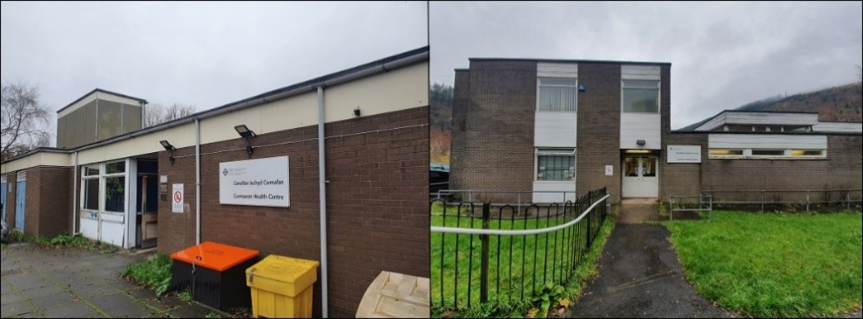

Engagement Document on Site Options for new Cymmer Health Centre

Engagement from
Monday 24th June to Friday 19th July 2024
- Introduction / background
Swansea Bay University Health Board and Neath Port Talbot County Borough Council have been working closely for several years to find a solution to the issues with the highway and the Cymmer viaduct. This route provides the only suitable access for heavy vehicles, including lorries, buses and emergency vehicles for the communities of Abercregan and Glyncorrwg. Improvements to the road next to Cymmer viaduct would mean heavy vehicles could use this road and reduce the risk of these communities becoming cut off. These improvements would need to use the land where Cymmer Health Centre is currently located. An alternative site for the health centre therefore needs to be identified.
In addition, the current accommodation for Cymmer Health Centre is no longer suitable for providing 21st century health care. Cymmer Health Centre has been sold to Neath Port Talbot Council and a lease agreed so primary care services will continue to be provided from the building until the alternative premises are available for use.
An alternative location in a suitable building would provide the opportunity to widen the services offered and provide a Health and Wellbeing Centre for the Upper Afan Valley.

- Engaging with the community and Neath Port Talbot Council
During 2022 we wrote to patients from Cymmer and Cwmafan practices and asked for their help in identifying potential premises that could be used to deliver health care in the future. We had 72 responses and 5 possible sites were identified.
The Health Board completed feasibility studies and initial design work on the five sites which were:
- Site adjacent to Cymmer Primary School.
- Site of former Cymmer High School.
- Site adjacent to Cymmer Fire Station, Library and existing Cymmer High School.
- Existing Cymmer Health Centre.
- Croeserw Community Enterprise Centre.

During 2023 the Health Board set up stakeholder meetings with local politicians and the Members of the Senedd to discuss these. It was agreed the Health Board needed to work with the Neath Port Talbot Borough Council to discuss the potential sites and identify whether the Council had any plans for these areas and to cross-reference these options with the Council’s options for the new road. The location of the five potential sites were also discussed with patients as part of the series of public meetings held in Croeserw, Cwmafan and Tonmawr during 2023.

- Site Options - Longlist
The feedback received alongside the feasibility studies of the five potential sites meant some sites were not suitable for a number of reasons including:
- Being impacted by the proposed road works
- Limited parking availability
- Poor site and road access
- Limited future growth space
- Site security issues
- Unknown ground conditions.
- Excessive temporary site location and decanting costs

Details of how each of the five possible sites met the requirements for the new practice building are outlined below:

- Site adjacent to Cymmer Primary School – met requirements and no decanting costs
- Former Cymmer High School site – met requirements and no decanting costs
- Site adjacent to Cymmer Fire Station and Library – met requirements and no decanting costs
- Existing Cymmer Health Centre (parking, impact of road works and limited space plus the need to find another location to move the surgery to whilst building works were completed)
- Croeserw Community Enterprise Centre – met requirements and no decanting costs

Following discussions with the Council and cross referencing with their plans for the area and the new road, options 1, 3 and 4 were discounted.

- Site Options - Shortlist
As a result of the above discussions and analysis, two sites were shortlisted:
- Proposal 1 - The site on former Cymmer High School
- Proposal 2 - Croeserw Community Enterprise Centre

As a minimum both sites will be able to house:
- Cymmer primary care provision
- Midwifery
- Health Visiting
- Screening services, including Abdominal Aortic Aneurysm provided by Public Health Wales
- Primary Care Mental Health Services
- Speech and Language Therapy
- Minor Surgery
- Third Sector Support Services
- Community Clinics
- Outpatient Clinics
- Integrated hot-desking office accommodation for district nursing, health visiting teams and other services
There is also the potential to include other out-of-hospital services for example community audiology, diabetes and Musculoskeletal physiotherapy services as part of the Afan Cluster together with group therapy accommodation for chronic conditions management.

Proposal 1 – Former Cymmer High School
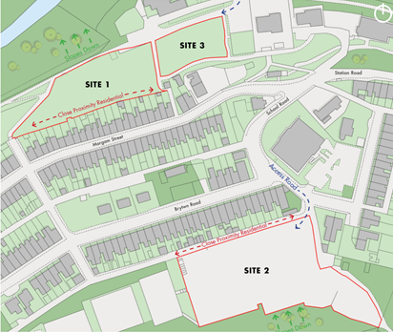
The location of the former High School is shown as site 2 in the plan on the left. The site is owned by Neath Port Talbot County Borough Council (NPTCBC) and available for purchase. It is a large site with potential for future growth.

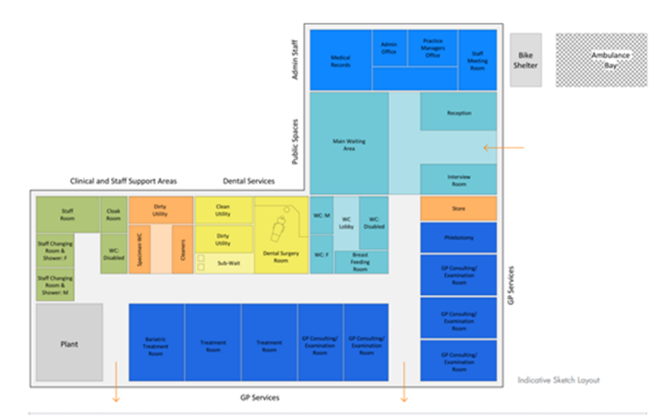
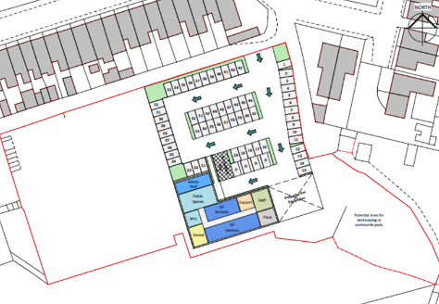

The completed feasibility studies for this site detail a building footprint with a recommended building area of 616m2. The site layout with proposed car park plan and indicative new build layout is shown above.

The benefits of the former Cymmer High School site are:
- Development would be compliant with Welsh Primary Care Estates Development Guidelines from the outset and the site isn’t restricted by size.
- Site location not impacted by proposed road works
- Meets Welsh Government requirements for parking provision if criteria for proximity to local facilities and transport is met.
- No decanting costs, as the practice would remain in its current location until the building was complete
- Good road access
- Potential for growth space and future expansion
- Site remains in Cymmer

The dis-benefits are:
- Longer project timescales, with an estimated opening date of December 2027
- Increased Project Costs, the estimated new build construction costs are £3.5m (May 2024)
- There are limited options for creating a Health and Wellbeing Centre development, due to services already located at Croeserw Enterprise Centre, which will lead to potential delays in obtaining funding for the project
- Full planning permission will be required before the work can commence
- Unknown ground conditions which may lead to increased construction costs.
- Public transport is poor

Proposal 2 – Croeserw Community Enterprise Centre

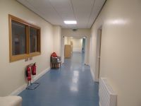
The Croeserw Community Enterprise Centre was opened in 2011 and already has many of the recommended requirements for modern Primary Care facilities. This includes wide corridors and doorways, large waiting areas suitable for adults, wheelchair users and children, office space compliant with modern power and data requirements with good daylighting and rooms of suitable size that can be converted quickly for clinical use.

The refurbishment of the existing Croeserw Community Enterprise Centre will be the most cost effective option and provides the opportunity to retain all of the existing education and community services presently based on the site to create a joint health and wellbeing centre. This is a requirement to access West Glamorgan Regional Partnership Funding.
The premises already has appropriate public facilities including waiting areas, toilets, disabled toilets and access (lift) so substantial savings can be made over new build costs. The adaptation of the existing facility will allow full access for all patients and will enable the provision of a joint health and wellbeing centre for use by an increased number of organisations and services as outlined above
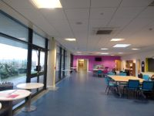
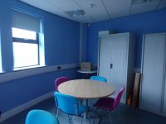
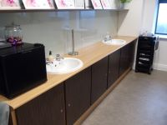
The proposed building layout plans are shown below. It is proposed the space including waiting rooms, private dental capacity and consulting, group and office space will be located on the ground floor. This is detailed below.
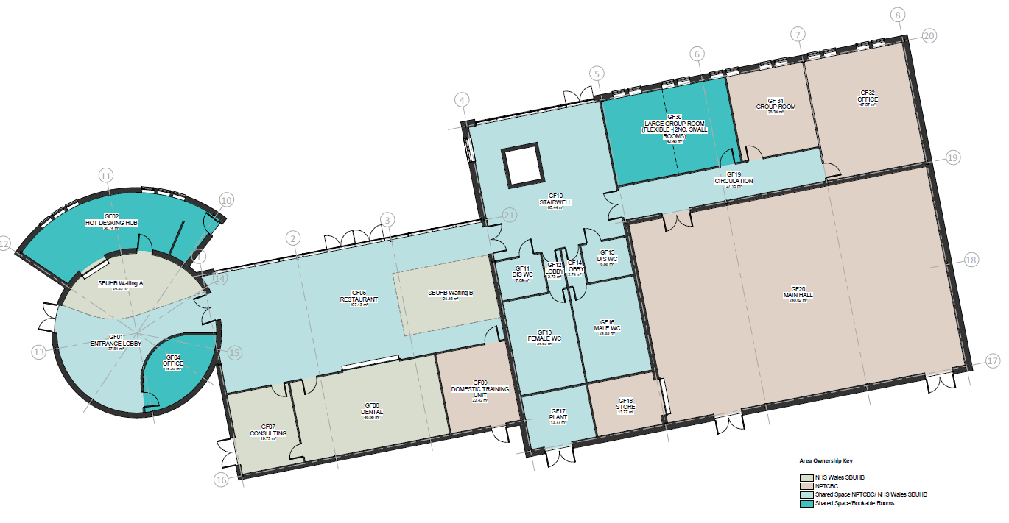

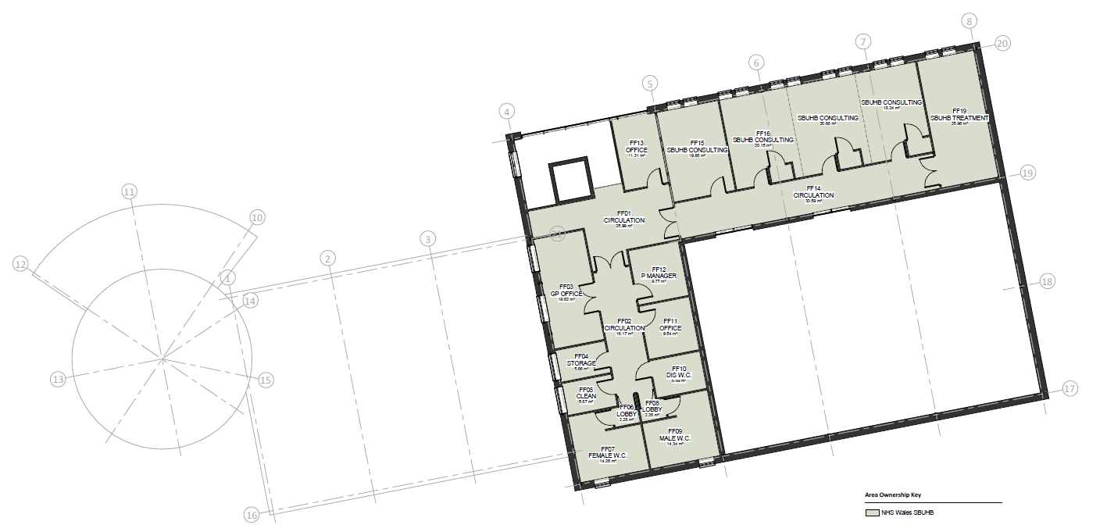
The First floor will be accommodation for the GP practice including four consulting rooms, a treatment room and associated facilities. These are shown on the plan below.
All existing plans are subject to future design changes.
The benefits of Croeserw Community Enterprise Centre:
- Compliant Welsh Government parking provision could be achieved if criteria for proximity to local facilities and transport is met.
- Site location not impacted by proposed road works
- Potential for health and wellbeing centre due to existing services and community groups that support prevention and wellbeing and third sector services.
- No decanting costs
- Reduced project timescale and risk - estimated opening date is 2026.
- Good road access
- Potential for growth space and future expansion
- Reduced planning requirements – change of use
- Reduced risk of unknown ground conditions
- Support the long-term sustainability of the building

The dis-benefits are
- Alternative site location in Croeserw and not Cymmer. It should however be noted that 48% of practice patients are located in Croeserw.
- Public transport is poor
- Potential for disrupted access during inclement weather.

- What about the staff affected by these proposed changes?
Discussions will be held with any staff who will have to change their base as a result of the new site. The staff of the Primary Care Practice will also be asked for their views as part of this engagement process.

- What about the impacts on equality groups?
We need to make sure that any decisions we make following engagement ensures we understand and take account of any impacts on people with protected characteristics under the Equality Act 2010. In addition, the new socio-economic duty, introduced on 31st March 2021, means we need to also actively consider the effects of these changes on increasing inequalities both nationally and locally. Therefore, we have produced an Equality Impact Assessment on these proposed changes which we will also engage on alongside this document.

- What about the impacts on the Welsh language?
We need to make sure that any decisions we make following engagement ensures we understand and take account of any impacts on the Welsh Language. As this is a site change within a local community, we anticipate this will not have an impact on the Welsh language in this community and will use the engagement to test this assumption

- What do you think of these two options?
One of the two proposed sites needs to be selected as the single site to replace the existing Cymmer Health Centre. This will enable an application to be made for funding to provide a new Health and Wellbeing Centre for the Afan Valley from the West Glamorgan Regional Partnership Board funds.
Your views are important to us – please tell us what you think about the proposals, we will be gathering your views from Monday 24th June to Friday 19th July 2024
The outcome of this engagement and all the responses received will be considered by Llais and the Health Board in July 2024. Based on these, a decision will be made by the Health Board on which of the two short-listed options should be taken forward.

You can let us know what you think by:
Completing the online form:
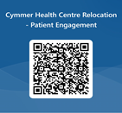

Posting your comments in the boxes at the GP Surgeries in Cymmer and Cwmafon

Writing to us: Chief Executive
Swansea Bay UHB
One Talbot Gateway
Baglan, SA12 7BR
Emailing us: SBU.engagement@wales.nhs.uk
Phoning us and leaving us a message: (01639) 683355
Contacting us on Facebook: Swansea Bay NHS
Twitter: @SwanseabayNHS

Hard copy versions of this document, in Welsh, large print (English and Welsh can be requested by ringing 01639 683355 or emailing us at SBU.engagement@wales.nhs.uk.

Alternatively you can let Llais know your views by:
Writing to them: Llais (NPT & Swansea)
Cimla Hospital
Cimla
Neath
SA11 3SU
Or emailing them: nptandswansea.enquiries@llaiscymru.org

