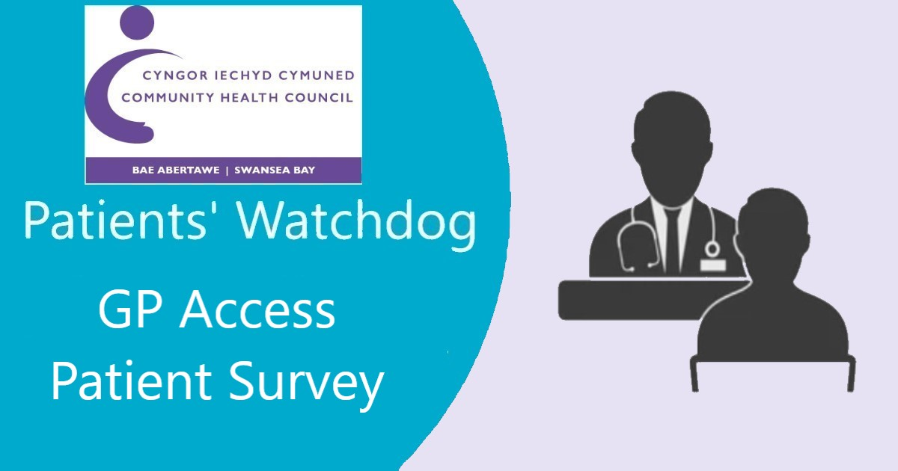

**Do you feel you have good access to general practice care?**

How easy is it to get through to your practice by telephone?

Is your local surgery providing appointments when needed?

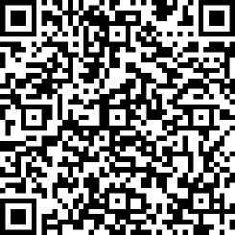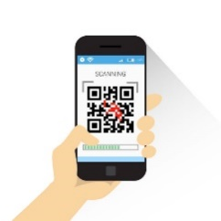**We want to hear from you!**

Swansea Bay Community Health Council,

Cimla Health & Social Care Centre, Cimla,

Neath SA11 3SU

Email: [swanseabay@waleschc.org.uk](mailto:swanseabay@waleschc.org.uk)

Web: [www.swanseabaychc.nhs.wales/](http://www.swanseabaychc.nhs.wales/)

**Online:**

<https://forms.office.com/r/VhsxuWFxMj>

**OR**

Scan the QR code with your

Smartphone or mobile device

**Call us:**

01639 683 490

