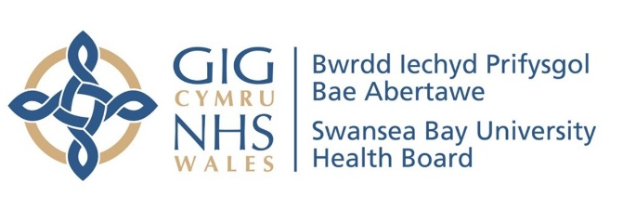
Easy Read

Where should our acute mental health assessment beds go?
Response Form
Please send this form back to us by 18 March 2022
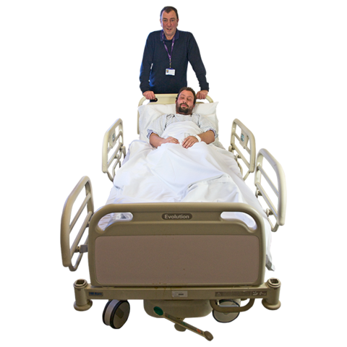

This document was written by the Swansea Bay University Health Board. It is an easy read version of ‘Changing for the Future. Public Engagement on Our Proposals for the location of Adult Acute Mental Health Assessment Beds’
February 2022

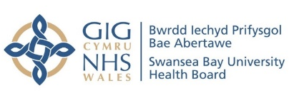
About this response form
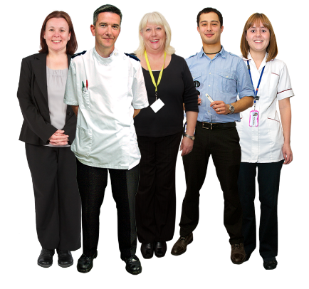
Hello. We are Swansea Bay University Health Board.
We run your local NHS services in Neath, Port Talbot and Swansea. We also run some services for people who live further away.
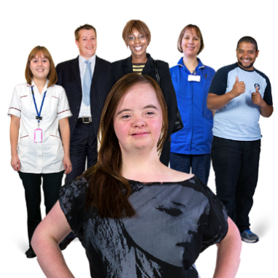

We run community and hospital mental health services together with social services and local councils.

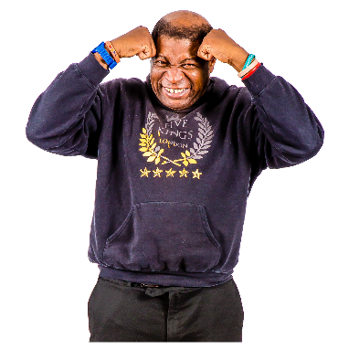
We have written about our ideas for where to put new Adult Acute Mental Health Assessment beds.

Acute means severe or very serious.
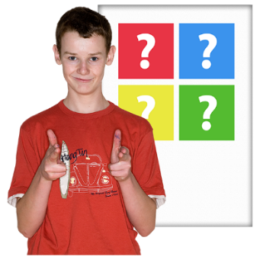

We want to know what you think about our ideas.

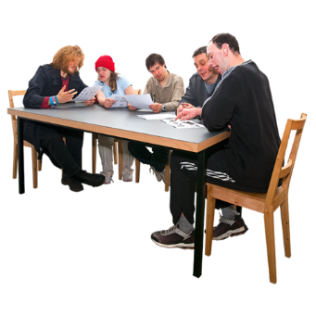
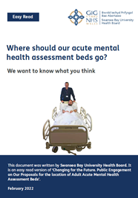
Before you answer these questions, please read the main document called: Where should our acute mental health assessment beds go? We want to know what you think.
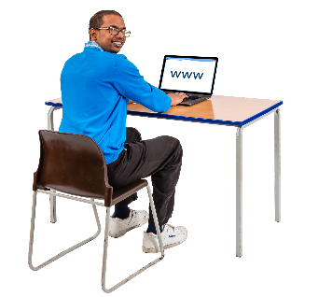
We plan to run some sessions where we will explain the changes. And answer any questions you may have.
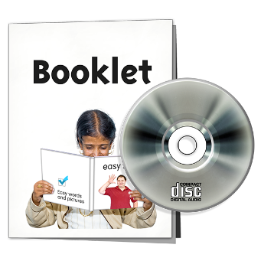
Check our website to find out when these events are taking place.
You can also find copies of this document on our website, in Welsh and Audio Books.


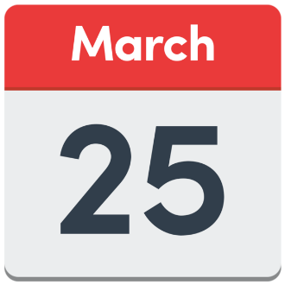
Please answer the questions on this form and send it back to us by 25 March 2022
You can email it to: SBU.engagement@wales.nhs.uk
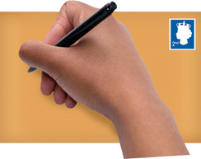
Or post it to:
Chief Executive
Swansea Bay UHB
One Talbot Gateway
Baglan
SA12 7BR.

If you would like any help filling out this form please contact us:

Email: SBU.Engagement@wales.nhs.uk

Or telephone: 01639 683355

Other ways to tell us what you think

You can speak to the Community Health Council

Write to them at:
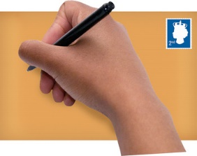
Swansea Bay Community Health Council
Cimla Health and Social Care
Cimla
Neath
SA11 3SU

Email: Swanseabay@waleschc.org.uk


Facebook: Swansea Bay NHS

Twitter: @SwanseabayNHS

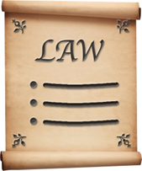
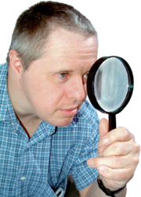
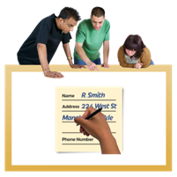
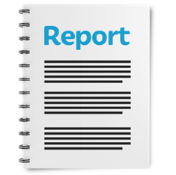
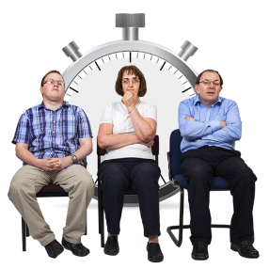
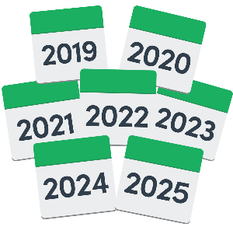
How we use your information
We use your information by following a law called UK General Data Protection Regulation (GDPR)
Our staff will be able to see your answers.
Sometimes we ask other organisations to help us understand people’s answers. So they may see your information too.
We normally publish a report showing the kinds of things people said.
If you are in our report the information could be available for a long time.
But information that is not published is only kept for 3 years.
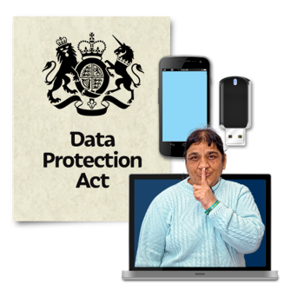
The data protection laws give you the right to:
- Know what information we have about you and how you can see it.
- Make us change any mistakes in the information about you.
- Ask us not to use the information in some cases.
- Ask us to delete the information we have about you in some cases.
- Move the information about you somewhere else in some cases.

If you would like to know more about how your information is kept and used, please contact us at:

Data Protection Officer,
Swansea Bay University Health Board Headquarters
1 Talbot Gateway
Port Talbot
SA12 7B

You can also contact the Information Commissioner’s Office:
Wycliffe House
Water Lane
Wilmslow
Cheshire
SK9 5AF

Phone: 01625 545745 or 0303 123 1113
Website: ico.org.uk

Questions
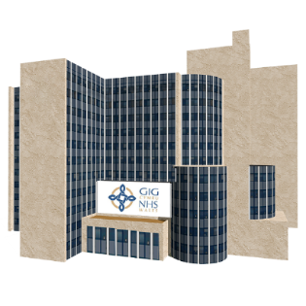
- Do you agree or disagree with our ideas for where the Adult Acute Mental Health Assessment beds should go?

I strongly disagree ☐
I disagree ☐
I don’t agree or disagree ☐
I agree ☐
I strongly agree ☐
I don’t know ☐

What issues or thoughts do you have about there being one single Mental Health Hospital Service? Tell us what you think

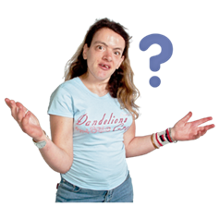
- We know that people have bad ideas about Cefn Coed. And judge the people that go there.

If we decide to put the new unit in Cefn Coed, we will give it a new name. What do you think would be a good name?

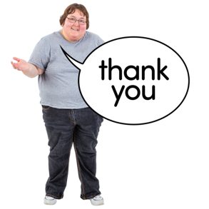
Thank you for answering the questions.

Equality
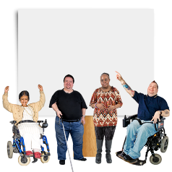
We must think about how our decisions affect people with protected characteristics.

Protected characteristics are things about a person that they might be treated unfairly for. For example, age, race or religion.

- Do you think there are any groups of people with protected characteristics that will be affected by the changes we want to make?

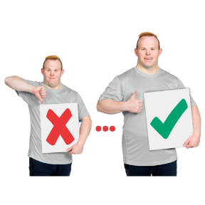
- If you think there are any possible affects, what do you think we could do to make things better?

About You
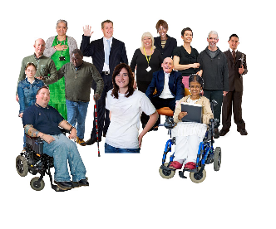
We want to make sure we hear from lots of different people.
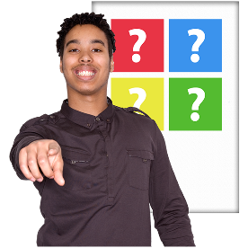
We would be grateful if you can answer these questions about you.

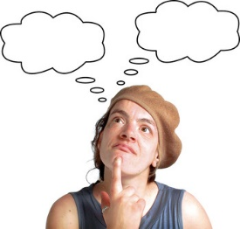
If you don’t want to answer these questions, that is fine. We will still listen to your thoughts and ideas in this response form.

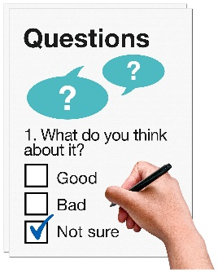
Are you:
Answering these questions for yourself?
Answering these questions for an organisation?

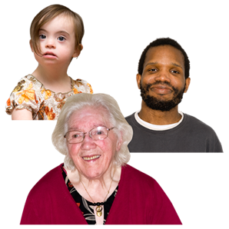
How old are you?
Under 16
16 – 24
25 – 34
35 – 44
45 – 54
55 – 64
65 – 74
75 or over
I don’t want to say

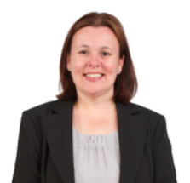
Gender
Are you:
Female
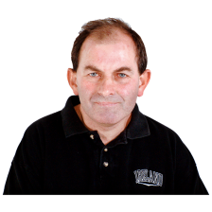
Male
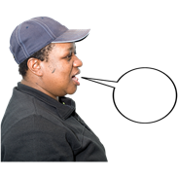

Other / I use my own term
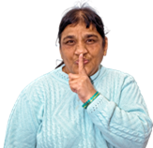
I don’t want to say

Background
Are you:
White
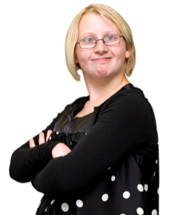
Welsh / English / Scottish / Northern Irish / British
Irish
Gypsy or Irish Traveller
Any other white background (please describe)
………………………………………

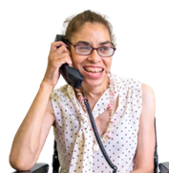
Mixed / Multi ethnic groups
White and Black Caribbean
White and Black African
White and Asian
Any other mixed/multi ethnic background (please describe)
……………………………………….

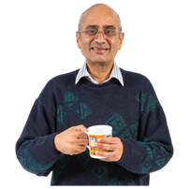
Asian / Asian Welsh / Asian British
Indian
Pakistani
Bangladeshi
Chinese
Any other Asian background (please describe)
………………………………………..

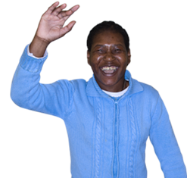
Black / Black Welsh / African / Caribbean / Black British
African
Caribbean
Any other Black / Black British / African / Caribbean background (please describe)
…………………………………………….


Other ethnic group
Arab
Any other ethnic group (please describe)
……………………………………………
I don’t want to say
Disability
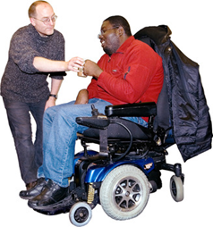
Do you have a disability – a learning disability, physical disability, mental health disability or a condition or illness that will last a year or more?
Yes
No

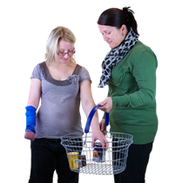
If you have said Yes, does how does your disability affect your daily life?
A lot
A little
It doesn’t
I don’t want to say

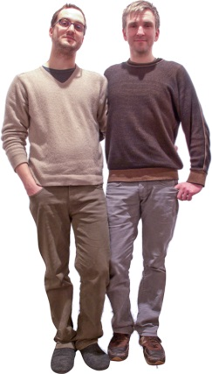
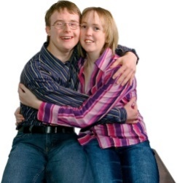
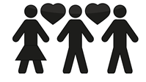
Sexual Orientation
Are you:
Bisexual
Gay or Lesbian
Straight / Heterosexual
Other / I use my own term
I don’t want to say
Marriage and Civil Partnership
Are you:

Never married and never in civil partnership
Married
Divorced
Widowed
In a civil partnership
Separated but still legally in civil partnership
Was in a civil partnership that is now legally finished
Surviving partner from civil partnership
I don’t want to say

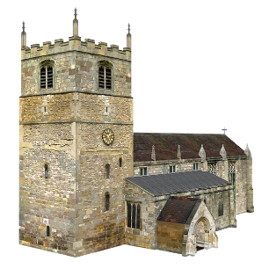
Religion
What is your religion?
No religion
Christian
Buddhist
Hindu
Jewish
Muslim
Sikh
Any other religion (please describe)
……………………………………………..
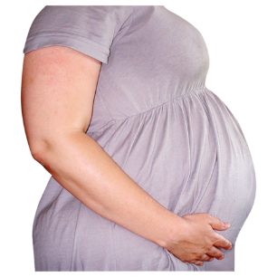
Pregnancy and Maternity
Are you pregnant or have you been pregnant in the last year?
Yes
No
I don’t want to say

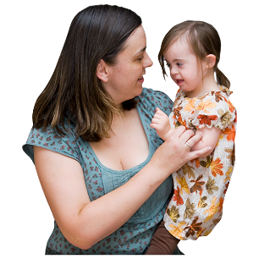
In the last year have you taken:
Maternity leave
Extra Paternity Leave (more than 2 weeks)
Adoption Leave
I don’t want to say

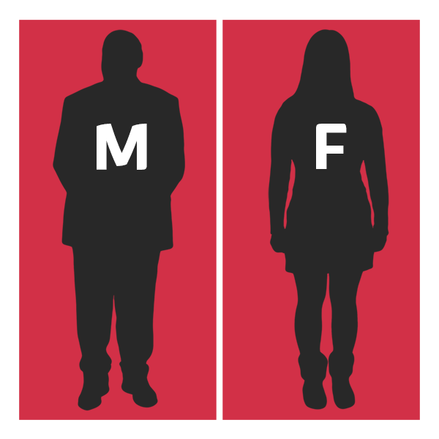
Gender Identity
Do you describe yourself as having the same gender you were born with?
Yes
No
I don’t want to say

