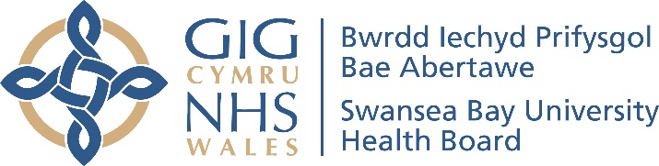

Ymgysylltu Cyhoeddus ar y
Cynigion ar gyfer Gwasanaethau Hydrotherapi
Yn dilyn Covid-19

Cyfarfod Cyhoeddus Rhithwir

Mae'r ymgysylltu cyhoeddus yn sôn am newid ein gwasanaethau hydrotherapi wrth symud ymlaen, er mwyn cynorthwyo datblygiad ein prif ysbytai i Ganolfannau Rhagoriaeth ar gyfer gwasanaethau penodol ac i sicrhau y gallwn ddarparu gwasanaethau gwell ar gyfer ein cleifion, gwella cynaliadwyedd ein gwasanaethau, a defnyddio'r adnoddau sydd gennym yn effeithiol.

Hoffai'r Bwrdd Iechyd eich gwahodd i fynychu Cyfarfod Cyhoeddus Rhithwir i glywed cyflwyniad ar y cynigion ar gyfer Gwasanaethau Hydrotherapi. Mae'r trefniadau ar gyfer y Cyfarfodydd Cyhoeddus Rhithwir yma:

Dyddiad: Chwefror 3, 2022 neu Chwefror 15, 2022
Amser: 6.00pm a 7.00pm
Cynhelir y cyfarfodydd cyhoeddus drwy Teams.

I archebu’ch lle, cysylltwch â: SBU.Engagement@wales.nhs.uk neu 01639 683355

Public Engagement on the
Proposals for Hydrotherapy Services
Following Covid-19

Virtual Public Meetings

This engagement is about changing our hydrotherapy services going forward, to support the development of each of our main hospitals as Centres of Excellence for specific services and to ensure we can provide improved services for our patients, improve the sustainability of our services, and use the resources we have most effectively.

The Health Board would like to invite you to attend a Virtual Public Meeting to hear a presentation on the proposals for Hydrotherapy Services. Arrangements for the Virtual Public Meetings are as follows:

Date: 3rd February, 2022 or 15th February, 2022
Time: 6.00 pm to 7.00 pm
The public meetings will be held via Teams.

To book your place, please contact: SBU.Engagement@wales.nhs.uk or 01639 683355

