Easy Read

Swansea Bay University Health Board
Our plan for Hydrotherapy Services after COVID-19
Response Form
Please send this form back to us by 18 February 2022

This survey was written by the Swansea Bay University Health Board. It is an easy read version of ‘Changing for the Future. Public Engagement on Our Proposals for Hydrotherapy Services following COVID-19’

January 2022

About this response form
Hello. We are the Swansea Bay University Health Board.
We run your local NHS services in the Neath Port Talbot and Swansea areas.
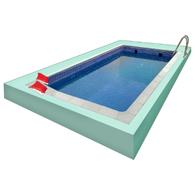
We have made a plan about improving our Hydrotherapy services.
Hydrotherapy is treatment for some health problems using movement in a special pool.
We want to know what you think about our plan.

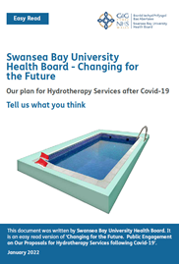
Please read the main document called Changing for the Future - Our plan for Hydrotherapy Services after COVID-19 to help you answer these questions.
Please answer the questions on this form and send us the form by 18 February 2022
You can email it to: SBU.engagement@wales.nhs.uk
Or post it to:
Chief Executive
Swansea Bay UHB
One Talbot Gateway
Baglan
SA12 7BR.

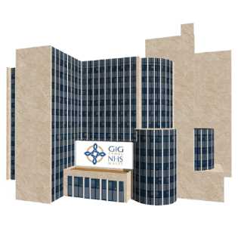
You can put it in a drop box in the Physiotherapy departments at:

    - Neath Port Talbot Hospital
    - Singleton Hospital or
    - Morriston Hospital

If you would like any help filling out this form please contact us:

Email: SBU.Engagement@wales.nhs.uk

Or telephone: 01639 683355

Other ways to tell us what you think

You can write to us:
Chief Executive
Swansea Bay UHB
One Talbot Gateway
Baglan
SA12 7BR.

Email: SBU.Engagement@wales.nhs.uk
Phone: 01639 683355
Facebook: Swansea Bay NHS
Twitter: @SwanseabayNHS

How we use your information
We use your information by following a law called UK General Data Protection Regulation (GDPR)
Our staff will be able to see your answers.
Sometimes we ask other organisations to help us understand people’s answers. So they may see your information too.
We normally publish a report showing the kinds of things people said.
Sometimes this means people’s personal details are included. Please tell us if you do not want your personal information included.
If you are in our report the information could be available for a long time.

But information that is not published is only kept for 3 years.
The data protection laws give you the right to:
- Know what information we have about you and how you can see it.
- Make us change any mistakes in the information about you.
- Ask us not to use the information in some cases.
- Ask us to delete the information we have about you in some cases.
- Move the information about you somewhere else in some cases.
If you would like to know more about how your information is kept and used, please contact us at:

Data Protection Officer,
Swansea Bay University Health Board Headquarters
1 Talbot Gateway
Port Talbot
SA12 7B

You can also contact the Information Commissioner’s Office:
Wycliffe House
Water Lane
Wilmslow
Cheshire
SK9 5AF
Phone: 01625 545745 or 0303 123 1113
Website: ico.org.uk

Questions
- Do you agree with our plans to close the Hydrotherapy pool at Morriston Hospital permanently?

Tell us what you think

- Do you agree with our plans to use the pools at Neath Port Talbot and Singleton Hospitals for all Hydrotherapy sessions?

Tell us what you think

- Please add anything else you would like to say here.

Thank you for answering the questions.

