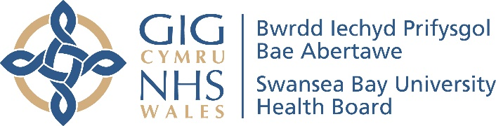
Easy Read

Improving mental health services for older people in Swansea Bay

Response form
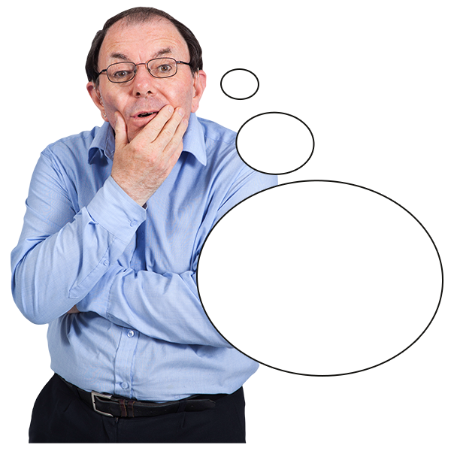
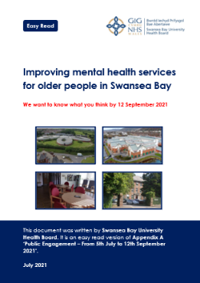

This survey was written by the Swansea Bay University Health Board. It is an easy read version of ‘Our Plan to Improve Mental health Services for Older People in Swansea Bay’.

July 2021
How to use this document
 | This is an easy read document. But you may still need support to read it. Ask someone you know to help you.
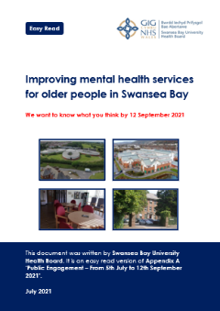 | Words in bold blue writing may be hard to understand. You can check what the words in blue mean on page 23 of the main document.
 | Where the document says we, this means Swansea Bay University Health Board. For more information contact:
Website: sbuhb.nhs.wales
E-mail: SBU.engagement@wales.nhs.uk
Phone: 01639 683355
 | This document was made into easy read by Easy Read Wales using Photosymbols. To tell us what you think about this easy read version, click here.

About this response form
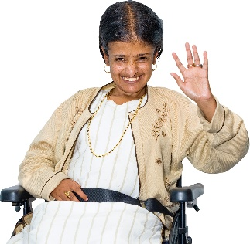 | Hello. We are the Swansea Bay University Health Board.
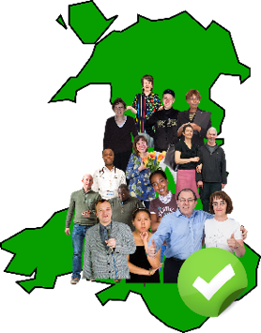 | We run your local NHS services in the Neath Port Talbot and Swansea areas.
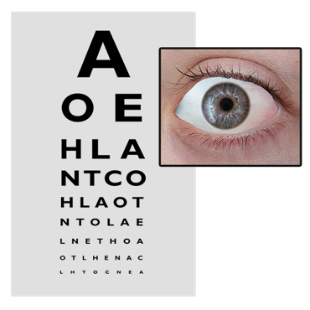 | For example:  - GPs, dentists, chemists and opticians
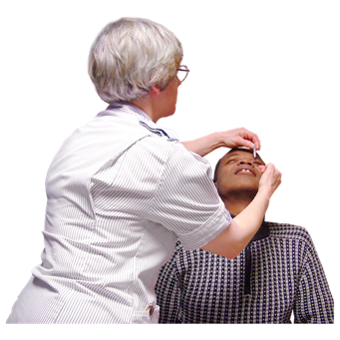 | - and community services like therapists, school nurses and health visitors
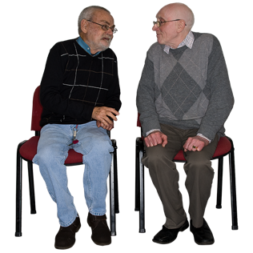 | We want to improve health services for older people with mental health needs in Swansea Bay.

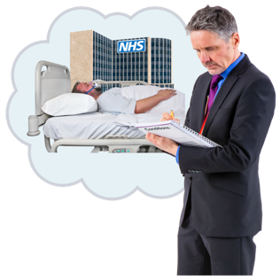 | We have a plan to improve the health services for older people with mental health needs in Swansea Bay.
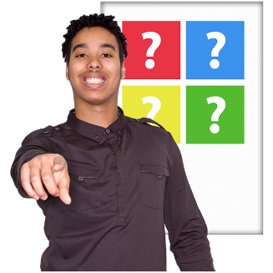 | We would like to know what you think about our plan.
 | Please read “Improving Mental Health Services for Older People in Swansea Bay” and then answer the questions in this response form.
 | We want to know:  - your experiences of how we support older people with mental health needs in the Swansea Bay area  - what you think about our plans to make 1 service for older people with mental health needs across Swansea Bay  - what you think about our plans to lower the number of hospital beds we have across Swansea Bay. We also want to change how we use them  - if our changes might have a bad effect on some groups of people
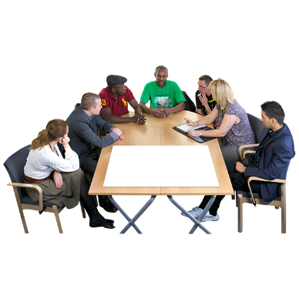 | We will use your ideas to make changes to the service for older people with mental health needs.
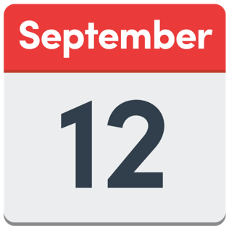 | We need your answers by 12 September 2021.
 | If you have any questions, please e-mail us at SBU.engagement@wales.nhs.uk.
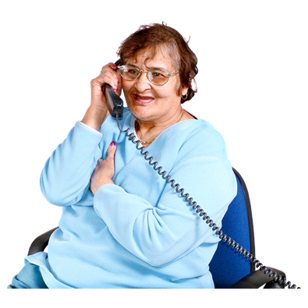 | If you would like to talk to us, please phone us on 01639 683355.
 | This survey was made into easy read by Easy Read Wales using Photosymbols.

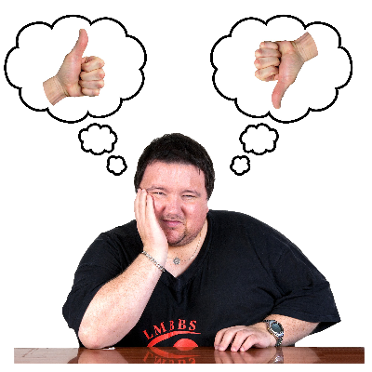 | You do not have to take part in this survey if you do not want to.
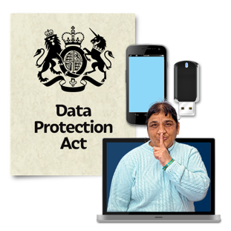 | We follow a law called the General Data Protection Regulation (GDPR) to keep your information safe.
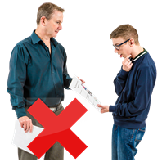 | We will only use your information for this survey. We will not share it without your permission.
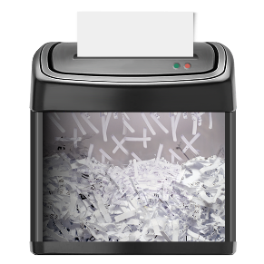 | We delete any personal information after 3 years. Your personal information is anything that identifies you. For example, your address.
 | If you have any questions about how we use and keep your personal information, you can email us at SBU.engagement@wales.nhs.uk.

Questions
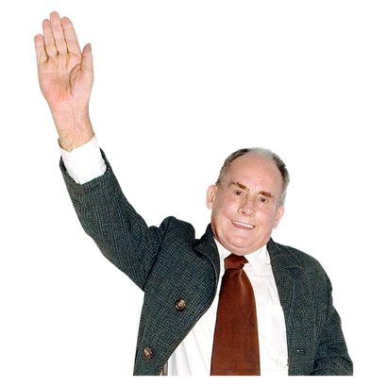 |  | - Have you, or a family member, or a friend ever used our mental health services for older people in Swansea or Neath Port Talbot?
 |  | Yes | ☐
 |  | No | ☐
 | If you answered no, please go to question 4.

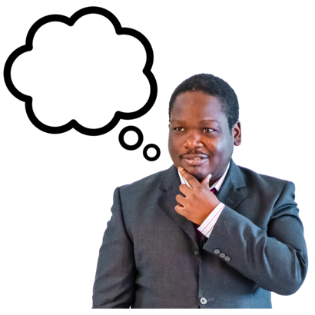 |  | - If you answered Yes, what did you think of the older people’s mental health services?  Please use the space below.

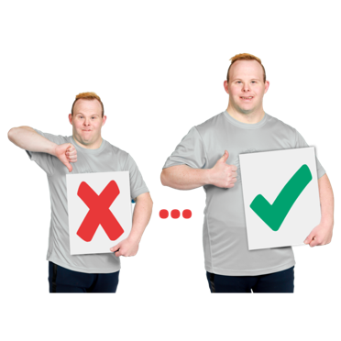 |  | - How do you think we could make our mental health services for older people better?  Please tell us in the space below.

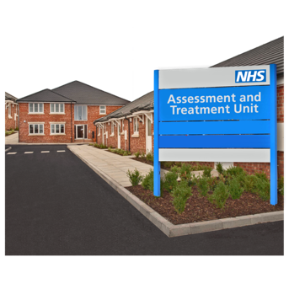 | - What do you think about our plans to make 1 service for older people with mental health needs?  Please tick 1 box.
 |  | I strongly disagree | ☐
 |  | I disagree a bit | ☐
 |  | I do not agree, and I do not disagree | ☐
 |  | I agree a bit | ☐
 |  | I strongly agree | ☐
 |  | I do not know | ☐

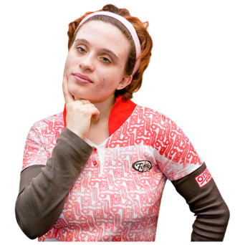 | Is there anything else you want to tell us about our plans to make 1 service for older people with mental health needs across Swansea Bay?  Please use the space below.

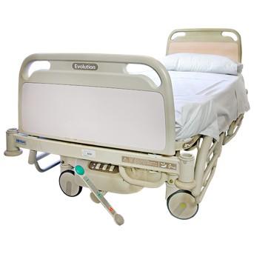 | - What do you think about our plans to lower the number of hospital beds we have?  Please tick 1 box.
 |  | I strongly disagree | ☐
 |  | I disagree a bit | ☐
 |  | I do not agree, and I do not disagree | ☐
 |  | I agree a bit | ☐
 |  | I strongly agree | ☐
 |  | I do not know | ☐

Is there anything else you want to tell us about our plans to lower the number of hospital beds we have across Swansea Bay?
Please use the space below.

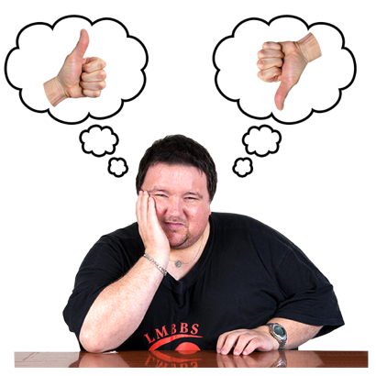 |  | - Do you think our plans for people with the greatest mental health needs will have a good or bad effect on some groups of people? For example, disabled people.  Please tick 1 box.
 |  | Yes | ☐
 |  | No | ☐
 | If you answered No, please go to the next section.

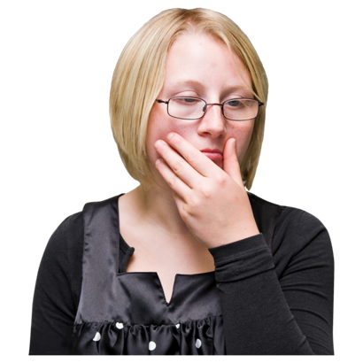 |  | - If you answered yes, please tell us why you are worried. What can we do to help these groups of people?

Tell us about yourself

- Are you:
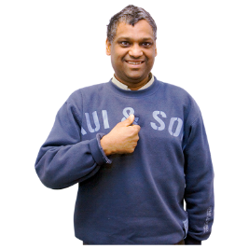 | - answering this survey for yourself? | ☐
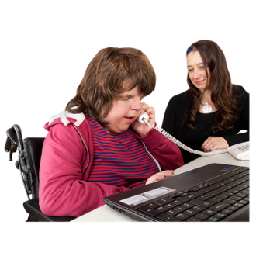 | - answering this survey for an organisation? | ☐

- How old are you?
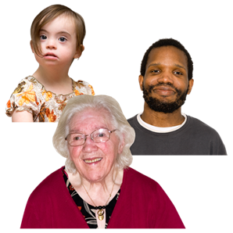 | Under 16 years old | ☐
 | 16 to 24 years old | ☐
 | 25 to 34 years old | ☐
 | 35 to 44 years old | ☐
 | 45 to 54 years old | ☐
 | 55 to 64 years old | ☐
 | 65 to 74 years old | ☐
 | 75 years old or over | ☐
 | I do not want to say | ☐

- How do you describe yourself?
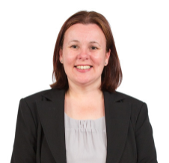 | Female | ☐
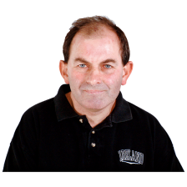 | Male | ☐
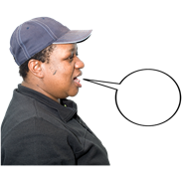 | Other or I want to use my own word. | ☐
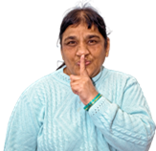 | I do not want to say | ☐
 | If you said other, please tell us how you describe yourself:

- How do you describe your ethnic group or background?

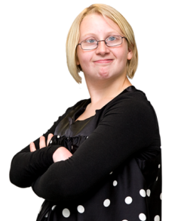 | White
 | White English, Welsh, Scottish, Northern Irish or British | ☐
 | White Irish | ☐
 | White Gypsy or White Irish Traveller | ☐
 | Any other White background. Please tell us what this is: | ☐

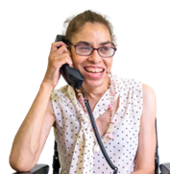 | Mixed or multiple ethnic groups
 | White and Black Caribbean | ☐
 | White and Black African | ☐
 | White and Asian | ☐
 | Any other mixed or multiple ethnic background. Please tell us what this is: | ☐
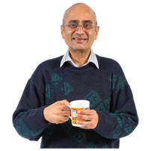 | Asian or Asian British
 | Indian | ☐
 | Pakistani | ☐
 | Bangladeshi | ☐
 | Chinese | ☐
 | Any other Asian background. Please tell us what this is: | ☐

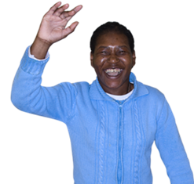 | Black, African or Caribbean or Black British
 | Black African | ☐
 | Black Caribbean | ☐
 | Any other Black, African or Caribbean background. Please tell us what this is: | ☐
 | Other ethnic group
 | Arab | ☐
 | Any other ethnic group | ☐
 | I do not want to say | ☐

- Do you find every day activities difficult because of:
- a health condition
- an illness
- or disability
that has lasted or will last for 1 year or more?

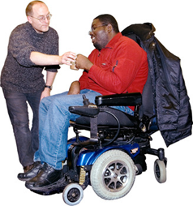 | Yes. I find everyday activities very difficult. I am limited a lot. | ☐
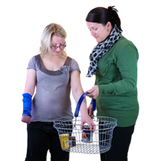 | Yes. I find everyday activities quite difficult. I am limited a little. | ☐
 | No | ☐
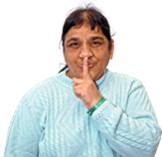 | I do not want to say | ☐

- Which of these words best describes how you think of yourself?

 | Bisexual - I love and fancy men and women | ☐
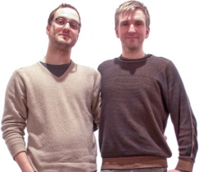 | Gay - I am a man and I love and fancy other men | ☐
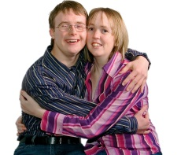 | Heterosexual - I love and fancy people of the opposite sex | ☐
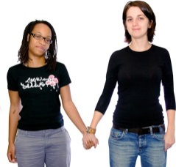 | Lesbian - I am a woman and I love and fancy other women | ☐
 | I would rather not say | ☐
 | Other | ☐
 | If you ticked other please tell us what:

- Please tell us about your marital status

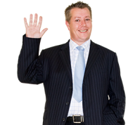 | I am single. I have never been married or had a civil partnership. | ☐
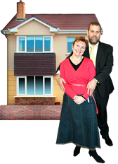 | I am married and I live with my husband or wife. | ☐
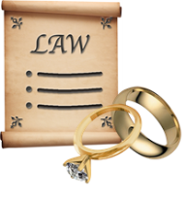 | I am separated, but still married by law. | ☐
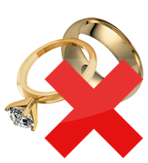 | I am divorced. | ☐
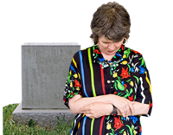 | I am widowed. | ☐
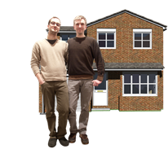 | I am in a same sex civil partnership. And I live with my partner. | ☐
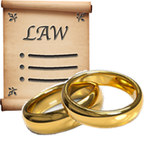 | I am separated, but I am still in a same sex civil partnership by law. | ☐
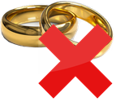 | I was in a civil partnership. But this has been ended by law. | ☐
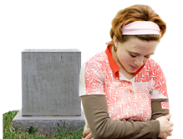 | My civil partner died | ☐
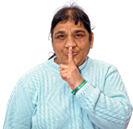 | I would rather not say | ☐

- What is your religion?

 | I do not have a religion | ☐
 | I am Christian (all types) | ☐
 | I am a Buddhist | ☐
 | I am Hindu | ☐
 | I am Jewish | ☐
 | I am Muslim | ☐
 | I am Sikh | ☐
 | I would rather not say | ☐
 | Other | ☐
 | If you ticked Other please tell us what:

- Please tell us about your pregnancy and maternity.

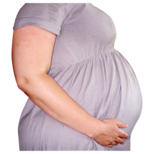 | Are you currently pregnant or have been pregnant in the last year? | ☐
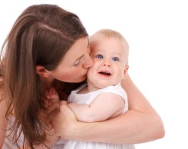 | Have you taken maternity leave from work in the last year? | ☐
  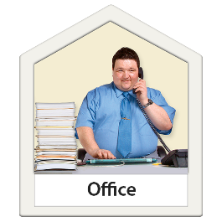 | Have you taken more than 2 weeks paternity leave from work in the last year? | ☐
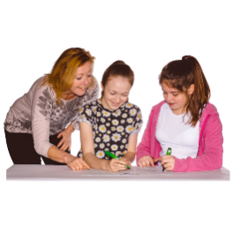 | Have you taken adoption leave from work in the last year? | ☐
 | I would rather not say | ☐

- When you were born were you described as
 | Male | ☐
 | Female | ☐
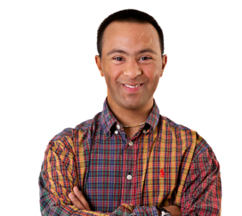 | Intersex | ☐
 | Other or I want to use my own word. | ☐
 | If you said other, please tell us how you describe yourself:
 | I do not want to say | ☐

- How do you think of yourself?

 | Male | ☐
 | Male | ☐
 | Other or I want to use my own word. | ☐
 | If you said other, please tell us how you describe yourself:
 | I do not want to say | ☐

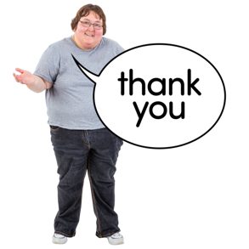 | Thank you for taking part in this survey.
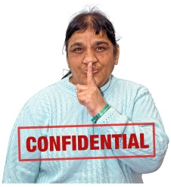 | We will collect all the answers and make we keep your information private.
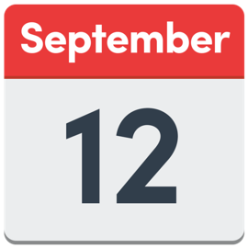 | Please return this form by 12 September 2021.
 | You can email it to us at SBU.engagement@wales.nhs.uk
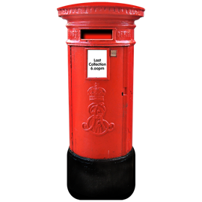 | You can post it to us at  Chief Executive  Swansea Bay UHB, One Talbot Gateway, Baglan SA12 7BR
 | Or you can fill it in on the Swansea Bay Health Board website.
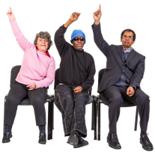 | If you have any questions you can email us at SBU.engagement@wales.nhs.uk or phone us on 01639 683355.

