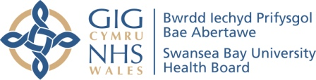
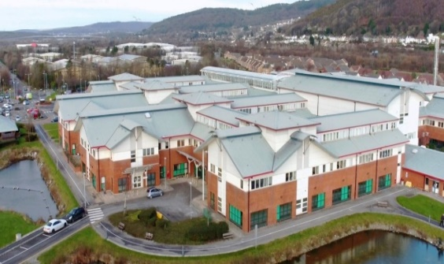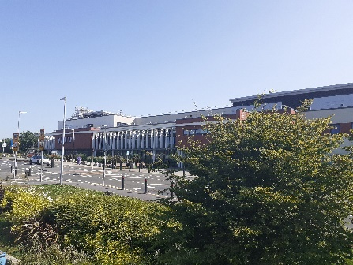
Public Engagement
Changing Orthopaedic Services for the Future
Engagement
20th February 2023 to 14th April 2023
Neath Port Talbot Hospital will be a centre of excellence for orthopaedic and spinal care, diagnostics, urology, rehabilitation and rheumatology.

Who are we, and what do we do?
Swansea Bay University Health Board runs your local NHS services in Neath Port Talbot and Swansea areas, specialist services for South West Wales and some very specialist services for people from further away. We plan and provide services provided by family doctors (GPs), dentists, chemists and opticians as well as providing community services such as district nurses, therapists, school nursing and health visiting.
About 390,000 people live in Swansea Bay and we employ approximately 12,500 staff and spend around £1billion every year on providing health services for our population.
In all of this we work closely with patients, their families and carers, the ambulance service, local authorities, universities and the voluntary sector.

What is this engagement about and who should read it?
Firstly, we will explain how orthopaedic services are currently organised for people from Swansea and Neath Port Talbot areas. Then we will explain the impact the Covid-19 pandemic has had on the number of people waiting and how long they are waiting for. And finally we will explain the changes we want to make.
Most people will either be on a waiting list for orthopaedics or will know family members or friends who are. We are aware that our waiting lists are far too long and we want to take action to ensure that we can provide comprehensive, equitable and sustainable orthopaedic services going forward. The changes to services we outline in this document include changes we are already making as a result of the public engagement in 2021 on Changing for the Future – which included agreement to develop Neath Port Talbot Hospital as a Centre of Excellence for Orthopaedic and Spinal Surgery. But we also include some additional proposals for how we believe we can improve our orthopaedic services more quickly and in a way which means we will have enough capacity for the future not only to reduce our waiting lists significantly, but also to cope with changing and increasing demands over time.

What Orthopaedic Services are there now for Swansea Bay residents?
Orthopaedics focuses on treating bones and joints and provides operations such as hip and knee replacements, often for older people.
Within Swansea Bay Health Board currently people referred to see an orthopaedic surgeon by their GP will attend outpatients at Neath Port Talbot Hospital and then when a decision is made that they need surgery, they are added to the Swansea Bay orthopaedics waiting list. If their operation is likely to be complicated they will have this at Morriston Hospital, but otherwise they will be operated on at Neath Port Talbot Hospital. A lot of our patients also have hand surgery at the Day Surgical Unit at Singleton Hospital.
This is in line with Changing for the Future, our plan for clinical services, which was publicly engaged on in 2021. In this we outlined plans to develop a Centre of Excellence for Orthopaedic and Spinal Surgery at Neath Port Talbot Hospital and increase surgery at Singleton Hospital.
However some Swansea Bay patients, due to arrangements which continued after the Bridgend Boundary Change in April 2019, are referred by their GP to Cwm Taf Morgannwg University Health Board (CTM). These patients attend outpatients at Neath Port Talbot Hospital and then when a decision is made that they need surgery, they are added to the CTM orthopaedics waiting list. If their operation is likely to be complicated they will have this at Princess of Wales Hospital, Bridgend, otherwise they will be operated on at Neath Port Talbot Hospital. Some CTM residents are also currently seen at Neath Port Talbot Hospital, either as an outpatient or for their operation.
Currently there are 8,649 Swansea Bay residents waiting to see an orthopaedic surgeon in outpatients at Neath Port Talbot Hospital, with 8,201 on the Swansea Bay waiting list, and 448 on CTM’s. There are 916 Swansea Bay residents waiting for complicated orthopaedic surgery at Morriston Hospital (on the SB waiting list), and an estimated 180 waiting to go to Princess of Wales Hospital, Bridgend (on the CTM waiting list). There are also 3,833 Swansea Bay residents waiting for uncomplicated orthopaedic surgery at Neath Port Talbot Hospital (3,086 on the Swansea Bay waiting list and 747 on CTM’s). This is shown below:
Type / Location of treatment | CTM Waiting List | SB Waiting List
Complicated operations:
Princess of Wales Hospital | 180 (estimated)
Morriston Hospital |  | 916
Uncomplicated operations:
Neath Port Talbot Hospital | 747 | 3086
Outpatients:
Neath Port Talbot Hospital | 448 | 8201
Prior to the pandemic Swansea Bay already had long waiting times for orthopaedic surgery although it was working hard to reduce these. When the Covid-19 pandemic started early in 2020, the NHS in Wales worked hard to identify how its available beds could be increased to cope with the huge number of patients we would need to treat. Unfortunately, this meant that planned surgery, including orthopaedics, had to be stopped as all available beds and facilities needed to be concentrated on responding to the pandemic. As a result, the total orthopaedic waiting list in Swansea Bay increased from 7,611 in March 2020 to 12,610 in March 2022.
In 2021 planned surgery started to be reintroduced, but by then waiting lists had grown massively and there was also a backlog of patients who had not been willing or able to access orthopaedic services during the pandemic. Although we are now recovering from the pandemic, some processes continue to be in place to limit risks to our patients and staff from Covid-19, flu and other respiratory diseases, which do impact how many patients we can treat, and we expect these to continue to be required.

What changes are already underway?
Changing for the Future, our Clinical Services Plan, outlined how we wanted to make each of our main hospitals Centres of Excellence. Part of this was the intention to make Neath Port Talbot Hospital a Centre of Excellence for Orthopaedic and Spinal Surgery and Urology.
Key to this is separating trauma from planned orthopaedic services in line with the British Orthopaedic Association and “Get It Right First Time” best practice guidance.
To achieve this we have already:
- Created 21 extra outpatient consultation rooms at Neath Port Talbot Hospital (in the former Ward G)
- Relocated fracture clinic back to Morriston Hospital into purpose-built facilities, so freeing up space at Neath Port Talbot Hospital (fracture clinic was moved from Morriston to Neath Port Talbot during the pandemic to minimise risk to patients attending)
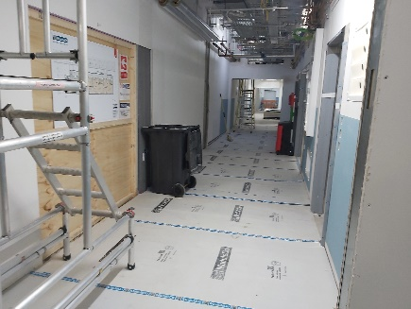
- Ring-fenced 10 beds at Morriston Hospital for complex orthopaedic patients so that they don’t have their operations cancelled due to emergency pressures
- Bought three additional modular theatres for Neath Port Talbot Hospitals, which have arrived and are being fitted out so that they are ready for use from June 2023
- Started work on an Enhanced Care Unit at Neath Port Talbot Hospital which will open in March 2023. This will mean that some patients with more complicated surgery will be able to be operated on at Neath Port Talbot Hospital instead of having to go to Morriston Hospital
- Introduced an Orthopaedic Prehab service which aims to support patients to prepare for surgery and to recover more quickly after their operation. This provides supervised exercise classes, access to pain relieving injections, specialist weight loss advice and access to community based weight loss programmes and is available to all patients waiting for hip and knee surgery.
This is all aimed at supporting our patients while they are waiting for operations and significantly increasing the number of orthopaedic patients we can see as outpatients and operate on at Neath Port Talbot and Morriston Hospitals so reducing the time patients are waiting.
Hand surgery in the Day Surgical Unit at Singleton Hospital will continue as currently.

What are our new proposals for changing orthopaedic services?
Currently CTM utilise 13 theatre sessions per week at Neath Port Talbot Hospital to treat patients on their orthopaedics waiting list. The surgeons and anaesthetists are employed by CTM but all support staff (for example nurses, theatre staff) are provided by our Health Board.
We believe that we can provide better, more equitable and sustainable orthopaedic services in Swansea Bay to meet both current and future needs by having access to some of the operating theatre time currently used by CTM at Neath Port Talbot Hospital. We have discussed this with CTM and they have agreed to release 6 of these operating sessions per week so that we can increase our activity. They have agreed this on the basis of all Swansea Bay patients currently on CTM orthopaedic waiting lists being transferred onto Swansea Bay waiting lists and all new referrals being received onto our waiting lists.
CTM will continue to utilise the remaining 7 sessions per week for their waiting lists. We also have other agreements in place with CTM, similar to orthopaedics, where we provide facilities and some of the staff at Neath Port Talbot Hospital for them to treat patients as part of the historical arrangement from Bridgend Boundary Change which we will keep under review and further changes may be required in the future.
Increasing the number of theatre sessions at Neath Port Talbot Hospital available to us, alongside the other developments outlined above, will mean we will be able to provide access to the same services for everyone in Swansea Bay, for example the orthopaedic prehab service described above, rather than have these services only available to patients on the Swansea Bay orthopaedic waiting list.
It will also mean that over the next year all our Swansea Bay residents who are waiting for orthopaedic treatment will see their waiting times reduce more quickly as the benefit from the additional facilities outlined above come fully into operation. We have already seen some improvements without the benefits of all these services being available yet – for example, in relation to the Ministerial target regarding the number of patients waiting over 52 weeks for a first outpatient appointment. We had agreed with Welsh Government to reduce these at the end of December 2022 to 3818 and managed to reduce this to 3401. Whilst there are still clearly too many people waiting, and waiting too long, this demonstrates that our efforts are starting to deliver the improvements we are working towards. The further facilities and staff we are recruiting to support this mean we will be able to make further significant progress in 2023.
Unfortunately it will mean that as a result of this proposal to transfer Swansea Bay residents from the CTM orthopaedics waiting list onto ours, some patients will have to wait longer for treatment. There are currently an estimated 1,375 Swansea Bay patients on the CTM orthopaedics waiting list who will need to be added to the current Swansea Bay orthopaedic waiting list of 12,203. Inevitably adding another 11% of patients to our existing lists will mean some impact for patients.
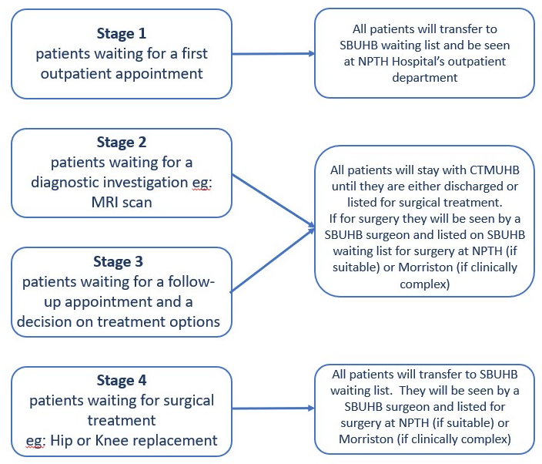
To minimise the impact of this we have timed this engagement so that should the proposals be agreed, these patients will be added to the Swansea Bay waiting lists as the new additional theatre capacity is already operational at Neath Port Talbot Hospital. As a result of all our plans coming into operation over the coming months, waiting times for Swansea Bay orthopaedic patients will already be reducing faster than currently, so the impact on patients should be reduced. We have also agreed to clinically review all Swansea Bay patients transferred from CTM to ensure they have an up-to-date care plan and that they are prioritised for the waiting list according to their needs, which may well have changed since they were initially assessed. Outlined below is a flowchart to show what we are proposing will happen to patients depending on where they are in their orthopaedics journey to help clarify this:
If these proposals are agreed Swansea Bay Health Board is confident that by April 2024 none of its patients will be waiting longer than 2 years for an orthopaedic operation.

What about the money?
Significant additional monies, both on staff and running costs and on new facilities, are being devoted to reducing waiting times in Swansea Bay. All the service changes outlined above have been financed, or funding is being sought in discussion with Welsh Government to bring these plans to fruition.

What are the benefits and drawbacks of these proposed changes?
Detailed below are some of the benefits which should be delivered by these proposed changes:
- By April 2024 all Swansea Bay residents will wait a maximum of 2 years for orthopaedic treatment
- All Swansea Bay residents will wait comparable times based on their clinical need for orthopaedic care
- All Swansea Bay residents will receive access to the same range of services, for example the Orthopaedic Prehab service outlined above.
- Swansea Bay residents on CTM orthopaedic waiting lists will have their cases clinically reviewed and their treatment plans and urgency updated where appropriate to reflect their current situation
- Swansea Bay residents who would have had their treatment at Princess of Wales Hospital, Bridgend will now have care provided closer to home in either Neath Port Talbot or Morriston Hospitals
- Swansea Bay will have sufficient capacity to reduce waiting times and achieve Ministerial and Welsh Government targets
- Neath Port Talbot Hospital will be able to move closer to becoming the Centre of Excellence for Orthopaedic and Spinal Surgery for Swansea Bay
Detailed below are some of the disadvantages we would arise from these proposed changes:
- Some patients will experience longer waits until the additional capacity planned within Swansea Bay becomes fully operational later in 2023

What will happen to staff affected by these proposed changes?
We have had some initial discussions with the teams providing orthopaedic care across Swansea Bay as well as with CTM in relation to the proposed changes, while recognising the importance of not prejudging the outcome of this engagement process. There is no risk to jobs and no transfers of staff from one organisation to another are involved.
No staff will be affected by the change proposed as they will all continue to work in the same location and service as they are currently do. We will be engaging with staff and Trade Unions as part of this engagement process to ensure any views are taken on board as part of this process.
Summary of our proposals
Outlined above are the changes we are already planning to improve orthopaedic services and deliver our vision of creating a Centre of Excellence for Orthopaedic and Spinal Surgery at Neath Port Talbot Hospital.
The specific change we are engaging on within this document is our plan to transfer operating theatre sessions from CTM to Swansea Bay so that we can provide a high quality, equitable and sustainable orthopaedics service for all our residents. As part of this we will transfer all Swansea Bay residents on CTM orthopaedic waiting lists to Swansea Bay orthopaedic waiting lists which will result in some patients having longer waiting times. It is anticipated that this situation will improve as Swansea Bay brings online the additional capacity planned at Neath Port Talbot and Morriston Hospitals and as a result waiting times for all Swansea Bay patients reduce.
If these proposals are agreed Swansea Bay Health Board is confident that by April 2024 none of its patients will be waiting longer than 2 years for an orthopaedic operation.

What about the impacts on equality groups?
We need to make sure that any decisions we make following engagement ensures we understand and take account of any impacts on people with protected characteristics under the Equality Act 2010. In addition, the new socio-economic duty, introduced on 31st March 2021, means we need to also actively consider the effects of these changes on increasing inequalities both nationally and locally. Therefore, we have produced a Stage 1 Equality Impact Assessment on the proposed changes which we will also engage on alongside this document. Any additional information on equality impacts identified through the engagement will be included in a Stage 2 Equality Impact Assessment which the Health Board and Community Health Council will consider when it considers the outcome of the engagement with a view to deciding whether the proposed change can go ahead or if further public consultation is required.

What do you think of these proposed changes?
In partnership with the Swansea Bay Community Health Council, the NHS Watchdog for our area, we will be discussing these proposals with our patients, their carers, the public, politicians and partner organisations. It is important that we get as many views as possible on these proposals for change and on how we can improve our services and the support we provide going forward.
Between 20th February and 14th April 2023 we are engaging on this proposed change.
We have agreed the range and scope of engagement with the Swansea Bay Community Health Council and will also be using events being run by partner organisations to talk to people (albeit virtually in some cases) about the proposed change. We will be talking to our orthopaedic patients directly as well by attending outpatient clinics.
The outcome of the engagement and all the responses received will be considered by Llais (the new national organisation replacing the CHC from 1st April 2023) and Health Board in May 2023. Based on this, decisions will be made about whether the proposed change can be implemented or whether further public consultation is required. Any other ideas put forward by the public and our partners will be considered as part of the diligent consideration of the responses to this engagement and we will agree any changes to what we have proposed with the CHC prior to the Health Board considering the outcome of the engagement.
You can let us know what you think by:
Writing to us: Chief Executive
Swansea Bay UHB
One Talbot Gateway
Baglan, SA12 7BR
Emailing us: SBU.engagement@wales.nhs.uk
Phoning us and leaving us a message: (01639) 683355
Contacting us on Facebook: Swansea Bay NHS
Twitter: @SwanseabayNHS

We have produced a response form so that it is easier for you to respond to this engagement. We would appreciate you filling this in and sending / emailing it to the contact points listed above.
Alternative versions of this document, in Welsh, large print (English and Welsh), audiobook (English and Welsh), British Sign Language video, Easy Read and Braille are available at https://sbuhb.nhs.wales/about-us/public-engagement-consultation/ and you can request these by ringing 01639 683355 or by emailing us at SBU.engagement@wales.nhs.uk.
We will be holding some face-to-face community events and online sessions to talk to people about these changes and get their views as we normally do. These events will be found on our website and we will also be publicising these on social media.
Alternatively, you can let the Community Health Council know your views by:
Writing to them: Swansea Bay Community Health Council
Cimla Hospital
Cimla
Neath
SA11 3SU
Or emailing them: swanseabay@waleschc.org.uk

Although the Community Health Councils in Wales are being replaced by Llais, the new Citizens’ Voice Body from 1st April 2023, arrangements have been put in place to ensure that any views sent to the Swansea Bay CHC will be transferred to Llais so there will not be any disruption to this or other engagements as a result.

