Rydym yn croesawu gohebiaeth yn y Gymraeg neu'r Saesneg.

Atebir gohebiaeth Gymraeg yn y Gymraeg, ac ni fydd hyn yn arwain at oedi.

We welcome correspondence in Welsh or English. Welsh language correspondence will be replied to in Welsh, and this will not lead to a delay.

**Brunswick Health Centre Premises Relocation Proposal - Information Leaflet**

Brunswick Health Centre want to move their premises from 139/140 St Helens Road, Swansea SA1 4DE to Heathfield House, 91 Heathfield, Swansea SA1 6EL.

Their current premises are (A) on the map. Heathfield House is (D) on the map. Heathfield House is 0.8 miles away from the current building.

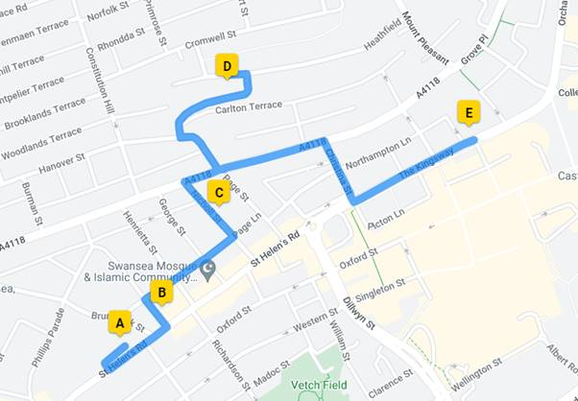

The new building will have many advantages:

* Better facilities for staff and patients in a renovated building
* More car parking with spaces reserved for disabled visitors
* An ambulance bay
* A better building may help to get and keep more staff
* The building will be away from a busy road location

However, it may be more difficult for patients who use public transport to get there.

The Health Board would like to hear your thoughts about this possible move. If you have suggestions about other buildings we could look at please let us know.

**The engagement will start on the 30th January 2023 and end on 27th February 2023**

We are holding a drop-in session for all patients from 2pm – 6pm on 13 February 2023 in Room 10 YMCA, Swansea. Please come and share your views.

You contact us in one of these ways:

* email - [SBU.BrunswickPatientFeedback@wales.nhs.uk](mailto:SBU.BrunswickPatientFeedback@wales.nhs.uk)
* Telephone 07815 478 291 and leave a message and you will be called back within three working days.
* Complete a feedback form that can be accessed by scanning this QR code:

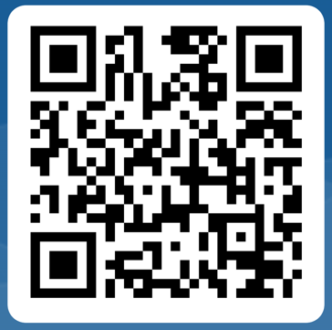

You can also get a copy of the feedback form by contacting the above e-mail address or telephone number.

Thank you for your help and we look forward to hearing from you.