Brunswick Health Centre – Moving Premises
Frequently Asked Questions

What might change?
Brunswick Health Centre have asked Swansea Bay University Health Board for agreement to move their premises from 139/140 St Helens Road, Swansea SA1 4DE to Heathfield House, 91 Heathfield, Swansea SA1 6EL.

The doctors, nurses and practice staff are not changing; nor are the opening hours or services offered. The practice telephone number will move to the new building and the appointment system will be the same. There will be no interruption to your prescription or home visits for those in need. The only change will be the location of the surgery building.

What does this mean for me?
You will have the same care but will need to travel to the new building for face-to-face appointments. The practice say that the new building will have many advantages:
- Better facilities for staff and patients in a renovated building
- Changes to meet the needs of people with disabilities and mobility issues including safe disabled access and toilet facilities
- More car parking with spaces reserved for disabled visitors
- An ambulance bay
- A better building may help to get and keep more staff
- The building will be away from a busy road location

Do I need to do anything?
You do not need to do anything yet and can carry on using the practice as normal. If the move does happen, you will be told and you won’t have to fill in any forms.

Why does the practice want to move?
The current practice building needs a lot of work and alteration to meet modern health care standards. The building is rented and a new lease has not been agreed as the building owners cannot make the improvements needed. Moving to a new building will provide the practice with security, better facilities and more space to grow and improve.

Can I register with another practice if I prefer?
If you think the new building would not suit you, you can register with another practice of your choice. All you need to do is contact your preferred surgery and fill in a registration form. Your medical notes will be transferred automatically, and your care and prescription provision will not be interrupted. You can also phone the Registration Team on 01792 860 500, who will be happy to help you.

How do I get to the new building?

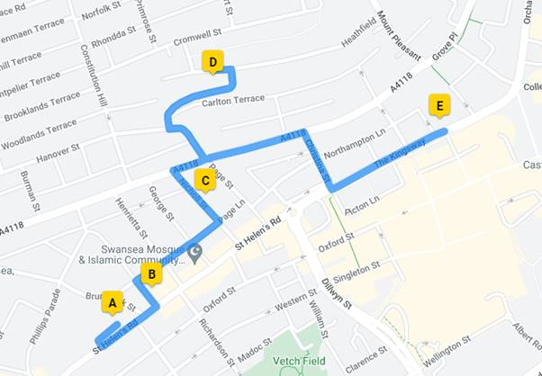

The practice want to move Brunswick Health Centre, St Helen’s Road (A) to Heathfield House (D). The new building is 0.8 miles away from the current building and used to be a solicitors’ office.

Other Practices in the local area include:
Abertawe Medical Partnership, 0.1 miles from Brunswick Health Centre (B)
Nicholl Street 0.3 miles (C)
Kingsway Surgery 0.5 miles (E)

The nearest bus routes from Swansea bus station to the new building are on:
Christina Street, a 0.2-mile uphill walk or
Terrace Road. a 0.3 mile downhill walk

New building pictures

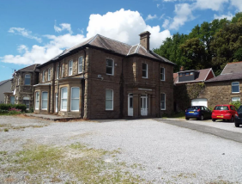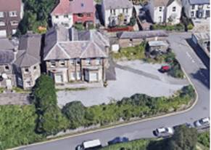

Will this move definitely happen?
It is likely that the practice will have to move because their building is rented and a new lease has not been agreed as the building owners cannot make the improvements needed. But where they move to can be discussed and the Health Board would like to hear your thoughts on other buildings that could be looked at.

