Rydym yn croesawu gohebiaeth yn y Gymraeg ac yn y Saesneg.
We welcome correspondence in Welsh or English.

30 January 2023

To: All patients registered at Brunswick Health Centre

Dear Sir/Madam,

Brunswick Health Centre Premises Relocation Proposal

Brunswick Health Centre want to move their premises from 139/140 St Helens Road, Swansea SA1 4DE to Heathfield House, 91 Heathfield, Swansea SA1 6EL.

Therefore the Health Board wants to hear your views about this proposal. We will be contacting patients and other interested parties to hear their views. The engagement will explain why the GP Practice wants to move and about the proposed new site so that you can tell us your views. We want to know how this would impact you as a patient and if you have any ideas about alternative sites for the surgery which we could look at.

Attached is an information sheet with details of the proposals and what this will mean for you.

Yours sincerely

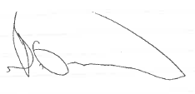

Brian Owens
Group Director – Primary, Community Services & Therapies

