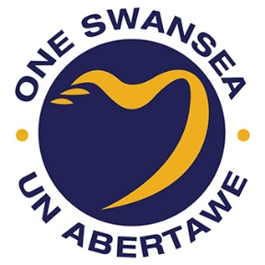

**Swansea Public Services Board**

**Annual Report 2018 / 2019**

**July 2019**

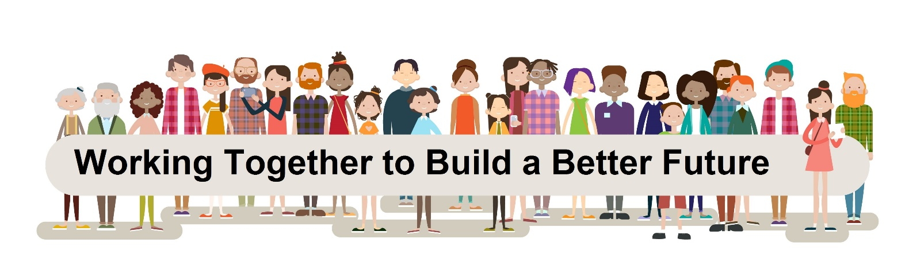

**Contents**

Message from Swansea Public Services Board Page 3

Our Vision and Local Well-being Objectives Page 4

The Way we Work- Governance Page 6

Swansea’s Local Well-being Page 10

Progress towards Our Local Well-being Objectives Page 12

Our Ways of Working Page 27

Our Next Steps Page 31

How you can get involved? Page 31

**Message from Swansea PSB**

Foreword from Chair/Vice Chair

It has been a year since Swansea Public Services Board published our first Local Well-being Plan in May 2018.

This Report aims to highlight not only the progress made towards the ‘Swansea we Want’ but also to reflect on how we have applied the sustainable development principle’s ways of working and how we might better work towards well-being in the future.

Our first year of operation focused on research to understand Swansea’s challenges and opportunities, while the second year concentrated on planning and prioritising areas where collectively we could make the biggest difference. This Report focuses on 2018/19 - our first year of implementation and delivery. In addition, to the meaningful outcomes that have helped change lives in Swansea, we have also created and continue to develop a delivery infrastructure and governance system.

While we have achieved a great deal in the first year of delivery, Swansea PSB is not complacent and will continue to innovate and seek new ways to improve Swansea’s well-being both today and for future generations.

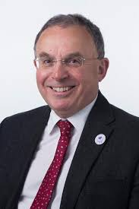 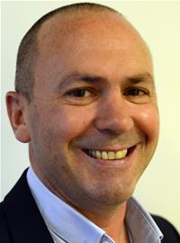

**Professor Andrew Davies Cllr Clive Lloyd**

**PSB Chair Vice-Chair**

**Our Vision and Local Well-being Objectives**

**Swansea PSB - The story so far**

The Well-being of Future Generations Act (Wales) 2015 created Public Services Boards so that local organisations could work together to improve the economic, social, environmental and cultural well-being of their area by contributing to the achievement of Wales’s Well-being goals.

In 2016, the Public Services Board (PSB) started a conversation about well-being in Swansea. We carried out an Assessment of Local Well-being to understand what matters most to communities. The Assessment told us that for many reasons Swansea is a great place to live but that we need to work harder together to make sure everyone can live well, benefit from and be proud of Swansea.

Using information from the Assessment and by listening to people, in 2018, Swansea Public Services Board developed a Local Well-being Plan. This identified our four Well-Being Objectives and a cross-cutting action.

This report aims to provide an update on the progress we have made towards meeting our objectives, the lessons learnt and our future ambitions.

**Our Vision**

In Swansea, we believe in the rights of every person. Our vision is to work together to make Swansea a place which is prosperous, where our natural environment is appreciated and maintained and where every person can have the best start in life, get a good job, live well, age well and have every opportunity to be healthy, happy, safe and the best they can be.

To achieve our vision we have prioritised four Local Well-being Objectives. We hope that by focusing our collective efforts, we can make the biggest difference by working together.

**Our Local Well-being objectives for 2040**

Our four key long term areas of work are prioritised below

Cross Cutting Action – Sharing for Swansea

**Early Years** – To ensure that children have the best start in life to be the best that they can be.

**Live Well, Age Well –** To make Swansea a great place to live well and age well.

**Working with Nature** - To improve health, enhance biodiversity and reduce our carbon footprint.

**Strong Communities** – To build strong communities with a sense of pride and belonging

In addition, our cross cutting action for change underpins each of the local well-being objectives.

**Sharing for Swansea** – To work towards integrated public services in Swansea by sharing resources assets and expertise, in order to develop a common language and make every contact count.

However over the past year Swansea PSB has reflected that the flexibility to respond to emerging agendas and regional concerns are also important. This value is demonstrated by the responsive work carried out regionally with our partners at Neath Port Talbot Public Services Board on substance misuse detailed on page 28.

**The Way We Work - Governance**

**The Sustainable Development Principle**

Swansea PSB is committed to acting in a manner which seeks to ensure the needs of the present are met without compromising the ability of future generations to meet their own needs.

We do this by ensuring every decision we make or action we take considers the sustainable development principle’s five ways of working.

|  |  |
| --- | --- |
|  | **Long term:** The importance of balancing short-term needs with the need to safeguard the ability to also meet long-term needs. |
|  | **Prevention:** How to act to prevent problems occurring or getting worse may help public bodies meet their objectives. |
|  | **Integration:** Considering how public body’s well-being objectives may impact upon each of the well-being goals, on their other objectives, or on the objectives of other public bodies. |
|  | **Collaboration:** Acting in collaboration with any other person (or different parts of that body itself) that could help the body meet its well-being objectives. |
|  | **Involvement:** The importance of involving people with an interest in achieving the well-being goals, and ensuring that those people reflect the diversity of the area which the body services. |

**The National Well-being Goals**

We aim to make our actions deliver as much value as possible by ensuring we look for multiple outcomes in all we do. By ensuring we think about each of the national well-being goals below we maximise our contribution to the Wales We Want.

|  |  |
| --- | --- |
| **Goal** | **Description of the Goal** |
| **A prosperous Wales** | An innovative, productive and low carbon society which recognises the limits of the global environment and therefore uses resources efficiently and proportionately (including action on climate change); and which develops a skilled and well-educated population in an economy which generates wealth and provides employment opportunities, allowing people to take advantage of the wealth generated through securing decent work. |
| **A resilient Wales** | A nation which maintains and enhances a biodiverse natural environment with healthy functioning ecosystems that support social, economic and ecological resilience and the capacity to adapt to change (for example climate change). |
| **A healthier Wales** | A society in which people’s physical and mental well-being is maximised and in which choices and behaviours that benefit future health are understood. |
| **A more equal Wales** | A society that enables people to fulfil their potential no matter what their background or circumstances (including their socio economic background and circumstances). |
| **A Wales of cohesive communities** | Attractive, viable, safe and well-connected communities. |
| **A Wales of vibrant culture and thriving Welsh language** | A society that promotes and protects culture, heritage and the Welsh language, and which encourages people to participate in the arts, and sports and recreation. |
| **A globally responsible Wales** | A nation which, when doing anything to improve the economic , social, environmental and cultural well-being of wales, takes account of whether doing such a thing may make a positive contribution to global well-being. |

**Our Commitments**

In addition, all Swansea PSB Partners have signed up to a set of commitments. These commitments are below and go beyond the legal duties that the different organisations have and are reviewed taking account of advice from Wales’s Commissioners.

* **Healthy City Status**

Swansea is part of the Healthy Cities network promoting good health and addressing health inequality in our communities.

* **Swansea as a Human Rights City**

Swansea Public Services Board supports the development of a Human Rights City approach in Swansea.

* **Children and Young People’s Rights (UNCRC)**

The Board is committed to making sure that services have a positive effect on children and young people in Swansea and have embedded the United Nations Convention on the Rights of the Child (UNCRC) into the way we set our policies.

* **First 1000 Days Collaborative**

Swansea Public Services Board has joined the First 1000 Days collaborative, which supports families throughout pregnancy and the first two years of life.

* **Age Friendly Cities and Communities**

The Board endorses the principles and actions set out in the Dublin Declaration on Age-Friendly Cities and Communities in Europe.

* **Good Practice in Public Engagement**

The Board endorses the National Principles for Public Engagement in Wales and will follow them in all engagement and consultation. The Board is committed to engaging people who are interested in improving local well-being in the development of both the Well-being Assessment and the Well-being Plan and will strive to reflect the diversity of the population when doing so.

* **Participation of Children and Young People**

The Board is committed to the principles of the National Standards for Children and Young People’s Participation.

* **Armed Forces Community Covenant**

The Board is committed to the Armed Forces Community Covenant and to nurturing understanding and awareness amongst the public of the issues affecting the armed forces community.

* **Convention on Biological Diversity**

The Board is committed to delivering against the principles of the Convention on Biological Diversity as set out in the adopted Swansea Local Biodiversity Action Plan 2005.

* **One Public Sector**

The Board is committed to a culture that cuts across organisational boundaries and sectors. Where everyone involved in the delivery of public services in Wales is part of this common endeavour, sharing common values and working together for the benefit of the people of Wales.

**How we work**

Each Local Well-being Objective and the cross cutting action for change has been led by an Objective Lead (initially Design Leads were also in place for the agreement of frameworks but this was later felt to add little value so was discontinued). Each Objective Lead co-ordinated a range of stakeholders to agree how the steps might best be progressed. The Chairs of each subgroup also sat on the PSB Partnership so that the work of the Board could be considered holistically.

On reflection, Swansea PSB has recognised a need for more formal oversight with direct reporting by accountable PSB statutory members rather than officers from a range of organisations.

Each Objective Delivery group operates in very different ways, with varied terms of reference. Some groups were initially established for a different purpose and others deliver on other commitments (e.g. Healthy Cities) as well as their PSB responsibilities. The PSB has identified that integration could improve if these informal links and arrangements are mapped and clarified.

While Swansea PSB has consciously sought to improve how we involve ‘unusual suspects’ there is still scope to include a wider stakeholder audience and opportunities to further involve the public more regularly moving forward.

A Research Group delivered the Assessment of Local Well-being and has focused on indicators etc. while a Planning group was tasked with delivery of the Local Well-being Plan. We have learnt that a pool of experts and specialists could better benefit from PSB wide communications and contribute their skills to projects on a task and finish basis would be more effective in involving officers.

In addition, regional working has taken place via joint meetings of Swansea and Neath Port Talbot PSBs. It was agreed that joint action was required to respond to the rate of drug related deaths, levels of opioid injecting practices and a new phenomenon – county lines. This work is detailed further under Collaboration in the Our Ways of Working section.

**Swansea’s Local Well-being**

In October 2018, a ‘Well-being Measures Workshop’ was held at Technium 2 (UWTSD). This was a joint workshop of the PSB’s Research and Planning sub groups, which considered draft proposals for an initial ‘basket’ of population-level measures, focusing on the National Indicators, to inform an initial view of well-being in Swansea.

This chapter summarises the situation in Swansea and recent local trends in a number of the National Indicators, using the latest published statistics:

* The **healthy life expectancy gap** between the most and least deprived areas in Swansea (2010-14) was 21.9 years for males (Wales 18.7) and 16.3 years for females (Wales 18.2). Since 2005-09, the gaps have slightly reduced for males in Swansea (from 22.4 years), but increased for females (from 15.0). *(National Indicator 2)*
* 10.9% of adults in Swansea reported fewer than two (of the five) healthy **lifestyle behaviours** (Wales 10.3%) (National Survey 2016-18). Swansea is currently higher than the Welsh average for smoking and drinking (above guidelines), but better on measures of eating fruit and vegetables, physical activity and healthy weight. *(NI 3)*
* **Air quality** in Swansea, as measured by annual average levels of Nitrogen Dioxide (NO2) pollution exposure, has improved; falling from 14.3 µg/m3 in 2007 to 9.5 in 2017 (modelled data – pollutants per cubic metre of air). Average NO2 concentrations in Wales are slightly lower (9.3 µg/m3 in 2017). *(NI 4)*
* In 2017-18, 21% of people aged 16+ living in households in Swansea live in **material deprivation** (that is, cannot afford particular goods and activities that are typical in society at a given point in time); above the Wales average (16%) and increasing from 18% in 2016-17, although these are (national) survey-based estimates. *(NI 19)*
* 81% of adults in Swansea were moderately or very satisfied with their jobs in 2017-18 (Wales 82%). Employed respondents are asked to rate their **job satisfaction** on a scale from 0 to 10, and this includes those that answered 6 or above. The 2016-17 Swansea figure was 86%, although local changes in survey estimates require caution. *(NI 20)*
* In 2016-17, 66% of adults in Swansea **felt safe** (Wales 73%). Respondents were asked how safe they felt after dark at home, walking in the local area, and travelling (on a five point scale). Those that responded either ‘very safe’ or ‘fairly safe’ to all three questions were coded by the National Survey as ‘feeling safe’. *(NI 25)*
* In the National Survey 2016-17, 46% of people aged 16+ in Swansea agreed with all three statements related to **community cohesion** (Wales 50%): people agreeing that they belong to the area; people from different backgrounds get on well together; people treat each other with respect. The Swansea figures for individual statements were 66%, 68% and 74% respectively. *(NI 27)*
* **Volunteering** is undertaken by 31% of people aged 16+ in Swansea in 2016-17 (Wales 28%). These figures reflect people who stated that they currently (at time of survey) give their time for free (formally and informally) to help a list of clubs or organisations. *(NI 28)*
* The National Survey also includes a set of six questions to assess levels of **loneliness**, calculated using the De Jong Gierveld loneliness scale. Based on these, 17% of people aged 16+ in Swansea (16% in Wales) were found to be lonely in 2017-18; slightly lower than in 2016-17 (19% in Swansea, 17% in Wales). *(NI 30)*
* The number of households for whom **homelessness** was successfully prevented for at least 6 months, as a rate per 10,000 households, is also a National Indicator. During 2017-18 the rate for Swansea was 73.7 per 10,000 household, which reduced from 78.1 (revised) during 2016-17 (Wales: 44.9 in 2017-18; 43.0 in 2016-17). *(NI 34)*
* In terms of **child obesity**, 74.8% of children in reception year (aged 4 to 5) were of healthy weight in 2017-18, above the equivalent Wales rate (73.6%). The Swansea figure has fluctuated but remained relatively constant overall since 2012-13 (74.2%). *(Thriving Places 2018 measure 15)*
* In Swansea, 59.8% of children obtained **five or more GCSEs A* to C** including English or Welsh language and Maths in 2017-18 (Wales 55.1%). There is a clear gap between girls (66.3%) and boys (53.7%). In the last five years, overall attainment in Swansea has improved from 55.3% in 2012-13. *(TP 28)*

For some of the measures identified at the workshop – child development *(NI 6)*, young people not in education, training or employment *(NI 22)*, area of healthy ecosystems *(NI 43)* and domestic-abuse related offences and incidents *(TP 10)* – published data at local authority or PSB area level is not readily available.

**Progress towards Our Local Well-being Objectives**

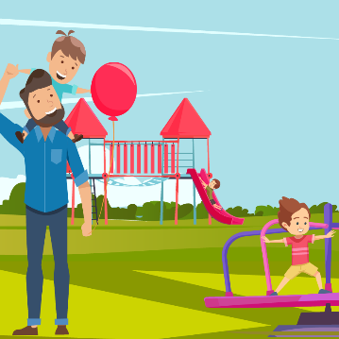**Early Years**

**To ensure that children have the best start in life to be the best that they can be.**

**Lead –** This work was coordinated by the Early Years Steering Group and led by Professor Andrew Davies.

**Partners/ Stakeholders Involved**

Early Years Partnership; Early Years Steering Group; Best Start Steering Group; Primary Care Early Years Pilot; Jig-So service; Early Intervention Services; Childcare sector**/** Family Information Service; Healthy Pre School Scheme; Active Young People Team; Early Years Progression Officer; Early Learning and Language Development Team; Health Visiting; Swansea Council-Education; Swansea Bay University Health Board Public Health Wales; Flying Start Link Teachers/Foundation Phase Strategic Lead; University Wales Trinity Saint David, Flying Start childcare settings; families, community groups, Midwifery.

**The Steps we have taken**

This Local Well-being Objective builds on the success of previous collective activity. This success has been recognised by Welsh Government who have asked both Swansea PSB and Neath Port Talbot PSB to act as **Early Years Integration Pathfinders** for Wales. While relationships between partners are extremely close as a result of this joint working, it is recognised that the next step is to widen participation particularly from groups not traditionally associated with Early Years work. This would maximise contribution to all of the well-being goals, not only goals explicitly linked to the Local Well-being Objective (e.g. a resilient Wales as well as a healthier Wales are fully more addressed).

Swansea PSB is committed to learning from good practice in Swansea and beyond sharing and gathering ideas and good practice through the **Sustained Shared Thinking and Emotional Well-being (SSTEW)** pilot in Swansea Flying Start is an example of this commitment. National networks, such as the Healthy pre-school scheme network and national play organisations are other examples of good collaborative work. Swansea is also learning from Cwm Taf in the Welsh Government pathfinder initiative.

In 2018, Swansea PSB formally joined the **First 1000 Days Collaborative** having delivered a well-attended engagement event. In addition, an action plan has been drafted along with a communications strategy to promote the First 1000 Days work in Swansea to key stakeholders. In order to reduce duplication and improve integration, the Action Plan is merged with our Children have the Best Start in Life Plan.

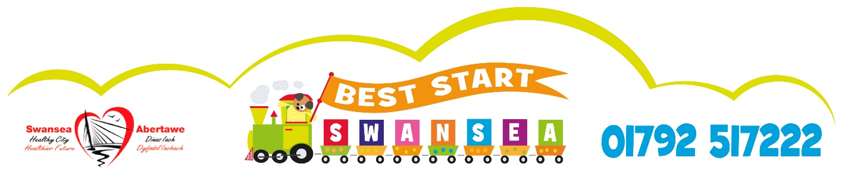

Prevention is at the heart of this local well-being objective so we aim to engage all our PSB workforces to make every contact count by promoting key messages and knowledge to families. This has included promoting **‘Best Start’** key messages by social media and at events, displaying posters and associated materials in settings and by raising awareness at the team meetings of a wide variety of agencies throughout Swansea.

Parents and families have also been actively involved in promoting key messages. This has involved collaboration with the third sector for example in the creation of a storybook resource. Other effective means have included the Primary School **Big Conversation** and community engagement events such as the flagship **Buggy Push** event.

Focusing on a specific area to widely promote an intervention to all stakeholders has proved successful for example this has been applied with the development of the **SKIP (Meithrin)** programme which applies University of Wales Trinity St David research on the importance of supporting children’s motor development in early years in a practical way in early years settings across Swansea. To date 15 settings have received this intervention, with more planned over the coming year.

The adoption of **social prescribing** at all levels is an important step where Early Years staff are being upskilled to access alternatives to formal interventions and medication. An Early Years Worker has been employed and has successfully delivered on this approach at Penderry GP Cluster. This approach has been extended for year 19/20 to the Loughor and Cwmtawe GP Cluster areas. Adverse Childhood Experience (ACE) Awareness training has also been effectively rolled out across partners to raise awareness and assist data collection.

One of the areas which best demonstrates each of the ways of working being used to best effect is the **Jig-so** multi agency initiative for young families. The initiative aims to fill the gaps between statutory services across sectors. In the past the only involvement with vulnerable families in a child’s first 1000 days was via health services, Jig-so changes that. The team of midwives, community nursery nurses, family facilitators and language development workers offers support to all young parents up to 18 and vulnerable parents aged 19-24. This award winning intervention results in long term health and educational benefits for the families, this claim is supported by a yearlong study undertaken by Swansea University which has shown the project is working, and changing young parents’ lives. Using a cost avoidance tool developed by Swansea Council, the project can have cost avoidance benefits of an average £8,783 per client.

In order to ensure interventions are made earlier in life several cross agency pilots have been developed including a Swansea wide system for children age 0-3 with Additional Learning Needs via the Flying Start Pathway, the review of Speech and Language Referral changes and changes to transition processes and documentation.

In order to deliver preventative services at an earlier stage to stop issues becoming worse, a review has taken place of current perinatal mental health and well-being services. This identified that midwives and health visitors would benefit from a greater range of tools and training to support patients. The findings of the local review were also reflected at a national level. Collaborative improvements are being led by the Wales NHS Collaborative.

**Live Well, Age Well**



**To make Swansea a great place to live well and age well.**

**Lead –** This work was coordinated by the Aging Well Steering Group and Led by Cllr Mark Child.

**Partners/ Stakeholders Involved**

West Glamorgan Regional Partnership Board; Swansea Bay University Health Board; Dementia Friendly Swansea; Mid & West Wales Fire & Rescue Service ; South Wales Police; Swansea University; Swansea Council Education; Swansea Council Social Services, Universities, Alzheimer’s Society, Health, Voluntary Sector, Coastal Housing, Pobl; Voluntary sector; Housing Associations; Private Sector, Schools.

**The Steps we have taken**

The ‘Live Well, Age Well’ Local Well-being Objective reflects Swansea’s increasing focus on the life course rather than simply addressing issues facing people over 50. This approach recognises that living well is to age well and is this is the concern of people of all ages rather than just a challenge for today’s older people. Progress has been already made against many of the steps outlined in the Well-being Plan.

Innovative approaches to health and social care have been taken by supporting dementia friendly communities. Action has been taken to co-produce a **Dementia Friendly Action Plan** which will be further developed in 2019/20. An action plan and engagement plan has been developed within the life stages team setting out priorities for the next 3 years this includes promoting Intergenerational projects e.g. The BIG Intergenerational conversation, Dementia Friendly Schools and Dementia Friendly Homes.

The **Dementia Friendly Generations** project has developed schools packs to increase awareness of dementia in young people and develop and promote intergenerational projects. This project has been co-produced with colleagues from Swansea Council, Health, Social Services, Education and the Alzheimer’s Society. A pilot project that aims to raise awareness and initiate Dementia Friendly actions is being tested by a primary and secondary school and two care homes in Swansea. This has delivered information sessions to pupils, staff and parents.

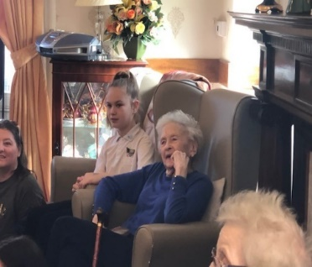People Speak Up are tasked with delivering intergenerational work. The aim of which is to create a digital storytelling project bringing together the young and older people in the participating schools and care homes. The first stage of the project will run training workshops with staff, residents and their families in the care homes and workshops in schools for pupils to create and understanding of storytelling, communication and dementia awareness.

***Intergenerational work- bringing together young and older people***

The second stage will bring the younger and older people together via 5 workshops. The resultant digital stories will be shared with photographs from the project process with family and networks invited to celebrate the project.

The **Dementia Friendly Homes** project aims to support families to stay together at home for as long as possible. It aims to develop a training and information programme to support families to fully understand the dementia journey and give practical advice and support in how to create a dementia supportive environment in the home. This commenced in April 2019 with a successful consultation event.

A **Making Every Contact Count** model for Live Well, Age Well is in development. This aims to share key health, safety and well-being messages across public services so staff are able to identify problems that their service users experience outside their specialist area at an early stage and signpost effectively to prevent them from happening or getting worse.

To date training has been provided across participating PSB organisations and champions for the roll out of this approach have been identified and training has taken place. Aide memoire cards have also been developed to support staff. Two training sessions have taken place with a total of 19 participants. This has resulted in potential issues being raised for example the limited time and capacity of staff and other lessons learnt which we intend to consider before taking the project further.

**Community based approaches** are a step that aims to explore a range of initiatives to tackle social isolation and build personal resilience across the PSB and voluntary sector. Actions include exploring opportunities for building confidence, improving well-being and helping people who are over 50+ to get back into employment. ‘Swansea Working’ a single entry point for employability support in Swansea, is working with the Department for Work and Pensions on an initiative of tailored support with our partners for 600 people from the 50+ age group who are long term unemployed and have issues such as social isolation.

‘Our Club’ will have a focus on engaging with some of our older clients (particularly those over 50), but we will consider everyone who expresses an interest. The programme will consist of an introduction day, two weeks training with a built in graduation day. ‘Our Club’ will link up with existing initiatives if clients are ready for work experience following the programme.

Work is taking place to ensure Swansea is an **Age Friendly City** Centre in line with World Health Organisation (WHO) Guidelines. Engagement events with our older community members have taken place in relation to about what an Age Friendly City looks like for Swansea.

Planning colleagues and developers have been provided with advice and resources to ensure City Centre development is considerate of issues relating to older community members and is accessible to people of all ages. This builds on the Council’s commitment signing the Dublin Declaration to be an Age Friendly City in 2015. The Older Persons Commissioners Office supports Swansea in exploring the possibility of submitting an application to be the first WHO Age Friendly City in Wales.

PSB Partners celebrated Falls Prevention Week in February 2019 sharing materials and raising awareness.

In 2018/19 the **Local Area Coordination** team has continued to expand, from seven co-ordinators in March 2018 to eleven in January 2019.  Partnership working continues to be vital to development.  The Leadership Group, who support the growth of the programme and which meets monthly, is comprised of internal and external partners including housing associations, Swansea Bay University Health Board, Public Health Wales, Swansea University and Third Sector partners.

Three of the housing associations invest financially, while Mid and West Wales Fire & Rescue Service provided a secondment during 2018. A new post has been financed by Pobl Housing Association and second new post through a successful Transformation fund bid by the Cwm Tawe GP Cluster to support Neighbourhood Working. Further partnership investment is being sought for further expansion of the team in 2019.

Culture change is an important step progressed in 2018/19. The PSB has commenced an intergenerational debate about what it means to live well and age well with the longer term aim of developing a campaign based on the feedback that can be promoted across the life stages.

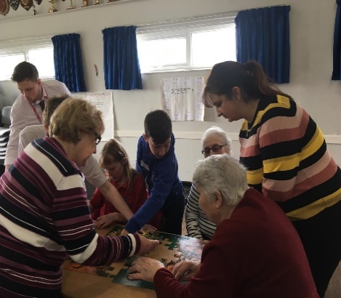The first **Big ‘Intergenerational’ Conversation** which took place on December 10th 2018 at St Teilo’s Community Cwtch. The content of this Big Conversation was based on the fact that the session took place on International Human Rights Day and served as the launch of the our intergenerational approach to improving quality participation and wellbeing across the life stages.

***Big Intergenerational Conversation at St Teilo’s***

There were three workshops when attendees explored the following:

* A City For Everyone – Participants watched a fly-through video and had access to the tactile models, maps and artist impressions before creating their idea of a ‘Best City’ using drawings, words and Playdough models.
* All Ages Working Together – Participants created Venn diagrams of similarities and differences across the age range and considered how we can successfully work across the ages.
* Digital Heroes - Participants learnt about the Digital Heroes programme and were able to explore different technologies like apps and virtual reality headsets to bring all ages together.

Moving forward, we aim to increase the emphasis on work along the whole life course, building on what has been achieved with children’s participation and due regard to children’s rights via successful initiatives such as Rights Respecting Schools. This holistic approach will improve voice, choice and control and lead to coproductive opportunities.

**Working with Nature**



**To improve health, enhance biodiversity and reduce our carbon footprint.**

**Lead –** This work was coordinated by the Working With Nature Task Group and Led by Natural Resources Wales (NRW) and Swansea Environmental Forum (SEF).

**Partners/ Stakeholders Involved**

Natural Resources Wales (NRW); Swansea Council; Green Infrastructure Consultancy; The Environment Centre; Trees for Cities; Swansea Community Green Spaces Project; Swansea Environmental Forum; Swansea Local Nature Partnership; Low Carbon Swansea Bay network, Swansea University, University of Wales Trinity St David’s; Swansea Bay University Health Board; Mid and West Wales Fire and Rescue and Welsh Government.

**The Steps we have taken**

The Working with Nature Task Group meets on a monthly basis. The membership of the group is expanding as we identify other PSB partners that are interested in supporting the work.

The Task Group has been primarily developing the Working with Nature action plan to build on the steps in the Swansea Well-being Plan by agreeing specific actions and milestones. We have added appendices to the action plan to highlight the way the steps and actions will contribute to the seven well-being goals, demonstrate the five ways of working and support the other objectives in the Swansea Well-being Plan.

Good progress has been made with some of the Working with Nature steps over the past year but some areas are less developed:

**Green Infrastructure (GI)**: Green infrastructure means all the green space, soil, vegetation and water that make our cities liveable. We have been developing a green infrastructure strategy for Swansea City Centre which will connect and improve areas of green space making the city more resilient to the impacts of climate change and enhancing nature. Connecting urban areas of green space helps improve the health and well-being of both people and wildlife. Greening the City Centre will also improve prosperity by encourage visitors to stay longer and enjoy the city centre’s offer.

A **Green Space Factor Toolkit** is being developed by Green Infrastructure Consultancy which will help developers maximise the quality of their green impact, for example by designing in green roofs.

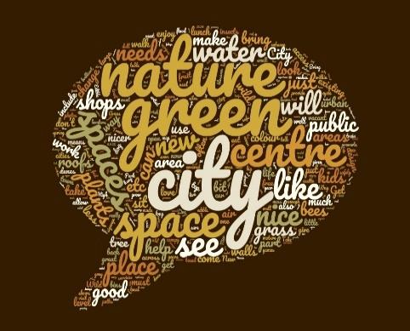

The vision and strategy will be informed by the voices of City Centre residents and users, including those of the next generation. Several stakeholder involvement events and public consultation activities have taken place. This word cloud summarises some of the responses received.

***Word Cloud of responses received***

Several Green infrastructure demonstration projects are being developed. Urban tree planting schemes have been undertaken in partnership with Trees for Cities. The Swansea Community Green Spaces project has continued to support communities improve and manage local green spaces.

**Ecosystem Services**: some ecosystem mapping work to understand how nature helps us has been undertaken at a macro level but more detailed mapping is needed. The Task Group plans to liaise with the Swansea Local Nature Partnership to develop a Local Nature Recovery Action Plan and will develop plans for Swansea to become a Bee-friendly City.

**Carbon Reduction**: The Low Carbon Swansea Bay network continues to support knowledge exchange and encourage collaboration between organisations and is expanding. The Task Group will explore methodologies for the measurement of carbon footprints.

**Improving Knowledge and Understanding**: Events have been organised to expand understanding across the Working with Nature action plan areas for example lunchtime talks at Swansea Museum and a presentation on One Planet Cities- making the connection between a resilient and a wales of vibrant culture and thriving Welsh language.

A **Working with Nature Conference** was held on the on 8th May that aimed to raise awareness of the Working with Nature actions and to ensure PSB members and partners, decision-makers across different sectors and the general public become more involved in exploring the difficult challenges and great opportunities in Working with Nature for health and well-being.

**Strong Communities**



**To build strong communities with a sense of pride and belonging.**

**Lead –** This work was coordinated by the Strong Communities Steering Group and is led by Amanda Carr of Swansea Council Voluntary Services (SCVS).

**Partners/ Stakeholders Involved**

Coastal; Family Housing; Pobl; SCVS; South Wales Police; Public Health Wales; Regeneration Swansea, Poverty Partnership Forum; Swansea Council Local Area Co-ordination; third sector forums, Regional Partnership Boards (RPB); Swansea City of Sanctuary and others supporting refugees and asylum seekers (Eyst and others); Regional Black Minority Ethnic Network; Community Cohesion group; Womens Aid /multi agency domestic violence practitioners; Clase 4 All, Morriston Regeneration Group;

Intercultural cities; Swansea Council, Community Cohesion Steering Group (which sits under Safer Swansea Partnership) City of Culture Steering Group; Menter Iaith Abertawe; Merched Y Wawr and other 3rd sector Welsh Language groups; Co Production Network; South Wales Police; GP Cluster Networks, Human Rights City group

Swansea Council Poverty Forum; Swansea Learning Partnership; Council housing and social landlords; Poverty Truth Commission; West Glamorgan Social Value Forum; GP Cluster Networks; Partner agency Procurement staff; Beyond Bricks and Mortar; Training / Learning providers

**The Steps we have taken**

This Local Well-being Objective focuses on areas not previously addressed collectively in Swansea and brings together partners without relationships together. This contrasts with more mature groups like the Early Years group where participants have an explicit common focus and have gained experience working together as a group. As a result, outcomes at this stage may be relatively modest in comparison to developed groups although the distance travelled is arguably greater.

A Steering Group has been formed and has met and key areas of focus agreed. The work of the group is to be taken forward by the participating partners. Each theme is led by a different partner, for example Coastal Housing have led on the Asset Based Community Development (ABCD) work.

In order to ensure people feel safe and confident in their communities, we aim to develop common understandings of asset-based approaches to developing community resilience, building on existing practice, leading on an action plan.

To date, we have ensured regular communication to and from relevant partnerships including the West Glamorgan Regional Partnership Board, Swansea Poverty Partnership Forum, the Safer Swansea Partnership and Regeneration Swansea. Asset Based Community Development (ABCD) activities have been promoted and new partners were identified.

A key area of focus in 2018/19 has been to map and understand what ABCD/other community development work is being undertaken in which areas.

In partnership with other social landlords, South Wales police and others, a range of asset based approaches have been undertaken. Coastal Housing has established the **‘Hub on the Hill’** project, offering a community space within Mount Pleasant, the hub is widely used by local residents including refugees and asylum seekers, community groups and individuals. In Blaenymaes community asset mapping has been undertaken, led by Pobl, along with regeneration focussed activities.

In Clase, Building Communities Trust funding for the area has led to the development involving and led by local people, of an action plan for the area which has now been signed off. The ‘**Clase 4 All’** plan has been co-produced and includes actions to improve facilities within the local area. A refurbishment of play facilities was a key priority and construction work is due to start in the next few months.

Area based work and place based approaches continue to develop, in particularly via the Cwmtawe and Llwchwr GP Cluster Network linked to Transformation funding via the Regional Partnership Board and Health Board. Over the coming year, asset mapping we be undertaken by local volunteers living within these areas. Local people will have access to support to develop new ideas and initiatives where people have identified that there is a desire to come together to make things happen.

**Social prescribing pilots** have been undertaken based on a place based model (Cwmtawe) and will continue to develop with a focus on social prescribing linked to mental and physical wellbeing.

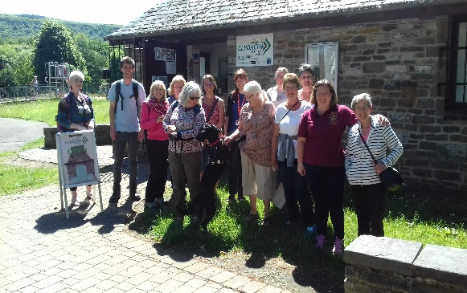To work towards individuals and communities being connected and feeling a sense of belonging we have worked together to develop ways to develop positive messages, opportunities and the removal of barriers to participation. The formation of a Human Rights Steering group and the scoping work achieved to date is an excellent example.

***Social Prescribing- Walk***

We also aim to use the principles of an intercultural city to promote the diversity of cultures and languages within Swansea sharing and making the best use of resources we have. Community language provision is being audited across agencies so we can understand where the access points for language provision exist. We are seeking an agreement to share resources for the benefit of citizens and promote common language access points.

We are working towards a thriving economy in which households achieve at least the minimum income standard by developing a single public service approach. This promotes and encourages all businesses and agencies to pay the living wage via the **Living Wage Pledge** and exploring ways to include living wage requirements in procurement and grant giving – encouraging all PSB partners to build this into their own terms and conditions when distributing funding to others.

An example of this approach is via funding applications endorsed by the Regeneration Swansea Partnership.  The partnership has developed guidance for Property Enhancement Development Grant/ Sustainable Living Grant applicants, which aims to maximise benefits from the funding scheme. This includes encouraging applicants to ensure all staff / employees are paid a fair wage for the skills required and receive the living wage as a minimum.

Across a range of grant sources work has been undertaken to include the Wellbeing Goals as a point that applicants need to address. This has helped to promote the Act and we hope will start to inform and shape the way that groups consider the act when planning their activities and services. This area of work is ongoing and developing and we aim to reach more funders to shape their focus and criteria.

Across Western Bay (now West Glamorgan) Regional Partnership Board Integrated Care Fund and Transformation funds and ABMU (now Swansea Bay University Health Board) Charitable funds, work has been undertaken to coordinate grant giving from public sources improve effective communication between grant givers and funders to maximise use of external sources of funding across Swansea avoiding duplication. We aim to use these funding sources as another way of promoting the living wage.

The West Glamorgan Regional Partnership Board has established a **Social Value Forum** where members have met to identify joint priorities for change. Following the re organisation of boundaries a new forum has been established with a work plan that will focus on areas of work including social value procurement and how members will demonstrate social return on investment. The social value forum focusses on the wellbeing of citizens using the wellbeing goals and ways of working as core elements of its approach to social value.

A key observation resulting from this first year of work is the need to ‘join up’ different the different strands that build strong communities. This means we must work to ensure that the Well-being of Future Generations (Wales) Act and Social Services and Wellbeing Act (Wales) are considered and referenced together to ensure consistency maximising the impact that one has on the other.

**Sharing for Swansea**

**Cross Cutting**

**Action for Change**

**To work towards integrated public services in Swansea by sharing resources assets and expertise, in order to develop a common language and make every contact count**

**Lead –** This work was coordinated by Swansea Council and Led by Adam Hill of Swansea Council.

**Partners/ Stakeholders Involved**

Swansea Human Rights City Steering Group; Swansea Local Property Board; Swansea Bay University Health Board, Welsh Government, South Wales Police, Swansea Council Voluntary Services (SCVS), University, Department of Working Pensions (DWP) , Social Landlords Welsh Government, South Wales Police, University, Social Landlords, Clydach local community councillors, third sector. DVLA, VOA, Natural Resources Wales (NRW), Probation Services, Swansea Council.

**The Steps we have taken**

This cross cutting action for change differs from our Local Well-being Objectives in that the steps are unrelated they are co-ordinated by a statutory partner rather than managed by a group.

**‘Understanding one another’s priorities and objectives’** has been taken forward by the continuation of a ‘walking in our shoes’ programme. The aim is for each organisation to spend time learning about the services delivered and challenges faced by other partners so they can better understand each other and identify ways to work together to make better use of resources.

This process was highlighted as good practice by the Future Generations Commissioner in October 2018. Sessions have been hosted by Swansea Council, Fire and Rescue, and Natural Resources Wales with the next event being hosted by SCVS. We feel the programme has improved working relationships between partners and all the feedback received has been positive.

**Our Physical Estates (and /or assets)** step recognises how public services can work more efficiently and effectively by sharing land, buildings, facilities or equipment in Swansea. The group explores options for further asset sharing and planning. Partners benefit from an integrated perspective so that risks can be mitigated and opportunities for collaboration identified. Future work is ongoing involving the development of proposals for the development of significant public sector hub in the City Centre which would create a core facility to not only provide better, joined up services to our citizens but would enable further regeneration and vitality in the City Centre.

Each additional participant brings new insights, for example Natural Resources Wales has helped the group consider how green infrastructure can add value to our plans. Our **Local Property Board** has expanded to include a wider membership over the past 12 months. The group is now also part of the Welsh Government Ystradau National Assets Working Group.

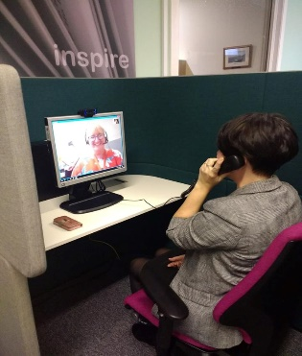A review of assets in Clydach has resulted in the development of a pilot community hub which in in operation via the Services in the Community Initiative. **My Clydach** was launched in October 2018. This has successfully involved local people, councillors, partner organisations and the community and voluntarily sector groups throughout the process. In addition to library services, the site offers agile working space, access to a wide range of Council Services, training courses, job centre services and the area’s PCSO.

***Accessing Council Services***

This approach contributes to a resilient and globally responsible Wales by minimising travel outside of the locality, supports the prosperity of the local economy, a vibrant culture and Welsh language through the provision of cultural services, enables a cohesive community by bringing people together, combats loneliness improving mental health leading to a healthy Wales and offers opportunities creating an equal Wales.

In the future there will be a focus on further pilots in Gorseinon and Morriston to ensure appropriate resourcing and organisational structures.

Swansea PSB is committed to developing a **Human Rights City** approach in Swansea. This means taking account of the Universal Declaration of Human Rights in a way that makes sense for our city. We aim to employ a co-productive approach to understand and define what human rights mean for the people of Swansea. Swansea aims to be the first city in Wales to sign a declaration for human rights.

This will involve agreeing a shared understanding of human rights objectives and priorities for our stakeholders. Opportunities for the delivery of these objectives through the work of PSB members and community organisations can then be identified and pilot projects to test feasibility developed. This builds on existing partnership work around children’s rights.

**Coproduction and engagement** activities have been led by SCVS in Swansea. This has included the formation of Swansea Coproduction Network which aims to include a more diverse range of people to discuss, think and learn about coproduction ideas, principles and practice.

Work to better understand and generate best practice has been undertaken on the co-productive commissioning of Independent Professional Advocacy Services for adults. This has helped to identify what good looks like and has developed capacity for citizens to engage further in co-productive activities with PSB partners.

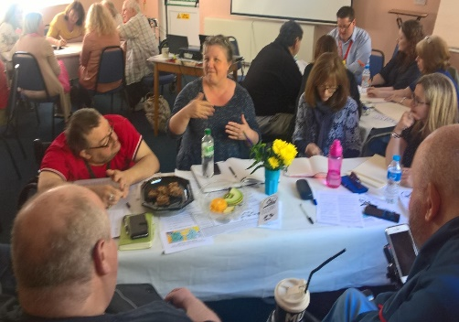This has been a learning experience for everybody involved. To support working co-productively, a collective understanding of involving people with needs to develop to ensure service users carers and staff all have a positive experience.

Moving forward CVCs across the West Glamorgan Regional Partnership Board are also going to be doing similar scoping work on coproduction so there may be synergy with our partners in Neath Port Talbot PSB.

***Swansea Coproduction Network***

A learning point over the past year of delivery has been has been that these steps actually either are common to all groups and may be better delivered within them or sit more naturally within another group. For example, a Human Rights City has naturally evolved to align with the Live Well Age Well objective while our commitment to developing people and ways of working where we aim to develop a simple common language and identify areas for joint delivery is actually implemented across all objectives.

**Our Ways of Working**

**Involvement**

While no Town and Community Councils in Swansea are currently subject to the Well-being Duty, Swansea PSB actively engages with councillors via the Community and Town Council Forum. A representative has been invited to attend Partnership Group and bespoke training has been provided for Town and Community Councillors on Public Services Board and the Well-being of Future Generations Act (Wales) 2015.

A co-productive approach has been adopted across many areas of the PSB. The principle underpins all ‘Best Start’ work where families helped to develop the key messages underpinning the programme. Practical examples include the production of storybooks created by families and human scale games used as engagement tools which were developed by children. While the Local Area Coordinator programme involves local people in the recruitment of coordinators.

Greater use of the Welsh Language within mainstream programmes has contributed to the goal of a ‘vibrant culture and thriving Welsh language’. A Swansea Early Years Conference (collaboratively organised by Early Years partners and developed taking into account the five ways of working) has resulted in closer relationships between Welsh and English language childcare providers. As a direct result of these links being forged several Early Years settings have benefited from free Welsh language sessions provided by Mudiad Meithrin.

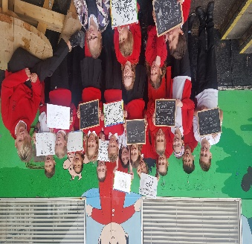

The development of the City Centre Green Infrastructure Strategy has involved a wide variety of people of all ages and backgrounds in both English and Welsh. An excellent example is the *#*natur yn y ddinas engagement with Ysgol Gyfun Gymraeg Brynymor.

***Ysgol Gyfun Gymraeg Brynymor.***

The PSB is conscious that more accessible ways to communicate with the public are needed. As part of regional collaborative work in 2018/19, PSB members from across the region participated in Easy Read training to improve accessibility. In 2019/20, the regional PSBs aim to support each other in developing digital storytelling and other skills to improve communication.

**Collaboration**

Collaborative working is fundamental to the way in which PSB operates. In addition to collaborating with local partners on the Local Well-being Objectives, there is increasing joint working with Neath Port Talbot Public Services Board where interests collide and it makes sense to do so.

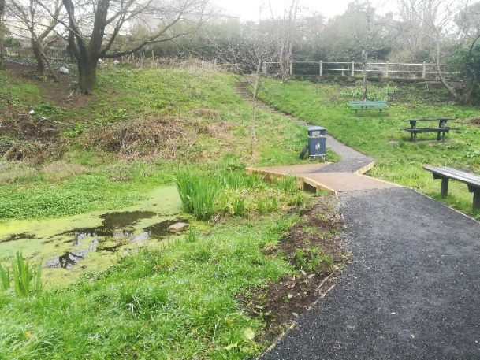A good example is a successful joint funding bid to access funding for green infrastructure projects across the region. While each region applied the funding to different aspects of green infrastructure, they worked together and will each learn from the complementary projects run by the others.

***Green Infrastructure at Mayhill Washing Pond***

Substance Misuse is an example where the wide variety of partners represented by Public Services Boards made it an effective forum to respond to an urgent and complex issue impacting both Neath Port Talbot and Swansea.

Following reports of high levels of drug-related deaths; serious infection and a growth in organised crime across the area, the two public services boards of Neath Port Talbot and Swansea agreed that a heightened level of attention was required across agencies. A Critical Incident Group was formed with membership drawn from a wide range of agencies to assess the risk, threats and harm in detail and to activate an immediate and appropriate response.

The Critical Incident Group met between September 2018 and February 2019. Key actions completed included:

* Reduction in long waits for drug treatment services;
* Introduction of a pilot outreach service targeted at people deemed at high risk of overdose, serious infection or death;
* Strengthening the Area Planning Board to respond to the needs of people in the area;
* Comprehensive awareness raising programme to build knowledge and understanding across agencies and within communities of the organised crime gangs behind County Lines, including how to spot concerns and how to report them;
* Multi-agency operations across the county borough to tackle drug dealing and to support vulnerable people caught up in the criminal gangs;
* Enhanced programmes across schools, youth services and further/higher education to equip teachers, teaching assistants and learners with knowledge and skills about county lines, substance misuse and how to respond to situations; and
* Joint working to provide more effective responses to people in a mental health crisis; with an acute health need; and children who are missing from residential care homes in the area.

The two Boards will meet at least twice in the next twelve months to monitor progress. Accountability for delivering the next phase of actions has set been set out in an action plan agreed by both boards.

This experience has encouraged both Boards to reflect on future joint working opportunities projects in particular Suicide and Self Harm Prevention has been identified as an areas that would benefit from PSB attention across the region in 2019/20.

**Integration**

In order to best consider how our local well-being objectives impact upon the local well-being objectives of neighbouring PSBs and the well-being objectives of our partner organisations, most of whom work regionally. We have participated in an increasing volume of regional work, much of which has been at a planning and co-ordination level. Some of this valuable activity has been made possible by resource provided by a Welsh Government via a regional funding grant.

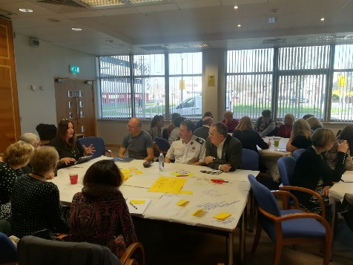A number of activities have been carried out jointly with the public services boards of Bridgend and Swansea.

***Joint Integration Event***

These include:

* Joint training for report authors in Easy Read writing approaches;
* A regional integration event has created the conditions for increased integrated and collaborative working in 2019/20. In addition to regional connections relating to shared objectives, both PSB’s took the opportunity to identify impacts across their well-being Objectives.
* Consideration of the respective roles of the public services boards established under the Well-being of Future Generations (Wales) Act 2015 and the regional partnership boards established to take forward reform of health and social care services. Key actions from this work include
* Focusing the work of PSBs on primary prevention with RPBs taking responsibility for secondary and tertiary prevention; and
* Holding a joint annual event to celebrate achievements and share learning.

Meetings between the PSB Co-ordinators and between the Lead Officers have also identified some common themes that will be explored in the next twelve months:

* + adopting a consistent approach to asset mapping;
  + information sharing;
  + data analysis;
  + evaluation;
  + developing new methods of engagement such as digital stories;
  + workforce development (making every contact counts).

It has been agreed that more regular meetings between co-ordinators and between lead officers will be scheduled in 2019-20. It was also agreed that partners should be encouraged to reflect the PSB’s local well-being objectives in corporate well-being plans and across partnership structures.

**Long term**

The initial years of Swansea PSB’s operation heavily focused on how current trends may impact future Generations in Swansea, as part of research underpinning our Assessment of Local Well-being**.**

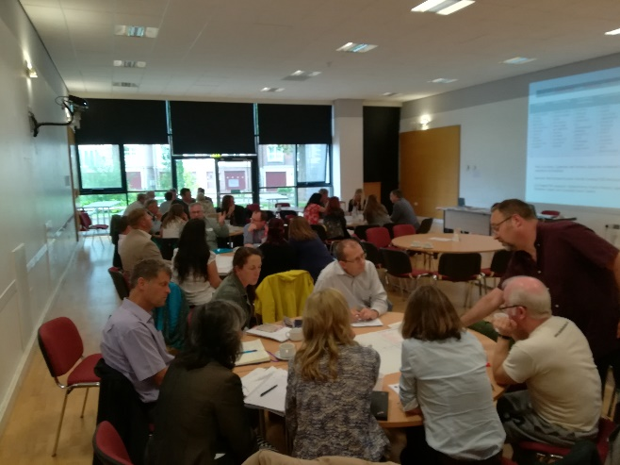The process of developing our Local Well-being Plan both began with a ‘blank page’ involvement process that invited citizens, leaders, officers and the third sector to imagine the future ‘Swansea We Want’. Our Local Well-being Objectives were based on the long term future ambitions prioritised.

***Workshop at Canolfan Gorseinon Centre***

Every Local Well-being Objective includes 2040 as a focal point to ensure that the short term actions we take today align with our vision for the Swansea where the next generation will live.

The challenge in 2018/19 has been to bring back the focus to short term actions while ensuring they contribute to long term outcomes. This has been beneficial in providing a flexible, responsive framework that has been able to react to disruptive short term change such as the regional health board footprint reorganisation while retaining the integrity of our long term vision. This long term focus balanced with short term flexibility has also meant that we have been able to plan a programme that takes advantage of unanticipated opportunities such as participation in the Early Years Integration Pathfinder programme.

However, we intend to work to improve the formal agreement of short term action plans moving forward. Our governance review being a key way this will be enabled. We also see opportunities to once again consider future trends across Objective delivery groups as part of our forward workplan.

**Prevention**

A focus on prevention and early intervention characterises all work undertaken by the Public Services Board in Swansea. Core members have each embraced this approach in their organisation work and value the collaborative opportunities offered by the PSB to take forward new approaches.

The work on Making Every Contact Count in particular has been effective across sectors in helping to manage and mitigate a wide variety of risks. While work on green infrastructure will help the next generation of City Centre development to incorporate nature and help issues like flooding climate change and loss of biodiversity from getting worse.

Early intervention and the value of a cross agency approach is demonstrated by the Jig-so project’s ability to identify and help address issues like worklessness and domestic violence during pregnancy before a child comes into the world. This reduces Adverse Childhood Experiences and increases the life chances of all members of the young families participating in the programme.

**Our Next Steps**

Swansea PSB’s strengths lie within the expertise, experience and enthusiasm of its partners, from the frontline staff working to deliver the Local Well-being Objectives to the leadership representatives who work together to strategically improve Swansea’s well-being. Over the past year, the limitations of the existing governance structure have been recognised. Advice from the Future Generations Commissioner has led to a Governance Review which we believe has enabled us to transform this previous weakness into a strength. Our new structure embraces the ways of working by placing the delivery of objectives, in ways that make a difference at its heart.

Austerity and continued uncertainty will continue to challenge our organisations moving forward. However significant opportunities have been identified to build our capacity by working together and increasingly share assets and resources. In particular, the benefits of increased regional working, improved communications that enables the greater involvement of wider stakeholders and clearer relationships with other partnerships such as West Glamorgan Regional Partnership Board will be a focus for the future.

**How you can get involved?**

The work undertaken by Swansea Public Services Board is published online at www.swanseapsb/swansea.gov.uk.

Our Partnership Group meetings are held in public and questions from the public are invited via a standing agenda item Public Question Time.

You can also contact our Public Services Board Co-ordinator directly by email at [Swansea.psb@swansea.gov.uk](mailto:Swansea.psb@swansea.gov.uk) or telephone 01792 635104.

We welcome involvement in all areas of our work and we would also welcome ideas and suggestions as to other areas of work that we could consider for the future.